Sperical Intersection Algorithm

The problem is to find the intersection of two paths on the globe, defined as parametric equations of the (possibly approximate) distance along the path from an initial point. The parametric equations give both the position of the point and the slope. We start with a first approximation of the two distances to the intersection point along each line, d₁ and d₂, which give us the initial points pt₁ and pt₂.
The basic algorithm is to approximate the path as a great circle tangent to the paths at the initial approximations, pt₁ and pt₂, as shown in Drawing 1. The distance d₁' = pt₁ - pt₃, so the new approximation for the intersection is therefore result of the parametric function at d₁ + d₁', and similarly for pt₂
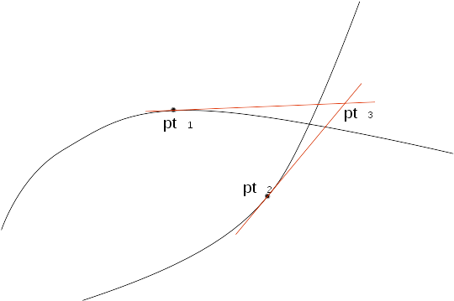Drawing 1: Approximation of Intersection
The problem, therefore, becomes that of finding the distances from pt₁ and pt₂ to the intersection at pt₃. On the plane this is simple, but a planar approximation using latitude and longitude behaves badly around the poles. Therefore spherical trigonometry is used instead.
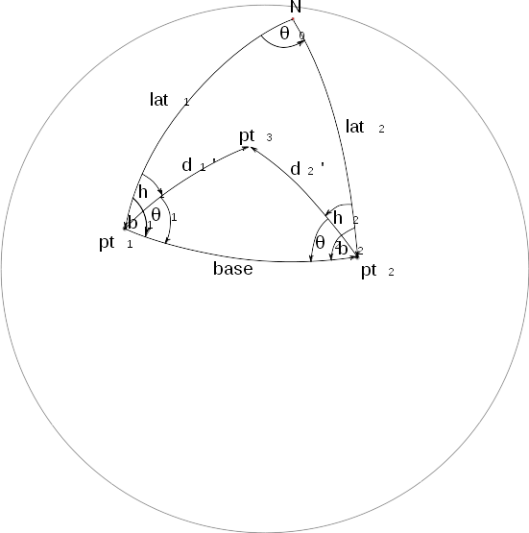Drawing 2: Intersection on a Sphere
The point N is the North Pole. Lines lat₁ and lat₂ are the lines of longitude from N down to pt₁ and pt₂. Therefore the angle θ₀ is the difference in longitude between pt₁ and pt₂.

