**Object-Oriented Programming**

Laboratory Activity No. 1

**Review of Technologies**

*Submitted by:*

**Polestico,Paul Justine D.**

**<Saturday> / <BS CpE 1-A>**

*Submitted to*

**<Engr. Maria Rizette Sayo>**

<Instructor>

*Date Performed:*

**18-January-2025**

*Date Submitted*

**18-January-2025**

I. Objectives

In this section, the goals in this laboratory are:

* To define the key terms in Object-oriented programming
* To be able to know the construction of OO concepts in relation to other types of programming such as procedural or functional programming

II. Methods

General Instruction:

1. Define and discuss the following Object-oriented programming concepts:
2. Classes

*🡪* ***Classes****,in terms of Object-Oriented Programming,is like the blueprint for programming.It simply allows you to create user-defined data structures. Classes define funcions called* ***methods****, which identify the behaviors and actions that an object created from the can perform with tis data.*

1. Objects

* *Relating to classes, an* ***instance*** *is what represents the haracteristics and properties that an object can have.While classes are the blueprints,* ***Objects*** *represent the properties and characteristics of that class. In other words,classes are similar to a template, while objects are what define classes.*

1. Fields

*🡪Also known as* ***attributes*** *or* ***properties****,are variables that are assigned within a class. They are, as defined,represent the various characteristics of an object. For example, we have a car and its attributes include headlights,tires,tail lights,etc.*

1. Methods

*🡪 are concepts used to modify or define the behavior of the class and its objects. For example,we have a car. Its attributes include headlights,tail lights, tires, etc. Now that we have defined its characteristics, we can now define the behavior of these attributes in order for them to do something, which include* ***headLightOn,Start,Brake,exhaustFumes****.*

1. Properties
   * *Phyton has several properties that make it a flexible tool for various fields.****Classes*** *are the blueprints,****Objects*** *are what define the classes****.Inheritance*** *allows a clas****s*** *to acquire properties and methods of another class. There are types of inheritance:* ***Single Inheritance, Multiple Inheritance, Multilevel inheritance, Hierarchical Inheritance and Hybrid Inheritance****.****Polymorphism*** *means that an object can have the same name,but different behavior depending on the object’s context. There are 2 types of Polymorphism:* ***Compile-Time Polymorphism and Run-Time Polymorphism.******Encapsulation*** *bundles the data and methods within a class restricting access to some components to control interactions. There are 3 types of Encapsulation:* ***Public Members, Protected Members, and Private Members.*** *Lastly,* ***Abstraction*** *hides the internal implementation details while exposing only the necessary functionality. It focuses more on “what to do” rather than “how to do it.” There are 2 types of abstraction:* ***Partial Abstraction and Full Abstraction.***

III. Results

*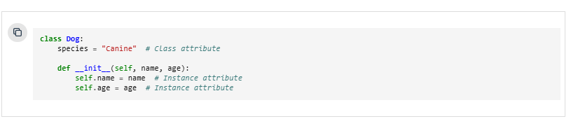***Figure 1: Classes**

*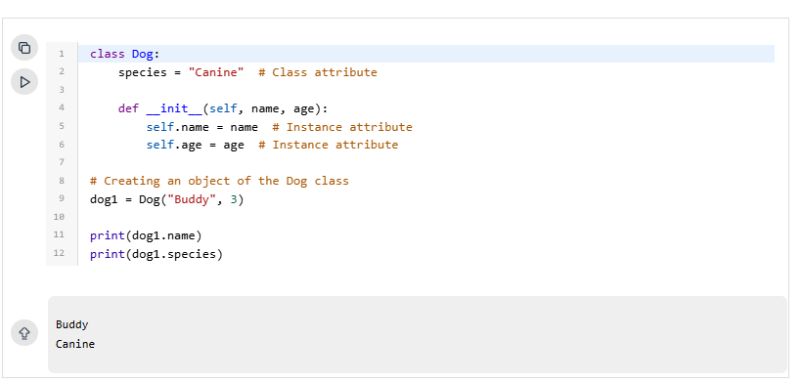****Figure 2: Objects***

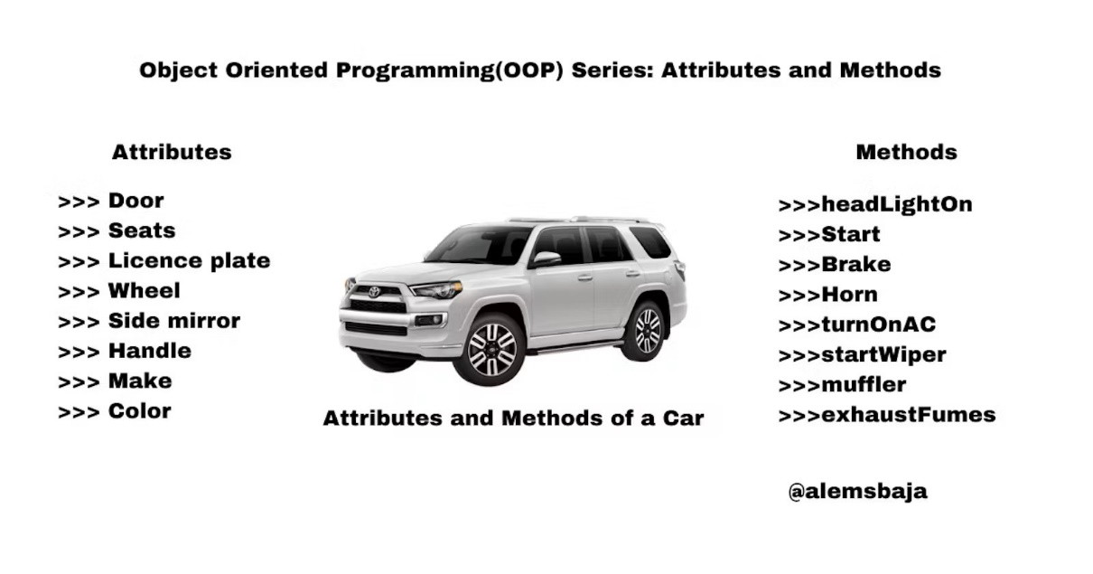

***Figure 3: Fields***

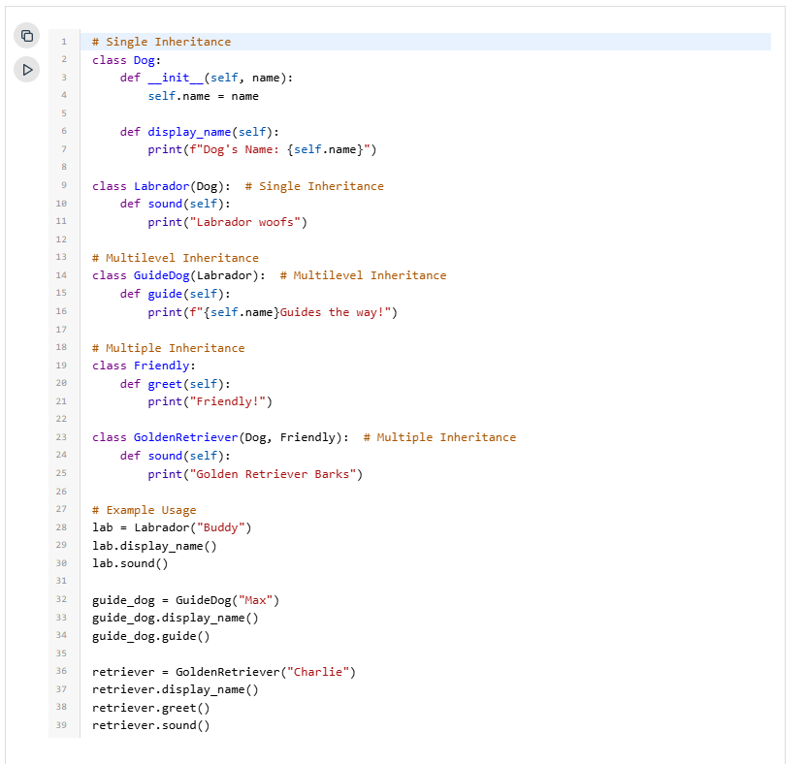***Figure 4: Inheritance***

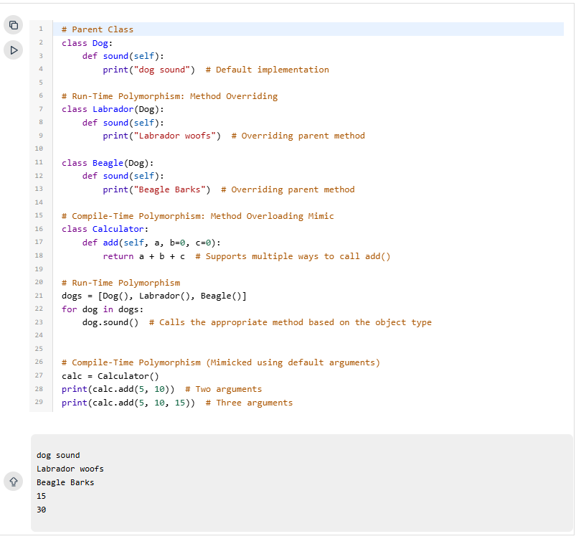***:***

***Figure 5: Polymorphism***

***Figure 6: Encapsulation***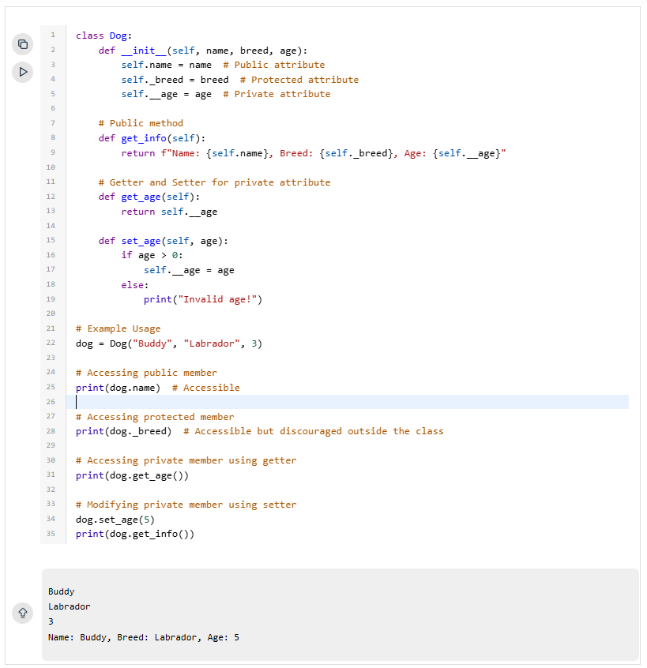

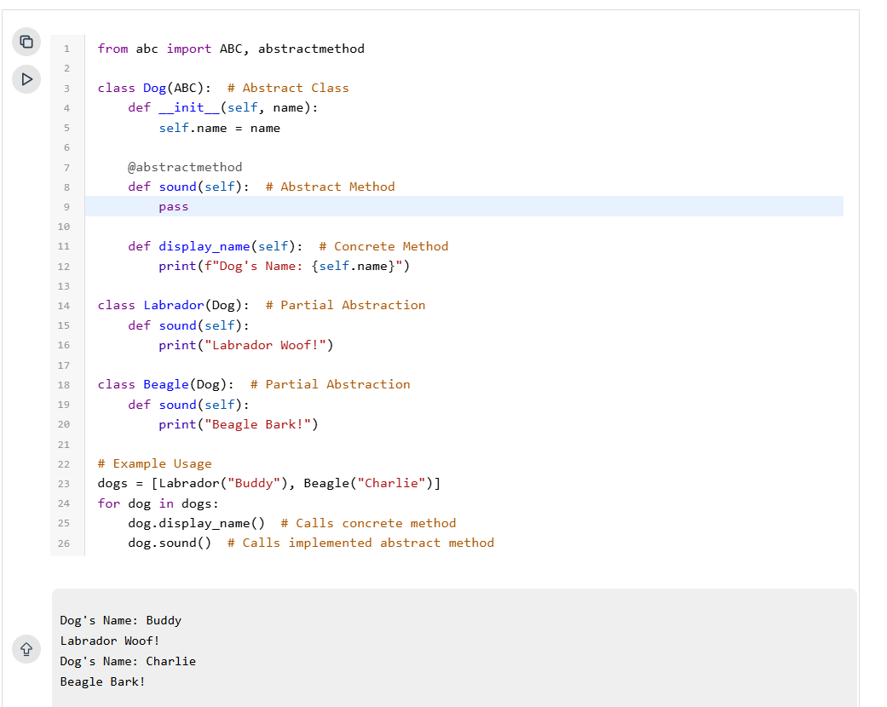***Figure 7: Abstraction***

IV. Conclusion

This research taught me the fundamental concepts of Object-Oriented Programming,particularly in phyton. It utilizes several techniques in order to not just develop,but also arrange and compile the code in a cleaner and more comprehensive way. Learning these concepts would help me in developing my programming skills that i will use in the future,including **Classes,Objects,Fields,Inheritance,Polymorphism,Encapsulation,and Abstraction.**

**Reference**

Book

[1]

Website

[1] “Classes (OOP) | Brilliant Math & Science Wiki.” [Online].

Available:

<https://brilliant.org/wiki/classes-oop/>

[Accessed January 18,2025].

[2] D. Amos, “Object-Oriented Programming (OOP) in Python,” Dec. 15, 2024.

[Online].Available:

<https://realpython.com/python3-object-oriented-programming/>

[Accessed January 18,2025].

[3] GeeksforGeeks, “Python OOPs Concepts,” *GeeksforGeeks*, Dec. 13, 2024.

[Online]. Available:

<https://www.geeksforgeeks.org/python-oops-concepts/>

[Accessed January 18,2025]

[4] A. R. Baja, “Object Oriented Programming(OOP) series: Attributes and methods,” *Alemoh Rapheal Baja*, Apr. 04, 2024. [Online]. Available: https://alemsbaja.hashnode.dev/object-oriented-programmingoop-series-attributes-and-methods

[Accessed January 18,2025]