Московский Государственный Технический Университет им. Н. Э. Баумана

Факультет «Информатика и системы управления»

**Отчет по лабораторной работе № 2**

**Курс «Разработка Интернет-приложений»**

|  |  |
| --- | --- |
| Выполнил: |  |
| студент группы ИУ5-54 | _____________________ |
|  | (подпись) |
| Кайнов П. И. | "__"__________2016 г. |

Проверил:

Преподаватель каф. ИУ5

|  |
| --- |
| ____________________ |
| (подпись) |

Гапанюк Ю. Е.

"__"_________2016 г.

Москва, МГТУ – 2016 г.

___________________________________________________________________

**Задание и порядок выполнения**

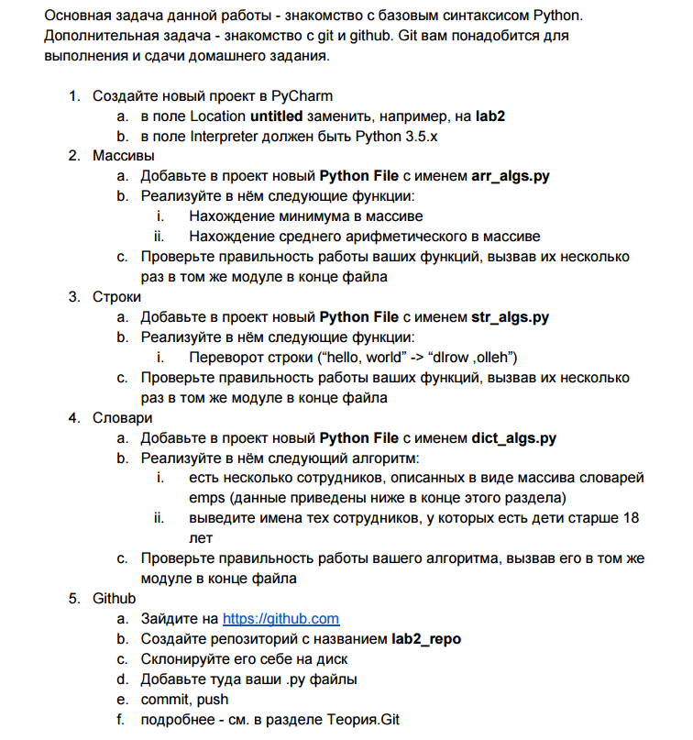

**Код программы**

massive=[14, 15, 16, 167, 71]

line = "hello, world"

ivan = {

"name" : "ivan" ,

"age" : 34,

"children" : [{

"name" : "vasja" ,

"age" : 19,

}, {

"name" : "petja" ,

"age" : 19,

}],

}

darja = {

"name" : "darja" ,

"age" : 41,

"children" : [{

"name" : "kirill" ,

"age" : 21,

}, {

"name" : "pavel" ,

"age" : 15,

}],

}

emps = [ivan, darja]

def fun_begin(massive):

print("massive: ")

for i in range(len(massive)):

print(massive[i])

def fun_min(massive):

print("min of massive:")

return print(min(massive))

def fun_med(massive):

print ("med of massive:")

med = sum(massive)/len(massive)

return print(med)

def fun_line(line):

print (line)

out = line[::-1]

print(out)

def fun_worker(emps, age_of_child):

filtered = []

for work in emps:

for child in work['children']:

if child['age'] > age_of_child:

filtered.append(work['name'])

break

return filtered

fun_begin(massive)

fun_min(massive)

fun_med(massive)

fun_line(line)

print(fun_worker(emps, 18))

**Результат выполнения программы**

massive:

14

15

16

167

71

min of massive:

14

med of massive:

56.6

hello, world

dlrow ,olleh

['ivan', 'darja']

=> None