Computer Programming Python
MovieMatch
Intelligent Movie Recommendation System — Project Report
Full Name | Paul Kipkoech Kiprop
Student ID | GH1051724
GitHub Repository | https://github.com/PaulKiprop/SupplyChainSystem
Video Demonstration | [Your Video URL — YouTube / OneDrive]
Submission Deadline | 26 June 2026, 18:00 Berlin Time

1. Introduction
MovieMatch is a desktop application that helps users discover films based on their personal tastes and viewing history. Rather than browsing endless lists, the user builds up a profile simply by rating and saving the movies they like, and the application responds with tailored, explainable recommendations.
The project demonstrates a complete, layered Python application: a live connection to a real web API, local data persistence, a content-based recommendation algorithm, data analytics with charts, and a responsive graphical user interface — all organised into clearly separated modules.
The six core capabilities delivered are:
- Discover the latest movies automatically on launch (Home page)
- Search for movies by title
- View movie details (overview, genres, poster, community score)
- Save favourites and rate movies (1–5 stars)
- Receive recommendations based on taste, with reasons
- Analyse watching habits through visual charts

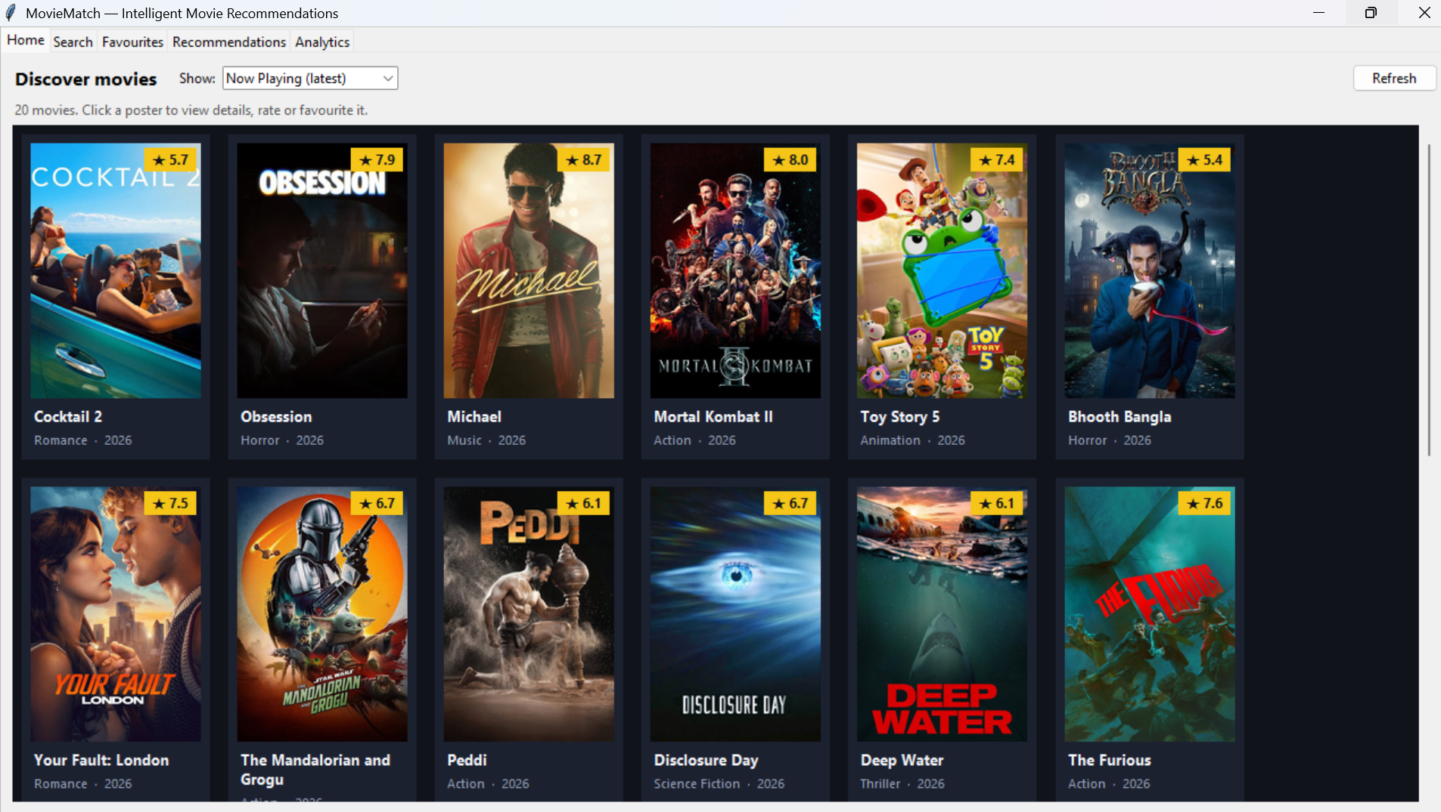
Figure: Home page showing the latest movies as a poster grid

2. Implementation Stack
Layer | Technology | Why it was chosen
Language | Python 3.14 | Module requirement; rich standard library
GUI | Tkinter / ttk | Built into Python — portable, no install needed
Movie data | TMDB REST API | Free source of real movie metadata, posters, ratings
HTTP client | requests | Clean, reliable API calls
Images | Pillow (PIL) | Decodes/resizes TMDB JPEG posters for Tkinter
Charts | matplotlib | Embeds analytics charts inside the window
Storage | SQLite (sqlite3) | Zero-config local database; standard library

External dependencies are limited to four well-established packages (requests, Pillow, matplotlib, python-docx), all listed in requirements.txt.

3. Architecture
The code is organised into a Python package, moviematch, with each concern isolated in its own sub-module. This separation makes the system easy to understand, test and extend.
moviematch/
├── config.py # API key loading, paths, constants
├── models.py # the Movie dataclass (shared everywhere)
├── api/tmdb_client.py # TMDB REST wrapper
├── data/storage.py # SQLite persistence layer
├── recommender/content_based.py # recommendation algorithm
├── analytics/habits.py # habit aggregation (pure functions)
└── gui/ # Tkinter UI: app + 5 tabs + details window
Design principles applied:
- Single source of truth — one Movie dataclass is used by every layer, so all parts of the system speak the same language.
- Separation of concerns — networking, storage, logic and presentation never mix; the analytics module is pure functions, making it directly testable.
- Responsiveness — all network calls run on background threads, so the interface never freezes; results return to the main thread via Tkinter's after().
- Graceful degradation — without an API key the app still opens; favourites and analytics work offline and online features show a clear message.

4. Key Features in Detail

4.1 Home (discovery) page
On startup the app automatically loads the latest cinema releases into a responsive poster grid. A dropdown switches between Now Playing, Popular, Top Rated and Upcoming. Each film is a card showing its poster, a gold rating badge and its title; posters load lazily so the page appears instantly.

4.2 Search and details
The user searches by title; results appear in the same poster grid. Clicking a poster opens a details window with the full overview, genres, poster and score, plus controls to rate and favourite the movie.

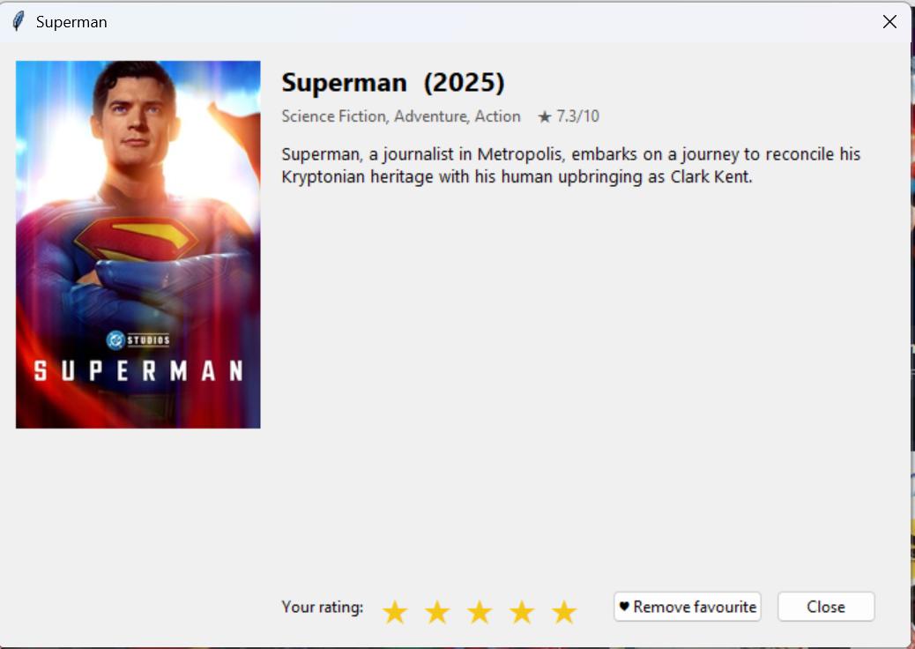
Figure: Movie details window with poster, rating stars and favourite button

4.3 Favourites and ratings
Favourites and 1–5 star ratings are stored in the local SQLite database and persist between sessions. Viewing a movie's details is also logged, building the history used by analytics and recommendations.

4.4 Recommendations (content-based)
The recommendation engine works in four explainable steps:
- Build a taste profile — each favourited/highly-rated movie contributes a weighted bag of genres and keywords; 5-star films count more than 3-star, genres more than keywords, and 1–2 star films are down-weighted.
- Gather candidates — fresh movies are pulled from TMDB by the user's top genres, plus popular titles to broaden the pool.
- Score each candidate against the profile using cosine similarity, excluding anything already seen.
- Explain — every recommendation shows a match % and the shared genres/keywords behind it, so suggestions are transparent rather than a black box.
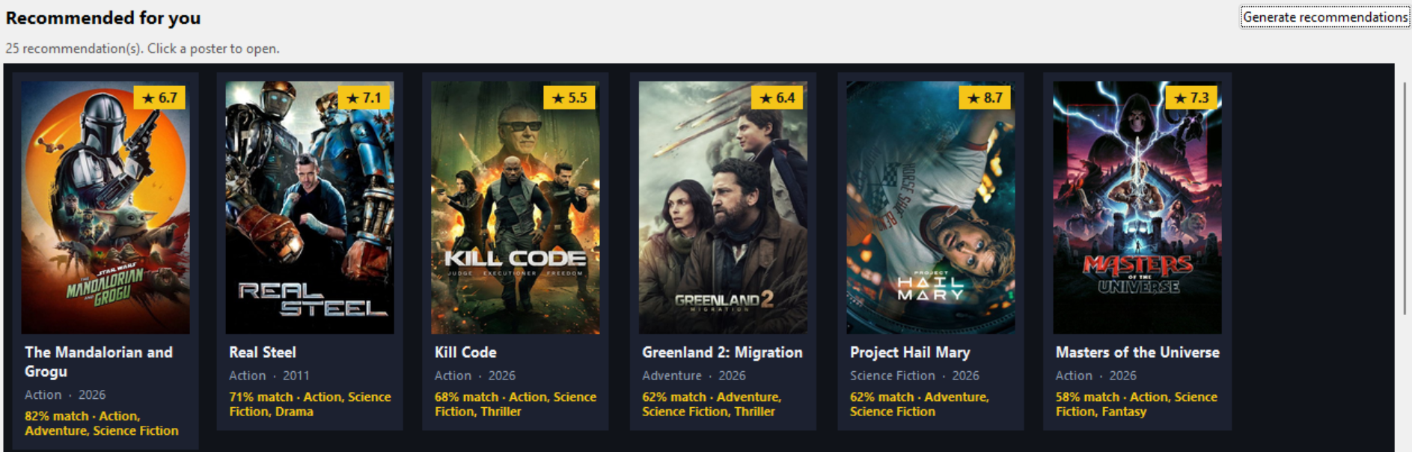
Figure: Recommendations tab: poster grid with match % and reasons

4.5 Analytics
The Analytics tab summarises viewing habits and renders three matplotlib charts embedded in the window: top genres, ratings distribution and movies by decade, alongside totals such as average rating and most-watched genre.
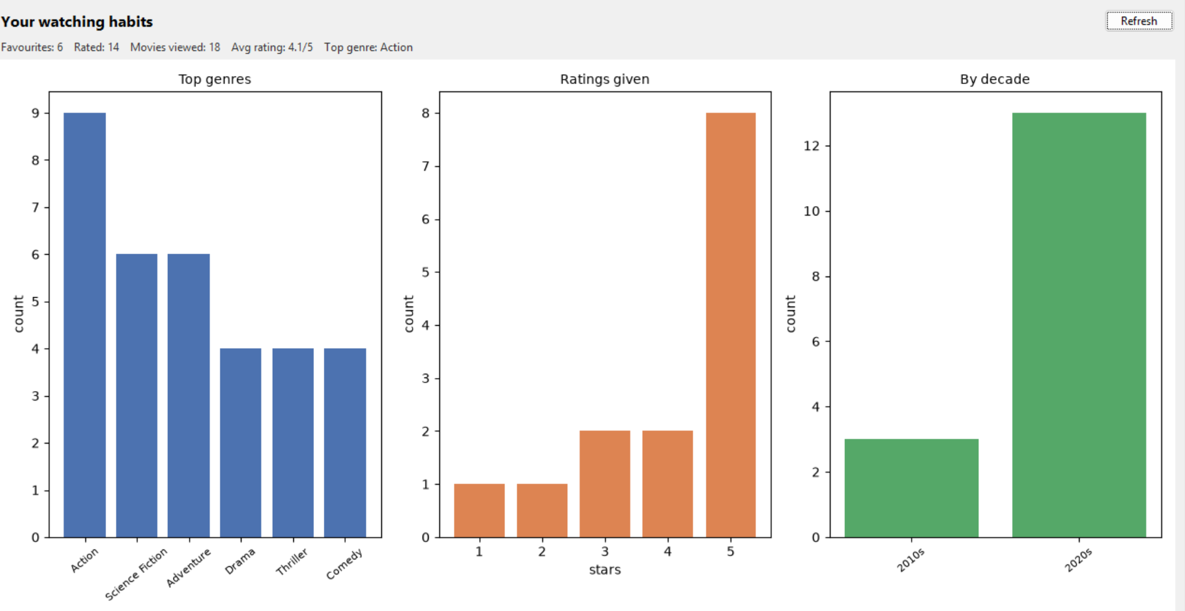
Figure: Analytics tab with top-genres, ratings and decade charts

5. Data Persistence
A single SQLite database (data_store/moviematch.db) holds four tables:
- movies — a cache of movie metadata, so favourites/analytics work offline
- favorites — saved movies
- ratings — the user's 1–5 star ratings (constrained at database level)
- history — a log of viewed movies
Movie-specific tables reference movies(movie_id) as a foreign key, avoiding duplicated data. All writes use parameterised SQL statements, protecting against SQL injection and malformed input.

6. Testing and Quality
A suite of offline unit tests covers the model, storage, recommender and analytics layers without needing the network or a display. Tests verify that ratings are validated (1–5 only), that recommendations prefer genre overlap and exclude already-seen films, and that analytics correctly aggregate genres, decades and average ratings. Keeping logic free of GUI code is what makes this isolated testing possible — a direct benefit of the layered architecture.

8. Challenges and Future Work
Challenges addressed:
- Keeping the UI responsive during network calls — solved with a background-thread helper that guides results back to the main thread.
- Displaying JPEG posters in Tkinter (which supports few formats natively) — solved with Pillow, creating Tk image objects on the main thread only.
- Making recommendations explainable — solved by reporting the shared features behind every suggestion.
Possible extensions:
- Add a lightweight collaborative-filtering layer ('users who liked X…')
- Support multiple user profiles
- Export the analytics charts to an image or PDF report
- Cache search results to reduce repeated API calls

9. Conclusion
MovieMatch brings together real-world web API, local persistence using SQlite to build an intelligent recommendation algorithm with the analytical visualizationwith a responsive interface. This demonstrates all the practical application of python concepts: object-oriented design, modular architecture, data handling, concurrency and GUI development.

