THE

LICINA
FAMILY RECIPE COLLECTION

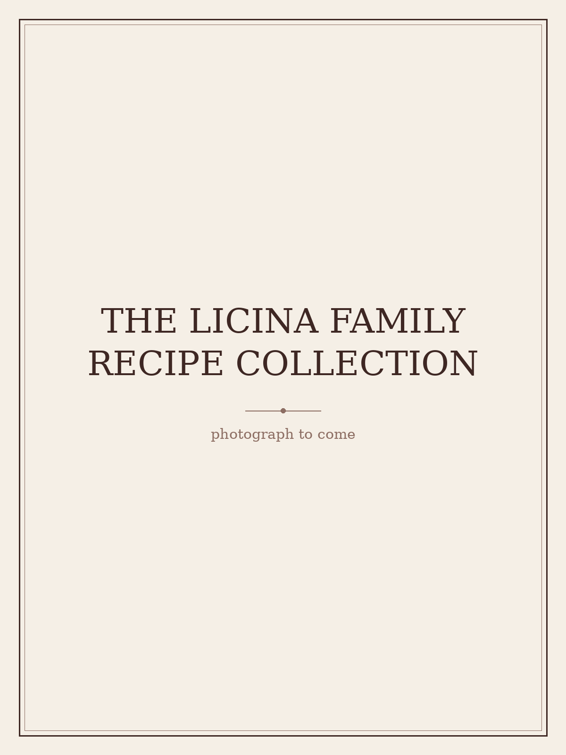

Recipes gathered with love, from Tatjana’s kitchen — to the kitchens of future generations of Licinas

About This Collection

My love of cooking is a creative outlet and a break from the administrative demands of my career in HR management — a space for relaxation, self-expression, and showing love to my family. Cooking and dining also help me organise and maintain social connections, from family dinners to events built around fine food and wine.
This collection gathers the dishes Natasha and Bianca grew up on, alongside my own creations and favourites drawn from my personal cookbook library.

How Recipes Are Tagged
- Family Favourite — dishes from Natasha and Bianca’s childhood
- Tanya’s Collection — recipes gathered from my cookbook library, credited to the original author
- Tanya’s Original — my own creations

RECIPE 1
Roast Chicken with Zucchini Stuffing
Poulet Rôti Farci aux Courgettes
Tanya's Collection — adapted from Diane Holuigue, Savouring Provence
Ingredients
- 2–3 zucchini, finely grated (2 cups)
- 2 spring onions, sliced
- 2 tbsp fresh breadcrumbs
- 2 tbsp grated parmesan
- 1 tbsp chopped oregano
- 1 tsp chopped thyme
- Salt and pepper
- 1 whole chicken (~2kg)
- 3 tbsp olive oil
- Optional jus: 1 cup chicken stock, splash of sherry or Madeira, touch of tomato paste
Method
Mix the zucchini, spring onion, breadcrumbs, parmesan, and herbs into a stuffing. Loosen the chicken's skin from the breast without tearing it, then pack the stuffing into that pocket so it bastes the meat as it roasts.
Truss, oil, and season the outside, then roast at 220°C for about 1¼ hours until the thigh juices run clear (or the thigh reaches 82°C internally). Rest for 10–15 minutes before carving into quarters.
For the jus, deglaze the roasting pan with stock, reduce, and adjust with tomato paste or sherry if needed.

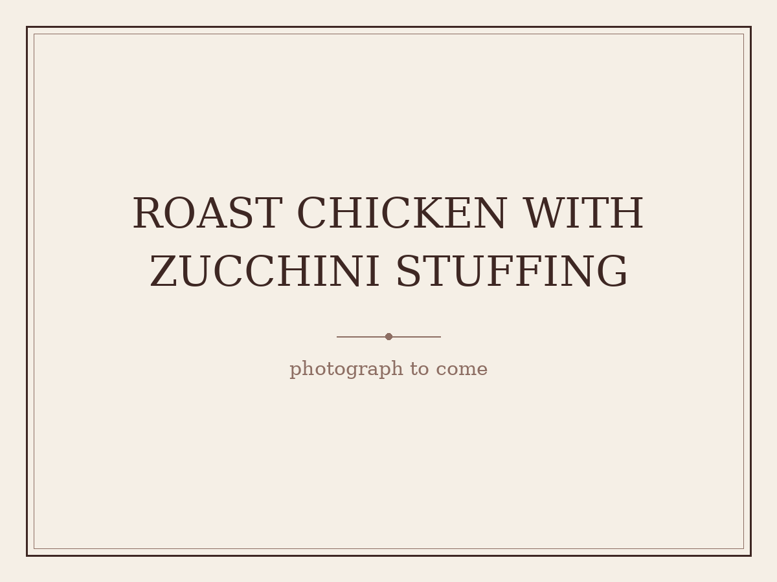
(placeholder — awaiting Tanya’s photograph)

RECIPE 2
Sour Cherry Pita
Pita s Višnjama
Family Favourite — Serbian heritage — from Veliki Narodni Kuvar ("The Great Folk Cookbook"), translated from the original Cyrillic
Ingredients
- 1 tbsp lard or butter
- 2 egg yolks (plus 1 extra for glazing)
- 4–5 tbsp sugar
- Juice of 1 lemon
- 5 tbsp milk
- ½ packet baking powder
- 2 egg whites, stiffly whipped
- Flour, as needed, to form a soft dough
- Sour cherries, cleaned/pitted
- Ground walnuts
- Fine sugar, for the filling and dusting
Method
Rinse the lard or butter, then whip until fluffy. Beat in the egg yolks, sugar, lemon juice, milk, and baking powder. Fold in the stiffly whipped egg whites. Add just enough flour to form a dough that isn't too firm, then roll into two sheets sized to fit your baking tray.
Grease the tray and dust with flour. Lay down the first sheet of dough, scatter over the cherries, then top with ground walnuts and a little fine sugar. Cover with the second sheet, brush the top with egg yolk, and bake in a fairly hot oven. Cut into squares once baked and dust with sugar to serve. Keeps well for several days — reportedly even better with time.


(placeholder — awaiting Tanya’s photograph)

RECIPE 3
Vanilice
Vanilla Sandwich Cookies
Family Favourite — Serbian heritage — from Veliki Narodni Kuvar ("The Great Folk Cookbook"), translated from the original Cyrillic
Ingredients
- 250g butter (or 200g lard)
- ½ kg flour
- 1 egg yolk, plus 1 whole egg
- 4 tbsp sugar
- Juice of 1 lemon
- 2 egg whites, whipped to a stiff foam (for coating)
- Finely chopped walnuts, for coating
- Jam (pekmez), for filling
- Vanilla sugar, for dusting
Method
Whip the butter or lard until fluffy, then beat in the egg yolk, whole egg, sugar, and lemon juice. Add the flour, turn the mixture out onto a pastry board, and knead into a dough. Roll it out to about half a centimetre thick.
Using a vanilice cutter, cut out small rounds. Dip each one into the whipped egg white foam, then sprinkle with finely chopped walnuts. Arrange on a greased tray and bake, taking care that they stay pale and don't brown. Once baked, spread with jam and sandwich two together. Dust with vanilla sugar and serve.


(placeholder — awaiting Tanya’s photograph)

RECIPE 4
Suve Kiflice od Oraha
Dry Walnut Crescents
Family Favourite — Serbian heritage — from Veliki Narodni Kuvar ("The Great Folk Cookbook"), translated from the original Cyrillic
Ingredients
- ½ kg walnuts, ground
- 1 kg fine sugar
- 14 egg whites, divided (12 for the base mixture, 2 added after cooling)
- Zest of ½ lemon
- Extra chopped walnuts, for coating
- Flour, for the board
Method
Grind the walnuts and place them in a pot with the sugar, egg whites, and lemon zest. Mix together and warm gently on the stove — just enough to dissolve the sugar into the mixture, without letting it boil. Remove from the heat and transfer to another dish to cool.
Once cooled, mix in the remaining 2 egg whites. Turn the dough out onto a floured board and work it until it no longer sticks to your hands. Shape into rolls about 10cm long, curve each into a crescent shape, sprinkle generously with chopped walnuts, and bake on low heat so they stay pale.

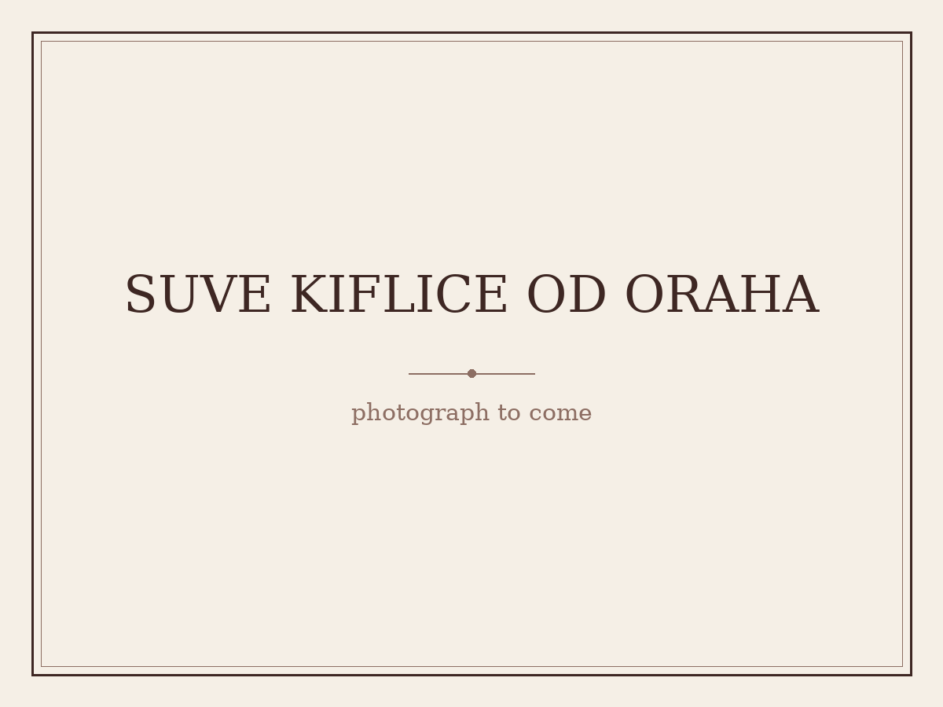
(placeholder — awaiting Tanya’s photograph)

RECIPE 5
Lamb Racks with Breadcrumbs, Parsley and Lemon
Family Favourite — adapted from Bill Granger, bills open kitchen
Ingredients
- 3 thick slices wholemeal or sourdough bread
- 7g (¼ cup) finely chopped flat-leaf parsley
- Finely grated zest of 1 lemon
- 1 garlic clove, crushed
- 60ml (¼ cup) olive oil, plus extra
- Sea salt and freshly ground black pepper
- 2 x 8 French-trimmed lamb racks
- 2 tbsp Dijon mustard
- 500g cherry tomatoes on the vine
- 4 garlic cloves, unpeeled (optional)
Method
Toast the bread until lightly golden, then crumble or process into breadcrumbs. Combine with the parsley, lemon zest, crushed garlic, olive oil, salt, and pepper.
Rub the lamb racks with a little extra olive oil and season well. Sear fat-side down in a hot pan for 2 minutes, then transfer to a baking tray. Spread the top of each rack with mustard and press on the breadcrumb mixture. Roast alongside the cherry tomatoes and whole garlic cloves at 180°C for 25–30 minutes, until the lamb is cooked and still pink inside. Rest, loosely covered in foil, for 5 minutes. Cut each rack in half and serve with the roasted tomatoes and garlic.

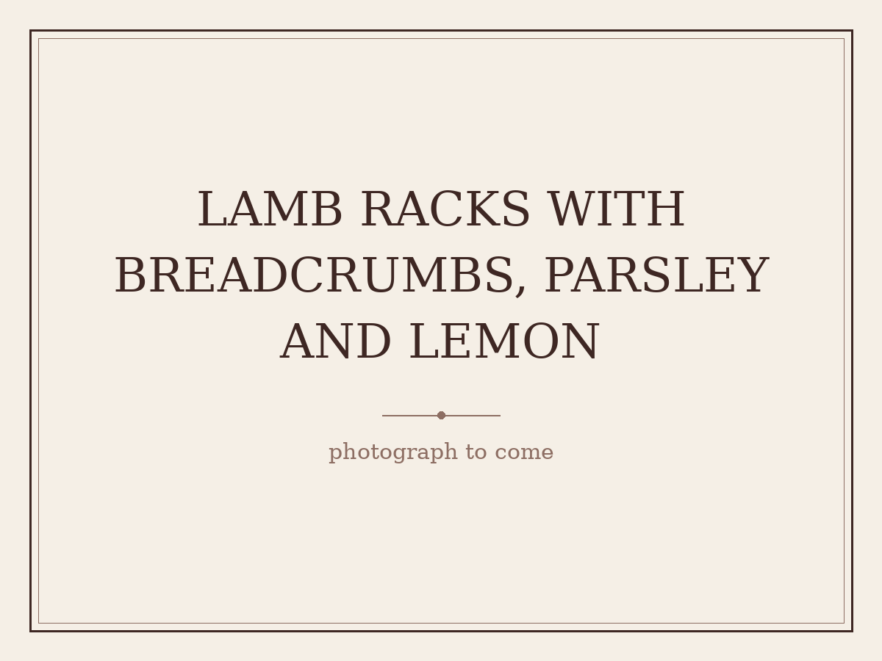
(placeholder — awaiting Tanya’s photograph)

