THE

LICINA
FAMILY RECIPE COLLECTION

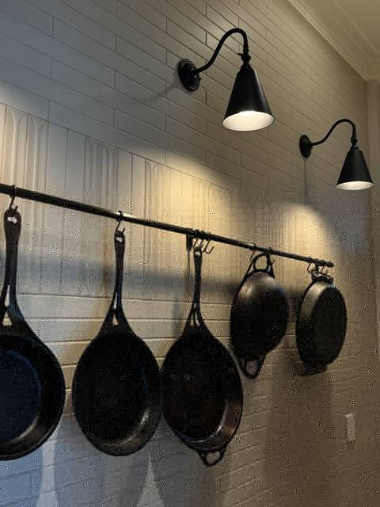

Recipes gathered with love, from Tatjana’s kitchen for the kitchens of future generations of Licinas

About This Collection

My beautiful daughters Natasha and Bianca asked me to write a recipe book of all their favourite meals they enjoyed as children and continue to enjoy as young adults. This collection includes those recipes and a collection of my own favourites from talented chefs and my own creations.
For me, cooking has always been an expression of my creativity and my kitchen a space for relaxation. Preparing and serving food for my family and friends is how I stay socially connected and show love. My husband motivates and encourages my passion for cooking; often joining me in designing menus, sourcing ingredients and preparing dinners for social occasions with our friends and family.

How Recipes Are Tagged
- Family Favourite — dishes from Natasha and Bianca’s childhood
- Tanya’s Collection — recipes gathered from my cookbook library, credited to the original author
- Tanya’s Original — my own creations

RECIPE 1
Roast Chicken with Zucchini Stuffing
Poulet Rôti Farci aux Courgettes
Tanya's Collection — adapted from Diane Holuigue, Savouring Provence
Ingredients
- 2–3 zucchini, finely grated (2 cups)
- 2 spring onions, sliced
- 2 tbsp fresh breadcrumbs
- 2 tbsp grated parmesan
- 1 tbsp chopped oregano
- 1 tsp chopped thyme
- Salt and pepper
- 1 whole chicken (~2kg)
- 3 tbsp olive oil
- Optional jus: 1 cup chicken stock, splash of sherry or Madeira, touch of tomato paste
Method
1. Mix the zucchini, spring onion, breadcrumbs, parmesan, and herbs into a stuffing.
2. Loosen the chicken's skin from the breast without tearing it, then pack the stuffing into that pocket so it bastes the meat as it roasts.
3. Truss, oil, and season the outside, then roast at 220°C for about 1¼ hours until the thigh juices run clear (or the thigh reaches 82°C internally).
4. Rest for 10–15 minutes before carving into quarters.
5. For the jus, deglaze the roasting pan with stock, reduce, and adjust with tomato paste or sherry if needed.
Chef’s Tips
1. Packing the stuffing under the skin bastes the meat as it roasts, so take care not to tear the skin when you loosen it.
2. The chicken is ready when the thigh juices run clear, or the thigh reaches 82°C internally.
3. Rest the chicken for 10–15 minutes before carving.

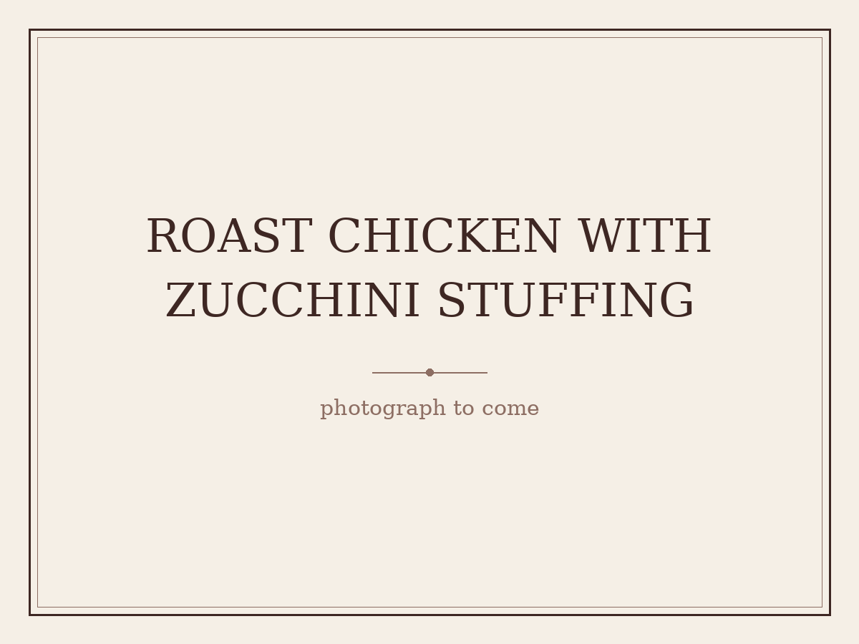
(placeholder — awaiting Tanya’s photograph)

RECIPE 2
Sour Cherry Pita
Pita s Višnjama
Family Favourite — Serbian heritage — from Veliki Narodni Kuvar ("The Great Folk Cookbook"), translated from the original Cyrillic
Ingredients
- 1 tbsp lard or butter
- 2 egg yolks (plus 1 extra for glazing)
- 4–5 tbsp sugar
- Juice of 1 lemon
- 5 tbsp milk
- ½ packet baking powder
- 2 egg whites, stiffly whipped
- Flour, as needed, to form a soft dough
- Sour cherries, cleaned/pitted
- Ground walnuts
- Fine sugar, for the filling and dusting
Method
1. Rinse the lard or butter, then whip until fluffy.
2. Beat in the egg yolks, sugar, lemon juice, milk, and baking powder, then fold in the stiffly whipped egg whites.
3. Add just enough flour to form a dough that isn't too firm, then roll into two sheets sized to fit your baking tray.
4. Grease the tray and dust with flour. Lay down the first sheet of dough, scatter over the cherries, then top with ground walnuts and a little fine sugar.
5. Cover with the second sheet, brush the top with egg yolk, and bake in a fairly hot oven.
6. Cut into squares once baked and dust with sugar to serve.
Chef’s Tips
1. Keeps well for several days — reportedly even better with time.


(placeholder — awaiting Tanya’s photograph)

RECIPE 3
Vanilice
Vanilla Sandwich Cookies
Family Favourite — Serbian heritage — from Veliki Narodni Kuvar ("The Great Folk Cookbook"), translated from the original Cyrillic
Ingredients
- 250g butter (or 200g lard)
- ½ kg flour
- 1 egg yolk, plus 1 whole egg
- 4 tbsp sugar
- Juice of 1 lemon
- 2 egg whites, whipped to a stiff foam (for coating)
- Finely chopped walnuts, for coating
- Jam (pekmez), for filling
- Vanilla sugar, for dusting
Method
1. Whip the butter or lard until fluffy, then beat in the egg yolk, whole egg, sugar, and lemon juice.
2. Add the flour, turn the mixture out onto a pastry board, and knead into a dough.
3. Roll it out to about half a centimetre thick.
4. Using a vanilice cutter, cut out small rounds.
5. Dip each one into the whipped egg white foam, then sprinkle with finely chopped walnuts.
6. Arrange on a greased tray and bake, taking care that they stay pale and don't brown.
7. Once baked, spread with jam and sandwich two together. Dust with vanilla sugar and serve.
Chef’s Tips
1. Roll the dough out to about half a centimetre thick.
2. Bake carefully so the biscuits stay pale and don't brown.


(placeholder — awaiting Tanya’s photograph)

RECIPE 4
Suve Kiflice od Oraha
Dry Walnut Crescents
Family Favourite — Serbian heritage — from Veliki Narodni Kuvar ("The Great Folk Cookbook"), translated from the original Cyrillic
Ingredients
- ½ kg walnuts, ground
- 1 kg fine sugar
- 14 egg whites, divided (12 for the base mixture, 2 added after cooling)
- Zest of ½ lemon
- Extra chopped walnuts, for coating
- Flour, for the board
Method
1. Grind the walnuts and place them in a pot with the sugar, egg whites, and lemon zest.
2. Mix together and warm gently on the stove — just enough to dissolve the sugar into the mixture, without letting it boil.
3. Remove from the heat and transfer to another dish to cool.
4. Once cooled, mix in the remaining 2 egg whites.
5. Turn the dough out onto a floured board and work it until it no longer sticks to your hands.
6. Shape into rolls about 10cm long, curve each into a crescent shape, and sprinkle generously with chopped walnuts.
7. Bake on low heat so they stay pale.
Chef’s Tips
1. Warm the mixture only enough to dissolve the sugar. Don't let it boil.
2. Work the dough on the floured board until it no longer sticks to your hands.
3. Bake on low heat so the crescents stay pale.

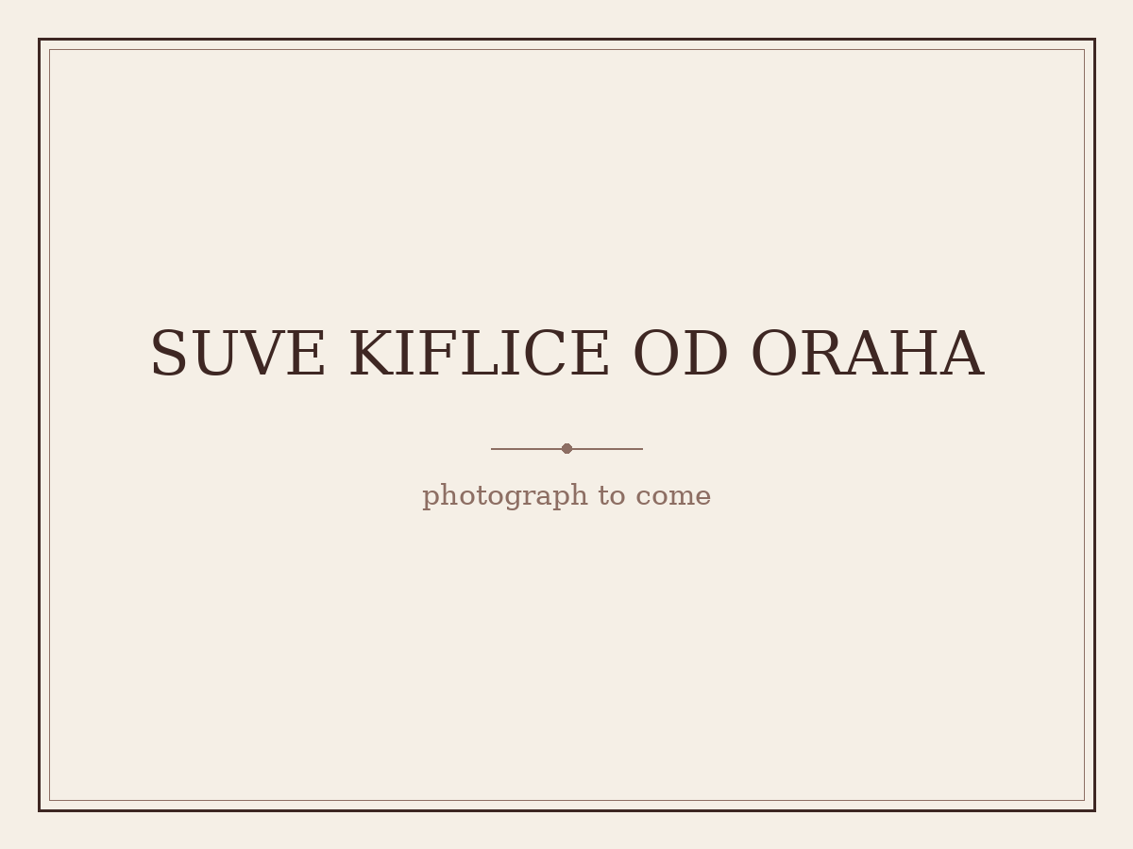
(placeholder — awaiting Tanya’s photograph)

RECIPE 5
Lamb Racks with Breadcrumbs, Parsley and Lemon
Family Favourite — adapted from Bill Granger, bills open kitchen
Ingredients
- 3 thick slices wholemeal or sourdough bread
- 7g (¼ cup) finely chopped flat-leaf parsley
- Finely grated zest of 1 lemon
- 1 garlic clove, crushed
- 60ml (¼ cup) olive oil, plus extra
- Sea salt and freshly ground black pepper
- 2 x 8 French-trimmed lamb racks
- 2 tbsp Dijon mustard
- 500g cherry tomatoes on the vine
- 4 garlic cloves, unpeeled (optional)
Method
1. Toast the bread until lightly golden, then crumble or process into breadcrumbs.
2. Combine with the parsley, lemon zest, crushed garlic, olive oil, salt, and pepper.
3. Rub the lamb racks with a little extra olive oil and season well.
4. Sear fat-side down in a hot pan for 2 minutes, then transfer to a baking tray.
5. Spread the top of each rack with mustard and press on the breadcrumb mixture.
6. Roast alongside the cherry tomatoes and whole garlic cloves at 180°C for 25–30 minutes, until the lamb is cooked and still pink inside.
7. Rest, loosely covered in foil, for 5 minutes.
8. Cut each rack in half and serve with the roasted tomatoes and garlic.
Chef’s Tips
1. Sear the racks fat-side down in a hot pan for 2 minutes before roasting.
2. Roast until the lamb is cooked but still pink inside, then rest it loosely covered in foil for 5 minutes.
3. Serve with the roasted tomatoes and garlic.


(placeholder — awaiting Tanya’s photograph)

RECIPE 6
Chicken Forestière with Mustard Cream
Tanya's Original
Ingredients
- 4 chicken breasts (skin-on preferred, skinless OK)
- plain flour, for coating
- 2 rashers bacon, chopped
- 100g small mushrooms, sliced
- 2 cloves garlic, finely chopped
- 2 stalks green shallots, chopped
- 30g butter
- 1 cup white wine
- 300ml whipping cream
- 1 tbsp Dijon mustard
- salt and pepper, to taste
Method
1. Heat the oven to 180°C.
2. Coat the chicken breasts in plain flour, shaking off the excess.
3. Melt the butter in a wide cast iron pan over medium heat and sear the breasts until they are a golden colour on both sides.
4. Halfway through the searing, add the chopped garlic and let it stick to both sides of the chicken — keep an eye on it, as the garlic shouldn't be allowed to burn.
5. Lift the chicken out of the pan into an ovenproof dish and bake for 20 minutes.
6. Meanwhile, fry the bacon and mushrooms in the same cast iron pan.
7. Return the chicken to the pan and add the wine, letting it reduce by half, then stir through the cream and Dijon mustard. Season with salt and pepper to taste.
8. Let the sauce thicken for a few minutes, and add the green shallots just before serving so they stay fresh and green.
Chef’s Tips
1. Serve with mashed potatoes and green beans.

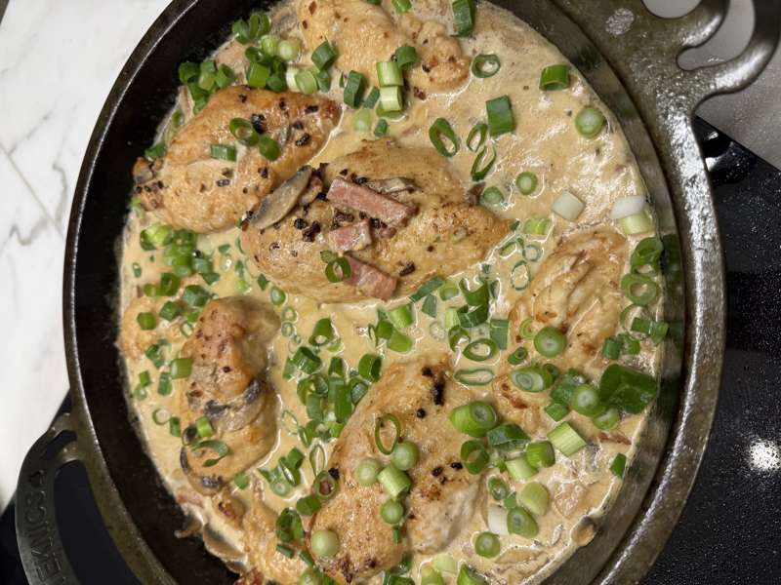

RECIPE 7
Black Pepper Beef
Tanya's Collection — adapted from Adam Liaw, Asian After Work
Ingredients
- 500g beef rump, topside or Scotch fillet, thinly sliced
- 3–4 tbsp peanut oil, or other vegetable oil
- 2 garlic cloves, peeled and roughly chopped
- 1 tsp grated ginger
- 1 medium brown onion, peeled and sliced
- 1 green capsicum, deseeded and thinly sliced
- Cooked rice, to serve
- Marinade: 1 tsp sesame oil, 2 tsp cornflour, 2 tsp light soy sauce, 1 tbsp Shaoxing wine
- Black pepper paste: 1 tsp freshly ground black pepper, 1 tbsp oyster sauce, 1 tsp light soy sauce, ¼ tsp caster sugar
Method
1. Mix the sliced beef with the marinade ingredients and set aside.
2. Mix the black pepper paste ingredients in a separate bowl and set aside.
3. Heat a wok over high heat and pour 2 tbsp of the oil around the edges.
4. Fry the beef in batches until browned but not quite cooked through, then remove from the wok and set aside.
5. Add the remaining oil to the wok, then the garlic and ginger, and fry over high heat for about 30 seconds, until the garlic is starting to colour.
6. Add the onion and capsicum and stir-fry for 2 minutes, until softened, then remove the vegetables and set aside.
7. Return the wok to high heat and add the beef along with any collected juices.
8. Spoon in the black pepper paste and toss the beef for 2–3 minutes, until well coated and the paste is starting to caramelise.
9. Return the vegetables to the wok, toss until well combined, and serve with rice.
Chef’s Tips
1. This recipe has a surprising amount of heat from the black pepper. For a milder version, reduce the amount of pepper in the paste and grind a little over at the end for flavour and aroma.
2. Also works well with pork or chicken.


(placeholder — awaiting Tanya’s photograph)

RECIPE 8
Serbian Chestnut Torte
Kolač od Kestena
Tanya's Collection — Serbian heritage — from Veliki Narodni Kuvar, translated from the original Cyrillic
Ingredients
- 8 eggs, separated
- 1 tsp vanilla essence
- 300g sweetened chestnut puree
- 1 tbsp plain biscuit crumbs
- 2 tsp rum
- Filling: 500g sweetened chestnut puree, 1 tsp vanilla essence, ½ tsp rum, 3 tbsp cream, 50g unsalted butter
- Topping: 125g dark cooking chocolate, 70g butter
Method
1. Beat the egg yolks with the vanilla essence until they form a thick foam.
2. Soak the biscuit crumbs in the rum, then add them to the yolks along with the chestnut puree.
3. Beat the egg whites to stiff peaks and fold them through the mixture.
4. Line two identical round tins with baking paper and divide the mixture evenly between them.
5. Bake at 170°C for 20–25 minutes, then remove from the oven and allow to cool to room temperature.
6. For the filling, whisk the chestnut puree, vanilla essence, rum, cream, and butter until smooth.
7. Spread over one cake base, place the second cake on top, and refrigerate for 30 minutes to firm up before the topping goes on.
8. Melt the chocolate and butter together in a small saucepan over low heat until glossy and smooth.
9. Pour over the top of the cake and return to the refrigerator to cool completely.
Chef’s Tips
1. To make small cakes from this recipe, use rectangular tins and cut into small squares.

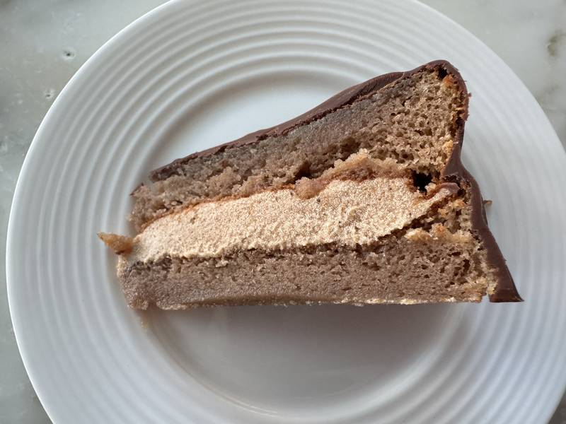

RECIPE 9
Choc Banana Bread
Tanya's Collection — adapted from Bill Granger, Bill's Food
Ingredients
- 250g (2 cups) plain flour
- 2 tsp baking powder
- 125g unsalted butter, softened
- 125g caster sugar
- 4 ripe bananas, mashed
- 2 eggs, lightly beaten
- 1 tsp vanilla extract
- 175g (1 cup) good-quality dark or milk chocolate chips
- 70g walnuts, chopped
Method
Makes 8 to 10 slices.
1. Preheat the oven to 180°C. Sift the flour and baking powder into a large bowl.
2. In a separate bowl, mix the butter, sugar, banana, eggs, vanilla, chocolate chips and walnuts.
3. Add to the dry ingredients and stir just to combine — a loose mixture keeps the loaf moist, so be careful not to overmix.
4. Pour the batter into a non-stick, or lightly greased and floured, 19 x 11cm loaf tin and bake for 1 hour 15 minutes, until a skewer comes out clean.
5. Leave to cool in the tin for 5 minutes before turning out onto a wire rack.
6. Serve in thick slices with butter.
Chef’s Tips
1. Stir the batter just to combine. A loose mixture keeps the loaf moist, so be careful not to overmix.
2. Serve in thick slices with butter.

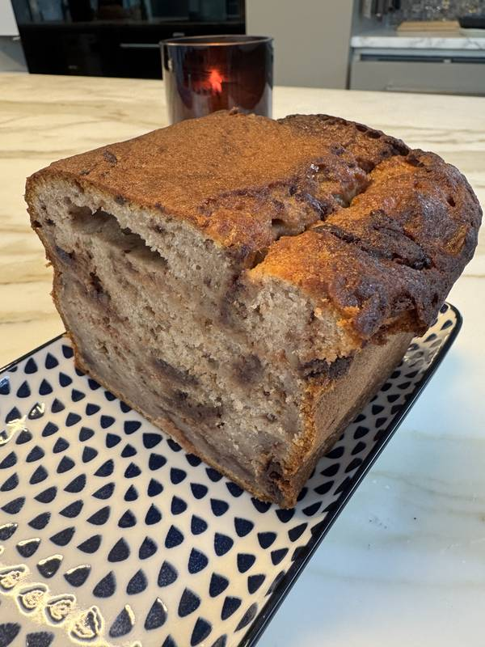

RECIPE 10
Mushroom Sauce
Tanya's Collection — adapted from Nagi Maehashi, RecipeTin Eats
Ingredients
- 1 tbsp unsalted butter
- 1 tsp olive oil
- 150g mushrooms, sliced (morels are lovely here)
- Pinch of salt and pepper
- 1 garlic clove, minced
- 30ml dry white wine or rosé
- 60ml (¼ cup) chicken or vegetable broth
- 125ml (½ cup) thickened cream
- 30g parmesan, finely grated
- 1 tsp fresh thyme leaves (or ¼–½ tsp dried)
Method
Enough for two.
1. Heat the oil and melt the butter in a skillet over medium-high heat.
2. Add the mushrooms and let them cook unhurried until golden brown, about 4–5 minutes — no need to stir constantly.
3. Just before they're done, add the garlic with a pinch of salt and pepper and cook for a minute more, until the garlic turns golden.
4. Pour in the wine — it will sizzle. Stir and scrape the bottom of the pan for a minute, until it has mostly evaporated.
5. Add the broth, cream and parmesan, then lower the heat to a gentle simmer; don't let it boil hard or the cream may split.
6. Stir occasionally and simmer for 2–3 minutes, until it thickens a little — it shouldn't be heavy, this is a rich sauce.
7. Stir through the thyme, taste for salt and pepper, and take it off the heat.
8. Serve over chicken breasts or eye fillet, or toss it through pasta.
Chef’s Tips
1. Let the mushrooms cook unhurried until golden brown. There's no need to stir constantly.
2. Keep the sauce at a gentle simmer. If it boils hard, the cream may split.
3. Serve over chicken breasts or eye fillet, or toss it through pasta.


(placeholder — awaiting Tanya’s photograph)

RECIPE 11
Moist Blueberry Muffins
Tanya's Collection — adapted from Nagi Maehashi, RecipeTin Eats
Ingredients
- 375g plain flour
- 3 tsp baking powder
- 1 tsp bicarb soda (or an extra 3 tsp baking powder)
- 220g caster sugar
- ¼ tsp salt
- 250ml buttermilk (or full-cream milk with 1 tsp white vinegar stirred in, left to stand 5 minutes until curdled)
- 60g unsalted butter, melted
- 65ml vegetable oil
- 2 large eggs, at room temperature, lightly whisked
- 2 tsp vanilla extract
- 250g blueberries (frozen are fine — don't thaw them, or they bleed into the batter)
Method
Makes 12.
1. Preheat the oven to 200°C and line a 12-hole muffin tin with paper cases.
2. Whisk the flour, baking powder, bicarb, sugar and salt together in a large bowl.
3. In a second bowl, whisk the buttermilk, melted butter, oil, eggs and vanilla.
4. Make a well in the dry ingredients, pour in the wet, and mix until only just combined — try not to stir more than eight times. A few lumps of flour are exactly right; overmixing is what makes muffins tough.
5. Fold through most of the blueberries, keeping a handful back.
6. Divide the batter between the paper cases and scatter the reserved berries over the tops.
7. Bake for 5 minutes, then turn the oven down to 180°C and bake a further 13 minutes (fan) or 15 minutes (standard), until a skewer comes out clean.
8. Lift them straight out of the tin onto a cooling rack. Best served warm.
Chef’s Tips
1. Mix until only just combined, and try not to stir more than eight times. A few lumps of flour are exactly right, because overmixing is what makes muffins tough.
2. Frozen blueberries are fine. Don't thaw them, or they bleed into the batter.
3. No buttermilk? Stir 1 tsp white vinegar into full-cream milk and leave it to stand for 5 minutes until curdled.
4. Best served warm.

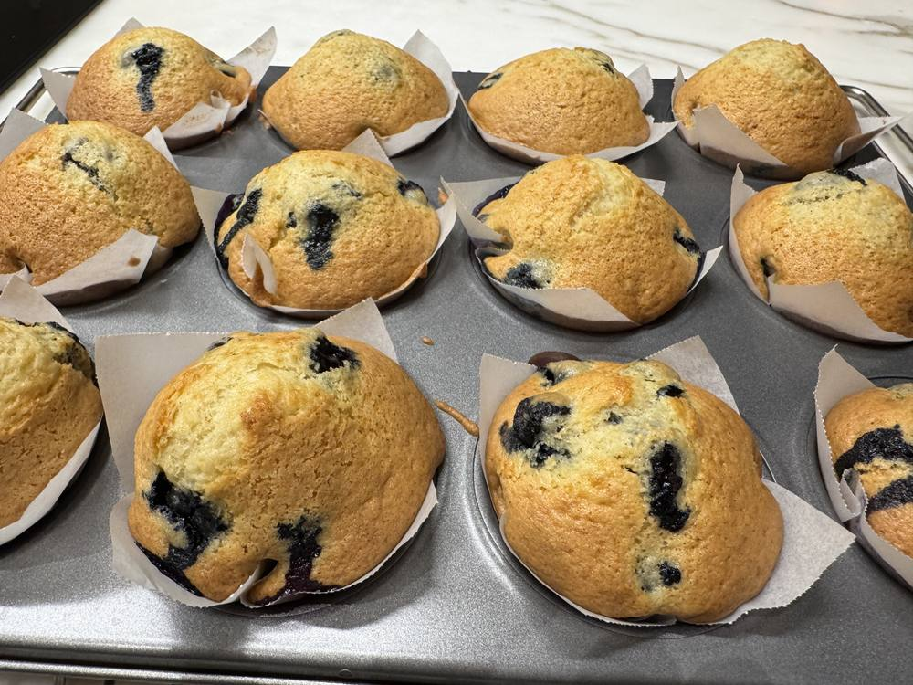

RECIPE 12
Traditional Shortbread Crescent Biscuits with Jam
Kiflice sa Džemom
Family Favourite — adapted from Ivana Lalicki, Serbian Cookbook: Recipes and Stories from Serbia
Ingredients
- 225 g unsalted butter, softened
- 200 g sour cream
- A pinch of salt
- 1 tbsp granulated sugar
- 1 tbsp vanilla sugar
- 1 tbsp lemon zest
- 1 egg
- 520 g plain flour, plus extra for dusting
- 150 g plum jam
- 250 g icing sugar, for coating
- 1 tbsp vanilla sugar, for coating
Method
Makes about 36.
1. Beat the softened butter, sour cream, salt, granulated sugar, vanilla sugar and lemon zest together with an electric mixer until creamy and fluffy.
2. Add the egg, then the flour, mixing only until the dough comes together.
3. Divide the dough into three even portions and shape each one into a disc.
4. Heat the oven to 180°C and line two large trays with baking paper.
5. On a well-floured surface, roll each disc out into a circle about 23 cm in diameter and 3 mm thick, and cut it into 12 even triangles. The easiest way is with a pizza cutter — divide the circle into quarters, then each quarter into thirds.
6. Place a teaspoon of jam at the wide base of each triangle, roll it up from the base, and set it on the tray with the point tucked underneath.
7. Bake for 15–20 minutes, until lightly golden on the bottom. Lift them onto a cooling rack and repeat with the remaining dough.
8. Once cool, toss them in the icing sugar mixed with the vanilla sugar.
Chef’s Tips
1. Do not refrigerate the dough. It will result in a much softer biscuit when baked, and less dry.
2. Homemade plum jam makes the best filling.

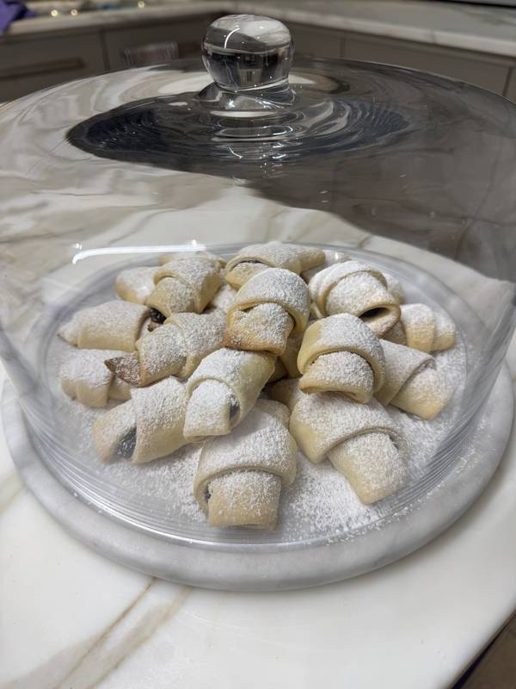

RECIPE 13
Lamb Tagine with Couscous & Harissa
Family Favourite — adapted from Philip Johnson, Eating In
Ingredients
- Marinade:
- 60 ml (¼ cup) olive oil
- a pinch of saffron threads
- 1 tsp ground ginger
- 1 tsp ground paprika
- 1 tsp ground cinnamon
- grated zest of 1 lemon
- a pinch of freshly ground black pepper
- Lamb tagine:
- 800 g lamb leg or shoulder, diced
- olive oil
- 3 onions, sliced
- 4 garlic cloves, sliced
- 600 ml tomato juice
- 600 ml white chicken stock
- 1 cinnamon stick, broken
- 150 g (1 cup) whole blanched almonds
- sea salt and freshly ground black pepper
- 4 tomatoes, blanched, peeled, seeded and chopped
- 60 g (½ cup) raisins
- 2 tbsp honey
- 12 small new potatoes, cut in half
- 1 large handful of coriander leaves, roughly chopped
- ½ quantity harissa
- Couscous:
- 370 g (2 cups) couscous
- 500 ml white chicken stock or water, boiling
- a knob of unsalted butter
- juice of ½ lemon
- ½ salted lemon, flesh discarded and zest finely diced
- 1 handful of flat-leaf parsley leaves, chopped
Method
1. Combine all of the marinade ingredients and mix well. Put the lamb in a non-reactive shallow tray and pour over the marinade to coat. Cover and refrigerate overnight.
2. Preheat the oven to 180°C.
3. Heat a little olive oil in a heavy-based frying pan over high heat and seal the lamb in batches, then set aside. Reduce the heat to medium, add the onion and garlic to the pan and cook for several minutes, until the onion is translucent. Add the tomato juice and chicken stock, stirring to loosen any sediment. Return the lamb to the pan with the cinnamon stick and almonds, and season with sea salt and black pepper. Bring to the boil, then remove from the heat. Transfer to a tagine pot or earthenware dish and cook in the oven for 1½ hours, or until the lamb is tender.
4. Remove the lamb from the tagine with a slotted spoon and keep warm. Add the tomato, raisins, honey and potato to the tagine and cook for 15–20 minutes, until the potato is tender and the sauce has thickened. Return the lamb to the tagine to heat through.
5. Meanwhile, make the couscous: put the couscous in a large bowl, pour over the boiling stock or water, stir briefly, then cover and set aside to steam for 10–15 minutes. Fluff with a fork, then stir through the butter, lemon juice, salted lemon and parsley, and season with sea salt and black pepper.
6. To serve, spoon the tagine into serving dishes with the couscous and scatter over the coriander. Serve the harissa separately on the side.
Chef’s Tips
1. A tagine is a Moroccan terracotta cooking dish with a conical lid that traps the aromas of the food as it slowly cooks — a good cast-iron pot works just as well if you don't have one.


(placeholder — awaiting Tanya’s photograph)

RECIPE 14
Chestnut & Chocolate Cake
Tanya's Original
Ingredients
- 175 g unsalted butter
- 175 g dark chocolate
- 40 g almond meal
- 450 g chestnut purée (unsweetened)
- 6 eggs, separated
- 40 g caster sugar
- 8 g orange zest
- 40 g raisins, soaked in Cointreau or Grand Marnier and squeezed
- 40 g walnuts, chopped
Method
1. Preheat the oven to 180°C and line a 20 cm round springform tin with baking paper.
2. Melt the butter and chocolate together.
3. Mix the orange zest, chestnut purée, egg yolks and almond meal until smooth, then stir through the walnuts and raisins.
4. In a separate bowl, whisk the egg whites and sugar until soft peaks form.
5. Fold the chocolate mixture into the chestnut mixture, then fold through the egg white mixture.
6. Pour into the prepared tin and bake for 30 minutes.
7. Allow to cool, then dust with icing sugar to serve.
Chef’s Tips
1. You can use unsweetened chestnut purée, but you will need to add 200 g caster sugar to the cake and 200 g caster sugar to the filling.


(placeholder — awaiting Tanya’s photograph)

RECIPE 15
Lamb Cutlets with Orzo
Mama's Lamb Manestra
Tanya's Collection — adapted from Helena & Vikki Moursellas, Peináo: A Greek Feast for All
Ingredients
- 1.5 kg lamb cutlets
- 80 ml (⅓ cup) confit garlic oil (recipe below)
- 3 garlic cloves, crushed
- 1 tbsp Greek spice mix (recipe below)
- salt flakes and freshly cracked black pepper
- 1 brown onion, chopped
- 700 g tomato passata (pureed tomatoes)
- 875 ml (3½ cups) boiling water
- 500 g orzo (kritharáki)
- 100 g Greek feta, crumbled
- finely chopped parsley leaves, to serve
- Confit garlic oil (makes about 375 ml / 1½ cups): 3 whole garlic bulbs, 4 fresh bay leaves and 375 ml (1½ cups) extra virgin olive oil
- Greek spice mix (makes about 50 g / 1 cup): 2 tbsp dried oregano; 1 tbsp each of dried dill, dried thyme leaves, dried basil, dried mint and garlic powder; 1 tsp each of ground cinnamon and sweet paprika; 2 tsp salt flakes; and 1 tsp freshly cracked black pepper
Method
1. To make the confit garlic oil, peel the garlic cloves and place them in a saucepan with the bay leaves and olive oil. Heat over high heat until it reaches 60°C on a kitchen thermometer, then reduce the heat to low and cook gently for 30 minutes, or until the garlic is soft and lightly coloured.
2. Allow the oil to cool completely in the pan, then gently pour it into a sterilised 600 ml jar and seal with a lid.
3. To make the Greek spice mix, combine all the spices in a jar and give it a good shake. Seal with a lid and add a label.
4. Preheat the oven to 180°C and grease a large baking dish (about 40 cm × 25 cm).
5. Toss the lamb cutlets in a bowl with half the garlic oil, the crushed garlic and Greek spice mix, then season generously with salt flakes and cracked black pepper.
6. Heat the remaining oil in a large frying pan over medium heat and cook the onion for 6–8 minutes, until soft. Spoon the onion into the prepared dish.
7. Turn the heat up high and, working in batches, fry the lamb cutlets for 1–2 minutes on each side until browned.
8. Transfer the cutlets to the dish, cover with the tomato passata and 500 ml of the boiling water, then bake for 30 minutes, or until the sauce has thickened and reduced.
9. Stir in the orzo along with the remaining boiling water and cook for a further 15 minutes, stirring every 5 minutes, until the orzo is cooked through.
10. Scatter with the crumbled feta and parsley leaves and serve immediately.
Chef’s Tips
1. Serve with roasted garlic and fennel tzatziki spooned over the top.
2. The confit garlic oil keeps on the kitchen bench or in the pantry for up to 3 months. The longer the garlic sits in the oil, the stronger the flavour, and Australian garlic gives the best results.
3. Once cooled, the confit garlic becomes like butter. Spread it over sourdough or add it to most recipes that call for garlic.
4. The Greek spice mix keeps in your spice drawer for up to 1 year. It's also great in a schnitzel crumb: combine 1 cup of dried breadcrumbs with 2 tbsp of the mix to crumb four chicken schnitzels.



