🌐 Key Concepts in Spring & RESTful APIs

📦 ResponseEntity
- ResponseEntity is a Spring class used to create custom HTTP responses in RESTful APIs.
- It allows you to define the status code, response body, and HTTP headers manually.

✅ .ok()
- .ok() is a convenient shortcut that creates a ResponseEntity with:
  - HTTP status: 200 OK
  - Body: The data you want to return to the client

🔁 RESTful API
- A RESTful API is a web service that follows the REST (Representational State Transfer) principles.
- It uses standard HTTP methods like GET, POST, PUT, and DELETE to access and manipulate resources.

📚 Dependency
- A dependency is like an external library or module your project uses to perform specific tasks or offer features.
- It’s called a dependency because your code relies on the classes, methods, or interfaces it provides.
- Internally, those elements may also be interdependent, forming a tightly integrated package of functionality.

🍽️ Analogy: A Restaurant Kitchen

🍳 Cohesion = Each Team's Focus
- Imagine the grill station in a kitchen only handles grilled items (like burgers and steaks).
- The salad station only prepares salads.
- Each station has a clear, focused role.
✅ High cohesion = a class or module does one well-defined job, just like each kitchen station.
In Spring:
- A UserService class only handles user-related logic.
- A UserController only manages HTTP requests for users.

🔗 Coupling = How Tightly Teams Depend on Each Other
- If the grill station needs to constantly talk to the salad station to make a burger, that’s tight coupling — they depend too much on each other.
- If each station works independently and just passes finished dishes to the front, that’s loose coupling.
✅ Loose coupling = components interact through clear interfaces and are independent.
In Spring:
- A controller doesn't directly manage database access — it delegates to a service.
- Services rely on interfaces (e.g., a UserRepository) that Spring injects using dependency injection.

🎯 Summary:
Concept | Analogy | In Spring
Cohesion | Each station has a focused job | Classes do one clear task
Coupling | Stations don't overly depend on each other | Components interact via interfaces, not tightly bound logic

📦 What Is the Spring Container?
The Spring container is the core part of the Spring Framework that:
- Creates, manages, and injects the objects (also called beans).
- Handles dependencies between these beans.
- Controls their lifecycle (when they are created, destroyed, etc.).

🧠 Analogy:
Think of the Spring container as a factory and manager:
- You tell it what components you need (via configuration or annotations like @Component, @Service, @Bean).
- It builds them for you, injects their required dependencies, and hands them over when needed.

🔧 How It Works:
- You define beans using annotations like @Component, @Service, or @Configuration.
- The container scans, instantiates, and injects them into the places where they're needed (@Autowired).
- All this is done automatically, reducing manual wiring and increasing modularity.

💡 Example:
java
CopiarEditar
@Component
public class MyService {
// some service logic
}

@RestController
public class MyController {
private final MyService myService;

@Autowired
public MyController(MyService myService) {
this.myService = myService;
}
}
Here, the Spring container:
- Detects MyService and MyController.
- Creates instances of both.
- Injects MyService into MyController.

✅ What Is a Bean in Spring?
A bean is any object that is managed by the Spring container.
That means:
- The object is created, configured, and injected by Spring.
- You don’t manually new it — Spring takes care of it for you.

🔍 More Details:
- Beans are typically created from classes annotated with:
  - @Component
  - @Service
  - @Repository
  - @Controller
  - Or registered via @Bean inside a @Configuration class

🔧 Why Use XML for Dependency Injection?

1. ✅ Legacy support
- Before annotations, XML was the main way to declare beans and their dependencies.
- Older Spring projects still use XML, and it's useful to know for maintaining those.

2. 🎯 Clear separation of configuration and code
- XML keeps all wiring and configuration outside the Java code.
- This can make code cleaner and easier to test, especially in large systems.

3. 🧩 Fine-grained control
- XML allows detailed control over bean scopes, init/destroy methods, constructor arguments, and property values.

4. 🌐 No need to modify source code
- In situations where you can’t change the source code (e.g. 3rd-party classes), XML allows you to inject dependencies without annotations.

📌 Summary
Reason | Description
Legacy Support | Used before annotations existed
Separation of Concerns | Keeps config out of source code
External Configuration | Useful when source code is not editable
Fine-Grained Control | XML provides detailed control over bean behavior

Scope defines the lifetime and visibility of a Spring bean — i.e., how long it exists and how it's shared.

📅 Scope Is Defined By...
- Annotations (in Java/annotation-based config)
- XML configuration (in XML-based config)

✅ Common Scopes in Spring:
Scope | Description
singleton | (Default) – One instance per Spring container; shared across the app.
prototype | A new instance is created every time the bean is requested.
request | One instance per HTTP request (only in web apps).
session | One instance per HTTP session (also for web apps).
application | One instance per ServletContext (web scope).
websocket | One instance per WebSocket session.

🏷️ What Are Stereotypes in Spring?
In Spring, stereotype annotations are special annotations used to mark a class as a Spring-managed component — or bean — with a specific role or responsibility in the application.

✅ Common Stereotype Annotations
Annotation | Purpose
@Component | Generic stereotype for any Spring-managed bean
@Service | Indicates a service layer component
@Repository | Indicates a data access layer component (DAO)
@Controller | Marks a web controller in an MVC web application
@RestController | Combines @Controller and @ResponseBody for REST APIs

📌 Why Use Stereotypes?
- Tells Spring to manage the class as a bean (automatically picked up by component scanning).
- Gives semantic meaning to the role of the class (e.g., service, repository).
- Enables AOP (Aspect-Oriented Programming) features like transaction management (@Repository enables exception translation).

🧠 In Short:
Stereotypes in Spring are annotations that mark classes for specific roles and tell the Spring container to manage them as beans.

ConfigurableApplicationContext context = SpringApplication.run(InyectionByAttributeApplication.class, args); Coche coche = context.getBean(Coche.class);: so in this lines we are getting the context of this springboot application and getting the class that match with Coche.class , since we mark our class as a component , in the context of springboot is now a bean, and a bean is something that it is managed by springboot with certain scope and another characteristics, since we get the bean and is a coche class we use its tostring method to see what contains?
ChatGPT Plus
✅ Exactly — you’ve got the core idea! Let’s break it down just a bit more clearly and precisely to reinforce your understanding and fill in any gaps:

🔍 Line-by-line Explanation
java
CopiarEditar
ConfigurableApplicationContext context = SpringApplication.run(InyectionByAttributeApplication.class, args);
- This starts your Spring Boot application.
- It performs component scanning, bean creation, dependency injection, etc.
- It returns the Spring Application Context, which is the container that holds and manages all Spring Beans.

java
CopiarEditar
Coche coche = context.getBean(Coche.class);
- Here, you're asking Spring to give you a bean of type Coche.
- Because you annotated the Coche class with @Component, Spring has already:
  - Created an instance of Coche
  - Injected any dependencies into it (e.g., a Motor field with @Autowired)
  - Registered it in the application context
So, yes — Coche is now a Spring Bean, meaning Spring manages its lifecycle, scope, and dependencies.

java
CopiarEditar
System.out.println(coche);
- This calls the toString() method of the Coche class.
- Assuming you've overridden toString(), it prints a readable summary of the object — including its fields like marca, modelo, and the injected Motor.

🧠 Core Concepts You Mentioned — Confirmed:
Concept | You're Right? | Explanation
Spring context holds beans | ✅ | context is the Spring container holding all beans
@Component makes a class a bean | ✅ | Spring automatically registers it in the context
@Autowired injects dependencies | ✅ | Automatically wires fields like Motor in Coche
Beans are managed by Spring | ✅ | Spring controls their scope, lifecycle, and configuration
You print it using toString() | ✅ | Exactly what happens with System.out.println(coche)

✅ Summary (Rephrased for Clarity)
You're starting the Spring Boot app, retrieving a Coche object from the Spring context (because it's a @Component), and printing it using toString(). The object is a Spring Bean, which means it's fully managed by the Spring Framework — including its dependencies like Motor.

Let me know if you want to explore:
- How Spring creates and wires beans under the hood
- Different bean scopes (singleton, prototype, etc.)
- How to customize or control bean creation using @Bean or @Configuration
In Spring, each stereotype annotation not only marks a class as a bean, but often adds specific behavior or meaning depending on the context or layer it's used in.

🔍 What does each stereotype actually do?

1. @Component
- 📦 Generic Spring-managed bean.
- ✅ Used when none of the more specific stereotypes apply.
- No special behavior — just gets registered as a bean.

2. @Service
- 🧠 Indicates that the class holds business logic.
- ✅ Makes it clear this class belongs to the service layer.
- Behavioral Add-on: Not much by default, but:
  - Used by tools like Spring AOP or documentation generators
  - Helps organize your code semantically

3. @Repository
- 💾 Marks a class as part of the persistence layer (DAO).
- ✅ Intended for classes interacting with the database.
- Special Behavior:
  - Enables automatic exception translation:
    - Converts low-level SQLException into Spring’s DataAccessException
    - Allows your app to remain database-vendor-agnostic

4. @Controller
- 🖥️ Marks a class as a web controller in a Spring MVC app.
- ✅ Handles HTTP requests and returns views (e.g., HTML templates).
- Behavioral Add-on:
  - Methods can use @RequestMapping, @GetMapping, etc.
  - Spring resolves return values to views (via ViewResolver).

5. @RestController
- 🌐 Special version of @Controller used in REST APIs.
- ✅ Automatically returns JSON or XML instead of views.
- Equivalent to:
java
CopiarEditar
@Controller
@ResponseBody
- Behavioral Add-on:
  - Automatically serializes return objects to JSON
  - Perfect for building APIs

🧠 Summary Table
Stereotype | Type of Bean | Extra Behavior
@Component | General-purpose bean | No extra behavior
@Service | Business logic | Semantic meaning; supports AOP
@Repository | DAO / Persistence | Exception translation
@Controller | MVC Controller | View resolution for web pages
@RestController | REST API Controller | Auto JSON/XML serialization

✅ What a @Qualifier Is in Simple Terms:
A @Qualifier is like a label or name that you attach to a bean so that Spring knows exactly which one to use when multiple beans of the same type exist.
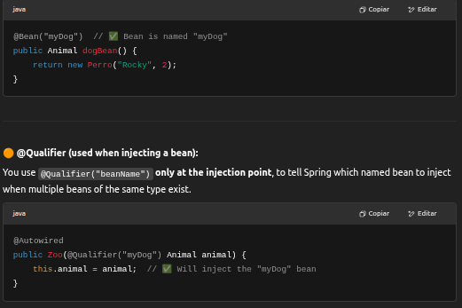

Purpose | Annotation Example | Where to Use
Name a bean | @Component("myDog") | On the bean class or method
Select a bean for injection | @Qualifier("myDog") | On constructor/field param

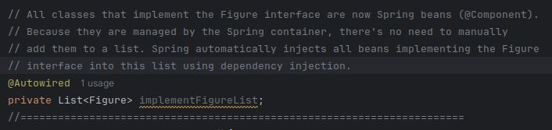

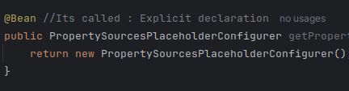

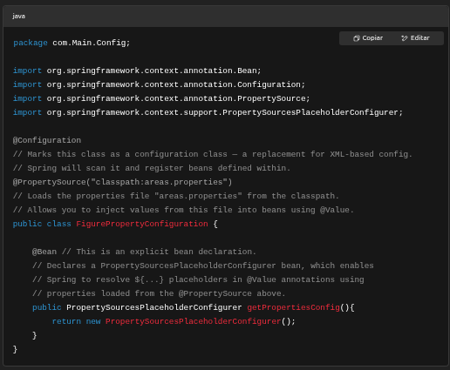

✅ What Happens at Startup (Step-by-Step)
When a Spring Boot application starts:
- Component Scanning Begins
  - Spring Boot automatically scans the base package (and subpackages) where your @SpringBootApplication class is located.
  - It looks for classes annotated with:
    - @Component
    - @Service
    - @Repository
    - @Controller
    - @Configuration ← your case here
- Bean Registration
  - Any class annotated with @Configuration is treated as a source of bean definitions.
  - Methods annotated with @Bean inside it are registered as singleton beans (unless you explicitly scope them otherwise).
- Auto-wiring
  - Spring automatically injects these beans into other parts of the application wherever they’re needed (e.g., via @Autowired or constructor injection).
- Singleton by Default
  - All Spring beans are singleton by default — created once and shared across the application.
  - So your PropertySourcesPlaceholderConfigurer bean is created only once, wired by Spring, and made available anywhere it’s needed.
- Property Resolution
  - Since you've used @PropertySource, Spring loads the specified .properties file.
  - The PropertySourcesPlaceholderConfigurer bean makes sure ${...} placeholders in @Value annotations are resolved correctly using the loaded properties.
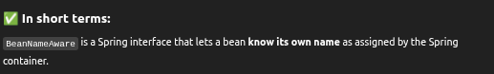

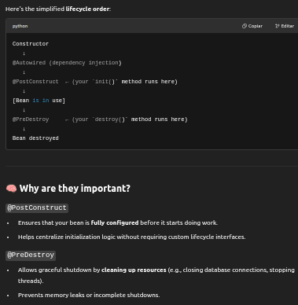
D

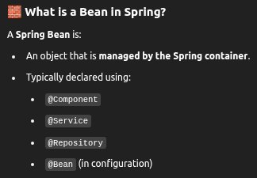

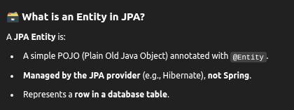
Spring handles:
- Lifecycle
- Dependency injection
- Scoping

✅ Updated Comparison Table
Annotation | Stereotype? ✅/❌ | Managed By | Purpose / Notes
@Component | ✅ Yes | Spring | Generic bean
@Service | ✅ Yes | Spring | Business logic bean
@Repository | ✅ Yes | Spring | DAO bean with persistence exception translation
@Controller | ✅ Yes | Spring MVC | Web controller
@RestController | ✅ Yes | Spring MVC | RESTful controller (@Controller + @ResponseBody)
@Configuration | ✅ Yes | Spring | Configuration class (@Bean methods)

❌ Non-Stereotypes That Look Similar
Annotation | Stereotype? ✅/❌ | Managed By | Purpose / Notes
@Entity | ❌ No | JPA (Hibernate, etc.) | Maps class to DB table
@Embeddable | ❌ No | JPA | Used for value objects in entities
@MappedSuperclass | ❌ No | JPA | Base class mapping for entities
@EnableAutoConfiguration | ❌ No | Spring Boot | Enables auto-configuration
@EnableJpaRepositories | ❌ No | Spring Data | Enables JPA repo scanning
@Table, @Column, etc. | ❌ No | JPA | Configure DB mapping
@RequestMapping | ❌ No | Spring MVC | Maps web requests
@PathVariable, @RequestParam | ❌ No | Spring MVC | Bind web parameters
@Transactional | ❌ No | Spring (or JTA) | Manages transactions
@Bean | ❌ No | Spring | Declares a method return value as a Spring bean
@Autowired | ❌ No | Spring | Inject dependencies
@Value | ❌ No | Spring | Injects property values
@Scheduled | ❌ No | Spring Task Scheduler | Schedules method execution
@Cacheable, @CachePut | ❌ No | Spring Cache | Enables method-level caching
@EntityListeners | ❌ No | JPA | Lifecycle callbacks
@Validated, @Valid | ❌ No | Spring / Bean Validation | Enable validation support
@Aspect | ❌ No | Spring AOP | Marks a class as an aspect

Yes — all stereotype annotations (@Component, @Service, @Repository, @Controller, @RestController, @Configuration) mark a class as a Spring bean.

BEANS BY DEFAULT ARE SINGLETON
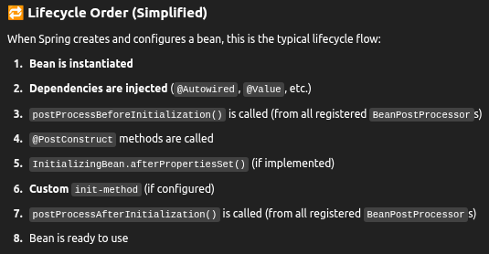

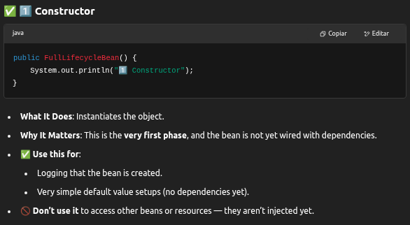
sd

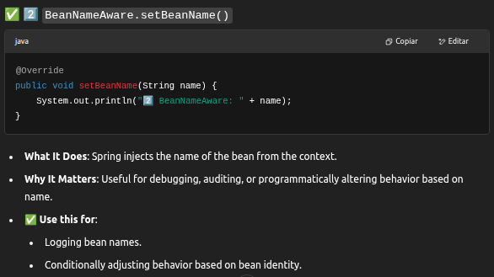
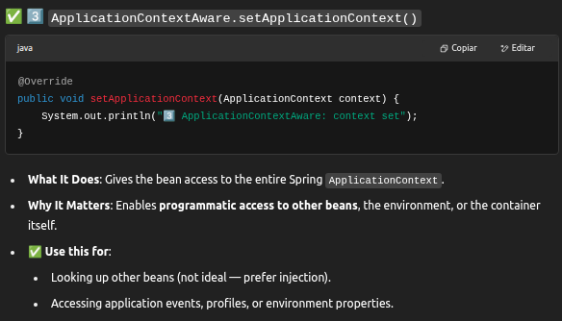

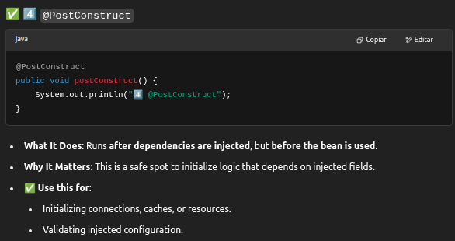
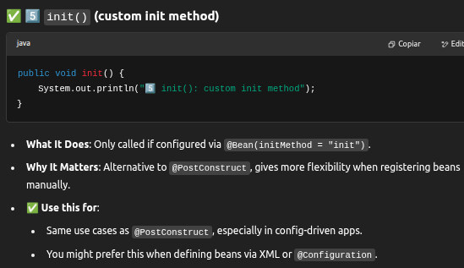

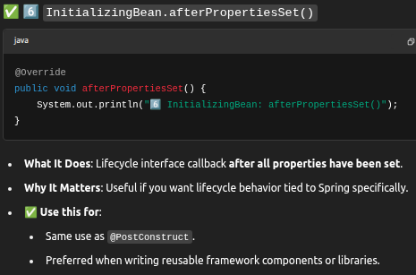

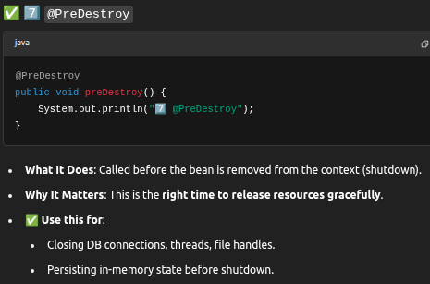

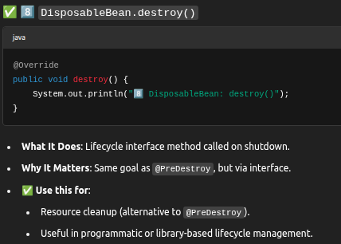

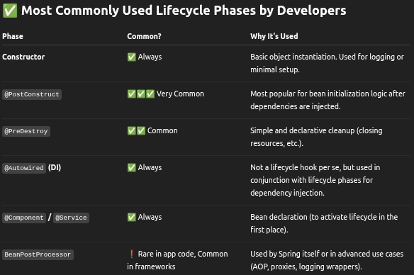
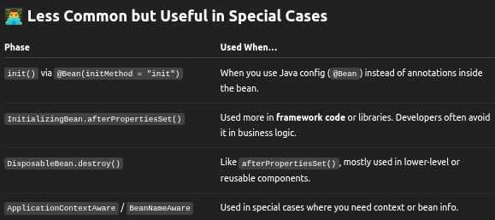

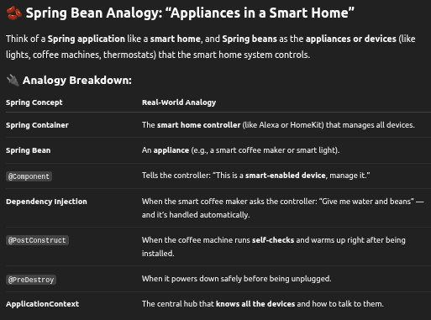

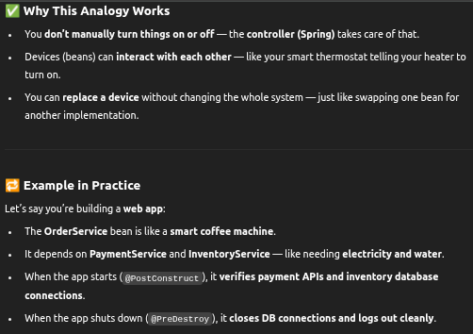

🧠 Quick Summary
You Ask | Bean Analogy
What is a bean? | A managed component (like a smart appliance).
Who controls it? | Spring (like your smart home hub).
How does it get its dependencies? | Spring injects them (like your hub wiring power, internet, etc.).
Can it be customized? | Yes — with annotations like @PostConstruct, @PreDestroy, @Autowired.

Awesome — let’s turn that bean analogy into a working Spring Boot example!
We'll build a simple simulation with the following:
- OrderService depends on PaymentService and InventoryService.
- We'll use @PostConstruct and @PreDestroy to simulate lifecycle actions.
- No real DB/API — just System.out.println to simulate behavior.

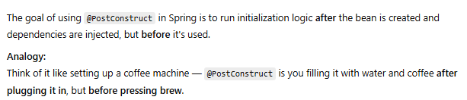

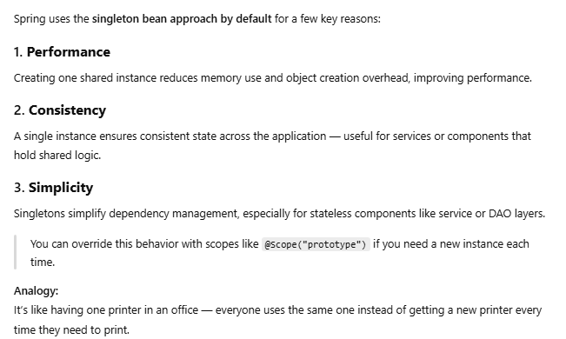
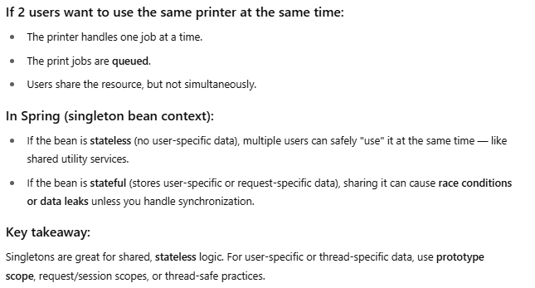

Aspect-Oriented Programming (AOP) is a programming paradigm that helps you separate cross-cutting concerns (like logging, security, or transaction management) from your core business logic.

🔍 Simple Definition:
AOP lets you inject code (called advice) into specific points in your program (called join points) without modifying the actual code.

💡 Analogy:
Imagine every time you open a door, someone automatically logs "Door opened" without you having to write that code on every door. AOP does that — it adds behavior around existing logic.

📦 In Spring:
Spring uses AOP to:
- Log method calls
- Handle transactions
- Perform security checks
- Monitor performance

🧩 Key Concepts:
- Aspect: A class that contains cross-cutting logic.
- Advice: The code to run (before, after, or around a method).
- Join point: A point in your code (like a method call) where advice can run.
- Pointcut: A rule that matches join points.
- Weaving: Applying the aspect logic into the main code (done at runtime in Spring).

