

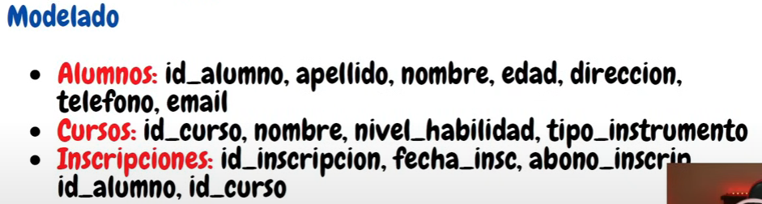

If the id_alumno is modified: this will update the reference id to the table where is this id_alumno linked.

Fecha_nacimiento

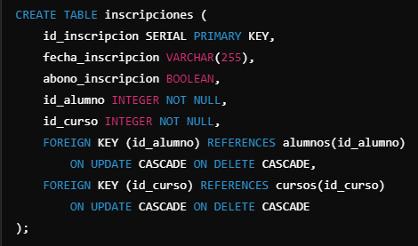



When you use case sensitive: you need to type explicity the name and in quotes the name of the column

Explicit join

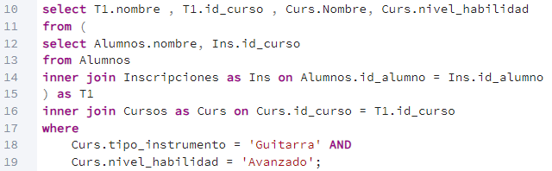

Implicit join

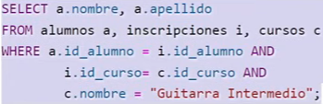

* When using grup by , ensure to use a aggregation command to the column that you are selecting
* Having: counts the number of rows according with the condition given by a grouping of the clause GROUP BY

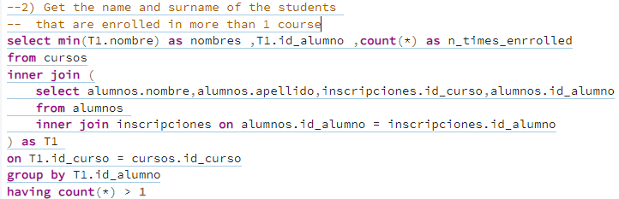

* Get the current age and use a command to be able to use **Where** clause

