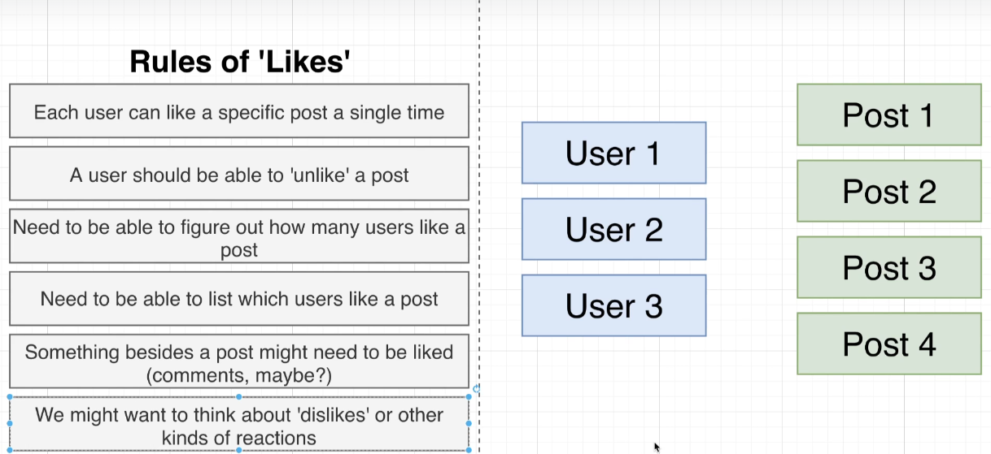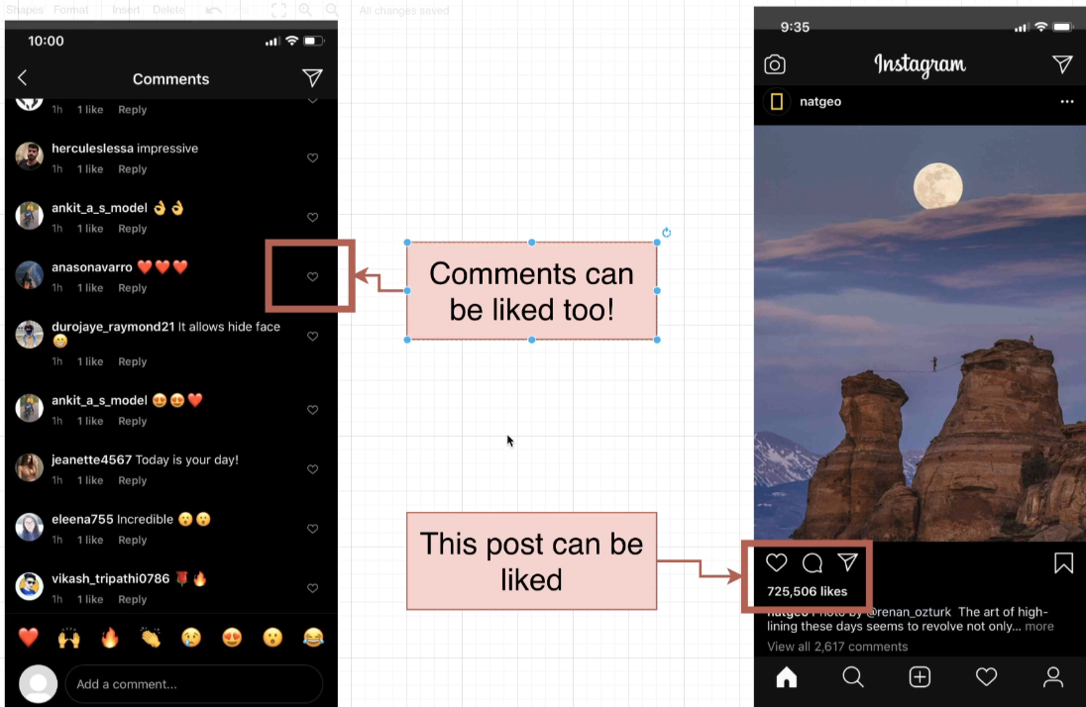

La cantidad de likes no debe de estar como una columna y debe ser una relacion, son entidades

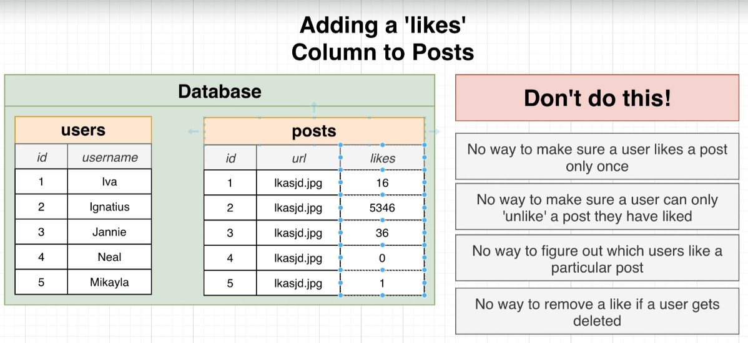

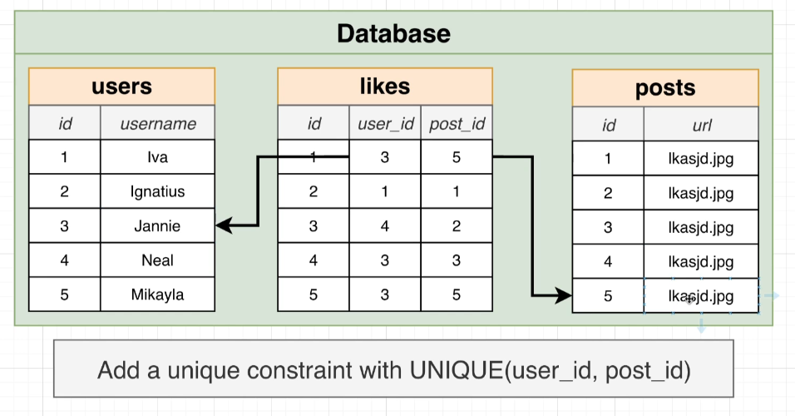

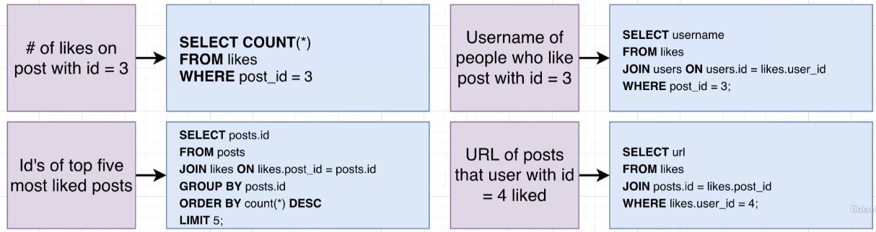

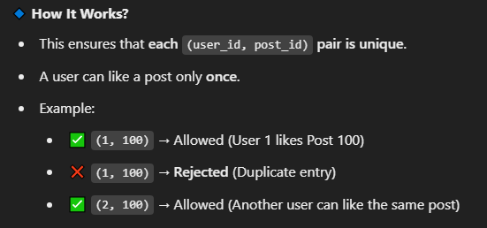

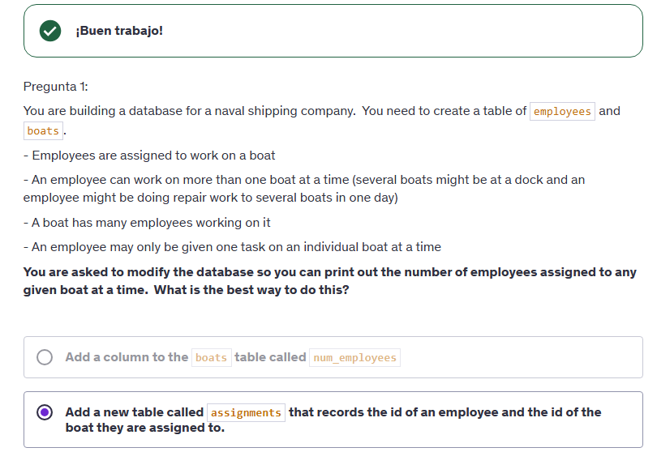

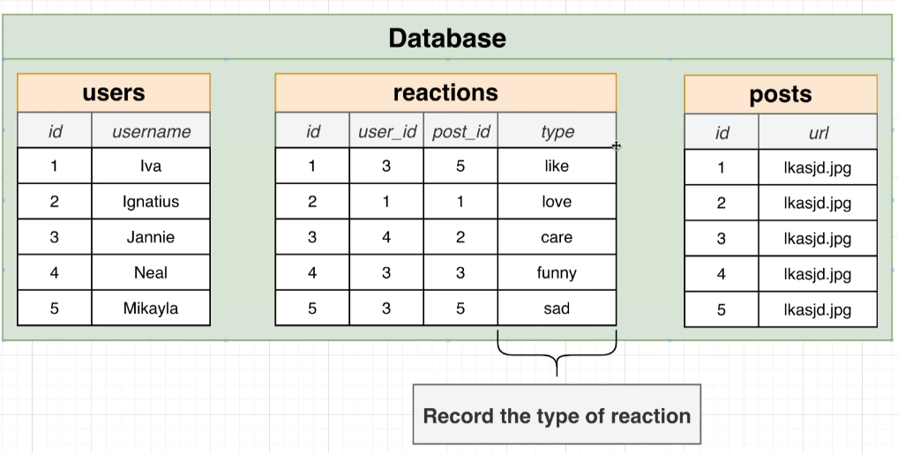

Video 154 : Polymorphic association are used for the programmer use or saving the data for own porpuses , but to write a query where involves the retrieve of a data that is not being retrieved will print and error, so this are just for the project/programmer porpusses

3 Possible solutions

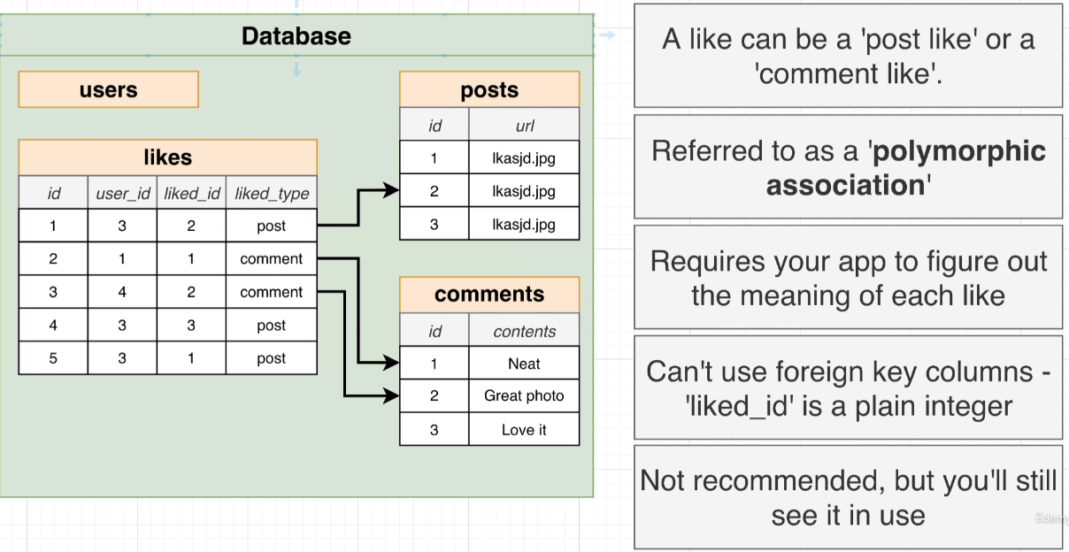

1

Video 155 COALENSCE: returns the first true value of a query/check that the sencence can be inserted correctly

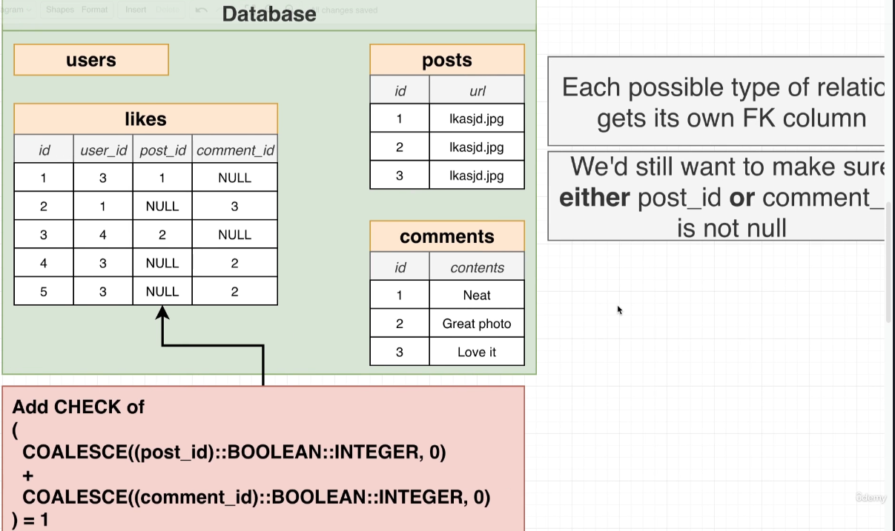

2

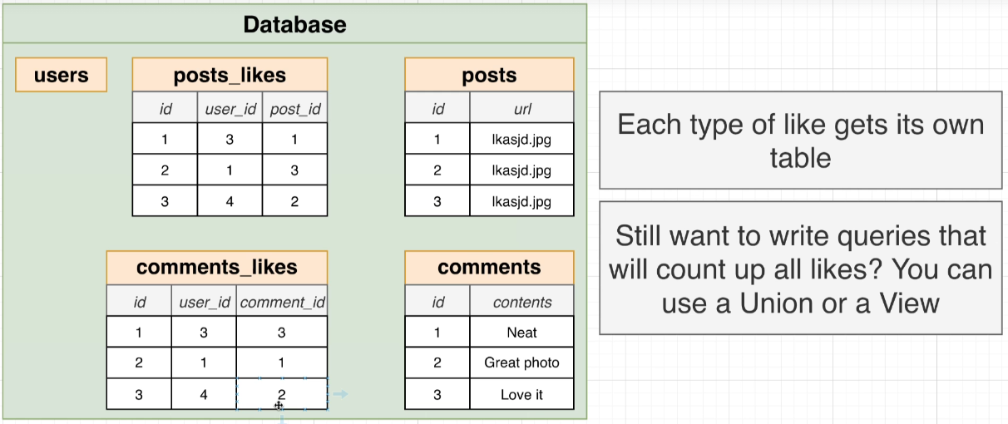

3

What table should I user? 1,2 or 3 ? | video 157