Improving the communication and transparency of stock assessment using interactive visualization tools

Paul M Regular, Gregory J Robertson, etc.?

Fisheries and Oceans Canada, Northwest Atlantic Fisheries Center, 80 East White Hills, St. John’s, Newfoundland and Labrador, A1C 5X1, Canada

In the age of data-intensive science and big data, scientists across many fields are faced with the challenge of synthesizing and communicating information from large and complex data sets . Scientific data are often presented as tabular summaries and static plots, however, seeing patterns in tables can be difficult and static plots preclude detailed explorations of the underlying data. New open source tools are bridging this gap by making it easier to build interactive figures (Perkel 2018). In particular, browser-based data visualizations have been playing an increasingly prominent role in communicating information on a wide range of topics. Interactive graphics are frequently utilized by media outlets, such as the FiveThirtyEight, and scientists from a wide range of disciplines are starting to apply interactive visualization tools to explore and communicate their results (Yeatman et al. 2018; Tushar and Reich 2017; Wick et al. 2015). This trend has been fueled by the development of JavaScript libraries (e.g. D3 (Bostock, Ogievetsky, and Heer 2011), plotly (Inc. 2015), leaflet (Leaflet 2015), highcharts (Highsoft 2015)) that enable the production of dynamic and interactive data visualizations in modern web-browsers. Interfaces to JavaScript libraries have also been developed to allow interactive plots to be coded using commonly used languages such as R (R Core Team 2017) or Python (Foundation 2010). By laying the technical infrastructure for creating interactive graphics, these new tools are ushering in a new era of big data by facilitating the exploration and communication of complex data and models.

The field of fisheries research has a long history of collecting and synthesizing a plethora of data using state-of-the-art computational technologies (Megrey and Moksness 2008). Fisheries science has evolved alongside the rise of the computing era, and as tools improve, so does the management advice provided by fisheries scientists. This management advice generally culminates from a stock assessment process whereby various sources of data and statistical methods are used to model the history, current status and future status of one or more fish stocks (Hilborn and Walters 1992). Recent advances in computational technologies have streamlined the process of stock assessment by facilitating the development and application of integrated assessment models (Maunder and Punt 2013). This means that analyses that were once carried out independently on different data sets can now be integrated into one analysis by using statistical modeling tools such as JAGS (Plummer and others 2003), AD Model Builder (Fournier et al. 2012) and Template Model Builder (Kristensen et al. 2015). From a computational perspective, analyses of a variety of large data sets has never been easier.

However, from a human perspective, contemporary stock assessment biologists are faced with the challenge of managing data from a variety of sources and also understanding the algorithms that convert these data to advice for fisheries managers. Here we aim to demonstrate how interactive visualization tools provide an efficient and effective means of exploring and communicating the ever expanding array of data inputs and model outputs. First, we focus on data that are commonly used in stock assessment and provide one example where interactive maps were used to simplify the detailed exploration of data from a long-term tagging program. Second, we focus on the modeling aspect of stock assessment and, again, we use an example to demonstrate how dynamic and interactive data visualizations can be used to explore, diagnose and communicate results from an integrated assessment model. This structure corresponds to the two general steps in the stock assessment process: 1) knowing the data, and 2) data modeling.

# Knowing the data

The data sets used in stock assessments are constantly growing. This growth in data either stems from the continuation of long-term monitoring efforts or from the addition of new monitoring programs. As such, stock assessment biologists often have to manage large volumes of data from a variety of sources. For instance, time series of reported landings and catch-at-age are “fishery-dependent” data that are frequently used in stock assessments. These data are often analyzed in conjunction with data from “fishery-independent” surveys that track changes in abundance and, in many cases, also monitor trends in biological factors such as age composition, growth rates, sex ratios and maturation stages. For some data-rich stocks, mark and recapture studies are also carried out to estimate movement, migration, growth rate, natural mortality, and discard mortality. All of the above-mentioned data sets are multidimensional and as the volume and variety of these data increases, it becomes more difficult to be aware of the details of each data set and discover key patterns within each. This challenge can be mediated, to a degree, by the application of interactive visualization tools as that they allow detailed exploration of the data behind the plot. For instance, the ability to zoom in on features or areas of interest and hover over specific points to reveal more information creates an interactive user-driven experience that expedites explorations of the data. This is exemplified by an interactive mapping tool developed for the exploration of a long-term tagging study.

Greg, can you introduce this tool, providing some info on the tagging database and the tools used to make the tool (Shiny, leaflet)?

TODO: the intro paragraph to this section could use some references if it is necessary

# Data modeling

Synthesizing data from multiple sources presents a key challenge to stock assessment. Analyses of different data sources were traditionally carried out independently and the summaries or parameters from these analyses were used in the assessment model. This approach, however, is less than ideal because information may be lost and uncertainty may be unaccounted for when we “do statistics on the statistics” (Link 1999; Maunder and Punt 2013). Such issues have largely been curtailed in contemporary stock assessments thanks to advances in software that have facilitated the analysis of all available data, in as raw a form as appropriate, in a single integrated analysis (Maunder and Punt 2013). Specifically, statistical modeling tools such as JAGS (Plummer and others 2003), AD Model Builder (Fournier et al. 2012) and Template Model Builder (Kristensen et al. 2015) allow the construction of a joint likelihood for an array of observations to, in theory, extract as much information as possible about the biological and fishery processes.

However, integrated analyses are not a panacea because model misspecifications and data conflicts are an inevitable consequence of simplifying reality to a small series of equations (Maunder and Piner 2017). A potential solution to this quandary to use a superensemble model, whereby multiple models with different structures are run and their predictions are supplied as covariates to an additional superensemble model (Anderson et al. 2017). Ensemble approaches reduce the risk of picking the “wrong” model and also expands the range of hypotheses explored (Dietterich 2000). These advances greatly improve our ability to assess the status and trends of fish populations, however, modern stock assessment biologists are now faced with the overwhelming task of understanding an ever expanding array of data inputs, model structures and outputs. This challenge is compounded by the ever increasing demand for rapid and sound fisheries advice. Here we argue that the process of providing fisheries advice can be further streamlined by utilizing dynamic and interactive visualization tools to explore, diagnose and communicate stock assessment models. We hope to demonstrate this using a recently developed interactive tool for exploring an integrated assessment model for Northern cod.

The Northern cod stock off southern Labrador and eastern Newfoundland is one of the most well studied stocks in eastern Canada, perhaps by virtue of its history. As such, there are multiple monitoring programs that help inform the status of the stock and data from most of these programs have been integrated into a state-space stock assessment model, called NCAM (Cadigan 2016). The “base case” model includes information from research vessel autumn trawl surveys (1983-present), Sentinel fishery surveys (1995-present), inshore acoustic surveys (1995-2009), fishery catch-at-age compositions and partial fishery landings (1983-present), and tagging (1983-present). Using a series of observation equations, this TMB based model reduces thousands of historical data points from these monitoring programs into quantities such as recruitment, spawning stock biomass, fishing mortality and natural mortality. Once the model is fit to the data, the next step is to produce visual representations of the data and model. An interactive and self-contained “dashboard” was developed for this purpose for the last assessment of Northern cod (Dwyer et al., n.d.). The concept of using a dashboard was borrowed from the business community where dashboards are frequently used to group a series of interactive visuals and tables to provide at-a-glance views of key performance indicators (REF). Many tools have been developed to facilitate the development of data dashboards and we leveraged R-based tools to construct a tool for exploring the input and output of NCAM. Specifically we utilized the flexdashboard (Allaire 2017) package to group interactive plotly-based (Inc. 2015) visuals into a dynamic document. We also used the crosstalk (Cheng 2016) package to link the data displayed across multiple plots.

The NCAM dashboard, which is included in Supplement 2 as a self-contained html file, contains a series of tabs, the first of which provides terse point-form background on the model (tab named “Background”). Subsequent tabs provide a series of diagnostic plots for assessing model fits to the catch (“Catch”), research vessel autumn trawl survey (“RV survey”), Sentinel fishery survey (“SN survey”), inshore acoustic survey (“SS survey”), and tagging (“Tagging”) data. For instance, the “RV survey” tab includes plots of observed and predicted values of mean numbers per tow captured in the research vessel survey (Figure 1). The dashboard also includes tabs focused on model estimates such as catchability and selectivity (“Catchability”), stock size and vital rates (“Trends”; Figure 2), and stock productivity (“Productivity”). Finally, some results from a retrospective analyses are included under the “Retro” tab and key inputs and outputs are included as tables under the “Tables” tab. The plots and tables included in the dashboard are similar to those typically presented at assessment meetings and in research documents, however, the interactive nature of the dashboard permits easy and efficient access to significantly more detail. Because the dashboard is contained in an html file, it acts as an interactive assessment document that can be shared for peer-review. This allows colleagues and stakeholders to independently scrutinize details of the data and model that are not easily accessed by users other than the analyst. Such access improves the transparancy of the stock assessment model which, in turn, leads to richer discussion and interogation of the biological and statistical rigor of the model.

TODO: should I add detail of questions not previously raised? If so, I can’t quite remember.

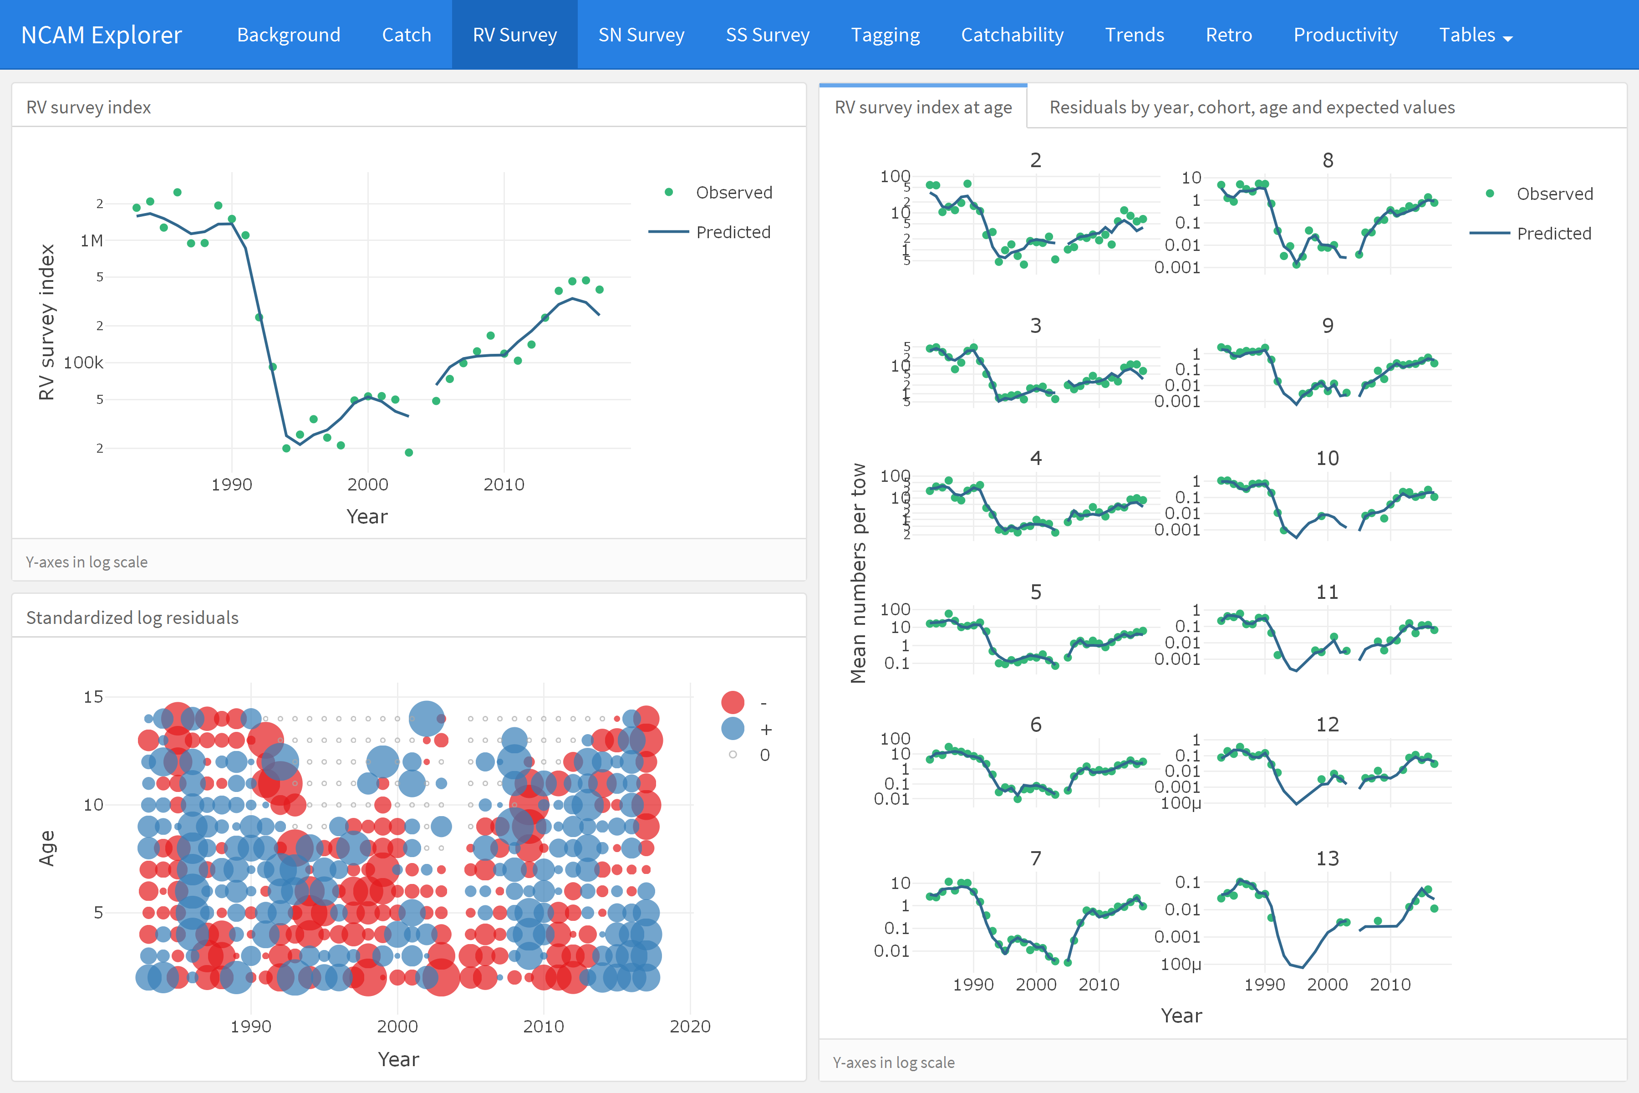

Figure 1 - Screenshot of the “RV survey” tab from the NCAM dashboard where total observed (dots) and NCAM model predicted values (lines) for the DFO RV survey index are shown in the upper left panel and scaled matrix plot of age-disaggregated standardized log residuals are shown in the lower left panel (blue = positive, red = negative, symbols scaled by size; grey = index values of zero). Age-disaggregated observed (dots) and perdicted (lines) values from the DFO RV survey are shown in the right panel. The tab on the right panel including residual plots are hidden here, but asscessable in the dashboard.

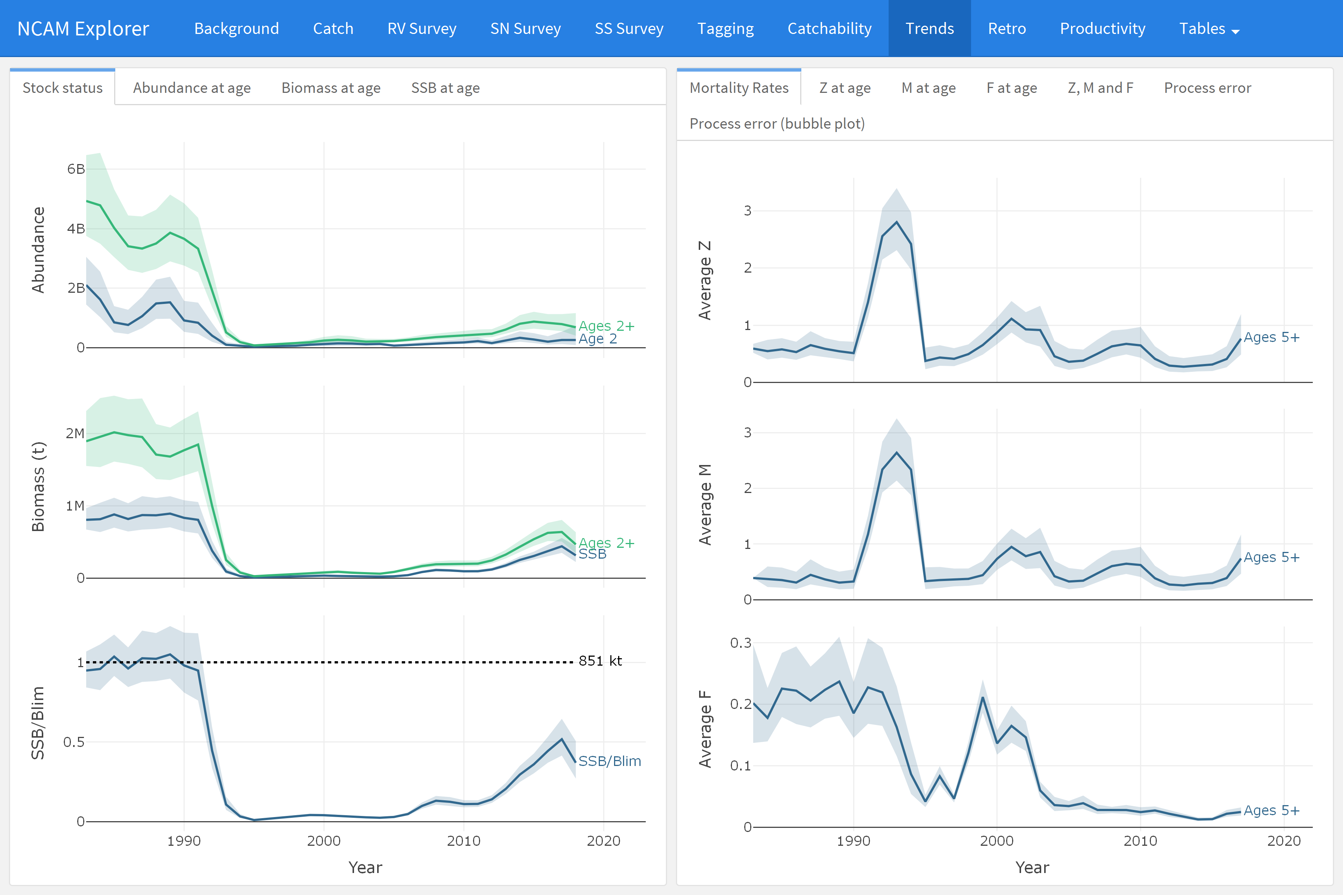

Figure 2 - Screenshot of the “Trends” tab which displays estimates of recruitment, stock size, and stock size relative to Blim (left panels) and mortality rates (F, M, Z, right panels).

# Open stock-assessment

The amount of data available to scientists has grown my orders of magnitude in recent decades as has the complexities of data management, exploratory data analysis, as well as the formal analyses and associated diagnostics. The majority of this sequence of events, sometimes called “the data pipeline”, have not traditionally been part of the peer-review process which sees only the end products. However, decisions made at these steps increasingly influence the outcome of the study. Gelman coined the term “the forked garden path” to illustrate that different conclusions can be arrived at depending on what decisions one makes along the garden path. Due to a number of limitations, such as available pages in journals, much of the data pipeline is not transparent nor is it reproducible, even if it is one’s own analysis. A number of authors have recently advocated for a culture of open science and reproducible research, i.e., a change in the transparency and reproducibility of science. Proponents of open science and reproducible research posit a number of benefits including a more productive and responsible scientific culture, an ability to address larger and more complex questions, as well as a more efficient workflow and ability to reproduce one’s own work (Lewis et al. 2018).

We submit that the dashboard tool is also a major step forward in terms of open science and reproducible research in addition to being a major step forward in how stock assessments are presented and critiqued. Consider the following process. Through the Canadian Science Advisory Secretariat (CSAS), DFO Science provides peer-reviewed science advice to fisheries managers at regular meetings (Regional Assessment Process). These meetings are attended by a variety of stake holders including harvesters, academics, and NGOs. Documents summarizing these processes (research documents, stock assessment reports, and proceedings summaries) are available to the public through the CSAS website. Ergo the CSAS process strives to uphold the ideal of transparency. However, as it currently stands, only the end products of an assessment are open and transparent; as with virtually all scientific analyses, the data pipeline of stock assessment is hidden from review.

With the exception of data management, the dashboard removes much this problem – all analyses and diagnostics can be readily reviewed. In terms of data management, this point is largely ameliorated because the dashboard tool is constructed in Program R using R Markdown and the code for creating the dashboard and all associated analyses are available on Github. Data are also available through information requests. So the entire data pipeline is transparent as well as reproducible, i.e., the requirements of open science are fulfilled.

The dashboard also promotes accessibility to the stock assessment. Even if one is able to download code from a content management system (e.g., GitHub or Bitbucket), submit a data request, and manipulate the data so that it conforms to the code, it is unlikely that an individual has the time to fully recreate a particular analysis in its entirety when most reviewers are already overcommitted (Banks 20XX). In the case of NCAM, considerable statistical experience and expertise is required simply to run the model (or perhaps to even tweak the model). However, the dashboard removes many of these difficulties. The html file contains all of the relevant analyses. The number of analyses can be expanded upon request and can be distributed prior to meetings and reviewers can assess the results and diagnostics at their leisure.

We submit that the plotly/flex dashboard tool is an important step forward in transparent and reproducible science. Further, this tool makes stock assessments more accessible to stakeholders. Beyond stock assessments, it this tool could be used for a more fulsome review of manuscripts (i.e., reviewers can now assess claims like “we examined the residuals and found that the assumptions of the model were met”) in many fields.

**Other draft text**

A wide array data may be collected for an assessment and, formally, the process often reduces to algorithms that convert these data to advice for fisheries managers. In some cases, particularly for commercially valuable species, this means that hundreds or thousands of historical data points from the monitoring program of a stock gets reduced into a single policy value, such as a recommended catch quota (Maunder, Schnute, and Ianelli 2009). Sound management advice therefore hinges on the ability of stock assessment biologists to manage, interpret and communicate large volumes of data from a variety of sources.

In this data-intensive era of stock assessment, one of the difficulties becomes visualizing the inputs and outputs to integrated stock assessment models. The standard approach has been to create a series of tables and static plots to help assess the inputs and model fits. Data presented in tables is incredibly valuable, but as human beings, seeing patterns can be challenging. Static figures, in contrast, help reveal patterns but they are divorced from the underlying data and, as such, limit detailed explorations. New tools are bridging this gap by making it easier to build interactive figures (Perkel 2018).

**Links to some handy references**

Interactive visuals…visual representation of the data and model that help us interpret complex data at a glance <https://campus.sagepub.com/blog/3-benefits-of-interactive-visualization>

<https://centricdigital.com/blog/digital-trends/the-value-of-interactive-data-visualization-and-why-it-matters-to-business/>

<https://www.nature.com/articles/s41467-018-03297-7>

<https://esajournals.onlinelibrary.wiley.com/doi/full/10.1890/120103>

<https://www.nature.com/articles/d41586-018-01322-9>

“The ultimate objective of Fisheries Science is to inform management” (<http://www.fao.org/tempref/docrep/fao/008/a0212e/a0212E02.pdf>)

# References

Allaire, JJ. 2017. *Flexdashboard: R Markdown Format for Flexible Dashboards*. <https://CRAN.R-project.org/package=flexdashboard>.

Anderson, Sean C, Andrew B Cooper, Olaf P Jensen, Cóilı́n Minto, James T Thorson, Jessica C Walsh, Jamie Afflerbach, et al. 2017. “Improving Estimates of Population Status and Trend with Superensemble Models.” *Fish and Fisheries* 18 (4): 732–41.

Bostock, Michael, Vadim Ogievetsky, and Jeffrey Heer. 2011. “D Data-Driven Documents.” *IEEE Transactions on Visualization & Computer Graphics*, no. 12: 2301–9.

Cadigan, Noel G. 2016. “A State-Space Stock Assessment Model for Northern Cod, Including Under-Reported Catches and Variable Natural Mortality Rates.” *Canadian Journal of Fisheries and Aquatic Sciences* 73 (2): 296–308.

Cheng, Joe. 2016. *Crosstalk: Inter-Widget Interactivity for Html Widgets*. <https://CRAN.R-project.org/package=crosstalk>.

Dietterich, Thomas G. 2000. “Ensemble Methods in Machine Learning.” In *International Workshop on Multiple Classifier Systems*, 1–15. Springer.

Dwyer, KS, J Brattey, N Cadigan, BP Healey, DW Ings, EM Lee, Maddock ParsonsD, MJ Morgan, PM Regular, and RM Rideout. n.d. “Assessment of the Northern Cod (*Gadus Morhua*) Stock in Nafo Divisions 2J3KL in 2018.” *DFO Can. Sci. Advis. Sec. Res. Doc.* 2019/nnn: v + 126p.

Foundation, Python Software. 2010. “Python Language Reference, Version 2.7.” Python Software Foundation Wilmington, DE.

Fournier, David A, Hans J Skaug, Johnoel Ancheta, James Ianelli, Arni Magnusson, Mark N Maunder, Anders Nielsen, and John Sibert. 2012. “AD Model Builder: Using Automatic Differentiation for Statistical Inference of Highly Parameterized Complex Nonlinear Models.” *Optimization Methods and Software* 27 (2): 233–49.

Highsoft. 2015. 2015. <https://www.highcharts.com/>.

Hilborn, Ray, and Carl J Walters. 1992. *Quantitative Fisheries Stock Assessment: Choice, Dynamics and Uncertainty*. Chapman; Hall.

Inc., Plotly Technologies. 2015. “Collaborative Data Science.” Montreal, QC: Plotly Technologies Inc. 2015. <https://plot.ly>.

Kristensen, Kasper, Anders Nielsen, Casper W Berg, Hans Skaug, and Brad Bell. 2015. “TMB: Automatic Differentiation and Laplace Approximation.” *arXiv Preprint arXiv:1509.00660*.

Leaflet. 2015. 2015. <https://leafletjs.com/>.

Link, William A. 1999. “Modeling Pattern in Collections of Parameters.” *The Journal of Wildlife Management*, 1017–27.

Maunder, Mark N, and Kevin R Piner. 2017. “Dealing with Data Conflicts in Statistical Inference of Population Assessment Models That Integrate Information from Multiple Diverse Data Sets.” *Fisheries Research* 192: 16–27.

Maunder, Mark N, and André E Punt. 2013. “A Review of Integrated Analysis in Fisheries Stock Assessment.” *Fisheries Research* 142: 61–74.

Maunder, Mark N, Jon T Schnute, and James N Ianelli. 2009. “Computers in Fisheries Population Dynamics.” In *Computers in Fisheries Research*, 337–72. Springer.

Megrey, Bernard A, and Erlend Moksness. 2008. *Computers in Fisheries Research*. Springer.

Perkel, Jeffrey M. 2018. “Data Visualization Tools Drive Interactivity and Reproducibility in Online Publishing.” *Nature* 554 (7690): 133–34.

Plummer, Martyn, and others. 2003. “JAGS: A Program for Analysis of Bayesian Graphical Models Using Gibbs Sampling.” In *Proceedings of the 3rd International Workshop on Distributed Statistical Computing*. Vol. 124. 125.10. Vienna, Austria.

R Core Team. 2017. *R: A Language and Environment for Statistical Computing*. Vienna, Austria: R Foundation for Statistical Computing. <https://www.R-project.org/>.

Tushar, Abhinav, and Nicholas G Reich. 2017. “Flusight: Interactive Visualizations for Infectious Disease Forecasts.” *Journal of Open Source Software* 2 (13).

Wick, Ryan R, Mark B Schultz, Justin Zobel, and Kathryn E Holt. 2015. “Bandage: Interactive Visualization of de Novo Genome Assemblies.” *Bioinformatics* 31 (20): 3350–2.

Yeatman, Jason D, Adam Richie-Halford, Josh K Smith, Anisha Keshavan, and Ariel Rokem. 2018. “A Browser-Based Tool for Visualization and Analysis of Diffusion Mri Data.” *Nature Communications* 9 (1): 940.