Improving the communication and accessibility of stock assessment using interactive visualization tools

Paul M. Regular, Gregory J. Robertson, Keith P. Lewis, etc?

Fisheries and Oceans Canada, Northwest Atlantic Fisheries Center, 80 East White Hills, St. John’s, Newfoundland and Labrador, A1C 5X1, Canada

**Abstract**: In the age of big data, scientists across many fields are faced with the challenge of synthesizing and communicating information from large and complex data sets. The field of stock assessment is no exception as the volume and variety of the data has grown alongside the computational methods used to integrate them. While this growth in data and model complexity has improved the assessments of many stocks, the process of communicating the results to stakeholders and fisheries managers in a meaningful way has become more daunting. The traditional approach of presenting information across a series of static slides often fails to convey the richness of information available and, as such, important patterns and details are easily overlooked. Here we contend that this problem can be mediated through the effective use of new open source tools for building interactive visualizations. These tools allow a broader audience to conduct detailed explorations of the results, leading to a deeper and collective understanding of both the data and models used to inform stock assessments. As a consequence, the peer review process is more open and accessible and the resulting science advice is improved and widely supported.

Quantitative stock assessment plays a central role in modern fisheries management. Over time, and as new methods are developed, there is an increasing amount of data available to inform stock assessments. These data might be richer information on stock structure using an increasing array of markers and biomarkers, and/or the continued lengthening of population status and catch time series. Concurrently, analytical methods are now able to integrate many data sources into one stock assessment model. For well-monitored stocks, the challenge has shifted from having sufficient data and information for providing sound advice on stock status, to presenting large quantities of data and output from increasingly complex statistical models in a meaningful way. Traditional formats (e.g. slides) of presenting information at stakeholder meetings, and to fisheries managers, are simply insufficient to convey the richness of the information available. More importantly, these static and linear formats tend to stifle meaningful discussion as important details and patterns tend to get lost under the sheer volume of output. A solution to this problem is the effective use of interactive visualization tools. These are common tools we use every day on a range of web sites, but their use is no longer restricted to web site developers as these tools are being integrated into software commonly used by the research community.

Here we aim to demonstrate how interactive visualization tools provide an efficient and effective means of exploring and communicating the ever-expanding array of data inputs and model outputs. First, we focus on data that are commonly presented in stock assessments and use interactive maps to simplify the detailed exploration of data from a long-term tagging program. Second, we focus on the modeling aspect of stock assessment and demonstrate how dynamic and interactive data visualizations can be used to explore, diagnose and communicate results from an integrated assessment model. This structure corresponds to two important steps in the stock assessment process: 1) knowing the data, and 2) data modeling.

# Knowing the data

The data sets used in stock assessments are constantly growing due to the continuation of long-term monitoring efforts, the addition of new monitoring programs, or both. As such, stock assessment biologists need to manage large volumes of data from a variety of sources. Time series of reported landings and catch-at-age are often analyzed in conjunction with data from “fishery-independent” surveys that track changes in abundance and, in many cases, also monitor trends in biological factors such as age composition, growth rates, sex ratios and maturation stages. For some data-rich stocks, mark and recapture studies are also carried out to estimate movement, migration, growth rate, natural mortality, and discard mortality. All of the above-mentioned data sets are complex and as the volume and variety of these data increases, it becomes more difficult to be aware of the details of each data set and discover key patterns within each. This challenge can be mediated, to a degree, by the application of interactive visualization tools as that they allow detailed exploration of the data behind a plot. For instance, the ability to zoom in on features or areas of interest, turn off layers and hover over specific points to reveal more information creates an interactive user-driven experience that expedites explorations of data. This is exemplified by an interactive mapping tool developed for the exploration of a long-term tagging study.

Northern cod (NAFO Divisions 2J3KL) has a rich history of tagging, starting in in 1954 (Taggart, Penney, Barrowman, & George, 1995) and continuing to this day. The tagging and recovery data are captured in a standardized database, with fields typical of most tagging programs. This data base has over 600,000 records as of early 2019, with 2,000-10,000 tags deployed annually in recent decades. The tagging and capture data are used in the current assessment model for this stock (Cadigan, 2016), but tools to explore this extensive data set were limited, especially from a spatial perspective. To begin to explore and understand this large data set, we built a simple shiny (Chang et al., 2018) application using the mapping package leaflet (Cheng, Karambelkar, & Xie, 2018), all within the framework of the R programming language (R Core Team, 2017) and the RStudio IDE (RStudio Team, 2015). Shiny provides a means for the user to easily interface with the application, including options to quickly and dynamically subset the data (e.g. ranges of release and capture years, specific geographic locations). As the application developed, it was incorporated into shinydashboard (Chang & Borges Ribeiro, 2018), to take advantage of the number of layout options available in shinydashboard. Given the large number of tags released, often at nearby sites, visualizing the data with static mapping was particularly challenging. The markercluster (<https://github.com/Leaflet/Leaflet.markercluster>) function available in leaflet was particularly useful as a means to dynamically scale the level of pooling of spatial points (Figure 1). This basic mapping tool allowed us to quickly become familiar with the data, identify outliers and incorrect data entries, as well as explore options on how to spatially pool the data for subsequent demographic analysis. Further tabs were added to provide basic summaries of the selected data (Figure 2).

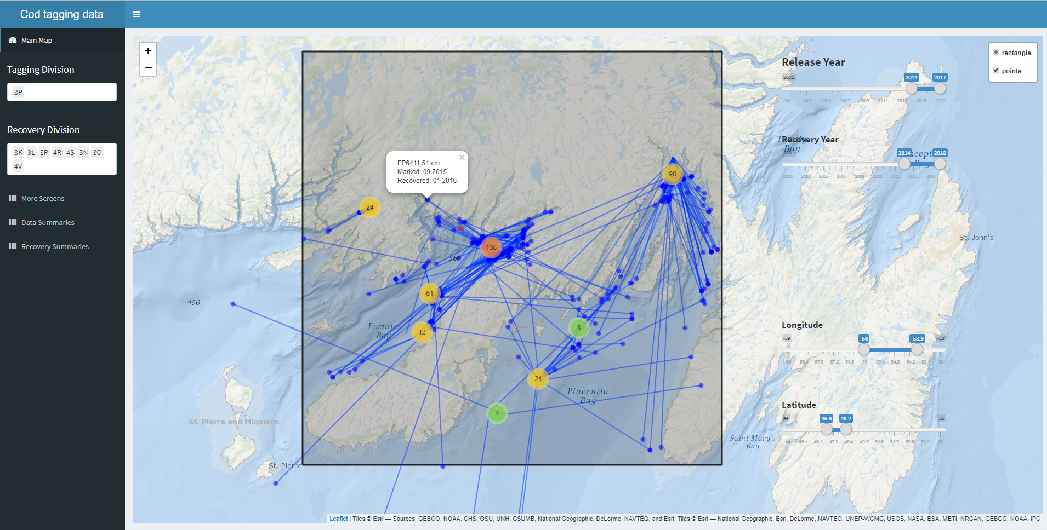

Figure 1 - Screen shot of cod tag mapping tool using shinydashboard and leaflet. The markercluster function dynamically splits or pools tagging locations (red, orange, green or yellow points) depending on zoom level, the recoveries positions (blue) are much fewer, and are left to be plotted individually at all scales. Options to include pop up labels are included, so specific information on each point can be retrieved with a mouse click (in this case: tag number, fish length, date released, and date captured), which is particularly useful when error checking.

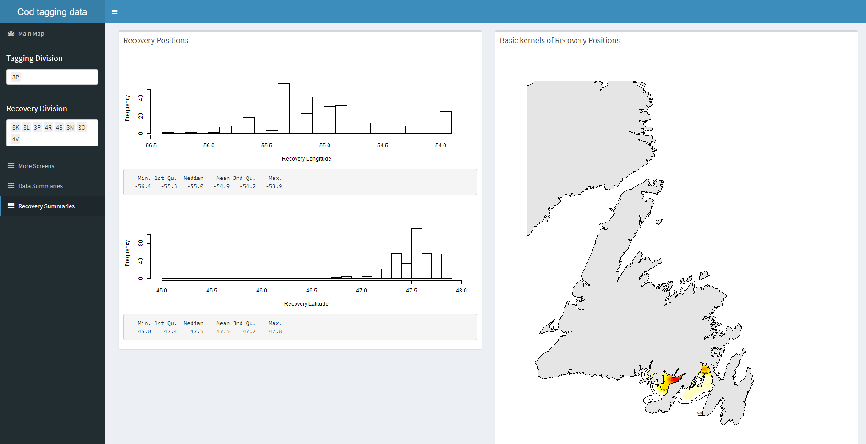

Figure 2 - Basic summaries of the recovery data from the tags selected within the shiny dashboard cod tag mapping tool. In this case, histograms and summary statistics of the recovery positions are returned, along with a simple map of kernels showing the 2D spatial distribution of the selected tag recoveries.

# Data modeling

Synthesizing data from multiple sources presents a key challenge to stock assessment. Analyses of different data sources were traditionally carried out independently and the summaries or parameters from these analyses were used in the assessment model. This approach, however, is less than ideal because information may be lost and uncertainty may be unaccounted for when we “do statistics on the statistics” (Link, 1999; Maunder & Punt, 2013). Such issues have largely been curtailed in contemporary stock assessments thanks to advances in statistical computing that have facilitated the analysis of all available data, in as raw a form as appropriate, in a single integrated analysis (Maunder & Punt, 2013). Specifically, statistical modeling tools such as JAGS (Plummer, 2003), AD Model Builder (Fournier et al., 2012) and Template Model Builder (Kristensen, Nielsen, Berg, Skaug, & Bell, 2016) allow the construction of a joint likelihood for an array of observations to, in theory, extract as much information as possible about the biological and fishery processes. From a computational perspective, analyses of a variety of large data sets has never been easier. However, from a human perspective, contemporary stock assessment biologists are faced with the challenge of understanding and integrating data from multiple sources into a single model and communicating the methods and results to stakeholders and fisheries managers. Using a recently developed tool for exploring the integrated assessment model for Northern cod as an example, we hope to demonstrate that interactive visualization tools can help meet these challenges.

The Northern cod stock off southern Labrador and eastern Newfoundland is one of the most well studied stocks in eastern Canada, perhaps by virtue of its history. As such, there are multiple monitoring programs that help inform the status of the stock and data from most of these programs have been integrated into a state-space stock assessment model, called NCAM (Cadigan, 2016). The model includes information from research vessel autumn trawl surveys (1983-present), Sentinel fishery surveys (1995-present), inshore acoustic surveys (1995-2009), fishery catch-at-age compositions and partial fishery landings (1983-present), and tagging (1983-present). Using a series of observation equations, this TMB based model reduces thousands of historical data points into quantities such as recruitment, spawning stock biomass, fishing mortality and natural mortality. Once the model is fit to the data, the next step is to produce visual representations of the data and model output. The usual approach would be to produce static presentations and documents with a series of figures and tables, but with large amounts of model inputs and outputs, this approach quickly becomes overwhelming for both the analyst and the stakeholders involved. First, it is no longer feasible for the analyst to include and describe every figure and table produced in a single document. Second, it is difficult for stakeholders to efficiently digest the information that has been compressed into a series of static slides or pages. Interactive documents provide a potential solution to this problem as they allow much more information to be contained and accessible on a single screen.

In the pursuit of an easier and more efficient way to communicate results from NCAM, an interactive and self-contained “dashboard” was developed for the 2018 assessment of Northern cod (Dwyer et al., 2019). The concept of using a dashboard was borrowed from the business community where dashboards are frequently used to group a series of interactive visuals and tables to provide at-a-glance views of key performance indicators. We used R-based packages (R Core Team, 2017) and the RStudio IDE (RStudio Team, 2015) to construct a tool for exploring the input and output of NCAM, specifically the flexdashboard (Allaire, 2017) package to group interactive plotly-based (Sievert, 2018) visuals into a dynamic document. We also used the crosstalk (Cheng, 2016) package to link the data displayed across multiple plots. Via R Markdown (Allaire, Horner, Xie, Marti, & Porte, 2018), the dashboard is rendered into a self-contained html file that is reproducible, interactive, and easy to update following modifications to the model or the addition of new data.

The NCAM dashboard (Supplement 2) contains a series of tabs, the first of which provides terse point-form background on the model (tab named “Background”). Subsequent tabs provide a series of diagnostic plots for assessing model fits to the catch (“Catch”), research vessel autumn trawl survey (“RV survey”), Sentinel fishery survey (“SN survey”), inshore acoustic survey (“SS survey”), and tagging (“Tagging”) data. For instance, the “RV survey” tab includes plots of observed and predicted values of mean numbers per tow captured in the research vessel survey (Figure 3). The dashboard also includes tabs focused on model estimates such as catchability and selectivity (“Catchability”), stock size and vital rates (“Trends”; Figure 4), and stock productivity (“Productivity”). Finally, some results from a retrospective analyses are included under the “Retro” tab and key inputs and outputs are included as tables under the “Tables” tab. The plots and tables included in the dashboard are similar to those typically presented at assessment meetings and in research documents, however, the interactive nature of the plots permit easy and efficient access to significantly more detail. Because the dashboard is contained in an html file, it acts as an interactive assessment document that can be shared for peer-review. This allows colleagues and stakeholders to independently scrutinize details of the data and model that are not easily accessed by users other than the analyst. Such access improves the transparency of the stock assessment model which, in turn, leads to richer discussion and scrutiny of the biological and statistical rigor of the model.

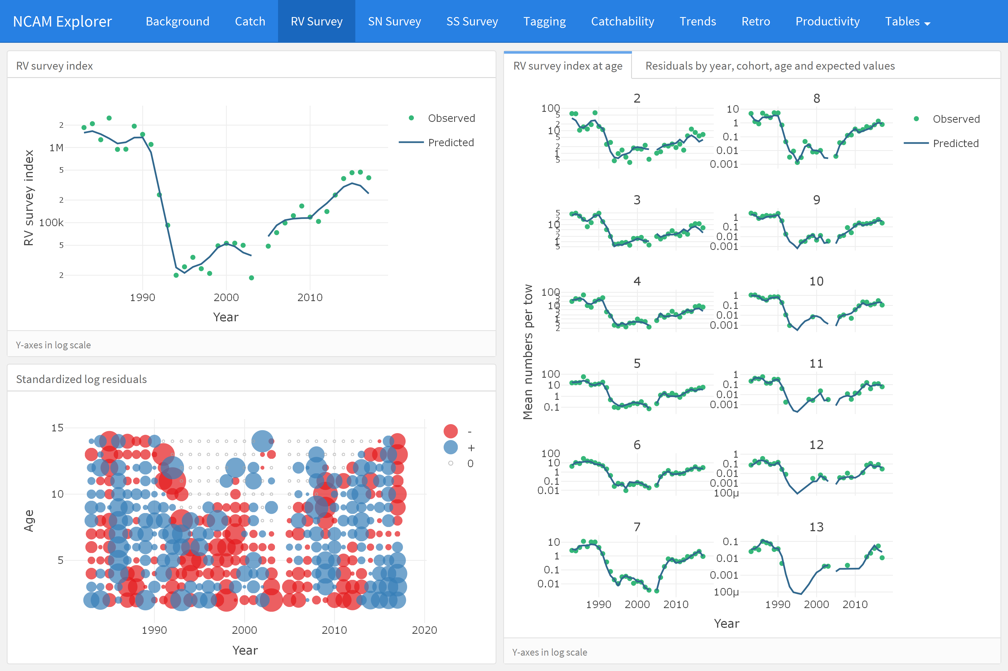

Figure 3 - Screenshot of the “RV survey” tab from the NCAM dashboard where total observed (dots) and NCAM model predicted values (lines) for the DFO RV survey index are shown in the upper left panel and scaled matrix plot of age-disaggregated standardized log residuals are shown in the lower left panel (blue = positive, red = negative, symbols scaled by size; grey = index values of zero). Age-disaggregated observed (dots) and predicted (lines) values from the DFO RV survey are shown in the right panel.

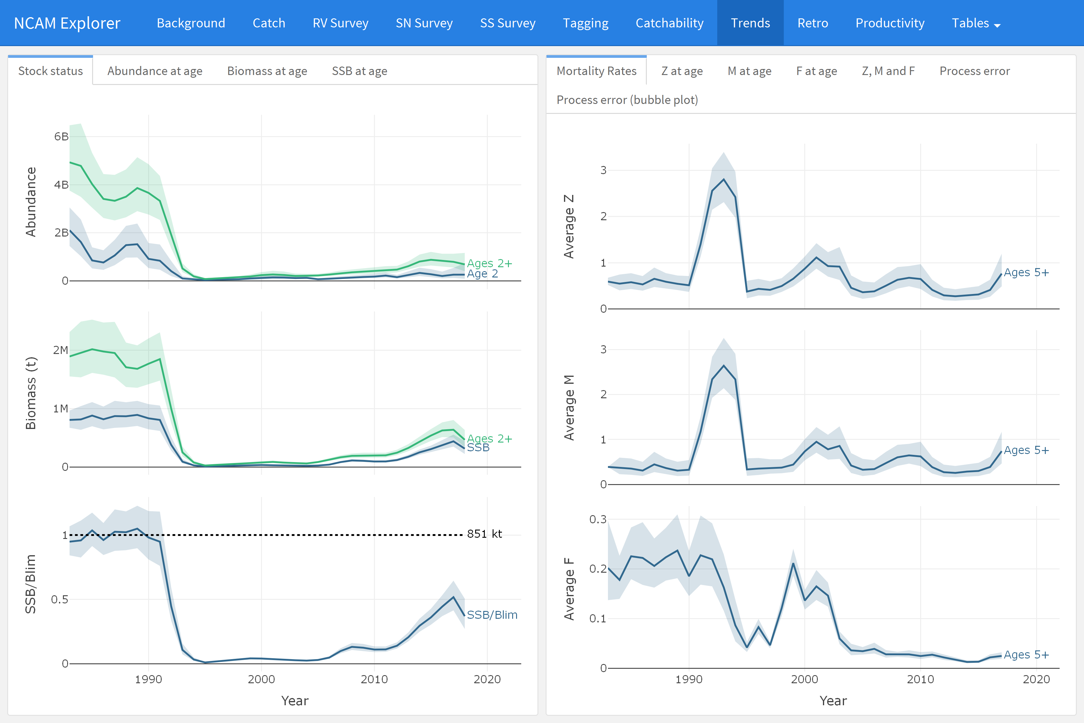

Figure 4 - Screenshot of the “Trends” tab which displays estimates of recruitment, stock size, and stock size relative to Blim (left panels) and mortality rates (F, M, Z, right panels).

# Towards open stock-assessment

The amount of data available to scientists has grown by orders of magnitude in recent decades as has the complexities of data management, exploratory data analysis, formal analyses and associated diagnostics (Lewis, Vander Wal, & Fifield, 2018). The majority of this sequence of events, sometimes called “the data pipeline” (Leek & Peng, 2015b), have not traditionally been part of the peer-review process which sees only the end products of an analysis. However, decisions made along the data pipeline increasingly influence the outcome of the study. Gelman and Loken (2014) coined the term “garden of forking paths” to illustrate that different conclusions can be arrived at depending on what decisions are made along during different stages of the analysis. Due to a number of limitations, such as available pages in journals, much of the data pipeline is not transparent nor is it reproducible. A number of authors have recently advocated for a culture of open science and reproducible research, i.e., a change in the transparency and reproducibility of science (Hampton et al., 2015, 2013; Leek & Peng, 2015b, 2015a). Proponents of open science and reproducible research highlight a number of benefits including a more productive and responsible scientific culture, an ability to address larger and more complex questions, as well as a more efficient workflow and ability to reproduce one’s own work (Fomel & Claerbout, 2009).

We believe that the dashboard tool is a step forward in terms of open science and reproducible research in addition to being a major step forward in how stock assessments are presented and critiqued. While the entire data-pipeline can be revealed to all by sharing code and data, it is unlikely that an individual has the time to fully review and recreate a particular analysis in its entirety when most participants are already overcommitted (Banks, 2011). In the case of NCAM, considerable statistical experience and expertise is required simply to run the model. However, the dashboard removes many of these difficulties. The html file contains all model inputs, outputs and diagnostics in an open and easy to use interactive document, and can be distributed prior to meetings and participants can assess the results and diagnostics at their leisure. Specific experience with the tools used to generate the results are not required to constructively and critically review of the results presented in the dashboard.

# Conclusions

We must acknowledge there are costs to adopting the use of interactive tools. The first and obvious one being that staff are required to have both the time and training to effectively develop these tools. In our two examples, the developers (first and second authors) were relatively proficient with R and have natural aptitudes for programming, but had their formal training in field-based population ecology. While some learning time was needed (a few weeks), the learning curve was relatively minor because there was no need to learn a new programming language (e.g. JavaScript, CSS, etc.). Moreover, a growing user base means that most programming issues were readily addressed through simple internet searches. We expect the accessibility and quality of these tools to continue to improve as more people in the fisheries community develop and use interactive documents. It is our experience that the upfront investment in time has already paid dividends in terms of efficiencies of delivering products for subsequent stock assessments, and in the quality of the data exploration and understanding. Scientific exploration is rarely a linear process, and the ability to navigate around a dashboard fits the natural way people pursue ideas.

# References

Allaire, J. (2017). *Flexdashboard: R markdown format for flexible dashboards*. Retrieved from <https://CRAN.R-project.org/package=flexdashboard>

Allaire, J., Horner, J., Xie, Y., Marti, V., & Porte, N. (2018). *Markdown: ’Markdown’ rendering for r*. Retrieved from <https://CRAN.R-project.org/package=markdown>

Banks, D. (2011). Reproducible research: A range of response. *Statistics, Politics, and Policy*, *2*(1), 4.

Cadigan, N. G. (2016). A state-space stock assessment model for northern cod, including under-reported catches and variable natural mortality rates. *Canadian Journal of Fisheries and Aquatic Sciences*, *73*(2), 296–308.

Chang, W., & Borges Ribeiro, B. (2018). *Shinydashboard: Create dashboards with ’shiny’*. Retrieved from <https://CRAN.R-project.org/package=shinydashboard>

Chang, W., Cheng, J., Allaire, J., Xie, Y., & McPherson, J. (2018). *Shiny: Web application framework for r*. Retrieved from <https://CRAN.R-project.org/package=shiny>

Cheng, J. (2016). *Crosstalk: Inter-widget interactivity for html widgets*. Retrieved from <https://CRAN.R-project.org/package=crosstalk>

Cheng, J., Karambelkar, B., & Xie, Y. (2018). *Leaflet: Create interactive web maps with the javascript ’leaflet’ library*. Retrieved from <https://CRAN.R-project.org/package=leaflet>

Dwyer, K., Brattey, J., Cadigan, N., Healey, B., Ings, D., Lee, E., … Rideout, R. (2019). Assessment of the northern cod (*Gadus morhua*) stock in nafo divisions 2J3KL in 2018. *DFO Can. Sci. Advis. Sec. Res. Doc.*, *2019/nnn*, v + 126p.

Fomel, S., & Claerbout, J. F. (2009). Reproducible research. *Computing in Science & Engineering*, *11*(1), 5.

Fournier, D. A., Skaug, H. J., Ancheta, J., Ianelli, J., Magnusson, A., Maunder, M. N., … Sibert, J. (2012). AD model builder: Using automatic differentiation for statistical inference of highly parameterized complex nonlinear models. *Optimization Methods and Software*, *27*(2), 233–249.

Gelman, A., & Loken, E. (2014). The statistical crisis in science. *American Scientist*, *102*, 460. <https://doi.org/10.1511/2014.111.460>

Hampton, S. E., Anderson, S. S., Bagby, S. C., Gries, C., Han, X., Hart, E. M., … Zimmerman, N. (2015). The tao of open science for ecology. *Ecosphere*, *6*(7), 1–13.

Hampton, S. E., Strasser, C. A., Tewksbury, J. J., Gram, W. K., Budden, A. E., Batcheller, A. L., … Porter, J. H. (2013). Big data and the future of ecology. *Frontiers in Ecology and the Environment*, *11*(3), 156–162.

Kristensen, K., Nielsen, A., Berg, C., Skaug, H., & Bell, B. (2016). TMB: Automatic differentiation and laplace approximation. *Journal of Statistical Software*, *70*(5), 1–21. <https://doi.org/10.18637/jss.v070.i05>

Leek, J. T., & Peng, R. D. (2015a). Reproducible research can still be wrong: Adopting a prevention approach. *Proceedings of the National Academy of Sciences*, *112*(6), 1645–1646.

Leek, J. T., & Peng, R. D. (2015b). Statistics: P values are just the tip of the iceberg. *Nature News*, *520*(7549), 612.

Lewis, K. P., Vander Wal, E., & Fifield, D. A. (2018). Wildlife biology, big data, and reproducible research. *Wildlife Society Bulletin*, *42*(1), 172–179.

Link, W. A. (1999). Modeling pattern in collections of parameters. *The Journal of Wildlife Management*, *63*(3), 1017–1027.

Maunder, M. N., & Punt, A. E. (2013). A review of integrated analysis in fisheries stock assessment. *Fisheries Research*, *142*, 61–74.

Plummer, M. (2003). JAGS: A program for analysis of bayesian graphical models using gibbs sampling. *Proceedings of the 3rd international workshop on distributed statistical computing*, *124*. Vienna, Austria.

R Core Team. (2017). *R: A language and environment for statistical computing*. Retrieved from <https://www.R-project.org/>

RStudio Team. (2015). *RStudio: Integrated development environment for r*. Retrieved from <http://www.rstudio.com/>

Sievert, C. (2018). *Plotly for R*. Retrieved from <https://plotly-book.cpsievert.me>

Taggart, C., Penney, P., Barrowman, N., & George, C. (1995). The 1954-1993 Newfoundland cod tagging database: Statistical summaries and spatial-temporal dynamics. *Canadian Technical Report of Fisheries and Aquatic Sciences*, *2042*.