Jeremy Cruz
UF ID: 6111 – 1421
Section #: 12129

COP 3530 Programming Assignment 1 Commentary

Computational Complexity:

- insertEnd method

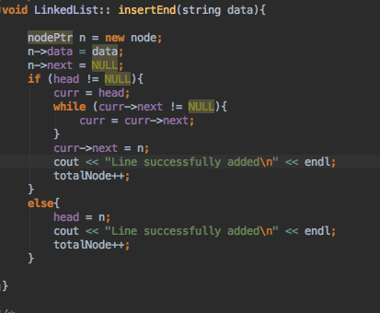

- The computational complexity is O(n) because of the while loop. The loop will iterate until curr->next is null. It will iterate through each node of the linked list

- Insert method

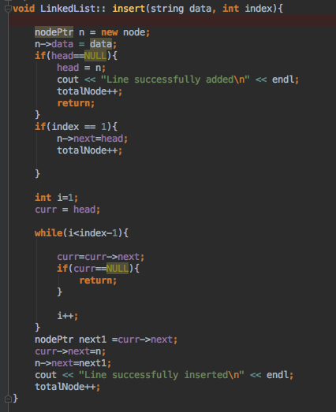
- The computational complexity of this method is O(n) as the while loop iterates until index-1 depending on whatever index is inputted

- deleteNode method

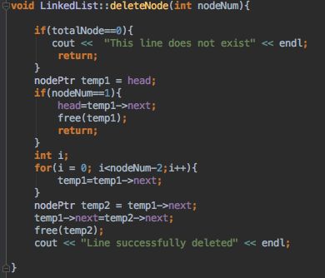
- The computational complexity of this method is O(n) as the for loop will iterate until nodeNum-2. All other lines of code are O(1) in this method.

- Search method
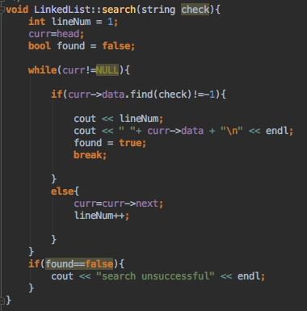

- The computational complexity of this method is O(n) due to the while loop. The while loop will loop until curr is null. It will iterate through every node in the linked list.

- Edit method
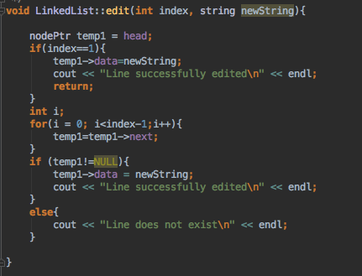
- The computational complexity of this method is O(n) due to the for loop. This loop will iterate until index-1 every time the method is called.

- printList method
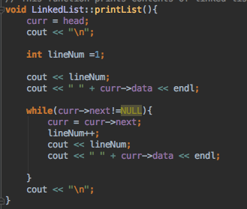
- The computational complexity of this method is O(n) because of the while loop. It will iterate through the list until curr->next is null. It iterates through every node in the list.
- extractSubstring method
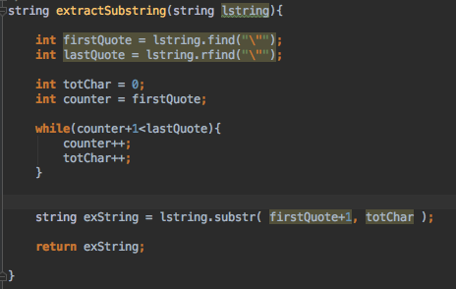
- The computational complexity of this method is O(n) due to the while loop. With every method call, the loop will iterate until integer counter+1 is equal to lastQuote.

- extractInt
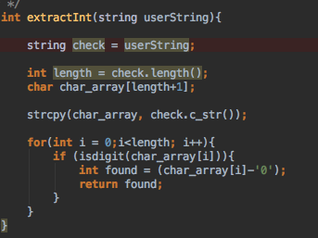
- The computational complexity of this method is O(n) due to the for loop. It will iterate n number of times each time the method is called.
- Main method
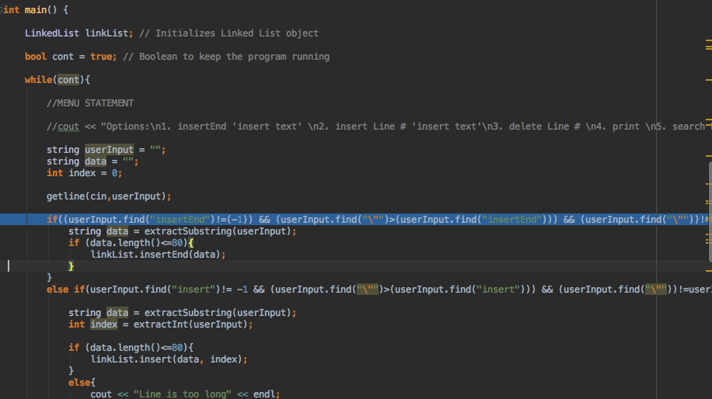

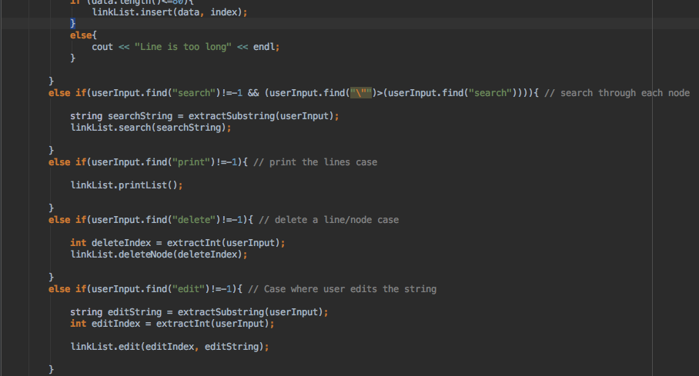

- The computational complexity of my main method is O(1).

Your thoughts on the use of linked lists for implementing a line editor. What are the advantages and disadvantages?
- I found it certain methods to be easier than others. For example, adding and deleting “lines”/nodes were easy due to the nature of linked lists. I found that linked lists also can be prone to different memory leaks. Also, each time I wanted to implement these functions (search, edit, etc.), I would have to traverse through each node in the list. This can be inefficient.
What did you learn from this assignment and what would you do differently if you had to start over?
- I learned to exercise my string parsing skills. I feel as though there may have been easier ways to do it then the way that I chose. Picking apart the user’s string was one of the harder things that I found do to in this assignment.

