On the Github page there are 7 steps but some of them are self-explanatory.

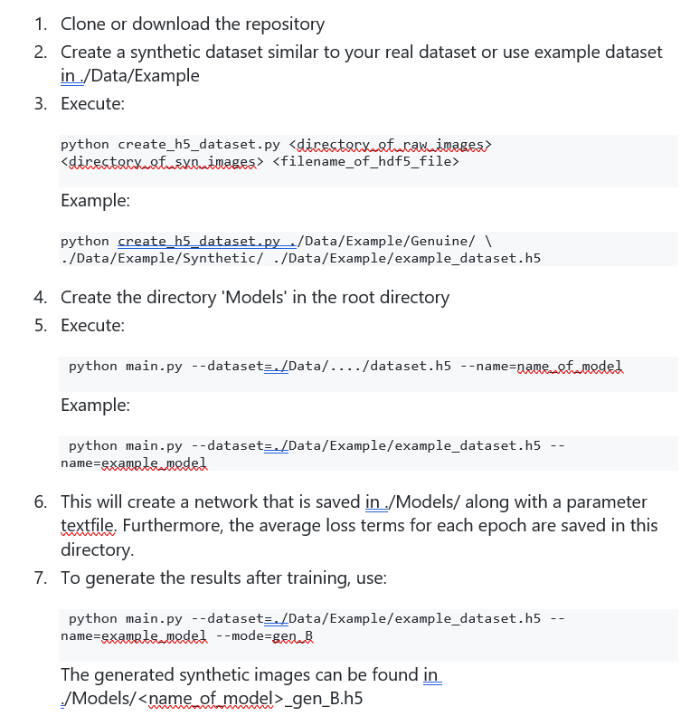

Find the script for this in C:/UDCT/NC_Generate_Synthetic/Synthetic_US_NC. These images are currently 512*512 but they should be resized and converted to a single grayscale channel, and converted to png. To do this, use Prepare_Synthetic.m in the main UDCT folder.



Each time you modify the training dataset, you need to re-run the above step (**NOTE: the ‘/’ at the end of the paths is vital**). If you get an error message (‘The following two images have different dimensions’), use Prepare_Synthetic.m or Prepare_Real.m to modify the images.



This is the training stage. Before this you need to scale the real input ultrasound images to the same dimensions (I’ve used 256*256). They also need to be grayscale.

To train, CD to the main UDCT folder and activate SYN_IMGs environment (tf = 1.15, python = 3.7, cv2 = 4.5.1.48)

**NOTE: If you abort training, make sure you delete the .ckpt files from the models folder that were created during the initial run. Otherwise, when you try to train again, it will continue from where it left off**



Run the code as above, then use ‘Read_UDCT_Ims’ in the main UDCT folder to access the generated images.