List of Web Service and ArcMap Customizations for the FRF/SMS Web Mapping project.

Paul Schrum

Mr. Schrum's VCL contains all customizations. They are all contained in C:\SMSbridge and its subdirectories.

Figure 1 shows a screen capture of the expanded project folder in Windows Explorer.

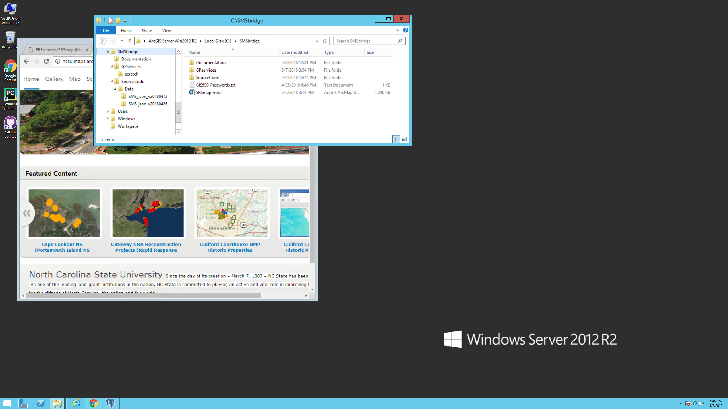

Figure 1: File Structure of the project on the server

Table 1 provides definitions for each element in the file structure.

Table 1: Description of each element in the file structure of Figure 3

|  |  |
| --- | --- |
| File or Directory | Description |
| SMSbridge | Root directory of all project files |
| GIS590-Passwords.txt | Text file containing information on all logins and their passwords. |
| SRSmap.mxd | The only map document used for this project. The REST Service is published from this file. |
| SourceCode | Directory containing all Python source code modules. (See Table 3, below.) |
| GPservices | Directory for all Geoprocessing services, including mxd files and a toolbox. |
| scratch | Directory for intermediate work to be saved by the process. |
| SMS_json_v20180412 | Folder containing all .json files from the client sent on 12 April 2018 |
| SMS_json_v20180426 | Folder containing all .json files from the client sent on 26 April 2018 |