**Study Information**

1. **Title**

Feature-Binding Errors After Eye Movements: Confidence reports

1. **Authorship**

Paul Scotti, Jiageng Chen, & Julie Golomb

1. **Research Questions**

Following eye movements, attention must be updated to a new location. This updating process can distort our ability to bind object locations with their features. Golomb, L’Heureux, & Kanwisher (2014) reported two types of feature-binding errors that can occur immediately following saccades: swapping errors and feature-mixing errors. Are subjects aware when they are committing these feature-binding errors? Here we add confidence reports to ask whether these different types of feature-binding errors are associated with higher or lower confidence ranges.

1. **Hypotheses**

We expect to replicate the original Golomb, L’Heureux, & Kanwisher (2014) study (expt. 1) finding feature-mixing and swapping errors 50ms after completion of an eye movement. The novel aspect of the current experiment centers on the addition of allowing subjects to specify a flexible range of error around their estimates on the continuous-report task (e.g., Chen & Golomb, VSS 2018). We hypothesize that subjects will generally report lower confidence in their responses during the period immediately following an eye movement. Moreover, we hypothesize that higher confidence trials will be generally associated with better performance (better precision, smaller guessing rate) than lower confidence trials. The critical question is whether feature-mixing and swapping errors will be made with different levels of confidence.

Hypothesis A: Both swapping and mixing errors will be associated with lower confidence ratings (more frequent errors on low than high confidence trials), suggesting that subjects are aware they may be making these errors.

Hypothesis B: Both swapping and mixing errors will be made with high confidence (equally likely or more frequent on high than low confidence trials), suggesting that subjects are confident in their response and unaware they are making these errors.

Hypothesis C: High confidence for swapping errors but low confidence for mixing errors. Subjects are unaware attention is lingering at the previous retinotopic location and think they are reporting the correct item.

Hypothesis D: High confidence for mixing errors but low confidence for swapping errors. Subjects know when they make big errors, but are not aware of the subtler distortions.

**Sampling Plan**

1. **Existing data**
   1. As of the time of submission of this research plan for preregistration, no data has been collected or analyzed.
2. **Data collection procedures.**
   1. *Timeline.*
      1. The study will take place during Spring 2018.
   2. *Participants.*
      1. Participants will be recruited from The Ohio State University and will either be paid according to an hourly rate of $10 or in exchange for credit in an introductory Psychology course.
3. **Sample size**
   1. The Ohio State University: 20 participants.
4. **Sample size rationale**
   1. Sample size is based on a power analysis of experiment 1 from Golomb, L’Heureux, and Kanwisher (2014). Power analyses (given a power of .80 and an alpha of .05) reveal 22 subjects needed for feature-mixing analysis (two-tailed, one-sample t-test comparing individual mean shift parameter to a null of 0, at 50 ms delay following saccade) and 25 subjects needed for swap error analysis (two-tailed paired t-test, comparing proportion of retinotopic swapping to proportion of control distractor swapping, at 50 ms delay following saccade). We therefore settled on a sample size of 25 for the proposed study.

**Design Plan**

1. **Study type**
   1. Psychophysics eye-tracking experiment
2. **Blinding**
   1. All participants that pass exclusionary criteria (see “Data exclusion” below) will be included.
   2. Lab: No blinding will be involved in this study (no between-subject conditions).
3. **Study design**

Protocol will follow that of experiment 1 in Golomb et al. (2014), with the addition of a confidence report following a continuous-report task. After a participant reports their best guess as to the cued, spatiotopic color (single click on the color), they will need to report their confidence range for that trial by making two additional clicks on the color wheel. This involves marking the portion of the color wheel that they are confident the correct target color fell within. That is, if they were highly confident about their initial report, they would select a narrow error margin on both sides of that guess, whereas if they were less certain about the exact target color, they would mark a larger portion of the color wheel. The confidence range could be asymmetrical around their target report, and the angular distance between the two end points could range from 0 degrees to 360 degrees (entire color wheel). Subjects will be instructed to choose the smallest range they think is likely to contain the correct target color. They will be also told they could select the entire color wheel or a very large range if they do not see the target color and are guessing.

Each of the four conditions (no-saccade or saccade; 50 ms or 500 ms delay) will be equiprobable and randomly intermixed per subject, and the experiment will be composed of 34 trials per block, with a total of 12 blocks.

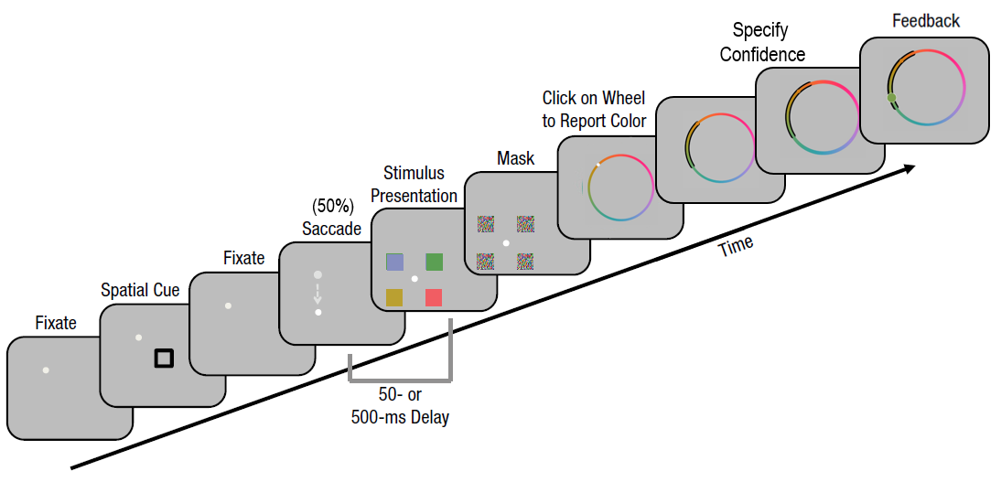

**Analysis Plan**

1. **Statistical models**
   1. Probabilistic mixture modeling will be conducted to characterize memory performance (Bays, Catalao, & Husain, 2009; Zhang & Luck, 2008). We will employ the models described in Golomb et al. (2014). Specifically, these models include:

: difference in radians between reported and target color values

: proportion of trials in which the subject responded at random

: von Mises distribution along with mean and concentration parameters

: probability of misreporting the retinotopic color value (with fixed mean and flexible )

: probability of misreporting the control color value

π: retinotopic distractor color value

-π: control distractor color value

* 1. We will further separate trials into “high confidence trials” and “low confidence trials” based on a median split of each subject’s confidence ranges. For high and low confidence trials separately, we will fit the target color report errors using the aforementioned probabilistic mixture models.

1. **Data exclusion**
   1. This study will use the same exclusionary criteria used in Golomb et al. (2014): we plan to exclude subjects according to their individual fits to a probabilistic mixture model (Model A), using no-saccade trials. We will exclude a subject if they either exceed over 50% guessing proportion or over 90 degrees target proportion standard deviation. We will also exclude a subject if they do not perform the confidence range task correctly, e.g. if more than 80% of the trials within a block have 0 confidence range size or a confidence range with the target response as one of the edges (meaning subjects only extend their confidence range for one direction, either clockwise or counterclockwise). Subjects need to complete at least 10 blocks to be included in the study.