Assignment Description  
  
1. Readme

Part 1:  
This program converts a temperature from Celsius to Fahrenheit. The program prompts the user for a temperature in Celsius (float), converts it to Fahrenheit, and then displays the result.  
  
Part 2:  
This program calculates the total cost of a meal purchased at a restaurant. It prompts the user for the cost of the food, calculates the tax, the tip, and then displays the total cost.

2. Source Code of All Files

Part 1:

"""

Author: Paul Sommers

Date written: 10/26/2024

Assignment: Module 01 Programming Assignment Part 1

Short Desc: This program converts a temperature from Celsius to Fahrenheit.

The program prompts the user for a temperature in Celsius (float),

converts it to Fahrenheit, and then displays the result.

"""

# Step 1: Prompt the user for the temperature in Celsius

celsius = float(input("Enter the temperature in Celsius: "))

# Step 2: Convert the Celsius temperature to Fahrenheit

# Formula: F = (9/5) * C + 32

fahrenheit = (9/5) * celsius + 32

# Step 3: Print the Fahrenheit temperature

print(f"The temperature in Fahrenheit is: {fahrenheit:.2f}°F")

Part 2:

"""

Author: Paul Sommers

Date written: 10/26/2024

Assignment: Module 01 Programming Assignment Part 2

Short Desc: This program calculates the total cost of a meal purchased at a restaurant.

It prompts the user for the cost of the food, calculates the tax, the tip,

and then displays the total cost.

"""

# Step 1: Prompt the user for the food cost

food_charge = float(input("Enter the cost of the food: "))

# Step 2: Calculate the sales tax (7% of the food cost)

sales_tax = food_charge * 0.07

# Step 3: Calculate the tip (18% of the total after tax)

total_with_tax = food_charge + sales_tax

tip = total_with_tax * 0.18

# Step 4: Calculate the total amount to be paid

total_amount = food_charge + sales_tax + tip

# Step 5: Display the results

print(f"Food charge: ${food_charge:.2f}")

print(f"Sales tax (7%): ${sales_tax:.2f}")

print(f"Tip (18% on total with tax): ${tip:.2f}")

print(f"Total amount to be paid: ${total_amount:.2f}")

3. Three Use Case Screen Shots

Part 1:

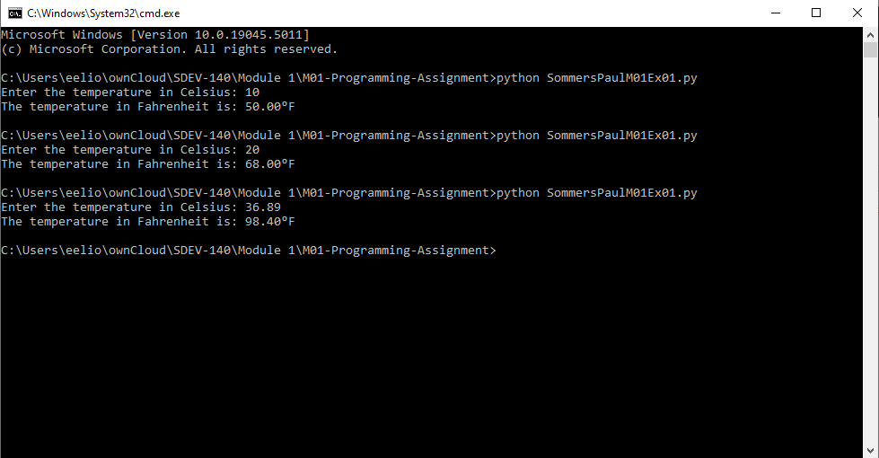  
Part 2: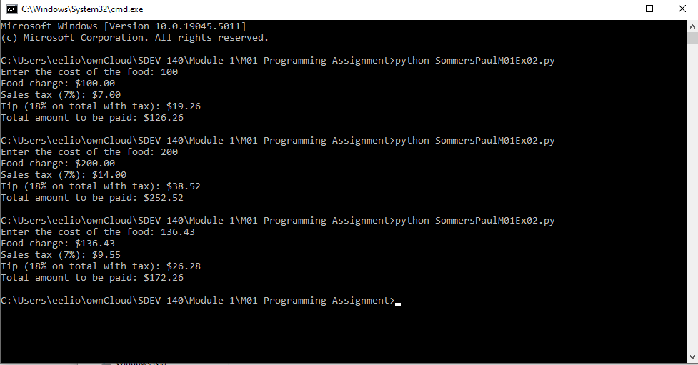

4. GitHub Url  
  
<https://github.com/PaulSommers/SDEV140-M01-Programming-Assignment>