Assignment Description  
  
1. Readme

Part 1:  
This program prompts the user to enter two primary colors (red, blue, or yellow). It uses While loops to ensure that the user enters valid colors. If the user enters an invalid answer, the program will keep asking until a valid color is entered. Once two valid, non-matching colors are entered, the program displays the combined secondary color based on the two primary colors.  
  
Part 2:  
This program prompts the user to enter a non-negative integer and calculates the factorial of that number. The program ensures that the user enters a valid non-negative integer and displays the factorial result.  
  
  
2. Source Code of All Files

Part1:  
"""

Author: Paul Sommers

Date written: 10/29/2024

Assignment: Module 02 Programming Assignment Part 1

Short Desc: This program asks the user to enter two colors (red, blue, yellow) and displays the resulting secondary color.

If the user enters something other than one of these options, the program will ask again until a valid color is entered.

"""

# Get the first primary color

while True:

color1 = input("Enter the first primary color (red, blue, yellow): ").lower()

if color1 == "red" or color1 == "blue" or color1 == "yellow":

break # Valid color entered, exit the loop

else:

print("Invalid color. Please enter 'red', 'blue', or 'yellow'.")

# Get the second primary color

while True:

color2 = input("Enter the second primary color (red, blue, yellow): ").lower()

if color2 == color1:

print("Don't pick the same color!")

elif color2 == "red" or color2 == "blue" or color2 == "yellow":

break # Valid color entered, exit the loop

else:

print("Invalid color. Please enter 'red', 'blue', or 'yellow'.")

# Determine the secondary color

if (color1 == "red" and color2 == "blue") or (color1 == "blue" and color2 == "red"):

print("Red and blue make purple!")

elif (color1 == "red" and color2 == "yellow") or (color1 == "yellow" and color2 == "red"):

print("Red and yellow make orange!")

elif (color1 == "blue" and color2 == "yellow") or (color1 == "yellow" and color2 == "blue"):

print("Blue and yellow make green!")

else:

print("Error! Something unforeseen occurred.")

Part2:  
"""

Author: Paul Sommers

Date written: 10/29/2024

Assignment: Module 02 Programming Assignment Part 2

Short Desc: This program prompts the user to enter a non-negative integer and calculates the factorial.

"""

# Get a non-negative integer from the user and loop until one is entered

while True:

num = int(input("Enter a non-negative integer: "))

if num >= 0:

break

else:

print("Error: Invalid input. Please enter a non-negative integer.")

# Initialize the factorial and counter

factorial = 1

count = 1

# Calculate the factorial

while count <= num:

factorial *= count

count += 1

# Show the result

print(f"The factorial of {num} is {factorial}.")

3. Three Use Case Screen Shots

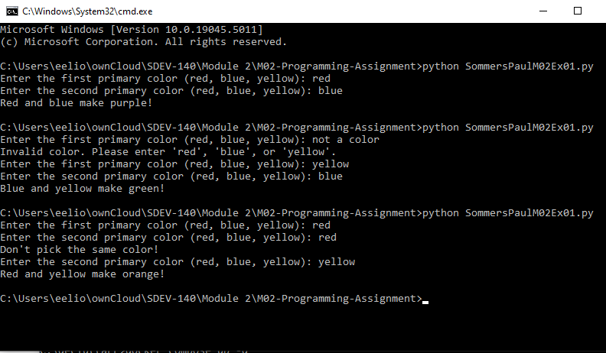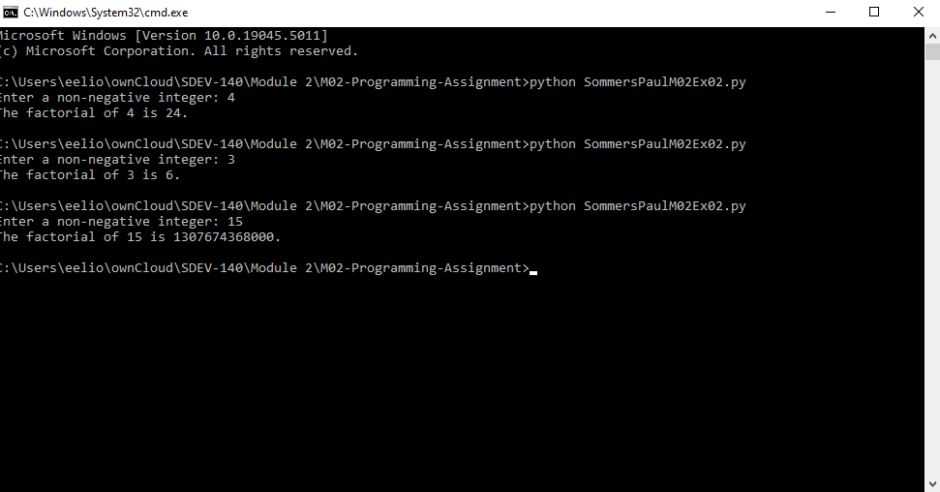

4. GitHub Url  
  
<https://github.com/PaulSommers/SDEV140-M02-Programming-Assignment>