Assignment Description  
1. Readme

This program calculates the Flesch Index and Grade Level Equivalent for the readability of a text file. It reads the text from a file, counts the number of sentences, words, and syllables, and then calculates the Flesch Index and Grade Level. The program was written by Ken, but it contained a bug where consecutive vowels were counted as multiple syllables. The bug was fixed by introducing a boolean check that tracks consecutive vowels, resulting in a more accurate syllable count.  
  
  
2. Source Code of All Files

"""

Author: Paul Sommers

Date written: 11/4/2024

Assignment: Module 03 Peer Exercise - Debugging

Short Desc: This program calculates the Flesch Index and the Grade Level Equivalent of a text file.

It has been modified to fix a bug.

"""

# Take the inputs

fileName = input("Enter the file name: ")

inputFile = open(fileName, 'r')

text = inputFile.read()

# Count the sentences

sentences = text.count('.') + text.count('?') + \

text.count(':') + text.count(';') + \

text.count('!')

# Count the words

words = len(text.split())

# Count the syllables

syllables = 0

vowels = "aeiouAEIOU"

for word in text.split():

last_lettervowel = False # Boolean to track consecutive vowels

for char in word:

if char in vowels:

if not last_lettervowel: # Only count if it's not a consecutive vowel

syllables += 1

last_lettervowel = True # Set True

else:

last_lettervowel = False # Reset if the current letter is not a vowel

for ending in ['es', 'ed', 'e']:

if word.endswith(ending):

syllables -= 1

if word.endswith('le'):

syllables += 1

# Compute the Flesch Index and Grade Level

index = 206.835 - 1.015 * (words / sentences) - \

84.6 * (syllables / words)

level = int(round(0.39 * (words / sentences) + 11.8 * \

(syllables / words) - 15.59))

# Output the results

print("The Flesch Index is", index)

print("The Grade Level Equivalent is", level)

print(sentences, "sentences")

print(words, "words")

print(syllables, "syllables")

3. Three Use Case Screen Shots

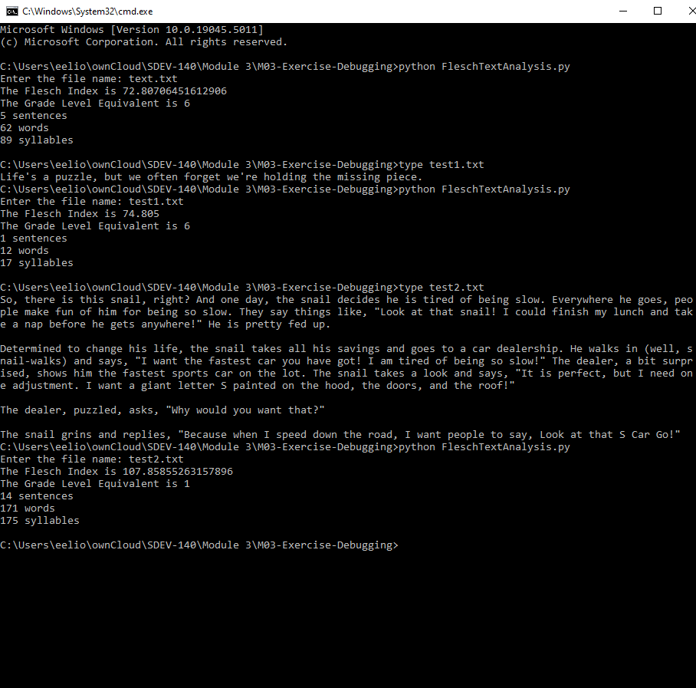

4. GitHub Url  
  
<https://github.com/PaulSommers/SDEV140-M03-Exercise-Debugging>