Assignment Description  
  
1. Readme

Part 1:  
This program prompts the user to enter a series of single-number numbers and calculates the sum of all the numbers in the string.  
  
Part 2:  
This program generates random numbers between 1 to 500, writes them to a file, and displays them to the console. The user specifies how many random numbers to generate.  
  
  
2. Source Code of All Files

Part1:  
"""

Author: Paul Sommers

Date written: 11/5/2024

Assignment: Module 03 Programming Assignment 1

Short Desc: This program prompts the user to enter a series of single-number numbers

and calculates the sum of all the numbers in the string.

"""

# Ask the user to input a series of numbers

user_input = input("Enter a series of numbers with no separators: ")

# Initialize the total

total = 0

# Loop through each character in the string

for number in user_input:

total += int(number) # Convert each number to an integer and add to the total

# Output the total sum of the numbers

print("The sum of the numbers is:", total)

Part2:  
"""

Author: Paul Sommers

Date written: 11/5/2024

Assignment: Module 03 Programming Assignment 2

Short Desc: This program generates random numbers between 1 to 500, writes them to a file, and displays them to the console.

The user specifies how many random numbers to generate.

"""

import random

# Ask the user how many numbers to generate

random_num_quantity = int(input("Enter how many random numbers to generate: "))

# Open a file to write the numbers

with open("randomly_generated_numbers.txt", "w") as file:

# Loop to generate, write, and print numbers

for _ in range(random_num_quantity):

random_number = random.randint(1, 500)

file.write(str(random_number) + "\n")

print(random_number)

3. Three Use Case Screen Shots

Part 1:  
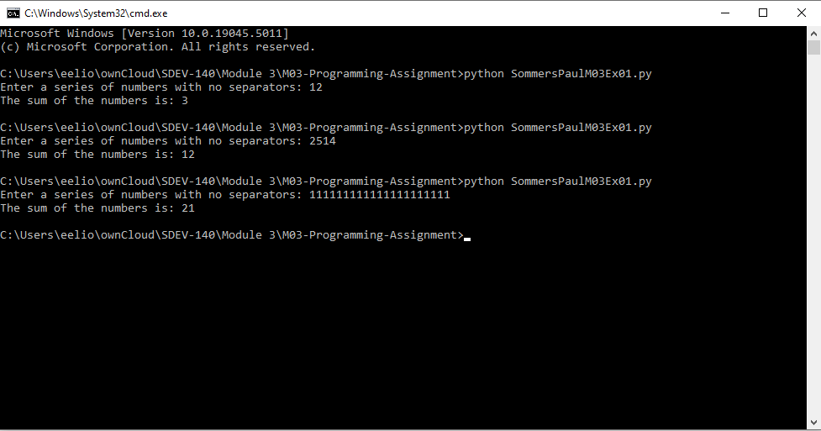  
  
  
  
  
  
Part 2:

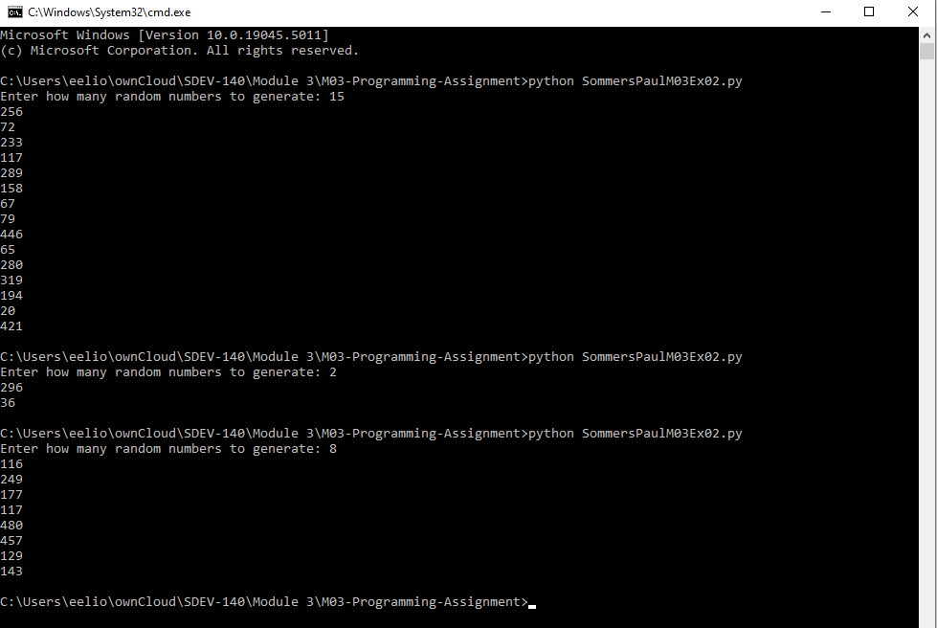  
4. GitHub Url  
  
<https://github.com/PaulSommers/SDEV140-M03-Programming-Assignment>