Assignment Description  
1. Readme

Part 1:  
  
This program prompts the user to enter a number greater than 1 and displays all prime numbers less than or equal to the number. It creates a list of all the numbers between 2 and the number the user entered, and then it loops trough this list checking each number to see if its prime or not (and outputting it if it is).  
  
Part 2:  
  
This program takes a dictionary of items and their prices, and displays the top three most expensive items.  
  
  
2. Source Code of All Files

Part 1:   
  
"""

Author: Paul Sommers

Date written: 11/13/2024

Assignment: Module 04 Programming Assignment 1

Short Desc: This program prompts the user to enter a number greater than 1 and displays all prime numbers less than or equal to the number.

It creates a list of all the numbers between 2 and the number the user entered, and then it loops trough this list checking

each number to see if its prime or not (and outputting it if it is).

"""

# Prompt the user to enter a number greater than 1

number = int(input("Enter an integer greater than 1: "))

# Initialize an empty list to store numbers

numberList = []

# Populate the list with integers from 2 up to the entered number

for numbers in range(2, number + 1):

numberList.append(numbers)

# Loop through the list to check if each number is prime

for num in numberList:

isPrime = True # Set flag for prime break-case

for divisor in range(2, num): # Check divisors from 2 to the number - 1

if num % divisor == 0: # If divisible, it's not a prime number

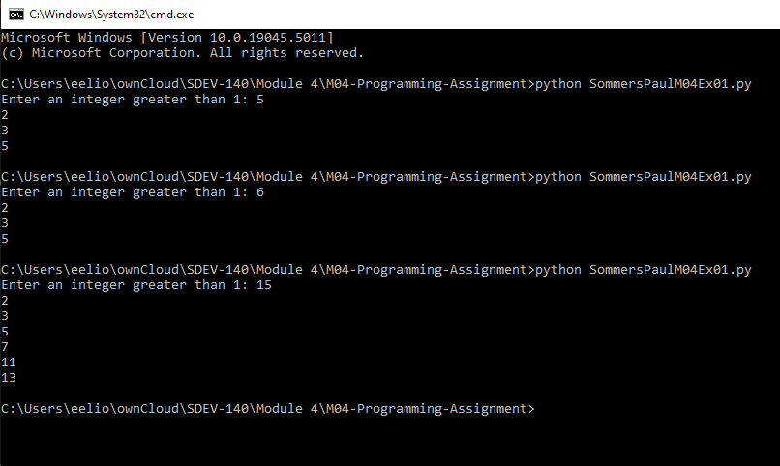 isPrime = False

break

if isPrime:

print(num) # Print the number if it's prime  
  
Part 2:   
  
"""

Author: Paul Sommers

Date written: 11/13/2024

Assignment: Module 04 Programming Assignment 2

Short Desc: This program takes a dictionary of items and their prices, and displays the top three most expensive items.

"""

# Create dictionary of items and their prices

shop = {'Apple': 0.50, 'Banana': 0.20, 'Mango': 0.99, 'Coconut': 2.99, 'Pineapple': 3.99}

# Sort the dictionary by price in descending order and get the top 3 items

sortedShop = sorted(shop.items(), key=lambda x: x[1], reverse=True)[:3]

# Display the top three items and their prices

for item, price in sortedShop:

print(item, price)

3. Three Use Case Screen Shots

Part 1:

Part 2:

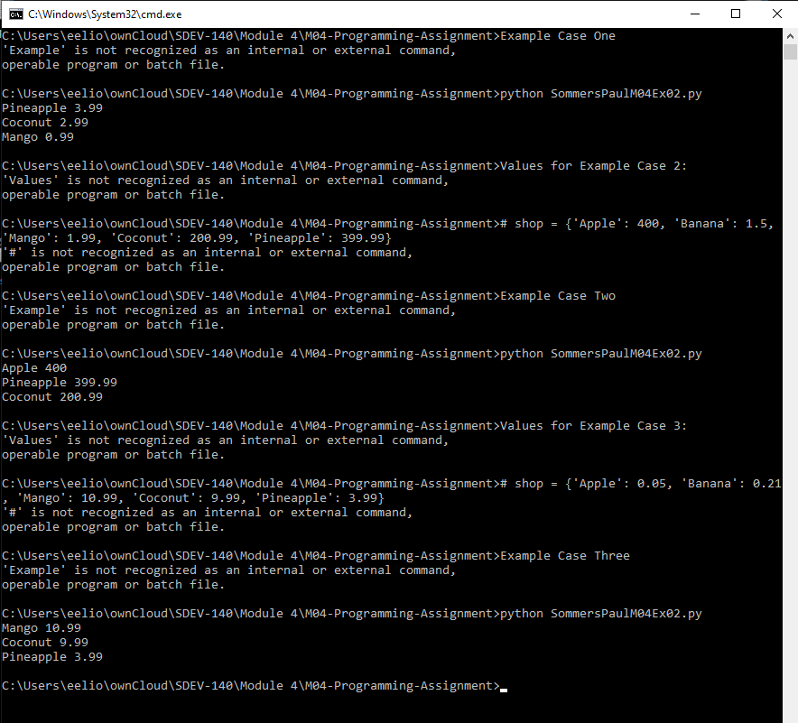

4. GitHub Url  
  
<https://github.com/PaulSommers/SDEV140-M04-Programming-Assignment>