Assignment Description  
1. Readme

Part 1:  
  
This program prompts the user for total sales for the month, and then calculates the county, state, and total sales tax.  
  
Part 2:  
  
This program generates a random number between 1 and 100 and asks the user to guess the number. It replies if the guess is too high or too low, and congratulates the user when the guess the number. The game restarts with a new random number after a correct guess.  
  
  
2. Source Code of All Files

Part 1:  
"""

Author: Paul Sommers

Date written: 11/20/2024

Assignment: Module 05 Programming Assignment 1

Short Desc: This program prompts the user for total sales for the month, and then calculates the county, state, and total sales tax.

"""

# Function to calculate and display sales tax

def calculateTax():

# Input: Ask the user to enter the total sales for the month

totalSales = float(input("Enter the total sales for the month: "))

# Calculate the county and state sales tax

countyTax = totalSales * 0.025 # 2.5% county tax

stateTax = totalSales * 0.05 # 5% state tax

# Calculate the total sales tax

totalTax = countyTax + stateTax

# Display the county, state, and total sales tax

print(f"The county sales tax is: ${countyTax:.2f}")

print(f"The state sales tax is: ${stateTax:.2f}")

print(f"The total sales tax is: ${totalTax:.2f}")

# Call the function

calculateTax()  
  
Part 2:   
  
"""

Author: Paul Sommers

Date written: 11/20/2024

Assignment: Module 05 Programming Assignment 2

Short Desc: This program generates a random number between 1 and 100 and asks the user to guess the number. It replies if the guess is too high or too low, and congratulates the user when the guess the number. The game restarts with a new random number after a correct guess.

"""

import random

# Function to run the number guessing game

def numberGame():

while True:

# Generate a random number between 1 and 100

randomNum = random.randint(1, 100)

# Let the user to keep guessing until they guess the number

while True:

# Ask the user to guess

guess = int(input("Guess a number (between 1 and 100): "))

# Check if the guess is too high, too low, or correct

if guess > randomNum:

print("Too high!")

elif guess < randomNum:

print("Too low!")

else:

print("Nice! You guessed the number!")

break # Exit the inner loop and pick a new number

# Call the function to start the game

numberGame()

3. Three Use Case Screen Shots

Part 1:

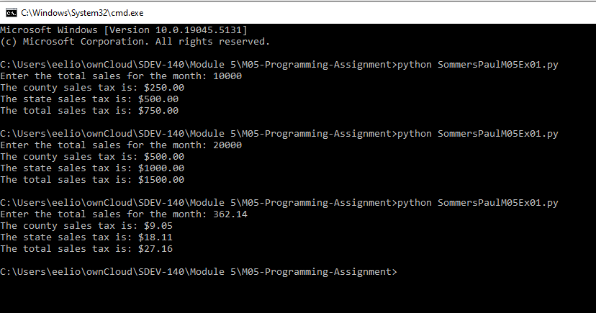

Part 2:

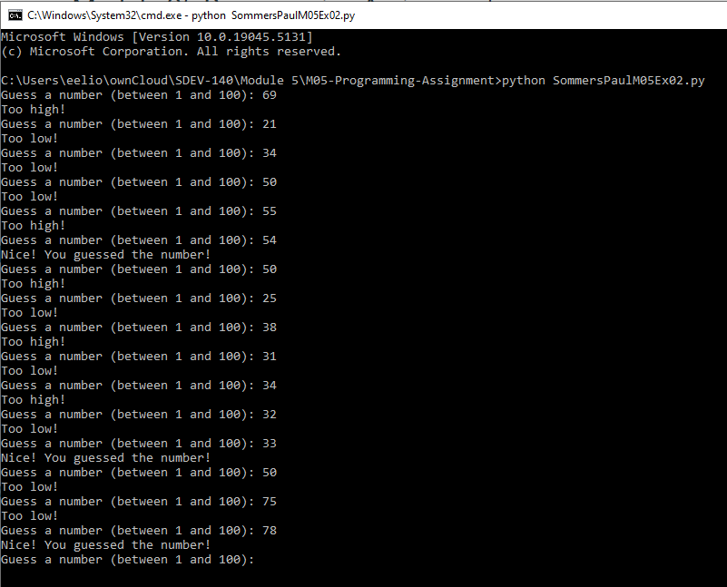

4. GitHub Url  
  
<https://github.com/PaulSommers/SDEV140-M05-Programming-Assignment>