Assignment Description  
1. Readme

This program creates a GUI-based window in tkinter, and the user provides a temperature. The program displays 2 buttons, a Celsius and a Farenheit button. When the user clicks the Celsius button, the program converts the temperature to celsius and displays it. When the user clicks the Farenheit button, the program converts the temperature to fahrenheit and displays it.  
  
  
2. Source Code of All Files

"""

Author: Paul Sommers

Date written: 11/27/2024

Assignment: Module 06 Programming Assignment 1

Short Desc: This program creates a GUI-based window in tkinter, and the user provides a temperature.

The program displays 2 buttons, a Celsius and a Fahrenheit button. When the user clicks the Celsius button,

the program converts the temperature to celsius and displays it. When the user clicks

the Fahrenheit button, the program converts the temperature to fahrenheit and displays it.

"""

# Import the tkinter library

import tkinter as tk

from tkinter import messagebox

# Create the function to convert the temperature to fahrenheit

def convert_to_fahrenheit():

try:

# Get the temperature from the entry field

celsius = float(temp_entry.get())

# Convert to Fahrenheit using the formula

fahrenheit = (9/5 * celsius) + 32

# Display the result

result_label.config(text=f"{celsius}°C = {fahrenheit:.1f}°F")

except ValueError:

messagebox.showerror("Error!", "Please enter a valid number")

# Create the function to convert the temperature to celsius

def convert_to_celsius():

try:

# Get the temperature from the entry field

fahrenheit = float(temp_entry.get())

# Convert to Celsius using the rearranged formula

celsius = (fahrenheit - 32) * 5/9

# Display the result

result_label.config(text=f"{fahrenheit}°F = {celsius:.1f}°C")

except ValueError:

messagebox.showerror("Error!", "Please enter a valid number")

# Create the main window

window = tk.Tk()

window.title("Temperature Converter")

window.geometry("300x200")

# Create and pack the input label

input_label = tk.Label(window, text="Enter Temperature:")

input_label.pack(pady=10)

# Create and pack the entry field

temp_entry = tk.Entry(window)

temp_entry.pack()

# Create and pack the buttons frame

button_frame = tk.Frame(window)

button_frame.pack(pady=10)

# Create the conversion buttons

celsius_button = tk.Button(button_frame, text="Convert to Fahrenheit", command=convert_to_fahrenheit)

celsius_button.pack(side=tk.LEFT, padx=5)

fahrenheit_button = tk.Button(button_frame, text="Convert to Celsius", command=convert_to_celsius)

fahrenheit_button.pack(side=tk.LEFT, padx=5)

# Create and pack the result label

result_label = tk.Label(window, text="")

result_label.pack(pady=10)

# Start the main event loop

window.mainloop()

3. Three Use Case Screen Shots

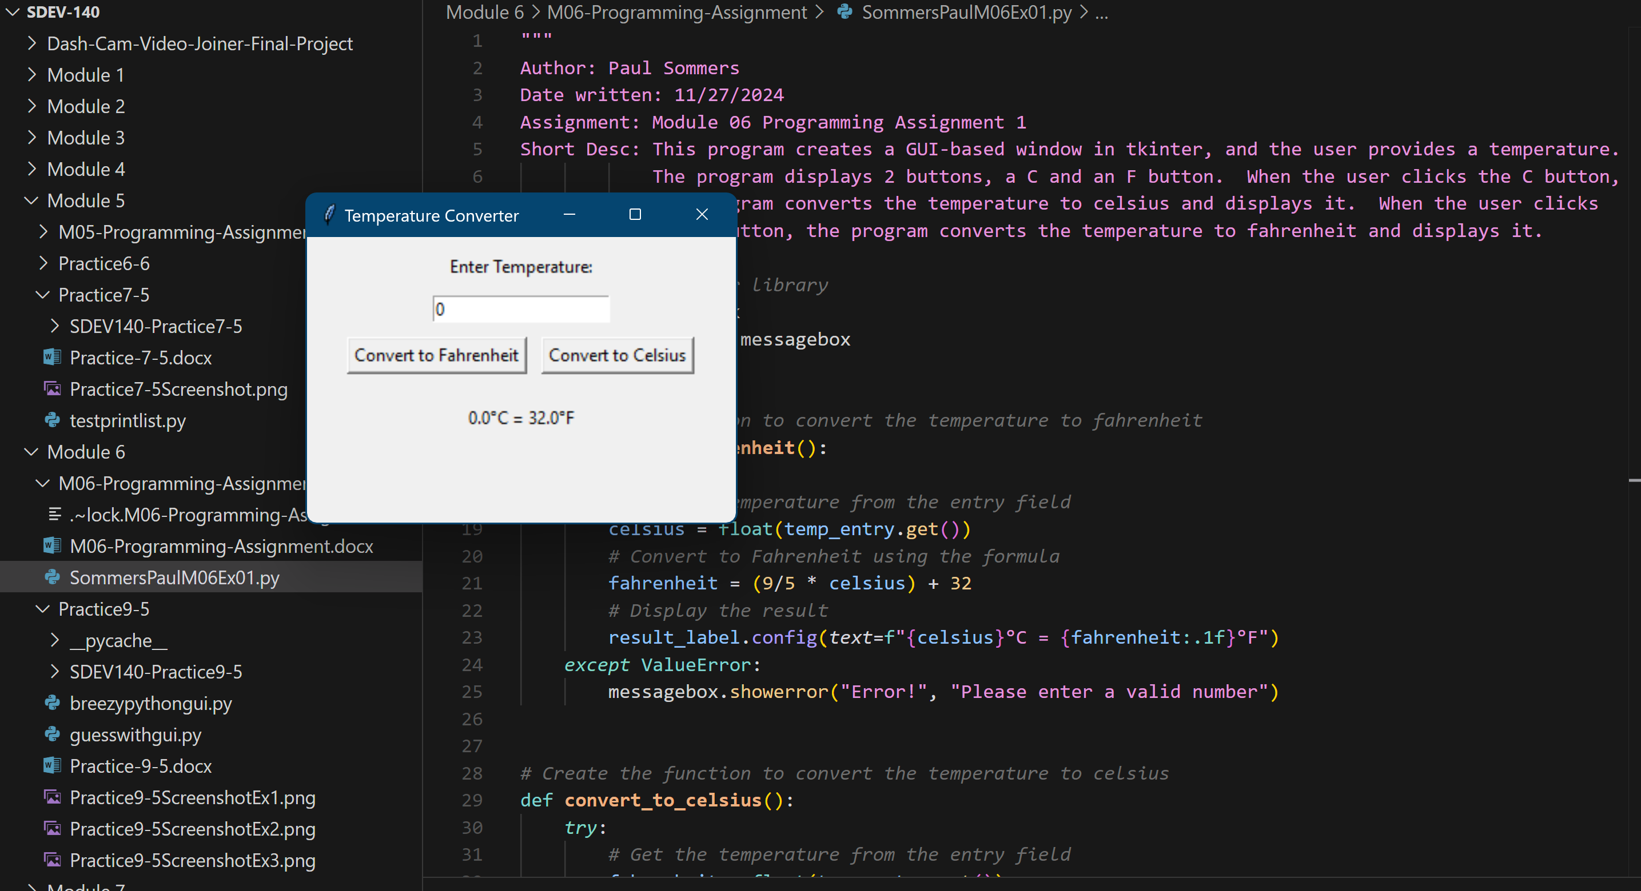

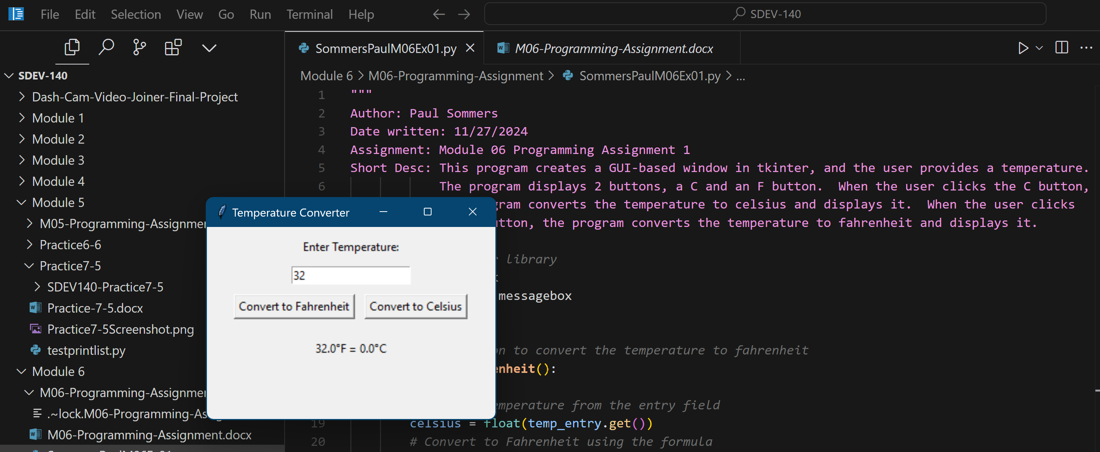

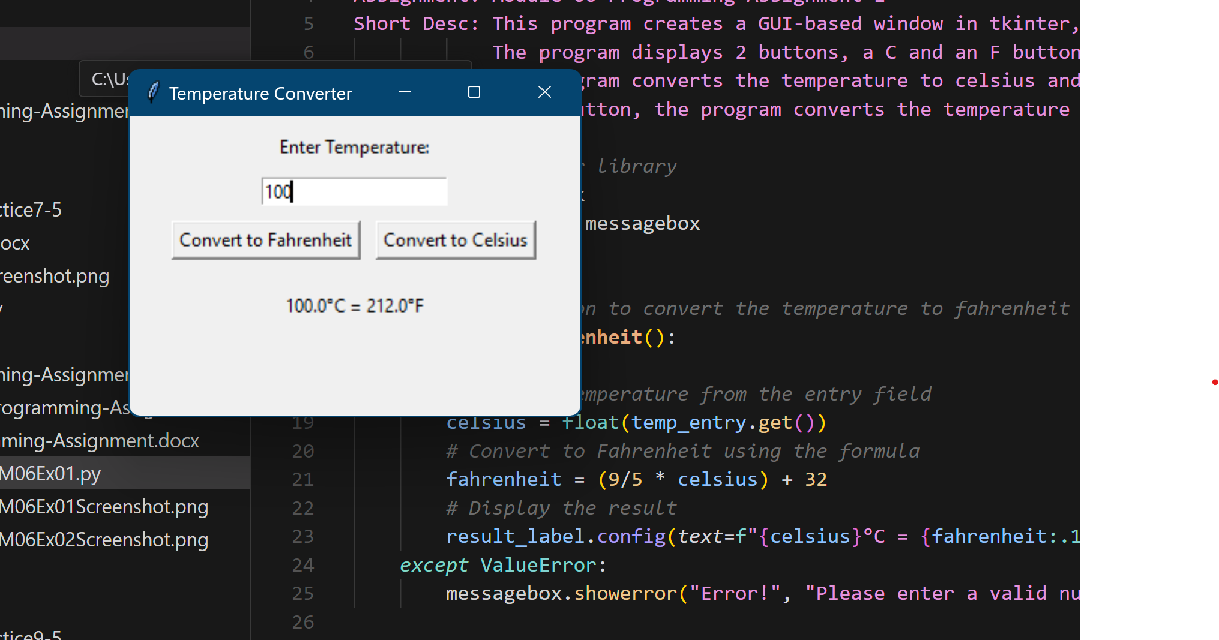

4. GitHub Url  
  
<https://github.com/PaulSommers/SDEV140-M06-Programming-Assignment>