Assignment Description  
  
1. Readme

This program displays my name, address, and phone number. The program defines three variables (strName, strAddress, and strPhone) and assigns them their respective values. It then prints these values.  
  
  
2. Source Code of All Files

mylab.py:

"""

Author: Paul Sommers

Date written: 10/25/2024

Assignment: Exercise 1-1

Short Desc: This program defines variables for my name, address, and phone number, assigns values to them, and outputs the values.

"""

# Define variables and assign values

strName = "Paul Sommers"

strAddress = "5273 Brandywine Drive, Whitestown, IN 46075"

strPhone = "317-970-6735"

# Display the values of the variables

print("Name:", strName)

print("Address:", strAddress)

print("Phone:", strPhone)

3. Three Use Case Screen Shots

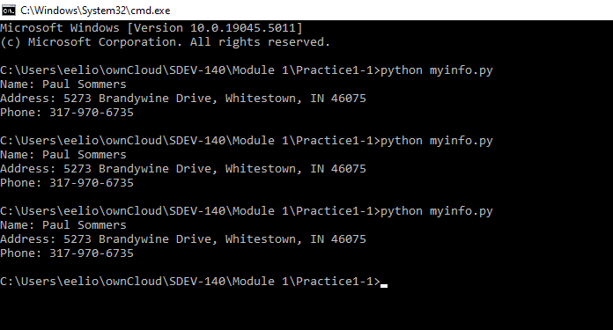

4. GitHub Url  
  
<https://github.com/PaulSommers/SDEV140-Practice1-1>