Assignment Description  
  
1. Readme

This program calculates the surface area of a cube based on the length of an edge. The program prompts the user for the length of the cube's edge (Int), calculates the surface area, and then it displays the result.

2. Source Code of All Files

"""

Author: Paul Sommers

Date written: 10/25/2024

Assignment: Practice Exercise 2-2

Short Desc: This program calculates the surface area of a cube based on the length of an edge.

The program prompts the user for the length of the cube's edge (Int),

calculates the surface area, and then it displays the result.

"""

# Step 1: Prompt the user for the length of the cube's edge

intCubeEdge = int(input("Enter the length of the cube's edge (integer): "))

# Step 2: Calculate the surface area of the cube

# Formula for surface area of a cube: 6 * (edge_length^2) or add the area of its 6 face squares

surface_area = 6 * (intCubeEdge ** 2)

# Step 3: Print the surface area

print(f"The surface area of the cube is: {surface_area} square units")

3. Three Use Case Screen Shots

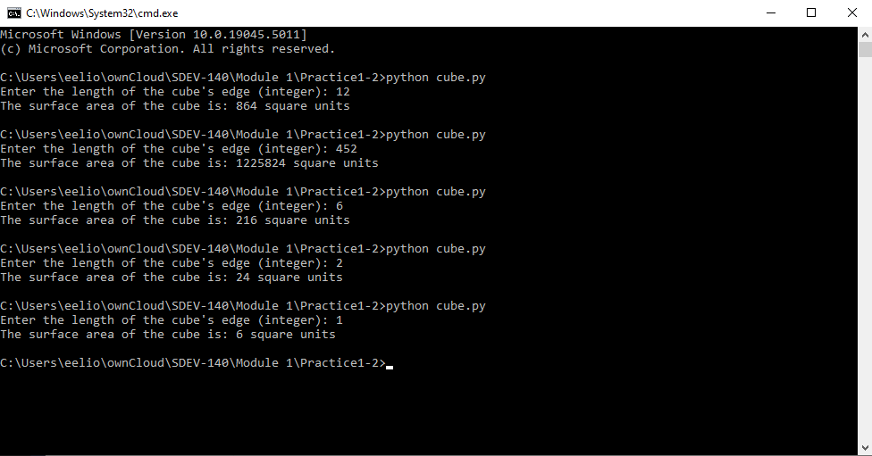

4. GitHub Url