Assignment Description  
  
1. Readme

This program calculates a payment schedule for a loan based on a purchase price. The user inputs the purchase price, and the program calculates the monthly payments, interest, principal, and remaining balance for each month until the loan is paid off. It assumes a 10% down payment and a 12% annual interest rate. The monthly payment is 5% of the purchase price minus the down payment.  
  
  
2. Source Code of All Files

"""

Author: Paul Sommers

Date written: 10/28/2024

Assignment: Exercise 3-10

Short Desc: This program takes an input price from a user and calculates a payment schedule for a loan based on the price.

"""

# Constants

ANNUAL_RATE = 0.12

MONTHLY_RATE = ANNUAL_RATE / 12

DOWNPAYMENT_RATE = 0.10

TABLEFORMATSTRING = "{:2d}{:15.2f}{:15.2f}{:17.2f}{:17.2f}{:17.2f}"

# Have the user input a price

price = float(input("Enter the purchase price: "))

# Initialize variables

monthlyPayment = 0.05 * price

month = 1

balance = price - (price * DOWNPAYMENT_RATE)

# Output table heading

print("\nMonth Starting Balance Interest to Pay Principal to Pay Payment Ending Balance")

# Loop to calculate and display payments

while balance > 0:

# If the monthly payment is greater than the balance, adjust the final payment

if monthlyPayment > balance:

monthlyPayment = balance

interest = 0

else:

interest = balance * MONTHLY_RATE

# Calculate principal and remaining balance

principal = monthlyPayment - interest

remaining = balance - monthlyPayment

# Display the current month's payment details

print(TABLEFORMATSTRING.format(month, balance, interest, principal, monthlyPayment, remaining))

# Update balance and increment month

balance = remaining

month += 1

3. Three Use Case Screen Shots

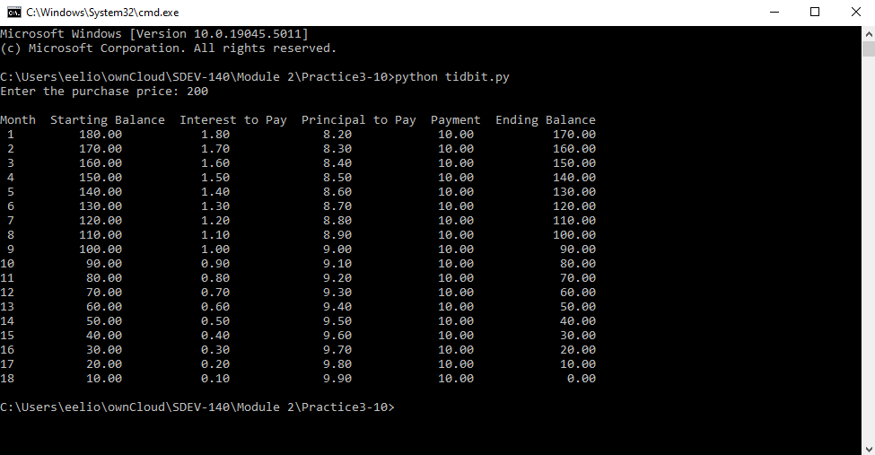

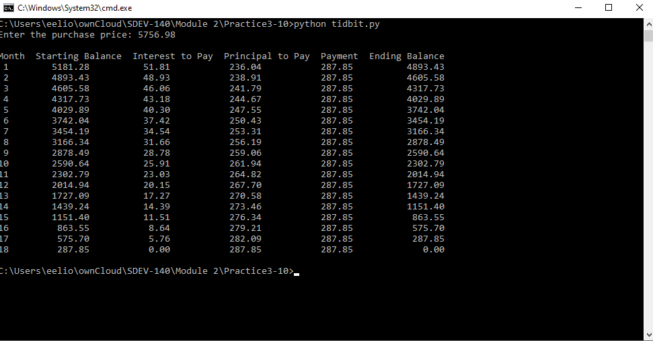

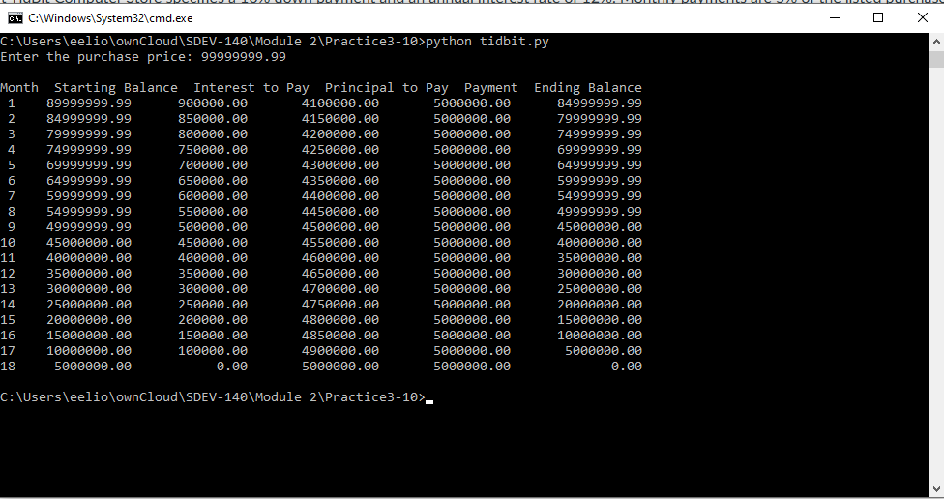

4. GitHub Url  
  
<https://github.com/PaulSommers/SDEV140-Practice3-10>