Assignment Description  
1. Readme

This program prompts the user to enter a series of numbers. Pressing the Enter key without input stops the input process. After the user finishes entering numbers, the program calculates and outputs the sum and average of the numbers entered. If no numbers are entered, the program outputs that no numbers were entered.  
  
  
2. Source Code of All Files

"""

Author: Paul Sommers

Date written: 10/28/2024

Assignment: Exercise 3-9

Short Desc: This program receives numbers from the user as input and calculates the sum and average.

"""

# Initialize variables

theSum = 0.0

count = 0

# Begin our Loop

while True:

# Prompt user for input

userInput = input("Enter a number or press Enter to quit: ")

# Check if the input is blank

if userInput == "":

break

# Convert to a float and add to the sum

number = float(userInput)

theSum += number

count += 1

# Display the sum

print(f"\nThe sum is {theSum}")

# Display the average if at least one number was submitted

if count > 0:

average = theSum / count

print(f"The average is {average}")

else:

print("No numbers were entered.")

3. Three Use Case Screen Shots

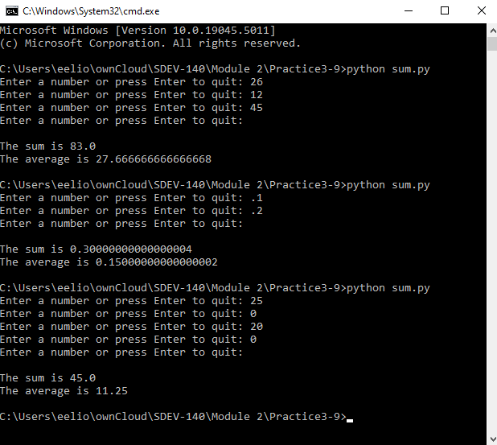

4. GitHub Url  
  
<https://github.com/PaulSommers/SDEV140-Practice3-9>