Assignment Description  
1. Readme

This program reads a text file that is submitted by the user, extracts unique words from the text, and prints the unique words in alphabetical order.   
  
  
2. Source Code of All Files

"""

Author: Paul Sommers

Date written: 11/11/2024

Assignment: Exercise 5-7 - Unique Words

Short Desc: This program reads a text file, extracts unique words, and prints them in alphabetical order.

"""

# Get the file name from the user

file = input("Enter the input file name: ")

# Initialize an empty list to store unique words

uniqueWords = []

# Open the file

with open(file, 'r') as f:

# Loop through each line

for text in f:

# Split the line into words

wordList = text.split()

# Loop through each word

for word in wordList:

# If the word is unique, add it to the list

if word not in uniqueWords:

uniqueWords.append(word)

# Sort the unique words in alphabetical order (capitalized words come first)

uniqueWords.sort()

# Output: Print each unique word

for word in uniqueWords:

print(word)

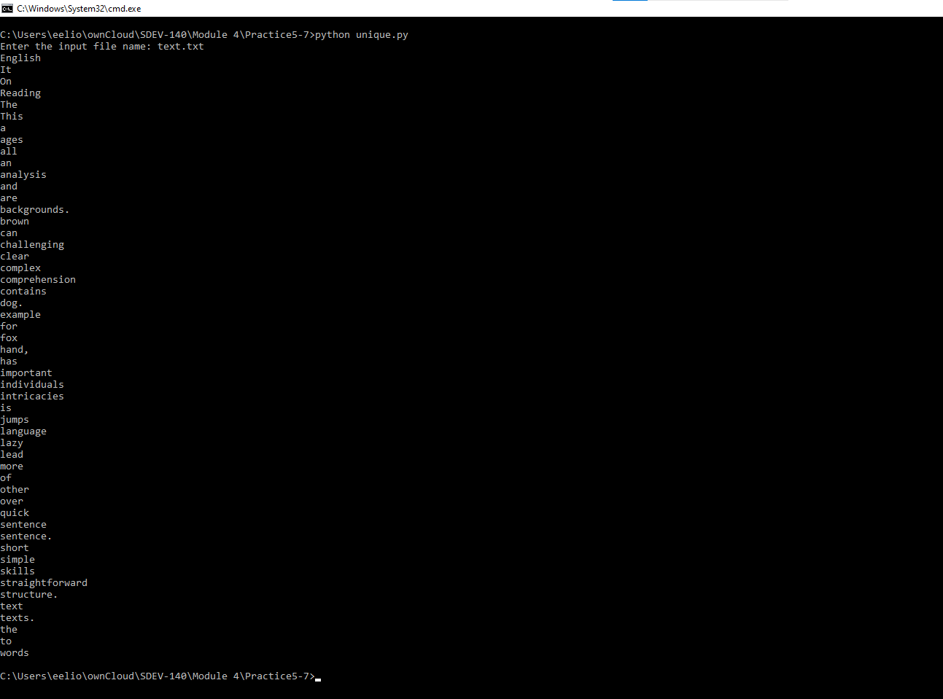  
3. Three Use Case Screen Shots

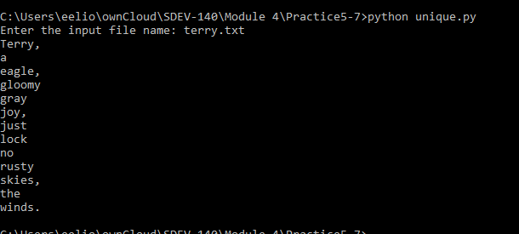

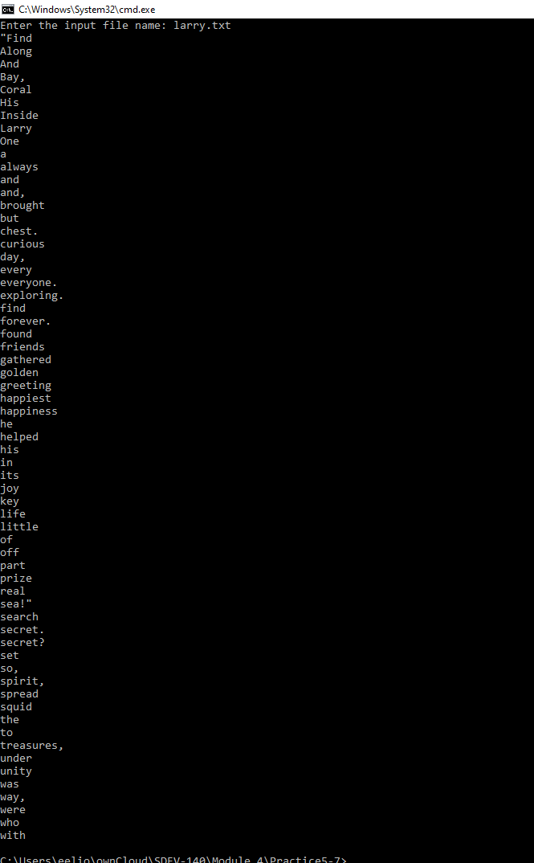

4. GitHub Url  
  
<https://github.com/PaulSommers/SDEV140-Practice5-7>