Assignment Description  
1. Readme

This program reads a text file that is input by the user, counts the frequency of each unique word that occurs within that text file, and prints the words and their frequencies in alphabetical order.  
  
  
2. Source Code of All Files

"""

Author: Paul Sommers

Date written: 11/11/2024

Assignment: Exercise 5-8 - Concordance

Short Desc: This program reads a text file, counts the frequency of each unique word, and prints the words and their frequencies in alphabetical order.

"""

# Get the file name

file = input("Enter the input file name: ")

# Initialize an empty dictionary for unique words and frequencies

uniqueWords = {}

# Open the file for reading

with open(file, 'r') as f:

# Loop through each line in the file

for text in f:

# Split the line into words

wordList = text.split()

# Loop through each word in the line

for word in wordList:

# If the word is already in the dictionary, increment its frequency

if word in uniqueWords:

uniqueWords[word] += 1

else:

# If the word is not in the dictionary, add it

uniqueWords[word] = 1

# Sort the words alphabetically

sortedWords = sorted(uniqueWords)

# Print each unique word and its frequency

for word in sortedWords:

print(f"{word} {uniqueWords[word]}")

3. Three Use Case Screen Shots

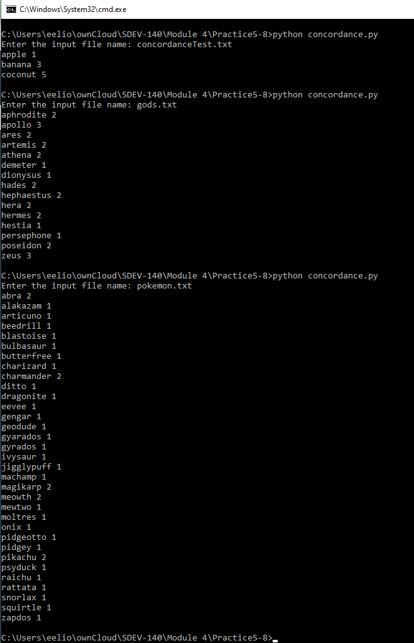

4. GitHub Url  
  
<https://github.com/PaulSommers/SDEV140-Practice5-8>