Assignment Description  
1. Readme

This program defines `myRange`, a function that emulates Python's built-in `range` function, but returns a list. It supports the same parameters as `range` (start, stop, step) and handles default values.

2. Source Code of All Files

"""

Author: Paul Sommers

Date written: 11/20/2024

Assignment: Exercise 6-6 Define and Test myRange Function

Short Desc: This program defines `myRange`, a function that emulates Python's built-in `range` function, but returns a list. It supports the same parameters as `range` (start, stop, step) and handles default values.

"""

# Define myRange function

def myRange(start=None, stop=None, step=None):

# Handle case where only stop value is provided

if stop is None and step is None:

stop = start

start = 0

step = 1

# Case where start and stop are provided, but step isn't

elif step is None:

step = 1

# Initialize an empty list to store the range

result = []

# If step is positive, count up

if step > 0:

while start < stop:

result.append(start)

start += step

# If step is negative, count down

elif step < 0:

while start > stop:

result.append(start)

start += step

return result

# Test cases

print(myRange(15))

print(myRange(2, 30))

print(myRange(1, 10, 2))

print(myRange(10, 2, -1)

3. Three Use Case Screen Shots

Note: all 3 test cases are included in one iteration of the program.

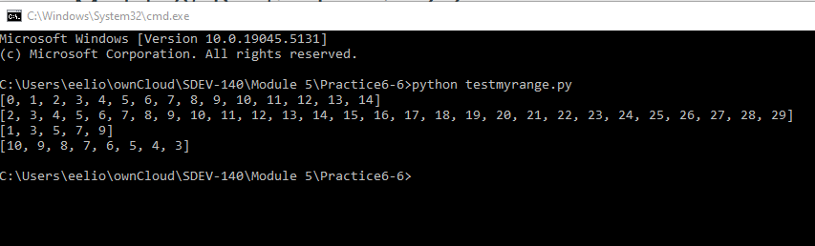

4. GitHub Url  
  
<https://github.com/PaulSommers/SDEV140-Practice6-6>