Assignment Description  
1. Readme

This program creates a GUI-based game where the computer guesses a number between 1 and 100, and the user provides hints (Too small, Too large, Correct). The game resets when the user clicks "New game".

2. Source Code of All Files

"""

Author: Paul Sommers

Date written: 11/27/2024

Assignment: Exercise 9-5 - GUI-Based Guess-the-Number Game

Short Desc: This program creates a GUI-based game where the computer guesses a number between 1 and 100, and the user provides hints (Too small, Too large, Correct).

The game resets when the user clicks "New game".

"""

from breezypythongui import EasyFrame

import random

class GuessingGame(EasyFrame):

"""A GUI-based guessing game where the computer guesses the user's number."""

def __init__(self):

"""Initialize the frame and instance variables."""

EasyFrame.__init__(self, title="Guessing Game")

# Create game variables

self.low = 1

self.high = 100

self.guess = random.randint(self.low, self.high)

# Create and add GUI parts

self.label = self.addLabel(text=f"Is the number {self.guess}?",

row=0, column=0, columnspan=4)

# Add buttons

self.tooSmallBtn = self.addButton(text="Too small", row=1, column=0,

command=self.too_small)

self.tooLargeBtn = self.addButton(text="Too large", row=1, column=1,

command=self.too_large)

self.correctBtn = self.addButton(text="Correct", row=1, column=2,

command=self.correct)

self.newGameBtn = self.addButton(text="New game", row=1, column=3,

command=self.new_game)

def too_small(self):

"""Handle Too small button click."""

self.low = self.guess + 1

if self.low <= self.high:

self.guess = random.randint(self.low, self.high)

self.label["text"] = f"Is the number {self.guess}?"

else:

self.label["text"] = "You must have made a mistake!"

self.disable_game_buttons()

def too_large(self):

"""Handle Too large button click."""

self.high = self.guess - 1

if self.low <= self.high:

self.guess = random.randint(self.low, self.high)

self.label["text"] = f"Is the number {self.guess}?"

else:

self.label["text"] = "You must have made a mistake!"

self.disable_game_buttons()

def correct(self):

"""Handle Correct button click."""

self.label["text"] = "Awesome! I'm a Winner! Thanks for playing!"

self.disable_game_buttons()

def new_game(self):

"""Reset the game."""

self.low = 1

self.high = 100

self.guess = random.randint(self.low, self.high)

self.label["text"] = f"Is the number {self.guess}?"

self.enable_game_buttons()

def disable_game_buttons(self):

"""Disable the game buttons."""

self.tooSmallBtn["state"] = "disabled"

self.tooLargeBtn["state"] = "disabled"

self.correctBtn["state"] = "disabled"

def enable_game_buttons(self):

"""Enable the game buttons."""

self.tooSmallBtn["state"] = "normal"

self.tooLargeBtn["state"] = "normal"

self.correctBtn["state"] = "normal"

# Start the game

def main():

GuessingGame().mainloop()

if __name__ == "__main__":

main()

3. Three Use Case Screen Shots

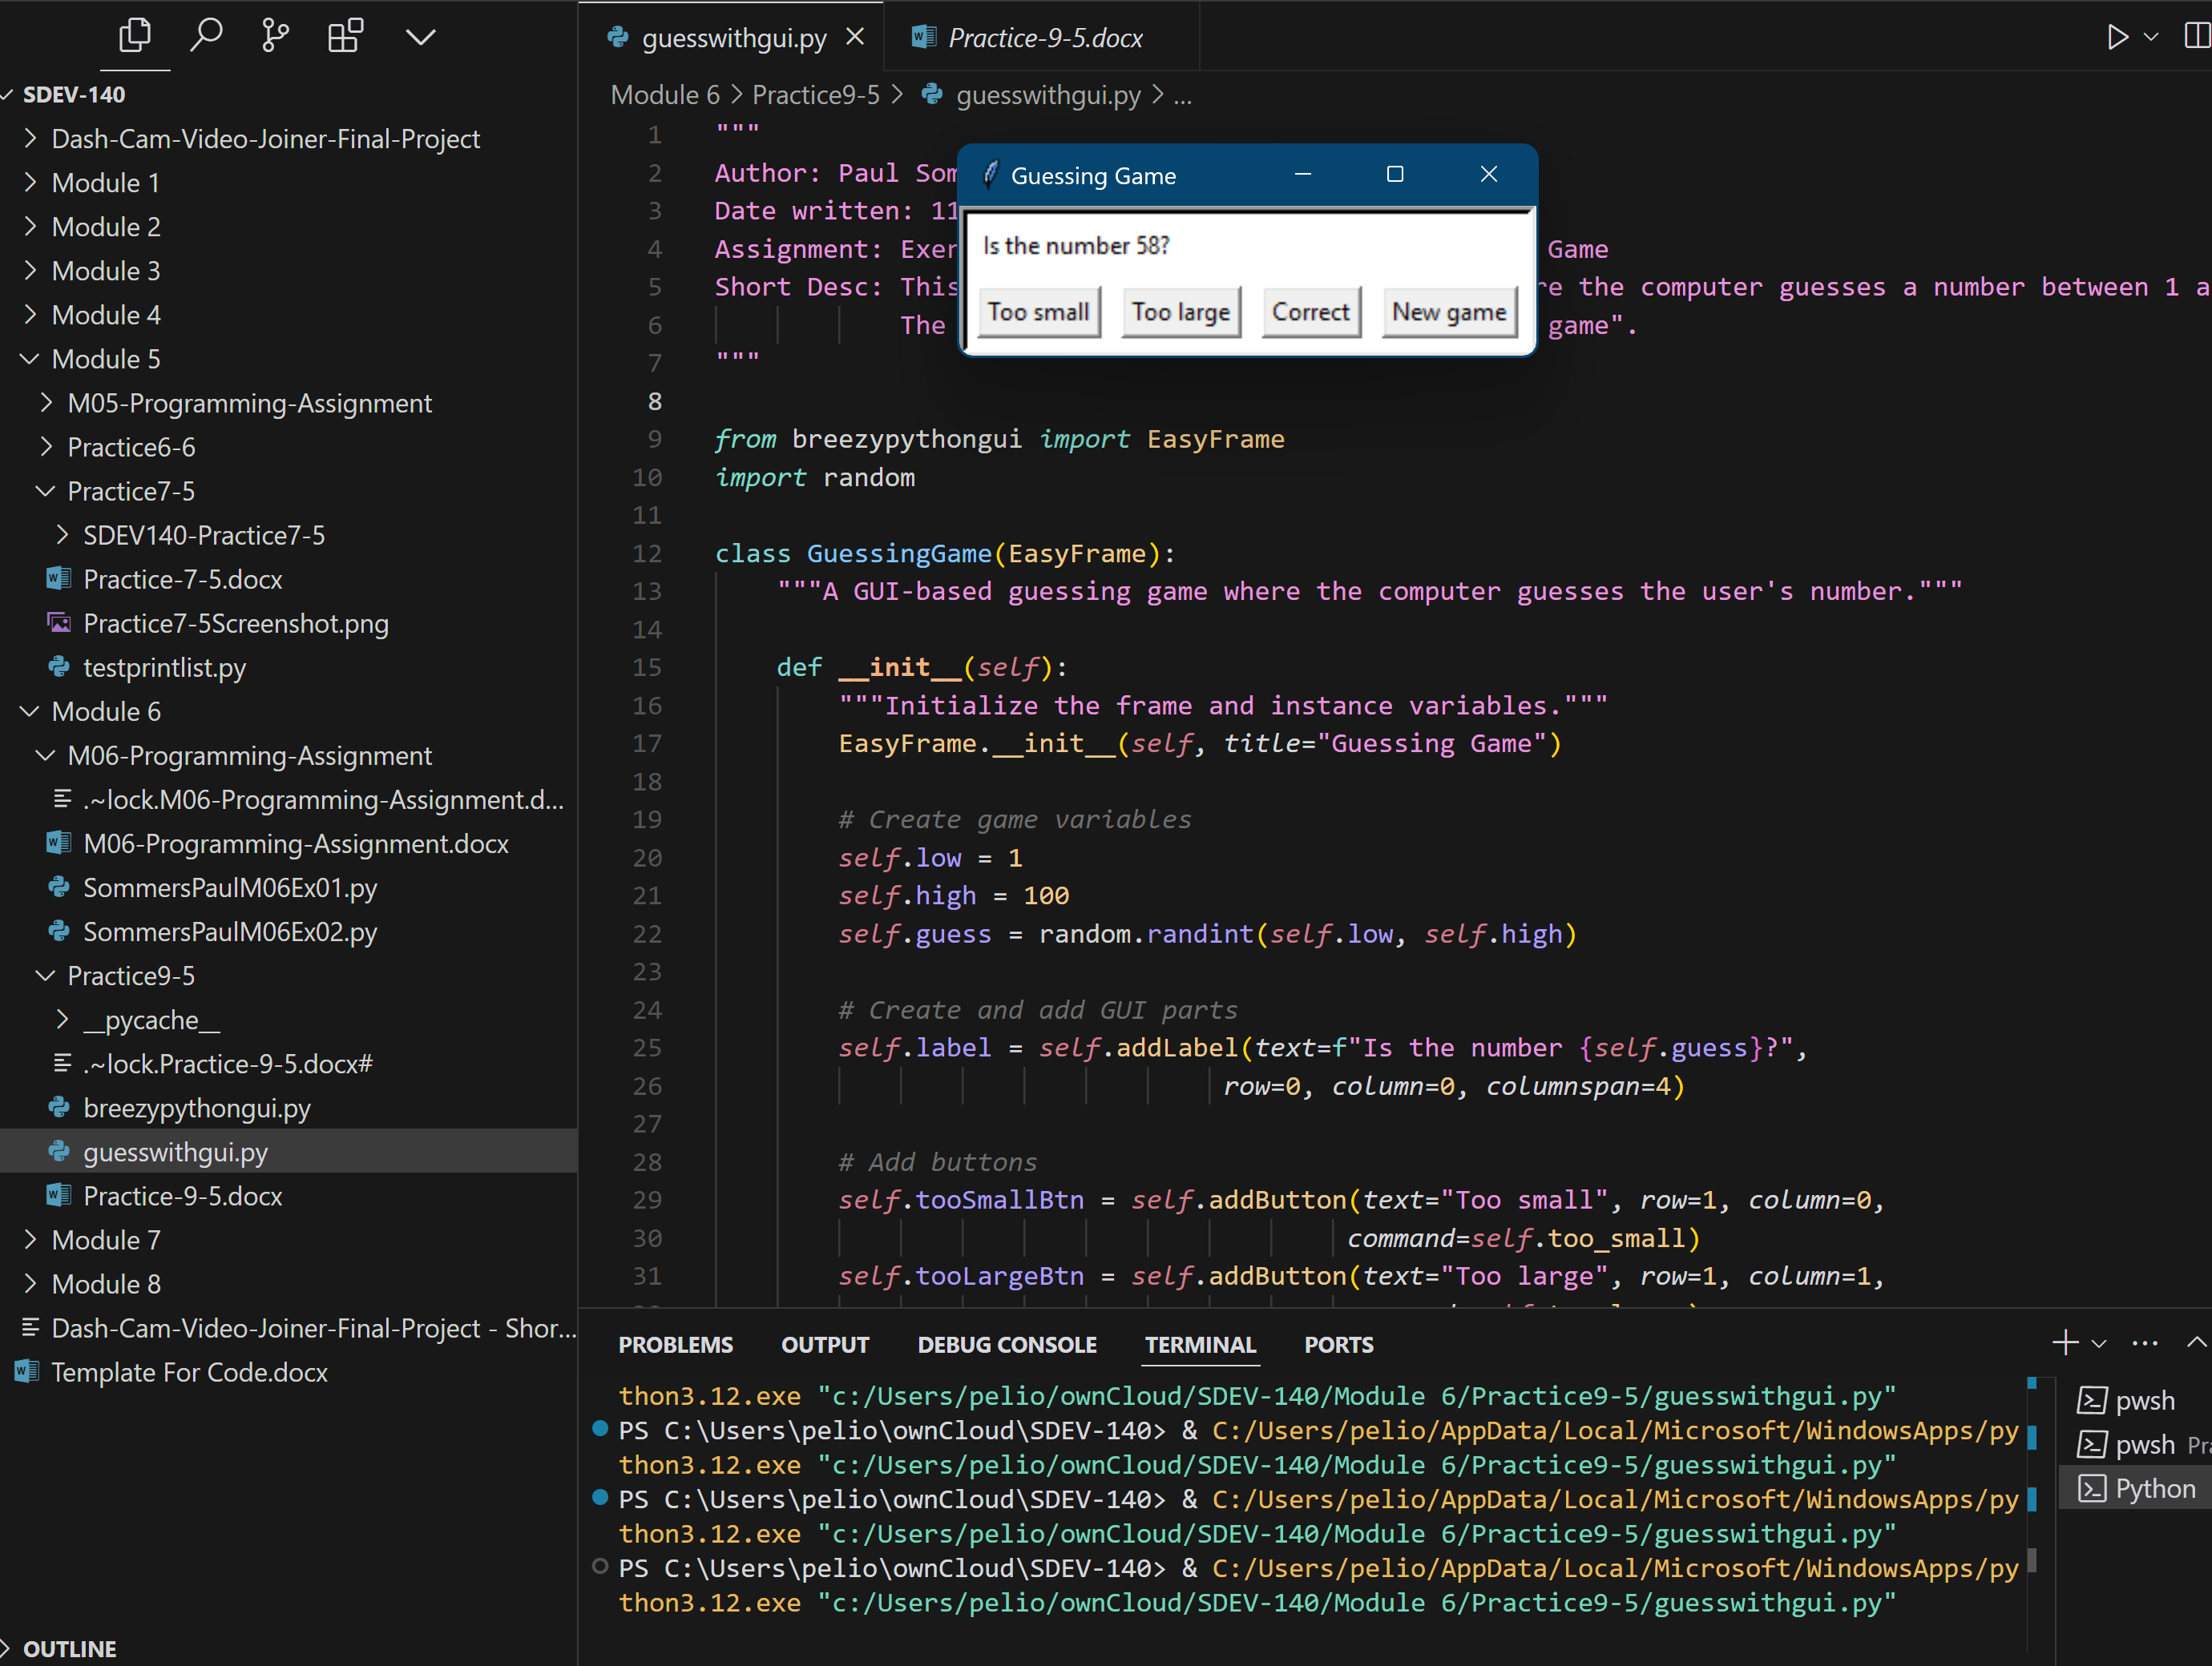

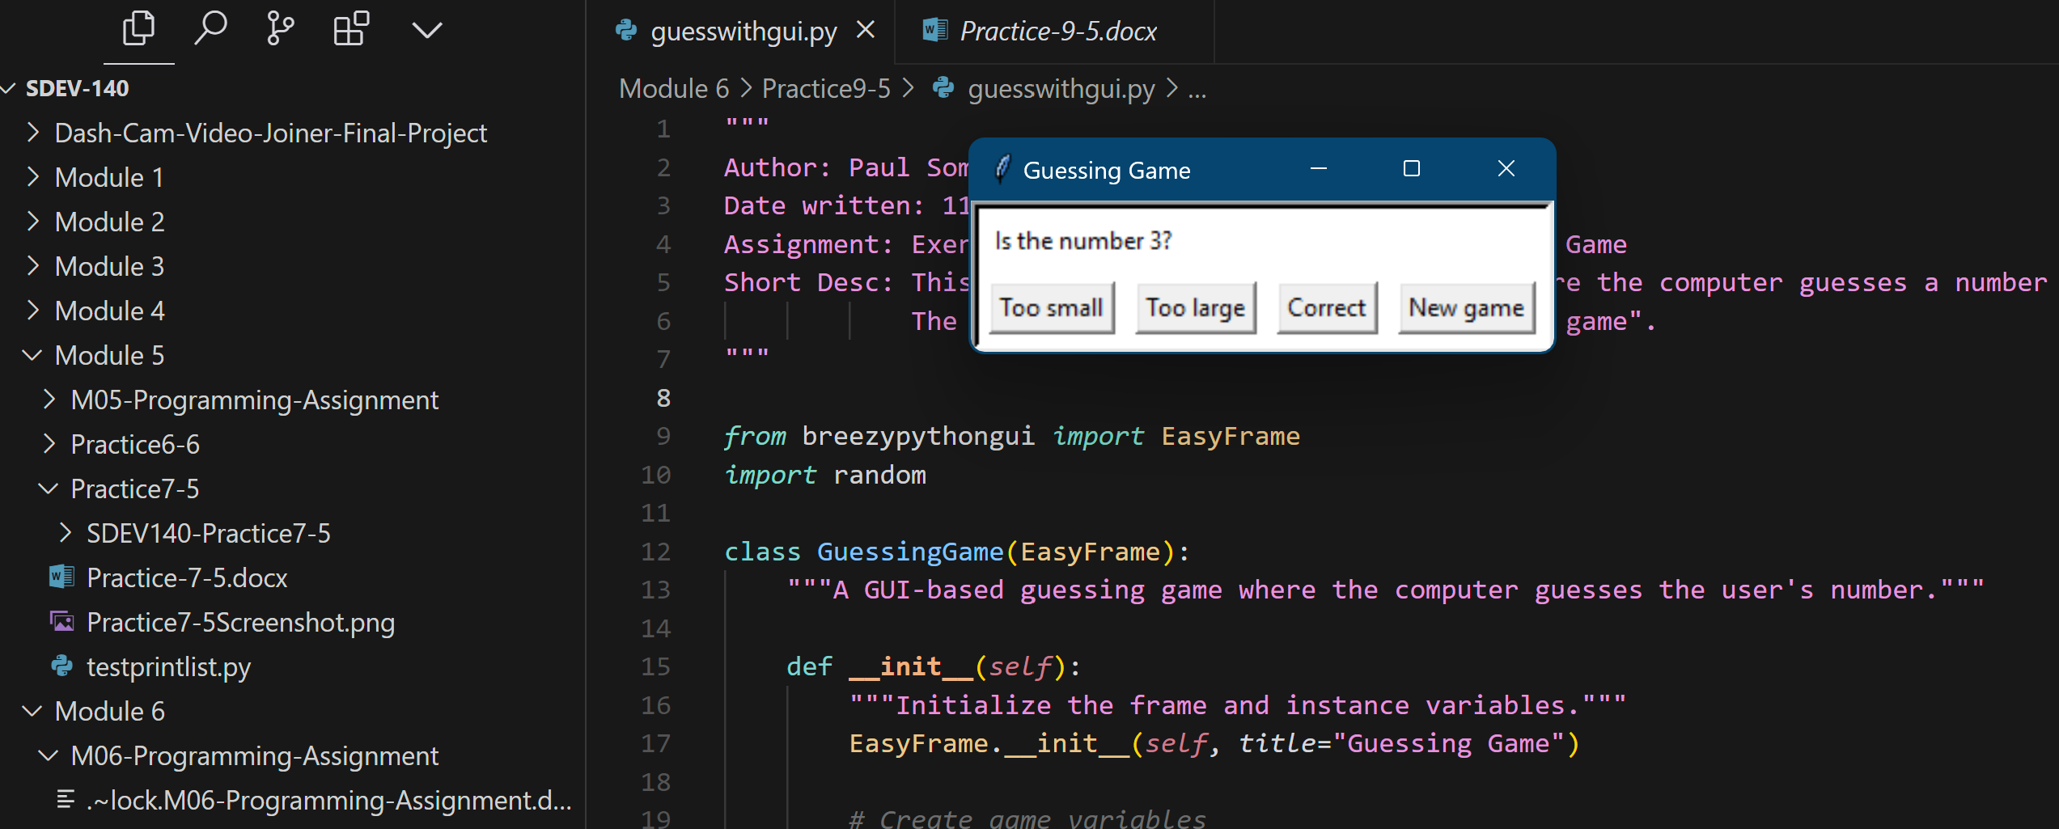

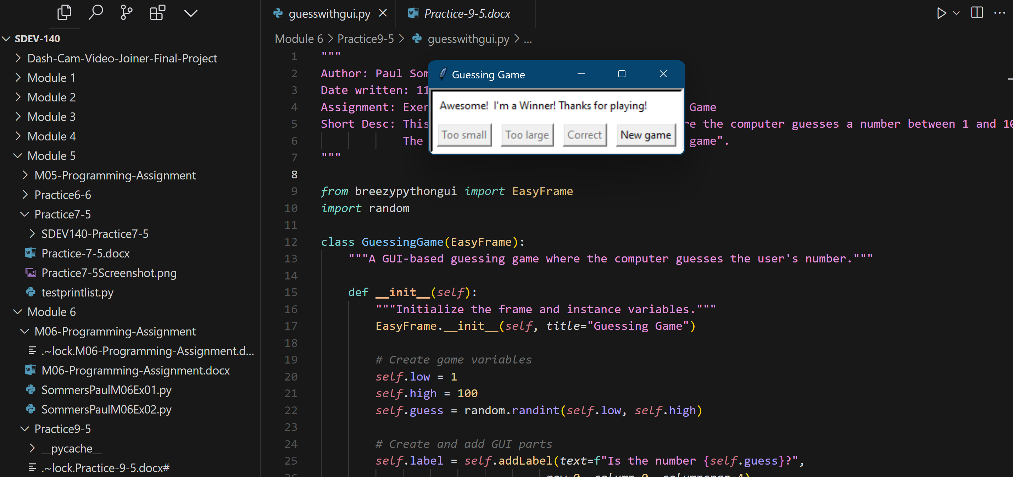

4. GitHub Url  
  
<https://github.com/PaulSommers/SDEV140-Practice9-5>