Radically Inclusive Lighting Workshop

This workshop is intended to enable you to create animated lighting sequences for the lights used by the CORE project, or any other similar DMX-512 controlled lights which are readily available from many sources. No special programming languages or other highly technical skills are needed.

This document serves a dual role. All the workshop steps are shown to help you learn how to use the lights. This document is also meant to serve as a reference manual for the lights, controller and software, in case you need information at Burning Man or another location without easy access to the internet or phone service.

1: Install Software
In this first section, you will put the software on your computer and take a quick first look at each program. Simply copy the contents of the USB stick onto your desktop.

USB Serial Driver
Just double click the "serial_install" program. Do this before plugging in the controller, so your computer will automatically recognize it when you plug the USB cable in.
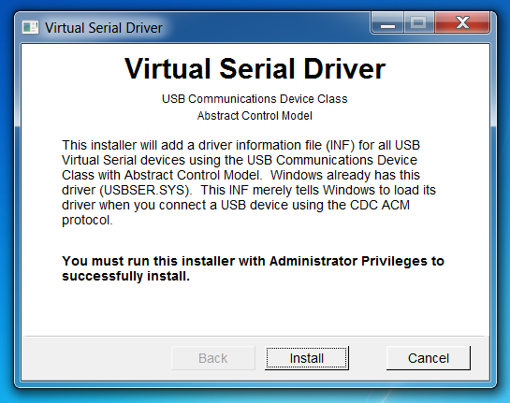
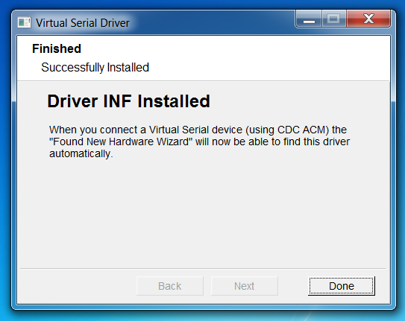

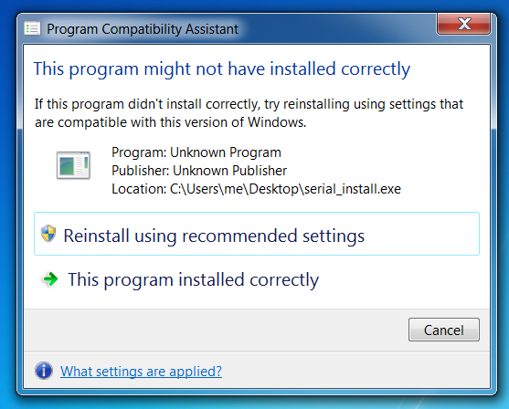
Just click the "Install" button. Depending on your computer's settings, a window may appear asking you to confirm the driver. You'll see "Driver INF Installed" when it's done.

On some computers, this "Program Compatibility Assistant" may appear, suggesting the program may not have installed. Just click "Cancel".

Vixen 2
Inside the Vixen2 folder you'll find the Vixen program. Vixen was designed for creating animated Christmas light shows, so it has a reindeer name and icon.
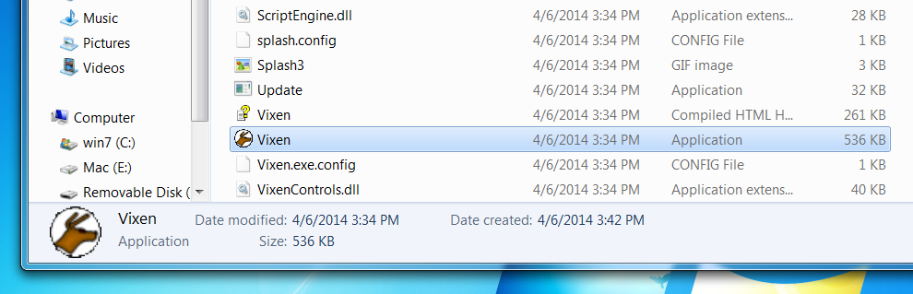
The first time you run Vixen, it will do some special setup. Just press the spacebar when it's done.
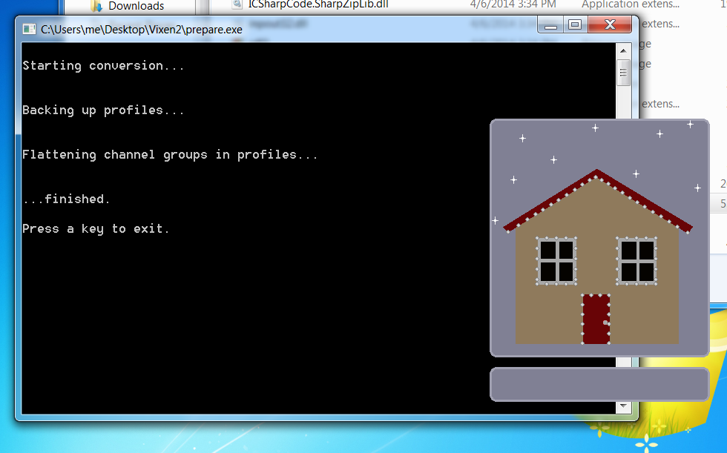

If this appears, just ignore it...
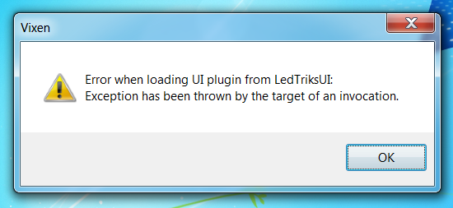

When Vixen starts, you'll have an empty window. The workshop files come with an example sequence for the CORE lights. Use the Sequence menu to open it:

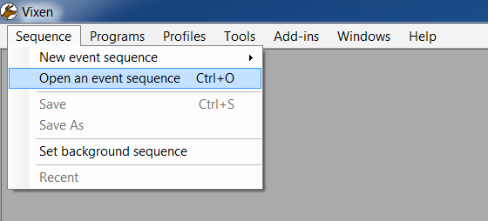

You should see a file called "workshop", already in Vixen's "Sequences" folder.
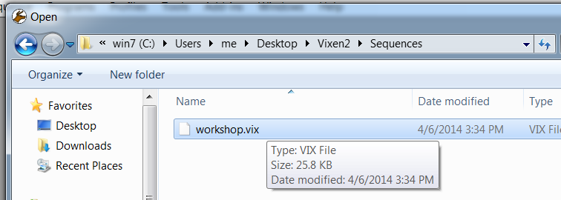

When you open this file, you should see this:
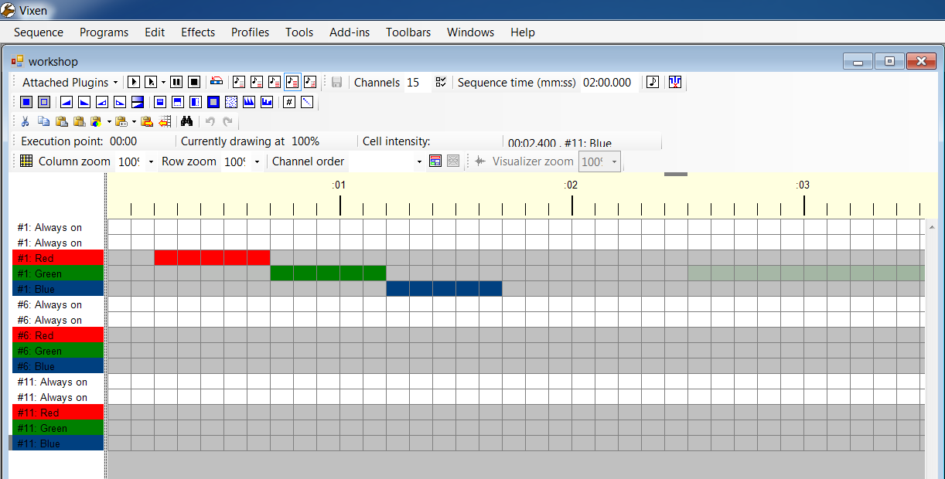
Later sections will cover how to use Vixen, after you've set up the lights...

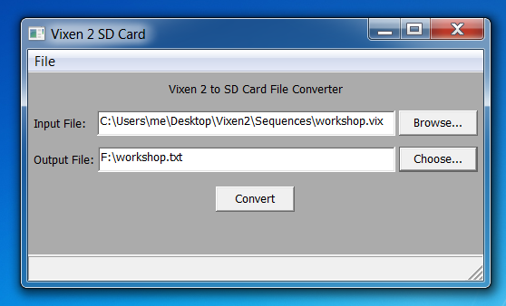
vixen2sdcard

The final program is vixen2sdcard, which you'll use to place your sequence onto a Micro SD card, so the light controller will play your sequence without a laptop connected.

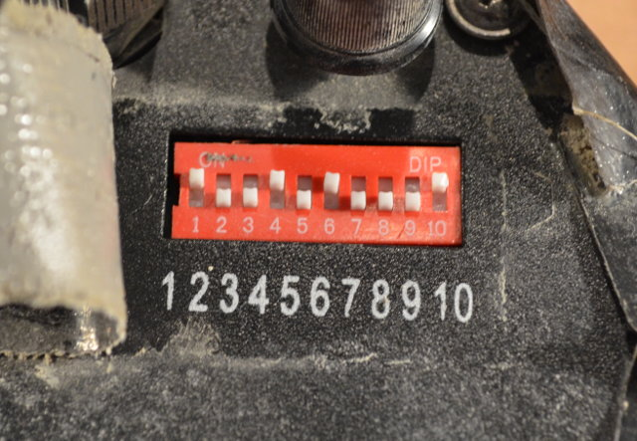
2: Light Setup

In this section, you'll physically configure the lights and connect the data cables.

DMX-512 lighting is based on "channels", where all data channels are transmitted to all the lights. Which channels each light uses are configured by tiny switches.

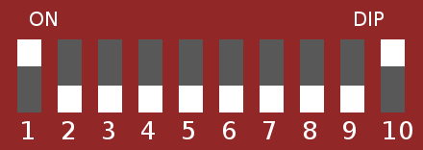  1 | 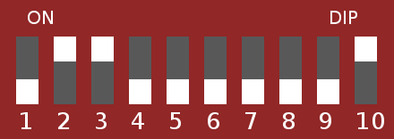  6 | 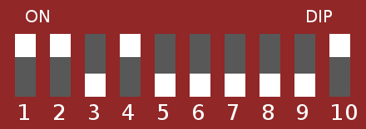  11 | 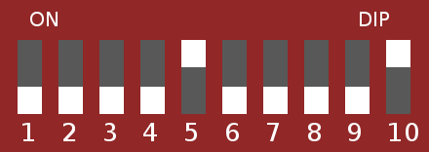  16 | 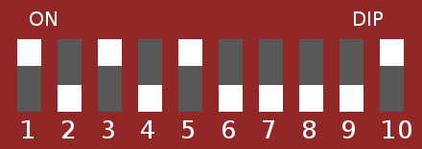  21
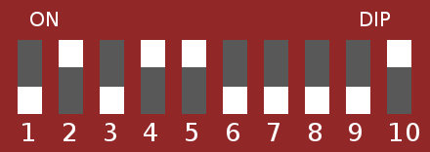  26 | 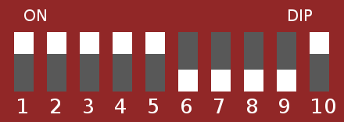  31 | 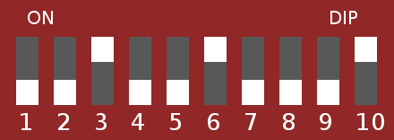  36 | 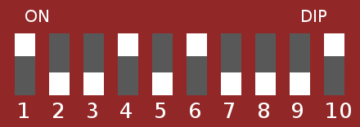  41 | 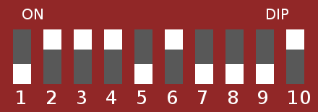  46
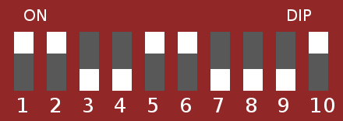  51 | 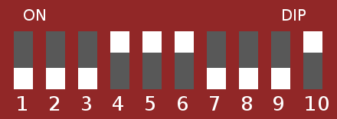  56 | 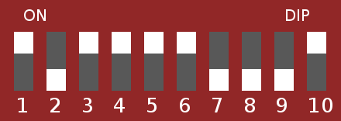  61 | 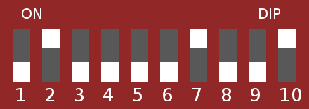  66 | 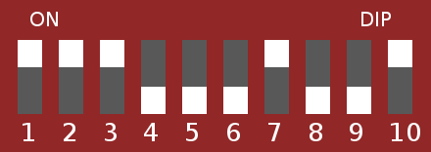  71
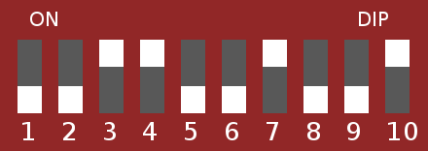  76 | 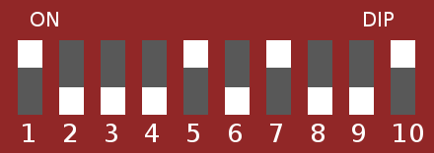  81 | 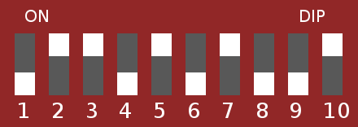  86 | 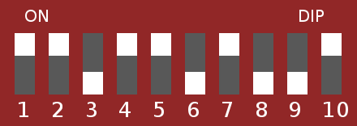  91 | 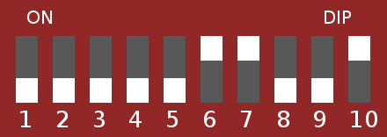  96
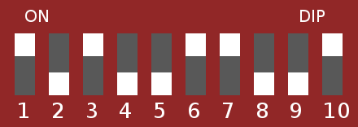  101 | 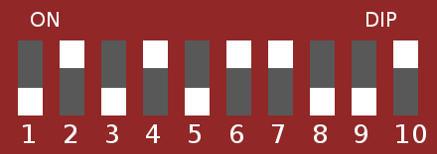  106 | 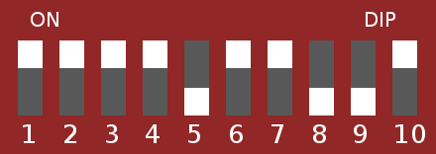  111 | 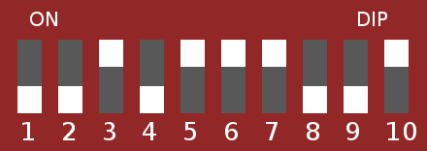  116 | 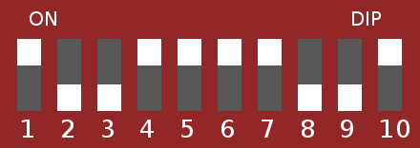  121
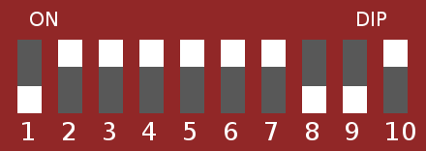  126 | 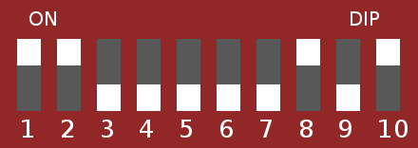  131 | 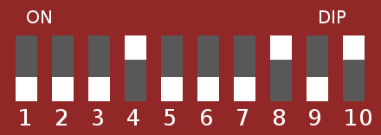  136 | 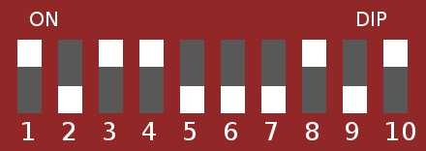  141 | 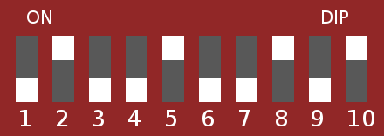  146
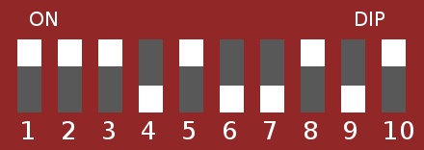  151 | 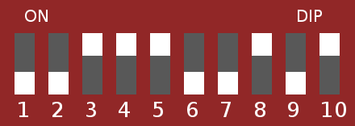  156 | 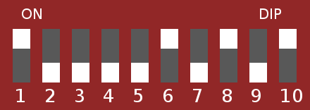  161 | 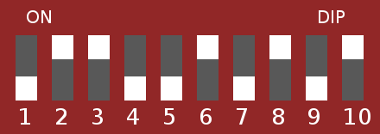  166 | 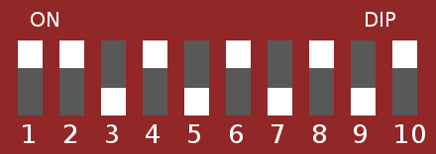  171
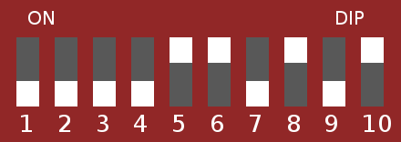  176 | 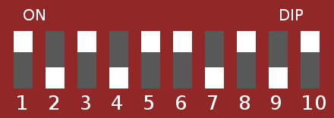  181 | 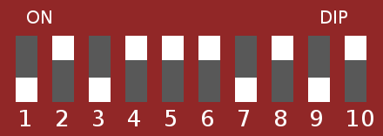  186 | 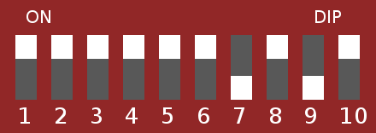  191 | 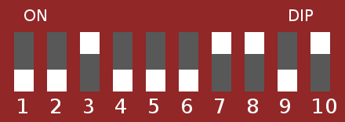  196
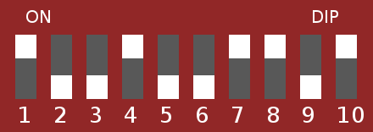  201 | 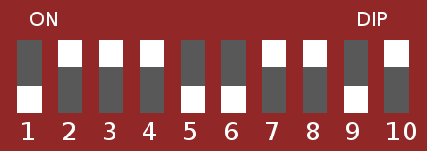  206 | 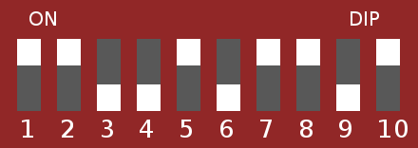  211 | 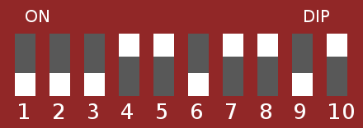  216 | 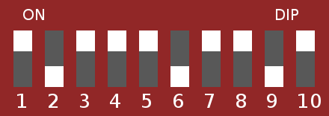  221
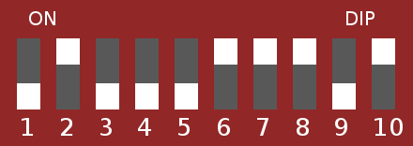  226 | 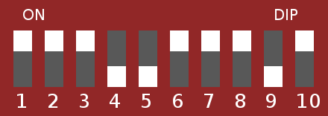  231 | 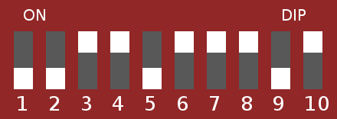  236 | 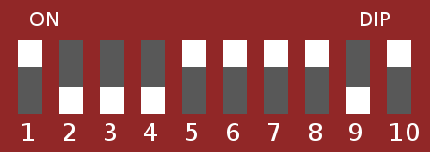  241 | 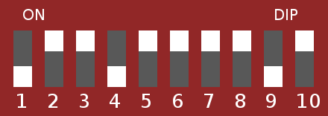  246

The CORE lights each respond to 5 channels. To control each light, its switches need to be configured for the first of the 5 channels it will use.

The table above shows all the useful switch settings. Simply setting first light to 1, the next to 6, then 11, then 16 and so on is the easiest way.

For reference (in case you need to know when on the Playa...) the switch functions are:

switch 1: on = Address +1
switch 2: on = Address +2
switch 3: on = Address +4
switch 4: on = Address +8
switch 5: on = Address +16
switch 6: on = Address +32
switch 7: on = Address +64
switch 8: on = Address +128
switch 9: on = Address +256
switch 10: on = DMX control mode, off = other stand-alone modes

Each light responds to 5 consecutive channels. For reference, the functions are:

channel+0 : always set to fully on (TODO: is this a blinking function?)
channel+1 : always set to fully on (TODO: is this a master brightness control?)
channel+2 : Red intensity
channel+3 : Green intensity
channel+4 : Blue intensity

Normally the first 2 channels are configured to be fully on, and the remaining 3 channels for each light control the intensity of each color.

After setting a light's address, it's good practice write the address on label on the light (so you can easily see which address it is) and cover the switches with tape to keep the Playa dust out.

Once the addresses are set, just plug the lights together with the data cables.

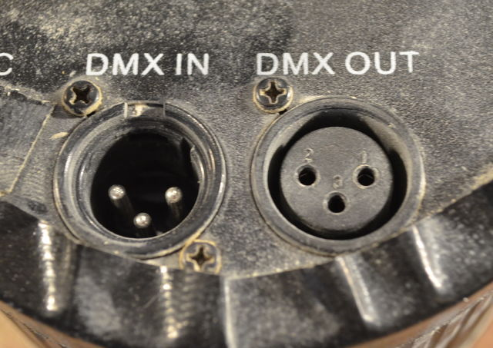
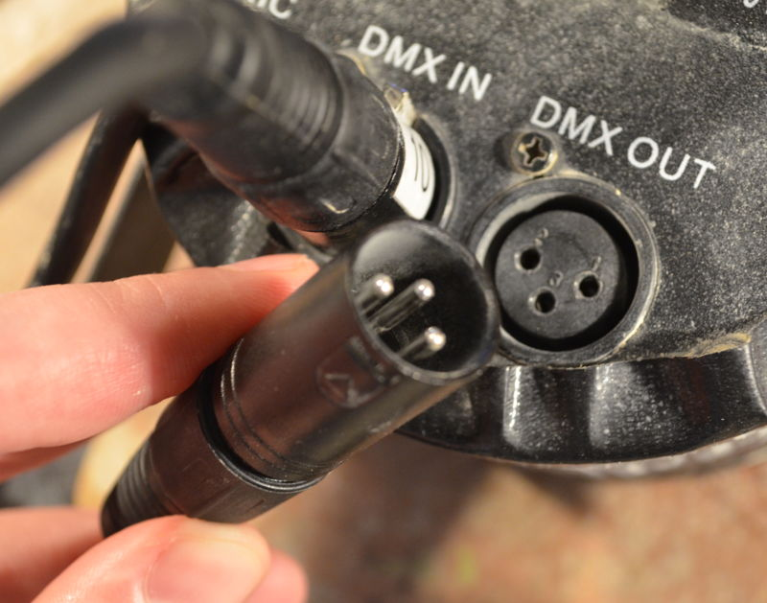

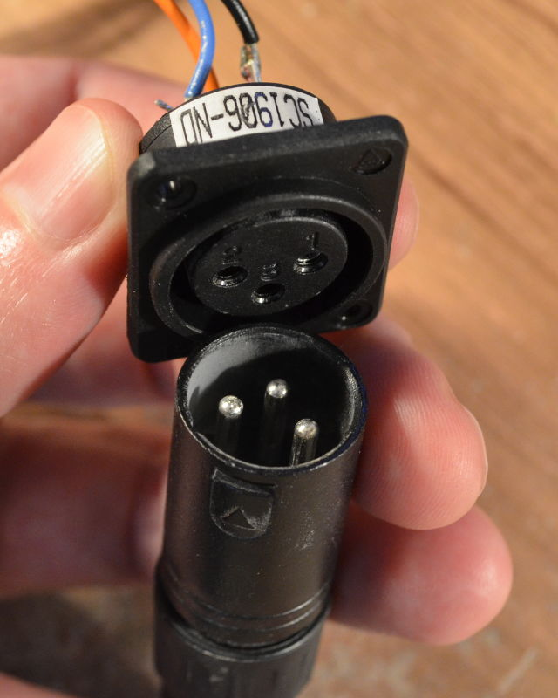
The lights can be chained together in any order. They do not need to be in order (eg, #1, then #6, then #11, etc). Any order is ok. The switches configure which light responds to which channels, not the way the cables are plugged together.

The controller has a female "OUT" connector, which needs a cable to link it to the first male "IN" of the lights.

The controller needs 12V power.

When it's all plugged in, you're ready to start controlling the lights.

Controller Troubleshooting
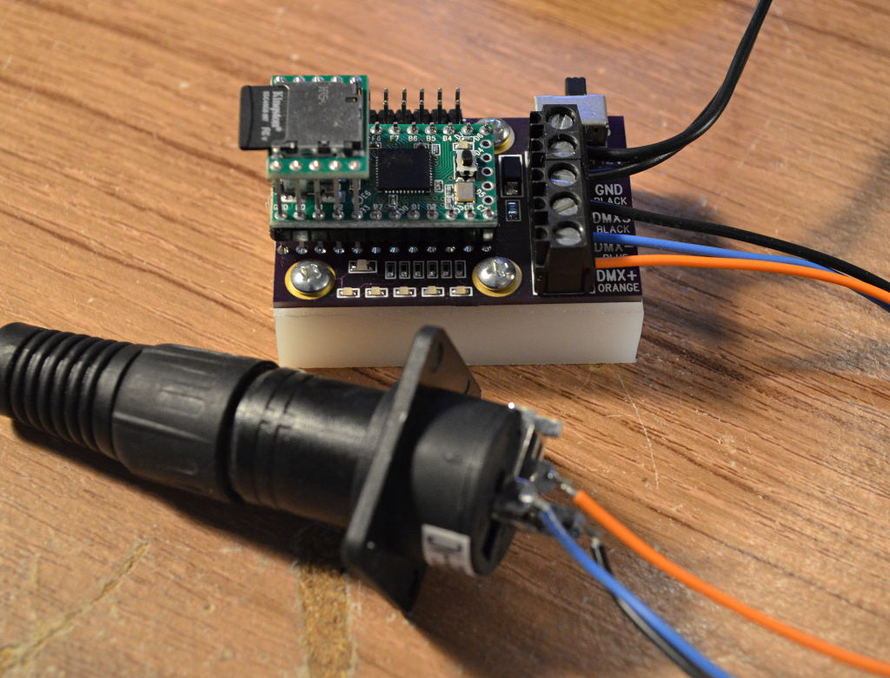
While on Playa, you may need to diagnose and troubleshoot problems.

(skip this for the workshop)

The lighting controller has a power switch and a green power LED to show you if it's powered. If you're having trouble, always glance at the green light first to make sure the controller has power.

Each controller also has 5 LEDs, orange on the newest controllers and red on the old ones, which show the status of the first 5 channels (the first light with its switches set to "1").

If the controller is powered, these 5 LEDs can give you an indication if the controller is working. The first two channels are supposed to be always on, and the remaining 3 control the red, green and blue intensity.

When troubleshooting, the LEDs can tell you if the controller is running and playing sequence data, indicating any problems are likely with the cables or lights. If the LEDs are not changing, you might conclude the controller has stopped or malfunctioned (shutting the power off momentarily might help). If all the lights are off, but the power is on, troubles may be due to a problem with the Micro SD card, or connection to your laptop if playing live from Vixen.

You can also view the text file from the SD card, if a problem is suspected with the file or SD card. See the final section for details on this file.

Using Vixen 2
In this section, you'll use Vixen2 with the already-made "workshop" sequence file that controls 3 lights. If you've quit Vixen since the first workshop segment, run it again and use the Sequences menu to open "workshop" again.

The first step is setting 10% column view, so you can see many seconds. Even then, Vixen shows you only a small part. Vixen usage involves a lot of horizontal scrolling if you want a long sequence!

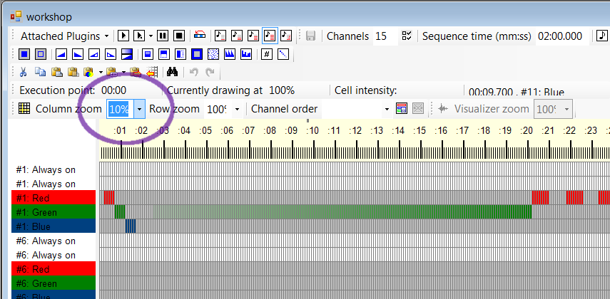
Nearly all editing in Vixen involves selecting a range of channels over time and applying Vixen's many tools. Every tool tells what does by hovering your mouse over it. Learn by experimenting...
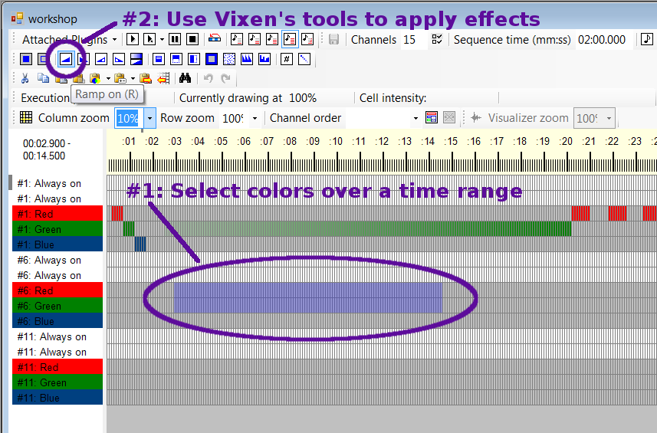

Playing Vixen Through USB
In this section, you'll connect the controller by USB to play your sequence. Usually you'll alternate between small edits in Vixen, and playing on the lights to see the results.
First, if you skipped the serial_install earlier, run it before connecting the controller. Then plug the USB cable in. Turn on power the controller. The green LED will light when the controller has power.
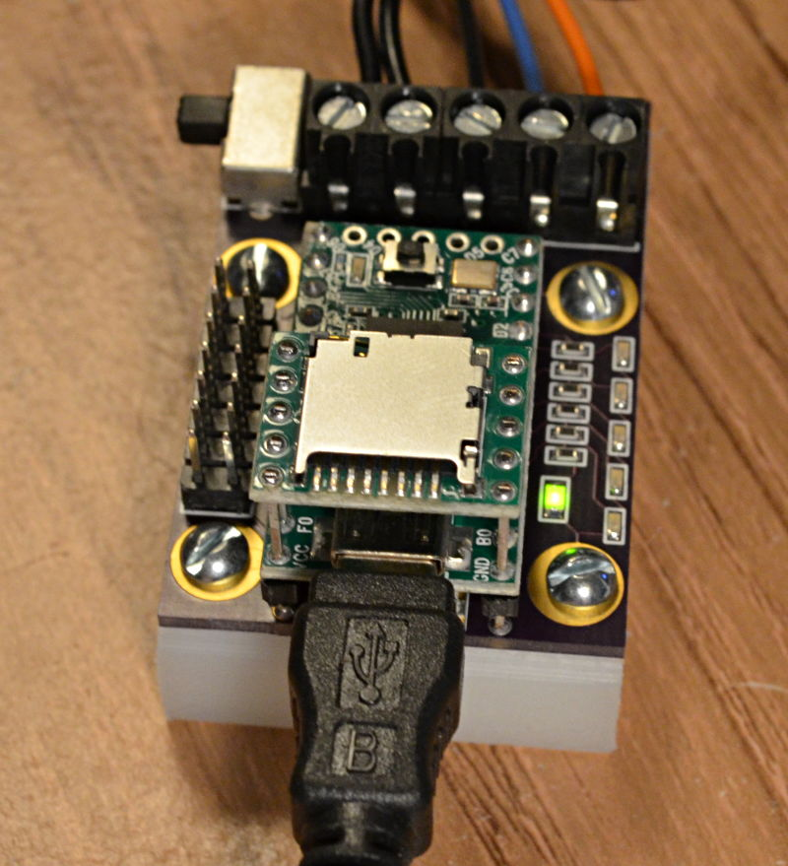
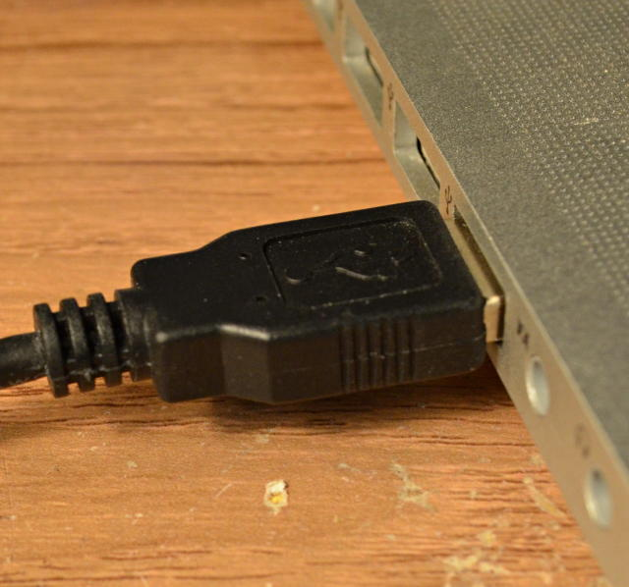

Windows will take a few moments to detect the USB device.
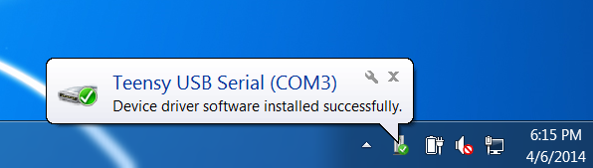

You will need to know the COM port number Windows assigns to the controller. It's different on every computer. The simplest way is to see it when Windows shows this notice.

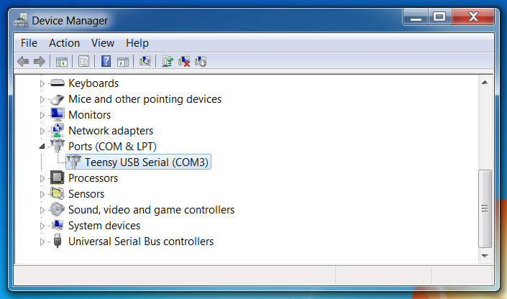
The Windows Device Manager can be used, if you didn't see the COM number. From the Start Menu, search for "Device Manager" and run it. The expand the "Ports" section.

When plugged in and turned on, the controller should appear as "Teensy USB Serial" with the COM number shown.

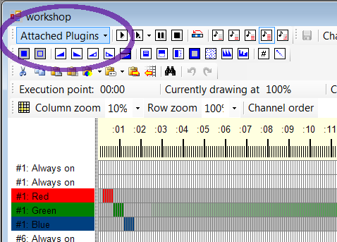
Vixen COM Setup

In Vixen, you'll need to click the "Attached Plugins" button to configure Vixen's USB output.

The plugins window will appear. The lighting controller emulates an "Entec DMX USB Pro". Select this plugin, and then click "Plugin Setup".

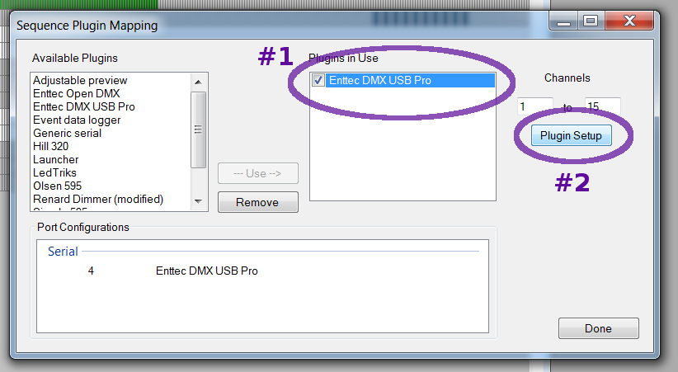

Inside the Entec DMX USB Pro setup, you must select the COM port that Windows assigned to the lighting controller. The other settings do not matter and should be left at their default values.
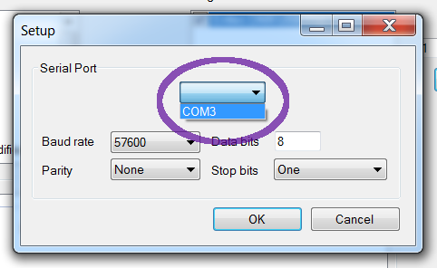

Once the correct COM port is selected, you're ready to see your sequence played on the lights!

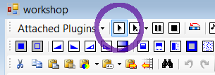
Vixen Sequence Playing
To play your sequence on the lights, just click this play button in Vixen's toolbar.

The nearby buttons allow you to pause or stop. There's also a continuous loop button, which causes the sequence to play over and over again, as it will when you transfer to the Micro SD card to play without your computer.
Do not unplug or turn the controller off while Vixen is playing.
If the controller does disconnect while Vixen is playing, you will need to completely quit Vixen. Don't forget to save your work. When completely out of Vixen, turn the controller off for 5 seconds, and then turn it back on again, and then try running Vixen again. In extreme cases, you may need to turn the controller off, restart Windows, and turn it back on after Windows reboots.

Convert the Sequence to Text and Write SD Card
In this final section, you'll convert the Vixen sequence data to a text format. The controller is able to play this text format from a Micro SD card without your computer connected.
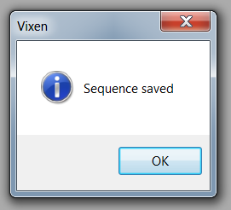
First, save the sequence. Make sure Vixen actually says it was saved. Sometimes CTRL-S in Vixen does not actually save, so use the menu or make sure the save confirmation message appears. If you don't see that message, Vixen didn't actually save your work.

Connect the Micro SD card to your computer. Windows should inform you of the drive letter assigned. You will need to know this when using vixen2sdcard.

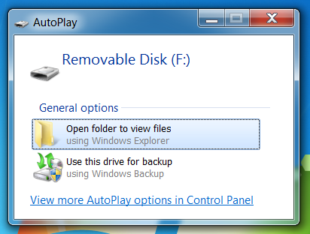
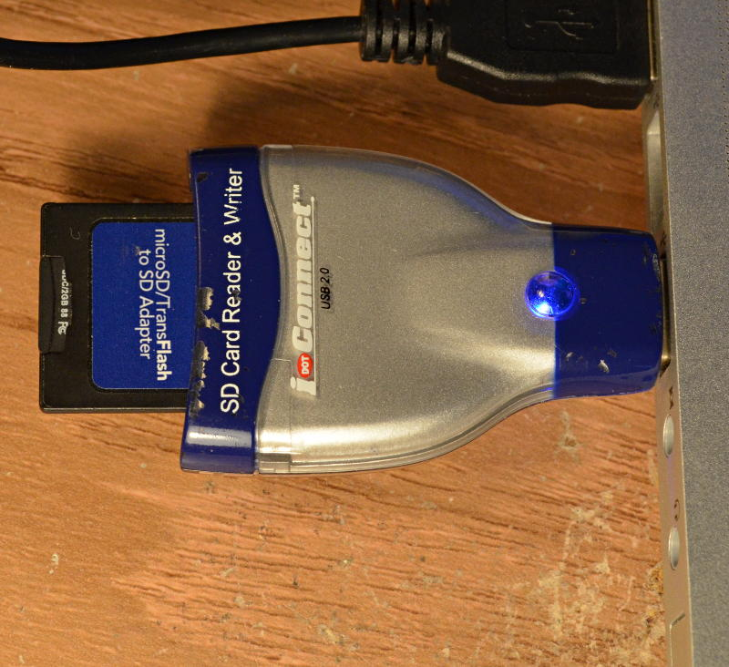

With the Vixen sequence saved and the Micro SD card connected, you're ready to run vixen2sdcard.
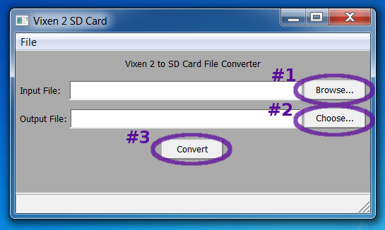

First, open the Vixen sequence file. Click "Desktop", then double click "Vixen2" and then "Sequences". Inside Sequences, you should find "workshop.vix", the sequence data you've created using Vixen.
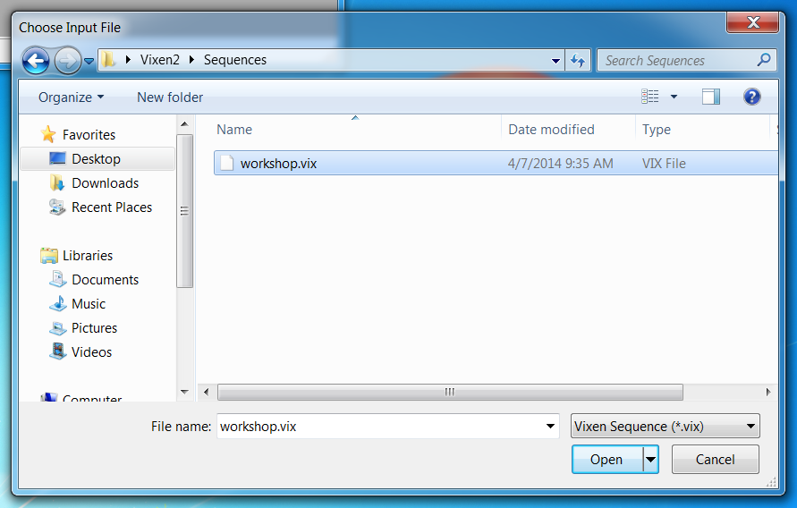

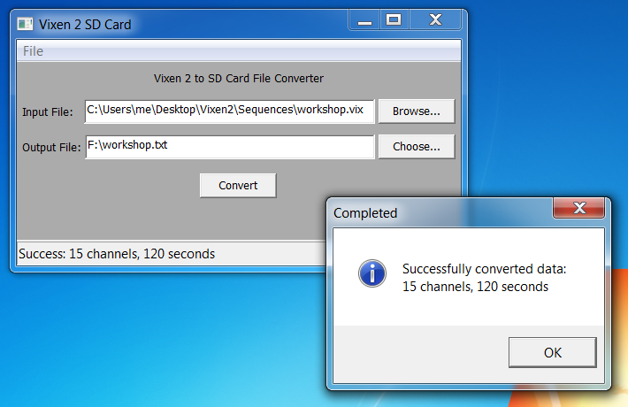
Then choose the location the drive which is the Micro SD card.

With both input and output files set, click "Convert".

The confirmation message should indicate the length and number of channels from your sequence.

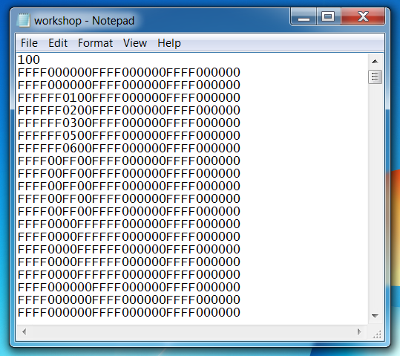
As a quick sanity check, you can look at the data vixen2sdcard wrote. Just find the file and double click it. Windows should automatically open it with Notepad, since it's a text file.
You should see something similar to this:
Each line is one time slot (column) of your sequence from Vixen. Every 2 characters are one of the channels. The "always on" channels appear as "FF", so a simple sanity check is to see the "FFFF" every 10 characters. You should see numbers in the other 6 characters which correspond to your lighting sequence.
Later, if you experience problems (on the Playa or at some other location), you can read the SD card with any PC, even if the software isn't installed, and simply double click the file to check if it contains correct-looking data.
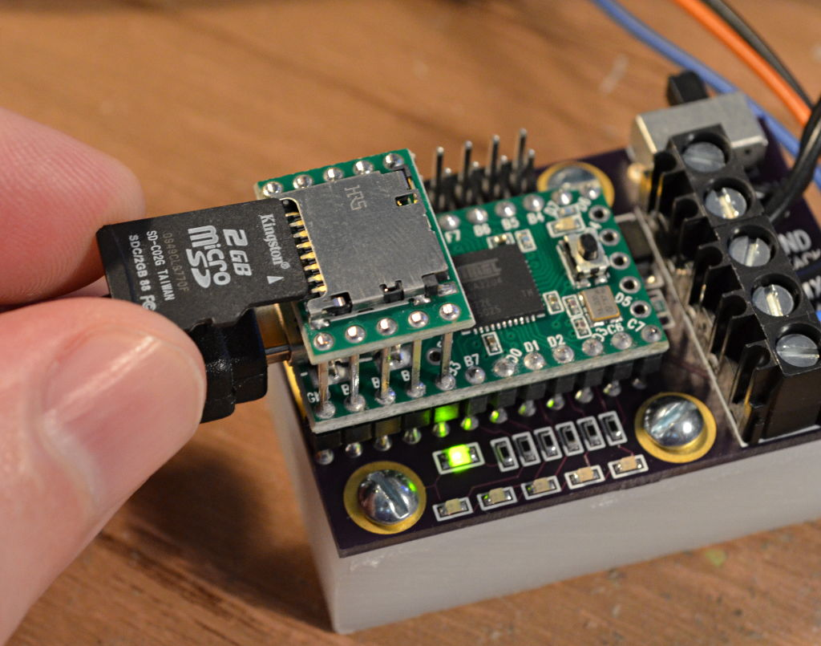

Before removing the card, use "Eject" or "Safely Remove Hardware", so Windows properly finishes any writing to the card.
Then turn the controller's power off, insert the card, and turn it on again. When the computer isn't playing, your sequence from the card will play automatically. Your computer can stay in a safe, dust-free environment while the controller plays your sequence.
You can put several sequences on the card. The controller will play them in a random order. If there's only 1 sequence, it will just play that 1 over and over.

