Spike2 – 1401 and PATEC script ReadMe

Table of Contents

BEFORE COLLECTING ANY DATA 2

ONCE YOU OPEN IT 5

BUTTONS EXPLANATION (left to right) 6

Draw trace 6

Change View 6

Rep XY /Seq Config 7

XY-Ramp 7

MVC Opts 8

Analysis Options 8

Equipment Options 9

Un/Freeze US (NOT ACTIVE AT THE MOMENT BUT IN THE CODE) 11

Start US 11

Move Isomed 11

Stop sampling 11

Save everything 11

Quit 11

# BEFORE COLLECTING ANY DATA

**Turn on the Computer first and then the 1401 device.** Wait until the light on the power button turns green and then you can open spike2 on the computer. **This prevents that any electrostatic shock discharge breaking the system when you are connecting the cables.** If the light doesn’t turn green it could be a failed of the system. In that case, please contact us!!! Connect the BNC cables according to the equipment you need! **Following, check that the BNC cables or any other cable you are using that are correctly connected!**

Be sure you have created the sampling configuration you need for your study/ purpose. To create a sampling configuration in Spike2 click on Sample 🡪 sampling configuration. Once you create it remember to save by clicking on File 🡪 Save configuration as…

Check the channels and whether the cables configuration is correct! Specifically, for the PaTec_Script you have to check the “fs_sequencer_adaptable.pls” you are using. Usually it is as follow:

* DAC 0 🡪 it’s free.
* DAC 1 🡪 is used for a transistor-transistor logical pulse (TTL) with 3V amplitude. You can use it to trigger and to sync many devices which need at least 2.5V inputs (ex: Myon EMG/IMU system, Vicon).
* DAC 2 🡪 is used to trigger the ultrasound system by sending a TTL square wave duty-cycle @100Hz (you can use to trigger optitrack too).
* DIGBIT 2 and 3: bits 2 and 3 are used to trigger the Isomed rotation (back panel).
* DAC 3 🡪 free

After you open Spike2, you will have a window like the following picture. To open the script, please go to File🡪 Open/Open File. A pop-up window will open and navigate to the folder where you put the PATEC_script. PS: YOU CAN RENAME THE SCRIPT FILE AS YOU LIKE! THE IMPORTANT PART IS THE LOCATION/PATH TO THE SEQUENCER (see following pages).

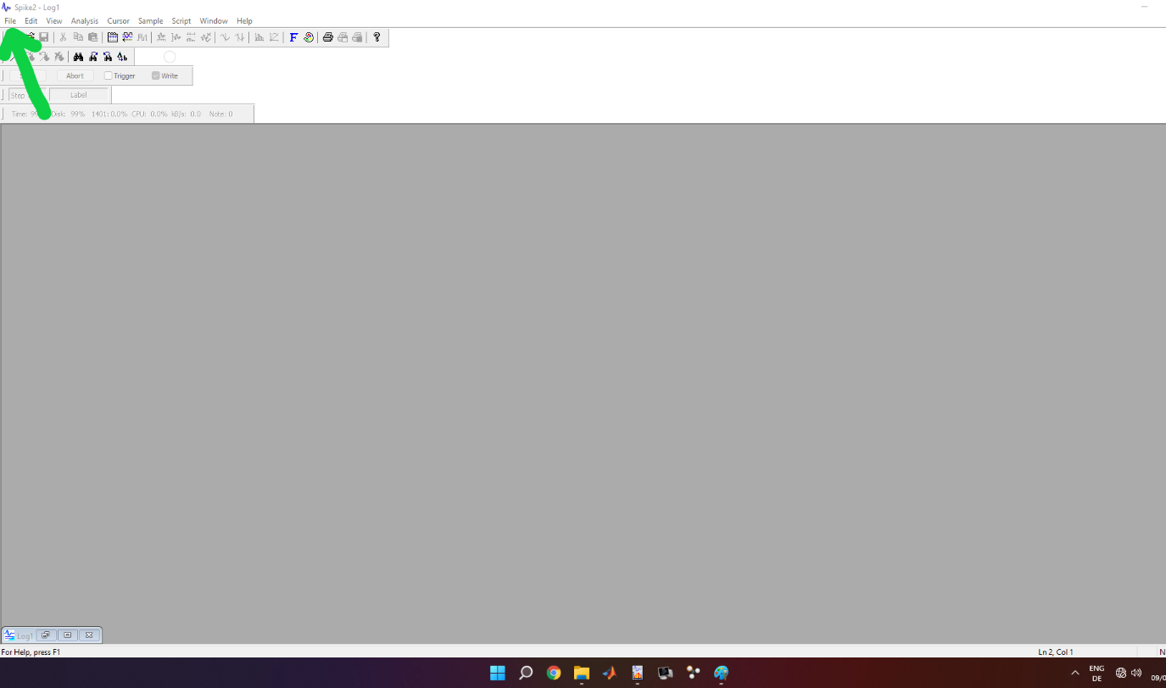

Once selected and opened, a window in spike2 with crazy nerdy code will appear. At this point, check at line 232 the path for the SampleSequencer and correct it based on the location where you put the “fs_sequencer_adaptable.pls” file.

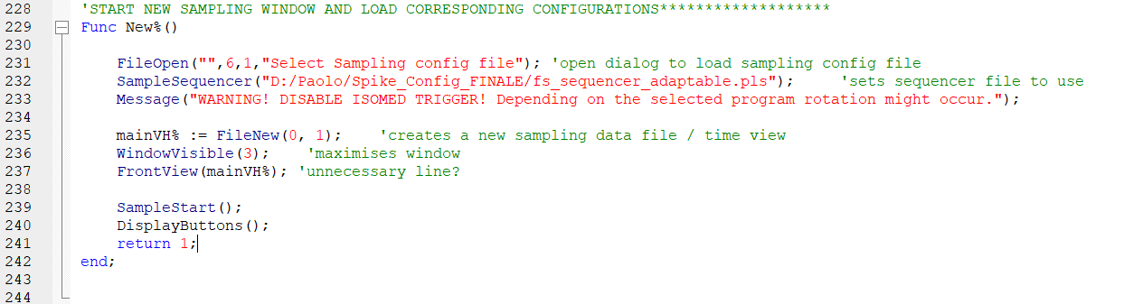

Further, if you are going to use the ultrasound system (in sync mode), remember to check at line 713 if the location of “SaveECO.exe” is correct. It is a program I created to save automatically the US tvd file via CMD with the same name of the spike2 mat files exported. Theoretically, such .exe file should be universal for everyone and always in the same location. The only difference is the path between the PC upstairs and downstairs. If someone touch or delete them, I allow you to kill them ☺

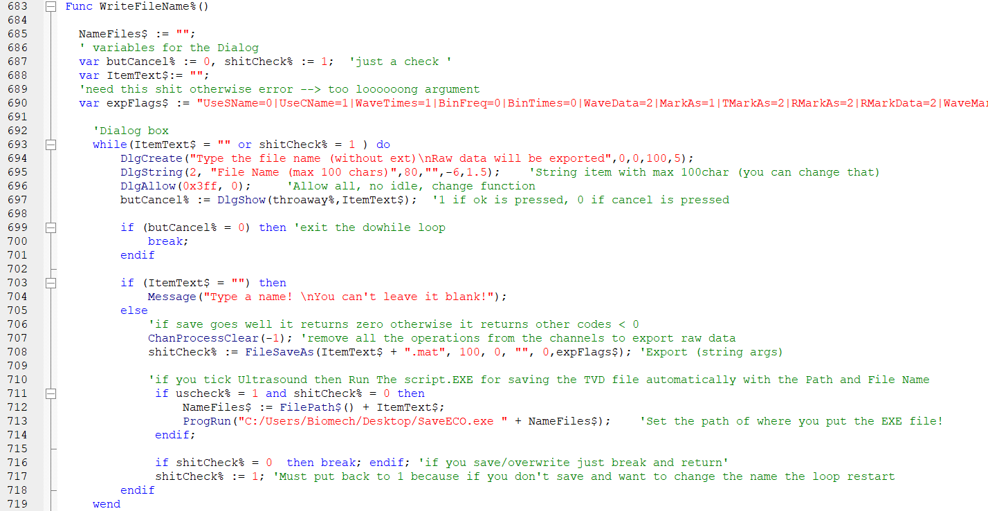

Once everything is ready, please press in the top right corner the second icon from left (or press F5 on the keyboard). It will run the script.

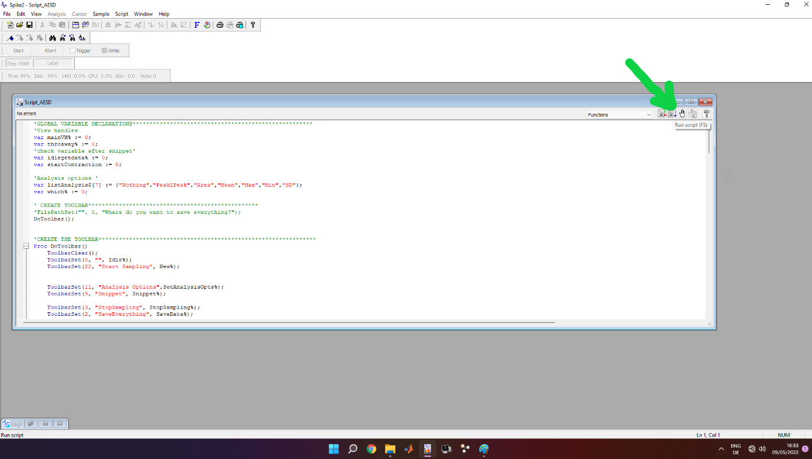

# ONCE YOU OPEN IT

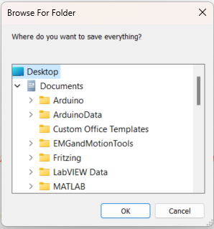After you run the script a pop-up window will appear. It asks you where you want to save the files. I recommend that you create a folder for each session or for each participant. (In this specific case I select the desktop for example).

After you select the folder, a new toolbar will appear in the upper part of Spike2 widonw. Two buttons are active:

* “Start sampling”🡪 to start sampling/collecting your data
* “Quit” 🡪 if you want to exit the script.

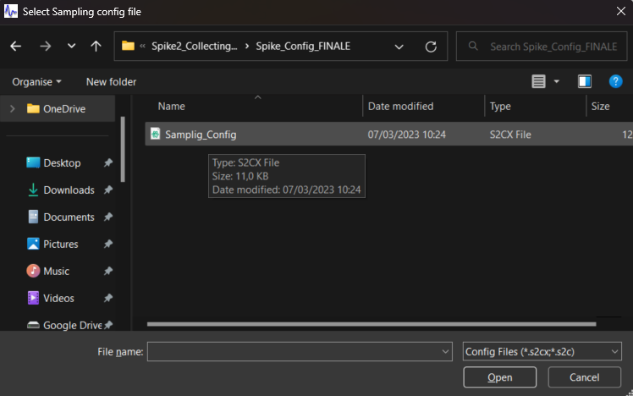Once you click on “Start sampling”, a pop-up window appears, and it asks you for a “Sampling Configuration” file. So, select the config file you created. In case you press cancel it will automatically load the last configuration used. If an error occurs, it means there was already a time view open (maybe old collected data). Please close any open window in spike2 and then run again the script.

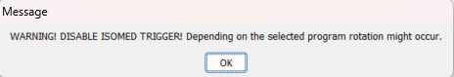Once you select (or not) the config file, a message will appear to inform you to disable the trigger to the Isomed. It’s a reminder!

**BUT BE 100% SURE THE ISOMED IS SET UP CORRECTLY AND THE PARTICIPANT IS IN SAFE CONDITIONS!**

**If the 1401 (or the CED device for collecting data) is off or not connected/recognized by windows, the script will return an error.** If the device is correctly set up and on, a window view with all the channels for your configuration will appear!

# BUTTONS EXPLANATION (left to right)



## Draw trace

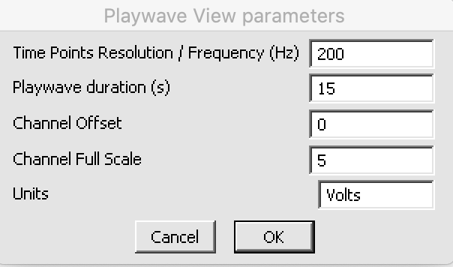A window will pop up asking you to insert the following parameters before drawing:

* **the points per second/frequency** 🡪 so it is like the “resolution” of such points you’ll draw (200Hz should be more than enough).
* **PlayWave duration** 🡪 Time length (X axis) (maximal value equals to XY width!)
* **Channel offset 🡪** not necessary
* **Channel full scale 🡪** not necessary
* **Units 🡪** not necessary

*The last three parameters are just arbitrary to set the Y in the correct scale for you to draw, but you can change it afterwards in the view as you prefer.* Following a result view will appear where you can draw the trace you want. To draw press **shift + left click mouse** and drag/move the mouse as you prefer in window.

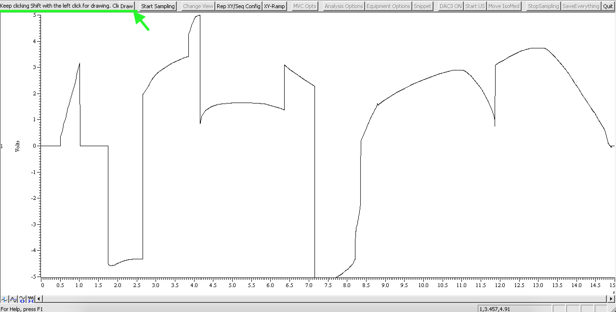Once you are done click the button **“DRAW”** in the toolbar to save it and the select the trace “***Hand Draw***” in the ***XY-ramp 🡪 select what to do.***

## Change View

Change view opens a pop-up window that let you to change between the main view with all the channels and the XY view. You can also re-size them as you prefer.

## Rep XY /Seq Config

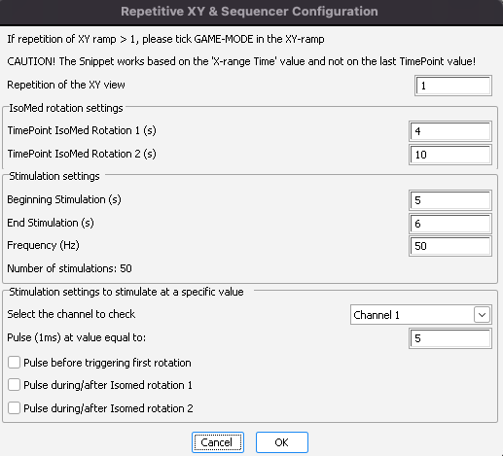Here you can configure how many times you want to perform a cycle and the time point to trigger the Isomed first rotation and the second one. So, for example a stretch-shortening cycle and/or Stimulation settings. The values you insert are in second and “real” so you can also put 4.15 (s). Such values must be smaller than the XY width (see XY-ramp).

The *stimulations settings* work without rotations or with only ISOMED 1, when this is tick in the “equipment options” (Two rotations are in “baustelle” ☺). It works with stimulation without any rotations, or stimulations before, during or rather after one rotation.

Remember, ***the stimulation lasts a tick and then there is a delta t as long as the stimulation time (-1 tick).***

All these values are sent to the sequencer to match your request and create the condition you desire and to sync everything.

The “*stimulation settings to stimulate at a specific value*” is currently in development. It works so far however is not perfectly implement with XY width and snippet because a double loop dual condition in assembly is quite hard to make. In a nutshell, everytime you change the value and/or the channel to use, the sequencer is opened as a text file in the background, a function looks for specific “CHAN” position and change the value with the one corresponding to the selected channels. While the value to check is converted back to 16bit integer (+32767 to -32768) with a threshold of +-7bits, and pass as a variable to the sequencer. The pulse lasts 1ms!

## XY-Ramp

In the XY-ramp you can create a “plot” of the ideal ramp your participant must follow. Starting from the top we have:

* ***Select feedback channel*** 🡪 you can select which channel Spike2 is gonna plot in the XY view. It can be torque, angle, EMG, whatever…depends on the sampling configuration you create. You can also plot a virtual channel!
* ***Select X-range*** 🡪 how long you want the view and the data be plotted? IMPORTANT! Your repetitive contractions (*set in the RepXY / Seq Config*) are based on this value as well as when you save the file after you click “Snippet”. So, if put X-range = 8s the output mat file (and the time you see the channel plotted in the xy-view) will end after 8s!
* **Select allowed offset** 🡪 how much is your tolerance error? So how large is the “space” between the two black lines drawn. For example, 0.1 = ±10%
* **Select what to do 🡪** select a ramp or a trace as follow
  + ***Ramp 1 and Ramp 2:*** they work in the same way. You adjust the Timepoints and the Values in the “Simple Ramp Box” below.
  + ***Ramp 3***: is for saving in an array what you are going to collect, like a curve ramp. You have to tick “arm for storing”. However, I would recommend to avoid this as with high frequency and noise, Spike2 crashes as well it is fixed to 30000 pts.
  + ***Import Array***: a pop-up window appears and asks you to select a txt file. In the txt file you can put the time value (first column) and the y value (second column) of a custom trace. So, in case you want to plot some non-linear or “special” traces. The txt file can be created easily in any program languages or even on notepad. Check “EXAMPLE_create_txt_ramp.m” for matlab (or .py for python).
  + ***MVC:*** in the “MVC opts button” you can set the max and min value manually or if you tick “Check Min and Max”, after you click snippet and the participant performs a contraction, it automatically calculates the min and the max of the selected feedback channel. Then it plots automatically horizontal lines according to the offset you set in the min and the max.

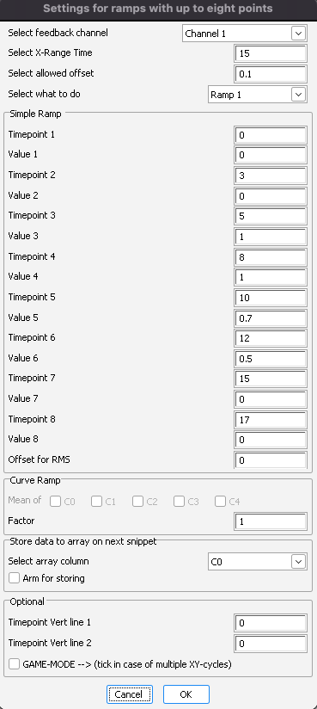

* + ***Hand draw:*** plot the hand draw trace drawn in the playwave view. For more details see ***DRAW TRACE***.
* ***Offset for RMS*:** delay of biofeedbackchannel, usually used when moving average filters are applied (e.g., RMS). It’s a real number and the value in second.
* ***Simple Ramp:*** here you insert manually the values for the Timepoints and the relative values. It’s up to 8 points!
* ***Curve ramp***: see ramp 3
* ***Store data to array on next snippet***: select the array where to store data when you select ramp3
* ***Draw vertical lines:*** here you can draw two vertical dashed lines at two specific time points in the XY view. It’s particularly useful for giving a visual-live-feedback to the subject on when start contracting or relaxing or maybe when something is triggered (you can also create a fake condition for the subject when the stimulation is sent for example even though is not true).
* ***Game-mode***: if you tick this, when you click snippet the X range is dynamic and moves. It’s really good to help the participant to follow the trace/ramp at his best. It’s mandatory to tick in case of multiple repetition of the XY ramp!

## MVC Opts

See XY-ramp 🡪 Select Ramp 🡪 MVC

## Analysis Options

You can basically select which type of analysis you want to perform between the cursors after Snippet and the X range * number of contractions is concluded.

## Equipment Options

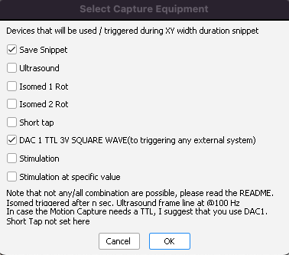The “equipment options” is the most important part because based on this, the instructions sent to the sequencer changes! In order from the top:

* **Save snippet** 🡪 export **all raw data from NON virtual channels** in a mat file (v7.3) since when you click snippet to X range * Repetition of XY width + 1 second. It must be ticked otherwise no instruction is found. If you don’t wanna save it, just press cancel afterwards;)
* **Ultrasound** 🡪 trigger the ultrasound with a square wave duty cycle @ 100Hz as long as to X range * Repetition of XY width. However, when “Stimulation” is tick, the ultrasound is triggered by my C# prompt app which use/open a terminal. So, you need that exe file (EchoWaveCMD.exe) to automatically trigger the US via Spike2. The US sync option must not be de-activated as Echowave is automatically triggered by the software. The saving is not affected! Important: Check the delay, as a cmd prompt up, there is a slightly bigger delay than a sec (about 1.8ish). Just check you do not create conditions where the Echowave starts recording too late relative to your conditions. For example: you start stimulating after 0.5s and Echowave starts recording after 1.2s…you lost 0.7s of information that is not baseline. You can adjust the delay by increase “Yield(1)” at line 700.

**BE sure that at line 203 and 703, the path to EchoWaveCMD.exe is correct, otherwise it won’t control Echowave and the telemed US system.**

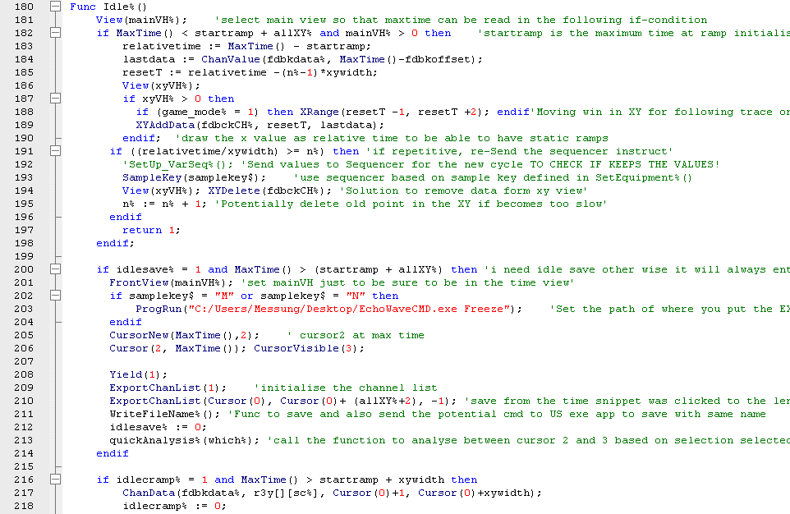



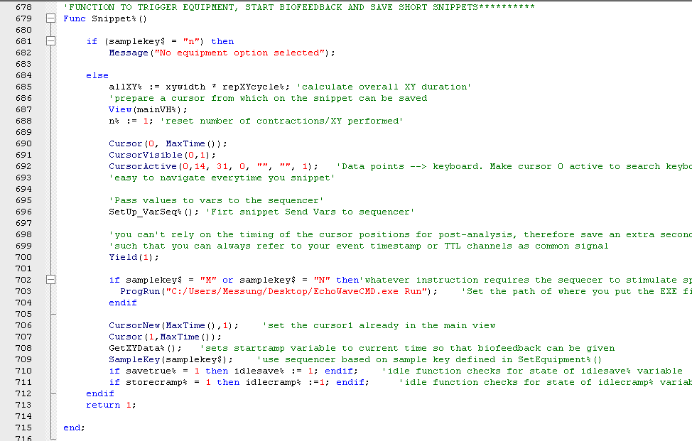



* **Isomed 1 Rot** 🡪 trigger only one rotation at the time point set in the Rep XY/ Seq Config
* **Isomed 2 Rot** 🡪 trigger second isomed rotation at the time point set in the Rep XY/Seq Config. If *you need super fast rotations cycle (<0.01s), please untick Ultrasound and trigger the US manually or you can set to use the console App like at line 707 “ProgRun("C:/Users/Messung/Desktop/EchoWaveCMD.exe Run");” to start the recording and “ ProgRun("C:/Users/Messung/Desktop/EchoWaveCMD.exe Stop)”; to stop the running. Keep it in mind, it takes about ~1.2s ish between sending the command and the actual execution of it in echowave. You can also hard code it in case or use DAC1 for triggering the US.*
* **Short Tap** 🡪 Not used right now (it was used for the tendon tapper).
* **DAC 1 TTL (to triggering any external system)**  🡪 basically a 3V TTL from DAC1. It is always on as I used it in all configuration independently whether people will you use it or not. It didn’t make sense to create tons of sequencer instructions when in the end is a simple TTL taking a simple tick

INFO: DAC1 raises up to 3V 10us before the Ultrasound system is triggered (so it’s sync unsless you need to control nuclear reactions). And DAC1 falls down to 0V 10us after the ultrasound system stop being triggered. So, unless you are recording at 100kHz you won’t see such difference. For more info check the sequencer file.

**IMPORTANT!** If you tick a combination that does not exist as command for the sequencer it returns the following message: *“No sequencer instruction found”.* So, no instruction will be sent to the sequencer, and nothing will be triggered/sync, but you can still click snippet. If you want for example to trigger specific conditions that the Script returns “No sequencer instruction found”, that’s because I created just some instructions that triggers more devices together, so you should also tick the other devices, even if you are not going to use them. Nothing bad happens, it’s just sending a signal to nothing :)! If you need a specific combination that does not exist, you have to create it in the sequencer!

**To give an idea how to integrate a new sequencer instruction into the script**: you select the equipment options and based on the selections, a letter (corresponding to the sequencer one) is assign to a variable (SampleKey). Following, once you click snippet the variables for the sequencer (SetSequencerVar function) are adjusted according to the values set in the script in live (REP XY/seq config) and the sequencer sample key is sent!

## Snippet

Snippet is the final step, it will set a cursor 0 at the moment you click, and after 1s it sends the corresponding sample key based on the equipment options you selected and it will start display the visual feedback into the X-Y ramp. One second after the end of the xy ramp (and by N cycles, so as many reps as you do of the XY ramp), a second and third cursor (1 and 2) are displayed, and the saving GUI appears.

## TAP DAC 1

Quick tap sends a 1ms pulse square wave via DAC 1, it’s useful for long lasting tasks that you don’t know how long a snippet will be, so you can export afterwards based on the pulse(s) you send for identifying the start and stop.

## Un/Freeze US (NOT ACTIVE AT THE MOMENT BUT IN THE CODE)

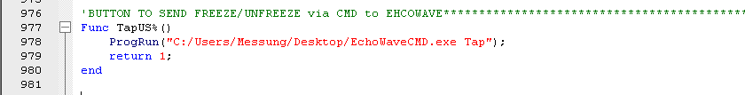If you want to control Echowave II interface via Spike2 but without using a specific duty cycle square wave. This sends a command via the C# prompt cmd app to freeze/unfreeze Echowave. Be sure you check and adjust the path to the exe at line 978.



## Start US

If you have put the TELEMED ultrasound system in sync mode (ultrasound frame line), you cannot control it fully by EchoWave II. So, in the beginning that maybe you just need to check the US probe orientation and position, you want to be able to see how the image looks like. By clicking start US you are just sending a square wave duty cycle (100Hz, 80/20 duty cycle 3V amplitude), so it will start showing images. By clicking again, you will stop it. Important: if you start it and then you click “move isomed”, the sequencer in background will stop sending any signal to the US. Remember to reset the frames count in EchoWave II before starting the data collection!

## Move Isomed

Just switch bit 2 and 3 (rear panel) to trigger the Isomed rotation. If you click this button while some instructions in the sequencer are still running, it will quit immediately those instructions and then switch the bits. It’s a simple TTL for closing/opening a circuit with two relays (check schematics in the repo).

## Stop sampling

Spike2 will stop sampling but the script is still on going. Further, a sample key (“Q”) will be sent to the sequencer to set to zero (or low) all outputs.

## Save everything

When you are happy and you have finished collecting all the data and after clicking “Stop sampling”, “Save Everything” will be active. By clicking a pop up window will appear and you can save the entire recording into a single Spike2 file. So, in case you missed something, you can always open the file in a second moment and double check it or re-export what you need. **I strongly recommend that you save the entire recording following the session.**

## Quit

Exit the script. It will be active only after you click “stop sampling”. To stop the script execution click on the button “Quit”. The bar on the top of Spike2 should disappear (see following figure). Now you can close Spike2, then turn off the 1401, the computer (and any devices you were using).

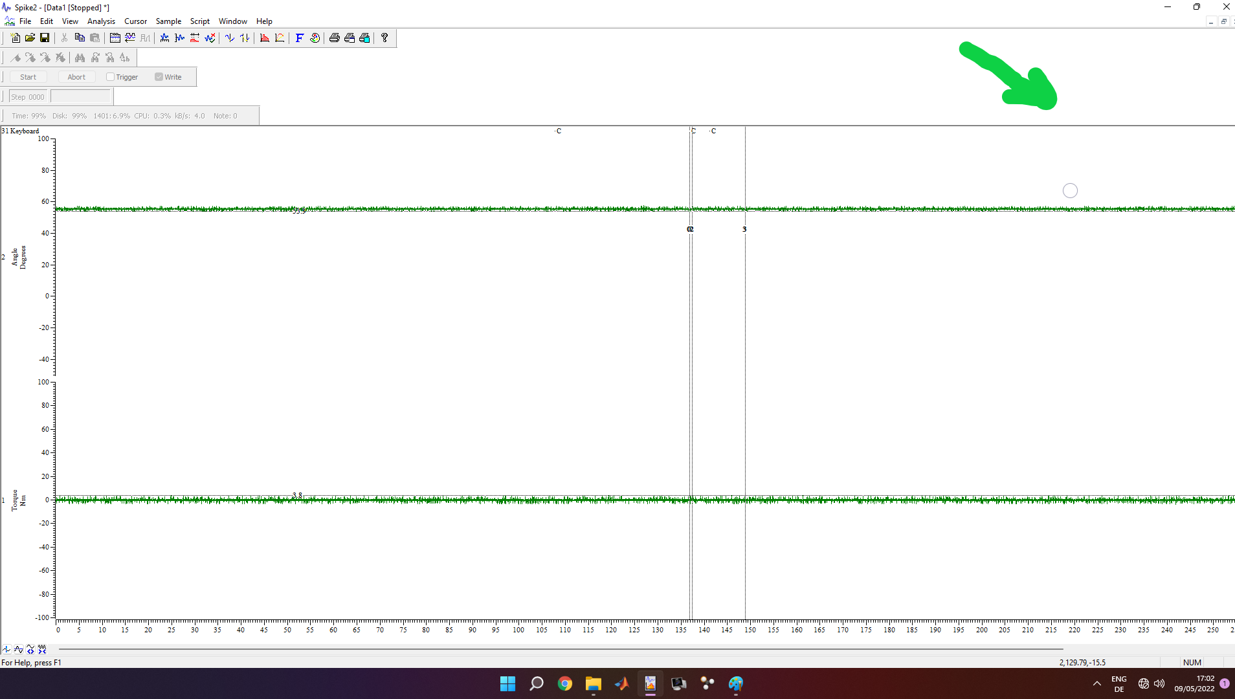

**FOR ANY REASONS, DO NOT EVER EVER PRESS “ESC” ON THE KEYBOARD!!!! IT STOPS THE SCRIPT FROM RUNNING BUT NOT THE LIVE RECORDING OF SPIKE. IN THAT CASE, YOU NEED TO DO AN “ABORT” RECORDING IN SPIKE.**