Spike2 – 1401 and PATEC script ReadMe

Table of Contents

BEFORE COLLECTING ANY DATA 2

ONCE YOU OPEN IT 5

BUTTONS EXPLANATION 6

Change View 6

Rep XY /Seq Config 6

XY-Ramp 6

MVC Opts 7

Analysis Options 8

Equipment Options 8

Start US 8

Move Isomed 9

Stop sampling 9

Save everything 9

Quit 9

# BEFORE COLLECTING ANY DATA

**Turn on the Computer first and then the 1401 device.** Wait until the light on the power button turns green and then you can open spike2 on the computer. **This prevents that any electrostatic shock discharge breaking the system when you are connecting the cables.** If the light doesn’t turn green it could be a failed of the system. In that case, please contact us!!! Connect the BNC cables according to the equipment you need! **Following, check that the BNC cables or any other cable you are using are correctly connected!**

Be sure you have created the sampling configuration you need for your study/ purpose. To create a sampling configuration in Spike2 click on Sample 🡪 sampling configuration. Once you create it remember to save by clicking on File 🡪 Save configuration as…

Check the channels and whether the cables configuration is correct! Specifically for the PaTec_Script check the “fs_sequencer_adaptable.pls” you are using. Usually it is as follow:

* DAC 0 🡪 it’s free.
* DAC 1 🡪 is used for a transistor-transistor logical pulse (TTL) with 4V amplitude. You can use it to trigger and to sync many devices which need at least 3.3V inputs (ex: Myon EMG/IMU system, Vicon).
* DAC 2 🡪 is used to trigger the ultrasound system by sending a TTL square wave duty-cycle @100Hz (you can use to trigger optitrack too).
* DIGBIT 2 and 3: bits 2 and 3 are used to trigger the Isomed rotation.
* DAC 3 🡪 it was used in one of my experiments. It is a high value (5V) that at a specific time point goes to 0V. You can use it or change it as you prefer. So, it is free.

After you open Spike2, you will have a window like the following picture. To open the script, please go to File🡪 Open/Open File. A pop up window will open and navigate to the folder where you put the PATEC_script.

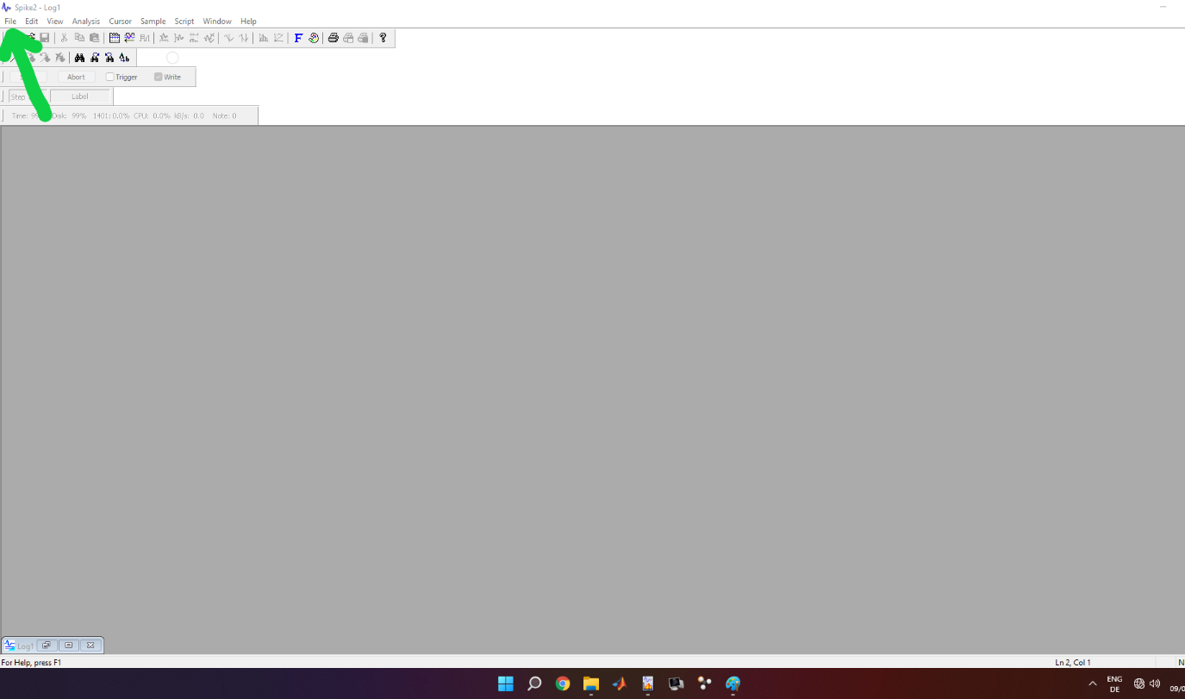

Once selected and opened, a window in spike2 with crazy nerdy code will appear. At this point, check at line 232 the path for the SampleSequencer and correct it based on the location where you put the “fs_sequencer_adaptable.pls” file.

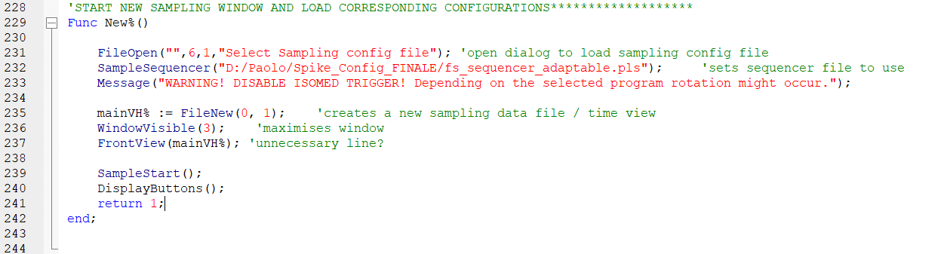

Further, if you are going to use the ultrasound system (in sync mode), remember to check at line 713 if the location of “SaveECO.exe” is correct. It is a program I created to save automatically the US tvd file via CMD with the same name of the spike2 mat files exported. Theoretically, such .exe file should be universal for everyone and always in the same location. The only difference is the path between the PC upstairs and downstairs. If someone touch or delete them, I allow you to kill them ☺

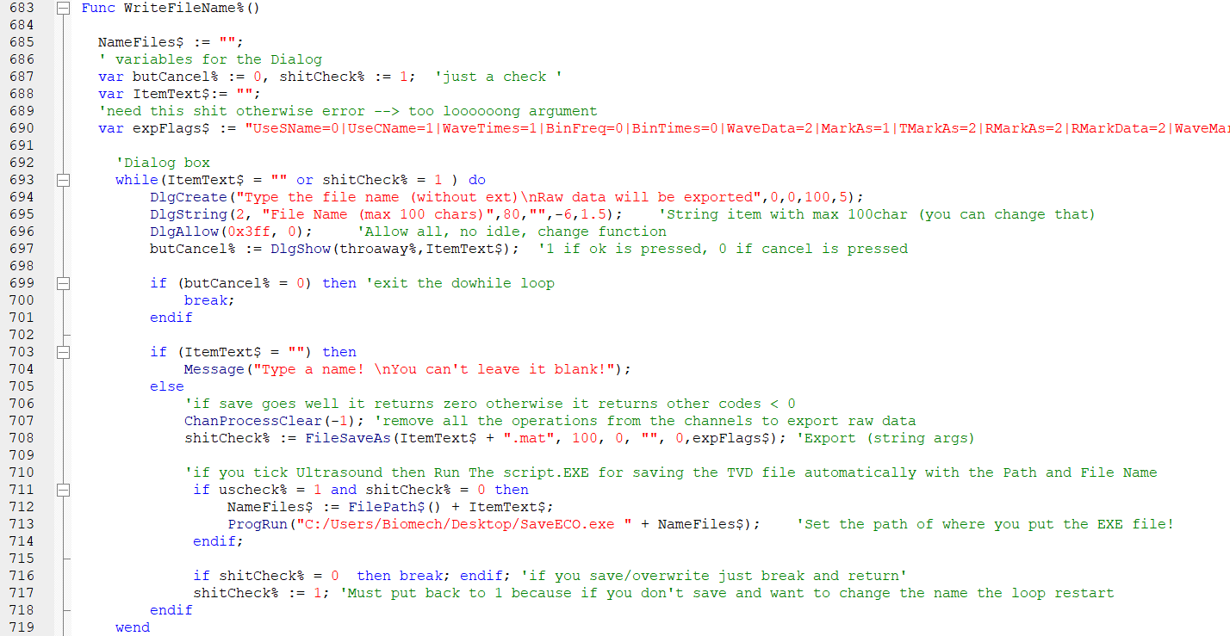

Once everything is ready, please press in the top right corner the second icon from left (or press F5 on the keyboard). It will run the script.

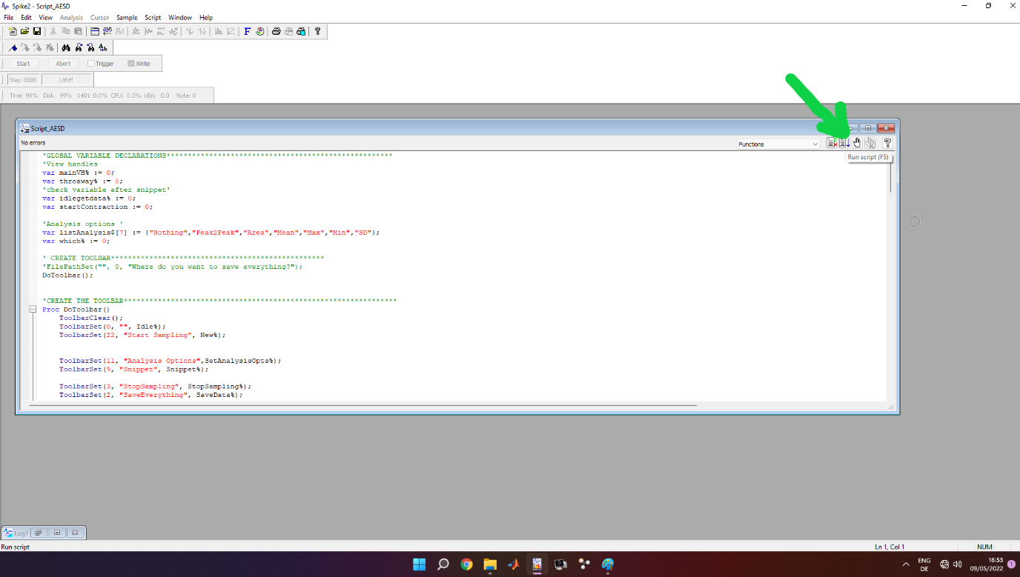

# ONCE YOU OPEN IT

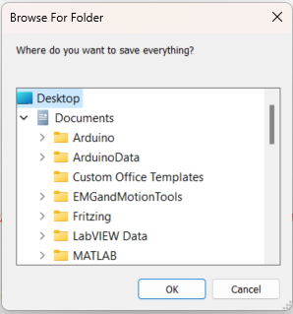After you run the script a pop-up window will appear. It asks you where you want to save the files. I recommend that you create a folder for each session or for each participant. (In this specific case I select the desktop for example).

After you select the folder, a new toolbar will appear in the upper part of Spike2 widonw. Two buttons are active:

* “Start sampling”🡪 to start sampling/collecting your data
* “Quit” 🡪 if you want to exit the script.

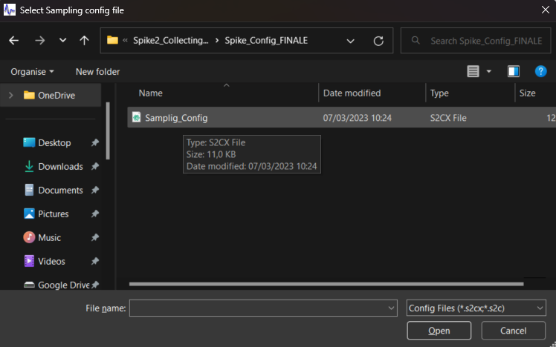Once you click on “Start sampling”, a pop-up window appears, and it asks you for a “Sampling Configuration” file. So, select the config file you created. In case you press cancel it will automatically load the last configuration used.

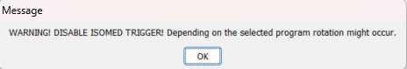Once you select (or not) the config file, a message will appear to inform you to disable the trigger to the Isomed. It’s a reminder!

**BUT BE 100% SURE THE ISOMED IS SET UP CORRECTLY AND THE PARTICIPANT IS IN SAFE CONDITIONS!**

**If the 1401 (or the CED device for collecting data) is off or not connected/recognized by windows, the script will return an error.** If the device is correctly set up and on, a window view with all the channels for your configuration will appear!

# BUTTONS EXPLANATION



## Change View

Change view opens a pop-up window that let you to change between the main view with all the channels and the XY view. You can also re-size them as you prefer.

## Rep XY /Seq Config

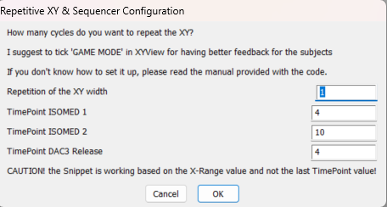Here you can configure how many times you want to perform a cycle and the time point to trigger the Isomed first rotation and the second one. So, for example a stretch-shortening cycle. The values you insert are in second and “real” so you can also put 4.15 (s). Such values must be smaller than the XY width (see XY-ramp).

These values are sent to the sequencer to match your requests and to sync everything.

## XY-Ramp

In the XY-ramp you can create a “plot” of the ideal ramp your participant must follow. Starting from the top we have:

* ***Select feedback channel*** 🡪 you can select which channel Spike2 is gonna plot in the XY view. It can be torque, angle, EMG, whatever…depends on the sampling configuration you create. You can also plot a virtual channel!
* ***Select X-range*** 🡪 how long you want the view and the data be plotted? IMPORTANT! Your repetitive contractions (*set in the RepXY / Seq Config*) are based on this value as well as when you save the file after you click “Snippet”. So, if put X-range = 8s the output mat file (and the time you see the channel plotted in the xy-view) will end after 8s!
* 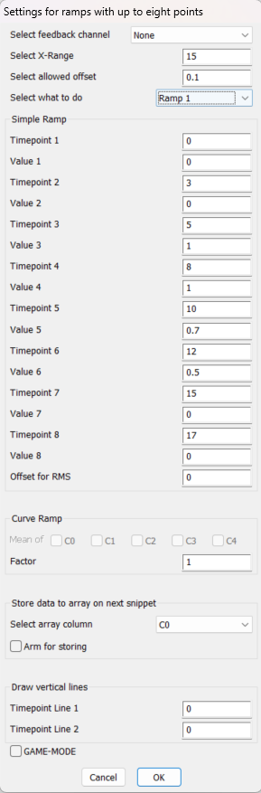**Select allowed offset** 🡪 how much is your tolerance error? So how large is the “space” between the two black lines drawn. For example, 0.1 = ±10%
* **Select what to do 🡪** select a ramp or a trace as follow
  + ***Ramp 1 and Ramp 2:*** they work in the same way. You adjust the Timepoints and the Values in the “Simple Ramp Box” below.
  + ***Ramp 3***: is for saving in an array what you are going to collect, like a curve ramp. You have to tick “arm for storing”. However, I would recommend to avoid this as with high frequency and noise, Spike2 crashes as well it is fixed to 30000 pts.
  + ***Import Array***: a pop-up window appears and asks you to select a txt file. In the txt file you can put the time value (first column) and the y value (second column) of a custom trace. So in case you want to plot some non-linear or “special” traces. The txt file can be created easily in any program languages. Check “EXAMPLE_create_txt_ramp.m” for matlab.
  + ***MVC:*** in the “MVC opts button” you can set the max and min value manually or if you tick “Check Min and Max”, after you click snippet and the participant performs a contraction, it automatically calculates the min and the max of the selected feedback channel. Then it plots automatically horizontal lines according to the offset you set in the min and the max.
* ***Simple Ramp:*** here you insert manually the values for the Timepoints and the relative values. It’s up to 8 points!
* ***Curve ramp***: see ramp 3
* ***Store data to array on next snippet***: select the array where to store data when you select ramp3
* ***Draw vertical lines:*** here you can draw two vertical dashed lines at two specific time points in the XY view. It’s particularly useful for giving a feedback to the subject on when start contracting or relaxing or maybe when something is triggered (you can create a fake condition when the stimulation is sent for example).
* ***Game-mode***: if you tick this, when you click snippet the X range is dynamic and moves. It’s really good to help the participant to follow the trace/ramp at his best.

## MVC Opts

See XY-ramp 🡪 Select Ramp 🡪 MVC

## Analysis Options

You can basically select which type of analysis you want to perform between the cursors after Snippet and the X range * number of contractions is concluded.

## Equipment Options

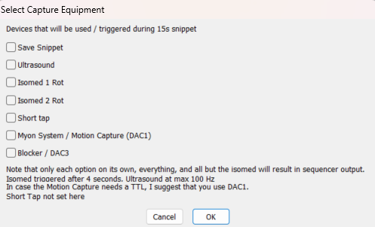The equipment options is the most important part because based on this, the instruction sent to the sequencer changes! In order from the top:

* **Save snippet** 🡪 export **all raw channels** in a mat file since when you click snippet to X range * Repetition of XY width + 1 second. I recommend to tick this to have single files for the single events or cycles
* **Ultrasound** 🡪 trigger the ultrasound with a square wave duty cycle @ 100Hz as long as to X range * Repetition of XY width.
* **Isomed 1 Rot** 🡪 trigger only one rotation at the time point set in the Rep XY/ Seq Config
* **Isomed 2 Rot** 🡪 trigger second isomed rotation at the time point set in the Rep XY/Seq Config
* **Short Tap** 🡪 nothing now
* **Myon System / Motion Capture (DAC 1)** 🡪 basically a 4V TTL from DAC1
* **Blocker / DAC3** 🡪 put the DAC3 to 0 after n second as set in the Rep XY / Seq Config

INFO: DAC1 raises up to 4V 10us before the Ultrasound system is triggered (so it’s sync!). And DAC1 falls down to 0V 10us after the ultrasound system stop being triggered. So, unless you are recording at 100kHz you won’t see such difference. For more info check the sequencer file.

**IMPORTANT!** If you tick a combination that does not exist as command for the sequencer it returns the following message: *“No sequencer instruction found”.* So, no instruction will be sent to the sequencer, and nothing will be triggered/sync, but you can still click snippet. If you want for example only trigger the dynamometer twice, you would tick *Isomed 1* *rot* and *Isomed 2 rot* (and save snippet), it will give you back the same “No sequencer instruction found”. That’s because I created just some instructions that triggers more devices together, so you should also tick ultrasound, even if you don’t use it. Nothing bad happens, it’s just sending a signal to nothing :)! If you need a specific combination that does not exist, you have to create it in sequencer!

**To give an idea how to integrate a new sequencer instruction into the script**: you select the equipment options and based on the selections, a letter (corresponding to the sequencer one) is save to a variable (SampleKey). Following, once you click snippet the variables to the sequencer and the sequencer sample key is sent!

## Start US

If you have put the ultrasound in sync mode (ultrasound frame line in), you cannot control it by EchoWave II. So, in the beginning that maybe you just need to check the US probe orientation and position, you want to be able to see how the image looks like. By clicking start US you are just sending a square wave duty cycle (100Hz), so it will start showing images. By clicking again, you will stop it. Important: if you start it and then you click “move isomed”, the sequencer in background will stop sending any signal to the US. Remember to reset the frame before starting the data collection!

## Move Isomed

Just switch bit 2 and 3 to trigger the Isomed rotation.

## Stop sampling

Spike2 will stop sampling but the script is still on going.

## Save everything

When you are happy and you have finished collecting all the data and after clicking “Stop sampling”, “Save Everything” will be active. A pop up window will appear and you can save the entire recording into a single Spike2 file. So, in case you missed something, you can always open the file in a second moment and double check it or re-export what you need.

## Quit

Exit the script. It will be active only after you click “stop sampling”. After you saved or not, to finish click the button “Quit”. The bar in the top of Spike2 should disappears (see following figure). Now you can close Spike2, then turn off the 1401, the computer and the dynamometer.

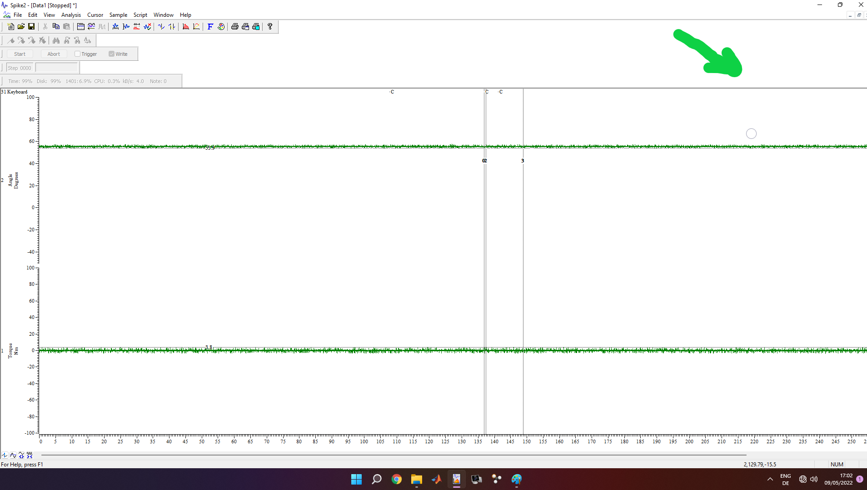

**FOR ANY REASONS, DO NOT EVER EVER PRESS “ESC” ON THE KEYBOARD!!!!**