**Expt No 3**

**CREATION OF DATABASE SCHEMA AND EXTRACTION OF ER DIAGRAM**

**AIM:** Creation of database schema - DDL (create tables, set constraints, enforce relationships, create indices, delete and modify tables). Export ER diagram from the database and verify relationships (with the ER diagram designed in step 1).

Create a database schema for the below diagram.

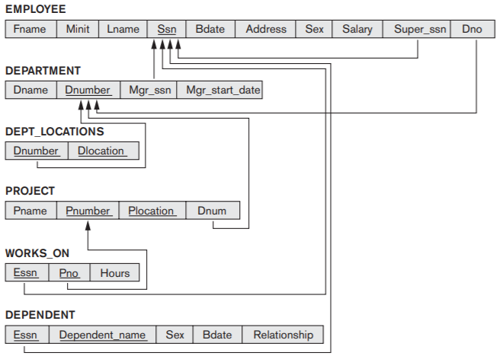

**QUERY:**

**EER diagram: <SCREENSHOT>**

**RESULT:**