* exam1-p1
  + link: <https://github.com/PaulWang0513/Electronic-System-Level-Design-and-Synthesis/tree/main/exam1/exam1-p1>
* exam1-p2
  + link: <https://github.com/PaulWang0513/Electronic-System-Level-Design-and-Synthesis/tree/main/exam1/exam1-p2>
  + 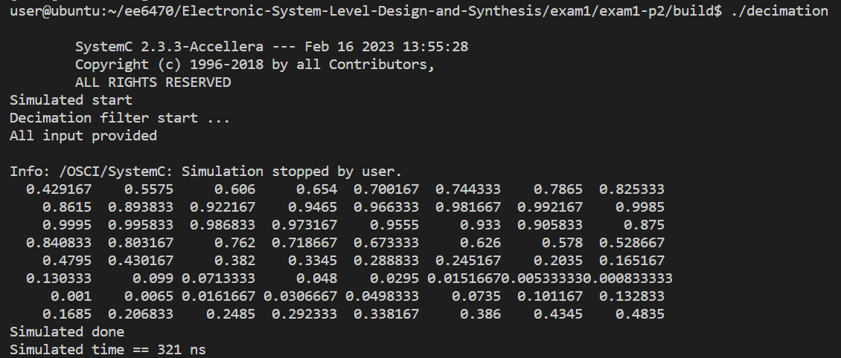result: