**How to use this template:**

1. If you haven’t done already, create a google drive folder named, “TeamName”, and   
   share the folder with your team members and me [inssong@gmail.com](mailto:inssong@gmail.com)
2. Make a copy of this template into your team folder: Goto File menu -> click Make a copy
3. Move the copy to your team folder: File -> Move-To-Folder, select the shared folder.
4. Please read [the referencing instruction](https://docs.google.com/document/d/1COZjLFySsWrIy71uPOpEXcAOH4-R2hdEgS8uii1RXWg/edit?usp=sharing) to use the Google research tool for writing reports.

[Make sure to work on a copy of this file in your shared folder “TeamName” with your team]

**_____________________________________________________________________________________________________________[marking notes]**

**CP3046** & **CP5046** ASSESSMENT TASK 1: **Project Documentation**

This assessment task has been prepared by Dr. Dmitry Konovalov for James Cook University. Updated 18 February 2015.

**© Copyright 2015**

This publication is copyright. Apart from any fair dealing for the purpose of private study, research, criticism, or review as permitted under the Copyright Act, no part may be reproduced by any process or placed in computer memory without written permission.

|  |  |
| --- | --- |
| Aligned BIT course & CP3046 subject learning outcomes | * SLO - Subject Learning Outcome: SLO-1, SLO-2; SLO-3 * BLO - BIT Course Learning Outcome: BLO-K1, BLO-K3, BLO-S3, BLO-S5. |
| **Group or individual** | *Group.* ***Every team member gets the same mark for this assessment item*** |
| **Weighting / Length** | *20%* |
| **Due date** | *before week-6 workshop* |
| **Aligned MIT course & CP5046 subject learning outcomes** | * **SLO - Subject Learning Outcome: SLO-1, SLO-2, SLO-3;** * **MLO - MIT Course Learning Outcome : MLO-K1, MLO-S4, MLO-S5.** |
| **Group or individual** | *Group* |
| **Weighting / Length** | *20%* |
| **Due date** | *before week-6 workshop* |

## ASSESSMENT TASK DESCRIPTION

This task is the ***iteration-1*** in terms of the Agile Software development. It defines the initial project specifications including goals, deliverables, and planning for ***iteration-2*** (***alpha release***).

## [Total awarded _____ out of 100 marks] ASSESSMENT TASK CRITERIA SHEET

The following is the list of items which are required to be completed in this assignment. Maximum possible marks are given in brackets at the beginning of each item. Where relevant, the SLOs and BLO/MLOs from the preceding table are specified.

**[____/Prerequisite for marking]** Assignment is completed using electronic copy of ***this*** document and submitted to LearnJCU electronically.One submission per team.

**[_____/20 marks, BLO-S5] Assignment is done in a group with 2-4 students.**

***Every team member gets the same mark for this assessment item***

Write group members here:

Student Name-1, Project role(s), specific ***individual*** contributions to this assessment item:

Student Name-2:

|  |  |  |  |
| --- | --- | --- | --- |
| **Student Name** | **Skills** | **Project roles** | **Contribution to the Product** |
| Lim Hui Ching | * HTML/CSS * Bootstrap * JavaScript * Trello | * HTML/CSS Developer * Designer | * Home Page * Student Page |
| Park Ji Hyun | * HTML/CSS * Bootstrap * JavaScript * Trello | * HTML/CSS Developer * Designer | * Teacher Page |
| Nguyen Kim Anh | * PHP * MySQL * Trello | * PHP Developer * Database Architect | * Connection to the Database in PHP |
| Paul Wenzel | * PHP * HTML/CSS * Bootstrap * JavaScript * SQL * Trello * Visio * UMLet | * Project Manager * PHP Developer | * PHP Model-View-Controller Framework * Backend Logic * Database Architecture |

**[_____/20 marks, SLO-1, BLO-K3, BLO-S3, MLO-K1, MLO-S5] Project description for non-ICT-technical stakeholders and general audience.** Write here: minimum **TWO** pages, maximum **TEN** pages.

* [___/10] Justification for the project: Why a new ICT solution is required. Include some market and ICT technology research, plus available ICT solutions.

**Justification for a new ICT solution for JCU Singapore**

Researchers, Charles Belanger from Canada and Bernard Longden from UK conducted an online survey of 1883 students from 10 European countries. Their research compares what students expect and what they experience from their teachers. The study found out that there was a gap of 35 percent between what students expected and what teachers were able to deliver.[1] The results of the research prove that it is important that there are ways for students to evaluate their lectures and give feedback to the teachers. If the students give feedback to their teachers, the gap between what students expect and what teachers deliver can be reduced. Especially the simple information in how far students are able to follow the lecture or got lost can be really useful for the teacher. If the teacher receives this information in real-time, he can adjust the speed of his lecture to enhance the students' learning experience significant.

In James Cook University, there are several methods for students to give feedback to the teachers’ lectures. First, there is a web-based student survey platform which gives students the chance to express their thoughts about how teachers conduct the class at the end of each semester. The platform also enables students to write recommendations for the teacher how he could improve his teaching quality. Second, students can make use of a suggestion box. The suggestion box allows students to write down their feedback and drop it into a box provided. The limitation of these two methods are, they are time-consuming, complicated and probably not even known by the students. This is also why students might not be motivated to do give feedback to their teachers. In addition to that, those solutions do not provide the teacher with real time information about how his students are feeling during his lecture. The third option students got to give feedback to their teachers is talking to them after or during the lecture. Fourth, students can give feedback over the web platform “Learn JCU”. When using the third or fourth option students have to reveal their identity. This could make students feel uncomfortable, since they might worry that it will affect their relationship to the teacher in a negative way.

In summary, the solutions provided currently are either too complicated to use, do not provide teachers with real-time information or are not anonymous.

To improve the learning experience for the students,by reducing the gap between what students expect and what teachers deliver, it is important to provide students and teachers with a really easy to use and fast solution that keeps the identity of the students private and enables teachers to get feedback in real-time.

In today’s world where almost every student has a smartphone[2] the most easiest way to give students the opportunity to give feedback to the teacher is by using an ICT solution. Considering the fact that almost every student has a smartphone and also every student gets provided with an iPad from the JCU Singapore, a ICT solution will be accessible by every student. Furthermore, an ICT solution can provide all three features listed above.

**Available ICT solutions**

There are various tools available on the market that make use of the internet and web technologies and can be used to gather real-time feedback during a lecture. Some available ICT solutions are for example, Poll Everywhere, Google Form, Doddle, or Kahoot. Each tool has specific features that can suit best in different situations.

1. *Google Form[3]*

Google Form is one of the most popular tools among the available tools. It is a great and fast approach to gather feedback by conducting an online survey form. Google Form is user friendly and has an intuitive user interface, even for first-time users. The results of a survey will be automatically collected in a spreadsheet which can be downloaded by the user. The user can also see the current status of the survey at any given time online. Respondents can be invited by sending them an email with a short link.

1. *Poll Everywhere[4]*

Poll Everywhere is a polling service which works based on SMS/Text messaging and the internet. Users can create customized surveys. Respondents can either write a SMS or follow a link to participate on the survey. Unfortunately, Poll Everywhere is only free for surveys with a maximum of 25 respondents.

**Justification for our product**

All of the available ICT solutions force the teacher to customize a poll on their own. This can take a lot of time especially if the teacher has to do it for each of his lectures. Furthermore, the available solutions are more complicated than it is necessary for the given situation. This reduces the user experience and stops teachers creating polls in order to receive feedback of his students. In addition to that, users have to pay for some of the available solutions. Last but not least, having to type in a URL or sending an email that contains the URL may also reduce the participation on a poll.

Considering the facts, a new ICT solution is needed to reduce the gap between what students expect and what teachers deliver.

Our lecture poll application will not have the above listed limitations. We will provide teachers and students with an application, that focuses on retrieving the information if the students are able to follow a specific lecture or not. Doing so allows us to provide teachers with a predefined poll that does not take them time to customize. It also allows us to optimize the user interface for students and teachers to provide them with an advanced user experience. Moreover, our solution is free to use and has no limit regarding the number of respondents per poll. To reduce the struggle of logging into a poll, our application does not require to distribute a URL. Instead users can login using a short alphanumeric code.

* [___/5] Project goals: Describe exactly what and how your proposed ICT solution will be delivered to the client.

**Project Goal**

The goal of the project is to reduce the gap between what students expect and what teachers deliver during lectures. In order to improve the learning experience of students at the JCU Singapore, we will develop a simple ICT solution that allows students to give feedback to the teachers.

**Stakeholders**

Our stakeholders for “Lecture Poll Web App” are:

|  |  |
| --- | --- |
| **Client** | JCU Singapore represented by Dr.Nicolas Greliche (Learning Advisor in Statistics and Mathematics) |
| **End User** | Students of JCU Singapore and Teachers of JCU Singapore |
| **Project Team** | Lim Hui Ching,  Park Ji Hyun,  Nguyen Kim Anh and  Paul Wenzel |

**Deliverables**

In order to achieve the goal, we will provide teachers and students with a web application that is specially optimized for mobile devices.

The web application will mainly consist of three pages: First, a homepage that allows teachers to start a new poll. Furthermore, students and teachers are able to login into a poll over the homepage. Second, a voting page where students can give feedback to the teacher anonymously by a simple press of a button. Third, a review page where teachers can view the status of his students in real-time during a lecture. Moreover, the page also allows teachers to download a spreadsheet that lists all the students’ ratings over the time of the lecture.

We will deliver a fully functional web application that provides the just mentioned functionality and is based on PHP, JavaScript, HTML/CSS and SQL. In order to enable our client to run the application on his own servers and also enable him to continue developing the application, we will provide him with all the necessary files:

* PHP files
* HTML files
* JavaScript files
* CSS files
* Images
* Font resource files
* SQL database structure that can be imported into a MySQL database
* .htaccess files

**Vision Statement**

“Lecture Poll Web App” is a web-based application for teachers who are concerned about if their students are able to follow their lecture and students who want to give their teacher anonymous feedback.

Unlike available ICT solutions “Lecture Poll Web App” is an easy to use web application that is specially optimized for mobile devices with small screens. Since it is designed for only one purpose, it has a really intuitive user interface and does not need any customization. This is why users who use “Lecture Poll Web App” will be more efficient and faster compared to users who are using other available solutions for the same purpose.

The application enables students to vote anonymously either “I got it!” or “I am lost!” in order to tell the teacher if they are able to follow the lecture. Additionally, the teacher sees through the application how the students are doing in real-time.

“Lecture Poll Web App” brings benefits for both, student and teacher. The teacher can react to the students in real-time by optimizing the speed of the lecture based on the students voting. Furthermore, the teacher can analyze the result of a lecture poll after the end of the lecture to see which parts of the lecture were easy and which parts were more difficult for the students to understand. Based on this information the teacher can adjust the lecture for future classes. For students, the application makes it easy to give honest feedback about the lecture since it is anonymous. As a result, students will receive a better learning experience.

* [___/5] Justify between two and four major milestones with timeline. Is your proposed schedule too ambitious (over-optimistic) or too conservative?

Milestones are important when it comes to project management as they clarify the work that has to be done. Additionally, they make it easier for the team to estimate the time that they will need to implement the requirements.

Upcoming is a list of the user stories that will be implemented for the alpha release during ICT 1. The list also shows the estimated time needed for each user story and to which milestone each user story belongs to.

**Milestone 1 (21.03.2016 – 01.04.2016)**

1. *Teacher can create a poll. (5 PEDs)*

Teacher can create a new poll and can give it a name.

1. *Teacher/Student can login to the poll via teacher/student poll code. (14 PEDs)*

The Teacher/Student can login (on the main page) to the poll via their poll code. After logging in they get redirected to the teacher/student page of the poll.

1. *Teacher can look up the teacher and student poll code. (8 PEDs)*

Teacher can look up the teacher-/student-poll codes.

1. *Student can rank the lecture. (10 PEDs)*

* Students can choose between two simple status: “I got it!” and “I am lost!“.
* Students are able to click on these buttons at any time during the lecture.
* The Student can see the name of the poll to clarify if they are filling out the right poll.

1. *Teacher can see the mood of his students in real time. (6 PEDs)*

* Two numbers are representing the mood of the students.
* The first number counts the number of students with the status “I got it!”.
* The second number counts the number of students with the status “I’m lost!”.

**Milestone 2 (11.04.2016 – 30.04.2016)**

1. *Teacher and Students get visual feedback if they entered a wrong poll code. (3 PEDs)*

If a teacher or student enters a wrong poll code the poll code text field turns red.

1. *Teacher is able to end a poll. (6 PEDs)*

* The teacher can end a poll, so the students cannot rate anymore.
* Students get informed that they can not give up a rate anymore.

1. *Teacher can see the mood of his students in real time in a faster way. (10 PEDs)*

* Teacher can see the overall mood of his students in one view.  
  (i. e. happy face = all good (>85% got it), neutral face = moderate (> 50% got it), sad face = warning (<= 50 % got it))
* Teacher can see in a “loading bar” how many students are able to follow the lecture and how many are lost.

1. *Teacher do not have to refresh his view in order to view the current mood of his students  
   (4 PEDs)*

The view of the teacher refreshes automatically as soon as a student rates the lecture.

1. *Teacher can export the poll result as a “.csv”-file. (19 PEDs)*

* Teacher can export a “.csv” file and either download it or send it via mail.
* The exported “.csv” file can be used to create a graph.

The alpha release consists of two milestones. Those two milestones will take in total 85 PEDs to implement.

In order to be aware of the due date of each user story and also deliver the alpha release to the client in time, we indicated start and end date for each milestone.

Our milestones are well-evaluated and focus on receiving a useful and working product at the end of milestone two. Milestone one will already deliver a runnable application. That makes sure that if unexpected events occur we will still be able to deliver a proper alpha release even though we might not be able to implement all user stories of milestone two. Nevertheless, it is still our goal to implement all user stories of both milestones.

Considering that we are 4 people who will work fulltime during the implementation phases, we have got a total estimated time volume of 4 team members * 24 days = 96 PEDs. Since the user stories will take us approximately 85 PEDs we still have 11 PEDs left to handle unexpected events.

All in all, our schedule is neither too ambitious nor too conservative based on our team size, skill level, time and the user stories that we have to be implement.

**[_____/20 marks, SLO-1, SLO-2, BLO-S3, MLO-S5] Project scope of the full final-release (Project audit at the end of CP3047/CP5047 subject). Clearly specify the scope of alpha-release (Project audit at the end of CP3046/CP5046 subject).** Write here: Minimum **TWO** pages, maximum **TEN** pages.

**Available days:** PASS-level (minimum) effort is 1-day and maximum is 3-days per teaching week (assume 12 weeks per study period), per team member. For example: 12 x 2 = 24 days is the minimum for a team with 2 students, 12x2x3=72 days is the maximum. The available days must match the SUM of your user story estimates below.

User story 1: title; (optional: short description only if title needs explanation); effort estimate (in days, maximum of 5 days).

User story 2:

The following scope lists the user stories and requirements addressed by the client. Our client is very strong technically and familiar with common technical terms. To simplify the communication between the client and us and adapting to the client, we are using the same technical terms in the scope agreement that he used to describe the requirements.

**Client Scope Agreement**

**“Lecture Poll Web App”**

**(Alpha Release ICT 1)**

**Project Description:**

“Lecture Poll Web App” is a web-based application that assists teachers to know whether students understand their lecture or if they got lost. The application can be accessed from any device that provides a web browser and an internet connection. Furthermore, the application is optimized for mobile devices with small screens.

The application enables students to vote anonymously either “I got it!” or “I am lost!” in order to tell the teacher if they are able to follow the lecture. Additionally, the teacher sees through the application how the students are doing in real-time.

The application brings benefits for both, student and teacher. The teacher can react to the students in real-time by optimizing the speed of the lecture based on the students voting. Furthermore, the teacher can analyze the result of a lecture after the end of the lecture to see which parts of the lecture were easy and which parts were more difficult to understand for the students. Based on this information the teacher can adjust the lecture for future classes. For students the application makes it easy to give honest feedback about the lecture since it is anonymous. As a result, students will receive a better learning experience.

**Scope for the Alpha Release ICT 1:**

|  |  |  |  |  |
| --- | --- | --- | --- | --- |
| **User Story Title** | **Description** | **Requirements** | **Priority** | **PED**  **(person equivalent days)** |
| **Milestone 1** | **21.03.2016 – 01.04.2016** |  | **Total PEDs** | **43** |
| **Teacher can create a poll.** | Teacher can create a new poll and can give it a name. | “Create Poll” button | H | 3 |
| “Poll Name” text field | H | 2 |
| **Teacher/Student can login to the poll via teacher/student poll code.** | The Teacher/Student can login (on the homepage) to the poll via their poll code. After the login they get redirected to the teacher/student page of the poll. | “Login” text field | H | 1 |
| “Login” button | H | 5 |
| Processing icon | L | 2 |
| Student poll page | H | 3 |
| Teacher poll page | H | 3 |
| **Teacher can look up the teacher and student poll code.** | Teacher can look up the teacher-/student-poll codes. | “Poll Codes” button | H | 3 |
| Popup Dialog (showing teacher and student poll codes) | H | 5 |
| **Student can rank the lecture.** | * Students can choose between two simple status: “I got it!” and “I’m lost!“. * Students are able to click on these buttons at any time during the lecture. * Students can see the name of the poll to clarify if they are filling out the right poll. | “I got it!” button | H | 2 |
| “I’m lost!” button | H | 2 |
| “Current-Status” view | H | 2 |
| “Poll Information” view | H | 4 |
| **Teacher can see the mood of his students in real time.** | * Two numbers are representing the mood of the students. * The first number counts the number of students with the status “I got it!”. * The second number counts the number of students with the status “I am lost!”. | Number of students with the status “I got it!” | H | 3 |
| Number of students with the status “I am lost!” | H | 3 |
| **Milestone 2** | **11.04.2016 – 30.04.2016** |  | **Total PEDs** | **42** |
| **Teachers and students get visual feedback if they entered a wrong poll code.** | If a teacher or a student enters a wrong poll code the poll code text field turns red. | “Login” text field with visual feedback | M | 3 |
| **Teacher is able to end a poll.** | * The teacher can end a poll, so the students cannot rate anymore. * Students get informed that they can not rate anymore. | “End Poll” button | M | 4 |
| “Poll Ended” view | M | 3 |
| **Teacher can see the mood of his students in real time in a faster way.** | * Teacher can see the overall mood of his students in one view. (i. e. happy face = all good (>85% got it), neutral face = moderate (> 50% got it), sad face = warning (<= 50 % got it)) * Teacher can see in a “loading bar” how many students are able to follow the lecture and how many are lost. | Overall status view | M | 4 |
| Bar chart | M | 4 |
| Bar chart description | M | 3 |
| **Teacher does not have to refresh his view in order to view the current mood of his students.** | The view of the teacher refreshes automatically as soon as a student rates his lecture. | Automated refresh | M | 4 |

|  |  |  |  |  |
| --- | --- | --- | --- | --- |
| **Teacher can export the poll result as a “.csv”-file.** | Teacher can export the poll data as a “.csv” file and either download it or send it via mail.  The exported “.csv” file can be used to create a graph.  Structure of the data: | “.csv” file | M | 5 |
| “Download” button | M | 5 |
| “Send E-Mail” button | L | 5 |
| “E-Mail” text field | L | 2 |
| **Alpha Release ICT 1** |  |  | **Total PEDs** | **85** |

**Scope for the Final Release ICT 2:**

|  |  |  |  |  |
| --- | --- | --- | --- | --- |
| **User Story Title** | **Description** | **Requirements** | **Priority** | **PED**  **(person equivalent days)** |
| **Milestone 1** |  |  | **Total PEDs** | **38** |
| **Teacher can review the history of the students’ mood during the poll.** | Teacher can review the history of the students’ status right in the teacher poll page. The history gets represented by a graph with two axis: the horizontal axis represents the time and the vertical axis represents the number of students who either got lost or can follow the lecture.  The history gets divided into 10 minutes periods. The teacher can open the bar chart for each period to get more details about the student’s mood during a specific period. | Student status graph | L | 5 |
| Graph divided into 10 minute periods | L | 3 |
| Individual bar chart for every period | L | 5 |
| **Teacher can record his lecture.** | Teacher can record his lecture and use this recording to see what he was talking about when his students voted “I got lost!”.  The Teacher can also download the recording as an audio file. | “Record” button | L | 5 |
| Audio timeline | L | 5 |
| “Play/Pause” button | L | 5 |
| “Download Audio File” button | L | 5 |
| Playback position pointer | L | 5 |

|  |  |  |  |  |
| --- | --- | --- | --- | --- |
| **Milestone 2** |  |  | **Total PEDs** | **43** |
| **Teacher and Students can read a manual to learn how to use the application.** | Manual is provided for both teacher and student on the homepage. | Teacher manual | L | 5 |
| Student manual | L | 5 |
| **Teacher can add custom questions to the poll.** | Teacher can add custom questions to a poll.  This also includes that students are able to answer more than one question and the teacher can see results in his teacher page too more than one question. | “Add Question” button | L | 3 |
| “Customize Question” dialog | L | 5 |
| Multiple results on the teacher poll page | L | 5 |
| Multiple questions on the student poll page | L | 5 |
| **Students can use a native iOS App.** | Students can use a native iOS app on their iPhone or iPad to rate lectures. | Login screen | L | 5 |
| Student poll screen | L | 4 |
| “I am lost!” button | L | 3 |
| “I got it!” button | L | 3 |
| **Beta Release ICT 2** |  |  | **Total PEDs** | **81** |

**Assumptions:**

1. This web application is believed to be a tool for students to express anonymously if they are able to follow the lecture or not.
2. Our client, Dr. Nicolas Greliche will offer us help by testing the web-application during a real lecture and gives us feedback.
3. In order to develop this project successfully each member will contribute to the project.
4. Each team member will complete their tasks as promised.
5. The MIS office of JCU Singapore will provide us with a PHP webserver and MySQL database.
6. At least one team member as strong PHP, HTML/CSS, JavaScript and SQL development experience.

**Constraints:**

1. Our group has a limited time of ten weeks to implement requirements and features for the implementation of the web application.
2. The team only consists of four people, some with limited experiences in the development of web applications.
3. All group members have different schedules, so the team might not always be able to attend to meetings as a whole.

**Risks**

1. One or more of the assumptions listed above may not occur.
2. Not all of the predefined user stories might get implemented due to a lack of time.

**Developers:**

Name: Lim Hui Ching Sign:____________________

Name: Nguyen Kim Anh Sign:____________________

Name: Park Ji Hyun Sign:____________________

Name: Paul Wenzel Sign:____________________

**Client:**

Name: Dr.Nicolas Greliche Sign: ___________________

Position: Learning Advisor in Statistics and Mathematics, JCU Singapore

**[_____/20 marks, BLO-K1, BLO-K3, BLO-S5, MLO-K1, MLO-S5] Project sponsor/client/customer signed/agreed to the scopes of the alpha-release and the final-release.** Cut/Paste clients’ email here, or show signed the preceding “**Project scope**” to your marking lecturer.

You can obtain the agreement from the client or provide one to the client.

See the sample contract and agreement [templates](https://drive.google.com/open?id=0BwKlOKhDpvhLfmVCWXhDNkZONkZuV09RdXpvVkNGT2plUU15UVZCSXRwVF9LUjRrWnF3QWc&authuser=0).

**Client Scope Agreement**

**“Lecture Poll Web App”**

**(Alpha Release ICT 1)**

**Project Description:**

“Lecture Poll Web App” is a web-based application that assists teachers to know whether students understand their lecture or if they got lost. The application can be accessed from any device that provides a web browser and an internet connection. Furthermore, the application is optimized for mobile devices with small screens.

The application enables students to vote anonymously either “I got it!” or “I am lost!” in order to tell the teacher if they are able to follow the lecture. Additionally, the teacher sees through the application how the students are doing in real-time.

The application brings benefits for both, student and teacher. The teacher can react to the students in real-time by optimizing the speed of the lecture based on the students voting. Furthermore, the teacher can analyze the result of a lecture after the end of the lecture to see which parts of the lecture were easy and which parts were more difficult to understand for the students. Based on this information the teacher can adjust the lecture for future classes. For students the application makes it easy to give honest feedback about the lecture since it is anonymous. As a result, students will receive a better learning experience.

**Scope for the Alpha Release ICT 1:**

|  |  |  |  |  |
| --- | --- | --- | --- | --- |
| **User Story Title** | **Description** | **Requirements** | **Priority** | **PED**  **(person equivalent days)** |
| **Milestone 1** | **21.03.2016 – 01.04.2016** |  | **Total PEDs** | **43** |
| **Teacher can create a poll.** | Teacher can create a new poll and can give it a name. | “Create Poll” button | H | 3 |
| “Poll Name” text field | H | 2 |
| **Teacher/Student can login to the poll via teacher/student poll code.** | The Teacher/Student can login (on the homepage) to the poll via their poll code. After the login they get redirected to the teacher/student page of the poll. | “Login” text field | H | 1 |
| “Login” button | H | 5 |
| Processing icon | L | 2 |
| Student poll page | H | 3 |
| Teacher poll page | H | 3 |
| **Teacher can look up the teacher and student poll code.** | Teacher can look up the teacher-/student-poll codes. | “Poll Codes” button | H | 3 |
| Popup Dialog (showing teacher and student poll codes) | H | 5 |
| **Student can rank the lecture.** | * Students can choose between two simple status: “I got it!” and “I’m lost!“. * Students are able to click on these buttons at any time during the lecture. * Students can see the name of the poll to clarify if they are filling out the right poll. | “I got it!” button | H | 2 |
| “I’m lost!” button | H | 2 |
| “Current-Status” view | H | 2 |
| “Poll Information” view | H | 4 |
| **Teacher can see the mood of his students in real time.** | * Two numbers are representing the mood of the students. * The first number counts the number of students with the status “I got it!”. * The second number counts the number of students with the status “I am lost!”. | Number of students with the status “I got it!” | H | 3 |
| Number of students with the status “I am lost!” | H | 3 |
| **Milestone 2** | **11.04.2016 – 30.04.2016** |  | **Total PEDs** | **42** |
| **Teachers and students get visual feedback if they entered a wrong poll code.** | If a teacher or a student enters a wrong poll code the poll code text field turns red. | “Login” text field with visual feedback | M | 3 |
| **Teacher is able to end a poll.** | * The teacher can end a poll, so the students cannot rate anymore. * Students get informed that they can not rate anymore. | “End Poll” button | M | 4 |
| “Poll Ended” view | M | 3 |
| **Teacher can see the mood of his students in real time in a faster way.** | * Teacher can see the overall mood of his students in one view. (i. e. happy face = all good (>85% got it), neutral face = moderate (> 50% got it), sad face = warning (<= 50 % got it)) * Teacher can see in a “loading bar” how many students are able to follow the lecture and how many are lost. | Overall status view | M | 4 |
| Bar chart | M | 4 |
| Bar chart description | M | 3 |
| **Teacher does not have to refresh his view in order to view the current mood of his students.** | The view of the teacher refreshes automatically as soon as a student rates his lecture. | Automated refresh | M | 4 |

|  |  |  |  |  |
| --- | --- | --- | --- | --- |
| **Teacher can export the poll result as a “.csv”-file.** | Teacher can export the poll data as a “.csv” file and either download it or send it via mail.  The exported “.csv” file can be used to create a graph.  Structure of the data: | “.csv” file | M | 5 |
| “Download” button | M | 5 |
| “Send E-Mail” button | L | 5 |
| “E-Mail” text field | L | 2 |
| **Alpha Release ICT 1** |  |  | **Total PEDs** | **85** |

**Scope for the Final Release ICT 2:**

|  |  |  |  |  |
| --- | --- | --- | --- | --- |
| **User Story Title** | **Description** | **Requirements** | **Priority** | **PED**  **(person equivalent days)** |
| **Milestone 1** |  |  | **Total PEDs** | **38** |
| **Teacher can review the history of the students’ mood during the poll.** | Teacher can review the history of the students’ status right in the teacher poll page. The history gets represented by a graph with two axis: the horizontal axis represents the time and the vertical axis represents the number of students who either got lost or can follow the lecture.  The history gets divided into 10 minutes periods. The teacher can open the bar chart for each period to get more details about the student’s mood during a specific period. | Student status graph | L | 5 |
| Graph divided into 10 minute periods | L | 3 |
| Individual bar chart for every period | L | 5 |
| **Teacher can record his lecture.** | Teacher can record his lecture and use this recording to see what he was talking about when his students voted “I got lost!”.  The Teacher can also download the recording as an audio file. | “Record” button | L | 5 |
| Audio timeline | L | 5 |
| “Play/Pause” button | L | 5 |
| “Download Audio File” button | L | 5 |
| Playback position pointer | L | 5 |

|  |  |  |  |  |
| --- | --- | --- | --- | --- |
| **Milestone 2** |  |  | **Total PEDs** | **43** |
| **Teacher and Students can read a manual to learn how to use the application.** | Manual is provided for both teacher and student on the homepage. | Teacher manual | L | 5 |
| Student manual | L | 5 |
| **Teacher can add custom questions to the poll.** | Teacher can add custom questions to a poll.  This also includes that students are able to answer more than one question and the teacher can see results in his teacher page too more than one question. | “Add Question” button | L | 3 |
| “Customize Question” dialog | L | 5 |
| Multiple results on the teacher poll page | L | 5 |
| Multiple questions on the student poll page | L | 5 |
| **Students can use a native iOS App.** | Students can use a native iOS app on their iPhone or iPad to rate lectures. | Login screen | L | 5 |
| Student poll screen | L | 4 |
| “I am lost!” button | L | 3 |
| “I got it!” button | L | 3 |
| **Beta Release ICT 2** |  |  | **Total PEDs** | **81** |

**Assumptions:**

1. This web application is believed to be a tool for students to express anonymously if they are able to follow the lecture or not.
2. Our client, Dr. Nicolas Greliche will offer us help by testing the web-application during a real lecture and gives us feedback.
3. In order to develop this project successfully each member will contribute to the project.
4. Each team member will complete their tasks as promised.
5. The MIS office of JCU Singapore will provide us with a PHP webserver and MySQL database.
6. At least one team member as strong PHP, HTML/CSS, JavaScript and SQL development experience.

**Constraints:**

1. Our group has a limited time of ten weeks to implement requirements and features for the implementation of the web application.
2. The team only consists of four people, some with limited experiences in the development of web applications.
3. All group members have different schedules, so the team might not always be able to attend to meetings as a whole.

**Risks**

1. One or more of the assumptions listed above may not occur.
2. Not all of the predefined user stories might get implemented due to a lack of time.

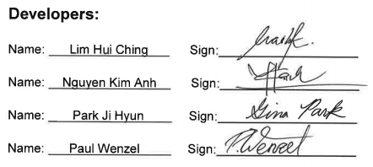

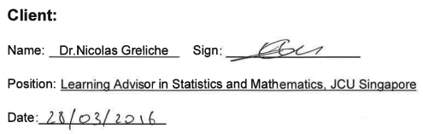

**[_____/20 marks, SLO-1, SLO-2, SLO-3, BLO-K1, BLO-S3, MLO-K1, MLO-S4, MLO-S5] Project development and release ICT infrastructure.** This must include development environment, programming languages, source code repositories (Configuration Management), project collaboration tools, and development tools. Write here: minimum **TWO** pages, maximum **TEN** pages.

* [___/5 marks] **Configuration Management**/version control, e.g. git, github, heroku, bitbucket;

Two different version control systems are used to make it easy to work on files together. First a Git repository hosted on Bitbucket is used to manage the source code. Second Google Drive is used to keep track of all Microsoft Office documents.

**Bitbucket**

Bitbucket (<https://bitbucket.org/>) is a web service offered by the company Atlassian. Like GitHub it enables users to host their own Git repository. One of the advantages of Bitbucket is, that there is no limit for creating private repositories.

**Google Drive**

Google Drive (<https://www.google.com/intl/de/drive/>) is a cloud based file storage that allows users to store, share and edit files. It supports a lot of different file formats especially the formats of Microsoft Word, Excel and PowerPoint files. Users can edit documents right inside the browser using Google’s own web based applications or download a file and upload a new version later on. Google Drive keeps always track of the history of the files. Any version of a file can be restored at any given point in time. In addition to that, Google Drive is able to synchronize files, if more than one person is editing a file at the same time.

* [___/5 marks] **Project tools**. Programming languages/IDEs, e.g. php/WebStorm, java/IntelliJ; Building tools/procedures, e.g. git-push to heroku; e.g. how to set-up your development environment for a new team member

To develop a web application, there are a variety of tools needed such as collaboration tools, development tools and programming languages.

**Collaboration Tools**

Collaboration Tools are needed to enable an easy and fast communication between all team members. Furthermore, they enable a team to organize itself and distribute tasks effectively.

1. *Trello*

Trello (<https://trello.com/>) is a simple web based application to manage projects. Projects are represented by boards in Trello. Users can add tasks as cards to a board and group multiple cards in lists on a board. Cards and lists can be easily rearranged on the board via drag-and-drop. With all its functions Trello can be used to keep track of the status of tasks and also for assigning tasks to group members.

1. *WhatsApp and E-mail*

A quick and reliable communication between all team members is essential. If the team is not able to meet up each day, other methods than face to face meetings have to be used to communicate. Two options are messaging services like WhatsApp and e-mail.

WhatsApp is an instant messaging service. It allows a group of users to share text messages, documents, images, videos or audio media either in group chats or in personal chats. A big advantage of WhatsApp is that it is the most common instant messaging service and so most of the peoples already have a WhatsApp account and are familiar with WhatsApp.

E-mail also enables users to text each other and send documents. The advantage of using e-mails is that they are really common in the business world.

1. *Google Drive and Bitbucket*

Version control system are really useful when working in a group on the same documents at a time. It guaranties that no changes will get lost. Furthermore, it is a good way to document the course of a project. Like introduced before, Google Drive is a good tool to share and manage documents and Bitbucket is great for hosting a Git repository to manage source code.

**Development Tools**

Project Tools are needed to enable an easy communication between all team members.

1. *Eclipse for PHP (PDT)*

Eclipse is an integrated development environment (IDE) which assists developers in developing applications in various programming languages, for example Java, C++, C, HTML/CSS, PHP, JavaScript, Perl, and Python. Eclipse is based on many different plug-ins which are mostly written in Java. Each plug-in provides a specific functionality for testing, coding, debugging, modeling or integrating other tools like version control systems. There are many different packages of Eclipse around, each providing a different set of plug-ins. For example, Eclipse PDT (<https://eclipse.org/pdt/>) is specially designed for developing web applications based on PHP. Eclipse PDT assists developers with syntax highlighting and automatic code completion for commonly for web applications used programming languages like PHP, JavaScript and HTML/CSS.

1. *XAMPP*

XAMPP (<https://www.apachefriends.org/de/index.html>) is a free and open source platform solution package providing an easy way to host a PHP webserver and MySQL database on a computer. In the context of developing a PHP web application it can be used by developers for testing their code.

1. *Git*

Git is one of the most common source code management systems for software development. It was initially designed by Linux developers to enhance their ability to develop in a group with lots of people and still keeping track of the code. There are many web services around, to host an own Git repository. One of the most common web services are GitHub, Bitbucket and Microsoft Visual Studio Team Services.

1. *Microsoft Visio*

Visio is a tool developed by Microsoft for designing diagrams and vector graphics. It can be used in the context of software development to describe how a system is build up, how the user’s workflow in the application is, what the user interface can look like and many other things. By visualizing the ideas and concepts the application might be based on, it guaranties that the client and the developers share the same visions. It also makes it easier to reflect about the concepts for an application, before investing a lot of effort in developing the application.

**Programming Languages**

1. *HTML (Hyper Text Markup Language)*

HTML is the standard markup language used to create web pages. HTML is mainly used to describe the structure of a web page. Furthermore, it provides simple elements to format text. HTML code exists of many tags similar to a XML file. Each tag has a specific meaning. A web browser is used to interpret a HTML file and render a web page.

1. *CSS (Cascading Style Sheets)*

CSS is a style sheet language most often used to describe the presentation/style of a HTML file including to set the color, margin, font style and size of HTML elements. While separating the structure and the presentation of a web page by using HTML as well as CSS it is easy to change the presentation at any point in time without affecting the content. The separation between structure and presentation also makes it easy to guarantee the same look and feel along all web pages of one domain. CSS also enables developers to define different presentations according to different screen sizes to provide a responsive design.

A CSS framework mainly provides pre-defined CSS styles for the most common HTML elements like buttons, input fields, navigation and tables and an easy to use grid layout for a responsive design. One of the most common CSS frameworks is *Bootstrap* (<http://getbootstrap.com/>) developed by Twitter. Besides predefined styles for most of the HTML elements and an easy to use grid layout for responsive web design, Bootstrap also provides some JavaScript based user interface elements for building a modern web page.

1. *PHP (Hypertext Preprocessor)*

PHP is a server side scripting language that can be used for developing web applications. While common web servers are only able to let clients download specific static files like HTML files, a PHP webserver in combination with PHP code can be used to generate HTML files dynamically based on the client’s needs. The PHP code gets only executed on the server side and generates HTML code as the output. PHP code can be directly embedded into HTML code. While PHP originally was only a scripting language, it provides object oriented programming concepts since PHP 5. One big advantage of PHP is, that it already offers libraries to connect to various database systems like a MySQL database system.

1. *JavaScript*

JavaScript is a dynamic programming language which gets interpreted and executed on the client side similar to HTML and CSS. Although JavaScript contains the name Java and also has a similar syntax compared to Java, it was developed independently. JavaScript code can be integrated in any HTML code to add dynamic elements to a web page. Moreover, it enables developers to manipulate HTML files while running on the client side. Without JavaScript a web page has to be reloaded every time a user interacts with the web page by clicking a button for example. Since JavaScript gets executed on the client side it can directly respond to a user interaction without necessarily having to reload the entire web page.

To easily enhance the capabilities of JavaScript, a JavaScript library can be used. One of the most common JavaScript libraries is *jQuery* (<https://jquery.com/>). jQuery is an open-source JavaScript library which provides developers with predefined methods to easily navigate and manipulate a DOM document, develop an Ajax application and handle events. In addition to that there are a lot of free and open-source user interface elements around based on jQuery, which can be integrated into the own web application.

1. *SQL (Structured Query Language)*

SQL is a programming language designed for managing data held in a relational data stream management system (RDSMS) like MySQL (<https://www.mysql.com/>). SQL code can be written to insert new data into a RDSMS, to select data from a RDSMS and to update data in a RDSMS.

**Set-up development environment for new team member**

The following illustration visualizes the steps a new team member has to accomplish in order to get fully integrated into the team and its work.

* [___/5 marks] **Testing** tools, data and procedures (what and how you are planning to test), e.g. junit; Client testing and access to release, e.g. domain name, domain hosting; Client training document, and procedures; Release testing tools, data and procedures (what and how you are planning to test);

There are two main reasons for testing a software application. First, to verify that the system works as it is supposed to work. Having tests that verify that the system works fine is especially useful in order to make sure that changes made to the code do not affect the existing code. Second, testing or more specifically writing tests is an act of documentation. Tests describe how a system is supposed to behave. In addition to that, tests document for developers how to call specific methods and how to use specific classes properly.

We are planning to perform two different types of tests. On the one hand, unit tests to verify that individual units of source code, like a method or class, work as they are expected to. Unit tests are white box tests which means that the test depends on the internal structure of the unit being tested. This is also the reason why they have to be defined by the developers. Unit tests are normally automated so that they can be lunched after every change made to the code, to check if each unit still behaves as expected. On the other hand, acceptance tests to verify that the customer’s requirements being met and that the system works properly as a whole. Acceptance tests are black box tests which means that they do not depend nor know the internal structure of the units that are being tested. Acceptance test get normally defined by all stakeholders especially the client. That is also why they have to be defined in non-technical terms.

**Sample Unit Tests**

The unit test will be automated and implemented by using PHPUnit (<https://phpunit.de/>). PHPUnit is a testing framework for writing unit test for PHP code. The following table describes the unit tests for the file “home.php”.

|  |  |  |  |  |
| --- | --- | --- | --- | --- |
| **File Name** | **Function Name** | **Function Description** | **Input** | **Expected output** |
| home.php | createNewPoll | The function creates a new poll in the database and links the user to the teacher page afterwards. | pollName: “TestPoll” | Redirect to “<domain>/teacher” |
| checkPollCode | The function checks if a given poll code is either a valid teacher or student poll code. | pollCode: “abc12” | true |
| login | The function checks if a given poll code is either a valid teacher or student poll code. If the given poll code is a valid poll code the function links the user either to the teacher or student page. | pollCode: “abc12” | Redirect to “<domain>/student” |
| **…** | **…** | **…** | **…** | **…** |

**Sample Acceptance Tests**

The acceptance tests will be performed manually. They make sure that the clients requirements are met. The following table shows some sample acceptance tests for the first user stories of milestone one.

|  |  |  |
| --- | --- | --- |
| **User Story Title** | **Description** | **Acceptance Criteria** |
| **Milestone 1** | **21.03.2016 – 01.04.2016** |  |
| **Teacher can create a poll.** | Teacher can create a new poll and can give it a name. | On the home page the teacher enters the name of the poll “TestPoll”, clicks on the “Create Poll” button, and views the teacher page of the new created poll. |
| **Teacher/Student can login to the poll via teacher/student poll code.** | The Teacher/Student can login (on the main page) to the poll via their poll code. After logging in they get redirected to the teacher/student page of the poll. | On the home page the teacher enters the teacher poll code “123ab”, clicks on the “Login” button, and views the teacher page.  On the home page the student enters the student poll code “abc12”, clicks on the “Login” button, and views the student page. |
| **Teacher can look up the teacher and student poll code.** | Teacher can look up the teacher-/student-poll codes. | On the teacher page the teacher clicks on the “Poll Codes” button, and views in a upcoming pop-up the teacher and student (“abc12”) poll code (“123ab”). |
| **…** | **…** | **…** |

* [___/5 marks] **Prototypes are demonstrated to justify the proposed alpha-release**;

**Prototype Agreement**

**“Lecture Poll Web App”**

**(Alpha Release ICT 1)**

**Home Page:**

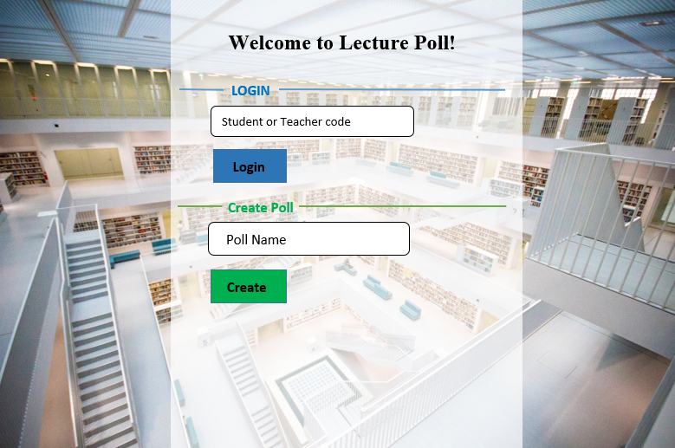

**Teacher Page:**

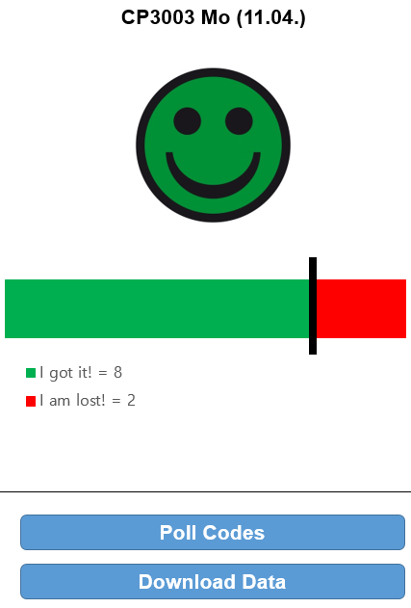 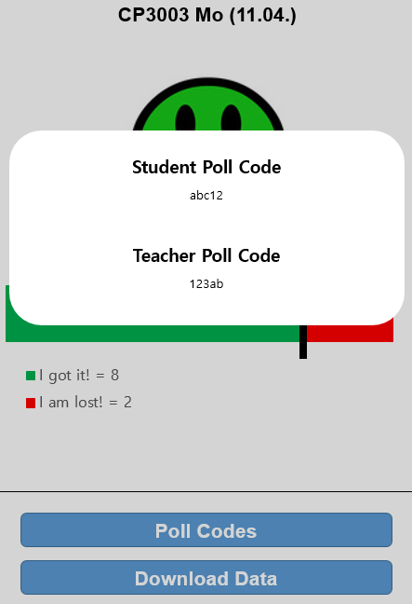

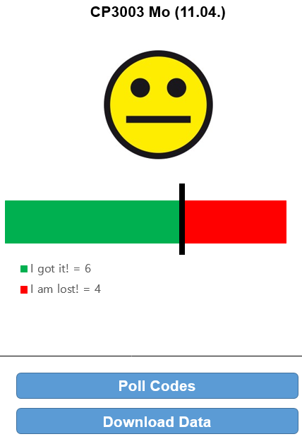 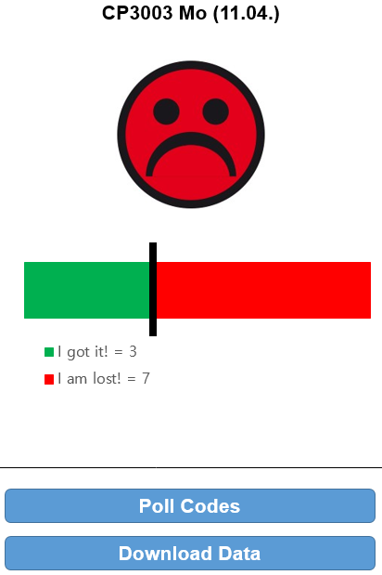

**Student Page:**

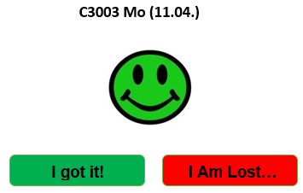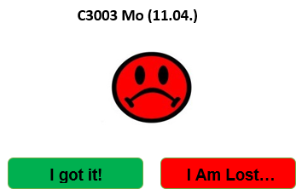





**Attachment**

The following mail proofs that our client agrees with the scope and prototypes and that he is fine that we inserted his signature digitally.

**From:** Paul Guenter Bruno Wenzel [<mailto:paulguenterbruno.wenzel@my.jcu.edu.au>]   
**Sent:** Monday, 11 April, 2016 2:27 PM  
**To:** Greliche, Nicolas  
**Cc:** Nguyen Kim Anh ([nguyenkimthanh1410@gmail.com](mailto:nguyenkimthanh1410@gmail.com)); Park Ji Hyun ([jihyun5496@gmail.com](mailto:jihyun5496@gmail.com)); Hui Ching ([mashilim@gmail.com](mailto:mashilim@gmail.com))  
**Subject:** Final Scope Agreement & Screenshots

Hello Nicolas,

Attached you find the final scope agreement and some prototyped screens. Please tell us if you have any doubts or questions.

Since we have to get both agreements signed, I just took the signatures from the previous scope. I hope you are fine with that. Doing it this way we do not have to waste paper. But if you prefer signing both agreements individually, we can of course do that as well.

Best Regards

Paul

**From:** Greliche, Nicolas [mailto:nicolas.greliche@jcu.edu.au]   
**Sent:** Dienstag, 12. April 2016 10:50  
**To:** Paul Guenter Bruno Wenzel <paulguenterbruno.wenzel@my.jcu.edu.au>  
**Cc:** Nguyen Kim Anh (nguyenkimthanh1410@gmail.com) <nguyenkimthanh1410@gmail.com>; Park Ji Hyun (jihyun5496@gmail.com) <jihyun5496@gmail.com>; Hui Ching (mashilim@gmail.com) <mashilim@gmail.com>  
**Subject:** RE: Final Scope Agreement & Screenshots

Hi Paul,

Hehe, I do that sometimes too (the signatures copied), so I’m good with that.

[…]

Cheers,

**Nicolas Greliche, PhD**

**Learning Advisor in Statistics and Mathematics,**JCU Singapore

T +65 6709 3791

**Marking Rubric for Project Documentation:** This assessment rubric provides you with the characteristics of exemplary, competent, marginal and unacceptable work in relation to task criteria.

|  |  |  |  |  |
| --- | --- | --- | --- | --- |
| **Criteria** | **Exemplary (DISTINCTION-level)** | **Competent (CREDIT-level)** | **Marginal (PASS-level)** | **Unacceptable (FAILED-level)** |
| **Assignment is done in a group with 2-4 students.** | **20**  Group demonstrated **exemplary ability** to work collaboratively, e.g. all team members always attended the same workshop | **15** Group demonstrated **competent ability** to work collaboratively, e.g. all team members nearly always attended the same workshop. | **10**  Group demonstrated **marginal ability** to work collaboratively, e.g. all team members sometimes attended the same workshop. | **0**  Group did not demonstrated ability to work collaboratively. |
| **Project description for non-ICT-technical stakeholders and general audience** | **20**  Project is described **very clearly** for a non-technical audience. No presentation and style errors | **15** Project is described clearly for a non-technical audience; or Outside page limits, or Minor presentation and/or style errors. | **10** Project is not described clearly. Outside page limits; or Major presentation and/or style errors. | **0**  Not done, or done unacceptably. |
| **Project Planning and scope** | **20**  All user stories are correct, and correctly estimated. | **15** Most user stories are correct, and correctly estimated. | **10**  More than half of user stories are correct, and correctly estimated. | **0**  Less than half of user stories are correct, and correctly estimated. |
| **Project client signed the scope** | **20**  Intellectual property (IP) in client agreement; Clear evidence of clients priority and ranking of user stories; Signed and agreed scope. | **15** Some evidence of clients priority and ranking of user stories. Signed and agreed scope | **10**  No evidence of clients priority and ranking of user stories.  Signed and agreed scope. | **0**  Not done, or done unacceptably. Project scope is not signed. |
| **Project development and alpha-release ICT infrastructure** | **20**  Description very clearly communicates exemplary ICT solutions. | **15** Description clearly communicates competent ICT solutions. | **10**  Description communicates ICT solutions. | **0**  Not done, or done unacceptably. |

## Reference BIT & MIT course and learning outcomes

|  |  |
| --- | --- |
| BIT course & CP3046 subject learning outcomes | * SLO - Subject Learning Outcomes: * SLO-1 Communicate technical information clearly through presentations, demonstrations and documentation; * SLO-2 Choose and apply the appropriate agile methodologies; * SLO-3 Evaluate and select appropriate tools and technologies to meet project requirements * SLO-4 Develop a general knowledge of industry standard project management approaches; * SLO-5 Critically reflect on progress to tailor self- learning goals to advance professional development. * BLO - BIT Course Learning Outcome: * BLO-K1 - Demonstrate essential knowledge for a career in technology related professions and practice; * BLO-K2 - Synthesise industry standard and underlying principles and concepts for decision making; * BLO-K3 - Critically analyse the core professional obligations, values and operations of organisations including sustainability; * BLO-S2 - Apply critical thinking to address IT related issues; * BLO-S5 - Demonstrate the ability to work collaboratively; * BLO-A1 - Apply technical skills, including numeracy, necessary for professional practice; * BLO-A3 - Identify and act upon, learning opportunities and self-improvements. |
| MIT course & CP5046 subject learning outcomes | * SLO - Subject Learning Outcome * SLO-1 - Communicate technical information clearly through presentations, demonstrations and documentation; * SLO-2 - Choose and apply the appropriate agile methodologies; * SLO-3 - Evaluate and select appropriate tools and technologies to meet project requirements * SLO-4 - Develop a general knowledge of industry standard project management approaches; * SLO-5 - Critically reflect on progress to tailor self learning goals to advance professional development; * MLO - MIT Course Learning Outcome * MLO-K1 - Critically analyse to select appropriate tools and technologies to meet project requirements; * MLO-K2 - Evaluate industry standard contexts for project management approaches; * MLO-S4 - Apply lateral and original thinking to conceptualise and evaluate a range of solutions to relevant problems; * MLO-S5 - Communicate technical information clearly through presentations, demonstrations and documentation; * MLO-A1 - Apply appropriate tools and technologies to meet project managements; * MLO-A3 - Critically reflect on progress to tailor self-learning goals to advance professional development. |

1. J. Ben (2012, May 9). “Should Students Evaluate Their Teachers?” Retrieved April 11, 2016,  
   from <http://www.edutopia.org/blog/student-evaluation-teachers-ben-johnson>
2. B. Chen, R. Seilhamer, L. Bennett, S. Bauer (2015, June 22). „Students' Mobile Learning Practices in Higher Education: A Multi-Year Study“ Retrieved April 14, 2016,form <http://er.educause.edu/articles/2015/6/students-mobile-learning-practices-in-higher-education-a-multiyear-study>
3. <https://www.google.com.sg/forms/about/>
4. <https://www.polleverywhere.com/>