Project: Scheduler

Group member: Jing Qian, Xinyi Zhang

Date: April 26 2016

Feature: 1. Implement 4-level feedback queue, mixed with lottery scheduler.

2. Implement zombie-cleaner mechanism in queue and random-number-generator in lottery.

3. Implement syscall statuler to check status of process in each queue

4. Implement test program “lazytest”

Bug unfixed: 1. priority of a process surpasses 3 at a very little probability.

Description:

1. Four-level feedback queue

* Data structure

Queues respectively contain process with priority 0,1,2,3, using data structure array.

* Priority in different queue

Any process is allocated in Q0, it is always scheduled before process in Q1 and so on.

* Priority in same queue

Processes in same queue will be scheduled by lottery. Winner uses CPU and run.

* Time slice in each queue

When a process is scheduled, it “clicks” the CPU. Process can run in a queue with its “Clicks limit” times.

* Reset time

Each process contributes to the total clicks. If total clicks reach 250, all unfinished process reset to Q0. When queues reset, system automatically shows as follow:.

|  |  |  |  |  |  |
| --- | --- | --- | --- | --- | --- |
|  | Priority | Clicks limit | Reset clicks | Size | First process pointer’s location |
| Queue 0 | 0 | 2 | 250 | 64 | Q0[0] |
| Queue 1 | 1 | 4 | 64 | Q1[0] |
| Queue 2 | 2 | 8 | 64 | Q2[0] |
| Queue 3 | 3 | No need | 64 | Q3[0] |

*Table 1.* Four level feedback queue

1. Lottery mechanism

* Initial lottery

Each process is allotted lotteries at initialization.

* Parameter

1. Number of process within that queue.
2. Totalclick (This is relative time parameter)

* Winner

Use “random number” to decide winner, and winner will use CPU with 1 “click”.

1. Zombie cleaner

* Function

Turn ZOMBIE process into UNUSED, remove the process from Queues.

Free its stack and virtual memory for future use.

1. Syscall statuler

* Function

Use statuler to check the status of each process at process table.

* Note
* Use this function before there are more than 64 process running.

1. Test program lazytest

* Function

Fork several process and each will sleep for a while. This will help statuler to check the status of process.

* Note

Please run this in background. Namely type ”lazytest&”

This is not a perfect test program. If a priority surpasses 3 at a very little probability, use this again when last program finish. For most time, it runs without mistake.

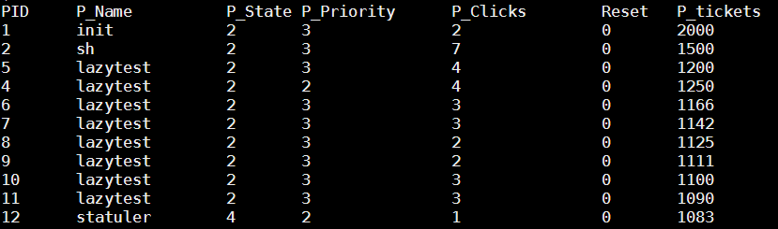

*Plot 1*. Scheduling process

This shows if there is any process in queue 3, no process in queue 4 can run.

Also, if there is any process in queue 1, no process in queue 2 or lower can run.

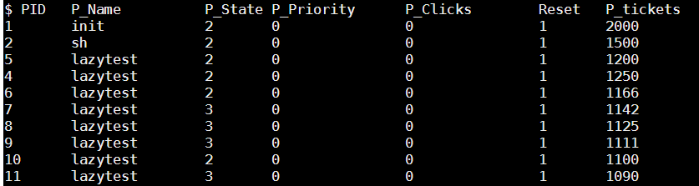

*Plot 2*. Reset

This shows all process are re-arranged into Queue 0 when it reaches reset time. Note that it is an automatic print when the scheduler reset.

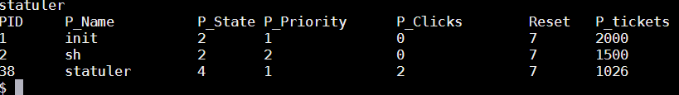

*Plot 3*. Finished status

This means all lazytest program have been finished.