Faculty of Management
Field of study: Business Engineering
Speciality: Business intelligence

Master Thesis

Investigating Labor Market Demand for Competencies Using Web Scraping and Natural Language Processing Tools

Paulina Bryk

Keywords:
Competency
GapKEU
Web scraping
short summary:
This thesis develops a hybrid web scraping and AI methodology to compare over 9,000 job advertisements with the IZ1 Business Engineering curriculum, revealing 72.8% competency alignment overall, with key gaps in Management Information Systems, Finance, Logistics, and cross-cutting AI literacy.

Supervisor | Robert Kapłon, PhD, Eng
Supervisor | Title/degree/name and surname
The final evaluation of the thesis
Chairperson of the Diploma Examination Committee
 |  | Title/ degree/ name and surname | grade | signature

For the purposes of archival thesis qualified to: *
- Category A (perpetual files)
- Category BE 50 (subject to expertise after 50 years)
* Delete as appropriate

Stamp of the faculty

Wrocław, 2026

Abstract
Rapid labour market transformation driven by Industry 4.0 and AI makes it difficult for university curricula to keep pace with employer expectations, while traditional verification methods - graduate surveys - are retrospective and infrequent. This thesis investigates current labour market demand for competencies and compares it with the learning outcomes of the Business Engineering (IZ1) programme at the Faculty of Management, Wrocław University of Science and Technology, to identify competency gaps. An original hybrid methodology was developed, combining web scraping, NLP, and a locally deployed language model (Gemma 3 4B QAT). Over 9,000 job advertisements from Pracuj.pl were compared against 56 programme-level learning outcomes (KEU), operationalized through 595 course-level outcomes (PEU), using deterministic technology extraction, bilingual lexical pre-filtering, AI-assisted semantic classification, and rule-based verification within an adapted CRISP-DM/PDCA framework. Results show 72.8% of competency occurrences map to existing outcomes, confirming strong alignment in soft skills, process optimization, data analysis, and project management. Significant gaps were found in Management Information Systems, Finance and Accounting, Production and Logistics, and cross-cutting AI literacy. The author's contribution comprises the full diagnostic framework: the scraper, PEU-KEU compression procedure, AI-matching pipeline, and original Coverage Score and Gap Index indicators.

Abstrakt
Dynamiczna transformacja rynku pracy napędzana przez Przemysł 4.0 i AI utrudnia programom studiów nadążanie za oczekiwaniami pracodawców, a tradycyjne metody weryfikacji - badania losów absolwentów - są retrospektywne i rzadkie. Praca bada aktualne zapotrzebowanie rynku pracy na kompetencje i porównuje je z efektami uczenia się kierunku Inżynieria Zarządzania (IZ1) na Wydziale Zarządzania Politechniki Wrocławskiej w celu identyfikacji luk kompetencyjnych. Opracowano autorską hybrydową metodologię łączącą web scraping, NLP oraz lokalnie wdrożony model językowy (Gemma 3 4B QAT). Ponad 9000 ogłoszeń z Pracuj.pl porównano z 56 kierunkowymi efektami uczenia się (KEU), operacjonalizowanymi przez 595 efektów przedmiotowych (PEU), stosując deterministyczną ekstrakcję technologii, dwujęzyczne filtrowanie leksykalne, semantyczną klasyfikację AI oraz weryfikację regułową w ramach zaadaptowanego modelu CRISP-DM/PDCA. Wyniki wskazują, że 72,8% wystąpień kompetencji odpowiada istniejącym efektom kształcenia, co potwierdza silne dopasowanie w obszarze kompetencji miękkich, optymalizacji procesów, analizy danych i zarządzania projektami. Wykazano istotne luki w systemach informacji zarządczej, finansach i rachunkowości, produkcji i logistyce oraz przekrojowym zapotrzebowaniu na kompetencje AI. Wkład autorki obejmuje cały aparat diagnostyczny: scraper, procedurę kompresji PEU-KEU, potok dopasowywania AI oraz autorskie wskaźniki Coverage Score i Gap Index.

Table of Contents
Introduction 3
1. The essence of competencies in the contemporary labor market 5
1.1 Definitions and evolution of the competency concept 5
1.2 Models, types and hierarchies of competencies 9
1.2.1 Models of competencies 9
1.2.2 Types of competencies 22
1.2.3 Hierarchies of competencies 27
1.3 Labour market demand for competencies in the era of Industry 4.0 and digital transformation 29
2. Research methodology 37
2.1 Research problem, aim and objectives 37
2.2 Characteristics of competencies in the IZ1 curriculum 39
2.3 Data collection design and procedure 43
2.3.1 Research framework: Adapted CRISP-DM with the PDCA quality loop 43
2.3.2 Web scraping as a data collection method 45
2.3.3 Modeling research framework 49
2.3.4 Local language model deployment 54
2.3.5 Local inference architecture 56
2.3.6 Evaluation and deployment 58
3. Empirical data analysis 60
3.1 Characteristics of competencies in the IZ1 curriculum based on syllabi analysis 60
3.1.1 Data preparation 60
3.1.2 Exploratory Analysis of the Prepared Syllabi Dataset 61
3.1.3 Semantic KEU Competency Buckets for the Classification Prompt 67
3.2 Current labor market requirements for Management Engineering graduates 70
3.2.1 Job-posting data collection 70
3.2.2 Data cleaning 73
3.2.3 AI-driven competence mapping and classification 75
3.2.4 Empirical analysis of labour market competency requirements 79
4. Identification of competency gaps and strategic recommendations 83
4.1 Comparative analysis - academic learning outcomes and employer expectations 83
4.2 Classification and evaluation of identified competency gaps 90
4.3 Recommendations for adjusting the IZ1 curriculum to contemporary market trends 90
Conclusions 92
Bibliography 94
List of figures 97
List of tables 98

Introduction
Higher education institutions face a persistent and growing challenge - aligning their study programmes with a labour market that evolves far more rapidly than academic curricula can be revised. The 4.0 Industrial Revolution, accelerated by the diffusion of artificial intelligence, big data analytics, and automation, has reshaped not only the structure of occupations but also the very nature of the competencies employers expect from graduates. According to the World Economic Forum's Future of Jobs Report 2025, nearly 39% of workers' core skills are expected to change by 2030, underscoring the urgency for academic institutions to develop mechanisms capable of verifying, on a continuous and evidence-based basis, whether their curricula still correspond to current market needs.
Traditional instruments used for this purpose - graduate tracer surveys, employer satisfaction studies, and periodic sectoral reports - suffer from a fundamental limitation: they are static, retrospective, and infrequent, and therefore poorly suited to capturing the dynamics of contemporary skill demand. At the same time, online job advertisements have emerged as a rich, real-time source of labour market intelligence, and advances in natural language processing and large language models now make it possible to extract and interpret competency requirements from such unstructured textual data at scale. This thesis builds on this opportunity, proposing a data-driven, reproducible methodology for diagnosing competency gaps between academic curricula and labour market demand.
The rationale for selecting this topic stems from a concrete and underexplored institutional need: at many universities, including the Faculty of Management of Wrocław University of Science and Technology, there is no regular, data-driven procedure for verifying whether a curriculum's formally documented learning outcomes still reflect what employers actually require. This research problem is addressed in this thesis through the case of the first-cycle Business Engineering (IZ1) programme.
The aim of this thesis is to investigate current labour market requirements in the context of desired competencies and to compare them with the learning outcomes of the IZ1 programme for the 2025/2026 education cycle, in order to identify potential competency gaps. In line with this aim, the thesis addresses six research questions concerning: the competencies most frequently required by employers (RQ1), the use of NLP and AI to extract and group competencies (RQ2), the limitations of lexical, dictionary-based matching and the role of AI-based semantic analysis in overcoming them (RQ3), the correspondence between job-posting competencies and IZ1 learning outcomes (RQ4), the resulting competency gaps (RQ5), and variation in competency demand across seniority levels (RQ6).
The scope of the thesis is structured around six objectives, each building on the previous one - identifying the most frequently required competencies in job postings relevant to the Business Engineering profile. Developing an NLP/AI-based methodology for extracting and categorising these competencies, identifying the limitations of lexical matching and applying semantic analysis to overcome them, assessing the extent to which job-posting competencies are reflected in the IZ1 curriculum, identifying concrete competency gaps, and examining how competency requirements differ across seniority levels.
The thesis is organised into four main chapters, preceded by this introduction. Chapter 1 presents a literature review on the essence, models (KSA/KSAO, the Iceberg Model, the Onion Model, the T-shaped professional model), types, and hierarchies of competencies, concluding with a discussion of labour market demand for competencies in the era of Industry 4.0 and digital transformation. Chapter 2 describes the research methodology, including the research problem and objectives, the structure of the IZ1 curriculum's KEU/PEU framework, the adapted CRISP-DM process integrated with a PDCA quality loop, the web scraping procedure, the proposed hybrid competency-matching framework, and the local language model deployment. Chapter 3 presents the empirical data analysis, covering the characteristics of curriculum competencies based on syllabi analysis and the current labour market requirements derived from the analysis of more than 9,000 job advertisements. Chapter 4 identifies competency gaps through the original Coverage Score and Gap Index indicators and formulates strategic recommendations for adjusting the IZ1 curriculum to contemporary market trends.
Methodologically, the thesis relies primarily on documentation review (analysis of the official IZ1 programme syllabi and learning outcomes), web scraping as the principal method of empirical data collection from online job postings, and a literature review of competency theory and labour market research reports. These are complemented by a custom-developed natural language processing and AI-assisted text analysis procedure, combining deterministic lexical methods with semantic classification performed by a locally hosted large language model, validated through an iterative, manually supervised Plan-Do-Check-Act evaluation cycle.

The essence of competencies in the contemporary labor market

Definitions and evolution of the competency concept
In the literature, the terms competence and competency are often used interchangeably, which leads to terminological inconsistencies. However, distinguishing between them is of considerable importance for the precision of academic discourse (Vitello et al., 2021, p. 8). The two concepts reflect different academic traditions: in the British tradition competence refers to behaviours that a person should be able to demonstrate, whereas in the American tradition competency is understood as a set of personal characteristics underlying superior performance at work (Schneider, 2019, p. 1939). This distinction is further refined by Hyland, who anchors competence at the level of the person - capturing the overall quality of an individual's performance against a given standard, such as being a competent driver in a general sense. Competency, by contrast, operates at a more granular level, designating a discrete, task-bound element of performance, such as the proficient execution of a single driving manoeuvre. On this basis, broad, overarching capacities fall under competence, while particular, observable aspects of an activity are more appropriately described through the lens of competency(Hyland, 1994, p. 21). The present study adopts a terminological convention based on this distinction: the term competence is used in its broad sense - as a general disposition of an individual - while competencies in the plural refers to its specific, distinguishable constituent elements.
The origins of the use of the term “competence” date back to ancient times. In Ancient Rome, the term competentia meant “responsibility,” “consistency,” and “readiness to act.” It derives from the word competere, which can be translated as “to correspond,” “to be suitable,” or “to be appropriate,” as well as from competentes - “appropriate” or “capable.” At that time, the term was used, among others, in reference to craftsmen and masters of their trade, as well as judges and officials who made decisions in various matters. It also applied to gladiators fighting in the arena. For this reason, it can be assumed that it is etymologically related to the English word compete, meaning “to compete” or “to struggle.” As a result, a competent person was understood as someone prepared and authorized to perform specific tasks and make decisions. Although the concept of competence has deep historical roots, its contemporary scientific approach developed much later, particularly within the field of psychology (Filipowicz, 2016, p. 11).
The analysis of these historical examples highlights several key aspects. Primarily, the concept of competence is closely linked to a specific field of activity, as it is not possible to be competent in all areas at once. A competent judge, despite their legal knowledge, would likely not manage in combat in the arena, just as a gladiator would not be capable of delivering judgments. Secondly, competence legitimizes human actions. It enables the execution of specific tasks and autonomous decision-making.
Two elements are combined: the readiness to perform specific actions and the right to carry them out. This was particularly evident in the case of craftsmen: a competent craftsman was not only able to perform his work to the appropriate standard, but also thereby gained the right to practice his profession. Competences are acquired through appropriate preparation, primarily through knowledge and skills gained from education and experience. Without such a foundation, no one should take on the role of a gladiator, a judge, or a craftsman (Filipowicz, 2016, pp. 11–12). Over the centuries, the concept of competence gradually ceased to be merely a subject of philosophical reflection and came to be viewed increasingly in practical terms. In 1782, Meyer, in his work Theoretische Einleitung in die praktische Wechsel- und Warenhandlung, described the competencies of entrepreneurs and merchants, referring to skills that today would be termed interpersonal and business competencies (Konarski, 2006, p. 41). Around the same time, the analysis of competencies also began in the field of psychology. Researchers sought answers to the question of why people achieve different results in their actions, despite comparable levels of education and experience (Filipowicz, 2016, p. 12).
The foundations of the scientific understanding of competence, along with its first definition, were formulated in 1959 by the American psychologist Robert W. White. His concept revolutionized the psychology of that time by challenging the dominant drive theory, which assumed that human motivation stemmed solely from basic biological needs, such as hunger, thirst, or fear. White recognized that the traditional approach overlooked key aspects of human nature; therefore, he proposed a new conceptualization, which he termed competence (White, 1959, pp. 297–298).
In White's view, this term acquired a broad biological meaning and was defined as an “organism's capacity to interact effectively with its environment” (White, 1959, p. 297). The author noted that, unlike simple organisms, humans and higher mammals are not born with a ready-made set of skills for dealing with their surroundings. This competence is developed successively over the course of life (White, 1959, pp. 297–298).
White based his argumentation, among other things, on numerous empirical studies of animal behaviour. It was observed in these studies that animals, such as rats or monkeys, engage in exploratory activity and exhibit cognitive curiosity even when their basic organic needs are fully satisfied. The author of the article also emphasizes that competence is not something that appears suddenly, but is a fitness to interact with the environment that is slowly attained through prolonged feats of learning (White, 1959, pp. 297–298).
The first references to competencies in the context of management concepts appeared at the beginning of the 20th century. At that time, attention was mainly focused on managerial skills, which are now considered one of the fundamental elements of competencies. One of the pioneers addressing this issue was Frederick Taylor, the creator of the modern foundations of management science, who presented his views on the subject as early as 1911. His mechanistic vision of the world resulted in several controversial theses. For example, he claimed that most people should perform simple and clearly defined tasks because they were not suited for intellectual work. However, despite earlier attempts to define and apply competencies within management theory, a more comprehensive and practical understanding of the concept did not emerge until the 1970s (Filipowicz, 2016, p. 13).
The concept of competence proposed by White laid the foundation for the further development of the term. This evolution accelerated with the work of David C. McClelland, who introduced a breakthrough perspective on competence in the context of human functioning in the occupational environment. In 1973, he published his manifesto, which challenged the prevailing methods of assessing human potential. In this work, McClelland famously questioned the status quo by asking: "How would one test for competence, if I may use that word as a symbol for an alternative approach to traditional intelligence testing?" (McClelland, 1973, p. 7). By using the word competence as a symbol, the author moved beyond the measurement of innate cognitive traits, focusing instead on an individual’s actual ability to perform effectively in specific life and work situations (McClelland, 1973).
In his considerations, the author posed a very significant question regarding whether grades are truly valid as predictors of how well we will do in life. School grades correlate primarily with good test results; however, they have virtually no bearing on the profession that an individual will pursue in the future. To perform a simple check of this claim, the author examined the fates of the top eight students and the eight who performed worst and received the lowest grades when he was their teacher. After nearly 20 years, it turned out that in terms of life outcomes, he could not distinguish between these two groups of men, as members of both performed professions such as lawyers, doctors, teachers, or research scientists, and all of them had very successful careers (McClelland, 1973, p. 2).
McClelland proposed that for a given position, one should assess the actual behaviours required for it, rather than conducting purely theoretical intelligence tests. He emphasized that the best form of testing is criterion sampling. For example, assessing driving ability is best accomplished through an actual driving test rather than through general intelligence measures or paper-and-pencil examinations. In other words, competence should be tested directly, in the context in which it is actually performed. In summary, the postulate stated that one should test for competence rather than intelligence. Behaviour and skills should be tested in practice rather than abstract abilities (McClelland, 1973, pp. 7–8).
In contrast to the concept of innate and fixed intelligence, McClelland argues that competencies are dynamic and developable. They are characterized as qualities that can be significantly enhanced through targeted training, formal learning, and professional experience. Consequently, there has been a shift in emphasis from measuring abstract cognitive abilities to analyzing specific behaviours and skills used in practice, which initiated the modern approach to competence in management sciences and organisational psychology (McClelland, 1973, pp. 7–8).
McClelland identifies key components of competence, which are:
- Communication skills: the ability to accurately convey intentions by word, look, or gesture.
- Patience: understood as response delay, which is essential in service occupations and interpersonal influence.
- Moderate goal setting: the tendency to set realistic and achievable goals, which leads to success in performance situations (McClelland, 1973, p. 10).
A significant shift in the understanding of competence came with the publication of Boyatzis's work in 1982, which marked a turning point in how competencies were conceptualized within organisational settings. He defined competencies as "an underlying characteristic of an employee (i.e., motive, trait, skill, aspects of one's self- image, social role, or a body of knowledge) which results in effective, and/or superior performance in a job" (Boyatzis, 1982, p. 20). The author also emphasized the pragmatic dimension of this concept. Competence is not a theoretical trait, but must lead to measurable success.
This approach constituted a significant expansion of previous definitions, indicating that competence encompasses not only knowledge and skills but, above all, deeper personality structures, such as:
- Motives: A motive is a recurrent concern for a goal state or condition appearing in fantasy, which drives, directs, and selects behaviour of the individual.
- Traits: A trait is a disposition or characteristic way in which a person responds to an equivalent set of stimuli.
- Self-image: A person's self-image is his or her perception of him- or herself and is often reflected in his or her 'values' (Boyatzis, 1982, p. 21).
While the psychological foundations of the competency concept are relatively well-defined, the term is interpreted in diverse ways within the framework of human capital theory. In earlier approaches, competencies were viewed primarily as innate cognitive predispositions that served as a baseline for absorbing knowledge and acquiring new skills. Today, however, the concept has evolved significantly, becoming a focal point for both extensive theoretical discourse and numerous empirical studies in organisations (Kocór, 2019).
To complement the previous analysis, Table 1 provides an overview of selected definitions of competence.
Table 1. Selected definitions of the term "competence"
Author | Definition
(Spencer & Spencer, 1993) | Underlying characteristics of an individual that are causally related to criterion-referenced effective and/or superior performance in a job or situation.
(Dubois & William J. Rothwell, 2007) | Characteristics of a person - such as knowledge, skills, attitudes, character traits, social behaviours, thought patterns, ways of thinking, feeling, and acting - that are used appropriately and consistently to achieve expected results.
(Oleksyn, 2010) | Education, knowledge, practical skills, experience, attitudes, behaviours, interests, internal motivation, health status, psychophysical condition, talents, and predispositions important in the work process, as well as formal authorizations to act.
(Stephen & Michael, 2016) | Characteristics and dispositions of an individual that contribute to effective action or superior performance.
(Fryczyńska, 2018) | The total set of predispositions that an employee engages to achieve the standards and results expected at work, appropriate to their position.
(Pocztowski, 2018) | A cluster of durable attributes/characteristics of an individual, constituting a configuration of knowledge, skills, abilities, motives, and values, enabling high performance and other superior achievements in a specific area and context of professional activity.
(Kocór, 2019) | Knowledge, skills, abilities, attitudes, and other human traits needed to perform specific activities (professional tasks), regardless of the way they were acquired.
Source: Own study based on (Tyrańska, 2021)
The definitions presented in Table 1 span nearly three decades. Each of them emphasizes slightly different dimensions and components of competence. Nevertheless, the common element to all definitions is the individual and the set of characteristics, attributes, and predispositions that contribute to effective performance and the achievement of measurable results. Despite the evolution of the concept over the years, the core elements constituting the understanding of competence have remained largely unchanged. The literature has yet to arrive at a universally accepted definition of competence, as consensus on the nature of the concept and its constituent elements remains elusive (Schneider, 2019, pp. 1939–1940).
Competence has an inherently repetitive nature. Being competent in a given domain does not simply mean succeeding on a single occasion; rather, it implies the capacity to perform reliably and predictably across a range of relevant situations. Central to this understanding is the notion of adaptability - a competent individual is not one who replicates an identical action under identical conditions, but one who adjusts and responds effectively to varied, yet contextually similar, circumstances within their domain of expertise. In this sense, competence carries a predictive quality: knowing that an individual is competent allows for an anticipation of likely performance in future, analogous situations (Vitello et al., 2021, p. 15).
A particularly relevant institutional perspective comes from the European Skills, Competences, Qualifications and Occupations framework (ESCO), developed by the European Commission to connect labour markets with education systems across EU member states. Following the European Qualifications Framework, ESCO defines competence as the proven ability to use knowledge, skills and personal, social and/or methodological abilities in work or study situations and in professional and personal development, described in terms of responsibility and autonomy (European Commission, 2025). The exceptional value of this definition lies in its explicit distinction between skill and competence: while skill concerns the application of methods in familiar, well-defined tasks, competence goes further - it is what a person draws on when facing new, unpredictable situations that require independent judgement. Understanding what competence is made of therefore becomes essential, which brings the analysis to the structural level.
At this stage, the evolution of the competency concept already revealed a gradual shift from broad and often abstract understandings of human capability toward more operational and measurable approaches applied within organisational contexts. Against this background, it is necessary to depart temporarily from a strictly chronological perspective and refer to one of the earliest internationally recognised conceptualisations of competencies, as it introduced a framework that continues to shape contemporary competency research and practice. One of the earliest globally accepted definitions of competencies emerged during an international conference held in Johannesburg, South Africa, in October 1995, attended by several hundred human resource development practitioners. Based on the contributions of the participants, competencies were defined as a cluster of interrelated knowledge, skills, and attitudes (KSA) that influence a significant part of an individual’s job, role, or responsibilities and are associated with job performance (Philippines Australia Human Resource and Organisational Development Facility, 2017, p. 27). The definition was later popularised by Scott B. Parry in his article The Quest for Competencies, published in Training magazine. Parry emphasized that competencies must be measurable against established standards and capable of being developed through training and experience (Parry, 1996). To illustrate the interdependence of their components, the metaphor of a “three-legged stool” can be used, arguing that the absence of any one element - knowledge, skills, or attitudes - renders competence incomplete and significantly less effective (Philippines Australia Human Resource and Organisational Development Facility, 2017, p. 28).

Models, types and hierarchies of competencies

Models of competencies
Moving beyond definitional considerations, the analysis of competence increasingly focuses on its internal structure and constituent elements. This shift has led to the development of competency models that organise and systematise the attributes underlying effective performance. Among them, the KSA framework, referring to Knowledge, Skills, and Abilities, remains one of the most widely recognised and foundational frameworks for conceptualising competencies in the literature. It describes competence as a combination of three distinct, yet interdependent, domains:
- Knowledge refers to the body of information required for effective task performance in a particular professional role (University of North Texas System, 2022). It encompasses theoretical concepts, factual information, procedures, and practical understanding that employees are expected to possess when entering a position or assuming new responsibilities. Knowledge may be acquired through formal education, professional training, workplace experience, or informal learning processes. In many professions, specialised knowledge forms the foundation for competent performance. For instance, medical professionals are expected to possess extensive knowledge of human anatomy, physiology, and diagnostic procedures, which they develop through academic study, clinical practice, and professional collaboration. In professional environments, knowledge is often standardized and assessed through formal frameworks and certification systems, such as the Project Management Body of Knowledge (PMBOK) used in project management (Straehle, 2017).
- Skills refer to practical proficiencies enabling individuals to apply knowledge effectively in real-world situations. They are usually developed through training, repetition, and direct experience in performing specific tasks. Unlike knowledge, which is primarily cognitive, skills are observable and measurable through performance (University of North Texas System, 2022). Some skills involve moderately simple and repetitive activities, while others require advanced coordination, adaptability, and problem-solving capabilities. For example, reading and following a recipe may constitute a basic skill, whereas preparing a complex meal requires the integration of multiple techniques, decision-making processes, and situational adjustments. Similarly, operating a vehicle safely involves a combination of learned procedural actions and the ability to respond appropriately to changing environmental conditions. Skills therefore represent the practical execution of acquired knowledge within specific occupational contexts (Straehle, 2017).
- Abilities constitute a broader and more enduring category describing an individual’s capacity to perform tasks successfully by combining knowledge and skills in action. They relate not only to current performance capabilities but also to underlying personal predispositions facilitating learning and adaptation (University of North Texas System, 2022). In contrast to skills, which are primarily acquired and improved through practice, abilities are often considered relatively stable characteristics that may be partly innate or developed independently of formal instruction. Abilities may include cognitive, physical, interpersonal, or organisational capacities such as analytical thinking, coordination, endurance, communication, or problem-solving aptitude. Individuals may naturally differ in areas such as physical balance, spatial awareness, or cognitive processing speed, which can influence the ease with which specific competencies are developed. Consequently, abilities are often understood as relatively enduring capacities that support effective learning and task performance across different situations (Straehle, 2017).
The KSA framework is widely applied in human resource management to organize professional requirements, describe job positions, evaluate employees, and support competency development. Elements of KSA are commonly incorporated into job descriptions and competency profiles, serving as tools for assessing whether candidates or employees possess the qualifications necessary for successful performance in a given role. The framework also enables organisations to identify key competency areas associated with specific professions and occupational roles. Consequently, KSA plays a particularly important role in recruitment, personnel selection, and employee assessment processes (University of North Texas System, 2022).
The origins of the KSA framework are closely associated with the practices of the American public sector and institutions such as the Office of Personnel Management. Importantly, KSA was developed primarily as a practical administrative instrument rather than as a formal scientific theory grounded in a single foundational publication. For this reason, the framework does not possess one universally fixed structure and has evolved differently across organisational and institutional contexts.
Although the formal conceptualization of the KSA framework is largely a product of the twentieth century, its roots suggest that understanding the attributes necessary for effective performance is a timeless challenge. Historian Mark A. Wilson speculates that systematic task documentation may have emerged as early as the construction of the Egyptian pyramids, where the immense complexity and coordination of thousands of workers likely required detailed activity lists. Though such ancient job descriptions may have been lost in destruction of the Library of Alexandria, Wilson ultimately defers to Jimmy Mitchell’s argument that the first documented job analysis took place in 1115 BC in the Chinese Imperial Court. This ancient selection process for officials utilized a "six-factor model" that assessed proficiency in writing, arithmetic, music, archery, horsemanship, ceremonies, and rites. Viewed through this historical lens, the KSA framework appears not merely as an abstract conceptual structure, but as a pragmatic response to evolving military, administrative, and economic demands (Wilson, 2014, p. 220).
The modern foundation for KSA was laid in the early twentieth century. In 1922, Richard Uhrbrock - an early historian of job analysis and a psychologist who later established a psychological research department at Procter & Gamble - introduced the term "man analysis" to describe the process of determining whether an individual possessed the necessary attributes to perform a specific job. Uhrbrock's work was significant because it linked the need for job analysis to fundamental changes in organisational structure, specifically the development of centralized human resource functions. He recognized that increasing organisational efficiency required matching the attributes of the person to established standards of performance. This shift from describing a task to analyzing the person performing it represents the spiritual ancestor of the modern competency model (Wilson, 2014, pp. 206–222).
The true proving ground for the development of the KSA framework was World War I. The U.S. military faced the unprecedented logistical challenge of matching millions of draftees to specialised roles. A significant portion of these recruits came from rural backgrounds with limited formal education, yet they had to be quickly and accurately assigned to technical military units. This military urgency resulted in the first large-scale systematic efforts to define job requirements and personnel specifications, producing foundational outcomes such as standardized trade tests. Following the war, these procedures migrated to the private sector, culminating in the 1939 publication of the Dictionary of Occupational Titles (DOT), which became a universal language of work in the American economy (Wilson, 2014, pp. 221–224).
Further development occurred during the period between 1941 and 1980, when competency-related approaches became increasingly institutionalised within organisational and legal practices. In the United States, the Civil Rights Act of 1964 significantly strengthened the need for job-related and measurable selection criteria, encouraging organisations to identify the underlying characteristics linked to effective occupational functioning. During this period, Edwin Fleishman developed influential taxonomies of cognitive, physical, and psychomotor abilities, providing researchers and practitioners with a more standardised vocabulary for describing human capabilities (Wilson, 2014, pp. 222–232).
In the contemporary Information Age, which began in the 1980s, the KSA framework adapted to the challenges associated with globalisation, technological advancement, and increasingly dynamic market conditions. Organisations gradually shifted their attention toward broader competency profiles that combined technical expertise with adaptability, interpersonal effectiveness, and continuous learning capabilities (Wilson, 2014, pp. 222–228). In this context, Michael Campion famously described competency modelling as the “Trojan Horse” of job analysis, arguing that it enabled rigorous analytical methods to enter executive management discourse through language more closely aligned with organisational strategy and business objectives(Campion et al., 2011, p. 226).
At the heart of this history lies a terminological dilemma regarding the letter "A" in the KSA acronym, which highlights the differences between psychological and developmental perspectives (Philippines Australia Human Resource and Organisational Development Facility, 2017, p. 29):
- Industrial-Organisational Psychology Perspective: Within the traditional psychological perspective, “A” refers to Abilities, understood as relatively stable cognitive, physical, and interpersonal capacities that facilitate the acquisition and application of skills. Examples include conceptual thinking, analytical reasoning, or manual dexterity. In this approach, abilities are treated as enduring predispositions supporting effective adaptation and performance across different situations (Philippines Australia Human Resource and Organisational Development Facility, 2017, p. 138).
- HR Development Perspective (Attitudes): Alternative approaches emerging within human resource development increasingly interpret “A” as Attitudes. This perspective gained prominence following the international competency conference held in Johannesburg in 1995, which was later popularised by Scott B. Parry. From this viewpoint, effective performance depends not only on knowledge and skills but also on behavioural orientations such as work ethic, motivation, customer orientation, or willingness to cooperate. Unlike abilities, attitudes are generally viewed as more susceptible to organisational influence, professional socialisation, and developmental interventions (Philippines Australia Human Resource and Organisational Development Facility, 2017, p. 27).
As organisations increasingly recognised the limitations of the traditional KSA framework in explaining long-term employee effectiveness, the model was expanded into KSAO through the inclusion of the “Other characteristics” category. This additional dimension encompasses a broader range of individual attributes influencing professional performance, including personality traits, attitudes, interests, values, motivation, and behavioural tendencies (Philippines Australia Human Resource and Organisational Development Facility, 2017, p. 29).
The introduction of the “O” component reflected the growing recognition that technical qualifications and task-related capabilities alone are often insufficient to explain why some employees perform more effectively than others within the same organisational environment. While knowledge, skills, and abilities primarily determine whether an individual can do a job, other characteristics are more closely associated with whether they will do the job effectively in practice (Straehle, 2017).
From the perspective of human resource management, this distinction carries important practical implications. Traditional KSA components are typically used to assess whether candidates possess the competencies necessary to perform a given role and therefore play a central role during recruitment and selection processes. In contrast, the “Other characteristics” category contributes more strongly to predicting employee engagement, adaptability, organisational fit, and long-term behavioural consistency within a specific work environment (Straehle, 2017).
Consequently, the KSAO framework enables organisations to move beyond narrowly defined occupational competencies and evaluate a broader range of attributes associated with sustained professional effectiveness and successful functioning within organisational contexts (Straehle, 2017).
Although frameworks such as KSA and KSAO provided organisations with structured methods for identifying the attributes associated with effective performance, their primary focus remained on categorising individual competency components. Over time, however, growing organisational complexity, strategic human resource management, and rapidly changing business environments created the need for more integrated approaches capable of linking competencies directly with organisational objectives and performance outcomes. As a result, competency modelling emerged as a broader and more dynamic methodology that not only identifies the attributes required for successful performance but also explains how these attributes contribute to organisational effectiveness within specific professional and strategic contexts (Philippines Australia Human Resource and Organisational Development Facility, 2017, pp. 21–22).
Rather than merely describing existing job duties, a competency model is a written description that defines the knowledge, skills, behaviours, and other attributes associated with effective or exemplary performance within a specific professional or organisational context (Philippines Australia Human Resource and Organisational Development Facility, 2017, p. 59). This approach is fundamentally deductive in nature. While traditional job analysis typically begins with specific tasks and responsibilities, competency modelling starts with desired organisational outcomes and subsequently identifies the knowledge, skills, behaviours, and other attributes necessary to achieve them (Campion et al., 2011, p. 227)
The origins of competency modelling can be traced back to the early 1970s, when the U.S. Department of State sought more reliable methods for selecting Foreign Service Officers. Traditional academic aptitude and knowledge-based tests were increasingly viewed as insufficient predictors of professional effectiveness in complex diplomatic environments. In response, the department collaborated with psychologist David McClelland and his consulting firm, MacBer and Company, to identify the characteristics associated with superior performance. As part of this initiative, McClelland’s team pioneered the use of Behavioural Event Interviewing, a method focused on analysing how individuals behave in critical professional situations. The study marked an important shift in human resource management by redirecting attention from formal qualifications and acquired knowledge toward observable behaviours and performance-related characteristics that distinguish outstanding employees from average performers. This approach later became one of the foundational methodological principles of contemporary competency modelling (Philippines Australia Human Resource and Organisational Development Facility, 2017, pp. 25–26, 103).
To ensure accuracy, comprehensiveness, and conceptual clarity in distinguishing outstanding from average performance, a robust competency model should incorporate several interrelated components. According to established competency modelling frameworks, such a model typically consists of the following elements (Philippines Australia Human Resource and Organisational Development Facility, 2017, pp. 81–82):
- Competency Title/Name: Provides a clear and concise label identifying the specific behavioural domain, such as Customer Focus, Leading Change, or Information Management. This serves as a primary reference point for users of the model (Philippines Australia Human Resource and Organisational Development Facility, 2017, p. 60).
- Competency Definition: Offers a general description of the construct, outlining the nature of the expected behaviours within a given competency area. In more advanced formulations, operational definitions may also be applied, specifying critical tasks, expected outcomes, and relevant contextual constraints, including technical, regulatory, or stakeholder-related requirements (Philippines Australia Human Resource and Organisational Development Facility, 2017, p. 60).
- Diagram of the Model: Provides a visual representation of the competency framework, ranging from simple two-dimensional schemas to more elaborate three-dimensional models. It serves to facilitate rapid understanding of the model’s key features and should clearly illustrate the relationships between individual competencies and broader competency clusters within the framework (Philippines Australia Human Resource and Organisational Development Facility, 2017, pp. 64–66).
- Behavioural Indicators: Constitute observable and measurable descriptions of effective performance. These indicators provide concrete evidence of competence by specifying how a competency is demonstrated in practice (Philippines Australia Human Resource and Organisational Development Facility, 2017, pp. 76–80).
- Proficiency Levels/Rubric: Describe progressive stages of mastery, typically organised on a scale of three to five levels, e.g., from basic to expert performance. These levels are commonly defined using explicit criteria, such as the complexity of tasks and data involved, degree of autonomy, time horizon, and the level of responsibility or supervision required (Philippines Australia Human Resource and Organisational Development Facility, 2017, p. 67).
Collectively, these components ensure that a competency model functions as a structured behavioural framework of performance excellence. In doing so, it establishes a shared language and objective standard within an organisation, thereby supporting more effective recruitment, performance evaluation, and targeted employee development (Philippines Australia Human Resource and Organisational Development Facility, 2017, pp. 130–133).
While the preceding discussion has focused on the structural components and methodological foundations of competency modelling, it is important to recognise that these elements are not merely theoretical constructs, but are also reflected in a range of applied models developed to operationalise the concept in organisational practice. Among these, one of the most influential and widely cited conceptualisations is the competency iceberg model. Its foundations can be traced indirectly to research on culture and social behaviour conducted by the American anthropologist Edward T. Hall. In his seminal work Beyond Culture, published in 1976, and based on his long-term experience of operating within different cultural contexts, he observed that visible human behaviour constitutes only a small part of the processes influencing human decisions and actions. Far more significant are the underlying values, beliefs, social norms, and cognitive frameworks through which reality is interpreted, all of which remain invisible to an external observer (Hall, 1989).
In his research, Hall placed particular emphasis on the role of cultural context in interpersonal communication. On this basis, he developed the concept of high-context and low-context cultures. In high-context cultures, a significant portion of information is not communicated explicitly but is instead embedded in social relationships, shared experiences, social hierarchy, and knowledge of group norms. Communication is more indirect, and meaning depends heavily on the situation in which it occurs. In contrast, low-context cultures rely on direct and explicit communication, where most information is conveyed through words. In such societies, greater emphasis is placed on individual autonomy, formal rules, and clearly defined boundaries between individuals. Hall classified Japan as a high-context culture, while the United States is widely regarded as one of the most representative examples of a low-context culture. At the same time, he emphasized that this distinction should be understood as a continuum, with individual societies exhibiting varying degrees of both orientations. In the case of Japan, he noted a particular complexity arising from the coexistence of strong relational orientation and indirect communication with a high degree of formalization in many social situations requiring strict adherence to established rules and procedures (Hall, 1989).
Hall illustrates this relationship through his own experience in Japan. During one of his visits, he was repeatedly moved between hotel rooms and even transferred to different hotels without prior notice. Upon returning to his room, he discovered that another guest’s belongings had been placed there, while his own possessions had been moved elsewhere without his consent. The situation triggered a strong emotional reaction. As an American, he interpreted it through the lens of his own cultural experience, perceiving it as disrespect, a violation of privacy, and a sign of low social status (Hall, 1989).
This reaction was not accidental. Hall observed that in American culture, space serves as an important social signal. A hotel room, office, or workplace is not only a functional environment but also a symbol of status, autonomy, and individual position. In organisations, moving an employee to a different office may be interpreted as a sign of demotion or loss of importance. Hall cites examples of managers who refused to move to a smaller office solely because it was slightly smaller than that of a colleague at the same hierarchical level. In this sense, physical space becomes a tool for communicating social and organisational status. Hall himself emphasized that his reaction was almost instinctive and rooted in deeply embedded cultural patterns. Only later did he realize that he had interpreted the situation entirely through the lens of his own cultural assumptions and norms (Hall, 1989).
It was only after numerous conversations with Japanese acquaintances that Hall came to understand that the same behaviour carried an entirely different meaning in Japanese culture. In a strongly group-oriented society, a person who checks into a hotel is treated as a temporary member of a collective community. Moving a guest is therefore not an act of disrespect, but rather a sign of inclusion within a group in which individual boundaries and ownership are less significant than in American culture. As Hall notes, after check-in, the guest ceases to be an external client and instead becomes part of a kind of “hotel family.” In this context, changing rooms can be seen as a natural element of maintaining the functioning of the group rather than an action directed against the individual. For Japanese culture, group harmony and collective efficiency are more important than individual autonomy (Hall, 1989).
This experience led Hall to an important conclusion: the same behaviour can be interpreted in entirely different ways depending on cultural background. Observable actions represent only the surface of a far more complex system of meaning. Beneath behaviour lie values, norms, beliefs, needs, and interpretative frameworks that remain invisible to the observer. Hall also noted that individuals often interpret the behaviour of others through the lens of their own cultural experience, failing to recognize the underlying assumptions shaping the actions of others. These invisible elements ultimately determine the meaning attributed to behaviour and how it is evaluated within social interaction (Hall, 1989).
The findings of Hall’s research became an important inspiration for later theories describing the hidden structure of human behaviour. They were particularly influential in the development of competency theory. Building on earlier work by David C. McClelland, researchers began to recognize that professional effectiveness does not result solely from knowledge and skills. Equally important are less visible characteristics of individuals, such as motivation, values, attitudes, personality traits, and self-concept (Hall, 1989).
Ultimately, the synthesis of Hall’s cultural observations and McClelland’s behavioural research contributed to the formalisation of the competency iceberg model developed by Lyle and Signe Spencer in 1993. In their seminal book Competence at Work, Spencer and Spencer adapted the iceberg metaphor to organisational settings by distinguishing between visible surface competencies, such as knowledge and skills, and deeper personality-based characteristics including self-concept, traits, and motives. These underlying elements function as psychological drivers that remain hidden beneath the waterline and exert a substantial influence on long-term professional performance (Spencer & Spencer, 1993, pp. 9–12).
At the surface level are knowledge and skills, representing the information individuals possess and their ability to apply it in practice. These constitute threshold competencies that are necessary for adequate job performance but insufficient to explain why some individuals consistently outperform others. Although they are relatively easy to assess and develop through training, they do not fully account for sustained excellence in complex professional environments (Spencer & Spencer, 1993, pp. 9–12).
Beneath the surface lies a more influential and less visible layer consisting of self-concept, traits, and motives. Self-concept refers to the way individuals perceive themselves and their professional roles, for example, as leaders rather than technical specialists. Traits describe relatively stable behavioural tendencies such as resilience, emotional self-control, or adaptability. Motives represent the deepest layer of the model and include the internal drivers that shape long-term behavioural patterns, aspirations, and decision-making processes (Spencer & Spencer, 1993, pp. 9–12).
A particularly important contribution of Spencer and Spencer’s model is the concept of “causal flow,” illustrated in Figure 1. According to this perspective, motives and traits located beneath the surface of the iceberg function as the primary drivers of behaviour. These deeper characteristics influence the actions individuals choose to undertake, which subsequently translate into measurable work outcomes and professional performance. As presented in Figure 1, personal characteristics such as motives, traits, self-concept, and knowledge shape behavioural actions, which ultimately determine job performance outcomes. Without the appropriate motivational foundation, knowledge and skills may remain underutilised despite being formally possessed by an employee (Spencer & Spencer, 1993, pp. 12–13).
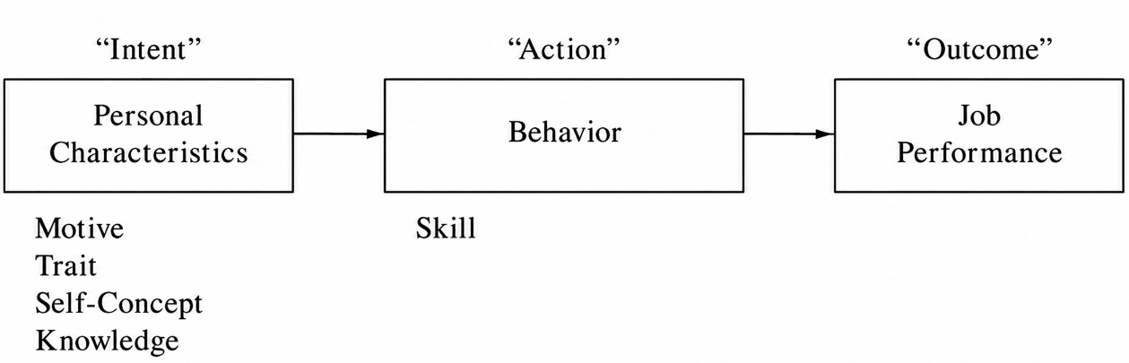
Figure 1. Competency Casual Flow Model
Source: (Spencer & Spencer, 1993, p. 13)
From the perspective of human resource management, the iceberg model therefore carries a significant practical implication. Spencer and Spencer argued that it is generally more cost-effective for organisations to recruit individuals on the basis of their underlying motives and personality traits, and subsequently develop the necessary knowledge and skills through training and professional experience. While technical competencies can often be improved relatively efficiently, changing deep-level personality characteristics located beneath the waterline is considerably more complex, time-consuming, and difficult to achieve within organisational settings (Spencer & Spencer, 1993, pp. 11–12).
Figure 2 presents two visual representations of Spencer and Spencer’s iceberg model of competence. Both diagrams distinguish between visible surface-level competencies (knowledge and skills) and deeper underlying components. The model further illustrates a hierarchical structure of deeper attributes, including self-concept, traits, motives, attitudes, and values, which are positioned closer to core personality and are therefore more difficult to observe and develop. The visualisation highlights that deeper levels exert a stronger influence on behaviour and performance while being less accessible to organisational interventions (Spencer & Spencer, 1993, p. 11).
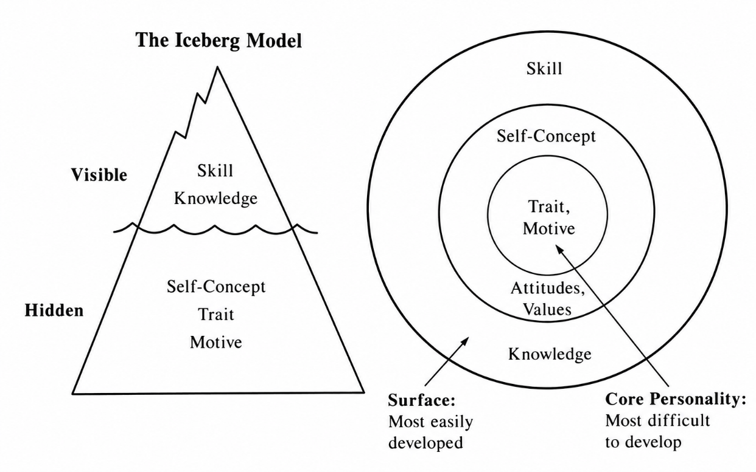
Figure 2. The Iceberg Model
Source: (Spencer & Spencer, 1993, p. 13)
The strength of the Iceberg Model lies in its empirical foundation. Spencer and Spencer developed it using Behavioural Event Interviews, which analysed critical incidents involving high performers. Their findings indicate that superior performance is shaped less by formal expertise and more by underlying behavioural and psychological characteristics (Spencer & Spencer, 1993, pp. 4–12).
Illustrative evidence from their research shows that effective diplomats often achieve success not through procedural knowledge alone, but through contextual intelligence and strategic use of informal networks. In politically sensitive settings, successful individuals demonstrated the ability to navigate institutional constraints creatively, often achieving results through indirect or adaptive strategies rather than formal channels(Spencer & Spencer, 1993, pp. 4–6).
Another example involved a diplomat instructed to screen a controversial film in a politically unstable region. Rather than refusing the directive, he scheduled the screening during an important religious holiday, ensuring minimal attendance while formally complying with the order. The incident illustrates how contextual intelligence, judgement, and behavioural flexibility may determine effective performance more strongly than technical expertise alone (Spencer & Spencer, 1993, pp. 5–6).
Military observations also illustrated the importance of hidden competencies. In one case, a private correctly anticipated the vulnerability of his unit due to the captain’s disregard of warnings about an undefended flank, demonstrating the value of receptiveness to subordinate input and upward flow of information in effective leadership (Spencer & Spencer, 1993, pp. 103–104).
Comparable mechanisms appear in other contexts. In business, a sales representative exceeded formal role expectations by spending an entire day repairing a client’s equipment, which strengthened customer trust and loyalty. In education, a teacher enhanced student engagement by linking an abstract topic to personally meaningful experiences, transforming a routine assignment into a process of personal development and increased motivation (Spencer & Spencer, 1993, pp. 143–144, 175).
Across these examples, Spencer and Spencer also highlighted the relative stability of deep competencies over time. Historical analyses, including leadership assessments of Julius Caesar, suggest that core competencies such as strategic thinking, achievement orientation, and judgement remain recognizable across vastly different institutional and historical environments (Spencer & Spencer, 1993, p. 111).
Taken together, these examples support the central assumption of the iceberg model: the key determinants of outstanding performance are often not directly observable in CVs or formal job descriptions. Instead, they reside in deeper motives, traits, and self-concepts that shape how individuals interpret situations and act under critical conditions (Spencer & Spencer, 1993, pp. 11–12).
The iceberg model of competencies serves not only as a framework for organising the structure of competencies, but also as a basis for their functional categorisation according to their impact on job performance. The distinction between visible and hidden elements of the iceberg leads directly to the concept of threshold competencies and differentiating competencies. This distinction was first formulated by Richard E. Boyatzis in 1982 and later further developed and popularised by Spencer and Spencer (Tyrańska, 2021, p. 15).
(Spencer & Spencer, 1993, pp. 11–15)Within the iceberg model, competencies located above the surface of the water - primarily knowledge and skills - are relatively easy to observe, assess, and develop. These constitute threshold competencies, understood as the minimum characteristics required to perform a job at an acceptable level (Tyrańska, 2021, p. 15). Possessing them enables an individual to function effectively within a given role; however, they do not in themselves determine superior performance. For instance, product knowledge in sales is an essential competency for every salesperson, yet it does not distinguish outstanding performers from average employees (Spencer & Spencer, 1993, pp. 11–15)
(Spencer & Spencer, 1993, pp. 11–15)Far greater significance from the perspective of organisational effectiveness is attributed to differentiating competencies, which are located beneath the surface of the iceberg. These include deep-seated motives, personality traits, values, and enduring psychological characteristics such as achievement orientation, initiative, resilience, or analytical thinking. It is these hidden components that explain why some individuals consistently achieve results significantly above the average level of performance (Spencer & Spencer, 1993, pp. 11–15).
This distinction has important implications for human resource management practices. In recruitment and selection processes, organisations increasingly focus not only on candidates’ formal qualifications and technical expertise, but also on identifying differentiating competencies, as these are stronger predictors of future job performance. Since such competencies are more difficult to detect through traditional application materials, organisations often employ advanced assessment methods such as the Behavioural Event Interview (BEI). The BEI is a structured interview technique based on analysing candidates’ past behaviours and critical workplace situations in order to identify underlying motives, traits, and patterns of action (Spencer & Spencer, 1993, pp. 11–15, 98, 114–115, 239–246)
The importance of differentiating competencies is also evident in relation to organisational value creation. Research indicates that in highly complex jobs, employees possessing strong differentiating competencies may generate economic value significantly exceeding that of average performers. Consequently, the Iceberg Model and the distinction between threshold and differentiating competencies have become important tools in succession planning and talent management, enabling organisations to evaluate employees not only on the basis of current technical capabilities, but also according to their long-term potential for superior performance in more demanding roles (Spencer & Spencer, 1993, pp. 12–15, 276–281).
The iceberg model introduced the distinction between visible competencies and deeper psychological characteristics. Later competency frameworks sought a more nuanced understanding of the internal structure of human capabilities. One of the most influential developments in this direction was the onion model of competencies, most commonly associated with Richard Boyatzis. The model extended the logic of the iceberg metaphor by presenting competencies not as two separate levels, but as a series of interconnected and hierarchical layers organised around a central core. As illustrated in Figure 3, the model resembles an onion, where each successive layer reflects a different category of competencies varying in visibility, stability, and developmental potential (Cao & Zhang, 2022, pp. 3–5). It is worth noting that the onion model was not originally created exclusively as a competency framework. Comparable layered “onion” models appear in other disciplines as well, such as Geert Hofstede’s cultural framework (Ehlers et al., 2009, p. 2) and Lynn Curry’s work on learning styles. This indicates that the onion structure is a broader analytical metaphor rather than one specific to competency theory (Cools & Bellens, 2012, p. 455).
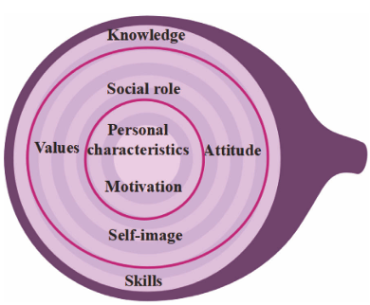
Figure 3. Onion Model of competencies
In the onion model, competencies are arranged in concentric circles that reflect both their visibility and their stability. The outermost layers consist primarily of knowledge and professional skills, which can be relatively easily observed, assessed, and developed through education or training. These elements represent the more technical and situational aspects of professional competence and are therefore the most accessible for organisational intervention and short-term development initiatives (Cao & Zhang, 2022, pp. 3–4).
Moving towards the middle layers of the onion, the model includes social roles, self-image, attitudes, and values. These dimensions influence how individuals perceive themselves, relate to others, and position themselves within organisational and social contexts (Cao & Zhang, 2022, pp. 3–4). Unlike technical skills, these competencies are less visible and considerably more resistant to change because they are closely linked to identity, behavioural preferences, and personal belief systems. They shape patterns of interaction, motivation, and professional behaviour across different situations (Cools & Bellens, 2012, p. 456).
At the core of the onion are motives and enduring personal characteristics, regarded as the deepest and most stable elements of human behaviour. Boyatzis argued that these inner layers exert a fundamental influence on how individuals respond to challenges, make decisions, regulate behaviour, and sustain performance over time. Because they operate at a deeply psychological level, they are often difficult to observe directly, yet they strongly determine long-term professional effectiveness, leadership potential, adaptability, and organisational fit. Consequently, the model suggests that superior professional performance cannot be explained solely through observable qualifications or experience, but must also be understood through deeper psychological drivers (Cao & Zhang, 2022, pp. 3–15).
An important implication of the onion model is the inverse relationship between observability and strategic importance. Competencies located in the outer layers are comparatively easy to identify and develop but possess more limited predictive value for exceptional performance (Cao & Zhang, 2022, pp. 3–4). In contrast, competencies situated near the core are substantially more difficult to assess and modify, yet they play a decisive role in determining long-term effectiveness and behavioural consistency across contexts (Cools & Bellens, 2012, p. 456).
From the perspective of contemporary human resource management, the onion model provides a more comprehensive framework for talent identification and competency assessment than approaches focused exclusively on technical qualifications. By recognising the layered and interconnected nature of competencies, organisations can better align individual potential with strategic organisational objectives. It also supports the design of recruitment, development, leadership, and succession processes that take into account both observable capabilities and deeper personal characteristics (Cao & Zhang, 2022, pp. 2–13).
Using this layered approach, the onion model provides a dynamic perspective of how external training interacts with internal, permanent traits. It provides a more detailed roadmap for talent assessment than the static binary structure of the Iceberg Model (Cao & Zhang, 2022, pp. 3–4).
While the Iceberg and onion models focus primarily on the internal structure and hierarchy of competencies, contemporary labour markets increasingly emphasise not only what competencies individuals possess, but also how effectively they apply them across interdisciplinary and organisational boundaries. In response to growing complexity, digital transformation, and the need for cross-functional collaboration, the concept of the T-shaped professional emerged as one of the most influential contemporary competency frameworks.
The origins of the concept are commonly associated with David Guest, a British scholar in human resource management and organisational psychology. He introduced the term to describe technology-oriented employees increasingly required in the emerging knowledge economy. The development of the model was also influenced by broader educational and managerial discussions. These debates emphasised the growing importance of systems thinking, problem-solving, and transferable workplace competencies alongside traditional specialist knowledge. In later years, the concept gained significant popularity within innovation-driven companies seeking to address competency gaps in highly interdisciplinary and rapidly changing environments (Gardner & Estry, 2017, pp. 1–15).
As illustrated in Figure 4, the model is structured around the shape of the letter “T”. The vertical and horizontal dimensions represent two complementary categories of competencies. The vertical component, commonly referred to as the T-Stem, represents deep expertise developed within at least one discipline or system. This dimension includes specialised knowledge, analytical thinking, and advanced problem-solving capabilities. These competencies are acquired through formal education, professional experience, and technical practice. Contemporary interpretations of the model increasingly distinguish between deep disciplinary knowledge and deep systems knowledge. This distinction emphasises not only expertise within a specialised field, but also the ability to understand complex interdependencies and feedback mechanisms within broader organisational or technological systems (Gardner & Estry, 2017, pp. 1, 18–20).
In contrast, the horizontal dimension of the model, known as the T-Top, represents boundary-crossing competencies. As presented in Figure 4, these competencies include teamwork, communication, networking, empathy, global understanding, project management, and critical thinking. These attributes serve to support cooperation across organisational “silos” - namely, departments that operate separately with limited knowledge sharing. Furthermore, they facilitate knowledge integration between different professional domains. Consequently, the horizontal dimension reflects the growing importance of interdisciplinary collaboration, while highlighting the ability to translate knowledge between technical, organisational, and social contexts (Freund et al., 2024, pp. 2–7).
At the centre of the model lies the “ME” component, which symbolises the integration of the professional profile and the individual’s capacity for self-development and adaptability. In contemporary interpretations, this element is associated with self-awareness, confidence, purpose, and continuous learning in response to changing environmental demands (Gardner & Estry, 2017, pp. 2, 24–26).
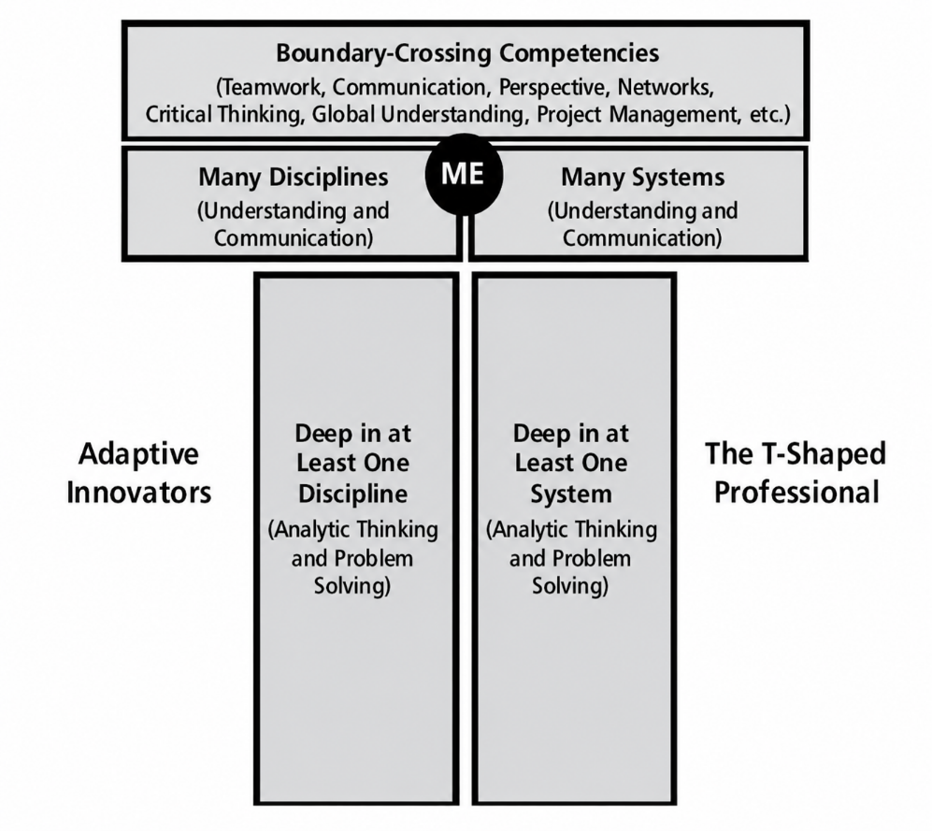
Figure 4. A T-shape professional model
(Gardner & Estry, 2017)Source: (Freund et al., 2024, p. 2) based on (Gardner & Estry, 2017)
The growing importance of the T-shaped model is particularly visible in the context of digital transformation and artificial intelligence. Unlike narrowly specialised “I-shaped” professionals, who possess deep expertise in only one field and limited interdisciplinary competencies, T-shaped professionals possess broader integrative capabilities. These capabilities support adaptability, interdisciplinary cooperation, and complex decision-making (Freund et al., 2024, pp. 3–4).
For this reason, the model is frequently associated with the concept of “Adaptive Innovators”. These are individuals capable of combining specialist expertise with collaborative leadership and holistic systems thinking in rapidly changing organisational environments (Gardner & Estry, 2017, pp. 2, 15).
Taken together, the discussed models show how thinking about competencies has gradually shifted from basic inventories of required attributes toward more layered and dynamic ways of understanding human capability. Early frameworks such as KSA and KSAO focused primarily on structuring what a person should know and be able to do in a specific role, giving organisations a clear and practical way to define job requirements. Later models, like the Iceberg and Onion approaches, went a step further by showing that competencies are not flat or fully visible, but instead consist of different layers, in which some elements are easy to observe and develop, whereas others are deeply embedded, more stable, and harder to access. More recent concepts, such as the T-shaped model, reflect how work itself has changed, highlighting that specialist knowledge alone is no longer enough and that the ability to connect across disciplines, collaborate, and adapt to changing contexts has become equally important. These models ultimately lead to a similar conclusion: competencies are not fixed traits, but shifting combinations of knowledge, skills, and deeper personal characteristics whose importance depends on context and the way work is changing today.

Types of competencies
Building on the discussion of competency models, the next step is to move from how competencies are structured to what they actually consist of in practice. At this point, the literature shifts attention towards different types of competencies, which allows for a more precise understanding of how various dimensions of human capability are defined, grouped, and applied in organisational settings. This typological perspective is essential for distinguishing between the kinds of competencies that support everyday task performance and those that shape broader professional effectiveness.
The wide scope and multidimensional nature of the concept of competencies naturally necessitate their categorisation. In the literature, the variety of classification approaches is virtually proportional to the number of researchers engaging with this discipline. The primary driver behind the development of successive typologies is the need to organise dispersed and heterogeneous concepts, although the methodological approaches applied for this purpose vary considerably (Filipowicz, 2016, pp. 90–91). As a result, competency typologies frequently overlap and complement one another, reflecting different perspectives on the nature, purpose, and application of competencies in both organisational and individual contexts (Wiśniewska, 2021, p. 20).
One of the theoretical foundations in this area is the concept developed by R.L. Katz, dating back to the 1950s. Although the author initially focused his analyses on managerial effectiveness, he distinguished three fundamental domains of abilities that determine the effectiveness of task performance at different levels of the organisational hierarchy (Filipowicz, 2016, p. 91).
- Technical competencies: These encompass specialised knowledge, familiarity with procedures, technologies, and production processes, as well as the operational use of tools and equipment. They form the basis for everyday problem-solving and for supporting subordinates (Filipowicz, 2016, p. 91).
- Social (interpersonal) competencies: These are defined as the ability to constructively shape relationships and exert influence. They include, among others, empathy, communication skills, cooperation, and diplomatic intuition, all of which determine the quality of interactions within the business environment - both internal and external (Filipowicz, 2016, p. 91).
- Conceptual competencies: These are associated with analytical and synthetic thinking processes, strategic reasoning, the generation of solutions under conditions of uncertainty, and the anticipation of market changes, which are essential for designing long-term organisational strategies (Filipowicz, 2016, p. 91).
The key value of Katz’s typology lies in the link between competency categories and different levels of the managerial hierarchy. As illustrated in Figure 5, the relative importance of each competency group changes depending on the managerial level. At the operational level, front-line managers rely mainly on technical competencies supported by social skills. As individuals move into middle management, interpersonal competencies become more important, including team coordination and motivating others. At the same time, the importance of purely technical knowledge decreases, while conceptual competencies begin to gain relevance. At the top strategic level, conceptual competencies become the main driver of success, whereas technical expertise plays a much smaller role and is often replaced by reliance on specialist advisors. This progression highlights how the emphasis shifts from technical competencies at lower organisational levels to conceptual competencies at higher managerial positions, while social competencies remain equally important throughout the hierarchy (Filipowicz, 2016, p. 92).
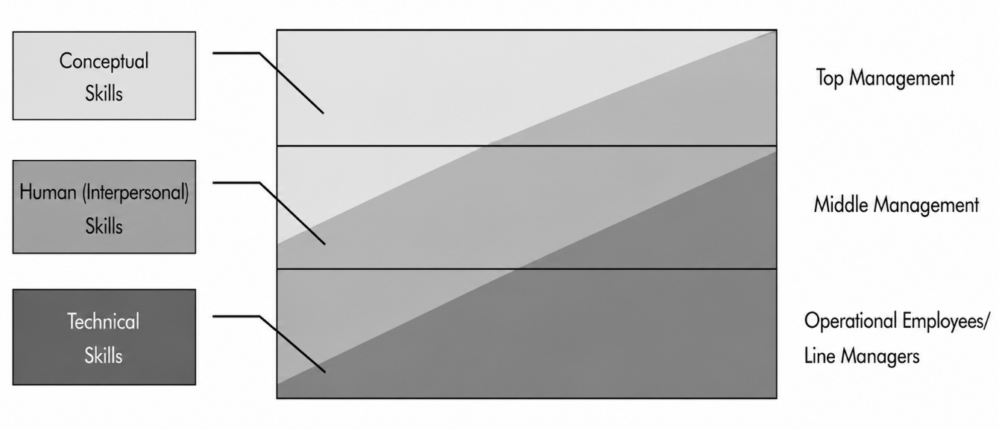
Figure 5. Katz's competency groups
Source: own study based on (Filipowicz, 2016, p. 92)
Despite its logical structure, the typology also has certain limitations. The author did not provide a closed or fully precise set of definitions assigned to each category. In addition, the rigid division does not account for the diversity of organisational cultures. In modern organisations, even lower-level managers are often involved in strategic processes, while top management is increasingly expected to possess a strong understanding of technological details (Filipowicz, 2016, pp. 92–93).
These limitations encouraged researchers and practitioners to develop alternative competency classifications that would better reflect the complexity of organisational reality. A different perspective is offered by the taxonomy developed by the consulting firm McBer, which identified six major competency domains (Filipowicz, 2016, p. 93):
- Achievement and action orientation: The essence of this cluster is a bias toward action directed more at task accomplishment than at impacting other people. It involves a concern for working well or competing against standards of excellence, ranging from one's own past performance to unique accomplishments or innovation. Key competencies in this group include achievement orientation, concern for order, initiative, and information seeking (Spencer & Spencer, 1993, pp. 25–34).
- Helping and human service: This cluster involves the intention to meet the needs of others. It is based on attuning to the concerns, interests, and requirements of others - interpersonal understanding - and working actively to satisfy those needs- customer service orientation (Spencer & Spencer, 1993, pp. 37–40).
- The impact and influence cluster: Reflecting an individual's concern with influencing others, this cluster expresses the intention to persuade, convince, or induce others to support a specific agenda. It includes competencies such as impact and influence, organisational awareness, and relationship building (Spencer & Spencer, 1993, pp. 44–50).
- Managerial competencies: These are a specialised subset of the impact and influence competencies that express the intention to have specific effects on a team or organisation. They include developing the potential of others, leading groups, fostering teamwork and cooperation, and using positional power - directiveness - to ensure compliance (Spencer & Spencer, 1993, pp. 54–64).
- Cognitive competencies: This domain functions as an intellectual version of initiative, where the individual works to understand a situation, task, or body of knowledge. These competencies measure how a person applies their intelligence to work situations through analytical thinking, conceptual thinking, and the application of technical/professional expertise (Spencer & Spencer, 1993, pp. 67–73).
- Personal effectiveness: These competencies reflect an individual's maturity in relation to others and to their work. They control the effectiveness of a person's performance when dealing with immediate environmental pressures, stress, and difficulties. This cluster includes self-control, self-confidence, flexibility, and organisational commitment (Spencer & Spencer, 1993, pp. 78–86).
The underlying assumption of this framework is that competencies within each domain are strongly interrelated and tend to occur together, while the relationships between different domains remain relatively weak. However, critical analysis of this classification reveals certain methodological inconsistencies. In particular, the first and third domains have been questioned, as they appear to describe specific behaviours and individual competencies rather than broad, overarching competency categories. The lack of clear empirical evidence makes it difficult to either definitively reject or uncritically accept this taxonomy (Filipowicz, 2016, p. 93).
In response to the limitations of earlier frameworks, the Universal Competency Model was developed as a more comprehensive approach, enabling the classification of virtually any set of professional skills within four fundamental categories. The model is based on the principle of within-context coherence, which assumes that the development of one attribute tends to stimulate the growth of related capabilities within the same category. This assumption provides a strong practical foundation for understanding competency development and assessment (Filipowicz, 2016, pp. 93–94).
The model comprises the following four competency groups:
- Social competencies: These determine the quality of interpersonal interactions both within the organisation and in external relationships, such as those with clients, business partners, or suppliers. They facilitate effective communication, cooperation, relationship building, and the ability to influence others (Filipowicz, 2016, pp. 93–94).
- Personal competencies: These are directly related to the manner in which individuals perform their tasks and responsibilities. They influence the pace, reliability, adaptability, and overall effectiveness of professional activities (Filipowicz, 2016, pp. 93–94).
- Managerial competencies: This category encompasses a broad range of behaviours associated with leading and managing people. It includes interpersonal and organisational aspects of management, as well as competencies required for coordinating teams, making decisions, and directing strategic processes (Filipowicz, 2016, pp. 93–94).
- Professional competencies: These are closely linked to the specific requirements of a particular position or professional role. They include specialised domain knowledge (e.g., legal, financial, or technical expertise) as well as job-specific technical skills and the ability to use professional tools and systems (Filipowicz, 2016, pp. 93–94).
It should be noted that the author does not present this framework as a formal competency model in the strict theoretical sense. Rather, it serves as a practical classification system designed to organise a broad range of competencies into a limited number of coherent categories. The term Universal Competency Model is used to emphasise its applicability to virtually any competency set and organisational context (Filipowicz, 2016, pp. 93–94).
A key assumption underlying this framework is the coherence of competencies within each category. In practice, this means that the development of one competency is likely to facilitate the development of other competencies belonging to the same group. For example, an individual who actively develops communication skills will generally find it easier to improve competencies such as presentation delivery than unrelated competencies such as specialised professional knowledge. Consequently, both communication and presentation skills are classified as social competencies. Although this principle of classification cannot be regarded as fully precise from a methodological perspective, its practical usefulness has been widely recognized (Filipowicz, 2016, pp. 93–94).
An important assumption of the model is that personal and social competencies constitute a universal foundation upon which more advanced competency groups are built. A sufficient level of these fundamental competencies is considered a prerequisite for the effective development and application of managerial and professional competencies. For example, inadequate communication skills may significantly hinder the performance of complex managerial activities such as delegation, motivation, or conflict resolution (Filipowicz, 2016, pp. 93–94).
Although the Universal Competency Model is primarily heuristic in nature and does not claim absolute conceptual precision, its practical applicability has made it a valuable tool for competency mapping, employee development, and human capital management in contemporary organisations (Filipowicz, 2016, pp. 93–94).
Another competency classification is based on the scope of their applicability and distinguishes between transferable and specific competencies (Wiśniewska, 2021, p. 22).
- Transferable competencies:These can be effectively applied across different jobs, positions, industries, and organisational contexts. Their versatility enables individuals to utilise their qualifications in a wide range of professional and non-professional situations, making them particularly valuable in dynamic labour markets characterised by frequent career transitions (Wiśniewska, 2021, p. 22).
- Specific competencies: These are highly specialised and closely linked to particular professional roles, technologies, or organisational processes. They are typically developed through extensive experience and are essential for performing complex tasks requiring advanced domain-specific expertise (Wiśniewska, 2021, p. 22).
This distinction is highly relevant to professional mobility; however, another widely recognised classification of competencies is based on their key components, distinguishing between hard and soft competencies (Wiśniewska, 2021, p. 21):
- Hard competencies: These refer to the knowledge and technical skills required to perform a specific profession or occupy a particular position. They encompass expertise characteristic of a given field and enable the effective use of specific methods, tools, techniques, processes, and procedures. Due to their technical nature, hard competencies are often expressed in a precise, measurable, and algorithmic manner (Wiśniewska, 2021, p. 21).
- Soft competencies: These are more universal and applicable across a wide range of occupations and organisational contexts. They are primarily related to behaviour, interpersonal relations, communication, and cooperation with others. Unlike hard competencies, they can be developed through diverse experiences and are generally more difficult to measure and evaluate objectively (Wiśniewska, 2021, p. 21).
The concept of soft skills gained prominence in the 1970s, particularly within the United States Army, where increasing attention was paid to competencies related to managing people, handling information, and operating in situations characterized by uncertainty. Unlike hard skills, which were associated with standardized technical tasks and clearly defined procedures, soft skills referred to abilities involving human interaction, supervision, communication, and decision-making in less predictable contexts. Despite their growing importance, the terminology surrounding soft skills remains inconsistent, with the literature using various related terms such as key competencies, transversal skills, life skills, and twenty-first-century skills (Kubátová et al., 2025, p. 3).
Contemporary research emphasizes the transferable nature of soft skills, distinguishing them from hard skills that are typically linked to specific occupations or technical functions. Soft skills are generally categorized into two broad dimensions: intrapersonal skills, which involve self-management and self-regulation, and interpersonal skills, which relate to interactions and cooperation with others. Among the competencies most frequently identified as essential in modern workplaces are communication, teamwork, problem-solving, creativity, critical thinking, leadership, adaptability, emotional intelligence, and decision-making. Their increasing importance reflects the growing demand for employees who can effectively navigate complex organisational environments and rapidly changing labour market conditions (Kubátová et al., 2025, pp. 3–32).
The growing recognition of the importance of soft skills has also encouraged researchers to examine their underlying nature and their role within broader competency frameworks. Building upon the previously discussed Iceberg Model, L. Spencer and S. Spencer linked the distinction between hard and soft skills directly to the different layers of the iceberg. Hard skills correspond to the visible part of the model and include knowledge and technical skills required to perform specific tasks. These competencies are relatively easy to observe, assess, and develop through traditional education and training. In contrast, soft skills are located beneath the surface and encompass self-concept, personality traits, and motives. According to the researchers, these underlying competencies play a crucial role in determining superior job performance because they function as the internal “causal flow” that transforms knowledge and skills into effective action. While hard skills serve primarily as threshold competencies that enable individuals to perform a job at a basic level, soft skills act as differentiating competencies that distinguish outstanding performers from average employees. Consequently, Spencer and Spencer argued that organisations should place greater emphasis on identifying and selecting candidates with the appropriate underlying personal characteristics, as it is generally easier to develop technical knowledge and skills than to change deeply rooted traits and motivations. (Spencer & Spencer, 1993, pp. 11–15)
The importance of soft skills has become even more pronounced with the rapid development of artificial intelligence and other digital technologies. While AI systems increasingly perform routine, technical, and even cognitive tasks, soft skills remain uniquely human competencies that are difficult to automate. Abilities such as communication, empathy, emotional intelligence, ethical judgment, adaptability, and relationship-building enable individuals to navigate complex social situations and make decisions in contexts characterised by uncertainty. Consequently, contemporary research emphasizes that professional success in the digital era depends not only on technical expertise but also on the capacity to effectively combine technological tools with distinctly human capabilities. As organisations continue to integrate artificial intelligence into their operations, soft skills are increasingly viewed as a critical factor supporting resilience, employability, and long-term career development (Kubátová et al., 2025, pp. 103–105).

Hierarchies of competencies
The structural division of competencies into specific types naturally introduces the question of their mutual relationship and hierarchical organisation. Academic literature consistently emphasizes that human capabilities do not operate in isolation or as a homogeneous set of equivalent traits. Instead, they form a systemic, vertical architecture where individual attributes are structurally dependent on one another. Analyzing these attributes through a hierarchical lens is essential for understanding how foundational, core capacities serve as mandatory structural prerequisites for the development of advanced professional and domain-specific skills (Wiśniewska, 2021, pp. 18–19).
A prominent framework for understanding the hierarchical structure of competencies was proposed by Marcin Kocór, who organised competencies into three progressively specialised levels. The model is based on the assumption that the development of more advanced competencies depends on the prior acquisition of more fundamental ones. Within this hierarchy, three levels of competencies can be distinguished (Wiśniewska, 2021, pp. 18–19):
- Key competencies: These are located at the foundation of the hierarchy, these competencies represent the basic cognitive and technical abilities required for the development of more advanced competencies. They include fundamental capabilities such as reading comprehension, mathematical skills, and the effective use of information and communication technologies. Without an adequate level of these competencies, further professional development may be significantly limited (Wiśniewska, 2021, pp. 18–19).
- General competencies: These positioned at the intermediate level, these competencies are transferable across different occupations and organisational contexts. Their broad applicability allows individuals to perform effectively in a variety of roles and work environments. Examples include managerial abilities, communication and interpersonal skills, technical adaptability, artistic abilities, and self-management skills (Wiśniewska, 2021, pp. 18–19).
- Professional competencies: These representing the most specialised level of the hierarchy, these competencies are directly related to the requirements of a particular profession or job position. They include specialised knowledge and skills necessary for performing occupation-specific tasks, such as the use of dedicated professional tools, technologies, or software (Wiśniewska, 2021, pp. 18–19).
The number and complexity of professional competencies depend on the nature and complexity of the tasks performed within a particular occupation. Due to their specific and measurable character, these competencies often serve as the basis for the development of national and international qualification frameworks. The hierarchical relationship between the three competency levels is illustrated in Figure 6 (Wiśniewska, 2021, pp. 18–19).
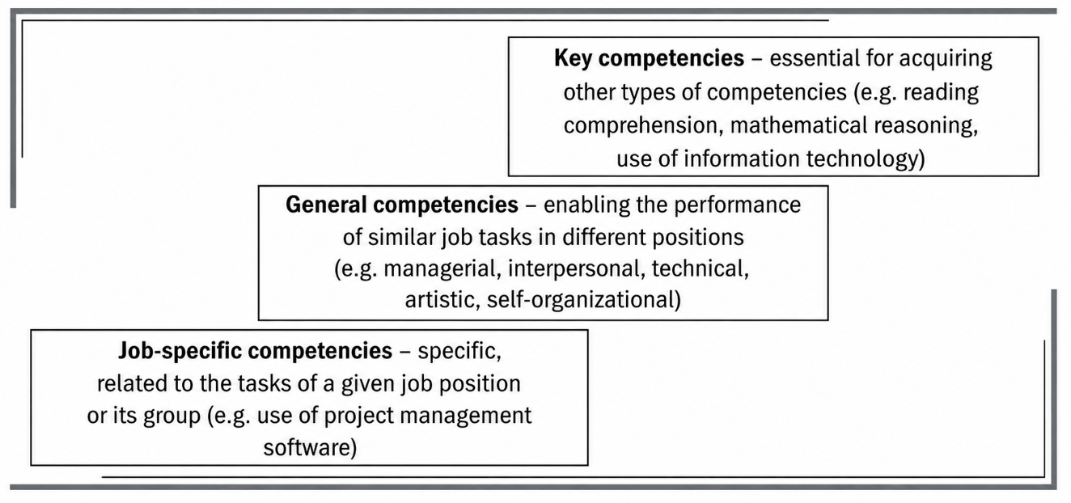
Figure 6. Competence levels
Source: (Wiśniewska, 2021, p. 19) based on (Kocór, 2019)
An alternative perspective on competency hierarchies is provided by the skill acquisition model developed by Stuart and Hubert Dreyfus. Unlike M. Kocór’s framework, which classifies competencies according to their level of specialization, the Dreyfus model focuses on the developmental progression through which individuals acquire and refine competencies over time (Dreyfus & Dreyfus, 1980).
The Dreyfus model conceptualizes competency development as a progression from strict rule-based behaviour to intuitive and experience-based performance. The model distinguishes five successive stages: novice, competent performer, proficient performer, expert, and master. At the novice level, individuals rely heavily on explicit instructions and predefined rules. As experience accumulates, they begin to recognize recurring situational patterns and develop the ability to interpret context rather than merely follow procedures (Dreyfus & Dreyfus, 1980, pp. 5–15).
At the proficient stage, decision-making becomes increasingly guided by situational understanding and the ability to identify the most relevant aspects of a problem. Expertise is reached when extensive practical experience allows individuals to respond intuitively to complex situations without consciously applying analytical rules. The highest stage, mastery, is characterised by complete absorption in the activity and exceptionally fluid performance, where action and understanding become almost inseparable (Dreyfus & Dreyfus, 1980, pp. 10–16)
An important contribution of the model is its explanation of how cognitive processes change throughout competency development. As illustrated in Figure 7, memory evolves from context-independent to situational recollection, recognition shifts from fragmented to holistic perception, decision-making progresses from analytical reasoning to intuition, and awareness develops from conscious monitoring to full immersion in the task. These transformations demonstrate that competency development involves not only the acquisition of knowledge and skills but also fundamental changes in the way individuals perceive, interpret, and respond to their environment (Dreyfus & Dreyfus, 1980, p. 15)
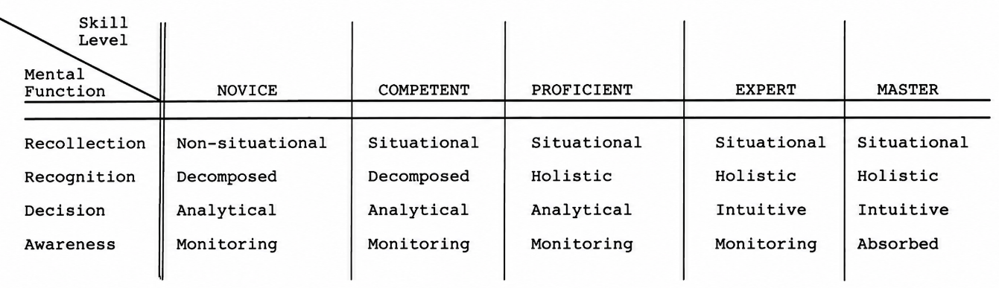
Figure 7. The five stages of skill acquisition
Source: (Dreyfus & Dreyfus, 1980, p. 15)
The Dreyfus model therefore highlights that higher levels of competence are achieved primarily through experience and practice rather than through the accumulation of formal rules alone. This perspective has important implications for education, professional training, and competency development programmes, emphasising the need to combine theoretical instruction with opportunities for experiential learning (Dreyfus & Dreyfus, 1980, pp. 5, 16).
It is also worth noting that hierarchical relationships between competencies are reflected in several competency models discussed earlier. For example, both the Iceberg Model and the Onion Model assume that observable competencies, such as knowledge and skills, are rooted in deeper and more stable personal characteristics, including motives, values, personality traits, and self-concept. While competency typologies primarily focus on identifying and categorising different types of competencies, hierarchical approaches highlight the relationships between them and the progressive nature of their development. Together, these perspectives provide a more comprehensive understanding of how competencies are structured, acquired, and applied in both professional and organisational contexts.

Labour market demand for competencies in the era of Industry 4.0 and digital transformation
The dynamic development of digital technologies has fundamentally transformed the economic and social environment in which contemporary organisations operate. One of the most influential concepts describing these changes is the Fourth Industrial Revolution, commonly referred to as Industry 4.0. It marks a profound shift in how people live, work, and relate to one another. Rather than a sudden break with the past, it can be seen as the latest phase in a long chain of major societal transformations. Industry 4.0, first introduced as a concept at the Hannover Fair in 2011, represents a new stage of socio-economic development characterised by the convergence of digital, physical, and biological technologies. Unlike previous industrial revolutions, which were driven by singular technological breakthroughs, the current transformation is distinguished by its unprecedented speed, scale, and systemic impact on economies, organisations, and labour markets (Schwab, 2016, pp. 7–12). At its core, Industry 4.0 involves the integration of information and communication technologies into industrial environments, enabling production systems to become increasingly interconnected, intelligent, and data-driven. This transformation is associated with the digitalisation and personalisation of production processes, greater levels of automation and system adaptability, closer cooperation between humans and machines, and the continuous exchange of data across integrated networks. By leveraging advanced digital technologies, organisations can collect and process vast amounts of information, apply sophisticated analytical methods, and use virtual models to support more informed and effective decision-making processes (Szabó et al., 2023).
The increasing integration of technologies such as artificial intelligence, advanced robotics, the Internet of Things, big data analytics, and cloud computing is reshaping production processes, business models, and patterns of work. These developments have accelerated the digital transformation of organisations and contributed to the emergence of highly interconnected digital environments in which human workers and intelligent technologies increasingly cooperate. As a result, labour markets are undergoing significant structural changes, affecting not only the number and distribution of jobs but also the competencies required for effective participation in professional life (Schwab, 2016, pp. 7–12, 37–45).
Industry 4.0 simultaneously creates opportunities and challenges for employment. While automation enables organisations to increase productivity and efficiency, it also reduces the demand for routine and repetitive tasks that can be performed more effectively by machines. At the same time, technological progress generates new occupations and professional roles that require a combination of analytical, technological, and interpersonal competencies. Consequently, the focus of labour market demand is shifting from narrowly defined technical expertise toward broader competency profiles that combine digital literacy, adaptability, problem-solving abilities, and continuous learning capacity (Schwab, 2016, pp. 37–47).
The transformation of work processes further increases the importance of competencies that are difficult to automate. As intelligent technologies assume responsibility for routine activities, uniquely human capabilities such as creativity, critical thinking, collaboration, emotional intelligence, and complex decision-making become increasingly valuable. In this context, the labour market is gradually shifting toward what is often described as “talentism,” a model in which human talent becomes a central factor of production. This shift reflects the growing importance of individual adaptability, creativity, and the ability to operate in complex, technology-driven environments. As a result, competitiveness in the labor market depends not only on formal qualifications but also on an individual's ability to adapt to rapidly changing technological and organisational conditions. Therefore, understanding the evolving demand for competencies has become essential for employees, employers, educational institutions, and policymakers seeking to respond effectively to the challenges of digital transformation (Schwab, 2016, pp. 43–47, 59–60).
The Fourth Industrial Revolution provides a useful framework for understanding the transformations taking place in contemporary labour markets. However, a more comprehensive understanding of current competency requirements can be gained through recent empirical studies and international labour market reports. These sources offer valuable insights into the competencies that are currently most sought after and increasingly determine success in a rapidly changing world of work.
The accelerating integration of digital technologies is fundamentally reshaping labour markets on a global scale. As illustrated in Figure 8, employers expect a substantial share of workers' core skills to change within a five-year period. According to the World Economic Forum's Future of Jobs Report 2025, employers anticipate that approximately 39% of workers' core skills will change by 2030, a figure that, while marginally lower than the 44% projected in 2023, still signals substantial and ongoing disruption. The slight stabilization in this estimate likely reflects growing employer experience with managing technological change, as well as an increase in continuous learning programmes: 50% of the surveyed workforce had completed training as part of long-term learning strategies in 2024, compared with only 41% in 2023 (World Economic Forum, 2025, pp. 32–33).
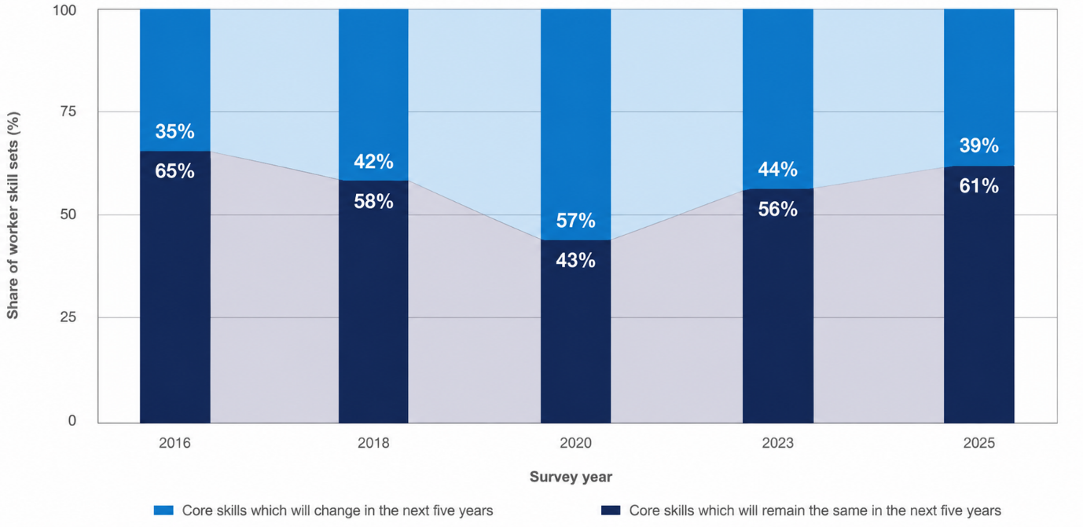
Figure 8. Expected disruption of workers’ core skills between 2016 and 2025
Source: (World Economic Forum, 2025, p. 33) based on Future of Jobs Surveys 2016, 2018, 2020, 2022 and 2024
The experience gained during and after the COVID-19 pandemic has also contributed to a better understanding of the competencies required in increasingly digitalised work environments. The accelerated adoption of digital tools, remote working arrangements, machine learning technologies, and generative artificial intelligence has enabled organisations to identify emerging skill requirements more effectively and to prepare employees for evolving job demands. As a result, employers have become more aware of future competency requirements and the importance of workforce upskilling and reskilling (OECD, 2025).
Nevertheless, projected skills disruption is not expected to occur uniformly across economies. Lower-middle and upper-middle-income economies, as well as those affected by geopolitical conflict, tend to foresee greater levels of skills instability, while high-income economies expect comparatively less disruption. Poland, for instance, registers among the lower end of projected disruption at 31%, suggesting a more gradual, though still significant, transformation of skill requirements. Beyond changes in the skills demanded by employers, technological transformation is also expected to alter the occupational structure of labour markets (World Economic Forum, 2025). McKinsey Global Institute projects that technological change will significantly reshape labour markets in the coming years. As employment demand shifts away from declining occupations towards emerging professional roles, up to 12 million workers in Europe may need to change occupations by 2030 (Hazan et al., 2024). These developments highlight the growing importance of identifying and developing the competencies that will enable individuals to remain competitive in an increasingly dynamic labour market.
Results from the Future of Jobs Survey 2024, conducted among 1,504 employers worldwide, indicate a clear shift in the skills considered essential in the modern workforce. Employers increasingly value a combination of cognitive, social, and self-management competencies rather than narrow technical or routine abilities. Figure 9 illustrates the relative importance assigned to different skill categories, revealing a clear dominance of cognitive, self-efficacy, and interpersonal competencies. A closer examination of the highest-ranked skills provides further insight into the competencies that employers consider most critical for success in the contemporary labour market (World Economic Forum, 2025, pp. 35–36).
Cognitive competencies are the most highly valued category, with analytical thinking identified as a core skill by nearly seven in ten employers. Notably, it has consistently ranked first across all three editions of the Future of Jobs Report published in 2021, 2023, and 2025, underlining its enduring importance in an increasingly complex and data-driven work environment. Creative thinking also ranks among the most valued competencies, reflecting its close connection to innovation and the ability to solve problems in situations where algorithmic solutions alone are insufficient (World Economic Forum, 2025, pp. 35–36).
At the same time, employers place strong emphasis on capabilities related to self-efficacy, particularly resilience, flexibility, and agility, which occupy the second position in the ranking of core skills. Their prominence highlights the growing demand for employees who can adapt to rapidly changing conditions, cope with uncertainty, and maintain high levels of performance in dynamic environments. Similarly, motivation and self-awareness are regarded as increasingly important attributes, reflecting employer interest in individuals with strong intrinsic drive and the capacity for reflective self-management (World Economic Forum, 2025, pp. 35–36).
Interpersonal and leadership-related skills also occupy a prominent position in the ranking of core competencies. Leadership and social influence rank third overall, highlighting the growing importance of employees who can effectively guide teams, influence decision-making processes, and facilitate collaboration across increasingly complex organisational structures. Similarly, empathy and active listening, together with service orientation, suggest that organisations place significant value on individuals capable of building strong relationships with colleagues, customers, and other stakeholders (World Economic Forum, 2025, pp. 35–36).
Furthermore, curiosity and lifelong learning underscore the importance of continuous professional development in response to rapid technological and organisational transformation. Talent management is also gaining importance as organisations face talent shortages and increasingly seek to develop internal capabilities through employee development and retention strategies. The growing prominence of these competencies reflects a broader shift associated with Industry 4.0, where technological advancement not only increases the demand for digital skills but also enhances the value of human-centred capabilities. As automation and artificial intelligence assume a greater share of routine tasks, skills related to leadership, communication, collaboration, adaptability, and continuous learning become essential for effectively navigating digitally transformed workplaces (World Economic Forum, 2025, pp. 35–36).
Although technology-related competencies are not among the highest-ranked skills, technological literacy and AI and big data have gained considerable importance. Other notable competencies include systems thinking, resource management and operations, as well as networks and cybersecurity. Particularly noteworthy is the growing importance of AI and big data, which has recorded a 17 percentage-point increase since 2023, reflecting the rapid integration of artificial intelligence technologies across industries. In contrast, skills associated with routine and standardised tasks, including dependability and attention to detail, quality control, and manual dexterity, have declined in relative importance since the previous edition of the report. This shift suggests that the ongoing automation of structured and repetitive activities is transforming skill requirements and increasing demand for competencies better aligned with digitally enabled work environments (World Economic Forum, 2025).
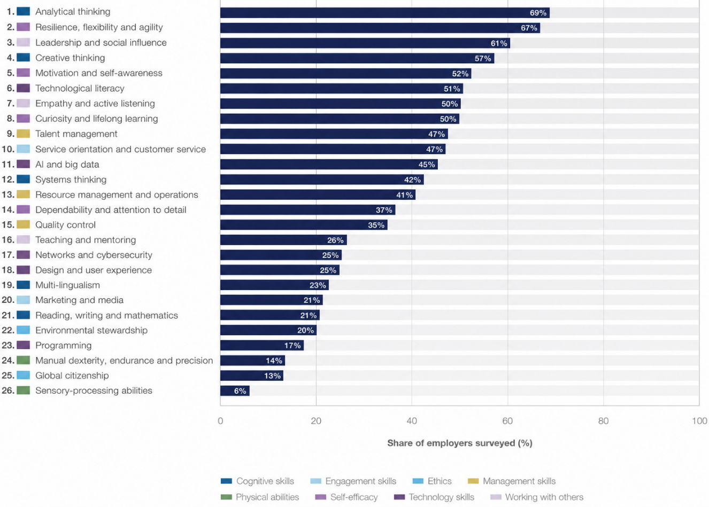
Figure 9. Core skills in 2025
Source: (World Economic Forum, 2025, p. 34) based on Future of Jobs Survey 2024
These findings are consistent with recent research on the impact of artificial intelligence on labour markets, which suggests that technological advancement is reshaping, rather than eliminating, the role of human skills in the workplace. Importantly, recent evidence suggests that artificial intelligence should not be viewed solely as a substitute for human labour. The OECD argues that, particularly in non-routine cognitive occupations, AI is more likely to augment human capabilities by improving productivity, supporting decision-making, and expanding the range of tasks workers can perform. As a result, labour market demand increasingly favours individuals capable of effectively collaborating with AI systems rather than simply competing against them (OECD, 2025).
According to McKinsey Global Institute, approximately 27% of current working hours in Europe and 30% in the United States could be automated by 2030 under a moderate adoption scenario of generative artificial intelligence. The report emphasises that generative AI significantly expands the automation potential of complex cognitive tasks that were previously considered resistant to automation. These developments are expected to transform job content across a wide range of occupations and further increase demand for advanced analytical, technological, and interpersonal competencies that complement rather than compete with intelligent systems (Hazan et al., 2024).
As artificial intelligence increasingly automates routine cognitive tasks, individual motivation and engagement become more important determinants of performance. OECD research suggests that workers who actively engage with complex and ambiguous challenges are more likely to create value in AI-augmented environments. Therefore, intrinsic motivation is emerging as an increasingly important factor supporting employability and career success in the digital economy (OECD, 2025).
While individual-level factors such as motivation and engagement are becoming increasingly relevant in AI-augmented work environments, these developments are reflected in broader shifts in skill demand. Future labour market projections confirm that technological transformation is reshaping not only how work is performed, but also which skills will grow or decline in importance over the coming years. These macro-level projections are reflected in employer-level assessments of future skill demand.
Figure 10 shows a striking polarization in the future of work as skills grow in importance by 2030. It presents employer expectations for the evolution of specific skill categories over a five-year horizon expressed as a net increase score which is the difference between the share of employers expecting a skill to grow in use and those expecting it to decline (World Economic Forum, 2025).
Among the fastest-growing categories, technological competencies lead by a considerable margin with a net increase of 87 percentage points. AI and big data stands out as the most dynamic area of growth, reflecting not only the expansion of AI tools across industries but also a deeper organisational shift toward workers who can interpret, govern, and collaborate with intelligent systems rather than simply operate them. Networks and cybersecurity as well as technological literacy follow closely, underscoring that digital infrastructure has become as foundational to modern organisations as physical infrastructure once was, and that its maintenance now requires a growing and specialised human skill base (World Economic Forum, 2025, pp. 37–38).
What is perhaps more revealing, however, is the strength of non-technical competencies in the upper tier of the ranking. Creative thinking and resilience, flexibility and agility share identical growth trajectories, pointing to a labor market that prizes not only what workers know, but how they respond to the unknown. Socio-emotional and cognitive skills also feature prominently among the fastest-growing categories. Creative thinking - innovation and the ability to generate novel solutions - are increasingly valued as automation assumes responsibility for standardised tasks. Curiosity and lifelong learning reflect employer demand for workers who proactively update their skill sets in response to technological and organisational change. Leadership and social influence is rising across sectors, with particularly strong growth in automotive and aerospace, telecommunications, and education. Talent management, driven in part by demographic pressures such as ageing workforces in high-income economies, highlights the growing importance of retaining and developing internal talent. Together, these trends suggest that organisations are preparing for prolonged uncertainty and increasingly investing in human capabilities that complement rather than compete with automation (World Economic Forum, 2025, pp. 37–38).
The trajectory of analytical thinking deserves particular attention. It continues to increase in importance. As of 2025, it is ranked among the top skills, reflecting its central role in modern work environments. This trend is consistent with the growing complexity of data-driven decision-making contexts. Its position among the most valued core skills overall confirms that the ability to make sense of complex, data-rich environments remains indispensable, even as AI tools become more sophisticated. Similarly, the rise of environmental stewardship reflects an important structural change, as sustainability is no longer a peripheral concern but a competency increasingly embedded in core workforce strategies across energy-intensive and manufacturing sectors (World Economic Forum, 2025, pp. 37–38).
At the opposite end of the spectrum, the data delivers a historically significant signal. For the first time in the Future of Jobs Report series, manual dexterity, endurance and precision register a net negative score, indicating an anticipated decline in demand for physical labour skills. This is not merely a statistical footnote. It marks a qualitative threshold in the automation of physical tasks and raises pressing questions about workforce transitions in sectors where such skills have long been central. Reading, writing and mathematics also show a marginal downward trend, suggesting that even foundational cognitive skills are being supplemented and, in some contexts, partially substituted by digital tools (World Economic Forum, 2025, pp. 37–38).
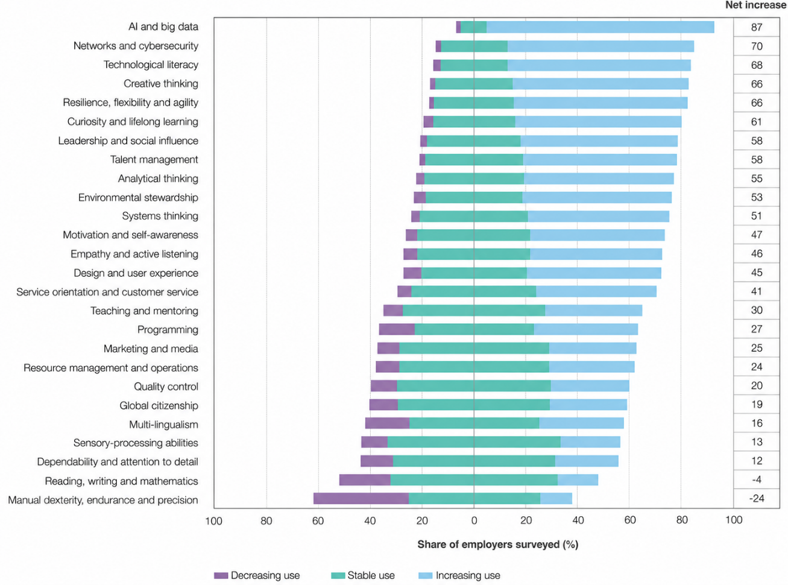
Figure 10. Forecasted changes in skill demand, 2025-2030
Source: (World Economic Forum, 2025, p. 37) based on Future of Jobs Survey 2024
Taken together, the findings presented in this section highlight a clear dual transformation of labour market competencies in the era of Industry 4.0 and digitalisation. On the one hand, there is a sustained and growing importance of human-centred and socio-emotional skills such as creative thinking, collaboration, leadership, and adaptability. These competencies remain difficult to automate and therefore continue to play a critical role in shaping effective performance in complex, uncertain, and rapidly changing work environments. Even as analytical thinking maintains its position as the most consistently valued core skill, its continued relevance reflects the increasing complexity of data-driven decision-making rather than a replacement of human judgement.
On the other hand, the analysis also confirms that technological competencies are gaining strategic importance and are expected to assume even greater prominence in the future. Skills such as AI and big data, technological literacy, and networks and cybersecurity are projected to experience the strongest growth, indicating that digital infrastructure and data-driven systems are becoming fundamental components of modern economies and organisations. This suggests that while human-centred skills remain essential, they are increasingly complemented by advanced technical capabilities, rather than existing in isolation from them.
At the same time, the findings indicate a declining relevance of skills associated with routine and physical tasks. In particular, manual dexterity, endurance, and precision are expected to decrease in importance as a result of the growing ability of technology to perform routine, repetitive, and physically structured activities more efficiently. This reflects the ongoing automation of standardised processes, which reduces demand for traditional forms of manual labour and reshapes the occupational structure of work.
A particularly important implication of these trends is the growing significance of curiosity and lifelong learning as a meta-competency. In an environment characterised by accelerating technological change and continuous restructuring of labour markets, the ability and willingness to constantly update one’s skills become a key determinant of long-term employability. Individuals who are open to learning, capable of adapting to new conditions, and motivated to continuously develop their capabilities are more likely to remain resilient in the face of ongoing transformation.
The evolution of labour market demand reflects not a replacement of human skills by technology, but rather a reconfiguration of their relative importance. The future of work is increasingly shaped by the interaction between human capabilities and advanced technologies, where success depends on the ability to combine analytical and technical proficiency with creativity, social intelligence, and continuous learning.
This systemic reconfiguration of skills directly challenges traditional higher education. If continuous adaptation has become the definitive meta-competency for the modern workforce, academic institutions must reflect the same structural agility. Static educational frameworks can no longer rely solely on historical standards; they require localised, real-time verification to remain relevant amid such rapid technological transformations. To translate these macro-level theoretical insights into a precise diagnostic tool, the analytical focus must shift from global projections to localised empirical data. The mismatch between rapidly evolving technology and academic curriculum adaptation represents a critical operational gap that can only be evaluated through direct, data-driven confrontation.

Research methodology

Research problem, aim and objectives
Skills mismatch is a multidimensional phenomenon encompassing various forms of labour market friction, including vertical mismatch (overeducation and overskilling), horizontal mismatch (field-of-study mismatch), skill gaps, and skill shortages. Although the concept is widely used in policy and academic discourse, it remains notoriously difficult to observe and measure directly due to the retrospective, static, and infrequent nature of conventional data sources, such as graduate tracer surveys, employer satisfaction surveys, and occasional sectoral reports. These traditional analytical tools are often collected too infrequently and too long after the fact to capture the rapid and dynamic evolution of workplace requirements, limiting their ability to provide timely and accurate evidence on emerging skill needs (McGuinness et al., 2018).
This methodological limitation has been increasingly emphasized in recent literature, particularly in the context of rapid technological disruption and the growing adoption of generative artificial intelligence. Contemporary research indicates that traditional sources of labour market information are becoming insufficient in the face of dynamic changes. While conventional methods offer valuable data, online job advertisements provide a rich source of real-time labour market information on specific job requirements and skills (European Centre for the Development of Vocational Training, 2017, pp. 1–6).
Consequently, contemporary research increasingly advocates a shift toward systems that collect and analyse data from online job portals using Big Data analytics. This approach complements existing skills-intelligence instruments by helping to identify emerging occupations, newly demanded skills, and changing job requirements that are not yet fully visible in static indicators (European Centre for the Development of Vocational Training, 2017, pp. 1–6). Big Data analysis also enables the detection of within-occupation variation in skills, offering a granular view of how competency requirements evolve even within the same job title. As a result, the competency gap can be understood not merely as a shortage of workers in a particular field, but increasingly as a shortage of specific, newly emerging skills. Given the scale and complexity of online job vacancy data, these analyses increasingly rely on artificial intelligence and natural language processing techniques to automatically extract, classify, and interpret skill requirements from millions of job advertisements. This enables researchers and policymakers to obtain timely and evidence-based insights into evolving labour market demands (Organisation for Economic Co-operation and Development, 2024).
This dynamic has direct consequences for higher education. Prospective students increasingly choose programmes based on how well they match current labour market expectations. As a result, universities should align curricula with both current labour market competency requirements and evidence-based forecasts of future demand, rather than relying only on what was relevant when a programme was last accredited. The challenge lies in the fact that the labour market changes faster than study programmes are updated. At many universities, there is no regular, data-driven way to verify whether a curriculum still reflects employer expectations. This is the research problem addressed in this thesis: the absence of a current, data-driven method for verifying whether university curricula still reflect what employers actually require.
The aim of this thesis is to investigate the current labour market requirements in the context of desired competencies. As an additional element, these requirements are compared with the learning outcomes of the first-cycle Business Engineering (IZ1) programme for the 2025/2026 education cycle at the Faculty of Management, Wrocław University of Science and Technology, in order to identify potential competency gaps.
This thesis approaches the competency gap as a phenomenon that can be examined using existing sources of evidence rather than relying solely on stakeholder perceptions. The analysis is based on two complementary sources: online job advertisements, which reflect employers' competency requirements, and the official learning outcomes of the selected study programme, which represent the competencies the programme is intended to develop. Comparing these sources makes it possible to assess the extent to which the programme aligns with current labour market expectations.
In line with this aim, the thesis addresses the following research questions:
- RQ1: Which competencies are most frequently required by employers in job postings relevant to the Business Engineering profile?
- RQ2: How can natural language processing and AI be used to extract and group competencies from job postings into meaningful categories?
- RQ3: What are the limitations of purely lexical, dictionary-based matching for identifying competencies in job postings, and how can these limitations be addressed using AI-based semantic analysis?
- RQ4: To what extent do the competencies emphasised in job postings correspond to the learning outcomes defined in the IZ1 curriculum?
- RQ5: What competency gaps, if any, can be identified between market demand and curriculum content?
- RQ6: Which competencies are most frequently required across different seniority levels?
Six objectives follow from the research questions, each corresponding to one of them and building on the previous objective.
Objective 1 is to identify the competencies most frequently required in job postings relevant to the Business Engineering profile. The analysis distinguishes between technical competencies, such as specific tools and methods, and broader behavioural, managerial, and methodological competencies, providing a comprehensive overview of current labour market requirements.
Objective 2 is to develop a methodology based on natural language processing and AI for extracting competencies from job postings and grouping them into meaningful competency categories. The objective is to create a structured representation of employer requirements that can be used in the subsequent stages of the analysis.
Objective 3 is to identify the limitations of purely lexical, dictionary-based matching in extracting competencies from job postings, particularly behavioural and methodological competencies expressed in varied and context-dependent language. Based on these limitations, the objective is to apply AI-based semantic analysis to identify and classify competencies that cannot be reliably captured using dictionary-based methods alone.
Objective 4 is to assess the extent to which the competencies required in job postings are reflected in the learning outcomes of the IZ1 programme. The analysis identifies both well-covered competencies and areas where no corresponding learning outcomes exist, providing a detailed picture of the programme's alignment with current labour market requirements.
Objective 5 is to identify competency gaps between labour market requirements and the learning outcomes of the IZ1 programme. The analysis highlights competencies that are strongly represented in employer demand but insufficiently reflected in the curriculum.
Objective 6 is to examine how competency requirements vary across different seniority levels. This analysis identifies which competencies are particularly relevant for entry-level roles and provides additional context for interpreting the competency gaps identified in the earlier stages of the study.

Characteristics of competencies in the IZ1 curriculum
Polish higher education programmes are required to define learning outcomes at two distinct levels of specificity. Both of them must be documented in the official programme - syllabus. In the IZ1 programme, these two levels take the form of programme-level learning outcomes named KEU and course-level learning outcomes called PEU.
Figure 11 presents the hierarchical structure of learning outcomes used in the IZ1 programme. Programme-level learning outcomes (KEU) are operationalised through course-level learning outcomes (PEU), which are defined within individual courses. Together with the corresponding course content, they form the semantic basis used later in the competency-matching procedure.
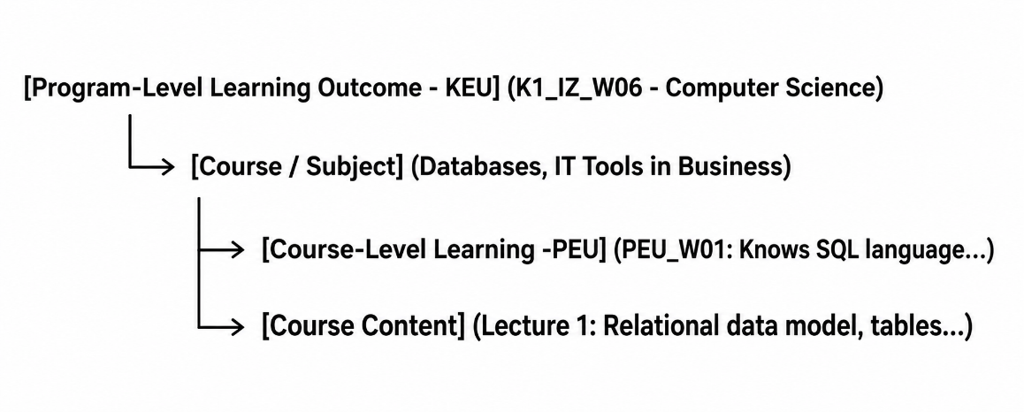
Figure 11. Structure of KEU and PEU in the IZ1 curriculum
Source: Own study based on (Wrocław University of Science and Technology. Faculty of Management, 2025)
KEU represent the broadest, most general statement of what a graduate of the programme is expected to know, be able to do, and understand. They are defined once for the entire programme. In the IZ1 curriculum, KEU codes follow a structured naming convention: the prefix K1_IZ identifies the level (K1 = first-cycle) and the field of study (IZ = Business Engineering), followed by a category letter indicating the domain W (knowledge), U (skills) and K (social competencies) - as well as a sequential number. The programme defines 28 knowledge outcomes (K1_IZ_W01–W28), 21 skill outcomes (K1_IZ_U01–U21), and 7 social competency outcomes (K1_IZ_K01–K07), yielding 56 KEU codes in total. Each KEU is formulated at a high level of generality and covers a broad thematic area. For example:
- K1_IZ_W06: Graduate possesses advanced knowledge in computer science, including information technology, computer programming, database design and implementation, knowledge bases, data warehouses and OLAP analysis, and web technologies.
- K1_IZ_U16: Graduate is able to independently or collaboratively design and implement an IT system/object - such as a computer program, database, knowledge base, data warehouse, decision-making procedure, information system, or business processes, as well as others typical for the field of Business Engineering - in accordance with the given specification, using appropriate methods, techniques, and tools.
- K1_IZ_K03: Graduate is ready to take responsibility for assigned tasks. Demonstrates the ability to effectively prioritize both independent work and collaborative efforts across various organizational roles.
This level of abstraction is deliberately broad, as the KEU are intended to describe the overall profile of the graduate rather than the content of any individual course. Taken in isolation, a single KEU does not provide enough semantic specificity to be reliably matched against the concrete language used in employer job postings. Competencies and requirements described in job postings are mostly expressed in operational, task-oriented terms such as proficiency in SQL, ability to build dashboards in Power BI, or experience with Agile project management methodologies.
To specify each KEU, all of them are connected with more specific PEU. They operate at the level of individual courses within the curriculum. Each course has its own set of PEU that describe the specific, measurable outcomes expected of a student who completes that course. PEU are formulated with greater operational detail than KEU and are directly associated with one or more KEU codes, making the relationship between individual course content and programme-level graduate competencies explicit and traceable. PEU codes within each course follow the same W/U/K domain structure as KEU, for example PEU_W01, PEU_U01, PEU_K01, though they are numbered independently within each course.
Examples from the IZ1 syllabi illustrate the contrast in specificity between the two levels:
- The course Databases defines PEU_W01 as: Student identifies and understands relational database objects. Adept at selecting appropriate database design methodologies. - linked to K1_IZ_W06. The same course defines PEU_U01 as: Student designs and implements relational database systems. - linked to K1_IZ_U16.
- The course Economy defines the same PEU_W01 as: Student characterizes selected regulatory theories and explains how social and economic regulations, along with state interventionism instruments at the national level, affect business operations - linked to K1_IZ_W23.
- The course IT Tools in Business defines PEU_W02 as: Student identifies appropriate information technologies, methods, techniques and tools for acquiring, collecting, analysing and presenting data describing economic processes and for solving managerial problems. - linked to K1_IZ_W06 and K1_IZ_W16.
These examples illustrate the core structural feature of the IZ1 competency framework. PEU are contextually specific operationalisations of KEU. A single KEU can be supported by multiple PEU across several different courses, and a single PEU typically references one or two KEU codes. This many-to-many relationship between courses, PEU, and KEU creates a web of connections that, taken as a whole, constitutes the full competency content of the programme. Importantly, unlike KEU, PEU codes are not globally unique. Identical identifiers (e.g., PEU_W01) carry different definitions depending on the specific course in which they are embedded.
The two-level structure has a direct and critical consequence for the methodology of this thesis. Connection between KEU and PEU stands at the center of the research design. KEU are formulated at a level of abstraction that does not lend itself to direct lexical or semantic matching with job posting language. This means that using KEU alone as the unit of analysis for the curriculum side of the comparison would produce results that are imprecise and difficult to interpret. A KEU such as K1_IZ_W06 - covering the entire domain of information technology, databases, and internet technologies - is too broad to determine whether a specific employer requirement is or is not addressed within the programme. Most competencies extracted from job postings require this granular level of detail to find an accurate equivalent in the curriculum. For instance, a market demand for SQL or data analytics can be explicitly mapped onto the specific PEUs of the Databases or IT Tools courses. By leveraging both levels, the matching field is precisely contextualised without losing the broader educational perspective.
PEU, provide exactly the level of operational specificity needed for this purpose. However, PEU cannot be used in isolation either, because they are not self-explanatory outside of the KEU framework to which they belong. A PEU such as: Designs and implements a relational database system carries greater meaning when it is understood as a concrete contribution to the broader programme-level competency defined by KEU.
For this reason, the analytical approach adopted in this study treats each KEU as a competency cluster whose full semantic content is constituted by the totality of PEU linked to it across all courses in the programme. The PEU texts associated with each KEU are concatenated into a single structured description, creating a composite competency profile for every KEU.
This design decision rests on the argument that the competency actually delivered by a programme is more accurately represented by what is concretely taught and assessed in individual courses (PEU) than by the programme-level summary statements (KEU) alone. At the same time, anchoring each bundle of PEU to its parent KEU ensures that the resulting competency profiles remain coherent and interpretable within the structure of the qualification as a whole. Furthermore, the ability to accurately distinguish between a genuine competency gap and an item already present in the syllabus is supported by strong evidence from these PEU-KEU interconnections, which directly informs the final determination of a competency's status.
Table 3.1 illustrates this logic with selected examples, showing how PEU from different courses aggregate into a richer, operationally specific description of their parent KEU.

Table 2. Example of PEU aggregation into composite KEU competency profiles
KEU code | KEU original description | KEU description based on PEU
K1_IZ_U08 | When executing engineering tasks -specifically those concerning IT applications in business under volatile and unpredictable conditions - is capable of planning and conducting experiments, including computer measurements and simulations. Demonstrates the ability to interpret the obtained results and draw conclusions. | Categorizes, selects, and utilizes development tools within selected software platforms for information structuring tasks aimed at decision-making based on complex information in domain-specific and natural languages. | Employs simulation methodologies to build simulation models designed to describe, improve, and forecast the course of business processes. | Plans and conducts simulation experiments to solve engineering tasks that support business process management.
K1_IZ_W14 | Possesses advanced knowledge of project management across all lifecycle stages. Familiar with project management methodologies as well as standard and dedicated IT tools, including open-source solutions for SMEs. | Explains the essence and types of project controlling. | Indicates the conditions for implementing project controlling in an organization. | Characterizes organizational and instrumental solutions in project controlling. | Characterizes selected project management methodologies (traditional, adaptive, and hybrid) and the relevant IT tools supporting project management at various stages of implementation within each methodology. | Defines a project and its characteristics, explains key processes within project management (including project initiation, planning, monitoring, and closing), and lists the methodologies and tools supporting these processes. | Identifies the stages of project management and project implementation planning. | Explains the elements of individual analyses, methods, and tools enabling a comprehensive analysis to develop a feasibility study (e.g., methods of socio-economic-ecological efficiency).
Source: Own study based on (Wrocław University of Science and Technology. Faculty of Management, 2025)
The structure of the IZ1 curriculum also defines the boundaries of what can and cannot be detected as a competency gap in this study. The comparison is limited to competencies that are explicitly articulated in the KEU framework and operationalised through at least one PEU in the programme's course syllabi. Competencies that may be developed incidentally through teaching practices, informal activities, or extracurricular engagement but are not reflected in documented learning outcomes fall outside the scope of the analysis. Similarly, the analysis captures the programme's formally stated intentions - what graduates should be able to do according to the curriculum documentation - rather than what students actually achieve in practice, which would require a separate empirical study of graduate performance.
The dataset includes job postings published within the 30 days preceding the date of data collection. This time frame corresponds to the standard publication period for job postings on Pracuj.pl, where each posting remains active for 30 days and cannot be directly extended. After this period, employers may republish the vacancy as a new job posting (Pracuj.pl, 2026) Consequently, the analysed dataset reflects employer demand within a defined 30-day observation window. The study therefore provides a cross-sectional view of employer demand at a specific point in time. A longitudinal analysis covering several months or years would require controlling for changes in labour market conditions and competency requirements, which is beyond the scope of this thesis. Moreover, recent labour market reports, such as the World Economic Forum's Future of Jobs Report, indicate that competency requirements are evolving rapidly. Consequently, the findings should be interpreted as a snapshot of employer demand within the analysed period rather than as a forecast of future trends.
The study has three main limitations that should be stated explicitly. First, the analysis is based exclusively on job postings published on Pracuj.pl. Consequently, it reflects labour market demand as represented on this platform and does not include vacancies advertised solely through company career websites, recruitment agencies, or informal recruitment channels. Second, the curriculum analysis is limited to the documented learning outcomes of the IZ1 programme and does not evaluate how these learning outcomes are implemented or achieved in teaching practice. Third, the study adopts a cross-sectional research design. As a result, it identifies the competencies currently demanded by employers but does not allow for conclusions regarding causal relationships between labour market demand and the curriculum. A competency that appears frequently in job advertisements should therefore be interpreted strictly as evidence of employer demand, rather than an evaluation of the educational quality or shortcomings of the IZ1 programme.

Data collection design and procedure

Research framework: Adapted CRISP-DM with the PDCA quality loop
To systematise the process of data collection and analysis, this study adopted the Cross -Industry Standard Process for Data Mining (CRISP-DM) methodology. Although numerous frameworks for knowledge discovery from data have been proposed in the literature, they all provide structured procedures that define the successive stages of analysis and establish guidelines for conducting data-driven research. Developed in 1996, CRISP-DM remains one of the most widely recognised and frequently applied methodologies in the field of data mining (Exenberger & Bucko, 2020, pp. 13–22).
The selection of this methodology was justified by the nature of the research. Although the study is situated within the fields of human resource management and curriculum design, from a methodological perspective it constitutes a data mining project. The research relies on unstructured textual data in the form of job advertisements and curriculum documentation, which were subsequently prepared, processed, and analysed using an original competency-matching procedure developed for this study. The final objective was to obtain reliable evidence enabling an assessment of the alignment between the Business Engineering (IZ1) curriculum at Wrocław University of Science and Technology and current labour market competency requirements. Such a workflow closely reflects the assumptions for which the CRISP-DM methodology was originally developed.
CRISP-DM describes knowledge discovery as a structured and iterative process consisting of six phases: Problem Understanding, Data Understanding, Data Preparation, Modeling, Evaluation, and Deployment. Applying this framework helps to organise the research process, reduce the risk of conducting analyses in an ad hoc manner, and provide a transparent structure for the entire study (Kulikowski, 2015). At the same time, the methodology explicitly allows returning to earlier phases whenever new insights emerge or initial assumptions require revision, making the process inherently iterative and enabling the gradual improvement of analytical results (Pondel & Korczak, 2017). Figure 4 presents the lifecycle of a data mining project according to the CRISP-DM reference model. It illustrates the individual project phases, the tasks performed within each phase, and the relationships between them. At this level of abstraction, not all interactions between tasks can be identified, as they depend on the objectives of the study, the analyst's experience, and, above all, the characteristics of the available data. Each phase comprises a set of specific activities that should be completed to ensure a systematic progression through the analysis. According to the original assumptions of the methodology, the primary objective of data mining is to generate knowledge that supports practical decision-making. Consequently, knowledge obtained during one phase may require revisiting earlier assumptions and reformulating subsequent analytical steps (Kulikowski, 2015, pp. 112–113). The arrows in the model indicate the most common dependencies between phases, while the outer loop represents the cyclical nature of data mining, emphasising that the process does not end with deployment. Instead, experience gained throughout the project often generates new and more focused business questions, allowing subsequent data mining projects to build upon previous findings (Pondel & Korczak, 2017).
A key component of the framework is the Evaluation phase, during which the quality of the obtained results is assessed and a decision is made either to complete the project or to return to one of the previous stages. However, CRISP-DM does not prescribe how this evaluation should be conducted. Therefore, the Evaluation phase in the present study was complemented by the Plan-Do-Check-Act (PDCA) cycle proposed by Deming as one of the fundamental methods of continuous quality improvement (Deming, 2018). Integrating PDCA into the CRISP-DM process does not constitute a separate methodology. It operationalises the Evaluation phase by introducing a structured procedure for planning validation activities, verifying analytical results, and implementing necessary improvements. This approach is fully consistent with the iterative philosophy of CRISP-DM and enables successive modelling and evaluation cycles to be conducted in a systematic, transparent, and reproducible manner.
Figure 12 illustrates how the six phases of the CRISP-DM methodology were mapped onto the five research stages adopted in this study. It also highlights the point at which the PDCA cycle was integrated-specifically within the Evaluation phase, where it served as the quality assurance and validation mechanism for the proposed competency-matching procedure. Furthermore, each CRISP-DM phase is accompanied by its corresponding activities specific to this research, providing a clear step-by-step overview of the methodology and the tasks performed at each stage.
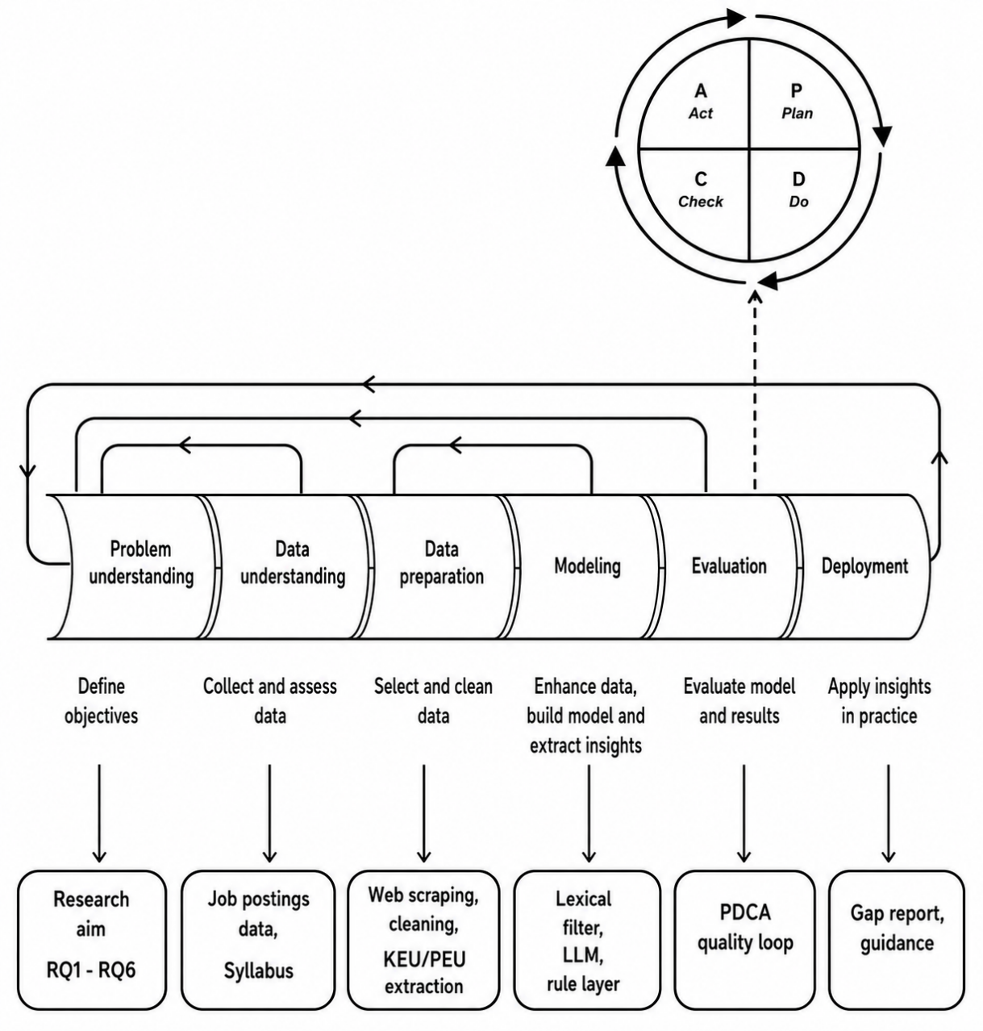
Figure 12. CRISP-DM process model adapted for this study and integrated with a PDCA quality loop
Source: Own study based on (Szeliga, 2017, p. 3) and (Patel & Deshpande, 2017, p. 197)
The Problem understanding phase was already specifically described in Section 2.1. The aim of this thesis is to investigate the current labour market requirements in the context of desired competencies. The research questions and the six objectives derived from them are the formal statement of what the project was trying to achieve before any data was scraped and analyzed, and every later phase is aligned with them.
The next phase is Data understanding. Before collecting data on a larger scale, both data sources were examined to assess their suitability for the research objectives. This involved evaluating the architecture, consistency, and completeness of the available information, as well as determining whether the data can be collected and processed in a structured and reproducible manner. For the labour market data, the analysis focuses on identifying which information is consistently available across both job listing pages and individual job advertisements, such as job titles, competency requirements, responsibilities, technologies, and other relevant attributes. The objective is to verify that these elements follow a sufficiently consistent framework to enable reliable automated extraction. For the educational data, the IZ1 programme syllabus is examined to confirm that the learning outcomes are organised according to a standardised structure. In particular, the analysis verifies that programme learning outcomes (KEU) and course learning outcomes (PEU) are represented in a consistent format that can be automatically parsed rather than requiring manual extraction. The full and in-depth overview of syllabus structure and the general approach to the semantic compression of the KEU/PEU framework - namely, the preparation of concise yet complete descriptions of competencies, consisting of PEUs assigned to each KEU code - was already described in Section 2.2. This phase is essential for planning the subsequent data collection process. By understanding the structure and quality of both data sources, it becomes possible to determine whether all information required for the study is available and to establish an appropriate strategy for its automated extraction and further processing.

Web scraping as a data collection method
The first sub-stage of the Data preparation phase consists of acquiring the raw empirical material on which the entire competency-gap analysis is based. Two independent data sources are used in this study. The demand side is represented by a large-scale corpus of job advertisements collected from the Polish online labour market, while the supply side consists of competencies extracted from the official curriculum documentation of the Business Engineering (IZ1) programme offered by the Faculty of Management at Wrocław University of Science and Technology. Although both datasets are cquired automatically, they require different extraction procedures due to the distinct structure of their source material. Job advertisements are collected using a custom web scraper, whereas curriculum competencies are extracted by automatically parsing the official programme documentation.
The fundamental methodological challenge concerns the scale of the labour-market dataset. The research questions addressed in this thesis require measuring how frequently particular competencies appear across the population of job advertisements relevant to the Business Engineering profile. Such questions cannot be answered reliably using only a small number of carefully selected examples. Competency demand in online labour markets is inherently heterogeneous: different employers describe similar requirements using different terminology, some competencies occur only rarely, and meaningful frequency comparisons require observations numbering in the thousands. At the scale required to draw statistically reliable conclusions, the final dataset contains more than 9000 individual job advertisements, making manual collection and coding impractical within the time and resource constraints of a master's thesis.
A data-driven approach directly addresses this limitation. Rather than analysing a small sample of advertisements in depth, the proposed methodology collects all job postings satisfying predefined selection criteria within the observation period, processes them systematically, and allows statistical patterns to emerge from the complete dataset. This is not a methodological compromise motivated by convenience but a necessity imposed by the research questions themselves. Frequency-based analyses require observations on a scale that cannot realistically be achieved through manual data collection.
Before selecting web scraping as the primary method for collecting labour-market data, several alternative approaches are considered and subsequently rejected:
- Official API access: Accessing the platform through an official Application Programming Interface (API) would constitute the methodologically cleanest solution, since APIs typically provide structured, machine-readable data without requiring HTML parsing. However, the analysed platform does not provide public API access for this purpose. Consequently, web scraping represents the standard alternative and has become a widely accepted method in computational labour-market research.
- Commercial or third-party datasets: Commercial datasets containing archived Polish job advertisements are available, but they present two important limitations. First, they are generally proprietary and inaccessible for academic research. Second, they do not provide sufficient control over the exact observation period, selection criteria, or extracted variables required by the present research design. Furthermore, using proprietary datasets substantially reduces reproducibility, as other researchers are unable to repeat the collection procedure on subsequent snapshots of the same platform.
- Manual collection and qualitative analysis: Manual coding remains a well-established approach in human resource management and curriculum research. However, while suitable for qualitative studies involving several dozen observations, it cannot support the large-scale frequency analysis required here without introducing considerable sampling bias. Consequently, manual data collection is rejected not because it lacks methodological validity, but because it addresses a fundamentally different type of research question.
Web scraping is therefore selected not because it represents the most technically sophisticated solution, but because it is the only approach capable of simultaneously satisfying the three principal methodological requirements of this study: large-scale coverage, researcher control over the scope of collected data, and full reproducibility of the collection procedure. This choice is consistent with established practice in computational labour-market research as well as methodological recommendations concerning the responsible use of publicly available web data.
Before describing the implementation developed for this study, it is useful to define web scraping in general terms and outline the generic workflow followed by virtually all web scrapers. Web scraping is an automated method of extracting large volumes of publicly available information from websites. Conceptually, it performs the same task as manually copying information from a webpage but does so programmatically and at a scale that would be impossible to achieve manually. A web scraper is capable of processing thousands of webpages during a single execution, making it particularly suitable for studies requiring large empirical datasets (ScraperAPI, 2026, p. 4).
A typical web scraping system consists of two functionally distinct components. The first is the web crawler, which operates similarly to a search-engine indexing bot. It traverses a predefined collection of URLs, follows hyperlinks where appropriate, and systematically identifies webpages that should subsequently be analysed. The second component is the web scraper itself, which retrieves the identified webpages and extracts the required information using predefined data locators, typically HTML tags, CSS selectors, or XPath expressions (ScraperAPI, 2026). These two processes are conceptually distinct: the crawler determines where to retrieve the data, whereas the scraper determines what content should be extracted.
Independent of the specific programming language or software implementation, this generic workflow can be divided into four recurring stages, illustrated in Figure 12: crawl, request and parse, extract, and export. These stages provide the conceptual framework for the custom scraper developed for this research. In the implemented solution, URL discovery is intentionally separated from data extraction, allowing interrupted collection runs to resume without repeating the crawling stage. Consequently, the implementation follows a two-pass architecture: the first pass corresponds to the crawling stage, while the second combines webpage retrieval, parsing, and data extraction before exporting the collected records to persistent storage.
The web scraping process begins with the crawl stage, during which the crawler visits a predefined list of target URLs. Similar to a search-engine crawler, it systematically issues HTTP requests to webpages and retrieves their contents for subsequent processing. No information is extracted at this stage. Instead, the crawler identifies and records the webpages that are subsequently processed by the scraper. Throughout the collection process, the scraper operates exclusively on publicly accessible webpages and does not attempt to bypass authentication mechanisms or access information unavailable to ordinary users.
The second stage, request and parse, begins once an individual webpage has been identified. The scraper downloads the page's HTML source code and parses it into a Document Object Model (DOM) tree, which represents the hierarchical structure of the webpage. Basic web scrapers analyse only the HTML document, whereas more advanced implementations additionally render CSS stylesheets and JavaScript in order to capture dynamically generated content. Representing the webpage as a DOM tree enables efficient identification of individual elements during the extraction stage.
The extract stage consists of locating and retrieving the information required for subsequent analysis. Using HTML tags together with CSS or XPath selectors, the scraper identifies specific webpage elements containing the target information and converts them into a structured representation. Depending on the application, these elements may include product descriptions, prices, addresses, job requirements, or any other publicly available content. The extracted information is subsequently transformed into a format suitable for further computational processing.
The final stage, export, stores the extracted data in a structured format suitable for subsequent analysis. Depending on the application, the output may be written to a relational database, spreadsheet, or JSON (JavaScript Object Notation) file - a lightweight, text-based format widely used for storing and exchanging structured information between software systems. Exporting the data in standardised formats facilitates downstream processing, including statistical analysis, data visualisation, natural language processing, machine learning, and integration with other analytical tools.
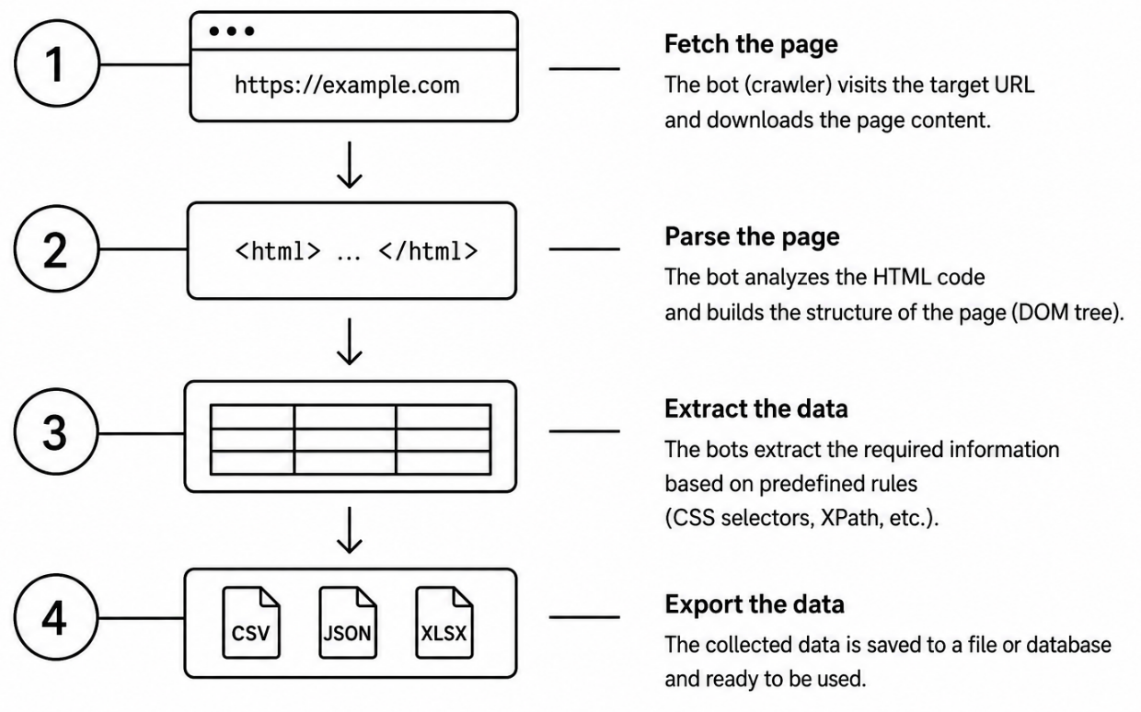
Figure 13. Generic web scraping workflow
Source: Own study based on (ScraperAPI, 2026, p. 7)
The generic workflow described above provides the conceptual basis for the data acquisition procedure developed for this study. Figure 14 illustrates both the generic four-stage web scraping workflow and its operationalisation within the data acquisition procedure adopted in this research. The following section explains how each of these stages is implemented in the proposed methodology.
Pass 1 - listing-page traversal. The first stage consists of traversing the paginated search results available on the selected job platform. The scraper systematically visits all pages matching the predefined search criteria and records the links to individual job advertisements. This stage is concerned solely with identifying relevant postings and preparing the list of webpages to be processed in the subsequent stage.
Pass 2 - detail-page extraction. In the second stage, the scraper visits each previously identified job advertisement and extracts the information required for the competency-gap analysis. Besides structured metadata describing the advertisement, the procedure also collects the textual content of the requirements and responsibilities sections. Combining structured information with free-text descriptions ensures that the subsequent natural language processing stage captures both explicitly labelled competencies and those expressed narratively by employers.
The second empirical dataset, representing the educational perspective, is acquired using a separate automated extraction procedure. Unlike job advertisements, which are distributed across thousands of webpages, the curriculum information is available as a structured programme document published by the university. The architecture and competency framework of this curriculum are described in detail in Section 2.2. An automated parser extracts the programme learning outcomes, course learning outcomes, and the relationships between them, producing a structured dataset comparable to the labour-market corpus. Applying automated extraction to both data sources ensures methodological consistency while eliminating the need for manual transcription.
Together, the resulting labour-market and curriculum datasets constitute the empirical foundation of the study. They provide a common, structured representation of both domains and serve as the input for the preprocessing, competency extraction, and comparative analyses presented in the following sections.
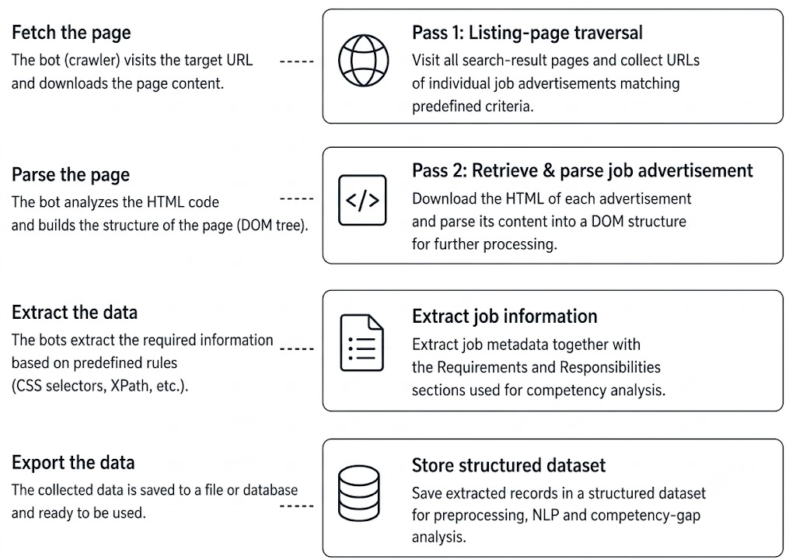
Figure 14. Data acquisition procedure adopted in this study
Source: Own study based on (ScraperAPI, 2026, p. 7)

Modeling research framework
The first stage of the proposed framework is dedicated to the extraction of explicitly named technologies, such as programming languages, software packages, database systems, cloud platforms, or commercial enterprise applications. Examples include technologies such as SQL, Python, Docker, Power BI, SAP, and similar products that are referred to by their official names in both the curriculum and job advertisements.
Named technologies represent deterministic entities whose interpretation is generally unambiguous. When the same technology is explicitly mentioned in both the curriculum and the job advertisement, no semantic reasoning is required to determine that the two references describe the same competency. For this reason, technology matching is performed before any language-model-based analysis.
This stage operates on the structured technology fields already identified by the recruitment platform. Matching is performed using a controlled vocabulary derived from the KEU and PEU descriptions, supported where necessary by a manually curated mapping of synonymous English and Polish technology names. Technologies successfully identified at this stage are immediately assigned to the corresponding curriculum competencies.
An important objective of this preliminary extraction is to prevent duplicate competency detection during subsequent semantic analysis. The deterministic technology extraction stage does not replace the subsequent semantic analysis but complements it. Competencies identified through explicit technology matching are treated as already resolved and are therefore excluded from further classification decisions. The language model subsequently focuses on the remaining competency statements expressed in natural language, where semantic interpretation is required.
The deterministic technology extraction stage therefore serves two complementary purposes: it maximises precision for explicitly named technologies while simultaneously reducing the search space for the subsequent semantic classification pipeline. The overall workflow of this stage is illustrated in Figure 15.
Behavioural, managerial, and methodological competencies cannot be handled using the same controlled-vocabulary approach applied to named technologies, because the same underlying competency may be expressed in many different ways across job advertisements. For example, requirements such as ownership, proactive attitude and willingness to learn may all refer to the broader competency of self-directed work. Likewise, Scrum represents a named instance of the broader competency of agile project management. Furthermore, the same competency is frequently expressed in different languages. Unlike named technologies, these competencies cannot be exhaustively represented by a predefined dictionary, making purely lexical matching insufficient for reliable classification.
At the same time, relying exclusively on subjective human judgement or unconstrained language-model reasoning would reduce the transparency and reproducibility of the methodology. To balance semantic flexibility with methodological rigour, the proposed framework adopts a layered text-analysis architecture that combines complementary techniques rather than relying on a single classification method. This design follows the broader principle of hybrid text analysis and mixed-methods research, where triangulating multiple independent procedures produces more robust and defensible results than any individual method used in isolation.
Accordingly, the second stage of the competency-matching framework consists of three consecutive layers:
- A bilingual lexical pre-filtering layer, which is designed to reduce the number of curriculum competencies requiring detailed semantic evaluation. This layer estimates the lexical similarity between the competency requirements expressed in a job advertisement and the descriptions of all KEU codes. The similarity score is calculated using the principles of the classical Term Frequency–Inverse Document Frequency (TF–IDF) approach, in which more distinctive terms contribute more strongly to the final score than common vocabulary. The pre-filter is explicitly bilingual because Polish job advertisements frequently contain English technical terminology, methodological concepts, and competency descriptions, whereas the curriculum documentation is written entirely in Polish. Consequently, relying solely on monolingual lexical similarity would overlook many conceptually equivalent expressions. To minimise this problem, the lexical comparison incorporates a manually curated English-to-Polish translation dictionary that maps commonly occurring competency terms to their Polish equivalents before the similarity score is calculated. This layer does not determine whether a competency is covered by the curriculum. Instead, it serves as a computationally efficient candidate-selection mechanism that identifies the highest-ranked candidate KEU codes for each job advertisement based on lexical similarity. By substantially reducing the number of candidate competencies considered during the next stage, the lexical pre-filter limits the amount of semantic inference required from the language model while preserving potentially relevant matches. The lexical pre-filter also addresses an important computational constraint of the proposed framework. Comparing every job advertisement against the complete set of curriculum competencies would require the language model to evaluate a large number of candidate matches, substantially increasing both the prompt size and the total number of language-model tokens processed during inference. Since the study analyses several thousand job advertisements, such an approach would make the semantic classification stage prohibitively time-consuming. By restricting the language model to only the highest-ranked candidate KEU codes identified through lexical similarity, the pre-filter substantially reduces computational cost while preserving the vast majority of potentially relevant matches. Consequently, semantic reasoning is reserved for cases in which lexical similarity alone is insufficient to determine whether a competency is represented by the curriculum. This layered design improves computational efficiency without replacing the semantic judgement performed in the subsequent classification stage.
- A language-model-assisted semantic classification layer, in which the language model is instructed to identify the remaining competencies expressed in the employer's own wording and to determine, for each one, whether it is conceptually represented by any of the candidate KEU codes, even when no lexical overlap exists, or whether it constitutes a genuine competency gap. This stage relies on contextual understanding rather than exact word correspondence, enabling conceptually equivalent expressions to be recognised despite differences in vocabulary, phrasing, or language. The use of a large language model reflects the growing adoption of foundation models for analysing unstructured labour-market data. Recent research has shown that job advertisements often contain highly variable and context-dependent language, making semantic understanding beyond surface-level text matching essential for reliable information extraction. Compared with earlier approaches based primarily on encoder architectures and sequence-labelling techniques, large language models offer greater flexibility in interpreting long and heterogeneous recruitment texts without requiring manually engineered extraction rules (Li et al., 2025). This characteristic is particularly relevant in the present study, where no manually annotated corpus exists for mapping job advertisements to the institution-specific KEU framework. To ensure methodological reproducibility while maintaining computational feasibility, semantic inference is performed using a locally hosted open-weight language model executed through a local inference server rather than a commercial cloud-based API.
- A deterministic rule-based verification layer, where the final layer performs a deterministic verification of the language model's output by applying a small set of explicit, manually defined decision rules. Its purpose is not to replace semantic classification but to validate those cases where relying solely on language-model reasoning could lead to systematic misclassification. Although large language models demonstrate strong semantic reasoning capabilities, their predictions remain probabilistic more than deterministic. Although large language models demonstrate strong semantic reasoning capabilities, their predictions remain probabilistic rather than deterministic, creating a risk of hallucinations or inconsistent classifications. Consequently, an additional verification layer is introduced to safeguard against predictable classification errors and to ensure that critical competency assignments remain fully transparent and auditable. Consequently, an additional verification layer is introduced to safeguard against predictable classification errors and to ensure that critical competency assignments remain fully transparent and auditable.
The most important verification rules concern named commercial software and specialised domain-specific systems. A competency referring to a specific platform, such as SAP or a CRM system, is accepted as covered by the curriculum only if that technology is explicitly mentioned in the corresponding KEU description. Consequently, a requirement for SAP cannot be matched to a curriculum outcome that refers only to enterprise information systems in general terms, regardless of the semantic similarity identified by the language model. Similar deterministic checks are applied to selected business-domain competencies that fall outside the scope of the IZ1 curriculum and are therefore prone to false-positive semantic matches. The verification stage also incorporates a small number of corrective rules designed to capture competencies that are systematically under-classified by the language model. These rules primarily concern general social competencies, such as teamwork, communication, and conflict resolution, which are explicitly represented within the curriculum but may appear in highly diverse linguistic forms across job advertisements. Applying transparent and reproducible pattern-based rules reduces recurring classification errors while preserving the semantic judgement produced by the previous stage. Introducing an explicit verification layer follows a fundamental principle of hybrid text-analysis methodologies - probabilistic model outputs should be complemented by transparent and auditable deterministic rules wherever domain knowledge permits unambiguous verification. Such hybrid architectures improve both reproducibility and interpretability by ensuring that critical classification decisions can be independently validated rather than relying exclusively on the reasoning of a language model.
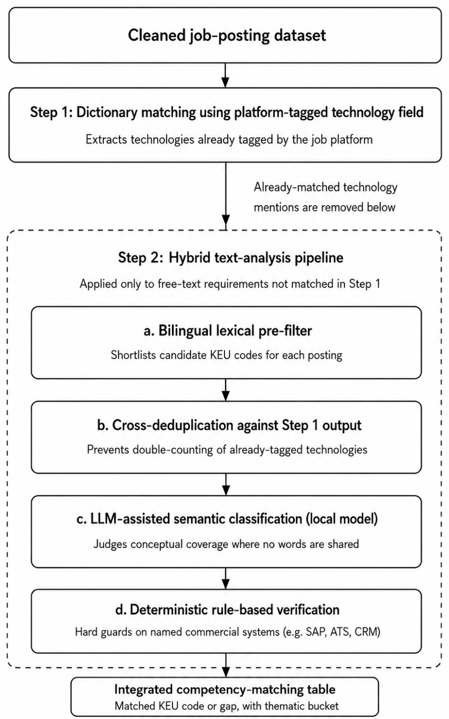
Figure 15. Hybrid competency-matching framework
Source: Own study
Figure 15 illustrates the sequential workflow of the methodology, beginning with deterministic technology matching, followed by bilingual lexical candidate selection, semantic classification using a locally hosted language model, and deterministic rule-based verification. The outputs of these stages are subsequently consolidated into an integrated competency-matching table, in which each identified competency is assigned either to the corresponding KEU code or classified as a curriculum gap, together with its associated thematic bucket. This integrated dataset provides a consistent and reproducible foundation for the quantitative analyses presented in the following chapters.
The entire analytical workflow presented in the following sections is implemented in the R programming environment using custom scripts developed specifically for this study. The R environment is used for data acquisition, preprocessing, lexical matching, communication with the locally deployed language model, parsing and validating the returned JSON responses, and the subsequent quantitative analyses.
The proposed competency-matching framework deliberately combines deterministic and probabilistic methods. Each layer addresses a specific methodological limitation of the preceding one while contributing a distinct function to the overall competency-matching process. Table 3 summarises the role of each component within the proposed architecture.

Table 3. Summary of the layered competency-matching architecture
Layer | Primary purpose | Main contribution
Dictionary matching | Deterministic technology extraction | High precision for explicitly named technologies
Bilingual lexical pre-filter | Candidate selection | Computational efficiency through TF–IDF-based ranking
LLM semantic classification | Competency interpretation | Semantic reasoning beyond lexical similarity
Rule-based verification | Output validation | Auditability, reproducibility, and correction of systematic classification errors
Source: Own study
The layered architecture exploits the complementary strengths of deterministic and semantic approaches. Dictionary matching provides highly precise identification of explicitly named technologies but cannot recognise paraphrases, conceptual equivalence, or multilingual expressions. The bilingual lexical pre-filter addresses the computational limitations of large-scale semantic analysis by restricting language-model evaluation to the most relevant curriculum outcomes identified through lexical similarity. The language model subsequently performs contextual reasoning to determine conceptual correspondence between competency requirements and curriculum learning outcomes, while the deterministic verification layer safeguards against predictable false-positive classifications in situations where explicit domain knowledge provides an unambiguous decision rule.
Semantic inference is applied only where it provides additional methodological value beyond deterministic matching. This hybrid design improves computational efficiency while maintaining transparency, reproducibility, and interpretability throughout the entire competency-matching procedure. Rather than replacing deterministic methods with artificial intelligence, the proposed framework integrates both approaches into a complementary workflow in which each technique is applied to the task for which it is best suited.
The layered architecture also supports the iterative PDCA evaluation process described in the previous section. Because each component operates independently, individual stages can be validated, refined, and re-evaluated without modifying the other elements of the framework. This modular structure facilitated successive refinement of the matching procedure throughout the development phase, allowing systematic sources of classification error to be identified and corrected before the methodology was applied to the complete corpus of job advertisements.

Local language model deployment
The semantic classification stage described in the previous section requires a language model capable of understanding both Polish curriculum descriptions and multilingual job advertisements containing a mixture of Polish and English terminology. The model also had to support structured JSON output, operate reliably over long inference batches, and be deployable in a way that ensured methodological reproducibility throughout the iterative development process.
The choice between a commercial cloud-based API and the local deployment of an open-weight language model was carefully evaluated.
An API provides remote access to a language model hosted by an external service provider, allowing the client application to submit prompts over the Internet and receive generated responses without maintaining the underlying model or computing infrastructure. In contrast, local deployment executes the model directly on the researcher's own hardware, with all inference performed within the local computing environment.
Commercial APIs provide access to state-of-the-art proprietary models and generally offer faster inference through dedicated cloud infrastructure. However, they also introduce recurring token-based costs, dependence on external servers and internet connectivity, and reduced control over model versioning and data processing. In contrast, locally hosted language models require greater computational resources on the researcher's hardware and typically provide lower reasoning performance than frontier commercial models, but they offer complete control over the inference environment, eliminate recurring API costs, ensure that all research data remain on the local machine, and guarantee that identical prompts are always processed by the same model version.
Considering the iterative nature of the study, which required repeated processing of several thousand job advertisements during prompt refinement and evaluation, local deployment represented the most appropriate methodological compromise between semantic performance, reproducibility, computational feasibility, and research cost.
The selection process involved screening multiple candidate models to identify the option best suited for this study. Table 4 summarises the principal characteristics of the considered models.

Table 4. Comparison of language models considered during model selection
Model | Advantages | Limitations
GPT-4o mini | State-of-the-art reasoning, excellent multilingual capabilities, highly reliable structured JSON output | Commercial API only, recurring token-based costs, dependence on external infrastructure
Gemini 2.5 Flash | Very fast inference, excellent multilingual support, large context window | Commercial API, recurring costs, cloud deployment only
DeepSeek-V4-Flash | Strong reasoning performance, competitive pricing, multilingual support | Commercial API, dependence on external infrastructure
Llama 3.1 70B | Supports local deployment, strong multilingual performance | High VRAM requirements, slow inference on consumer hardware
Gemma 3 4B QAT | Efficient local inference, multilingual, low hardware requirements, reproducible deployment; good Polish-language performance | Lower reasoning capability than larger frontier models
Source: Own study based on (LLM STATS, 2026)
The final model selection resulted from balancing semantic performance against the practical constraints of the study. GPT-4o and Gemini were initially considered because of their superior reasoning capabilities and excellent multilingual performance. Both models are primarily accessed through commercial cloud-based APIs. For the purposes of this research, however, a fully local and free deployment was preferred in order to support repeated large-scale experimentation, maintain full control over the inference environment, ensure reproducibility, and avoid recurring usage costs.
Llama 3.1 was also considered as an open-weight alternative suitable for local deployment. However, its hardware requirements substantially exceeded the computational resources available for the study, making large-scale local inference impractical. DeepSeek represented an attractive compromise in terms of reasoning performance and API pricing. Nevertheless, large-scale inference would still rely on external infrastructure or commercial API services, making it less suitable for the adopted research design.
Consequently, Gemma 3 4B QAT was selected as the most appropriate compromise between multilingual capability, semantic performance, computational efficiency, local deployability, reproducibility, and research cost. Although it does not achieve the reasoning performance of the largest commercial language models, it fully satisfies the methodological requirements of the proposed competency-matching framework and can be executed efficiently on consumer-grade hardware. Given the objectives of the study and the available computational resources, Gemma 3 4B QAT represents the most suitable and practical solution.

Local inference architecture
The language model is executed locally through a dedicated inference server. In this study, inference is performed using the llama.cpp server, which is launched on the researcher's computer and exposes an OpenAI-compatible HTTP endpoint at localhost:8080. An endpoint is a network address through which another application can send requests and receive responses. In the proposed framework, it serves as the communication interface between the R analysis environment and the locally hosted language model, allowing the R scripts to submit prompts and receive structured JSON responses using the same request format as commercial OpenAI-compatible APIs.
This deployment strategy offers several methodological advantages. First, it eliminates recurring token-based costs associated with processing several thousand job advertisements and repeating the analysis during iterative development. Second, all inference is performed within the researcher's local computing environment, safeguarding data privacy and ensuring that prompts, intermediate outputs, and mapping resources remain under full research control. Third, the use of a fixed model version guarantees methodological reproducibility, as identical prompts are always processed by the same model configuration rather than by continuously updated commercial services.
The workflow begins in the R analysis environment, where custom scripts developed for this study automatically prepare the prompt for each batch of job advertisements. The prompt combines the extracted job requirements, the candidate KEU descriptions identified during the lexical pre-filtering stage, and the classification instructions defining the expected JSON output. Figure 16 illustrates the local inference architecture adopted in the study.

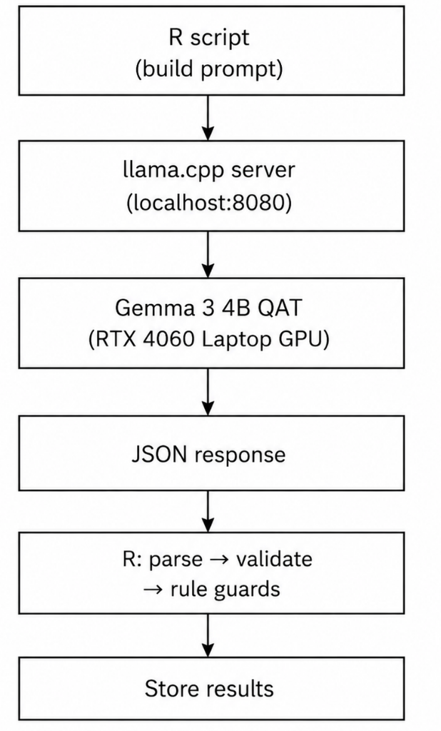
Figure 16. Local language-model inference architecture
Source: Own study
Before the local language model could be deployed, its weights were downloaded from the Hugging Face platform, which serves as one of the primary repositories for open-weight machine-learning models. A researcher account was created and a personal access token was generated to authenticate access to the selected model repository during the download process. The authentication token is required only to obtain the model weights; once they have been downloaded, all subsequent inference is performed entirely on the researcher's local machine without transmitting any data to external servers.
After the model had been deployed locally, communication between the R analysis environment and the language model was handled through the llama.cpp inference server. Once the prompt had been assembled, the R script sent it to the local inference endpoint exposed by llama.cpp. This endpoint follows the OpenAI API specification, allowing the local model to be accessed using the same communication format as commercial language-model APIs. Although the interaction resembles a cloud API call, the request never leaves the researcher's computer because it is directed to the local address localhost:8080.
The request is received by the locally running llama.cpp inference server, which exposes an OpenAI-compatible API on localhost:8080. The server acts as an intermediary between the R analysis scripts and the language model itself. It accepts the incoming prompt, prepares it for inference, and forwards it to the loaded Gemma model.
The inference server transfers the prompt to the Graphics Processing Unit (GPU), which is responsible for executing the neural-network computations required by the language model. The computational component of the research was carried out on an ASUS TUF Gaming A15 laptop equipped with an NVIDIA GeForce RTX 4060 Laptop GPU with 8 GB of dedicated VRAM. Unlike system memory (RAM), VRAM is specifically designed for massively parallel numerical computations, making it substantially more efficient for language-model inference. The available VRAM also determines the maximum model size that can be executed efficiently on the local hardware.
The prompt is processed by the locally deployed Gemma 3 4B QAT language model. Based on the supplied instructions and contextual information, the model identifies competencies within the job advertisements and assigns them either to the most appropriate KEU code or to a competency gap. Instead of generating free-form text, the model is instructed to return its results in a predefined structured format.
The model returns its output as a JSON (JavaScript Object Notation) document. JSON is a structured data format consisting of labelled fields and values that can be interpreted automatically by software without additional text processing. Using JSON instead of natural-language responses ensures that each extracted competency is consistently represented alongside its assigned KEU code, classification status, and thematic category.
The returned JSON response is processed automatically within the R environment. During the parsing stage, the document is converted into structured tabular objects suitable for direct analysis. Next, the validation stage checks whether the response follows the expected schema and contains all mandatory fields required for further analysis. Responses that do not satisfy these conditions are treated as invalid and can be reprocessed. Then, the deterministic rule guards described in Section 2.3.3 are applied. These rules automatically correct predefined edge cases that are difficult for probabilistic language models to classify consistently, including named commercial software and selected domain-specific competencies. Finally, the validated competencies are stored in the integrated competency-matching dataset, which forms the basis for the quantitative analyses presented in the following chapters.

Evaluation and deployment
The competency-matching framework was evaluated iteratively throughout its development rather than only after the final version had been completed. Following the Plan-Do-Check-Act (PDCA) cycle introduced earlier in the methodological framework, each evaluation round focused on improving the reliability of the competency-matching procedure.
During the Plan phase, specific aspects of the framework requiring verification were identified before each iteration. Typical objectives included evaluating whether competencies expressed in different linguistic forms were classified consistently, whether named technologies appearing in free-text competency descriptions were assigned appropriately, and whether selected categories of competencies should be excluded from further analysis according to the scope of the study.
During the Do phase, the competency-matching framework was executed on a smaller subset of job advertisements using the current version of the methodology. The resulting classifications provided the basis for evaluating the behaviour of the framework before it was applied to the full dataset.
The Check phase consisted of manually reviewing the generated classifications by comparing the competencies extracted from the job advertisements with the assigned KEU codes or curriculum-gap labels. Instead of evaluating whether the language model's explanation appeared convincing, the review focused on whether the final classification corresponded to the intended interpretation of both the curriculum and the competency expressed in the advertisement.
Whenever systematic classification errors were identified, the Act phase involved returning to the Modeling stage to refine the competency-matching framework. Depending on the observed problem, these improvements included refining the prompt instructions, expanding the contextual information provided to the language model, extending the bilingual translation dictionary, introducing additional deterministic verification rules, and updating the lexical resources used during candidate selection. After each modification, the revised framework was executed again on the evaluation subset and the resulting classifications were reviewed. This iterative process continued until the classification quality reached a satisfactory level for full-scale analysis.
Several such iterations were completed before the framework was applied to the full dataset of job advertisements. The repeated PDCA cycles, consisting of successive iterations between the Modeling and Evaluation phases, progressively reduced systematic classification errors while improving the robustness, consistency, and reproducibility of the proposed competency-matching procedure. Consequently, the final competency-matching framework represents the outcome of multiple cycles of testing, verification, and refinement, resulting in a substantially more reliable methodology for the final large-scale analysis.
Once the framework had been validated, the study proceeded to the Deployment phase of the CRISP-DM methodology. In the present research, deployment does not refer to operational implementation of the model but to applying the validated competency-matching framework to the full corpus of job advertisements to generate the final analytical dataset. The resulting integrated competency-matching table formed the basis for all subsequent quantitative analyses, including the identification of curriculum strengths, competency gaps, thematic distributions, and the formulation of curriculum recommendations presented in the following chapters.
Although the framework was developed for the Business Engineering (IZ1) programme, its overall architecture is independent of a particular curriculum. Applying the methodology to another study programme requires only the preparation of an analogous curriculum-competency table corresponding to the PEU/KEU structure adopted in this research. Once such a reference table has been prepared, the remaining stages of the workflow can be executed without modification, making the proposed framework reusable for other curricula, occupational domains, and future labour-market datasets.

Empirical data analysis

Characteristics of competencies in the IZ1 curriculum based on syllabi analysis

Data preparation
Before the characteristics of the curriculum competencies could be analysed, the learning outcomes had to be extracted from the official curriculum documentation of the Business Engineering (IZ1) programme. The source material consisted of a single Microsoft Word document containing 75 individual syllabus cards, each describing one course together with its subject learning outcomes (PEU) and references to programme learning outcomes (KEU).
Because the information was stored in structured tables rather than plain text, the extraction was performed directly from the XML representation of the document using a dedicated R script. This approach preserved the relationships between KEU codes, PEU codes, and their descriptions, which would have been lost using conventional text extraction methods.
The extraction procedure consisted of two stages. First, all programme learning outcomes (KEU), together with their complete descriptions, were identified and reconstructed from the syllabus tables. Second, the script extracted every subject learning outcome (PEU), its description, the corresponding course name, and all referenced KEU codes. Since a single PEU may correspond to several programme learning outcomes, the extracted data were expanded into separate records for each valid PEU-KEU relationship.
The two extracted datasets were subsequently merged into a single mapping table linking courses, PEU outcomes, and KEU outcomes. As the objective of the study was to evaluate competencies relevant to the professional profile of Business Engineering graduates, PEU records belonging to foreign-language courses and physical education were excluded before the final mapping table was created.
To ensure the quality of the extracted dataset, the script performed an automatic validation after each execution. The validation included verifying the expected number of KEU codes, confirming that every KEU outcome was represented in at least one PEU–KEU mapping, detecting potential parsing artefacts, and performing manual spot checks on selected records. This iterative verification ensured that the extracted dataset accurately represented the curriculum before it was used in the subsequent analyses.
After the mapping table had been generated, the extraction script automatically performed a series of data-quality checks to verify the correctness of the extracted information. These checks included confirming the expected number of KEU codes, verifying that every KEU outcome appeared in at least one PEU mapping, detecting potential parsing artefacts, and performing manual spot checks on selected records. Structural edge cases, such as multi-row KEU descriptions or PEU entries linked to multiple KEU codes, were identified during this verification process and resolved by refining the extraction script.
Consistent with the iterative Plan-Do-Check-Act (PDCA) approach adopted throughout the study, the extraction procedure was repeatedly tested and refined until the generated mapping accurately reflected the structure of the original curriculum documentation.
Table 3.1 presents an excerpt from the final PEU-KEU mapping dataset. Each record links a programme learning outcome (KEU), its competency category (Knowledge, Skills, or Social Competences), the corresponding course, and a subject learning outcome (PEU). As the complete descriptions of KEU and PEU outcomes are relatively extensive, only the initial part of each description is presented. The table contains two illustrative records from the complete dataset.
Table 5. Example records from the final PEU-KEU mapping dataset
KEU code | KEU type | KEU description | Subject | PEU code | PEU description
K1_IZ_K01 | Social  Competences | Potrafi  identyfikować i  interpretować  kulturowe,  prawne, etyczne,  ekonomiczne… | Analiza  ekonomiczna  decyzji  biznesowych | PEU_K01 | Ma świadomość  złożoności  systemów  społeczno-gospodarczych…
K1_IZ_K01 | Social  Competences | Potrafi  identyfikować i  interpretować  kulturowe,  prawne, etyczne,  ekonomiczne… | Analiza  ekonomiczna  decyzji  biznesowych | PEU_K01 | Jest zorientowany  na samodzielne  i krytyczne  poszukiwanie  i dobór metod…
Source: Own study

Exploratory Analysis of the Prepared Syllabi Dataset
After the PEU-KEU mapping dataset had been prepared and validated, the first stage of the empirical analysis examined the overall competency structure of the Business Engineering (IZ1) curriculum. The analysis began with the distribution of programme learning outcomes across the three competency domains defined by the Polish Qualifications Framework. The distribution of KEU codes across these domains is presented in Figure 16.
The IZ1 programme defines 56 programme learning outcomes (KEU). Exactly half of them (28 codes, 50.0%) belong to the Knowledge domain, while 21 outcomes (37.5%) represent Skills and only 7 outcomes (12.5%) correspond to Social Competences. This distribution should be interpreted with caution. The number of KEU codes reflects in how much detail each category of learning outcomes is defined, rather than its importance within the curriculum. A smaller number of Social Competence outcomes should therefore not be interpreted as indicating a lower emphasis on these competencies. Instead, this distribution reflects the structure of the Polish Qualifications Framework, where social competences are typically formulated more broadly, while knowledge and skills are described in greater detail.
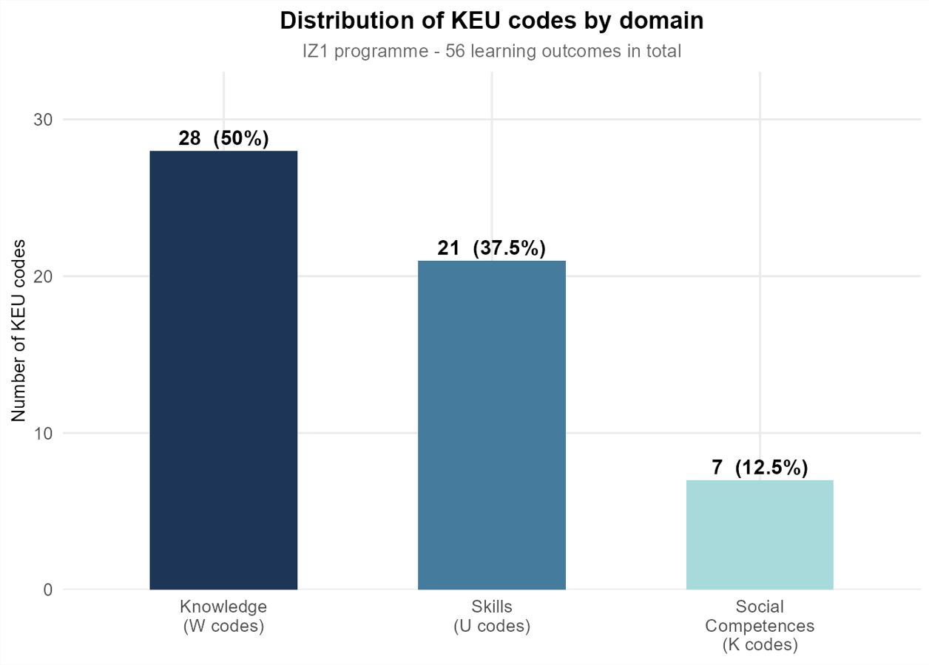
Figure 16. Distribution of KEU codes by domain
Source: Own study
From the perspective of the proposed competency-gap framework, identifying programme learning outcomes alone was insufficient. It was equally important to determine the extent to which each competency was operationalised throughout the curriculum. While each KEU code formally defines a programme learning outcome, the number of subject learning outcomes (PEU) linked to it indicates how frequently that competency is reinforced across different courses. For this reason, the distribution of PEU-KEU links associated with each KEU code was analysed and presented in Figure 17.
The distribution is skewed. Although the average number of PEU-KEU links per KEU code is 10.6, the histogram reveals considerable variation in the extent to which individual learning outcomes are represented across the curriculum. Most KEU codes are associated with relatively low to moderate numbers of PEU links, while only a small number accumulate substantially higher numbers of references. The most extreme case reaches 44 PEU-KEU links.
This pattern indicates that the curriculum does not reinforce all competencies with the same degree. Instead, a relatively small group of learning outcomes forms the educational core of the programme and is repeatedly developed across multiple courses, while many other competencies appear only occasionally.
The histogram also highlights differences between the three competency domains. Although the programme formally defines only seven Social Competence outcomes, one of them is referenced by 44 PEU outcomes, making it the most frequently referenced learning outcome in the curriculum. This suggests that selected transversal competencies are intentionally reinforced throughout many courses despite the relatively small number of formal Social Competence KEU codes. By contrast, Knowledge outcomes exhibit a more dispersed distribution of PEU-KEU links, indicating that theoretical competencies are represented by a larger number of distinct learning outcomes instead of being concentrated around a single dominant competency.
These findings are particularly relevant for the subsequent competency-gap analysis. The presence of a KEU code in the curriculum does not necessarily reflect the emphasis placed on that competency during the educational process. The frequency of PEU-KEU links provides an additional measure of curriculum emphasis by indicating how often a competency is reinforced through individual course learning outcomes. Competencies associated with numerous PEU outcomes are therefore likely to receive substantially greater instructional emphasis than those represented by only a few links.

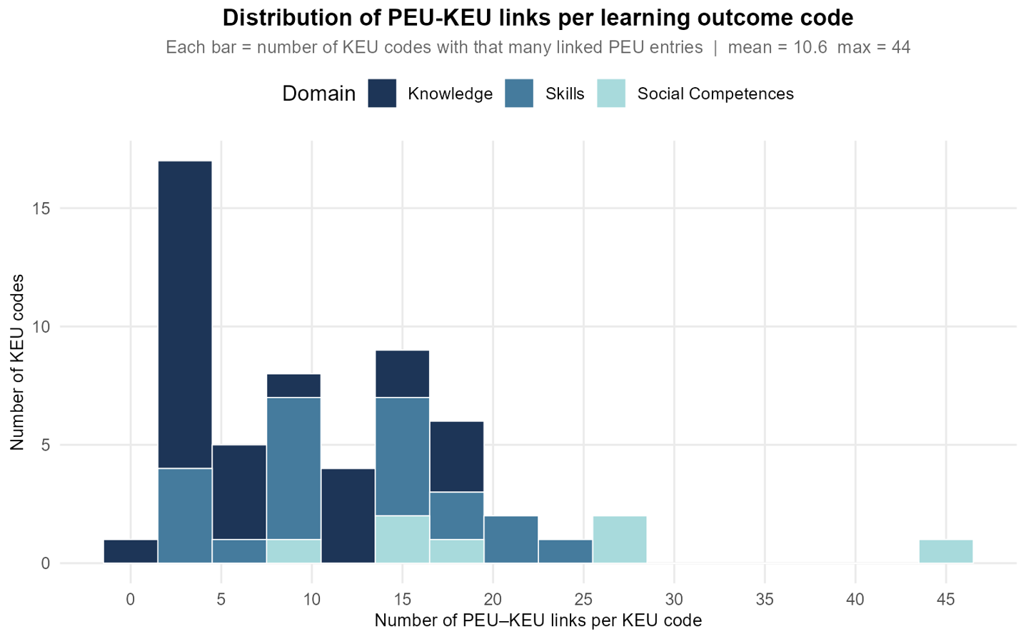Figure 17. Distribution of PEU-KEU links per learning outcome
Source: Own study
While the previous analysis demonstrated that programme learning outcomes were operationalised with different levels of intensity, it did not identify which specific competencies constituted the educational core of the curriculum. To address this question, the three most frequently referenced KEU codes were identified within each competency domain. Figure 18 presents the ranking based on the number of PEU outcomes linked to each KEU code.
The results reveal different patterns across the three competency domains. In the Knowledge domain, no single learning outcome clearly dominates the curriculum. The three highest-ranked KEU codes are referenced a very similar number of times, with K1_IZ_W19 (18 links) followed closely by K1_IZ_W15 and K1_IZ_W01 (17 links each). These competencies cover interconnected areas of the programme, including the broader social, legal and economic context of engineering activities, mathematical methods supporting engineering problem solving, and the mathematical foundations required for analysing technical and business systems. Their balanced distribution suggests that the theoretical component of the curriculum is built around several complementary knowledge areas instead of a single dominant subject.
A different pattern is observed within the Skills domain. K1_IZ_U18 is linked to 25 PEU outcomes, exceeding the next two most frequently referenced outcomes - K1_IZ_U19 and K1_IZ_U15, both with 20 links. The dominant competency focuses on designing systems, business processes, and workplaces, while the remaining highly ranked competencies concern applying analytical and information-technology methods to engineering problems and understanding the broader managerial, technological, and social context of engineering practice. This distribution indicates that the curriculum places particular emphasis on practical engineering design supported by analytical and digital skills.
The most pronounced concentration occurs within the Social Competence domain. K1_IZ_K03 is referenced by 44 PEU outcomes, substantially exceeding K1_IZ_K07 and K1_IZ_K01, each with 26 links. Unlike the other social competence outcomes, K1_IZ_K03 describes broadly applicable professional behaviours, including responsibility for assigned tasks, priority setting, and effective collaboration within organisational roles. These competencies are relevant across virtually all engineering and management subjects, which explains why they are repeatedly reinforced throughout the curriculum. By comparison, K1_IZ_K07 focuses on responsible professional conduct in response to changing social needs, while K1_IZ_K01 addresses ethical, legal, and societal aspects of engineering activity. Their more specialised scope may explain why they are referenced less frequently than the broadly applicable competency represented by K1_IZ_K03.
The ranking demonstrates that the curriculum is characterised by a combination of broadly distributed theoretical knowledge and a smaller number of highly reinforced practical and transversal competencies. These dominant learning outcomes represent the competencies most consistently embedded across courses and therefore constitute the strongest educational foundation of the Business Engineering programme.
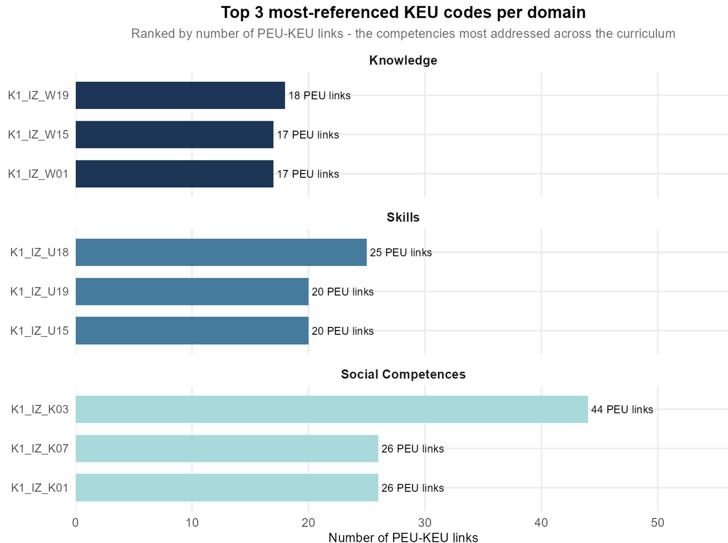
Figure 18. Top 3 moste-referenced KEU codes per domain
Source: Own study
Table 6 summarises the principal descriptive statistics of the PEU-KEU mapping generated from the Business Engineering (IZ1) curriculum. These statistics provide an overall picture of how programme learning outcomes are represented throughout the curriculum and establish the reference framework for the subsequent competency-gap analysis.
The mapping contains 56 programme learning outcomes (KEU) and 392 unique subject learning outcomes (PEU), resulting in 595 individual PEU-KEU relationships across 75 courses. This scale is particularly important from the perspective of the succeeding competency-matching process. Comparing every competency extracted from thousands of job advertisements against all curriculum learning outcomes would require a massive number of evaluations, making a direct pairwise semantic comparison between every job requirement and curriculum code computationally impractical. This observation provides the rationale for the multi-stage competency-matching framework proposed in Chapter 2, where the candidate search space is first reduced using deterministic lexical methods before semantic verification was performed by the language model.
Table 6. Descriptive statistics of the PEU–KEU mapping
Metric | Value
Total KEU codes | 56
KEU codes with at least 1 PEU link in the mapping | 56
Unique PEU entries (per course) | 392
PEU-KEU links | 595
Courses in the mapping | 75
KEU codes - Knowledge (W) | 28
KEU codes - Skills (U) | 21
KEU codes - Social Competences (K) | 7
Mean PEU links per KEU code | 10.6
Maximum PEU links per KEU code | 44
Minimum PEU links per KEU code | 1
Mean KEU references per course | 5.8
Source: Own study
However, the descriptive statistics also reveal that the curriculum does not emphasise all competencies equally. The number of PEU references per KEU code ranges from 1 to 44, with an average of 10.6 links. As demonstrated in the previous sections, this variation reflects differences in the extent to which individual programme learning outcomes are reinforced throughout the curriculum. Some competencies form the educational core of the programme and are repeatedly developed across multiple courses, while others are represented by only a small number of subject learning outcomes.
A similar pattern is visible from the perspective of individual courses. On average, each course contributes approximately 5.8 KEU references, illustrating that subjects typically support several programme learning outcomes simultaneously. This reflects the interdisciplinary nature of Business Engineering, where individual courses are designed to develop combinations of technical, managerial, and analytical competencies rather than focusing on isolated learning outcomes.
These descriptive statistics provide an important methodological foundation for the later comparison with labour-market requirements. The presence of a competency in the curriculum alone does not indicate the extent to which it is emphasised during the educational process. The PEU-KEU mapping therefore offers two complementary perspectives: whether a competency is represented in the curriculum at all, and how intensively it is reinforced across the programme. This distinction becomes particularly important in the following chapters, where curriculum competencies are compared with employer expectations to identify both missing competencies and competencies that may require stronger curricular emphasis.
Following the analysis of the most frequently operationalised competencies, it was also important to identify programme learning outcomes that received only limited coverage within the curriculum. Table 7 presents KEU codes associated with no more than two PEU-KEU links, representing the least frequently operationalised programme learning outcomes. In addition to the number of unique PEU outcomes and courses in which each KEU appears, the table also reports the total number of PEU-KEU links. This value may exceed the number of unique PEU outcomes or courses because a single course can contain multiple PEU outcomes linked to the same programme learning outcome.
Table 7. KEU codes with the weakest programme coverage
KEU code | KEU type | Unique PEU | Courses | Number of links
K1_IZ_W20 | Knowledge | 1 | 1 | 1
K1_IZ_U05 | Skills | 2 | 2 | 2
K1_IZ_U08 | Skills | 2 | 2 | 2
K1_IZ_W13 | Knowledge | 2 | 1 | 2
K1_IZ_W18 | Knowledge | 1 | 2 | 2
K1_IZ_W22 | Knowledge | 2 | 2 | 2
Source: Own study
The results show that six KEU codes fall into this category. Five of them belong to the Knowledge domain, while only one represents the Skills domain. This finding demonstrates that although the Knowledge domain contains the largest number of programme learning outcomes, their implementation is far from uniform. Some knowledge-related competencies are reinforced across many courses, whereas others are linked to only one or two PEU outcomes.
The least frequently operationalised competencies mainly represent specialised areas of the curriculum. Within the Knowledge domain, they include intellectual property protection (K1_IZ_W20), contemporary developments in management science (K1_IZ_W13), engineering methods and analytical tools applied in project management (K1_IZ_W18), and entrepreneurship and innovation (K1_IZ_W22). The Skills outcomes concern continuous professional development (K1_IZ_U05) and the planning, execution, and interpretation of experiments and computer simulations in engineering problem solving (K1_IZ_U08). The limited number of PEU–KEU links indicates that these specific programme learning outcomes are operationalised through relatively few subject learning outcomes. It should be noted, however, that this reflects the frequency with which particular KEU outcomes are referenced in the curriculum rather than the overall amount of teaching devoted to these broader subject areas.
From the perspective of curriculum design, limited operationalisation does not necessarily imply that a competency is unimportant. Some specialised competencies may intentionally be addressed within a small number of dedicated or advanced courses. Nevertheless, competencies supported by only one or two PEU outcomes provide students with fewer opportunities to develop and reinforce the corresponding knowledge or skills during their studies.
This observation is particularly relevant for the subsequent competency-gap analysis. If a weakly operationalised competency is also identified as highly demanded by employers, it may represent a priority area for curriculum improvement. Conversely, competencies with limited curriculum coverage that are also rarely requested on the labour market may appropriately occupy a more specialised position within the programme. Considering curriculum coverage together with labour-market demand therefore provides a more comprehensive basis for evaluating curriculum adequacy than either perspective in isolation.

Semantic KEU Competency Buckets for the Classification Prompt
While the PEU-KEU mapping provided complete information about curriculum coverage, it also created a practical challenge for the AI-based competency classification. The mapping contained 595 PEU-KEU relationships. Including every linked PEU description directly in the next-stage prompt would have produced unnecessarily long inputs, increased computational costs, and introduced a greater risk of inconsistent model responses, particularly given the resource-constrained local inference setup. Following the same iterative PDCA improvement approach adopted throughout the modelling stage, a separate R script was developed to create semantic KEU descriptions. Its objective was to reduce prompt length without losing any competency-related information required for the subsequent comparison with labour-market requirements.
The first improvement was to aggregate all PEU descriptions linked to the same KEU code into a single competency basket. Instead of processing 595 individual PEU-KEU relationships, the procedure operated on the programme's 56 KEU learning outcomes. This preserved all curriculum evidence while substantially reducing the number of prompt objects. Some aggregated descriptions were still very long because a single KEU code could combine learning outcomes originating from more than a dozen courses. Therefore, an additional reduction step was required before these descriptions could be efficiently embedded in the classification prompt.
An earlier version of this step asked the language model to perform compression and deduplication in a single pass by summarising each aggregated KEU description to "a maximum of 35 words" while "removing semantic repetition." These were the exact instructions included in the original prompt. This approach was abandoned because it was inherently flawed. The model must decide which information is important enough to keep, and this creates a risk that rare but essential concepts may disappear. For example, a tool such as Excel mentioned in only one of twelve linked PEU descriptions could easily be omitted in favour of more frequent, generic concepts, with no reliable way of detecting the loss afterwards. The process was therefore deliberately split into two independent stages with non-overlapping responsibilities, mirroring the broader separation between deterministic and model-based steps already established for the Stage 3 matching procedure.
Step A - Mechanical extraction. This stage was implemented entirely in R without any AI involvement. Every PEU description assigned to a given KEU code was divided into sentence- or clause-level phrases using the split_into_phrases() function. The function split text only at periods and semicolons, preserving complete semantic units instead of isolated words. For example, the phrase "uses the SQL query language to retrieve data from a relational database" remains intact instead of being reduced to the single token "SQL". Deduplication was performed twice before the language model processed the data. First, duplicate PEU descriptions were removed using unique (PEU_Description), eliminating identical descriptions reused across different courses. Next, duplicate phrases generated after splitting were removed using unique(unlist(...)). The remaining unique phrases were concatenated into a single field called All_Phrases.
This stage involved no semantic judgement. It only performed text splitting and exact-match deduplication. As a result, every distinct competency statement contained in the original curriculum was guaranteed to be preserved. This guarantee was built directly into the processing pipeline and did not depend on later verification.
Step B - AI-assisted concept extraction (local model). The language model was introduced only after the complete phrase pool had been created. Its task was intentionally limited. The model was not asked to summarise or rewrite the text. Instead, the system prompt instructed it to act as a technical concept extractor, identifying competencies, tools, technologies, methods, and skills mentioned in each phrase. To ensure consistent behaviour, the system prompt included the worked examples together with an explicit instruction described as an "absolute prohibition" against removing any unique tool, technology, or method, even if it appeared only once in the source text. The prompt explicitly listed examples such as Excel, Python, SQL, SAP, Power BI, R, VBA, Lean, and Six Sigma. The model was allowed to remove only literal duplicates or clearly synonymous concepts. The inference was performed using temperature = 0 together with a strict JSON response format (response_format = list(type = "json_object")). This ensured deterministic and reproducible outputs for all 56 KEU codes.
Table 8. reproduces, verbatim, the worked example embedded directly in the system prompt to anchor the model's behaviour - turning a full academic sentence into a short list of extracted concepts rather than a shortened paraphrase of the sentence itself.
Table 8. The worked input-output example included in the system prompt
Input (Aggregated PEU descriptions) | Output (Semantic PEU summary)
Is able to apply ergonomic research methods. | Is able to identify the normative conditions for ergonomic quality assessment. | Uses tools for usability evaluation in accordance with the ISO 9241 standard. | Is able to diagnose and correct factors determining the ergonomic quality of a workstation. | Is able to apply selected methods to design an ergonomic workstation for specified tasks and processes. | Is able to apply theoretical and methodological solutions in the field of management information systems diagnostics in practice. | Is able to apply theoretical and methodological solutions in the field of designing the computerisation of management information systems in practice. | Conducts computational experiments and interprets the obtained results. | Prepares a documented study, in both Polish and English, on a project management topic, including problem analysis, proposed solutions, and conclusions. | Searches for information using literature studies, databases, and other appropriately selected sources, and prepares a documented engineering project. | Delivers an oral presentation on specialised engineering topics, particularly those concerning the application of IT in business. | Is able, when formulating and solving engineering problems related to business processes, innovation processes, projects, and IT applications in business, to recognise their systemic aspects and apply appropriate technical as well as non-technical standards and regulations, including economic, legal, environmental, psychological, professional, and ethical considerations. | Uses selected tools for the graphic design of visual marketing communication. | Is able to apply selected computer graphics methods to design visual marketing communication. | Identifies and documents a managerial problem and plans and justifies its solution using engineering methods, techniques, and tools. | Is prepared to develop a professional engineering project. | Uses appropriate organisational methods applied within the various functional areas of an enterprise. | Ergonomic research methods; Ergonomic quality assessment; Usability assessment; ISO 9241 standard; Ergonomic design methods; Management information systems diagnostics; Design of the computerisation of management information systems; Computational experiments; Project management; Literature studies; Databases; Engineering project; IT applications in business; Business processes; Innovation processes; Systems thinking; Standards and regulations (economic, legal, environmental, psychological, professional, ethical); Graphic design of visual communication; Marketing communication; Computer graphics; Managerial problem; Engineering methods; Engineering techniques; Engineering tools; Organisational methods.
Source: Own study
Because Step B still relies on a language model to identify duplicate concepts, its output is never accepted without verification. Three independent validation mechanisms were built into the script before any summary is treated as final.
First, the complete pre-AI phrase pool is retained in the output file as All_Phrases_Raw. This allows every generated summary to be compared with its original source at any stage of the analysis instead of discarding the source data once the model has completed its task.
Second, a dedicated function, extract_tool_tokens(), extracts capitalised tool-like tokens (acronyms and proper nouns) from both the original phrase pool and the AI-generated summary. It then computes the set difference between the two lists. Any token present in the source but missing from the summary is recorded in the tools_lost_list column for the corresponding KEU code. This heuristic does not detect every possible omission - for example, concepts written entirely in lower case - but it directly addresses the main risk considered in this study: the silent removal of named tools or technologies during concept normalisation.
Third, the script calculates compression_pct, defined as the percentage reduction in character length between All_Phrases_Raw and KEU_Summary for each KEU code. Summaries with less than approximately 40% compression are automatically flagged. A summary that is only slightly shorter than its source suggests that the model largely reproduced the original text instead of extracting key concepts.
All three verification outputs - the retained raw phrase pool, tools_lost_list, and compression_pct - are exported together with the final results instead of being discarded. This makes it possible to identify KEU codes that may require manual review before the semantic descriptions are used in the following stage of the analysis.
The final output contains two complementary representations of each programme learning outcome. All_Phrases_Raw preserves the complete aggregated PEU evidence and serves as an auditable reference that can be used to verify every generated summary against its source. KEU_Summary provides a concise, concept-dense representation in the form of a semicolon-separated list of key concepts extracted from the aggregated PEU descriptions. This representation is sufficiently compact to be embedded efficiently in the next-stage classification prompt. The complete output file is then used in the next stage of the pipeline, where KEU_Summary serves as the semantic representation of each KEU competency basket during comparisons with competency requirements extracted from job advertisements.
This two-step separation of mechanical extraction and AI-assisted normalisation follows the same triangulation principle adopted throughout the overall matching procedure. Operations where information loss would be unacceptable remain fully deterministic, while the language model is limited to organising information whose completeness has already been guaranteed mechanically. The three verification mechanisms - the retained raw phrase pool, the tool-loss check, and the compression check - are therefore not an additional quality-control step but an integral part of the methodology. Together they demonstrate how a language model can be used for concept normalisation while preserving full traceability and allowing every generated summary to be verified against its source. This is directly relevant to the research questions because KEU_Summary forms the programme-side representation used to answer RQ2 and RQ3. Any undetected information loss at this stage would propagate through all subsequent competency-gap analyses, which is precisely the risk that the verification layer was designed to identify before further processing.

Current labor market requirements for Management Engineering graduates

Job-posting data collection
The first stage of the empirical analysis consisted of acquiring a representative dataset of current job advertisements from the Polish labour market. Since the objective of this study was to identify competency requirements across several thousand vacancies, manual data collection was neither feasible nor methodologically appropriate. Instead, an automated web scraping procedure was developed in the R programming language to systematically collect publicly available job advertisements from the Pracuj.pl platform.
Pracuj.pl was selected because it is the largest online recruitment platform in Poland, offering extensive coverage of vacancies related to business, management, analytics, and information technology. Consequently, the collected dataset provides a reliable representation of current employer expectations towards graduates of the Business Engineering programme.
The scraping procedure was implemented in R using the tidyverse, rvest, httr, and glue packages. The script follows a two-stage architecture reflecting the hierarchical structure of the Pracuj.pl website. During the first stage, the crawler traverses paginated search-result pages and collects the URLs of individual job advertisements together with basic metadata. In the second stage, every collected URL is visited separately to extract the complete content of each job posting.
A considerable advantage of the Pracuj.pl platform is its relatively consistent page structure. Most advertisements structure key information within dedicated HTML sections, allowing the scraper to extract data deterministically using predefined CSS selectors rather than relying on heuristic text processing or pattern matching. Structured sections are available for information such as mandatory technologies, optional ("nice-to-have") technologies, salary, and additional badges describing the position. Although not every advertisement contains all of these elements, their consistent implementation across the platform enabled a uniform extraction procedure for all available records. In contrast, the responsibilities and requirements sections are present in virtually every advertisement and constitute the primary textual source for the subsequent competency analysis.
The scope of data collection was defined to reflect the interdisciplinary profile of the Business Engineering programme, combining competencies related to business management, process optimisation, data analytics, and information technology. The collection process was restricted to carefully selected job categories corresponding to the expected career paths of Business Engineering graduates.
Two independent search queries were used. The first query targeted the dedicated IT section of the Pracuj.pl platform and included eight specialised categories:
- Agile
- AI / Machine Learning
- Big Data / Data Science
- Business Analytics
- Data Analytics & Business Intelligence
- Product Management
- Project Management
- System Analytics
The data collection process was executed through two targeted queries. The first query focused on information technology roles, accessed through the dedicated IT search URL provided by the platform. In this configuration, the scraper traversed 29 paginated search-result pages, collecting every advertisement matching the selected technical specialisations.
The second query targeted the general Business section of Pracuj.pl and included six categories directly related to management-oriented career paths:
- Finance / Economics
- Human Resources,
- Internet / e-Commerce / New Media
- Quality Management
- Logistics and Process Optimisation
- Marketing
These categories were retrieved using the platform category identifiers. The Business crawler traversed 171 paginated search-result pages, substantially extending the dataset with vacancies requiring managerial, organisational, and analytical competencies.
The use of two independent search strategies was a deliberate methodological decision intended to capture both technological and managerial labour-market demand, thereby reflecting the interdisciplinary nature of the Business Engineering curriculum. After completing both crawling procedures, all collected advertisements were merged into a single dataset before the detailed extraction stage.
To ensure reliable communication with the website, every HTTP request included a custom User-Agent header emulating a standard Google Chrome browser, reducing the likelihood of requests being rejected by basic bot-detection mechanisms. Additionally, random delays were introduced between consecutive requests to minimise server load and comply with good web-scraping practices.
During the first stage, the crawler iterates through all predefined search-result pages for both the Business and IT categories. Each listing page is parsed to identify individual job-offer cards using the platform's internal HTML attributes. From every card, the script extracts the unique URL of the job advertisement together with the employer's name. Advertisements without a valid URL are discarded at this stage to ensure that every collected record can subsequently be processed.
The collection procedure is executed independently for the Business and IT search queries. The resulting lists are stored separately and tagged according to their source category before being merged into a single dataset. To minimise unnecessary requests to the server and comply with good web-scraping practices, a random delay of between 1 and 1.5 seconds is introduced after every page request.
After completing both crawling loops, the collected advertisements are merged into a single dataset and subjected to a two-level deduplication procedure. The first stage consists of technical deduplication based on the unique job-offer URL, removing identical advertisements collected from multiple search-result pages or categories. Records containing missing URLs are discarded at this stage. The second stage applies semantic deduplication by identifying records sharing the same combination of job title and company name. This additional verification makes it possible to detect vacancies published under different internal identifiers but representing the same position offered by the same employer. As a result, each unique job position is represented only once in the dataset used for further analysis.
The script also supports interrupted scraping sessions. Before beginning the detailed extraction stage, it checks whether an output file from a previous run already exists. If such a file is found, all previously collected URLs are excluded from the new crawling session, allowing the scraper to resume automatically without re-scraping advertisements that have already been processed.
During the second stage, the scraper visits every collected job-offer URL individually and extracts the complete content of the advertisement. Thanks to the consistent HTML structure of the Pracuj.pl platform, the extraction is performed using predefined CSS selectors matched to the platform's internal data-test attributes. The collected information includes the job title, company name, salary, seniority badges, mandatory technologies, optional ("nice-to-have") technologies, and the complete textual descriptions of responsibilities and requirements. Although salary information was extracted for every advertisement in which it was disclosed, it was not used in the competency-gap analysis presented in this thesis. Nevertheless, the variable was retained in the dataset for completeness and potential future analyses.
The web scraping procedure collected 9 306 raw job advertisements, which were stored in the csv file and subsequently served as the input for the data cleaning and feature engineering pipeline described in the following section.
Table 9 presents the complete set of variables extracted during the web scraping stage before the data cleaning process.
Table 9. Structure of the raw job-posting dataset before data cleaning
Field | CSS selector | Content
Title | h1 | Job title
Company | carried over from previous stage | Employer name
Salary | div[data-test='section-salary'] | Raw salary text as displayed
Badges | [data-test='sections-benefit-list'] li, [data-test='offer-badge-title'] | Benefit / badge labels, pipe-delimited
Tech_mandatory | div[data-test='section-technologies-expected'] | Platform-tagged required technologies
Tech_nice_to_ have | div[data-test='section-technologies-optional'] | Platform-tagged optional technologies
Full_requirements | section[data-test='section-responsi bilities'] + section[data-test='sect ion-requirements'] | Combined free-text responsibilities and requirements, prefixed OBOWIĄZKI: / WYMAGANIA:
Source: Own study
The Full_requirements field constitutes the primary source of information for the subsequent competency analysis. The script extracts the Responsibilities and Requirements sections separately and concatenates them into a single text field while preserving explicit section markers. To improve robustness, an additional fallback mechanism was implemented. Whenever the extracted text was unusually short, indicating that the advertisement used a different HTML layout, the scraper automatically retrieved the entire job-description container instead of relying on the standard selectors. This solution ensured that advertisements using non-standard page structures were not omitted from the final dataset and substantially reduced the amount of missing textual data available for the subsequent natural language-processing stage.

Data cleaning
The raw dataset obtained during the web scraping stage required extensive cleaning before it could be used for further analysis. A dedicated data-processing script was developed in R using the tidyverse and stringr packages. The script transformed the raw output into the final analytical dataset through a sequence of validation, standardisation and feature-engineering operations.
The first step consisted of validating the integrity of the raw dataset. As part of the initial quality-control procedure, the extracted salary values were sorted in ascending order and manually inspected. This verification revealed the presence of internal test advertisements published by the Pracuj.pl platform, such as Oferta testowa Pracuj.pl posted by Firma Testowa PD, which did not represent genuine labour-market demand. Based on this inspection, records containing the Polish keyword "testowa" in the job title were removed, together with observations with missing job titles.
The salary field required the most extensive preprocessing because salary information was presented in highly heterogeneous formats. Employers used different currency symbols, decimal separators, dash characters, VAT annotations and contract descriptions. A sequence of text-normalisation operations standardised the salary strings by replacing decimal commas with decimal points, unifying different dash symbols, removing currency labels, VAT information, and other auxiliary text, and correcting formatting inconsistencies before numerical values were extracted.
Once the salary text had been normalised, the script identified the currency (PLN, EUR, or USD), distinguished between monthly and hourly remuneration, and determined the contract type (employment contract or B2B) using keyword detection. Numeric salary values were subsequently extracted with regular expressions, assigning the first detected value as the lower salary bound and the second as the upper bound. When only a single salary value was provided, it was interpreted as both the minimum and maximum salary.
The extracted salary values were then separated into two independent salary tracks corresponding to employment contracts (UoP) and B2B contracts. Hourly salaries were converted into monthly equivalents using the standard approximation of 168 working hours per month. Subsequently, all salaries denominated in EUR and USD were converted into Polish zloty using fixed reference exchange rates to ensure comparability across all job advertisements.
After all numerical transformations had been completed, a plausibility filter was applied to remove unrealistic salary values resulting from parsing errors. Salaries below 3 500 PLN or above 150 000 PLN per month were treated as structural anomalies and replaced with missing values. The sequence of these operations was deliberately preserved, since changing their order could lead to incorrect salary classification or erroneous removal of valid observations. Although salary information was systematically extracted and standardised during the data-cleaning process, it was not incorporated into the empirical analysis because it did not address the research objectives of this study. The thesis focuses on identifying competency requirements expressed in job advertisements and comparing them with the competencies developed within the Business Engineering programme. Salary information was therefore retained in the dataset for completeness but excluded from the subsequent analyses. The processed salary variables may, however, provide a valuable basis for future studies on remuneration patterns in the Polish labour market.
In addition to salary processing, the script derived a categorical seniority level using a cascading keyword-classification procedure implemented with the case_when() function. Job titles were first searched for predefined expressions indicating Director, Management, Junior, Senior and Mid-level positions. When no informative keyword was present in the title, the seniority badges extracted during the scraping stage were used as an auxiliary information source. This procedure allowed each advertisement to be assigned to a single experience category.
An additional cleaning step addressed a recurring artefact observed in the textual requirements field. Due to the HTML structure of some advertisements, the responsibilities and requirements sections were occasionally extracted twice during the scraping stage. A dedicated function (extract_clean_half()) detected duplicated text segments by comparing structural signatures rather than complete strings and removed the redundant copy while preserving all original content, including uncommon software names and abbreviations.
Finally, the script removed all intermediate variables created during processing and retained only the variables required for the subsequent empirical analysis. The final dataset included the job title, company name, seniority level, original salary text, standardised salary ranges for both employment contracts and B2B contracts, mandatory and optional technologies, the cleaned requirements text, and the original job-offer URL.
Table 10 presents the variables contained in the final analytical dataset after completion of the data-cleaning and feature-engineering pipeline.
Table 10. Structure of the final raw job-posting dataset before
Variable | Description
Job_title | Title of the job position as published in the advertisement
Company_name | Name of the employer offering the position
Seniority_level | Standardised seniority category (Junior, Mid, Senior, Management, Director) derived from the job title and seniority badges
Raw_salary_text | Original salary information extracted from the advertisement before standardisation.
Emp_min_gross | Minimum monthly gross salary for employment contracts (UoP), expressed in PLN after standardisation and currency conversion
Emp_max_gross | Maximum monthly gross salary for employment contracts (UoP), expressed in PLN after standardisation and currency conversion
Net_B2B_min | Minimum monthly net salary for Business-to-Business (B2B) contracts, expressed in PLN after standardisation and currency conversion
Net_B2B_max | Maximum monthly net salary for Business-to-Business (B2B) contracts, expressed in PLN after standardisation and currency conversion
Mandatory_tech | Technologies classified by the employer as mandatory (required skills)
Nice_to_have_tech | Technologies classified by the employer as optional ("nice-to-have" skills)
Full_requirements | Combined text of the responsibilities and requirements sections extracted from the advertisement and cleaned for further NLP analysis
Source: Own study

AI-driven competence mapping and classification
Following the data-cleaning stage, the final analytical dataset was transformed into a structured competence matrix using a hybrid artificial intelligence pipeline developed in R. This stage corresponds to the Modelling phase of the CRISP-DM methodology presented in Chapter 2. Its objective was to convert unstructured textual job requirements into a structured representation of competencies that could subsequently be compared with the learning outcomes (KEU) extracted from the Business Engineering curriculum.
The adopted approach combined deterministic, rule-based extraction with prompt-based, large language-model (LLM) classification. This hybrid architecture was selected because the information contained in job advertisements consists of two fundamentally different types of content. The first includes explicitly named technologies, software platforms, and programming languages, such as SQL, SAP, Power BI, or Python, whose identification requires only deterministic matching. The second consists of behavioural, managerial, and methodological competencies, such as stakeholder management, teamwork, analytical thinking, or Agile project management, which are expressed using highly heterogeneous language and therefore require semantic interpretation rather than exact string matching.
Using a purely dictionary-based approach would systematically underestimate conceptual competencies that appear under many different linguistic formulations. Conversely, classifying all extracted information exclusively with a language model would unnecessarily increase computational costs and introduce avoidable classification errors for explicitly named technologies that could be identified deterministically. Consequently, a hybrid pipeline was adopted, combining the strengths of both approaches while reducing their respective limitations.
The semantic pre-filtering stage was based on vector-space representations of both job advertisements and curriculum learning outcomes using Term Frequency–Inverse Document Frequency (TF-IDF). Cosine similarity between these vectors was then calculated to identify the three curriculum learning outcomes (KEUs) that were semantically closest to each advertisement. To refine this selection, an additional penalty was applied to unusually broad KEU descriptions containing exceptionally large numbers of competency phrases, preventing generic learning outcomes from being selected solely because they contained many common terms. Restricting the prompt to only the three highest-ranked candidates substantially reduced the prompt length while simultaneously limiting the search space available to the language model, thereby improving both computational efficiency and semantic classification accuracy.

Before the language model analyses the textual requirements, all technologies already identified during the deterministic stage are explicitly excluded from further consideration. This cross-deduplication mechanism prevents competencies appearing simultaneously in the structured technology fields and in the free-text description from being counted twice. A second deterministic verification step performed after classification removes any remaining overlaps detected between technology names and competencies extracted from the textual analysis.
In the proposed framework, a distinction was made between competency categorisation and curriculum mapping. Every extracted competence was assigned to exactly one Final Bucket regardless of whether it was covered by the curriculum. Independently, each competence was also mapped either to one of the curriculum learning outcomes (KEU) or to the competency_gap category. The latter designation indicates that no conceptual correspondence could be identified between the competence expressed in the job advertisement and any learning outcome defined in the Business Engineering curriculum. Consequently, Final Buckets support aggregated statistical analysis of labour-market demand, whereas the competency_gap classification directly measures areas in which employer expectations are not currently reflected in the curriculum.
For every unique job description, a structured prompt is automatically generated. The prompt contains the job title, the list of technologies already identified during the deterministic stage, the shortlisted candidate KEU descriptions retrieved during the TF-IDF pre-filtering stage, and the complete requirements section extracted from the advertisement. Rather than performing a single extraction task, the prompt instructs the language model to execute several consecutive operations within one inference. First, it extracts only competencies that have not already been identified during deterministic technology matching. Next, it ignores language requirements and driving licences, maps every extracted competence to one of the candidate KEU learning outcomes whenever a conceptual match exists, assigns the label competency_gap only if no suitable curriculum outcome covers the competence, and finally classifies every competence into one predefined thematic competence category.
The prompt instructed the model to perform several tasks simultaneously. First, it extracted only those competencies that had not already been identified during the deterministic technology-extraction stage. Second, each extracted competency had to be assigned either to one of the three candidate learning outcomes supplied within the prompt or, where no conceptual correspondence existed, to the competency_gap category. Finally, every competency was assigned to exactly one of the predefined thematic competence categories. Additional prompt instructions explicitly excluded language requirements and driving licences from the extracted competencies, distinguished between broadly transferable behavioural competencies and narrowly defined domain-specific knowledge, and required the model to return the results exclusively as a valid JSON structure suitable for automated parsing.
To facilitate subsequent quantitative analysis, every extracted competence was additionally assigned to one of twenty predefined thematic competence groups (known as Final Buckets). These categories were not adopted from an existing taxonomy but were developed specifically for this research based on the thematic structure of the Business Engineering curriculum and the content of courses offered within the programme. This bespoke structure ensured that extracted competencies could subsequently be aggregated into analytically meaningful groups while remaining fully consistent with the educational profile of the programme. Their purpose was to aggregate semantically equivalent competencies expressed using different terminology into common analytical categories, thereby enabling reliable statistical analysis despite the substantial linguistic variability observed across job advertisements. The Final Buckets included areas such as Artificial Intelligence, Big Data and Databases, Data Analysis, Programming, Project Management, Finance, Marketing, Leadership, Stakeholder Relations, Human Resources, and Soft Skills, as well as several other curriculum-related domains.
The prompt also contains a set of detailed interpretation rules developed during iterative validation experiments. These rules instruct the model to recognise conceptual rather than literal similarity between competencies and learning outcomes, correctly interpret methodologies such as Scrum or Kanban as Agile project-management competencies, distinguish broad behavioural competencies from domain-specific business systems, apply stricter matching criteria to exceptionally broad curriculum outcomes, and assign every extracted competence to exactly one Final Bucket. The prompt underwent multiple rounds of refinement, with classification errors identified during pilot runs systematically translated into additional instructions and verification rules until stable and satisfactory classification quality was achieved.
Unlike conventional supervised machine-learning approaches, no task-specific model training was performed. Instead, competence identification relied entirely on prompt-based in-context learning, allowing the model to perform semantic classification using only the task description and candidate learning outcomes supplied within each prompt. This approach was selected because no labelled dataset mapping employer competency descriptions to the institution-specific KEU framework was available. Candidate learning outcomes supplied within each prompt served as contextual anchors that constrained the model's semantic reasoning to the official curriculum, thereby reducing the likelihood of assigning competencies to unrelated learning outcomes.
The language model was executed locally through an OpenAI-compatible interface provided by llama.cpp using the quantised Gemma-2-9b-it model. The server was configured with a temperature of zero to maximise deterministic behaviour, a context window of 10,384 tokens, and speculative decoding enabled to improve inference speed. Two parallel workers were employed, allowing one worker to begin processing the next prompt while the other completed the current inference. This configuration proved to provide the best balance between computational performance and hardware limitations of the available workstation. Processing the complete dataset required approximately two days of continuous computation on a consumer-grade laptop.
Each response was required to return a valid JSON structure containing only the extracted competencies and their assigned classifications. Invalid responses automatically triggered repeated requests using an exponential back-off strategy, while intermediate results were periodically saved to disk to enable interrupted analyses to resume without repeating completed computations.
Finally, all model outputs were subjected to a deterministic verification stage designed to eliminate the most common classification errors observed during iterative validation. Three groups of verification rules were implemented. The first prevents named commercial systems and software platforms (e.g. SAP, AWS or Power BI) from being assigned to curriculum learning outcomes unless their names explicitly appear in the official syllabus. The second applies the same literal verification principle to selected business-domain concepts requiring exact curriculum coverage. The third corrects selected behavioural competencies, such as teamwork or collaboration, which preliminary validation indicated were occasionally underestimated by the language model. Additional filters remove language requirements, driving licence information and recurring boilerplate expressions that do not represent genuine competencies. Throughout the development process, the prompt and verification rules were refined iteratively by analysing classification errors observed during pilot runs. This iterative prompt-engineering process gradually reduced systematic misclassifications and improved the consistency of the final competence mapping.
The outputs generated by the deterministic technology extraction branch and the semantic text-analysis branch were subsequently merged into a single competence matrix. Each row of the resulting dataset represented one competency identified within one job advertisement together with its source, assigned curriculum learning outcome (or competency_gap), thematic competence category, job title, company name, and seniority level. The combination of duplicate detection, TF-IDF candidate retrieval, deterministic technology extraction, prompt optimisation, and parallel inference substantially reduced the computational cost compared with analysing every advertisement independently using the language model. The resulting competence matrix constituted the primary input dataset for all subsequent statistical analyses presented in the following chapters.
Table 11 presents the structure of the final competence matrix generated by the hybrid competence-mapping pipeline. This dataset constitutes the primary input for all subsequent statistical analyses aimed at assessing the alignment between labour-market competency requirements and the learning outcomes of the Business Engineering curriculum.
Table 11. Structure of the final competence matrix
Variable | Description
Competence_Name | Individual competency extracted from the job advertisement, either from the structured technology fields or the free-text requirements section.
Matched_Code | Identifier of the corresponding curriculum learning outcome (KEU). If no suitable learning outcome exists, the value competency_gap is assigned.
Status
  Classification result indicating whether the competency is covered by the curriculum (Standard) or represents a curriculum gap (Gap)
Source | Origin of the extracted competency, indicating whether it was identified through deterministic technology extraction (Tech_Mandatory, Tech_Nice_to_have) or semantic analysis of the textual requirements (LLM_Text or equivalent).
Final_Bucket | One of the twenty predefined thematic competence categories used for aggregated statistical analysis (e.g. Project Management, Data Analysis, Finance, Soft Skills).
Job_offer_URL | Original URL of the analysed job advertisement, retained for traceability and verification purposes.
Job_title | Job title extracted from the advertisement.
Company_name | Name of the employer publishing the advertisement.
Seniority_level | Standardised seniority category assigned during the data-cleaning stage (Junior, Mid, Senior, Management or Director).

Empirical analysis of labour market competency requirements
The distinction between mandatory and nice-to-have technologies provides additional insight into employer expectations beyond simple frequency counts. Technologies classified as mandatory represent competencies regarded as essential prerequisites for employment, whereas those listed as desirable indicate skills that increase a candidate's competitiveness without constituting strict recruitment requirements. Consequently, the relationship between mandatory and desirable mentions reflects not only the popularity of individual technologies but also the extent to which employers perceive them as fundamental or complementary competencies.
Several technologies clearly emerge as core labour-market requirements. SQL occupies the leading position in the ranking, with mandatory mentions exceeding desirable ones by almost seven to one. This indicates that SQL is widely regarded as a basic technical competence rather than a competitive advantage, appearing as a prerequisite across a broad range of analytical and business-oriented positions. A similar pattern can be observed for Python, whose high proportion of mandatory mentions demonstrates its transition from a specialised programming language into a general-purpose tool supporting data analysis, automation, reporting and systems integration. Consequently, Python is increasingly required not only for software development roles but also for analytical and managerial positions.
Project collaboration tools also demonstrate a predominantly mandatory character. Jira and Confluence appear substantially more frequently as compulsory requirements than as desirable qualifications, suggesting that familiarity with Agile project-management environments has become a standard expectation across organisations. Their occurrence across diverse occupational profiles further indicates that these platforms are no longer confined to software development but have become common organisational tools supporting project coordination and collaboration.
Similarly, BPMN and UML exhibit among the highest mandatory-to-desirable ratios in the entire dataset. Both modelling standards are consistently required for positions involving business analysis, systems analysis and process optimisation, suggesting that employers consider process and system modelling competencies to represent fundamental professional skills rather than optional qualifications. Given the profile of the Business Engineering programme, these findings are particularly relevant, as graduates frequently pursue careers in precisely these occupational areas.
Cloud and infrastructure technologies display a noticeably different pattern. Technologies such as Amazon Web Services (AWS), Google Cloud Platform, Microsoft Azure, Docker, and Kubernetes exhibit considerably lower mandatory-to-desirable ratios, indicating that employers frequently value familiarity with cloud computing environments without necessarily requiring expertise in a specific platform. This suggests that, at present, broad cloud literacy is often considered more important than advanced knowledge of individual vendor-specific technologies. An exception is Git, whose high proportion of mandatory mentions demonstrates that version-control systems have become an expected baseline competency for positions involving software development or technical collaboration.
Corporate information systems and analytical platforms reveal more specialised recruitment patterns. Oracle appears relatively infrequently within the analysed advertisements, yet when it is requested, it is almost always listed as a mandatory requirement. This reflects its role within established enterprise environments, where experience with existing infrastructure is essential. By contrast, SAP and Microsoft Power BI display more balanced mandatory-to-desirable ratios, indicating that although these technologies are increasingly expected, they remain associated primarily with organisations that have adopted specific enterprise software ecosystems. Databricks demonstrates one of the highest proportions of desirable mentions, suggesting that it currently represents an emerging technology whose market adoption is still developing and whose knowledge is viewed primarily as an additional competitive advantage.
Overall, the comparison between mandatory and desirable technologies distinguishes two complementary levels of labour-market expectations. The first consists of a core technological foundation - including SQL, Python, BPMN, UML, Jira and Confluence - which employers consistently treat as essential entry requirements. The second comprises cloud platforms, enterprise systems and specialised analytical tools, where employers generally expect graduates to possess conceptual understanding and practical familiarity rather than deep technical specialisation. For the Business Engineering curriculum, these findings suggest that fundamental competencies should be developed to a level enabling independent professional application, while emerging technologies should be incorporated in a manner that equips graduates with sufficient adaptability to evolving technological environments rather than narrow expertise in individual platforms.

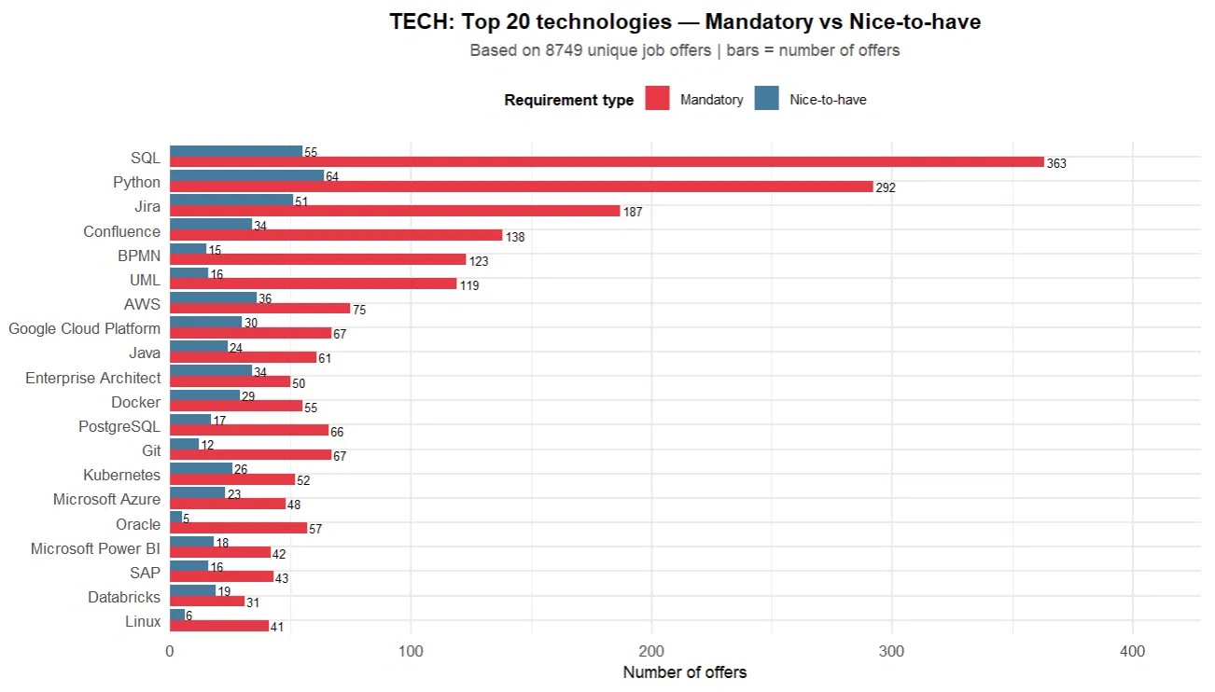
Process_optimization ranks second, appearing in 65.1% of job postings and including 8,059 distinct skills. This confirms that process analysis and optimisation are not niche capabilities but rather a core element of contemporary management-related roles. Similarly, Stakeholder_client_relations (54.2%), Management_information_systems (51.8%), and Data_analysis_stats (49.5%) complete the top tier. All three exceed the 49% threshold, meaning that at least half of all job advertisements include competencies from each of these categories. These areas frequently co-occur within job descriptions, particularly in management-related roles, where employers simultaneously expect skills in stakeholder relations, information systems, and data analysis.
The middle tier consists of competencies that are important but not universally required, typically appearing in 23–41% of job postings. This group includes Project_management (40.9%), Finance_accounting (36%), Leadership_decision_making (33.5%), Quality_management (32.7%), and Production_logistics (23.5%). These competencies are more strongly dependent on the specific type of role or industry. Project management appears in roughly one in four job advertisements, while quality management is present in about one in three. For the IZ1 programme profile, Production and logistics are particularly relevant, as 23.5% of job postings require these competencies, while the programme’s coverage in this area remains relatively low, suggesting a potential gap between educational outcomes and labour market expectations. Finance and accounting, with 36% of postings and 5,771 distinct skills, show a high degree of internal diversity, indicating that employers use a very broad range of terms to describe financial competencies, from basic accounting to controlling, budgeting, and ESG-related reporting.
The lower tier includes competencies that are either niche or emerging, typically appearing in less than 17% of job postings. This group includes Legal_economy_esg (16.5%), E_commerce_marketing (15%), It_services_cloud_ux (14.1%), and Hr_recruitment (12.1%). Although their overall share is relatively low, they remain important for specific career paths. It_services_cloud_ux is particularly noteworthy, as despite its limited presence in job advertisements, it includes a relatively large number of distinct skills, suggesting rapid development and increasing standardisation within this area. Big_data_databases (7%) and Ai_artificial_intelligence (5.7%) appear in a small share of postings, but this does not necessarily reflect their long-term importance, as both categories are among the fastest-growing areas of labour market demand. Programming_web (3.4%) and Ergonomics_workplace (1.9%) close the distribution as clearly niche competencies in the context of the IZ1 programme.
The number of skills provides an additional analytical dimension by revealing the level of standardisation in how competencies are described. Categories such as Soft_interpersonal and Process_optimization show extremely high lexical diversity, meaning that employers use a wide variety of expressions to describe similar underlying requirements. This lack of standardisation makes these competencies more difficult to map consistently to formal learning outcomes. In contrast, categories such as Ergonomics_workplace and Programming_web are described using more uniform technical terminology, which facilitates classification and alignment with competency frameworks.
The labour market for management-related graduates is primarily defined by five high-demand competency categories exceeding 40% of job postings: interpersonal skills, process optimisation, stakeholder relations, information systems, and data analysis. These form the core competency set expected from most graduates of the IZ1 programme. Below this threshold, a broad and more differentiated space of specialised competencies emerges, reflecting diverse career paths and industry-specific requirements, which can be addressed through elective modules and specialised study tracks within the curriculum.
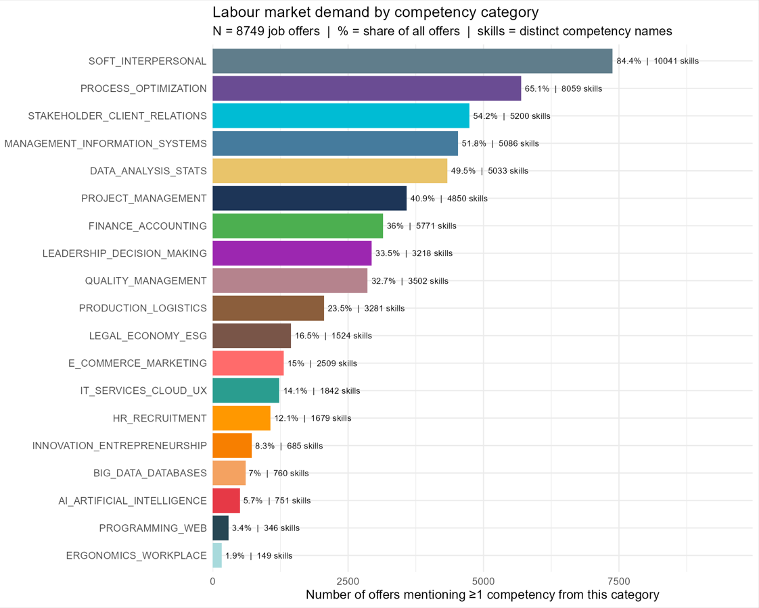

Identification of competency gaps and strategic recommendations

Comparative analysis - academic learning outcomes and employer expectations
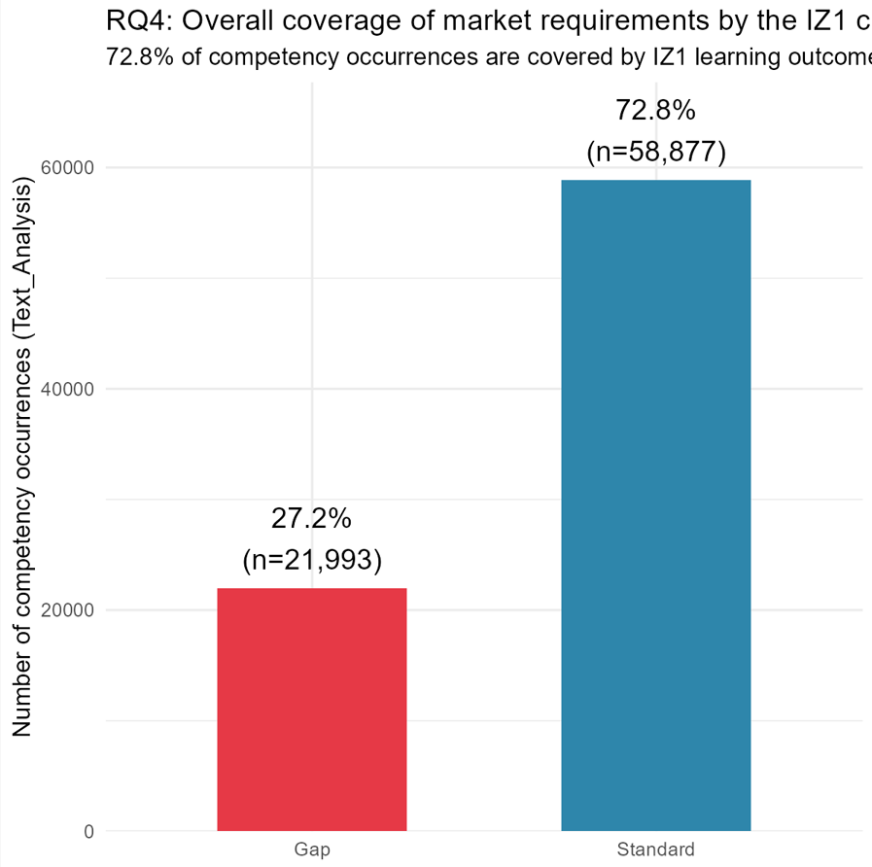
To complement the Gap Index, an additional performance indicator termed the Coverage Score was developed specifically for this study. Whereas the Gap Index combines labour-market demand with curriculum coverage into a single measure of alignment, the Coverage Score evaluates only the extent to which existing learning outcomes address competencies required by employers.
For each competence category, the Coverage Score represents the proportion of job advertisements requiring competencies from that category in which at least one extracted competence was successfully mapped to an official curriculum learning outcome (KEU). Formally, it is calculated as the number of advertisements containing at least one competence classified as Standard divided by the total number of advertisements requiring competencies belonging to the respective category. Consequently, the indicator measures the practical coverage of labour-market demand by the curriculum rather than simply the presence of related topics within the programme.
To facilitate interpretation, the obtained values were grouped into three coverage levels representing high, moderate and limited curriculum alignment.
High coverage (Coverage Score ≥ 85%) indicates competence areas in which the curriculum addresses the overwhelming majority of employer requirements. The highest values were observed for Leadership and Decision Making (95.7%) and Project Management (95.3%), suggesting that almost every job advertisement requiring competencies in these domains could be linked to existing curriculum learning outcomes. Similarly high coverage was identified for Innovation and Entrepreneurship (90.9%), Data Analysis and Statistics (88.2%), Process Optimization (87.9%), Ergonomics and Workplace (87.3%), and Soft and Interpersonal Competencies (86.4%), confirming that these domains constitute core strengths of the current Business Engineering curriculum.
The combination of Coverage Score and Gap Index provides additional analytical insight. For example, Soft and Interpersonal Competencies exhibit simultaneously a high Coverage Score (86.4%) and a positive Gap Index. This apparent contradiction results from exceptionally strong labour-market demand. Although the curriculum formally covers most competencies from this category, employer demand is proportionally higher than for any other competence domain, leaving a measurable unmet demand despite the relatively high level of curriculum coverage.
Moderate coverage (approximately 55-85%) identifies competence domains that are partially represented within the curriculum but still leave considerable proportions of labour-market requirements unmatched. This group includes Big Data and Databases (74.3%), Quality Management (69.8%), IT Services, Cloud and UX (66.8%), and Programming and Web Technologies (66.7%). In practical terms, approximately one-third of advertisements requiring competencies in these areas could not be associated with existing learning outcomes. Although these coverage levels cannot be considered critically low, they indicate opportunities for strengthening curriculum content, particularly because these technological domains are among the most frequently demanded by employers.
Management Information Systems (55.4%) represents a transitional case located near the boundary between moderate and low coverage. Together with its positive Gap Index, this result suggests that competencies related to enterprise information systems constitute one of the most important priorities for future curriculum development.
Low coverage (Coverage Score < 55%) reveals areas where substantial discrepancies exist between employer expectations and formally defined learning outcomes. The lowest coverage values were observed for Production and Logistics (24.9%), Human Resources and Recruitment (38.4%), Finance and Accounting (37.0%), Artificial Intelligence (42.0%), Legal, Economy and ESG (49.8%), and E-commerce and Marketing (51.4%).
Among these categories, Artificial Intelligence deserves particular attention because fewer than half of the advertisements requiring AI-related competencies could be linked to existing learning outcomes. This finding reflects the rapid emergence of AI technologies in industry, which has outpaced the corresponding evolution of university curricula. Likewise, the very low coverage observed for Production and Logistics is noteworthy given the industrial orientation of the Business Engineering programme. Approximately three-quarters of job advertisements requiring competencies in this domain could not be matched to existing learning outcomes, indicating a substantial curriculum gap despite the programme's engineering profile.
Overall, the Coverage Score provides a complementary perspective to the Gap Index. Whereas the Gap Index identifies whether labour-market demand exceeds curriculum coverage after accounting for demand intensity, the Coverage Score directly quantifies how much of the observed employer demand is currently represented by the official learning outcomes. Together, these two indicators provide a comprehensive framework for assessing curriculum-labour market alignment by simultaneously evaluating the magnitude of labour-market demand and the degree to which existing educational outcomes satisfy that demand.

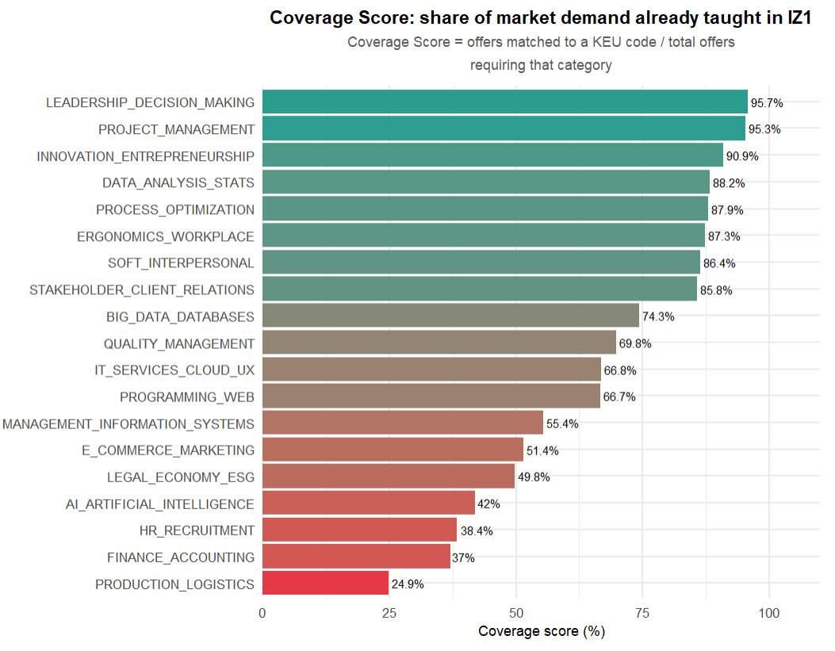
To facilitate the interpretation of curriculum alignment with labour-market demand, an original performance indicator termed the Gap Index was developed for this study. Rather than evaluating either employer demand or curriculum coverage separately, the indicator combines both dimensions into a single quantitative measure, enabling direct comparison across competency categories.
The Gap Index is calculated as the difference between the normalised labour-market demand for a given competency category and its corresponding Coverage Score, which represents the percentage of competencies within that category covered by the Business Engineering curriculum. Labour-market demand is first normalised to a 0-100 scale, where the category with the highest number of job advertisements is assigned a value of 100. The indicator is therefore defined as:

$$\text{Gap Index}=\text{Normalised Market Demand}-\text{Coverage Score}$$

Positive values indicate that labour-market demand exceeds curriculum coverage, suggesting that competencies within the category are requested relatively more frequently by employers than they are represented in the learning outcomes. Conversely, negative values indicate that curriculum coverage exceeds the relative level of employer demand. The Gap Index therefore serves as a synthetic Key Performance Indicator (KPI) developed specifically for this research, integrating two previously independent dimensions-market demand and curriculum coverage-into a single interpretable measure of curriculum-labour market alignment.
The proposed indicator is intended to support comparative interpretation rather than provide an absolute measure of curriculum quality. Its objective is to identify competency domains that may warrant further curriculum development or, conversely, domains that are comparatively well represented relative to current labour-market requirements.
Positive Gap Index values indicate competency categories where employer demand exceeds current curriculum coverage. Only four categories exhibited positive values, suggesting that these represent the principal areas in which the curriculum may require further development. The largest gap was observed for Soft and Interpersonal Competencies, indicating that behavioural and interpersonal skills are consistently required across job advertisements while being comparatively less formalised within the programme learning outcomes. Moderate positive values were also observed for Management Information Systems and Finance and Accounting, suggesting potential benefits from strengthening learning outcomes related to ERP systems, business intelligence, management accounting and financial analysis. A smaller but still positive gap was identified for Production and Logistics, reflecting the industrial profile of many analysed positions.
Negative Gap Index values indicate that curriculum coverage is proportionally higher than the corresponding level of labour-market demand. This should not automatically be interpreted as curriculum oversupply. In many cases, negative values simply reflect strong curriculum coverage in strategically important competency areas. For example, Process Optimisation and Data Analysis and Statistics exhibit relatively high curriculum coverage while remaining consistently demanded by employers. By contrast, categories such as Ergonomics and Workplace Safety or Innovation and Entrepreneurship display substantially lower market demand despite extensive curriculum coverage. Although these areas remain educationally valuable, the results suggest that they currently contribute less directly to graduate employability than other competency domains.
Finally, it should be noted that the Gap Index is influenced by the normalisation procedure applied to labour-market demand. Because demand values are scaled relative to the most frequently occurring competency category, secondary categories naturally receive lower baseline values. Consequently, moderately negative Gap Index values observed for categories such as Big Data and Databases, Programming and Web Technologies, Leadership and Decision Making, or IT Services and Cloud Technologies should not necessarily be interpreted as evidence of curriculum oversupply. Instead, they primarily reflect the relative rather than absolute distribution of employer demand across competency categories.

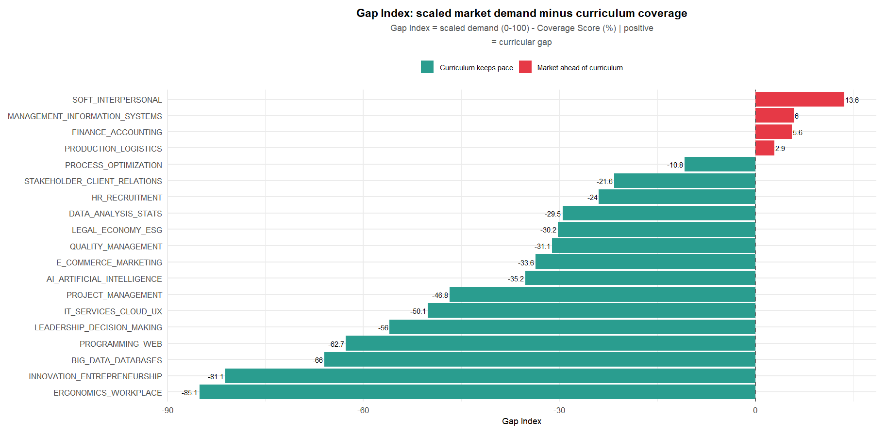
The heatmap combines two complementary dimensions of curriculum alignment for each competence category. The first dimension represents the Coverage Score, indicating the proportion of labour-market demand formally covered by the learning outcomes defined in the Business Engineering curriculum. The second dimension represents the absolute frequency with which competencies from a given category appeared in the analysed job advertisements. By presenting both measures simultaneously, the heatmap makes it possible to distinguish between categories that are highly demanded and well covered, categories characterised by substantial curriculum gaps, and areas in which the programme currently provides broader coverage than labour-market demand would suggest.
The strongest alignment between the curriculum and employer expectations can be observed for categories combining high labour-market demand with high curriculum coverage. Soft interpersonal competencies constitute the largest competence group within the analysed job advertisements and simultaneously achieve a Coverage Score exceeding 85%. Similarly high levels of alignment are visible for Process Optimization, Stakeholder and Client Relations, Data Analysis and Statistics, Project Management, and Leadership and Decision Making. These results indicate that the core managerial and analytical profile of the Business Engineering programme corresponds well with the competencies most frequently requested by employers.
The heatmap also identifies several categories where labour-market demand substantially exceeds the degree of curriculum coverage. Among these, Management Information Systems represents one of the most important findings. Although competencies related to enterprise information systems appear very frequently across the analysed advertisements, only slightly more than half of this demand is covered by existing learning outcomes. A similar situation is observed for Finance and Accounting, where the Coverage Score remains below 40%, despite the high importance of financial competencies for graduates of management-oriented engineering programmes. The most pronounced mismatch concerns Production and Logistics, which combines relatively high labour-market demand with the lowest Coverage Score among all analysed categories. This suggests that competencies associated with production processes, logistics and industrial operations are considerably underrepresented within the current curriculum relative to employer expectations.
Several categories exhibit comparatively low labour-market demand together with moderate or limited curriculum coverage. Examples include IT Services, Cloud and UX, Human Resources and Recruitment, Artificial Intelligence, and Programming and Web Development. Although these competencies currently account for a smaller proportion of the analysed job advertisements, they nevertheless represent emerging or specialised areas that may gain strategic importance as labour-market requirements continue to evolve. In particular, the relatively modest curriculum coverage observed for Artificial Intelligence should be interpreted in the context of the rapidly increasing adoption of AI technologies across industries rather than solely on the basis of their current frequency within the dataset.
The opposite situation can also be identified, where curriculum coverage is extensive despite comparatively limited labour-market demand. Innovation and Entrepreneurship together with Ergonomics and Workplace Safety both achieve high Coverage Scores while appearing relatively infrequently in job advertisements. These results do not imply that such topics lack educational value. Instead, they indicate that these areas currently receive greater emphasis within the curriculum than would be expected solely from contemporary recruitment trends. Such competencies remain important from the perspective of broader engineering education and graduate development, although their immediate contribution to labour-market competitiveness appears less pronounced than in several underrepresented technical and managerial domains.
The heatmap confirms that the Business Engineering curriculum demonstrates strong alignment with labour-market expectations in managerial, analytical and interpersonal competencies. At the same time, it consistently identifies three areas where curriculum development could provide the greatest benefit: Management Information Systems, Finance and Accounting, and Production and Logistics. These categories combine substantial employer demand with relatively low curriculum coverage and therefore represent the most evident priorities for future programme development. The heatmap also complements the previously discussed Coverage Score and Gap Index by simultaneously illustrating both the intensity of labour-market demand and the degree to which this demand is currently addressed within the curriculum, providing a comprehensive overview of curriculum-market alignment.

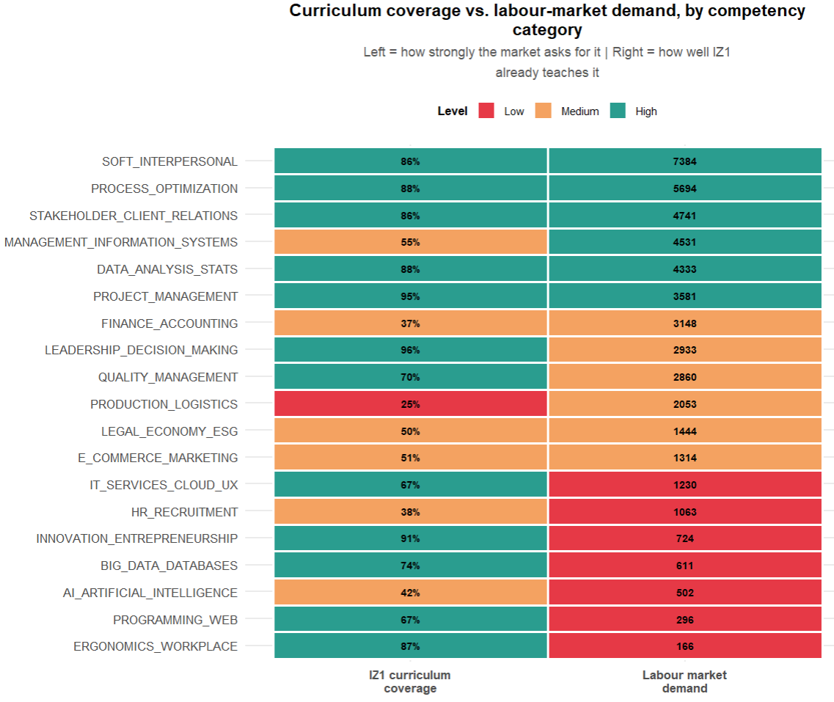
The distribution of artificial intelligence (AI) and application programming interface (API) terminology within the analysed job advertisements reveals an important characteristic of the contemporary labour market. The most significant observation is not the absolute number of AI-related competencies assigned to the Artificial Intelligence category itself, but rather the fact that AI terminology appears across every competence category identified in this study. References to artificial intelligence are present not only within explicitly technical domains but also in project management, finance, logistics, human resources, quality management and stakeholder relations. This finding suggests that AI has evolved from a specialised technical field into a transversal competence expected across a wide range of professional roles.
Overall, approximately 7.5% of all analysed job advertisements contained at least one reference to AI- or API-related terminology. In practical terms, roughly one in every fourteen job advertisements required applicants to possess at least a basic understanding of artificial intelligence tools or technologies, regardless of the occupational profile or industry.
The distribution simultaneously demonstrates both concentration and dispersion. As expected, the Artificial Intelligence competence category contains by far the largest number of AI-related competencies, accounting for approximately 5.6% of all analysed job advertisements and nearly 700 individual AI-related competence occurrences. This reflects the growing demand for specialists working directly with machine learning, large language models, retrieval-augmented generation (RAG), prompt engineering and related technologies.
At the same time, AI terminology is also distributed across the remaining competence categories, where it appears as an additional layer complementing existing domain-specific expertise. For example, competencies related to AI-supported process automation occur within Process Optimization, while references to AI-assisted decision support can be observed in Project Management. Similarly, AI terminology appears within Finance and Accounting, E-commerce and Marketing, Quality Management and several other domains, indicating that employers increasingly expect graduates to integrate AI tools into traditional professional activities rather than treat them as an isolated technical speciality.
From the perspective of curriculum design, this pattern has important implications. The widespread presence of AI terminology across virtually all competence domains suggests that employers increasingly expect graduates to possess AI literacy rather than only specialised artificial intelligence expertise. In other words, graduates are expected not only to understand AI concepts but also to apply AI-supported tools within their own professional discipline, whether this involves analysing financial data, supporting project planning, automating reporting processes, improving logistics operations or enhancing managerial decision-making.
This interpretation is reinforced by the relatively modest Coverage Score of approximately 42% obtained for the Artificial Intelligence competence category. When considered together with the broad distribution of AI terminology across all competence domains, this result indicates that the identified curriculum gap should not be interpreted as the absence of a single dedicated AI course. Instead, it reflects a broader need to integrate AI-related competencies throughout the curriculum, embedding AI literacy within multiple subject areas rather than treating artificial intelligence exclusively as a standalone topic. Such an approach would better reflect the increasingly interdisciplinary role of AI in contemporary business and engineering practice.

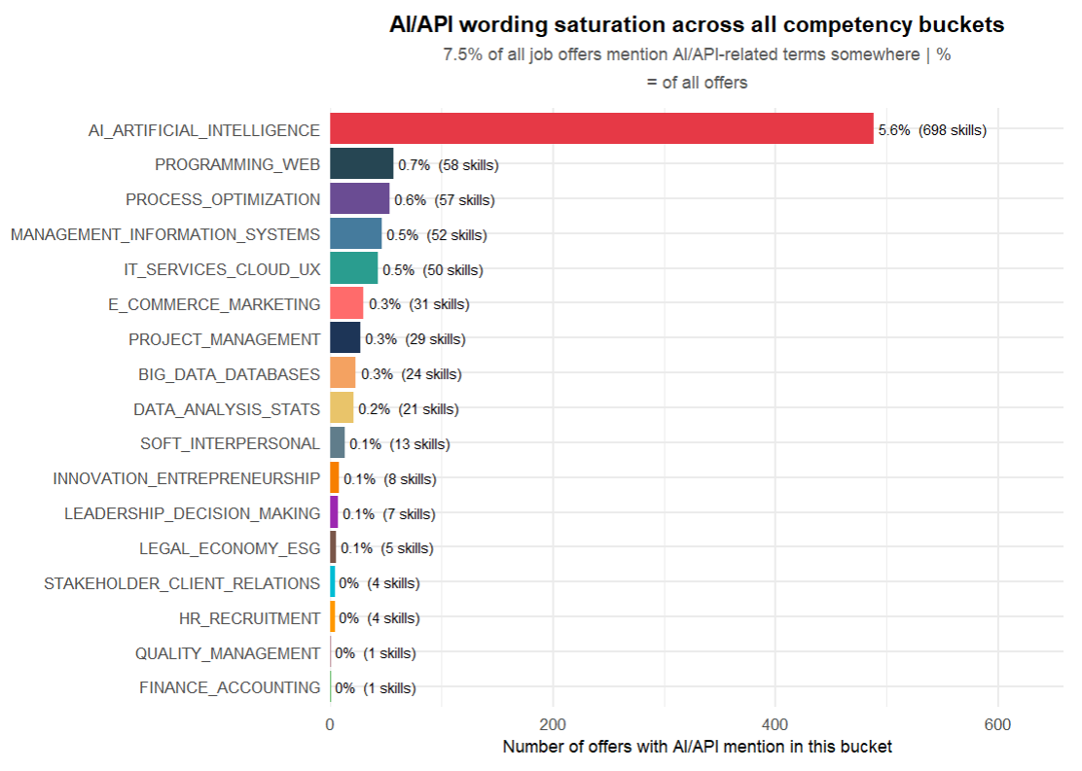

Classification and evaluation of identified competency gaps

Recommendations for adjusting the IZ1 curriculum to contemporary market trends
The results of the analysis indicate a generally strong alignment between the Business Engineering curriculum and labour-market expectations in core managerial, analytical and interpersonal competencies. In particular, high Coverage Scores combined with high labour-market demand confirm that areas such as soft and interpersonal skills, process optimisation, data analysis, project management, and stakeholder relations are adequately represented within the current programme structure. These findings suggest that the existing curriculum provides a solid foundation for graduate employability in key management-related roles.
At the same time, the analysis identifies several areas where the alignment between employer expectations and curriculum content is less balanced. The most critical gap concerns Management Information Systems, Finance and Accounting, and Production and Logistics. These categories combine relatively high labour-market demand with noticeably lower Coverage Scores, indicating that a substantial proportion of employer requirements in these domains is not fully addressed by existing learning outcomes. This suggests a need to strengthen curriculum content related to enterprise systems, financial and managerial accounting, as well as industrial and logistics processes. In practical terms, this could involve expanding coursework in ERP systems, business intelligence tools, supply chain management, and applied financial analysis.
A second important finding relates to the increasing role of Artificial Intelligence across all competence domains. The results show that AI-related terminology is no longer confined to a single specialist area but is instead embedded across a wide range of job profiles, including project management, finance, marketing, and operations. This suggests that AI should not be treated solely as a standalone topic within the curriculum, but rather as a transversal competence integrated across multiple modules. Strengthening AI literacy among students - particularly in the context of data analysis, decision support systems, and process automation - better reflect current labour-market expectations.
Finally, the analysis highlights a group of competencies, such as innovation and entrepreneurship and workplace ergonomics, where curriculum coverage is relatively high despite more limited labour-market demand. While these areas remain valuable from an educational and developmental perspective, the results suggest that their role in enhancing immediate employability is less pronounced compared to underrepresented technical and managerial domains. This does not imply that such topics should be reduced, but rather that their positioning within the curriculum could be reconsidered in favour of a more balanced integration with high-demand competencies.
Overall, the findings support a curriculum development strategy based on three priorities: strengthening underrepresented but high-demand technical and managerial areas, integrating digital and AI-related competencies across the programme, and maintaining but more clearly contextualising lower-demand yet educationally valuable content. Such an approach would ensure that the Business Engineering curriculum remains both academically comprehensive and closely aligned with evolving labour-market requirements.

Conclusions
The aim of this thesis - to investigate current labour market requirements for competencies and to compare them with the learning outcomes of the IZ1 programme in order to identify competency gaps - has been achieved. All six research questions formulated in Section 2.1 were answered through the design, implementation, and application of an original hybrid competency-matching framework to an empirical dataset of more than 9,000 job advertisements collected from Pracuj.pl and the complete set of 56 KEU and 595 PEU-KEU relationships extracted from the IZ1 curriculum documentation.
The analysis demonstrated that the most frequently required competencies in job postings relevant to the Business Engineering profile concern soft and interpersonal skills, process optimisation, stakeholder and client relations, management information systems, and data analysis, with named technologies such as SQL, Python, Jira, Confluence, BPMN and UML emerging as core, predominantly mandatory requirements (RQ1). The study showed that natural language processing combined with a locally deployed large language model can be effectively used to extract competencies expressed in highly heterogeneous, multilingual language and group them into meaningful, curriculum-relevant categories (RQ2). At the same time, the research confirmed that purely lexical, dictionary-based matching is insufficient for identifying behavioural and methodological competencies expressed through varied phrasing, and that this limitation can be substantially mitigated through AI-based semantic classification, supported by a deterministic verification layer that safeguards against systematic misclassification of named commercial systems and selected domain-specific competencies (RQ3).
With respect to curriculum-market alignment (RQ4 and RQ5), the results indicate an overall coverage rate of 72.8%, confirming that the IZ1 curriculum is well aligned with labour market expectations in core managerial, analytical, and interpersonal domains, where Coverage Scores frequently exceeded 85%. However, three clear and consistent gaps were identified using the original Coverage Score and Gap Index indicators: Management Information Systems, Finance and Accounting, and Production and Logistics, all combining substantial employer demand with markedly lower curriculum coverage. A further cross-cutting gap was identified in Artificial Intelligence competencies, which, despite a Coverage Score of only around 42%, were found to be distributed across virtually all competency categories rather than confined to a single technical domain, indicating that AI literacy has become a transversal rather than a specialist requirement. Finally, the analysis of competency demand across seniority levels (RQ6) provided additional context for interpreting these gaps in relation to entry-level versus more advanced professional roles.
The objective of the thesis can therefore be considered fully achieved. The proposed hybrid methodology - combining deterministic technology matching, bilingual lexical pre-filtering, AI-assisted semantic classification, and rule-based verification within an adapted CRISP-DM/PDCA framework - proved capable of producing a reproducible, auditable, and scalable diagnosis of curriculum-labour market alignment, overcoming the limitations of traditional, infrequent, and retrospective evaluation instruments described in the literature.
Based on these findings, the thesis recommends strengthening curriculum content related to enterprise information systems, financial and managerial accounting, and industrial and logistics processes, and recommends integrating artificial intelligence competencies as a transversal element across multiple courses rather than as an isolated subject. Areas such as innovation and entrepreneurship or workplace ergonomics, which showed high curriculum coverage relative to comparatively lower labour market demand, should not be removed but could be repositioned to achieve a more balanced distribution of curricular emphasis.
As directions for further research, the proposed framework could be extended to other study programmes by preparing an analogous KEU/PEU reference table, applied longitudinally to track the evolution of competency demand over time, or used with larger commercial language models to evaluate potential improvements in semantic classification accuracy relative to the locally deployed model used in this study.

Bibliography
- Boyatzis, R. E. (1982). The Competent Manager: A Model for Effective Performance. Wiley.
- Campion, M. A., Fink, A. A., Ruggeberg, B. J., Carr, L., Phillips, G. M., & Odman, R. B. (2011). Doing competencies well: Best practicies in competency modeling. Personnel Psychology, 64, 225–262.
- Cao, C., & Zhang, Z. (2022). Machine Learning-Assisted Competency Modeling for Human Resource Management Jobs. Mobile Information Systems, 2022. https://doi.org/10.1155/2022/8380307
- Cools, E., & Bellens, K. (2012). The onion model: Myth or reality in the field of individual differences psychology? Learning and Individual Differences, 22(4), 455–462. https://doi.org/10.1016/j.lindif.2012.04.002
- Deming, W. E. (2018). Out of the Crisis. The MIT Press.
- Dreyfus, S. E., & Dreyfus, H. L. (1980). A five-stage model of the mental activities involved in directed skillacquisition.
- Ehlers, U.-D., Helmstedt, C., & Richter, T. (2009). Analysing new e-learning culture.
- European Centre for the Development of Vocational Training. (2017). Real-time labour market information on skill requirements: setting up the EU system for online vacancy analysis Global report. http://www.cedefop.europa.eu/en/events-and-
- European Commission. (2025). Competence. European Skills, Competences, Qualifications and Occupations (ESCO).
- Exenberger, E., & Bucko, J. (2020). Analysis of Online Consumer Behavior - Design of CRISP-DM Process. Agris On-Line Papers in Economics and Informatics, 12(3), 13–22.
- Filipowicz, G. (2016). Zarządzanie kompetencjami: perspektywa firmowa i osobista (2nd exp.). Wolters Kluwer .
- Freund, L., Clinton Spohrer, J., Savva, P., & Gandhi, Y. (2024). T-shaped Professionals: The Past, Present, and Future of MyT-Me Development. The Human Side of Service Engineering, Vol. 143, 143, 1–11. https://doi.org/10.54941/ahfe1005078
- Gardner, P., & Estry, D. (2017). A Primer of the T-professional.
- Hall, E. T. (1989). Beyond Culture. Anchor Press/Doubleday.
- Hazan, E., Madgavkar, A., Chui, M., Smit, S., Maor, D., Dandona, G. S., & Huyghues-Despointes, R. (2024). A new future of work: The race to deploy AI and raise skills in Europe and beyond. www.mckinsey.com/mgi.
- Hyland, T. (1994). Competence, Education and NVQs: Dissenting Perspectives. Cassell.
- Kocór, M. (2019). Nadwyżka czy deficyt kompetencji? Wydawnictwo Uniwersytetu Jagiellońskiego.
- Konarski, S. (Ed.). (2006). Kompetencje społeczno-psychologiczne ekonomistów i menedżerów. Szkoła Główna Handlowa.
- Kubátová, J., Müller, M., Kosina, D., Kročil, O., & Slavíčková, P. (2025). Soft Skills for the 21st Century: Defining a Framework for Navigating Human-Centered Development in an AI-Driven World. Springer.
- Kulikowski, K. (2015). Zastosowanie modelu Cross Industry Standard Process for Data Mining (CRISP-DM) w badaniach postaw i opinii pracowników. Zeszyty Naukowe Politechniki Śląskiej. Seria: Organizacja i Zarządzanie, (82), 112–121.
- Li, N., Kang, B., & De Bie, T. (2025). LLM4Jobs: Unsupervised occupation extraction and standardization leveraging Large Language Models. Knowledge-Based Systems, 316, 1–16. https://doi.org/10.1016/j.knosys.2025.113302
- LLM STATS. (2026). Compare AI Models: Side-by-side benchmarks, pricing, and capabilities. LLM STATS. https://llm-stats.com/models/compare
- McClelland, D. C. (1973). Testing for Competence Rather Than for “Intelligence.” American Psychologist, 28(1), 1–14.
- McGuinness, S., Pouliakas, K., & Redmond, P. (2018). Skills mismatch: Concepts, measurement and policy approaches. Journal of Economic Surveys, 32(4), 985–1015. https://doi.org/10.1111/joes.12254
- OECD. (2025). OECD Skills Outlook 2025: Building the Skills of the 21st Century for All (OECD Skills Outlook). OECD Publishing. https://doi.org/10.1787/26163cd3-en
- Organisation for Economic Co-operation and Development. (2024). Artificial intelligence and the changing demand for skills in the labour market. OECD Artificial Intelligence Papers, 14.
- Parry, S. B. (1996). The Quest for Competencies. Training, 33(7), 48–56.
- Patel, P. M., & Deshpande, V. A. (2017). Application Of Plan-Do-Check-Act Cycle For Quality And Productivity Improvement - A Review. International Journal for Research in Applied Science & Engineering Technology (IJRASET), 5(1), 197–201. www.ijraset.com
- Philippines Australia Human Resource and Organisational Development Facility. (2017). A Guidebook on Competency Modelling and Profiling.
- Pondel, M., & Korczak, J. (2017). Metodyczne podejście do analizy i eksploracji danych marketingowych. Studia Ekonomiczne. Zeszyty Naukowe Uniwersytetu Ekonomicznego w Katowicach, (342), 52–71.
- Pracuj.pl. (2026). Czy mogę przedłużyć czas trwania ogłoszenia? Centrum Pomocy Pracuj.Pl Dla Firm. https://dlafirm.pracuj.pl/pomoc/moje-ogloszenie
- Schneider, K. (2019). What Does Competence Mean? Psychology, 10(14), 1938–1958. https://doi.org/10.4236/psych.2019.1014125
- Schwab, K. (2016). The Fourth Industrial Revolution. World Economic Forum. www.weforum.org
- ScraperAPI. (2026). Web Scraping: The Basics Explained. https://www.scraperapi.com
- Spencer, L. M., & Spencer, S. M. (1993). Competence at work: models for superior performance. New York : Wiley.
- Straehle, M. K. E. B. D. (2017). Understanding KSAOs. In Military Psychology (Vol. 18, Number 2). https://doi.org/10.1207/s15327876mp1802_2
- Szabó, Z. R., Hortoványi, L., & Ászity, S. (2023). Definitions and principles of Industry 4.0. In S. G. Nagy & T. Stukovszky (Eds.), Smart Business and Digital Transformation (pp. 3–4). Routledge.
- Szeliga, M. (2017). Data Science i uczenie maszynowe. Wydawnictwo Naukowe PWN.
- University of North Texas System. (2022). Knowledge, Skills, & Abilities (KSA) Bank.
- Vitello, S., Greatorex, J., & Shaw, S. (2021). What is competence? A shared interpretation of competence to support teaching, learning and assessment. https://www.cambridge.org/
- White, R. W. (1959). Motivation reconsidered: The concept of competence. Psychological Review, 66(5).
- Wilson, M. A. (2014). A History of Job Analysis. In L. L. Koppes (Ed.), Historical Perspectives in Industrial and Organizational Psychology (pp. 219–241). Psychology Press.
- Wiśniewska, S. (2021). Wybrane zagadnienia zarządzania kompetencjami pracowników w organizacji (M. Tyrańska, Ed.). C.H.Beck.
- World Economic Forum. (2025). Future-of-jobs-report-2025. www.weforum.org
- Wrocław University of Science and Technology. Faculty of Management. (2025). Study programme: Business Engineering, first-cycle studies, full-time studies, education cycle: 2025/2026.

List of figures
Figure 1. Competency Casual Flow Model Source: (Spencer & Spencer, 1993, p. 13) 16
Figure 2. The Iceberg Model Source: (Spencer & Spencer, 1993, p. 13) 17
Figure 3. Onion Model of competencies 19
Figure 4. A T-shape professional model 21
Figure 5. Katz's competency groups 23
Figure 6. Competence levels 28
Figure 7. The five stages of skill acquisition 29
Figure 8. Expected disruption of workers’ core skills between 2016 and 2025 31
Figure 9. Core skills in 2025 33
Figure 10. Forecasted changes in skill demand, 2025-2030 35
Figure 11. Structure of KEU and PEU in the IZ1 curriculum 39
Figure 12. CRISP-DM process model adapted for this study and integrated with a PDCA quality loop 44
Figure 13. Generic web scraping workflow 48
Figure 14. Data acquisition procedure adopted in this study 49
Figure 15. Hybrid competency-matching framework 53
Figure 16. Distribution of KEU codes by domain 62
Figure 17. Distribution of PEU-KEU links per learning outcome Source: Own study 63
Figure 18. Top 3 moste-referenced KEU codes per domain 65

List of tables
Table 1. Selected definitions of the term "competence" 8
Table 2. Example of PEU aggregation into composite KEU competency profiles 41
Table 3. Summary of the layered competency-matching architecture 54
Table 4. Comparison of language models considered during model selection 55
Table 5. Example records from the final PEU-KEU mapping dataset 61
Table 6. Descriptive statistics of the PEU–KEU mapping 65
Table 7. KEU codes with the weakest programme coverage 66
Table 8. The worked input-output example included in the system prompt 68
Table 9. Structure of the raw job-posting dataset before data cleaning 73
Table 10. Structure of the final raw job-posting dataset before 74
Table 11. Structure of the final competence matrix 78

