Contents

In General 2

How to use 2

Features 2

## In General

This Program can move your mouse to let other programs think, that you’re on the computer when you’re not. So, it is meant to beat idle restrictions.

## How to use

After you start it, you see this:

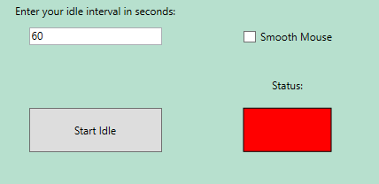

Press F5 to abort the cooperation immediately

In the upper left corner, you can type the interval the program moves your mouse around. Note: you can’t go below 5 seconds (you will then receive a message.

In the upper right corner, you can decide if you want a smooth mouse movement or not by ticking the checkbox it enables the smooth movement.

On the bottom left you can start the program when it says “Start Idle”. You can stop the program by pushing the same button again. This time it says “Stopp Idle”.

On the bottom right you see the current Status of the Program. Red means its off and green means its currently operating.

## Features

* Setup custom time
* Smooth out Mouse movement
* Stopp and start the idle
* See the Status
* Abort the cooperation immediately