Sport Data Analytics FS26
Notes on the dataset, and on the scope proposal
2 September 2026 · reply to Mayra’s note on scope
The direction in Mayra’s message works, and most of what follows supports it. One point needs correcting and it goes in her favour. Everything here is reproducible in notebooks/01_data_review.ipynb, with the cleaning in 02_cleaning.ipynb. Section numbers refer to the first notebook.

Already right in our summary
- The two mileage columns are redundant. Confirmed: keep miles, drop km.
- injury_severity is empty because there was no injury. Same for personal_best_minutes, which is null exactly for first-time marathoners. Both nulls carry information, so no imputation. (section 3)
- The medal codes are undefined. Still undefined after looking. They fall with finish time but overlap heavily, and even the slowest tenth wins something 6 % of the time. Not a clean podium flag; better treated as some reward versus none.
- Not naming the profiles in advance, as Petronela said in the meeting. Nothing in the data argues against that.

Things the summary missed
- Half the mileage column is a placeholder. weekly_mileage_km is exactly 20.0 for 49 % of rows, long_run_distance_km exactly 15.0 for 81 %. The km to miles ratio should always be 1.609 and reaches 9.67. Neither belongs in a clustering distance. (section 2)
- The runners with no finish time are drop-outs, not missing data. 2.5 % of the file, rising from 1.0 % with no injuries to 8.7 % with four, and beginners drop out twice as often as advanced runners. Our summary lists actual_finish_time_minutes under missing values to preprocess. Cleaning it away deletes an outcome we should be using. (section 4)
- target_finish_time_minutes cannot be a predictor of absolute finish time. Actual equals target plus 11 to 60 minutes, so any model given the column scores R² = 0.96 and has learned nothing. As part of the outcome it is a different matter, see below. (section 1)
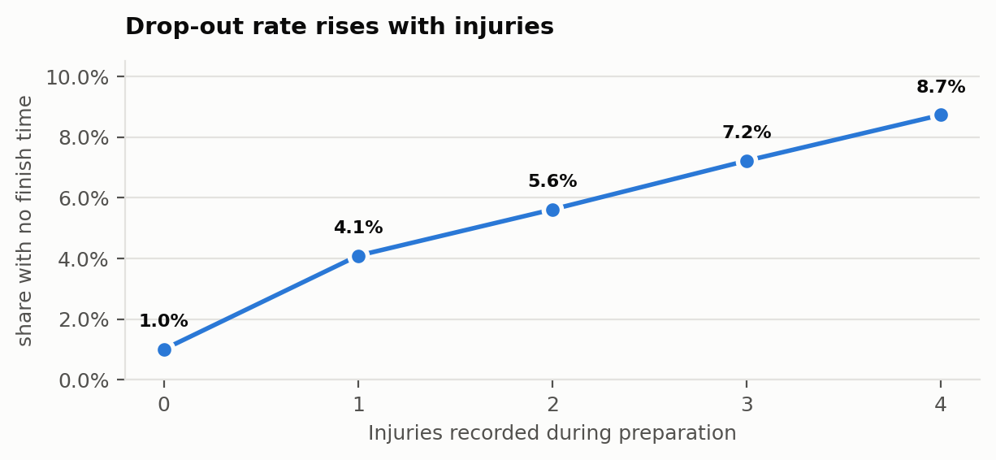
Figure 1. notebook, section 4.

The performance gap is the right call
Mayra’s suggestion to work with actual minus target rather than absolute time is stronger than it looks, and it is what makes the psychological angle work at all.
- The behaviour block explains almost nothing about absolute finish time: R² = 0.016.
- On the gap it reaches R² = 0.238, roughly twelve times more.
- The reason is clean: the target already encodes how good the runner is, so subtracting it strips the ability term out and leaves how well the preparation and the day went. Which is what we actually want to measure.
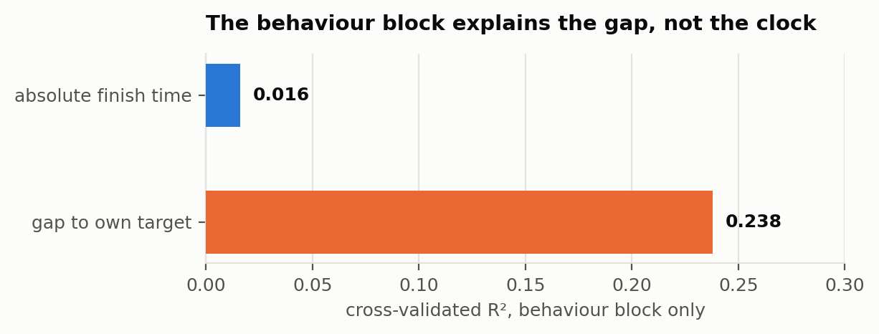
Figure 2. notebook, section 5.
One correction to subquestion 3, though. Nobody in this file finishes ahead of their target: the gap runs from +11 to +60 minutes, mean 39. So the question cannot be who does better or worse than their target. It has to be how far short they fall, and why.
Worth saying out loud in the dossier rather than letting Martin find it: that floor at +11 is the synthetic generator showing through. He already told Petronela the methodology matters more than the numbers, so this is fine as long as it comes from us.

Race day is a measurable part of the answer
The gap also picks up things the runner does not control, which is exactly the skill and luck split from Martin’s slides.
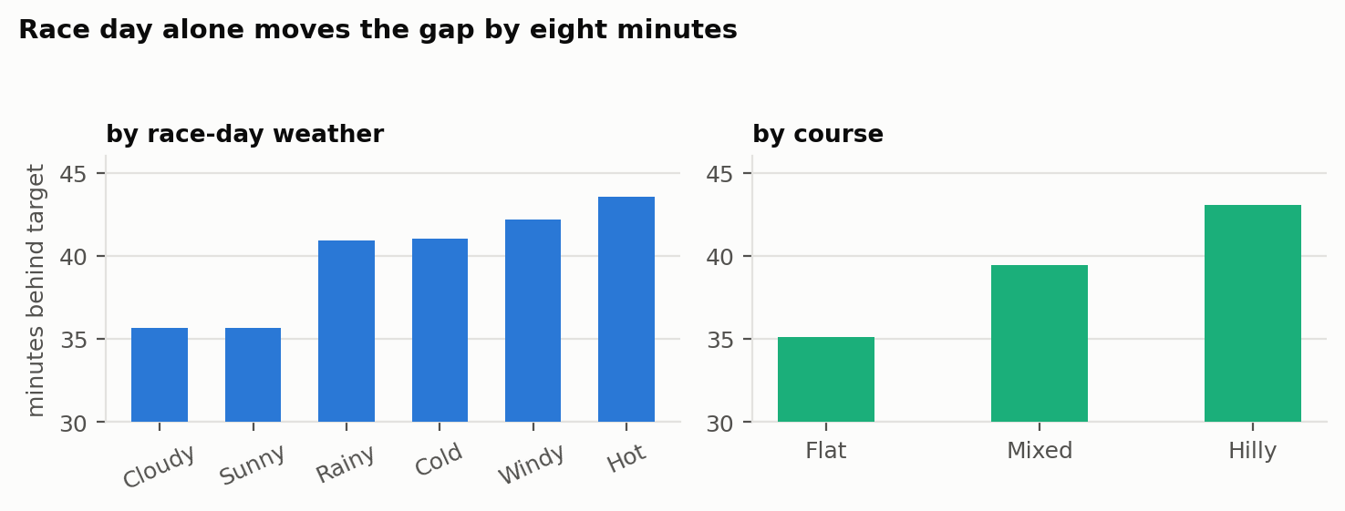
Figure 3. notebook, section 6.
- Hot day 43.6 minutes behind target, cloudy 35.6. Hilly course 43.1, flat 35.1.
- That is eight minutes from conditions alone, against three minutes across the whole range of training adherence.
- So the profiles should be compared with weather and course held constant, or the comparison will partly be measuring who got a nicer race.

One more outcome worth keeping
Absolute time, the gap and the medal do not rank runners the same way, and the behaviour block behaves differently in each.
- On winning a medal the behaviour block alone reaches AUC 0.709. (section 6)
- Across adherence quintiles, mean finish time moves 3 minutes while medal probability goes from 24 % to 38 %.
- Split by speed first and high adherence still beats low adherence inside every band: 63 % against 52 % among the fastest, 12 % against 6 % among the slowest. So it is not simply that fast runners are also disciplined.
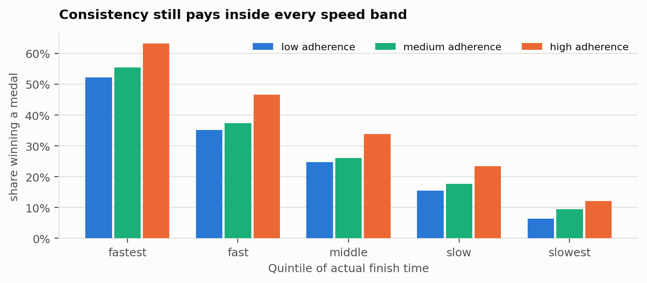
Figure 4. notebook, section 6.
Practical consequence for subquestion 2: compare the profiles on the gap, on the medal and on the drop-out rate. On absolute time alone they will look more alike than they are.

Proposed wording
Main question, unchanged from Mayra’s version:
Can distinct runner profiles be identified based on training behaviour, physical condition, recovery and psychological preparation, and how do these profiles differ in marathon performance?
Subquestions, with 3 reworded and one added:
- Which distinct runner profiles emerge from the available variables?
- How does performance differ across the profiles, measured as the gap to target, the medal outcome and the drop-out rate?
- How far short of their target do runners fall, and how much of that is preparation against race-day conditions?
- Which of the behavioural indicators carry that, once physical condition is accounted for?

Consequences for the profiles plan
- The clustering design stays as written: build on preparation, compare on outcomes.
- training_adherence_pct and missed_workout_pct correlate at 0.89. Same construct twice, so one has to go before clustering or it gets double weight. (section 7)
- motivation_level shows up in behaviour (early-morning runs 0.65, run club 0.63) but never in results. That gap is worth a short section.

Plan to 23 September
Week | What
1 to 7 Sep | Agree the question. Review the cleaning in 02_cleaning.ipynb: km column dropped, DNFs kept, structural nulls given a meaning, the rest median-filled with a flag. Sign the team agreement.
8 to 14 Sep | Clustering and modelling in parallel. Whoever takes the behavioural side writes what each construct means before we cluster on it.
15 to 19 Sep | Freeze findings. Build the Observable notebook around the figures that survive. Write the reflection.
20 to 22 Sep | Read-through, tidy the code, check every claim against the cell that produced it.
23 Sep | Submit.
The reflection is one of the seven marks and the material is already there: the leakage, the skill and luck framing, the synthetic-data caveat.

Open
- Sample down for Observable? 80k points will not render interactively.
- Is drop-out its own section or a paragraph? Most original thing in the file, currently the least developed.
- Tell Martin about the target-time leakage before submitting? He offered to coach, and it would show working.

