**Hydro-meteorology**

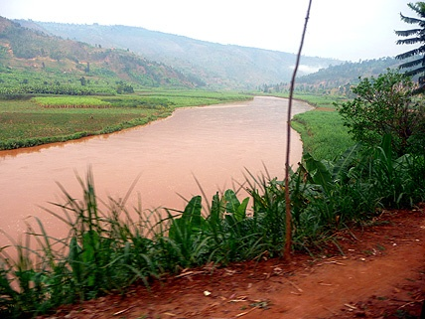

Hydrometeorology is defined as the part of meteorology concerned with hydrological responses in a watershed basin. This is relevant to many sectors, particularly to flood control, hydroelectric power, irrigation, construction and similar fields of engineering and water resources.

Water balance can be described as the flow of water in and out of a system. Establishing the water balance in any given basin is a critical tool in understanding the hydrological behaviour of a basin, and the impact that water abstractions or regulations will have. Water balance can be established through analysing precipitation, run-off, infiltration and evaporation in the basin.

Thumbnail: Akagera River, Rwanda

Hydro-meteorological data series are required to establish a water balance for the basin and the different hydro-geographical zones. Meteorological data include rainfall, temperature, humidity, wind sunshine, evaporation and evapotranspiration.

The hydro-meteorological section at Rwanda Meteorological Service is currently in development. The key activities it will undertake during the next year include:

1. Conducting a wide-scale hydrometric survey to integrate the data from numerous hydro-meteorological stations that are being operated by different agencies.
2. Establishing where new sites are required, procuring the equipment and training hydro-met observers to collect data from the sites
3. Collecting hydro-meteorological data from around the country and performing analysis to develop a range of hydro-met services.

If you feel that hydro-meteorological services would be useful to you or your organisation, your assistance in filling in the following questionnaire would be appreciated. This will be used to determine the range of hydro-meteorological services that RMS should develop. Please send completed questionnaires to [meteo.rwanda@gmail.com](mailto:meteo.rwanda@gmail.com).

For any other questions about hydro-meteorology at RMS, please email [meteo.rwanda@gmail.com](mailto:meteo.rwanda@gmail.com).