|  |
| --- |
|  |
|  |
|  |

**Cooking School**

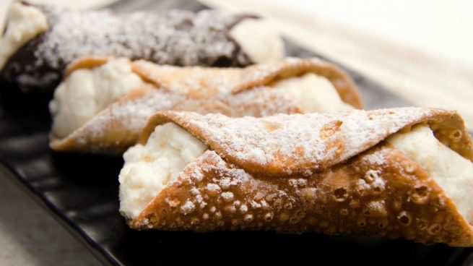

«ITALIAN DESSERT COURSE: Sicilian Canolo - 5hours course»

1. Introduction

I used to work for a Hospitality School and I was in charge of organizing courses. We use to look for places or neighborhoods where candidates could be found to take the course, so we organized a course in that place.

For this project I will imagine I have to find a good place where a teacher would go to give a short course of preparing an italian dessert. So I will look for a neighborhood where there is a high density of Italian Restaurants, cafeterias, coffee shops, etc. where there may be candidates to take the cooking course, that will take place in one of those coffee places.

1. Data

I will use 2 sources of data:

* Data about neighbourhoods
* Data from venues

I will work with Manhattan data for simplicity reasons for this project.

Data from venues will be from FourSquare.

1. Methodology

I will first get a database with New York data and I will filter for Manhattan neighborhoods.

I will get venues for those neighbourhoods and I willl filter for the venues we anr interested on: Italian Restaurants, Coffee shops, Cafes, Cafeterias and Pizza Places, where there can be found cooks interested in taking the italian dessert course.

I will look for the neighborhood with more quantity of places.

1. Results

The objective was to find the 5 neighbourhoods with more venues of the kind that may be interested on the course to offer 5 courses in those neighborhoods. Usually, we give the course in 1 of the restaurants so we do not charge for the course and also we do not pay for renting a place to give the course.

1. Conclusion

The 5 neighbourhoods where found so we can start promoting the courses and we can star organizing them.

<https://github.com/PauliBCN/cooking_course/blob/master/CanoloCourse.ipynb>