a.

b.
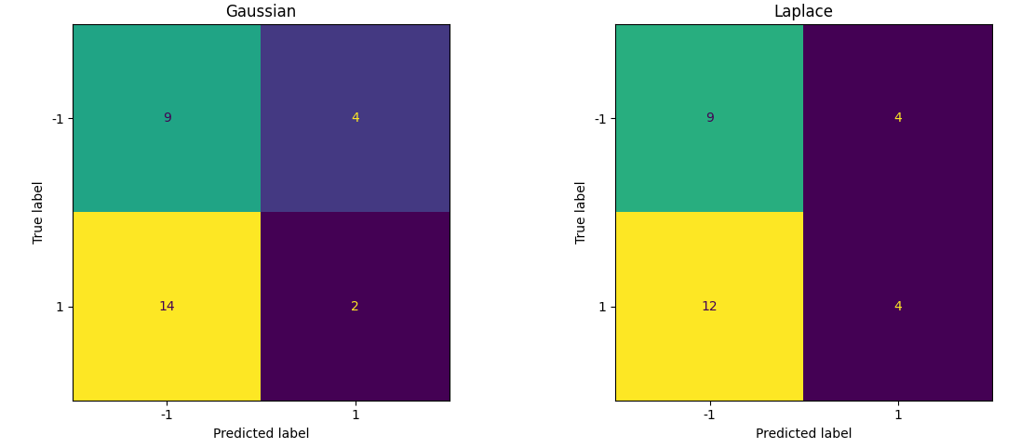
 | Gaussian | Laplace
Accuracy | 46.96% | 47.68%

Both models are generally not accurate, possibly due to the high bias in the dataset itself or caused by overlapping distributions in the features or bad assumptions in feature selection due to the assumption that the data of each pixel is independent of the data of other pixels which both models assume. However, the Laplace model is slightly better for the image dataset as compared to the Gaussian one.

