**Московский государственный технический университет им. Н.Э. Баумана**

Кафедра «Системы обработки информации и управления»

**Лабораторная работа №6**

**по курсу «Методы машинного обучения»**

**на тему**

**«Ансамбли моделей машинного обучения.»**

**Выполнил:**

**Хотин П.Ю.**

**ИУ5-24М**

Москва, 2020 год

import numpy as np  
import pandas as pd  
import matplotlib.pyplot as plt  
from sklearn.model_selection import train_test_split  
from sklearn.ensemble import RandomForestRegressor, GradientBoostingRegressor  
from sklearn.metrics import mean_absolute_error,accuracy_score, r2_score

data = pd.read_csv("advertising.csv")

data.head()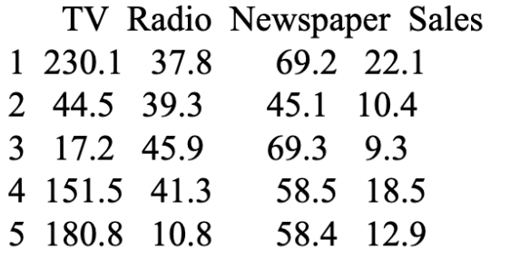

data_X = data[["TV", "Radio", "Newspaper"]]

data_X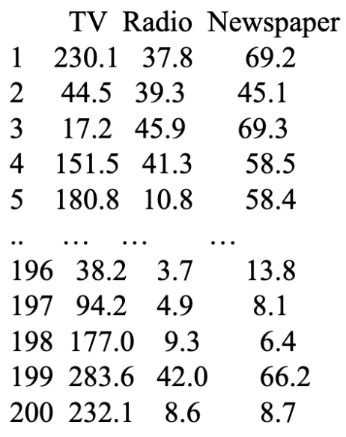

200 rows × 3 columns

data_Y = data[["Sales"]]

X_train, X_test, y_train, y_test = train_test_split(  
 data_X, data_Y, test_size=0.25, random_state=1)

*# Качество отдельных моделей*  
**def** val_mae(model):  
 model.fit(X_train, y_train)  
 y_pred = model.predict(X_test)  
 plt.plot(X_test, y_test, 'g.')  
 plt.plot(X_test, y_pred, 'ro')  
 plt.show()  
 result = mean_absolute_error(y_test, y_pred)  
 r2 = r2_score(y_test, y_pred)  
 print(model)  
 print('MAE={}'.format(result))  
 print('R2={}'.format(r2))

**for** model in [  
 GradientBoostingRegressor(),  
 RandomForestRegressor(n_estimators=50)  
]:  
 val_mae(model)  
 print('==========================\n\n')

/usr/local/lib/python3.7/site-packages/sklearn/ensemble/_gb.py:1454: DataConversionWarning: A column-vector y was passed when a 1d array was expected. Please change the shape of y to (n_samples, ), for example using ravel().  
 y = column_or_1d(y, warn=True)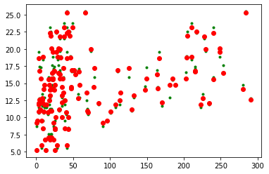

/usr/local/lib/python3.7/site-packages/ipykernel_launcher.py:3: DataConversionWarning: A column-vector y was passed when a 1d array was expected. Please change the shape of y to (n_samples,), for example using ravel().  
 This is separate from the ipykernel package so we can avoid doing imports until  
  
  
GradientBoostingRegressor(alpha=0.9, ccp_alpha=0.0, criterion='friedman_mse',  
 init=None, learning_rate=0.1, loss='ls', max_depth=3,  
 max_features=None, max_leaf_nodes=None,  
 min_impurity_decrease=0.0, min_impurity_split=None,  
 min_samples_leaf=1, min_samples_split=2,  
 min_weight_fraction_leaf=0.0, n_estimators=100,  
 n_iter_no_change=None, presort='deprecated',  
 random_state=None, subsample=1.0, tol=0.0001,  
 validation_fraction=0.1, verbose=0, warm_start=False)  
MAE=0.48997309191670874  
R2=0.9831579266623767  
==========================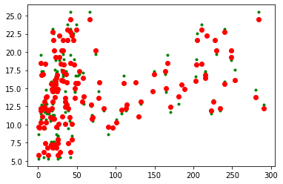

RandomForestRegressor(bootstrap=True, ccp_alpha=0.0, criterion='mse',  
 max_depth=None, max_features='auto', max_leaf_nodes=None,  
 max_samples=None, min_impurity_decrease=0.0,  
 min_impurity_split=None, min_samples_leaf=1,  
 min_samples_split=2, min_weight_fraction_leaf=0.0,  
 n_estimators=50, n_jobs=None, oob_score=False,  
 random_state=None, verbose=0, warm_start=False)  
MAE=0.5131199999999992  
R2=0.9815468551914713  
==========================

Модель градиентного бустинга показала лучший результат на тестовой выборке

from sklearn.model_selection import RandomizedSearchCV  
  
n_estimators = [int(x) **for** x in np.linspace(start = 200, stop = 2000, num = 10)]  
  
max_features = ['auto', 'sqrt']  
  
max_depth = [int(x) **for** x in np.linspace(10, 110, num = 11)]  
max_depth.append(None)  
  
min_samples_split = [2, 5, 10]  
  
min_samples_leaf = [1, 2, 4]  
  
bootstrap = [True, False]  
  
random_grid = {'n_estimators': n_estimators,  
 *'max_features'*: max_features,  
 *'max_depth'*: max_depth,  
 *'min_samples_split'*: min_samples_split,  
 *'min_samples_leaf'*: min_samples_leaf,  
 *'bootstrap'*: bootstrap}  
random_grid

{'n_estimators': [200, 400, 600, 800, 1000, 1200, 1400, 1600, 1800, 2000],  
 'max_features': ['auto', 'sqrt'],  
 'max_depth': [10, 20, 30, 40, 50, 60, 70, 80, 90, 100, 110, None],  
 'min_samples_split': [2, 5, 10],  
 'min_samples_leaf': [1, 2, 4],  
 'bootstrap': [True, False]}

rf = RandomForestRegressor()  
  
rf_random = RandomizedSearchCV(estimator = rf, param_distributions = random_grid, n_iter = 100, cv = 3, verbose=2, random_state=42, n_jobs = -1)  
  
rf_random.fit(X_train, y_train)

Fitting 3 folds for each of 100 candidates, totalling 300 fits  
  
  
[Parallel(n_jobs=-1)]: Using backend LokyBackend with 16 concurrent workers.  
[Parallel(n_jobs=-1)]: Done 9 tasks | elapsed: 3.3s  
[Parallel(n_jobs=-1)]: Done 130 tasks | elapsed: 20.3s  
[Parallel(n_jobs=-1)]: Done 300 out of 300 | elapsed: 47.8s finished  
/usr/local/lib/python3.7/site-packages/sklearn/model_selection/_search.py:739: DataConversionWarning: A column-vector y was passed when a 1d array was expected. Please change the shape of y to (n_samples,), for example using ravel().  
 self.best_estimator_.fit(X, y, **fit_params)  
  
  
  
  
  
RandomizedSearchCV(cv=3, error_score=nan,  
 estimator=RandomForestRegressor(bootstrap=True,  
 ccp_alpha=0.0,  
 criterion='mse',  
 max_depth=None,  
 max_features='auto',  
 max_leaf_nodes=None,  
 max_samples=None,  
 min_impurity_decrease=0.0,  
 min_impurity_split=None,  
 min_samples_leaf=1,  
 min_samples_split=2,  
 min_weight_fraction_leaf=0.0,  
 n_estimators=100,  
 n_jobs=None, oob_score=Fals...  
 param_distributions={'bootstrap': [True, False],  
 'max_depth': [10, 20, 30, 40, 50, 60,  
 70, 80, 90, 100, 110,  
 None],  
 'max_features': ['auto', 'sqrt'],  
 'min_samples_leaf': [1, 2, 4],  
 'min_samples_split': [2, 5, 10],  
 'n_estimators': [200, 400, 600, 800,  
 1000, 1200, 1400, 1600,  
 1800, 2000]},  
 pre_dispatch='2*n_jobs', random_state=42, refit=True,  
 return_train_score=False, scoring=None, verbose=2)

rf_random.best_params_

{'n_estimators': 800,  
 'min_samples_split': 2,  
 'min_samples_leaf': 1,  
 'max_features': 'auto',  
 'max_depth': 100,  
 'bootstrap': True}

**def** evaluate(model, test_features, test_labels):  
 predictions = model.predict(test_features)  
 error = mean_absolute_error(y_test, predictions)  
 r2 = r2_score(y_test, predictions)  
 print('Model Performance')  
 print('MAE: {:0.4f}'.format(error))  
 print('R2 score: {:0.4f}'.format(r2))  
 print('======================\n\n')  
  
base_model = RandomForestRegressor(n_estimators = 10, random_state = 42)  
base_model.fit(X_train, y_train)  
evaluate(base_model, X_test, y_test)

Model Performance  
MAE: 0.5994  
R2 score: 0.9713  
======================  
  
  
  
  
/usr/local/lib/python3.7/site-packages/ipykernel_launcher.py:11: DataConversionWarning: A column-vector y was passed when a 1d array was expected. Please change the shape of y to (n_samples,), for example using ravel().  
 # This is added back by InteractiveShellApp.init_path()

best_random = rf_random.best_estimator_  
evaluate(best_random, X_test, y_test)

Model Performance  
MAE: 0.5178  
R2 score: 0.9820  
======================

Видно, что подбор гиперпараметров улучшил нашу модель, уменьшив ошибку на 0.08

n_estimators = [int(x) **for** x in np.linspace(start = 200, stop = 2000, num = 10)]  
  
max_features = ['auto', 'sqrt']  
  
max_depth = [int(x) **for** x in np.linspace(10, 110, num = 11)]  
max_depth.append(None)  
  
min_samples_split = [2, 5, 10]  
  
min_samples_leaf = [1, 2, 4]  
  
bootstrap = [True, False]  
  
random_grid_Booster = {'n_estimators': n_estimators,  
 *'max_features'*: max_features,  
 *'max_depth'*: max_depth,  
 *'min_samples_split'*: min_samples_split,  
 *'min_samples_leaf'*: min_samples_leaf,  
 }

gb = GradientBoostingRegressor()  
  
gb_random = RandomizedSearchCV(estimator = gb, param_distributions = random_grid_Booster, n_iter = 100, cv = 3, verbose=2, random_state=42, n_jobs = -1)  
  
gb_random.fit(X_train, y_train)

[Parallel(n_jobs=-1)]: Using backend LokyBackend with 16 concurrent workers.  
  
  
Fitting 3 folds for each of 100 candidates, totalling 300 fits  
  
  
[Parallel(n_jobs=-1)]: Done 9 tasks | elapsed: 0.4s  
[Parallel(n_jobs=-1)]: Done 221 tasks | elapsed: 7.7s  
[Parallel(n_jobs=-1)]: Done 300 out of 300 | elapsed: 10.2s finished  
/usr/local/lib/python3.7/site-packages/sklearn/ensemble/_gb.py:1454: DataConversionWarning: A column-vector y was passed when a 1d array was expected. Please change the shape of y to (n_samples, ), for example using ravel().  
 y = column_or_1d(y, warn=True)  
  
  
  
  
  
RandomizedSearchCV(cv=3, error_score=nan,  
 estimator=GradientBoostingRegressor(alpha=0.9, ccp_alpha=0.0,  
 criterion='friedman_mse',  
 init=None,  
 learning_rate=0.1,  
 loss='ls', max_depth=3,  
 max_features=None,  
 max_leaf_nodes=None,  
 min_impurity_decrease=0.0,  
 min_impurity_split=None,  
 min_samples_leaf=1,  
 min_samples_split=2,  
 min_weight_fraction_leaf=0.0,  
 n_estimators=100,  
 n_...  
 iid='deprecated', n_iter=100, n_jobs=-1,  
 param_distributions={'max_depth': [10, 20, 30, 40, 50, 60,  
 70, 80, 90, 100, 110,  
 None],  
 'max_features': ['auto', 'sqrt'],  
 'min_samples_leaf': [1, 2, 4],  
 'min_samples_split': [2, 5, 10],  
 'n_estimators': [200, 400, 600, 800,  
 1000, 1200, 1400, 1600,  
 1800, 2000]},  
 pre_dispatch='2*n_jobs', random_state=42, refit=True,  
 return_train_score=False, scoring=None, verbose=2)

gb_random.best_params_

{'n_estimators': 1400,  
 'min_samples_split': 10,  
 'min_samples_leaf': 2,  
 'max_features': 'auto',  
 'max_depth': 40}

**def** evaluate(model, test_features, test_labels):  
 predictions = model.predict(test_features)  
 error = mean_absolute_error(y_test, predictions)  
 r2 = r2_score(y_test, predictions)  
 print('Model Performance')  
 print('MAE: {:0.4f}'.format(error))  
 print('R2 score: {:0.4f}'.format(r2))  
 print('======================\n\n')  
  
base_model = GradientBoostingRegressor()  
base_model.fit(X_train, y_train)  
evaluate(base_model, X_test, y_test)

Model Performance  
MAE: 0.4890  
R2 score: 0.9832  
======================  
  
  
  
  
/usr/local/lib/python3.7/site-packages/sklearn/ensemble/_gb.py:1454: DataConversionWarning: A column-vector y was passed when a 1d array was expected. Please change the shape of y to (n_samples, ), for example using ravel().  
 y = column_or_1d(y, warn=True)

best_random = gb_random.best_estimator_  
evaluate(best_random, X_test, y_test)

Model Performance  
MAE: 0.5078  
R2 score: 0.9839  
======================

Подбор параметров в градиентном бустинге не дал прироста качества (оно и так в целом было достаточно высокое)