**Software Engineering 1**

**USE Lab Test**

**Paulina Czarnota C21365726**

1.

**lib.use file**

model Library

class Book

attributes

title : String

author : String

no_copies : Integer

no_onshelf : Integer

operations

borrow()

end

class Copy

attributes

status : String

operations

borrow( m : Member)

end

class Member

attributes

name : String

student_id : String

address : String

no_onloan : Integer

fine : Integer

operations

okToBorrow() : Boolean

borrow(c : Copy)

end

association HasBorrowed between

Member[0..1] role borrower

Copy[*] role borrowed

end

association CopyOf between

Copy[1..*] role copies

Book[1] role book

end

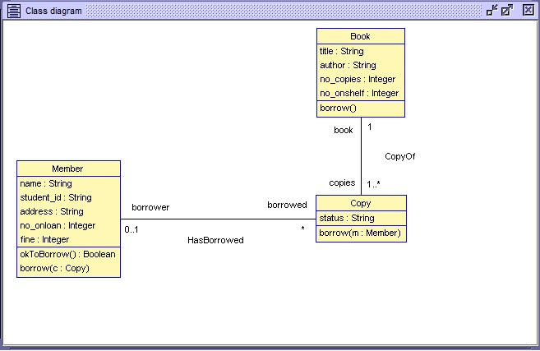

2.

**lib.soil file**

-- Script generated by USE 4.1.1

!new Book('bible')

!bible.title := null

!bible.author := 'The Man Above'

!bible.no_copies := 2

!bible.no_onshelf := 2

!new Book('WandP')

!WandP.title := 'War & Peace'

!WandP.author := 'Tolstoy'

!WandP.no_copies := null

!WandP.no_onshelf := null

**lib.olt file**

<?xml version="1.0" encoding="UTF-8"?><diagram_Layout version="13">

<diagramOptions>

<autolayout>false</autolayout>

<antialiasing>false</antialiasing>

<showassocnames>true</showassocnames>

<showattributes>true</showattributes>

<showmultiplicities>false</showmultiplicities>

<showoperations>false</showoperations>

<showrolenames>false</showrolenames>

<showgrid>false</showgrid>

<ShowStates>false</ShowStates>

</diagramOptions>

<node id="c3" sizeCalculated="true" type="Object">

<name>c3</name>

<strategy type="org.tzi.use.gui.views.diagrams.elements.positioning.StrategyFixed">

<x>54.419274001381126</x>

<y>157.8733188503061</y>

</strategy>

<hidden>false</hidden>

</node>

<node id="bible" sizeCalculated="true" type="Object">

<name>bible</name>

<strategy type="org.tzi.use.gui.views.diagrams.elements.positioning.StrategyFixed">

<x>301.29627999459177</x>

<y>25.12984832531268</y>

</strategy>

<hidden>false</hidden>

</node>

<node id="tom" sizeCalculated="true" type="Object">

<name>tom</name>

<strategy type="org.tzi.use.gui.views.diagrams.elements.positioning.StrategyFixed">

<x>326.15954345309996</x>

<y>256.63894023864106</y>

</strategy>

<hidden>false</hidden>

</node>

<node id="WandP" sizeCalculated="true" type="Object">

<name>WandP</name>

<strategy type="org.tzi.use.gui.views.diagrams.elements.positioning.StrategyFixed">

<x>58.820248628056675</x>

<y>28.013570947597714</y>

</strategy>

<hidden>false</hidden>

</node>

<node id="c1" sizeCalculated="true" type="Object">

<name>c1</name>

<strategy type="org.tzi.use.gui.views.diagrams.elements.positioning.StrategyFixed">

<x>244.54027555141704</x>

<y>183.42111255000066</y>

</strategy>

<hidden>false</hidden>

</node>

<node id="you" sizeCalculated="true" type="Object">

<name>you</name>

<strategy type="org.tzi.use.gui.views.diagrams.elements.positioning.StrategyFixed">

<x>51.00955895973016</x>

<y>256.8373428827382</y>

</strategy>

<hidden>false</hidden>

</node>

<node id="c2" sizeCalculated="true" type="Object">

<name>c2</name>

<strategy type="org.tzi.use.gui.views.diagrams.elements.positioning.StrategyFixed">

<x>418.2561002302849</x>

<y>182.0793140683425</y>

</strategy>

<hidden>false</hidden>

</node>

<edge type="BinaryEdge">

<source>c2</source>

<target>bible</target>

<name>CopyOf</name>

<properties>

<edgeproperty id="[CopyOf : (book:bible, copies:c2)]::target::rolename" sizeCalculated="true" type="rolename" userDefined="false" visible="true">

<name>book</name>

<strategy type="org.tzi.use.gui.views.diagrams.elements.positioning.StrategyRelativeToAttached">

<userOffsetX>0.0</userOffsetX>

<userOffsetY>0.0</userOffsetY>

<attached>[CopyOf : (book:bible, copies:c2)]::WayPoint::1</attached>

<offset_x>8</offset_x>

<offset_y>8</offset_y>

<placement>TOP</placement>

</strategy>

<hidden>false</hidden>

</edgeproperty>

<edgeproperty id="[CopyOf : (book:bible, copies:c2)]::target::multiplicity" sizeCalculated="true" type="multiplicity" userDefined="false" visible="true">

<name>1</name>

<strategy type="org.tzi.use.gui.views.diagrams.elements.positioning.StrategyRelativeToAttached">

<userOffsetX>0.0</userOffsetX>

<userOffsetY>0.0</userOffsetY>

<attached>[CopyOf : (book:bible, copies:c2)]::WayPoint::1</attached>

<offset_x>8</offset_x>

<offset_y>8</offset_y>

<placement>BOTTOM</placement>

</strategy>

<hidden>false</hidden>

</edgeproperty>

<edgeproperty id="[CopyOf : (book:bible, copies:c2)]::source::multiplicity" sizeCalculated="true" type="multiplicity" userDefined="false" visible="true">

<name>1..*</name>

<strategy type="org.tzi.use.gui.views.diagrams.elements.positioning.StrategyRelativeToAttached">

<userOffsetX>0.0</userOffsetX>

<userOffsetY>0.0</userOffsetY>

<attached>[CopyOf : (book:bible, copies:c2)]::WayPoint::0</attached>

<offset_x>8</offset_x>

<offset_y>8</offset_y>

<placement>BOTTOM</placement>

</strategy>

<hidden>false</hidden>

</edgeproperty>

<edgeproperty id="[CopyOf : (book:bible, copies:c2)]::source::rolename" sizeCalculated="true" type="rolename" userDefined="false" visible="true">

<name>copies</name>

<strategy type="org.tzi.use.gui.views.diagrams.elements.positioning.StrategyRelativeToAttached">

<userOffsetX>0.0</userOffsetX>

<userOffsetY>0.0</userOffsetY>

<attached>[CopyOf : (book:bible, copies:c2)]::WayPoint::0</attached>

<offset_x>8</offset_x>

<offset_y>8</offset_y>

<placement>TOP</placement>

</strategy>

<hidden>false</hidden>

</edgeproperty>

<edgeproperty id="[CopyOf : (book:bible, copies:c2)]::AssociationName" sizeCalculated="true" type="associationName" userDefined="true" visible="true">

<name>CopyOf</name>

<strategy type="org.tzi.use.gui.views.diagrams.elements.positioning.StrategyInBetween">

<userOffsetX>28.0</userOffsetX>

<userOffsetY>3.0</userOffsetY>

<offsetX>0.0</offsetX>

<offsetY>-10.0</offsetY>

<related length="2">

<related0>[CopyOf : (book:bible, copies:c2)]::WayPoint::0</related0>

<related1>[CopyOf : (book:bible, copies:c2)]::WayPoint::1</related1>

</related>

</strategy>

<hidden>false</hidden>

</edgeproperty>

</properties>

<waypoints>

<edgeproperty id="[CopyOf : (book:bible, copies:c2)]::WayPoint::0" sizeCalculated="true" type="WayPoint" userDefined="false" visible="true">

<name>0</name>

<strategy type="org.tzi.use.gui.views.diagrams.elements.positioning.StrategyAttachedIntersection">

<userOffsetX>0.0</userOffsetX>

<userOffsetY>0.0</userOffsetY>

</strategy>

<id>0</id>

<specialid>1</specialid>

<hidden>false</hidden>

</edgeproperty>

<edgeproperty id="[CopyOf : (book:bible, copies:c2)]::WayPoint::1" sizeCalculated="true" type="WayPoint" userDefined="false" visible="true">

<name>1</name>

<strategy type="org.tzi.use.gui.views.diagrams.elements.positioning.StrategyAttachedIntersection">

<userOffsetX>0.0</userOffsetX>

<userOffsetY>0.0</userOffsetY>

</strategy>

<id>1</id>

<specialid>2</specialid>

<hidden>false</hidden>

</edgeproperty>

</waypoints>

<hidden>false</hidden>

<linkValue>[CopyOf : (book:bible, copies:c2)]</linkValue>

</edge>

<edge type="BinaryEdge">

<source>c1</source>

<target>bible</target>

<name>CopyOf</name>

<properties>

<edgeproperty id="[CopyOf : (book:bible, copies:c1)]::target::multiplicity" sizeCalculated="true" type="multiplicity" userDefined="false" visible="true">

<name>1</name>

<strategy type="org.tzi.use.gui.views.diagrams.elements.positioning.StrategyRelativeToAttached">

<userOffsetX>0.0</userOffsetX>

<userOffsetY>0.0</userOffsetY>

<attached>[CopyOf : (book:bible, copies:c1)]::WayPoint::1</attached>

<offset_x>8</offset_x>

<offset_y>8</offset_y>

<placement>BOTTOM</placement>

</strategy>

<hidden>false</hidden>

</edgeproperty>

<edgeproperty id="[CopyOf : (book:bible, copies:c1)]::target::rolename" sizeCalculated="true" type="rolename" userDefined="false" visible="true">

<name>book</name>

<strategy type="org.tzi.use.gui.views.diagrams.elements.positioning.StrategyRelativeToAttached">

<userOffsetX>0.0</userOffsetX>

<userOffsetY>0.0</userOffsetY>

<attached>[CopyOf : (book:bible, copies:c1)]::WayPoint::1</attached>

<offset_x>8</offset_x>

<offset_y>8</offset_y>

<placement>TOP</placement>

</strategy>

<hidden>false</hidden>

</edgeproperty>

<edgeproperty id="[CopyOf : (book:bible, copies:c1)]::source::multiplicity" sizeCalculated="true" type="multiplicity" userDefined="false" visible="true">

<name>1..*</name>

<strategy type="org.tzi.use.gui.views.diagrams.elements.positioning.StrategyRelativeToAttached">

<userOffsetX>0.0</userOffsetX>

<userOffsetY>0.0</userOffsetY>

<attached>[CopyOf : (book:bible, copies:c1)]::WayPoint::0</attached>

<offset_x>8</offset_x>

<offset_y>8</offset_y>

<placement>BOTTOM</placement>

</strategy>

<hidden>false</hidden>

</edgeproperty>

<edgeproperty id="[CopyOf : (book:bible, copies:c1)]::source::rolename" sizeCalculated="true" type="rolename" userDefined="false" visible="true">

<name>copies</name>

<strategy type="org.tzi.use.gui.views.diagrams.elements.positioning.StrategyRelativeToAttached">

<userOffsetX>0.0</userOffsetX>

<userOffsetY>0.0</userOffsetY>

<attached>[CopyOf : (book:bible, copies:c1)]::WayPoint::0</attached>

<offset_x>8</offset_x>

<offset_y>8</offset_y>

<placement>TOP</placement>

</strategy>

<hidden>false</hidden>

</edgeproperty>

<edgeproperty id="[CopyOf : (book:bible, copies:c1)]::AssociationName" sizeCalculated="true" type="associationName" userDefined="true" visible="true">

<name>CopyOf</name>

<strategy type="org.tzi.use.gui.views.diagrams.elements.positioning.StrategyInBetween">

<userOffsetX>-35.0</userOffsetX>

<userOffsetY>4.0</userOffsetY>

<offsetX>0.0</offsetX>

<offsetY>-10.0</offsetY>

<related length="2">

<related0>[CopyOf : (book:bible, copies:c1)]::WayPoint::0</related0>

<related1>[CopyOf : (book:bible, copies:c1)]::WayPoint::1</related1>

</related>

</strategy>

<hidden>false</hidden>

</edgeproperty>

</properties>

<waypoints>

<edgeproperty id="[CopyOf : (book:bible, copies:c1)]::WayPoint::0" sizeCalculated="true" type="WayPoint" userDefined="false" visible="true">

<name>0</name>

<strategy type="org.tzi.use.gui.views.diagrams.elements.positioning.StrategyAttachedIntersection">

<userOffsetX>0.0</userOffsetX>

<userOffsetY>0.0</userOffsetY>

</strategy>

<id>0</id>

<specialid>1</specialid>

<hidden>false</hidden>

</edgeproperty>

<edgeproperty id="[CopyOf : (book:bible, copies:c1)]::WayPoint::1" sizeCalculated="true" type="WayPoint" userDefined="false" visible="true">

<name>1</name>

<strategy type="org.tzi.use.gui.views.diagrams.elements.positioning.StrategyAttachedIntersection">

<userOffsetX>0.0</userOffsetX>

<userOffsetY>0.0</userOffsetY>

</strategy>

<id>1</id>

<specialid>2</specialid>

<hidden>false</hidden>

</edgeproperty>

</waypoints>

<hidden>false</hidden>

<linkValue>[CopyOf : (book:bible, copies:c1)]</linkValue>

</edge>

</diagram_Layout>

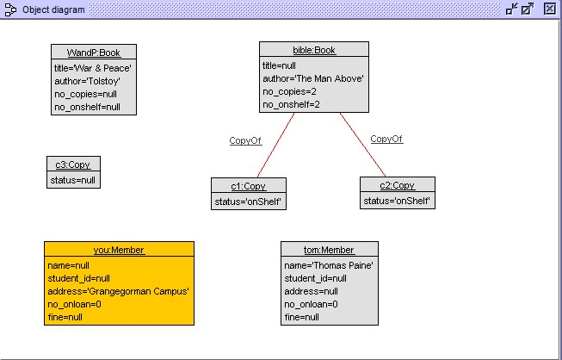

3.

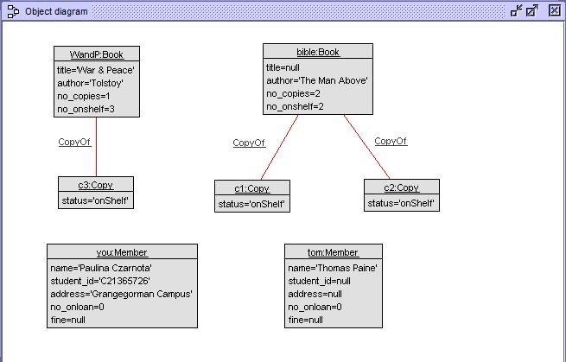

4.

**lib.use file**

model Library

class Book

attributes

title : String

author : String

no_copies : Integer

no_onshelf : Integer

operations

borrow()

end

class Copy

attributes

status : String

operations

borrow( m : Member)

end

class Member

attributes

name : String

student_id : String

address : String

no_onloan : Integer

fine : Integer

operations

okToBorrow() : Boolean

begin

if (self.no_onloan < 2) then

result := true

else

result := false

end

end

borrow(c : Copy)

end

association HasBorrowed between

Member[0..1] role borrower

Copy[*] role borrowed

end

association CopyOf between

Copy[1..*] role copies

Book[1] role book

end

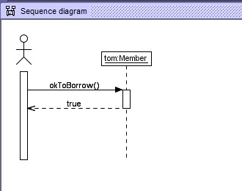

5.

**lib.use file**

model Library

enum BookStatus { available, unavailable, onreserve}

enum CopyStatus { onLoan, onShelf, onreserve }

class Book

attributes

title : String

author : String

no_copies : Integer

no_onshelf : Integer

operations

borrow()

begin

self.no_onshelf := self.no_onshelf - 1;

end

return()

begin

self.no_onshelf := self.no_onshelf + 1;

end

end

class Copy

attributes

status : String

operations

return()

begin

--self.status := #onShelf;

self.book.return()

end

reserve()

borrow( m : Member)

begin

--self.status := #onLoan;

self.book.borrow()

end

end

class Member

attributes

name : String

student_id : String

address : String

no_onloan : Integer

fine : Integer

operations

okToBorrow() : Boolean

begin

if (self.no_onloan < 2) then

result := true

else

result := false

end

end

borrow(c : Copy)

begin

declare ok : Boolean;

ok := self.okToBorrow();

if( ok ) then

insert (self, c) into HasBorrowed;

self.no_onloan := self.no_onloan + 1;

c.borrow(self)

end

end

return(c : Copy)

begin

delete (self, c) from HasBorrowed;

self.no_onloan := self.no_onloan - 1;

c.return()

end

end

association HasBorrowed between

Member[0..1] role borrower

Copy[*] role borrowed

end

association CopyOf between

Copy[1..*] role copies

Book[1] role book

end

6.

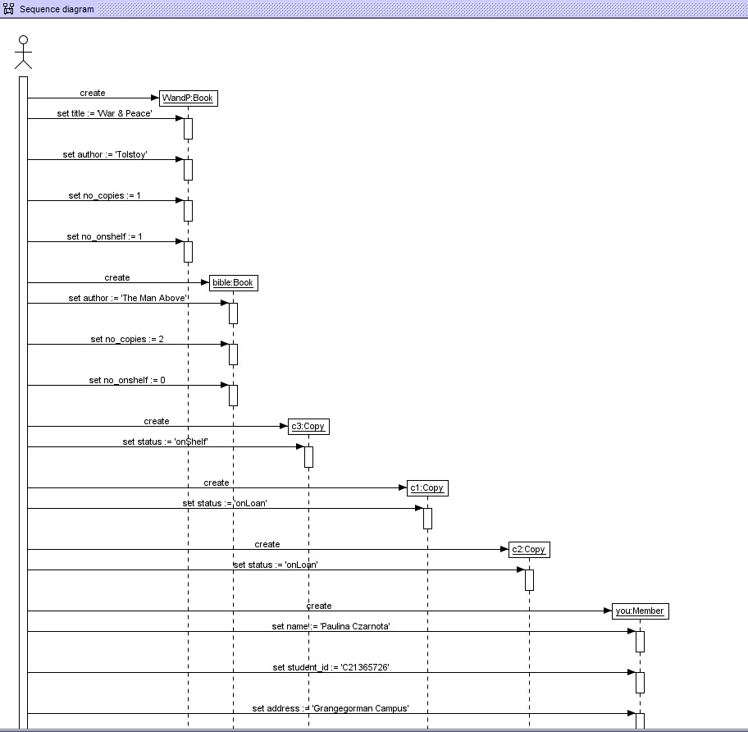

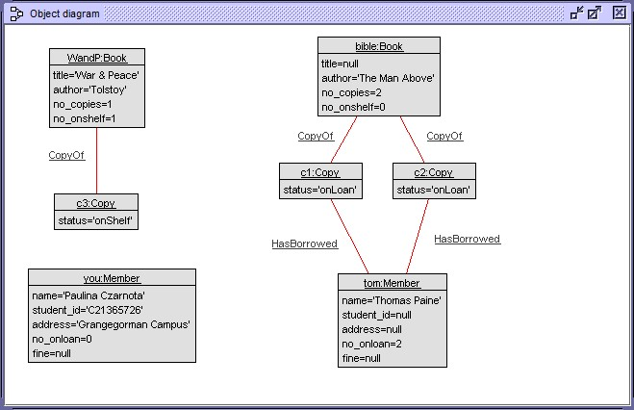

7.

**lib.use file**

model Library

enum CopyStatus { onLoan, onShelf, onreserve }

class Book

attributes

title : String

author : String

no_copies : Integer

no_onshelf : Integer

operations

borrow()

end

class Copy

attributes

status : String

operations

borrow(m : Member)

end

class Member

attributes

name : String

student_id : String

address : String

no_onloan : Integer

fine : Integer

operations

okToBorrow() : Boolean

begin

if (self.no_onloan < 2) then

result := true

else

result := false

end

end

borrow(c : Copy)

begin

declare ok : Boolean;

ok := self.okToBorrow();

end

end

association HasBorrowed between

Member[0..1] role borrower

Copy[*] role borrowed

end

association CopyOf between

Copy[1..*] role copies

Book[1] role book

end

constraints

context Member::borrow(c:Copy)

pre cond1: self.borrowed->excludes(c)

post cond2: self.borrowed->includes(c)

post cond3: self.no_onloan < 2