

 Project Plan: Bluewater Limited OPA System

**Module: Software Engineering with Test**

**Lecturer: Paul Lennon**

**Date: 12/12/2019**

**Authors:**

Paulina Osikoya - G00348898

Padraig O Cosgora - G00311302

Stephen Mclntyre - G00325469

Armen Petrosyan - G00343137

Table of Contents

Executive Summary

The proposed company Bluewater LTD seek to implement a new Online Payment Application (OPA).

Bluewater LTD is a Galway based business which provides water filtration using advanced top-class water purification technology which in turn provides its clients with drinking water which is free from impurities, such as contaminants that are commonly found in water sources.

While the business does flourish in its endeavours, the company’s downfall resides with the execution process of obtaining the client's data to successfully implement their services into their home.

Currently, Bluewater deals with all order requests in an arduous futile manner, using a series of manual processing techniques.

These techniques include back and forth communication between a sales representative from the company and clients, when in fact, all these cumbersome tasks can be alleviated introducing the system previously alluded to.

Based on this knowledge from our client Bluewater LTD, we propose as a team, to neglect the current error-prone cumbersome system because it features lengthy processing times, which results in the cost of maintaining this manual system is much higher than an automated system.

As part of this project plan, we will split the implementation of the Online Payment Application system or “OPA” into four phases which are the initiation, planning, Analysis and Design and Execution, Monitoring and Control phase.

We believe that this new functionality will streamline and accelerate the current ordering process thus improving customer service. Additionally, it is projected to obtain a 10% increase of revenue and projects annually through the implementation of the OPA system and also reduced handler employees by 50% over 18 months.

Section 2: Introduction

2.1 What is an Online Payment Application?

An Online Payment Application system or “OPA” is what the company BlueWater LTD will be used to rectify the current payment system the company has in place. An OPA system is an e-commerce payment system or the electronic exchange of money for a product displayed on a website, which facilitates the acceptance of electronic payment for online transactions.

The system allows a vendor to accept payments over the web or over other Internet connections, such as direct debit connections between retail stores and their suppliers. These payments are executed by using a Credit Card and the money is then transferred to the bank account of the business. Presently in the OPA system, credit and or debit cards remain the most common forms of payment for e-commerce transactions.

The OPA has two functions. It provides a facility for a business to add a product or service. It also provides a method for customers to view the product/service, create an account and enter their payment details on a secure payment page.

It is often difficult for an online retailer envisioning to incorporate an OPA without supporting credit and debit cards due to their widespread use.

To successfully run an OPA system, a business must obtain a merchant account to be able to electronically sell their products to customers. Online merchants must comply with stringent rules stipulated by the credit and debit card issuers (e.g. Visa and MasterCard) in accordance with the bank and financial regulation in the countries where the debit/credit service conducts business.

OPA Project Phases for Bluewater LTD

For the implementation of the OPA system for the company BlueWater LTD, the project has been divided into the following project phases. Splitting the project into these phases is crucial for the OPA’s feasibility.

Initiation Phase

The initiation phase is the initial part of the project plan, which details the major factors such as the critical assumptions and constraints, preliminary requirements and potential risks. After these factors been discussed and documented, finally, a project charter will be established and drawn up to measure the success of the project plan.

Planning Phase

The planning phase in its very name is the next step of the project plan and is constructed and defined to plan the entirety of the project plan. This phase includes features such as creating the work breakdown structure (WBS) of the plan, the summary of the project scope, deliverables, schedule and characteristics and requirements of the project. After these documents have been drafted, completed and submitted, the creation of the following documents such as the scope introduction and verification plan commences.

Analysis and Design Phase

The analysis and design phase is viewed through the creation of various diagrams, that will be drafted for the design of the OPA system. These diagrams are entitled the Context Flow, Use Case, Actively, Class, Sequence and State diagram. These diagrams are vital to the planning of the OPA system because it gives our team greater insight to understand the key requirements from our client.

Execution, Monitoring and Control Phase

Lastly, in culmination to our project plan, there must be a factor/measure that notifies us of any risks that we may face during the execution of the project plan and how to possibly solve them or discuss whether these risks are far greater than what the client envisions to do. In hand with risks, comes responsibility and control, in specific, how to control the project to avoid such risks coming up during the project journey. To monitor this we must be aware of the following: risk logs, planning of risk management, identifying risks, track and control of the project, possibly a change of control management in the plan or process, identifying the roles and responsibilities and lastly a Changelog.

3. Initiation Phase

3.1.4. Critical Assumptions and Constraints

Assumptions –

* If OPA system sales handler employees will be reduced by 50% over 18 months and there will be an increase in profits by 10% in 18 months due to the new OPA system.
* If customers will not be contacted directly over post because the new system will allow customers to set up a direct debit.
* If Bluewater believes the new OPA system will streamline and accelerate the current ordering process because time will be saved from not having to wait for customer details to get back to us by post.
* Assuming the company will need a server room to keep website and database running to prevent the loss of data or any malfunctions.
* Assuming a domain will need to be bought to open the website to the public.
* Assuming if the direct debit payment system will be secure using and secure payment method.
* Assuming if a database will be created to store customer information i.e. first name, last name, email, phone number, direct debit information and shipping information.
* Assuming It will penetrate new consumer, market and improve customer service.
* Assuming it will reduce human error about manual ordering and reduce delays in the process.
* Assuming a 10% increase of revenue annually through the implementation of the OPA system.
* If the Project Team forecasts that based on direct debit sign up by 1,000 customers at €120 a year, the organization will yield a revenue stream of €120,000.
* An assumption would be that we will need to advertise for new customers and businesses.

Constraints –

* Due to the cumbersome system that Bluewater LTD still chooses to implement, it impedes the customer subscription process.” This, in turn, will take a toll on validation times to adjoin the customer the existing service or retrieve any kind of payment.
* Cost to keep a database, domain and server room running.
* Money/cost. Can Bluewater afford to pay for this OPA?
* Making sure direct debt is done securely.
* Common errors can occur when the customer is filling out the PDF monthly direct debit form, or when the employee is inserting customer data into the database. We need to make sure error-checking will be put into the website to minimize the error in the application.

3.1.7 Preliminary Requirements

* A new database will have to be created to store customer information i.e. first name, last name, email, phone number, direct debit information, etc...
* Designing and building a new server room for the new OPA system in order to host the website and database so it can be monitored and check daily, so nothing goes wrong.
* One requirement would be to create a new website for Online Payment Application.
  + This website will have to consist of different water filtration products and water filtration services for customers to be able to review and decide which would be the best suited for them.
  + Another section that will be needed, would be a place/section to facilitate business to add water filtration products or water filtration services.
  + A secure security system will have to be implemented into the website to make sure a customer's information will be safe and secure. Also, so the direct debt is secure, and no money will be lost due to fraud.
* we will need to set up a business account in the bank for money to be transferred into from the direct debit.
* Advertisement will be needed to promote our new OPA system and attract new customers and business.

3.1.8 Potential Risks

* Power cuts.
* Loss of data.
* No encryption.
* Hackers getting customers information.
* Fraud.
* Loss of confidentiality.
* The conflict between executive stakeholders disrupts the project.
* Design is infeasible.
* Technology components have security vulnerabilities.
* Information security incidents.
* Project disrupts sales.
* The project doesn’t sell.
* Service quality is low.
* No response to RFP (request for proposal).
  + The risk that there is a limited response to an RFP. This occurs when the request for proposal terms are unacceptable to vendors or if your firm has a bad reputation amongst vendors.
* Failure to integrate with the systems

3.1.10 Project Charter

This Charter formally authorizes the Online Payment Application system or “OPA” to develop and implement a new OPA system for use in company BlueWater LTD. A project plan will be developed and submitted to the Project Sponsors for approval. The project plan will include scope statement; schedule; cost estimate; budget; and provisions for scope, resource, schedule, communications, quality, risk, procurement, and stakeholder management as well as project control. All resources will be assigned by the Project Sponsors, I.P.Freeley, Human Resources Director.

The purpose of the Online Payment Application system or “OPA” project is to improve the timeliness and accuracy of OPA operations. This project meets BlueWater LTD’s need for improved efficiencies across all departments by reducing OPA cycle time and minimizing staffing required for OPA operations. The project deliverables shall include OPA system design, all coding, testing, implementation of an integrated system for use with existing IT infrastructure, and a user’s guide. The objectives of the BlueWater LTD’s OPA project are to reduce OPA cycle time by 80% and reduce BlueWater LTD’s staffing by 50%. High-level risks for this project include ensuring implementation is completed without impacting ongoing OPA operations and ensuring there are no issues with migrating OPA accounts from the legacy system to the new system. Success will be determined by the Project Sponsors once the system is implemented and one full OPA cycle has been completed that meets the objectives with no discrepancies.

The Project Manager, Homer. J. Simpson is hereby authorized to interface with management as required, negotiate for resources, delegate responsibilities within the framework of the project, and to communicate with all contractors and management, as required, to ensure successful and timely completion of the project. The Project Manager is responsible for developing the project plan, monitoring the schedule, cost, and scope of the project during implementation, and maintaining control over the project by measuring performance and taking corrective action.

This Charter formally authorizes the Online Payment Application system or “OPA” to develop and implement a new OPA system for use in company Bluewater LTD. A project plan will be developed and submitted to the Project Sponsors for approval. The project plan will include scope statement; schedule; cost estimate; budget; and provisions for scope, resource, schedule, communications, quality, risk, procurement, and stakeholder management as well as project control. All resources will be assigned by the Project Sponsors, I. P. Freeley, Human Resources Director.

The purpose of the Online Payment Application system or “OPA” project is to improve the timeliness and accuracy of OPA operations. This project meets Bluewater LTD’s need for improved efficiencies across all departments by reducing OPA cycle time and minimizing staffing required for OPA operations. The project deliverables shall include OPA system design, all coding, testing, implementation of an integrated system for use with existing IT infrastructure, and a user’s guide. The objectives of the Bluewater LTD’s OPA project are to reduce OPA cycle time by 80% and reduce Bluewater LTD’s staffing by 50%. High-level risks for this project include ensuring implementation is completed without impacting ongoing OPA operations and ensuring there are no issues with migrating OPA accounts from the legacy system to the new system. Success will be determined by the Project Sponsors once the system is implemented and one full OPA cycle has been completed that meets the objectives with no discrepancies.

The Project Manager, Homer. J. Simpson is hereby authorized to interface with management as required, negotiate for resources, delegate responsibilities within the framework of the project, and to communicate with all contractors and management, as required, to ensure successful and timely completion of the project. The Project Manager is responsible for developing the project plan, monitoring the schedule, cost, and scope of the project during implementation, and maintaining control over the project by measuring performance and taking corrective action.

The project plan will be submitted and approved by the milestone schedule below. Upon approval of the project plan resources will be assigned to the project and work will commence within 5 business days. The Project Sponsor must approve any schedule changes which may impact milestones. A detailed schedule will be included in the project plan. The high-level milestone schedule is:

* 1: The first critical milestone is planning, and this includes having the following drafted, completed and signed by Bluewater LTD, sponsors and contractors.
* 2: To Establish and create a WBS.
* 3: To Establish and create various diagram that outlines the project functionality.
* 4: Implementation and decision of the software to use to implement the OPA system.
* 5: Building of the OPA system.
* 6: Signing off on the code and accepting that the code is ready for commercial utilization by the new customer.
* 7: Demoing the working code to Bluewater.
* 8: Accepting a new user on the blue water website.
* 9: integrating old customer onto the new OPA system by adding their pre-existing data to the database of the OPA system.

The budget for the OPA project is €420,000. It is to be financed by Bluewater LTD.

Section 4: Planning Phase

4.1 Project Work Breakdown Structure

The project work breakdown structure for BlueWater will define all the task that has to be done to install and implement the OPA system. The tasks will be then broken into smaller, more manageable tasks.

Finally, from this, the outputs will yield the work breakdown structure that has been created below. This structure will ensure that our team is on track to implement the OPA over the following four months.

The work breakdown for the OPA system has also been broken and displayed in the form of a Gantt chart. The Gantt chart explains how the work is broken in smaller more manageable tasks and it also shows the dependencies from other teams in order to implement the OPA system. The Gantt chart also shows the work that must be completed over the four months.

4.3 Scope Verification Plan

Scope verification plan discusses how the deliverables for the OPA System for Bluewater will be verified against the original scope that we have previously defined in the project and finally, how the deliverables from the project will be formally accepted. The deliverables for this project will be formally accepted and signed off on by our client Bluewater Ltd throughout the lifecycle of the project. This will enforce agile techniques and ensure that the signing off will not be held back as a single deliverable at the end of the project. Doing the latter is waterfall tactics, which isn’t a characteristic of this project structure.

As this project progresses, we will verify the interim project deliverables against the original scope as defined in the scope statement and WBS that we have drafted for Bluewater.

Once our team have verified that the scope is on par with the requirements defined in the project plan, Our Team and Sponsors and Blue Water LTD will meet for formal acceptance of the deliverable.

During this meeting, the Project Manager will present the deliverable to the Project Sponsor for formal acceptance. The Project Sponsor will accept the deliverable by signing a project deliverable acceptance document. The Scope verification will occur at the end of each project phase, and as part of the project closeout process to make sure everything did or didn’t go to plan.

This will ensure that project work remains within the scope of the project on a consistent basis throughout the life of the project.

We plan to host a fortnightly meeting regarding the verification of the OPA system that is being implemented for blue water over the nine-month period mark that we have forecasted for the scope of this. Project.

Refer to appendices that show scope statement that is signed

<http://co-resyf.eu/wordpress/wp-content/uploads/2017/01/CORESYF-T2-VVR-VVP01-E-R_Verification-and-Validation-Plan-Framework_V1_0.pdf>

4.3.1 Scope Introduction

For our Client, Blue Water LTD, it is vital for the scoping plan that we as a team define the factors and processes that come into play when constructing a scope verification plan. The factors are the following: [ taken from PMBOK GUIDEtm]

* The Plan Scope Management to devise a plan for the project. Collecting Requirements is then introduced afterwards, identifying any gaps and needs for the projects. Afterwards, the scope is defined and this sets about the implementation and creation of the WBS. The Factors are then accepted, validated and then a plan for completing the project is set in stone.
* **The Plan Scope Management**

The process of creating a scope management plan that documents how the project and product scope will be defined, validated, and controlled. 5Collect Requirements—The process of determining, documenting, and managing stakeholder needs and requirements to meet project objectives.

* **Defining the Scope for Bluewater LTD**

The process of developing a detailed description of the project and OPA that the company Bluewater LTD wishes to implement.

* **Creation of the WBS**

The creation of the WBS will give us a clear view of how we will execute the project. The project will be subdivided into smaller, more manageable components.

* V**alidate Scope**

Bluewater LTD project’s nature is that of Agile Project Management (APM). Therefore, it is paramount, that for the completion of this project constant validation and acceptance is required from any known stakeholders and or stakeholders.

* **Control Scope**

The process of monitoring the status of the project scope will be managed SCRUMs and bi-weekly sync ups. These meetings will identify the work being accomplished, work left to be done and any hinderances that the team may face.

4.3.2 Project Characteristics and Requirements:

The characteristics of the water filtration system are majorly influenced by agile tactics.

Below are the functional and non-functional requirements for the implementation of the OPA for Bluewater:

4.3.3 Summary of Project Deliverables

The purpose of project deliverables is a way of keeping track of the work that is required to complete the project. Project deliverables clearly alert the team of certain milestones that need to be accomplished within a certain time frame.

For this project, it is estimated that the duration of the project will span 4 months to complete and implement in replacement of blue water old system that they use to retrieve payment from their customer.

The project deliverables are as follows:

* Milestone 1: the first critical milestone is planning and this includes having the following drafted, completed and signed by Bluewater LTD, sponsors and contractors:
  + The Project Charter
  + The project scope statement
  + Outline requirements and potential requirements
  + Have a Kick-off meeting to start the project development
  + Developing a risk log
* Milestone 2: To Establish and create a WBS
* Milestone 3: To Establish and create a various diagram that outlines the project functionality such as the:
  + Context Flow Diagram
  + Use Case Diagram
  + Actively Diagram
  + Class Diagram
  + Sequence Diagram
  + State Diagram
* Milestone: Implementation and decision of the software to use to impen#ment the OPA system.
* Milestone: Building of the OPA system which includes
  + Setting up the equipment
  + Set up the merchant account for blue water to allow blue water to use the banks APIs
  + Start the creation of the server and client for the OPA system
  + Set up the global payment account with realex to allow blue water to accept from international customers
  + Developing the payment gateway
  + Integrating the payment gateway onto BleWater online website
  + Contact the banks to to use their API for the OPA system to be able to verify the payment
  + Making unit tests to test the co#de for the OPA system
* Milestone: signing off on the code and accepting that the code is ready for commercial utilization by the new customer
* Milestone: Demoing the working code to Bluewater
* Milestone: Accepting new user on the blue water website
* Milestone: integrating old customer onto the new OPA system by adding their pre-existing data to the database of the OPA system.

4.3.4 Project Scope:

Project Scope Management is documentation of what work is to be done to implement and deploy a project. Project scope refers to the total amount of work that must be done in order to deliver a product, service, or result with specified functions and features. It includes everything that must go into a project, as well as what defines its success.

The project scope has many different aspects. It defines the beginning to the end of the project. This aspect of the project is crucial as it enables all parties involved to know what is expected to do for the project and the outputs it will yield.

While drafting the project scope for Bluewater, our team used to SMART tactics. SMART is the techniques used in different forms of management which stands for: Specific, Measurable, Agreed Upon, Realistic and Time-Bound. We as a team agreed to use this project to make sure that the project will be successful in the endeavour to implement the OPA system. An additional feature to using SMART avoids the common reasons why projects fail in the long run by not drafting a concise clear project scope.

The project scope for Bluewater Ltd will be broken up into the following categories. Which is also displayed in the diagram below:

* The Planning of the project
* The analysis and the feasibility of the project
* The design and code that goes into the project
* The implementation of the OPA system for the Bluewater
* The test and integration of the OPA system
* The deployment and release of the OPA
* The support and maintenance of the OPA

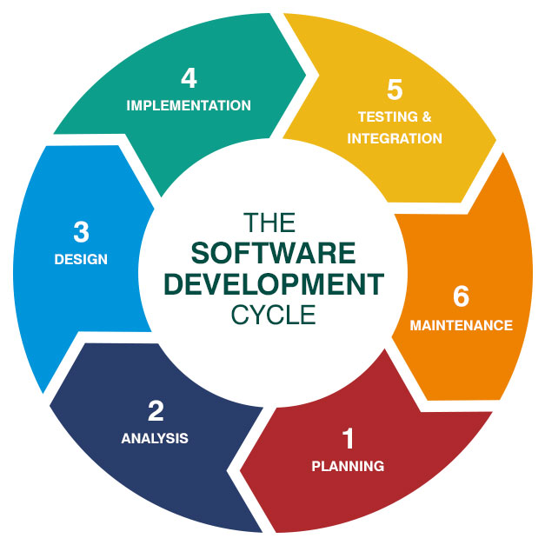

Explanation of what will be done

<https://www.brighthubpm.com/project-planning/57950-example-and-evaluation-of-project-scope-statements/>

**Project Title: OPA System for Bluewater Ltd**

**Project Justification:**

Bluewater, at present, has a cumbersome system for retrieving money from their customer from their product. The system that blue water has currently featured lengthy processing times due to the work involved summarizing data and manually inserting it into the database and because there may be a human error when entering some of the information. An additional factor is the cost of maintaining this manual system is much higher than an automated system because of the amount of manpower needed to keep it on track.

An Online Payment Application system or “OPA” will be used implemented by our team of software developers will be used to rectify this problematic system. the new OPA system will streamline and accelerate the current ordering process. It will penetrate new consumer markets and improve customer service. Additionally, it will reduce human error in relation to manual ordering and reduce delays in the billing process.

We believe and have agreed with Bluewater Ltd and their sponsors that the proposed product is forecasted to take no longer than four months to implement. All the work that we have set out to do has been included in a WBS, Scope verification, control and Gantt Chart.

This will then reduce sales handling employees by 50% over 18 months and there will be an increase in profit by 10% in 18 months. Bluewater is expected to obtain a 10% increase of revenue annually through the implementation of the OPA system. The Project Team forecasts that based on direct debit sign up by 1,000 customers at €120 a year, the organization will yield a revenue stream of €120,000

The identified stakeholders for the OPA system would be the Bluewater, banks, mobile payment solution providers, merchants, and financial institutions.

stakeholders such as mobile carriers and mobile payment solution providers would be a stakeholder to Bluewater OPA system as a mobile user would access the OPA system via the internet which would be part of their phone plan

For credit card firms, banks and finical institutions, they would be involved in the OPA system because when a new or existing customer wants to avail of the OPA system offered by Bluewater, they would have to verify with their bank provider/branch that they have enough funds in their account to proceed with the payment for the OPA system.

Bluewater would be a stakeholder in the OPA system as it would be vital to obtain their preference and opinion in the implementation of the OPA system.

|  |  |  |  |  |  |  |
| --- | --- | --- | --- | --- | --- | --- |
| **Stakeholder Name** | **Contact Person**  *Phone, Email, Website, Address* | **Impact**  *How much does the project impact them? (Low, Medium, High)* | **Influence**  *How much influence do they have over the project? (Low, Medium, High)* | **What is important to the stakeholder?** | **How could the stakeholder contribute to the project?** | **How could the stakeholder block the project?** |
| ***Bluewater*** | *BlueWater@gmail.com*  *091 123 4567* | *High* | *High* | *Maintaining working conditions for the OPA system* | *Agree for the implementation of the OPA system* | *Constituent alteration to the proposed project*  *Adding more items to the project scope* |
| ***Marketing*** | *Marketing@gmail.com*  *091 123 4567* | *High* | *Medium* | *Making sure the project is on track, for the marketing team to kick off their work for marketing the OPA system* | *The marketing team will be responsible for making sure the OPA system gets the exposure it needs to be accessible to new and old customers’* | *Constituent alteration the proposed project*  *Adding more items to the project scope in terms of how the OPA system will be marketed to the new and old customers’* |
| ***Bank*** | *Bank@gmail.com*  *091 123 4567* | *Medium* | *High* | *Making sure the payments are processed correctly* | *Giving their API to allow the Bluewater Merchant account to process their customers' payments account* | *Refusal of the bank’s API for the OPA system l* |
| **Mobile provider** | *mobileprovider@gmail.com*  *091 123 4567* | Low | Low | *Making sure the project is on track so they can add their element to the OPA system* | Adding the element of the customer being able to access the site via their mobile device on their specific mobile plan | Refusal of collaboration with the OPA system |
| **Internet provider** | *internetporvider@gmail.com*  *091 123 4567* | High | Low | *Making sure the project is on track so they can add their element to the OPA system* | Adding the element of the customer being able to access the site via their mobile device on their specific internet plan | Refusal of collaboration with the OPA system |

Project Scope:

The OPA system will start development on the 1st of October 2019 and will be completed on the 1st of February 2020. The following Milestones include the deliverables in the specific months:

* During the month of October the following tasks will be completed:
  + A Kick-off meeting will be held to start the project development of the OPA system. This set to take place on the 3rd of October at 11:30 am in the morning. During this meeting the following tasks will be completed:
    - The Project Charter will be created and signed by BlueWater, Sponsors and our team
  + The project scope statement will then written subsequently on the 4th of October and signed by all involved In the OPA system project on the 7th of October 2019.
  + On the week of the 15th of October the following documentation will be prepared:
    - A risk log will then be prepared to inspect the feasibility of the project
    - Our Team will draft a list of functional and non-functional requirements for the OPA system
    - Near the end of the week of the 22nd of October, the project plan will be drafted, completed and presented to our client BlueWater and then a client acceptance form will be signed by our client BlueWater.
* During the month of November the following tasks will be completed:
  + On the first week of November, the Work Breakdown Structure (WBS) will be established for the OPA System
  + On the second week of November, the setting up of the equipment that the team will use to create the software for the OPA system will be implemented which allows the software developers on our teams to start production of code for the OPA system.
  + The third week of November the following diagrams and graphs will be drafted and completed for the OPA system: Context Flow Diagram, Use Case Diagram, Actively Diagram, Class Diagram, Sequence Diagram and the State Diagram. These diagrams will give our team a clearer view of what is required to implement the OPA system for BlueWater
  + Also on the third week of November, Our team will contact banks on BlueWaters behalf to use their APIs to allow BlueWater’s Business Merchant account to process payments made by their customers. After this has been accepted, Our team will set up For our client Bluewater an account will be set with realex which is a Global Payment Service allows you to receive payments from companies and marketplaces globally, by providing you with receiving accounts to which you can receive payments in supported currencies. This will be beneficial for the blue water company because they will be able to accept payments from customers worldwide.
  + At the end of November, starting the week of the 25th of November, The team then begin the creation of the server and client for the payment gateway OPA system. This week will be dedicated to establishing a structure for both the server and client for the OPA system.
* During the month of December the following tasks will be completed:
  + Our team will create software algorithms for the OPA system to process the customers' payments on the week of the 1st of December. This work is dependent on responses from the stakeholder the bank who will allow BlueWater Ltd to use their APIs to validate customers payments.
  + The team will then begin the creation of the interface GUI that will allow the BlueWater customer to communicate server and client for the payment gateway OPA system at the end of the second week of December.
  + On the third week of December, the Integration of the payment gateway onto BlueWater online website will commence and will be closed out by week 3 of December.
* During the month of January 2020, the following tasks will be completed:
  + During the first week of January, the following will be implemented:
    - Unit tests to test the code for the OPA system will be written and deployed on the software made for both the server and the client for the OPA system.
    - Code documentation by our team needs will be written for the OPA system for blueWater and documented.
    - Release notes for the OPA System Making a full evaluation of the project in its whole before closing out the project
  + On the second week of January, Our team will work on the following:
    - Accepting new users on the blue water website to allow the processing of the OPA System.
    - integrating old customer onto the new OPA system by adding their preexisting data to the database of the OPA system.
  + On the final week of January beginning January 27th, Our team will demo the working code to Bluewater and will also sign off on the code. BlueWAter will then sign an agreement form, accepting that the code is ready for commercial utilization by new customers

**Risks:**

**As part of the project scope, we will outline the risks that come with trying to implement the OPA system and they are as follows:**

* There is the concern that our team might not meet up to our code deadlines for the OPA system and this will, in turn, impede the implementation of the OPA system Bluewater and add to the cost of production for the OPA system.
* Another risk is the loss of power in the building where development is being orchestrated or unexpected Power/electricity cuts which could result in the loss of Software vital to the construction of the OPA system.
* Loss of data is another speculation that could be detrimental to the OPA system for Bluewater limited. This could be the result of neglecting backing up software and data for the OPA system which will have a knock-on effect which will result in our team falling behind in milestones and unexpectedly altering the Project Scope. By doing so, this increase productions cost and resources being used.
* No encryption is a vital risk which could ultimately be the downfall of the OPA system. Non-encryption implies that Customers private data could be exposed and vulnerable to the internet and possible Hackers and this will have negative impacts on Bluewater as a business. This may result in Bluewater facing sue charges against customers for the breach of GDPR.
* Fraud is another risk that the company Bluewater could incur. This boils down to the trust Bluewater places in their employees when the OPA system is released. The prime risk is individuals inside the company could exploit the OPA system and wrongful charge customer through direct debit payments.

**Budget for the OPA system**:

The proposed Budget for the OPA system implements is approximately 420,000 euro. This price will cover the cost of the 15 software developers both front and back end that will develop the software for the OPA system, the equipment used to establish the system and finally the time it will involve deploying the system to commercially.

The project will be determined successful if the OPA reduces sales handler employees by 50% over 18 months increases profits by 10% in 18 months. Then based on this, Bluewater will then be expected to obtain a 10% increase of revenue annually through the implementation of the OPA system. The Project Team forecasts that based on direct debit sign up by 1,000 customers at €120 a year, the organization will yield a revenue stream of €120,000 and this will deem the OPA system successful

**SMART**

<https://www.betaalvereniging.nl/wp-content/uploads/Stakeholders-UK.png>

4.4 Project Schedule

From the task layout that has bee given

Acceptance from the stakeholders and the target date to roll out the project

The project schedule is the tool that communicates what work needs to be performed, which resources of the organization will perform the work and the timeframes in which that work needs to be performed. The project schedule should reflect all the work associated with delivering the project on time.

For this project, it is estimated that the duration of the project will span 4 months to complete and implement in replacement of blue water old system that they use to retrieve payment from their customer.

The project Schedules is as follows:

* Month #1:
* The first month of the development of the OPA system for BlueWater the following tasks and actions should be completed by the end of this month. This month focuses on the administrative tasks that need to be concluded in order to see whether the OPA project is feasible for BlueWater LTD. At the end of the moth BlueWater ltd, it’s sponsors and our team will convene and review the project schedule scope in a scrum like a meeting. This will inform us of whether we are on track with our project schedule or whether there are any adjustments or updates that need to be added to the project scope plan.
  + The tasks and actions that need to be completed for the blue water OPA system are the following:
    - A Kick-off meeting will be held to start the project development of the OPA system.
    - The Project Charter will be created and signed by BlueWater, Sponsors and our team
    - We will define the project scope for the OPA system and display it to our client Bluewater. From the project scope definition. We will be able to draft up a cost estimation of how much the project will cost.
    - The project scope statement will then written subsequently and signed by all involved In the OPA system project.
    - A risk log will then be prepared to inspect the feasibility of the project
    - Our Team will draft a list of functional and non-functional requirements for the OPA system
    - The project plan will be drafted, completed and presented to our client BlueWater and then a client acceptance form will be signed by our client BlueWater.
* Month #2:
* The second month of the development of the OPA system for BlueWater, the following tasks and actions should be completed by the end of this month. This month month focuses on the development that need to be concluded in order implement the OPA software for BlueWater LTD. At the end of the moth BlueWater ltd, it’s sponsors and our team will convene and review the project schedule scope in a scrum like a meeting. This will inform us of whether we are on track with our project schedule or whether there are any adjustments or updates that need to be added to the project scope plan.
  + The tasks and actions that need to be completed for the blue water OPA system are the following:
    - To Establish and create a WBS for the OPA System
    - Setting up the equipment that the team will use to create the software for the OPA system.
    - The following diagrams and graphs will be drafted for the OPA system: Context Flow Diagram, Use Case Diagram, Actively Diagram, Class Diagram, Sequence Diagram and the State Diagram
    - For our client Bluewater, an account will be set with realex which is a Global Payment Service allows you to receive payments from companies and marketplaces globally, by providing you with receiving accounts to which you can receive payments in supported currencies. This will be beneficial for the blue water company because they will be able to accept payments from customers worldwide.
    - The team will contact banks touse their APIs that allows Business Merchant account to process payments made by their customers
    - The team will then begin the creation of the server and client for the payment gateway OPA system.
    - The team will create software algorithms for the OPA system to process the customers' payments
    - The team will then begin the creation of the interface GUI that will allow the BlueWater customer to communicate server and client for the payment gateway OPA system.
    - Integrating the payment gateway onto the BlueWater online website
    - Make an update/adjust the Project scope plan if appropriate.
* Month #3:
* The third month of the development of the OPA system for BlueWater, the following tasks and actions should be completed by the end of this month. This month focuses on the testing and implementation of the OPA software for BlueWater LTD. At the end of the month BlueWater ltd, it’s sponsors and our team will convene and review the project schedule scope in a scrum like meeting. This will inform us of whether we are on track with our project schedule or whether there are any adjustments or updates that need to be added to the project scope plan.
  + The tasks and actions that need to be completed for the blue water OPA system are the following:
    - Unit tests to test the code for the OPA system need to be written and deployed on the software made for both the server and the client for the OPA system.
    - Code documentation by our team needs to be written for the OPA system for blueWater and documented.
    - Make an update/adjust the Project scope plan if appropriate.
* Month #4:
* The fourth month and final month of the development of the OPA system for BlueWater, the following tasks and actions should be completed by the end of this month. This month focuses on the closing out of the OPA software for BlueWater LTD. At the end of the month BlueWater ltd, it’s sponsors and our team will convene and review the project schedule scope in a scrum like a meeting. This will inform us of whether we are on track with our project schedule or whether there are any adjustments or updates that need to be added to the project scope plan.
  + The tasks and actions that need to be completed for the blue water OPA system are the following:
* Making release notes for the OPA system
* Making a full evaluation of the project in its whole before closing out the project
* Demoing the working code to Bluewater
* Accepting new user on the blue water website
* Milestone: integrating old customer onto the new OPA system by adding their preexisting data to the database of the OPA system.
* Adding support for the OPA system

1. signing off on the code and accepting that the code is ready for commercial utilization by the new customer

Section 5: Analysis and Design Phase

# Context Flow Diagrams

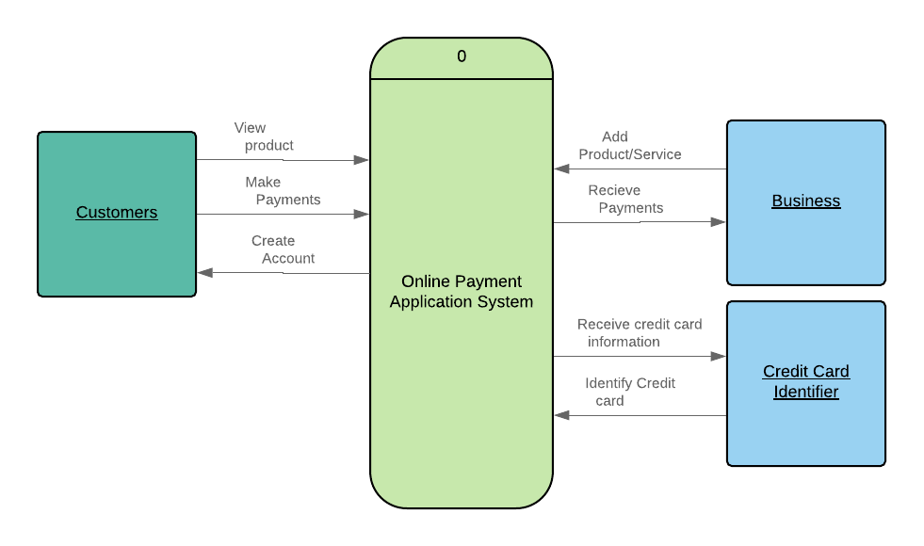

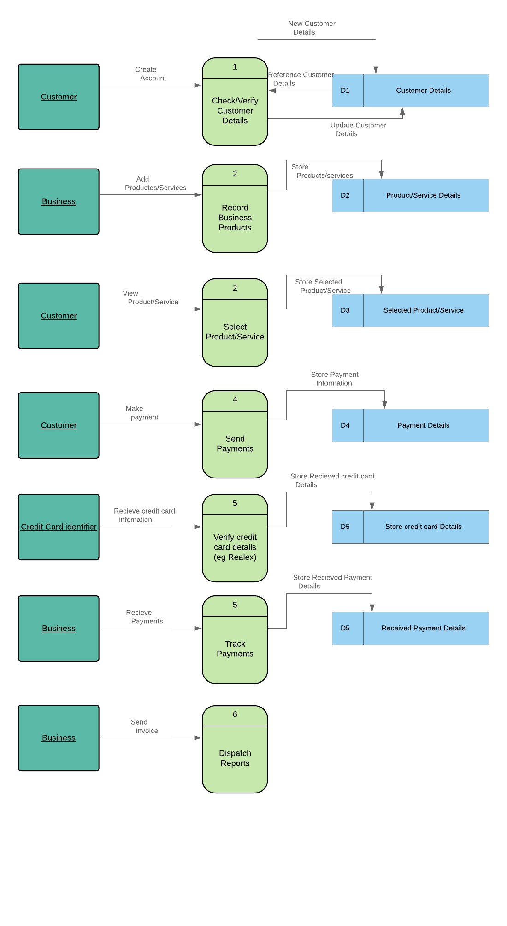

# Use Case Diagram

# Activity Diagram

# A picture containing text Description automatically generatedClass Diagram

# Sequence Diagram

# State Diagram

# Section 6: Execution, Monitoring and Control Phase

## 6.1.1 Introduction - Risk Log

The risk log (provided below) provides information on threats and opportunities that may impact project execution.

|  |  |  |  |  |  |  |  |  |
| --- | --- | --- | --- | --- | --- | --- | --- | --- |
| **#** | **Risk** | **Probability (1-5)** | **Impact (1-5)** | **Owner** | **Risk Response** | **Date** | **Updates** | **Status** |
| 1 | Hardware may not be adequate for performance, resulting in slow load times | 3 | 4 | Stephen | **Reduce** | 01-Jun | Performance testing booked for early July. | Open |
| Carry out performance testing |
| 2 | Staff may not be available during the holiday season | 4 | 3 | Paulina | **Reduce** | 17-Jul | Paulina will review the dev team's holidays and raise any issues. No cover available at present. | Open |
| Review staffing rotas |
| 3 | Declining employee morale may result in increased employee turnover | 3 | 3 | Padraig | **Reduce** | 01-Sep | Team meeting recently held, and morale seems high. | Open |
| Carry out performance testing |
| 4 | Software Development schedule getting delayed | 4 | 3 | Armen | **Accept** | 17-Oct | Currently on schedule. | Open |
| Identify contingency plan should it occur |
| 5 | Software Requirements Inflation | 4 | 2 | Stephen | **Accept** | 02-Dec | Not currently envisaged. | Open |
| Identify contingency plan should it occur |
| 6 | Employee Turnover | 3 | 2 | Paulina | **Reduce** | 17-Jan | Only 1 employee has left this quarter. | Open |
| Review staffing rotas |
| 7 | Specification Breakdown | 3 | 2 | Padraig | **Reduce** | 03-Mar | Not currently envisaged. | Open |
| Carry out performance testing |
| 8 | Poor Productivity | 2 | 3 | Armen | **Reduce** | 18-Apr | Productivity targets currently trending high. | Open |
| Ensure management |
| 9 | Unauthorised system access | 2 | 5 | Stephen | **Share** | 03-Jun | The firm will test the new OPA system once it’s completed. | Open |
| Security consulting firm hired. |
| 10 | Employee fraud | 1 | 5 | Paulina | **Contingency** | 19-Jul | No update. | Open |
| Plan in place. |
| 11 | Counterfeiting of electronic money | 2 | 3 | Padraig | **Contingency** | 03-Sep | No update. | Open |
| Plan in place. |
| 12 | Service provider risk | 2 | 5 | Armen | **Accept** | 19-Oct | No update. | Open |
| Contingency plan in place. |
| 13 | Outdated staff and management expertise. | 3 | 2 | Stephen | **Reduce** | 04-Dec | Training program currently being prepared. | Open |
| Carry out training of the new system. |
| 14 | Inadequate customer security practices. | 3 | 2 | Paulina | **Reduce** | 19-Jan | Training webpage currently being prepared. | Open |
| Incorporate customer training page on the website. |
| 15 | Customer access to their funds or account information is impaired | 2 | 2 | Padraig | **Reduce** | 06-Mar | Testing is ongoing of the new system. | Open |
| Rigorous testing of the system before implementation. |
| 16 | Noncompliance of GDPR laws and regulations | 1 | 4 | Armen | **Share** | 21-Apr | GDPR firm has held first of their quarterly reviews, with positive results. | Open |
| GDPR consultancy firm hired. |
| 17 | Failure to protect customer privacy`1 | 1 | 3 | Stephen | **Reduce** | 06-Jun | No issues reported. | Open |
|  |

## 6.1.2 Planning Risk Management

The approach for managing risks for the OPA Project includes a methodical process by which the project team identifies, scores, and ranks the various risks. Every effort will be made to proactively identify risks ahead of time in order to implement a mitigation strategy from the project’s onset. The most likely and highest impact risks were added to the project schedule to ensure that the assigned risk managers take the necessary steps to implement the mitigation response at the appropriate time during the schedule. Risk managers will provide status updates on their assigned risks in the bi-weekly project team meetings, but only when the meetings include their risk’s planned timeframe.

Upon the completion of the project, during the closing process, the project manager will analyze each risk as well as the risk management process. Based on this analysis, the project manager will identify any improvements that can be made to the risk management process for future projects. These improvements will be captured as part of the lessons learned knowledge base.

## 6.1.3 Identifying Risks

|  |  |  |
| --- | --- | --- |
| **A. Product Development** | | ***Think about risks to the project that may arise from the nature of the product being developed.*** |
| **1** | **Requirements** | **Are there risks that may arise from requirements being placed on the product?** |
|  | * Clarity | Requirements of the new OPA must be continuously communicated and discussed between both parties to ensure clarity. |
|  | * Validity | Requirements must be met with the latest security standards (SSL) to ensure the validity of transactions. |
|  | * Feasibility | A feasibility report has been completed on the implementation of the new OPA system by Bluewater LTD. |
|  | * Scale | The new OPA system must be designed to be scalable as Bluewater LTD has plans to expand into new markets. |
| **2** | **Design** | **Are there risks that may arise from the design chosen to meet the project's requirements?** |
|  | * Functionality | The design of the new OPA system must have full functionality of an OPA system while being developed ensuring industry-standard design. |
|  | * Difficulty | The new OPA system must not be overly difficult to use for customers that may not be computer proficient. |
|  | * Interfaces | The interface must be seamlessly integrated within Bluewater’s current website page. |
|  | * Performance | The performance of the OPA system must meet performance targets in terms of speed and load times. |
|  | * Testability | The design must be testable to industry standard. |
|  | * Hardware constraints | Bluewater LTD’s current server hardware. |
| **3** | **Code and Unit Test** | **Are there risks that may arise from the method chosen to subdivide the design and construct the pieces?** |
|  | * Testing | Expensive security testing may require an external company. |
|  | * Coding/implementation | Meeting the assigned deadline. |
| **4** | **Integration and Test** | **Are there risks that may arise from the way the project team is choosing to bring the pieces together and prove that they work as a whole?** |
|  | * Environment | Bluewater’s hardware and software support facilities. |
|  | * Product | Integration of certain parts of the product. |
|  | * System | Integration with the larger system within Bluewater’s current working website. |
| **5** | **Non-Functional Attributes (formerly: Functional Attributes)** | **Are there risks that may arise from special attributes of the product?** |
|  | * Maintainability | Training of Bluewater’s current staff to the new system. |
|  | * Reliability | Ensuring the new OPA system is tested thoroughly before launch. |
|  | * Safety | Data privacy and GDPR concerns. |
|  | * Security | Bluewater’s security of server’s and data along with ensuring SSL standard. |
|  | * Human Factors | Use of new hardware and software for current Bluewater employees. |
| **6** | **Development Process** | **Are there risks that may arise from the process being used to develop the product?** |
|  | * Process control | Management support for process control. |
|  | * Familiarity | Bluewater IT staff’s familiarity with the process of development. |
|  | * Product control | Management support for product control. |
| **7** | **Development System** | **Are there risks that may arise from the hardware and software tools being used to control and facilitate the development process?** |
|  | * Capacity | Bluewater’s current server capacity. |
|  | * Suitability | Bluewater’s current server hardware suitability for new OPA system. |
|  | * Usability | Bluewater’s current hardware infrastructure usability by an external implementation team. |
|  | * Reliability | Bluewater’s current server’s reliability with the new OPA system. |
|  | * System support | Bluewater’s server’s utilising old Windows Server OS. |

|  |  |  |
| --- | --- | --- |
| **B. Project Management** | | ***Think about risks to the project that may arise from the way the product is being developed.*** |
| **1** | **Project Management Process** | **Are there risks that may arise from: the way the project budget or schedule is planned, monitored, or controlled; management experience; the project's organizational structure; or the way that internal and external organizational interfaces are handled?** |
|  | * Planning | The current schedule of implementation is quite strict. |
|  | * Mgmt. experience | Bluewater’s management expertise in the area of implementing a new payment system. |
| **2** | **Management Methods** | **Are there risks that may arise from the way the development or project personnel are managed?** |
|  | * Personnel Mgmt. | Lack of managerial experience at present. |
|  | * Quality assurance | New quality assurance manager recently employed. |
| **3** | **Work Environment** | **Are there risks that may arise from the general environment in which the project is found?** |
|  | * Communication | Communication between Bluewater LTD management and staff with regards to re-training is a concern. |
|  | * Morale | New software implementation and staff retraining may impact the morale of Bluewater LTD staff. |
| **C. Project Constraints** | | ***Think about risks to the project that may arise from sources outside the project team's control.*** |
| **1** | **Resources** | **Are there risks that may arise because of resources needed for the project that cannot be obtained or maintained?** |
|  | * Schedule | Schedule currently on schedule, however, any setbacks will likely impact the tight schedule. |
|  | * Staff (HR) | The HR department is responsible for the re-training of Bluewater LTD staff. |
|  | * Facilities | Bluewater LTD facilities are outdated. |
| **2** | **Contract** | **Are there risks that may arise from the [already legally] binding contract?** |
|  | * Dependencies | Dependency on Realex for online payments verification. |
| **3** | **Project Interfaces** | **Are there risks that may arise from outside interfaces that the project team cannot reasonably expect to control?** |
|  | * Customer | Current customers of Bluewater’s old payment system being transferred to the new online payment system. |
|  | * Contractors | Contracts to be re-negotiated and adhered to my Bluewater’s current contractors. |
|  | * Corporate Mgmt. | Support from Bluewater LTD corporate management required throughout the implementation of new OPA. |

<https://medium.com/@surbhimahnot/how-to-do-change-management-with-mind-map-ac3e6f7c9a6a>

<http://documents.worldbank.org/curated/en/226461531293264583/pdf/Digital-financial-services-and-risk-management-handbook.pdf>

<https://www.jisc.ac.uk/guides/project-management/managing-risks>

# 6.4 Change Control Management Plan

The Change Management Plan was created for the Bluewater OPA Project in order to set expectations on how the approach to changes will be managed, what defines a change, the purpose and role of the change control board, and the overall change management process. All stakeholders will be expected to submit or request changes to the Bluewater OPA Project in accordance with this Change Management Plan and all requests and submissions will follow the process detailed herein.

The following steps comprise our organisation change control process for all projects and will be utilized on the OPA project:

**Step #1: Identify the need for a change (Any Stakeholder)**

The requestor will submit a completed change request form to the project manager

**Step #2: Log change in the change request register (Project Manager)**

The project manager will maintain a log of all change requests for the duration of the project

**Step #3: Conduct an evaluation of the change (Project Manager, Project Team, Requestor)** The project manager will conduct an evaluation of the impact of the change to cost, risk, schedule, and scope

**Step #4: Submit a change request to Change Control Board (CCB) (Project Manager)**

The project manager will submit the change request and analysis to the CCB for review

**Step #5: Change Control Board decision (CCB)**

The CCB will discuss the proposed change and decide whether it will be approved based on all submitted information

**Step #6: Implement change (Project Manager)**

If a change is approved by the CCB, the project manager will update and re-baseline project documentation as necessary as well as ensure any changes are communicated to the team and stakeholders

Any team member or stakeholder may submit a change request for the OPA Project. The OPA Project Sponsor will chair the CCB and any changes to project scope, cost, or schedule must meet his approval. All change requests will be logged in the change control register by the Project Manager and tracked through to completion whether approved or not.

## 6.4.4 Change Control Process

The Change Management approach for the Bluewater OPA Project will ensure that all proposed changes are defined, reviewed, and agreed upon so they can be properly implemented and communicated to all stakeholders. This approach will also ensure that only changes within the scope of this project are approved and implemented.

The Change Management approach is not to be confused with the Change Management Process which will be detailed later in this plan. The Change Management approach consists of three areas:

* Ensure changes are within the scope and beneficial to the project
* Determine how the change will be implemented
* Manage the change as it is implemented

The Change Management process has been designed to make sure this approach is followed for all changes. By using this approach methodology, the Bluewater OPA Project Team will prevent unnecessary change from occurring and focus its resources only on beneficial changes within the project scope.

# **Definitions of Change**

There are several types of changes which may be requested and considered for the Bluewater OPA Project. Depending on the extent and type of proposed changes, changes project documentation and the communication of these changes will be required to include any approved changes into the project plan and ensure all stakeholders are notified. Types of changes include:

* Scheduling Changes: changes which will impact the approved project schedule. These changes may require fast-tracking, crashing, or re-baselining the schedule depending on the significance of the impact.
* Budget Changes: changes which will impact the approved project budget. These changes may require requesting additional funding, releasing funding which would no longer be required, or adding to project or management reserves. May require changes to the cost baseline.
* Scope Changes: changes which are necessary and impact the project’s scope which may be the result of unforeseen requirements which were not initially planned for. These changes may also impact the budget and schedule. These changes may require revision to WBS, project scope statement, and another project documentation as necessary.

The project manager must ensure that any approved changes are communicated to the project stakeholders. Additionally, as changes are approved, the project manager must ensure that the changes are captured in the project documentation where necessary. These document updates must then be communicated to the project team and stakeholders as well.

# **Change Control Board**

The Change Control Board (CCB) is the approval authority for all proposed change requests pertaining to the Bluewater OPA Project. The purpose of the CCB is to review all change requests, determine their impacts on the project risk, scope, cost, and schedule, and to approve or deny each change request. The following chart provides a list of the CCB members for the Bluewater OPA Project:

|  |  |  |
| --- | --- | --- |
| **Name** | **Position** | **CCB Role** |
| I. P. Freeley | OPA Project Sponsor | CCB Chair |
| Homer J. Simpson | OPA Project Manager | CCB Member |
| S. McIntyre | OPA Project Technical Lead | CCB Co-Chair |
| A. Petrosyan | OPA Project Operations Lead | CCB Member |

As change requests are submitted to the Bluewater OPA Project Manager by the project team/stakeholders, the Project Manager will log the requests in the changelog and the CCB will convene every other Friday to review all change requests. For a change request to be approved, all CCB members must vote in favour. In the event more information is needed for a change request, the request will be deferred and sent back to the requestor for more information or clarification. If a change is deemed critical, an ad hoc CCB meeting can be called in order to review the change prior to the next scheduled bi-weekly CCB meeting.

# **Change Control Process**

The Change Control Process for the Bluewater OPA will follow the organizational standard change process for all projects. The project manager has overall responsibility for executing the change management process for each change request.

1. Identify the need for a change (Stakeholders) – Change requestor will submit a completed change request form to the project manager.
2. Log change in the change request register (Project Manager) – The project manager will keep a log of all submitted change requests throughout the project’s lifecycle.
3. Evaluate the change (Project Manager, Team, Requestor) – The project manager will conduct a preliminary analysis on the impact of the change to risk, cost, schedule, and scope and seek clarification from team members and the change requestor.
4. Submit a change request to CCB (Project Manager) – The project manager will submit the change request, as well as the preliminary analysis, to the CCB for review.
5. Obtain Decision on change request (CCB) – The CCB will discuss the proposed change and decide whether it will be approved based on all submitted information.
6. Implement change (Project Manager) – If a change is approved by the CCB, the project manager will update and re-baseline project documentation as necessary.

## 6.4.6 Roles and Responsibilities

The following are the roles and responsibilities for all change management efforts related to the Bluewater OPA Project:

Project Sponsor:

* Approve all changes to budget/funding allocations
* Approve all changes to the schedule baseline
* Approve any changes in project scope
* Chair the CCB

Project Manager:

* Receive and log all change requests from project stakeholders
* Conduct preliminary risk, cost, schedule, scope analysis of change prior to CCB
* Seek clarification from change requestors on any open issues or concerns
* Make documentation revisions/edits as necessary for all approved changes
* Participate on CCB

Project Team/Stakeholders:

* Submit all change requests on standard organizational change request forms
* Provide all applicable information and detail on change request forms
* Be prepared to address questions regarding any submitted change requests
* Provide feedback as necessary on impact of proposed changes

## 6.4.7 Changelog

The changelog is a document that is used by the project team to log and track change requests throughout the life of the project.

|  |  |  |  |  |  |  |  |
| --- | --- | --- | --- | --- | --- | --- | --- |
| **#** | **Change Type** | **Description** | **Requestor** | **Date Submitted** | **Date Approved** | **Comments** | **Status** |
| 1 | Design | E-mail verification | Stephen | 1st May |  | An extra layer of verification | Open |
| 1st May |
| 2 | Scope | More documentation required | Paulina | 3rd May |  | Extra documentation requested | Open |
| 8th May |
| 3 | Schedule | Delay starting of the project | Padraig | 25th June |  | Extra planning required | Open |
| 28th June |
| 4 | Design | 3rd party payment card authenticator | Armen | 17th July |  | Realex preferred | Open |
| 20th July |
| 5 | Scope | Additional Hardware requirement | Stephen | 20th July |  | To expand server resources | Open |
| 26th July |

# APPENDIX LIST

* [Explain an Online Payment System | Chron.com](https://smallbusiness.chron.com/explain-online-payment-system-1780.html) - [*https://smallbusiness.chron.com › explain-online-payment-system-1780*](https://smallbusiness.chron.com/explain-online-payment-system-1780.html)
* [E-commerce payment system - Wikipedia](https://en.wikipedia.org/wiki/E-commerce_payment_system) - [*https://en.wikipedia.org › wiki › E-commerce_payment_system*](https://en.wikipedia.org/wiki/E-commerce_payment_system)
* [What Is an E-payment System? - Business 2 Community](https://www.business2community.com/ecommerce/e-payment-system-01641721) - [*https://www.business2community.com › ecommerce › e-payment-system-0...*](https://www.business2community.com/ecommerce/e-payment-system-01641721)
* *Scope intro the book he gave us – peoject scooe management pg 166*
* Scope Verification - ICPM
* https://www.theicpm.com › blog › item › 60-scope-verificatio
* https://www.projectinsight.net › project-management-basics › project-manag..
* https://payoneer.custhelp.com › app › answers › detail › a_id › global-paym...
* Hussung, T. (2016). What Is the Software Development Life Cycle?. Available: https://online.husson.edu/software-development-cycle/. Last accessed 31st Oct 2019.

# APPENDIX 1: A List of Functional and Non Functional Requirements

**Functional requirements**

* The system must be able to process and accept various forms of electronic payments
* The system must be able to handle the credit/debit card payments coming through system and then have a way of temporarily storing the information in form of some “token” system
* The system must include having an admin page with administrator privileges
* The system must allow the customer to check their payment plan and order history
* The OPA system must be able to contact the bank’s API to successfully validate the client’s selected cards
* The OPA system must be integrated into the website
* The system must store the client’s payment information to automate payments

**Non-functional requirements**

* The system must be accessible via all form of mobile and electronic devices
* The user must have access to the system to view their accounts
* The system must be able to exchange different currencies as the system will gain a new customer from new territories
* Users must be able to get view payments that they have made and view outstanding payments due
* The new system must be easy to use for old and new customers
* The system must secure all data and be protected against attacks
* The system must be scalable, maintainable and available to customers 24/7

# APPENDIX 2: Work Breakdown Structure (WBS)

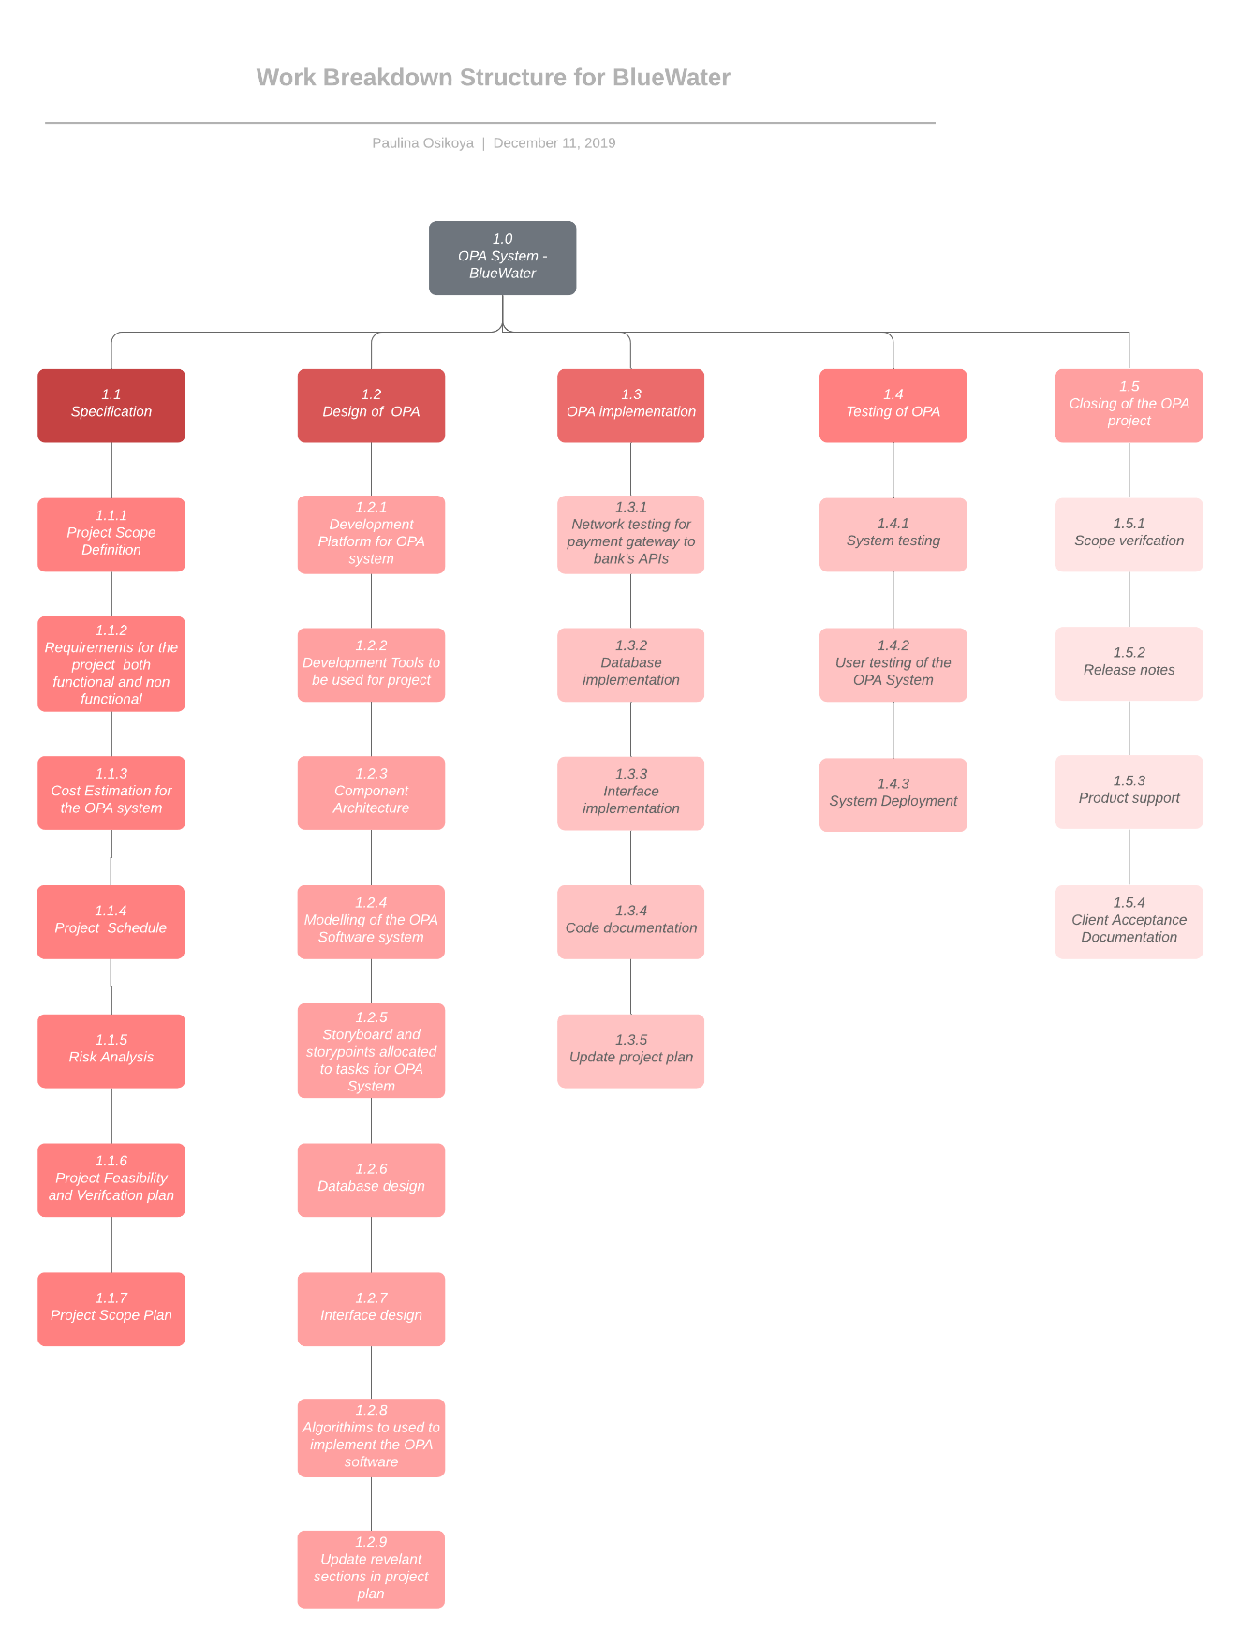

APPENDIX 3 – Record of Meetings



**Meeting Minutes**

**Online Payment Application**

**Company**

**Bluewater LTD**

**Old Dublin Rd,**

**Galway**

**Date: October 1ST, 2019**

**Time: 12:00 PM to 1:00 PM**

**Location: Bluewater conference room 3**

**Manager: Homer J. Simpson**

**Meeting Objectives**

Outline the overall scope of the project, and what is required for the completion of this online payment application.

Discuss software and tools used, deadlines for completion of this OPA, and financials.

**New Action Items**

**Schedule Outline**

***Planned Work for the Next Two Weeks***

* Action Item 1 – Summarize financials and expected final cost.
* Action Item 2 – Draw out UML diagram of how the OPA will work.
* Action Item 3 – Create sample designs of the OPA look and feel.



**Meeting Minutes**

**Online Payment Application**

**Company**

**Bluewater LTD**

**Old Dublin Rd,**

**Galway**

**Date: October 15TH, 2019**

**Time: 12:00 PM to 1:00 PM**

**Location: Bluewater conference room 7**

**Manager: Homer J. Simpson**

**Meeting Objectives**

Discuss minutes from meeting one and discuss changes to the original project outline.

Finalize OPA features and software.

**New Action Items**

**Schedule Outline**

***Work Completed***

* Item 1 – Summarize financials and expected final cost.
* Item 2 - Draw out UML diagram of how the OPA will work.
* Item 3 – Create sample designs of the OPA look and feel.

***Planned Work for the Next Month***

* Action Item 1 –
* Action Item 2 –



**Meeting Minutes**

**Online Payment Application**

**Company**

**Bluewater LTD**

**Old Dublin Rd,**

**Galway**

**Date: November 15TH, 2019**

**Time: 12:00 PM to 1:00 PM**

**Location: Bluewater conference room 7**

**Manager: Homer J. Simpson**

**Meeting Objectives**

Discuss minutes from meeting two.

Implement new features that need to be implemented into the OPA system.

Discuss AOB.

**New Action Items**

**Schedule Outline**

***Work Completed***

* Item 1 –
* Item 2 -
* Item 3 -

***Planned Work for the Next Month***

* Action Item 1 –
* Action Item 2 –

# APPENDIX 4: List of tools used for communication

* Lucid charts
* Microsoft Teams
* Trello

# C:\Users\G00311302\Downloads\OPA System Gantt Chart.pngAPPENDIX 5: Gantt chart

# APPENDIX 6: List of Software Used

* Front End – HTML/CSS /JavaScript
* Back End – Java
* Database – SQL

APPENDIX 7: Abbreviations

**OPA** – Online Payment System

**CCB** – Change Control Board

**LTD** – Limited

**PDF** – Portable Document Format

**RFP** - Request for Proposal

**UML** - Unified Modeling Language

**HTML** – Hypertext Mark-up Language

**SQL** - Standardized Query Language

**CSS** - Cascading Style Sheets

**GDPR** – General Data Protection Regulation.

**AOB** - Any Other Business

APPENDIX 8: References

// Padraig