Bayesian Meta Analysis on Lead Exposure & IQ Loss
Paulina Sell
2025-08-25

Table of contents

Table of contents 1
Introduction 2
Step 1: Standardizing Effect Estimates 2
Visually Checking Transformations 3
Transforming Estimates to ln(BLL) 3
Case 1: log10(BLL) -> ln(BLL): Dantzer et al. 2020 4
Case 2: log2(BLL) -> ln(BLL): Desrochers-Couture et al. 2018 5
Case 3: linear(BLL) -> ln(BLL): Iglesias et al. 2011 5
Step 2: Meta Analysis 7
Setting Priors 7
Fitting the model 9
Assessing Convergence & Model Validity 9
Interpreting the Results 13

Introduction
The aim of this project is to estimate the environmental burden of disease (EBD) attributable to lead exposure in Germany. Our focus will be on the neurodevelopmental effects of lead; therefore, the health outcome will be IQ point loss in children and adolescents. In order to estimate these population health effects, we must find solid evidence for exactly how lead exposure is related to IQ loss. The exposure data we are working with is based on whole blood samples from 720 children and adolescents (ages 3 - 17) in Germany, collected as part of the German Environmental Survey (GerES V) between 2014 and 2017.
In order to quantify exactly how lead exposure is related to IQ loss, we turn to the epidemiological literature. Many studies have been published focusing on the neurodevelopmental effects of lead. Rather than selecting an estimate from a single study for our EBD analysis, we will pool estimates from multiple studies in order to gather and strengthen the evidence we base our analysis on. And since uncertainty plays an important role in the final burden of disease results, we will use a Bayesian approach. This approach allows us to easily model uncertainty and obtain a full posterior distribution of the pooled effect (rather than a mean and a hard-to-interpret confidence interval). Later, we will be able to directly use the posterior distribution in our EBD analysis! But first, let’s meta-analyze some epi studies.
I found help and inspiration in multiple sources and have (hopefully) linked them all. I especially found this hands-on guide from Harrer et al. 2021 very helpful.

Step 1: Standardizing Effect Estimates
We first need to search for and identify relevant studies and extract the data necessary for our analysis. This was already done by Philippe Palmont and his team at ANSES.
Next, we need to harmonize / standardize the effect estimates before we can pool them. Most of the studies transformed their blood lead level (BLL) data to a logarithmic scale in order to fulfil the assumption of a linear relationship between BLL (exposure) and IQ points (outcome) in their regression analyses. Unfortunately, they did not always use the same log base. Some used log₁₀, some ln, and some used log₂. Also, 3 of the 13 included studies did not transform their BLL at all, so it’s on a linear scale. In their analysis, Philippe Palmont and his team standardized all estimates to linear increments of BLL, using the template proposed by Rodriguez Barranco 2017. What happens to the effect estimates, if we transform them in this way?

Visually Checking Transformations
Let’s compare an original beta coefficient from Crump et al. 2013 (ß = -2.65) for ln(BLL) to the transformed one (ß = -0.277), which can now be used for linear BLL.
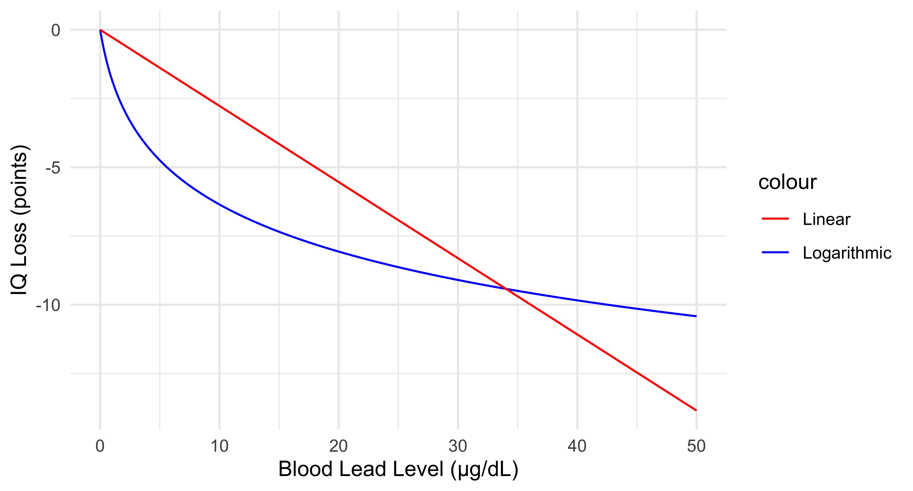
It appears that we would heavily underestimate the effects of lower BLL and overestimate the effects of higher BLL. Since today, BLL are often found to be much lower than even 30 µg/dL (in our sample, the range is approximately 0.04 to 4.5 µg/dL), we would likely underestimate the population health effects of BLL on IQ in children.
Therefore, transforming log estimates to linear seems to be problematic in our case.

Transforming Estimates to ln(BLL)
In order to preserve the correct exposure-response curves and harmonize the effect estimates for the meta analysis, we could try to transform all estimates to ln(BLL), as this is closer to the original estimates reported by the studies, which mostly just used different bases for their logarithmic transformations.
These are the formulas I used to transform the different estimates to ln(BLL):
$$β_{ln}=β_{linear}×C_{ref}$$
$$β_{ln}=\frac{beta_{log_{2}}}{ln\left(2\right)}$$
$$β_{ln}=\frac{beta_{log_{10}}}{ln\left(10\right)}$$
Where:
$β_{ln}$ = harmonized beta coefficient (natural logarithm)
$β_{linear}$ = beta coefficient for linear BLL
$β_{log_{2}}$ = beta coefficient for log₂-transformed BLL
$β_{log_{10}}$ = beta coefficient for log₁₀-transformed BLL
$C_{ref}$ = reference concentration for linear transformation

Case 1: log₁₀(BLL) -> ln(BLL): Dantzer et al. 2020
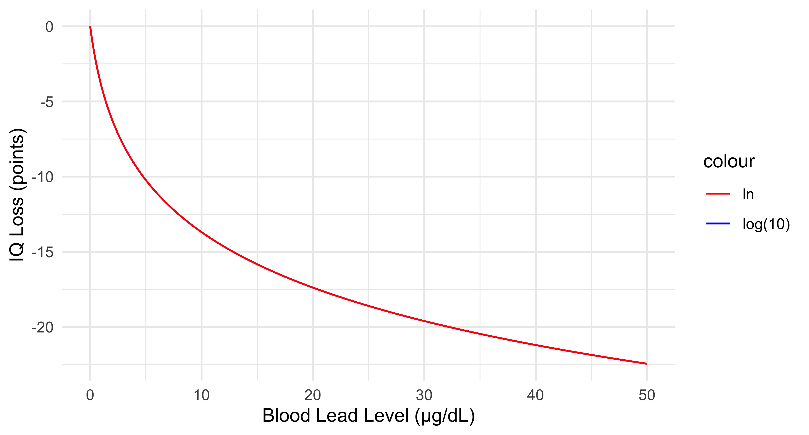
We can’t even see the blue curve, so the transformation should be valid.

Case 2: log₂(BLL) -> ln(BLL): Desrochers-Couture et al. 2018
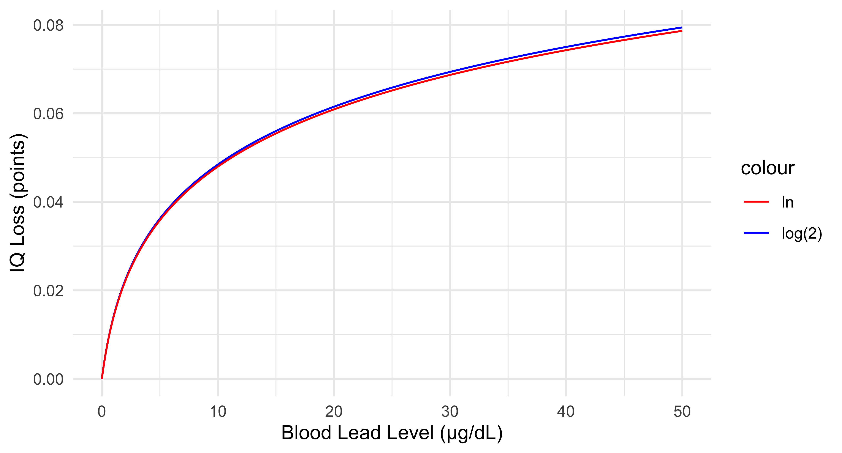
For the transformation from log₂ to ln, we can see that at least in this concentration range, the transformed estimate is a good approximation of the original.
! Note that this study reported a small protective effect of lead exposure, this is why the curve is flipped.

Case 3: linear(BLL) -> ln(BLL): Iglesias et al. 2011
In order to transform this estimate, we need to set a reference BLL ($C_{ref}$). Here, I chose 2.2 µg/dL.
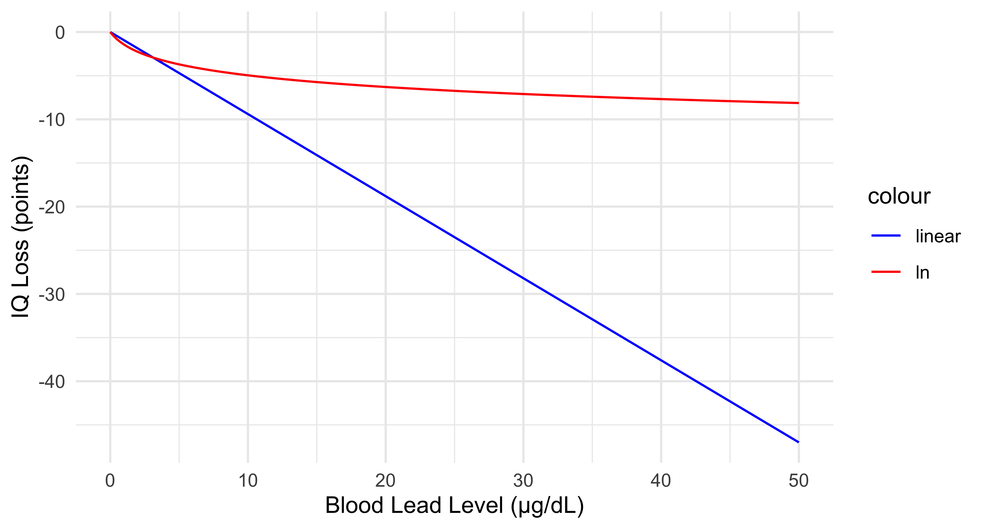
This looks problematic… However, the concentration range is quite high in this plot, so let’s zoom in.
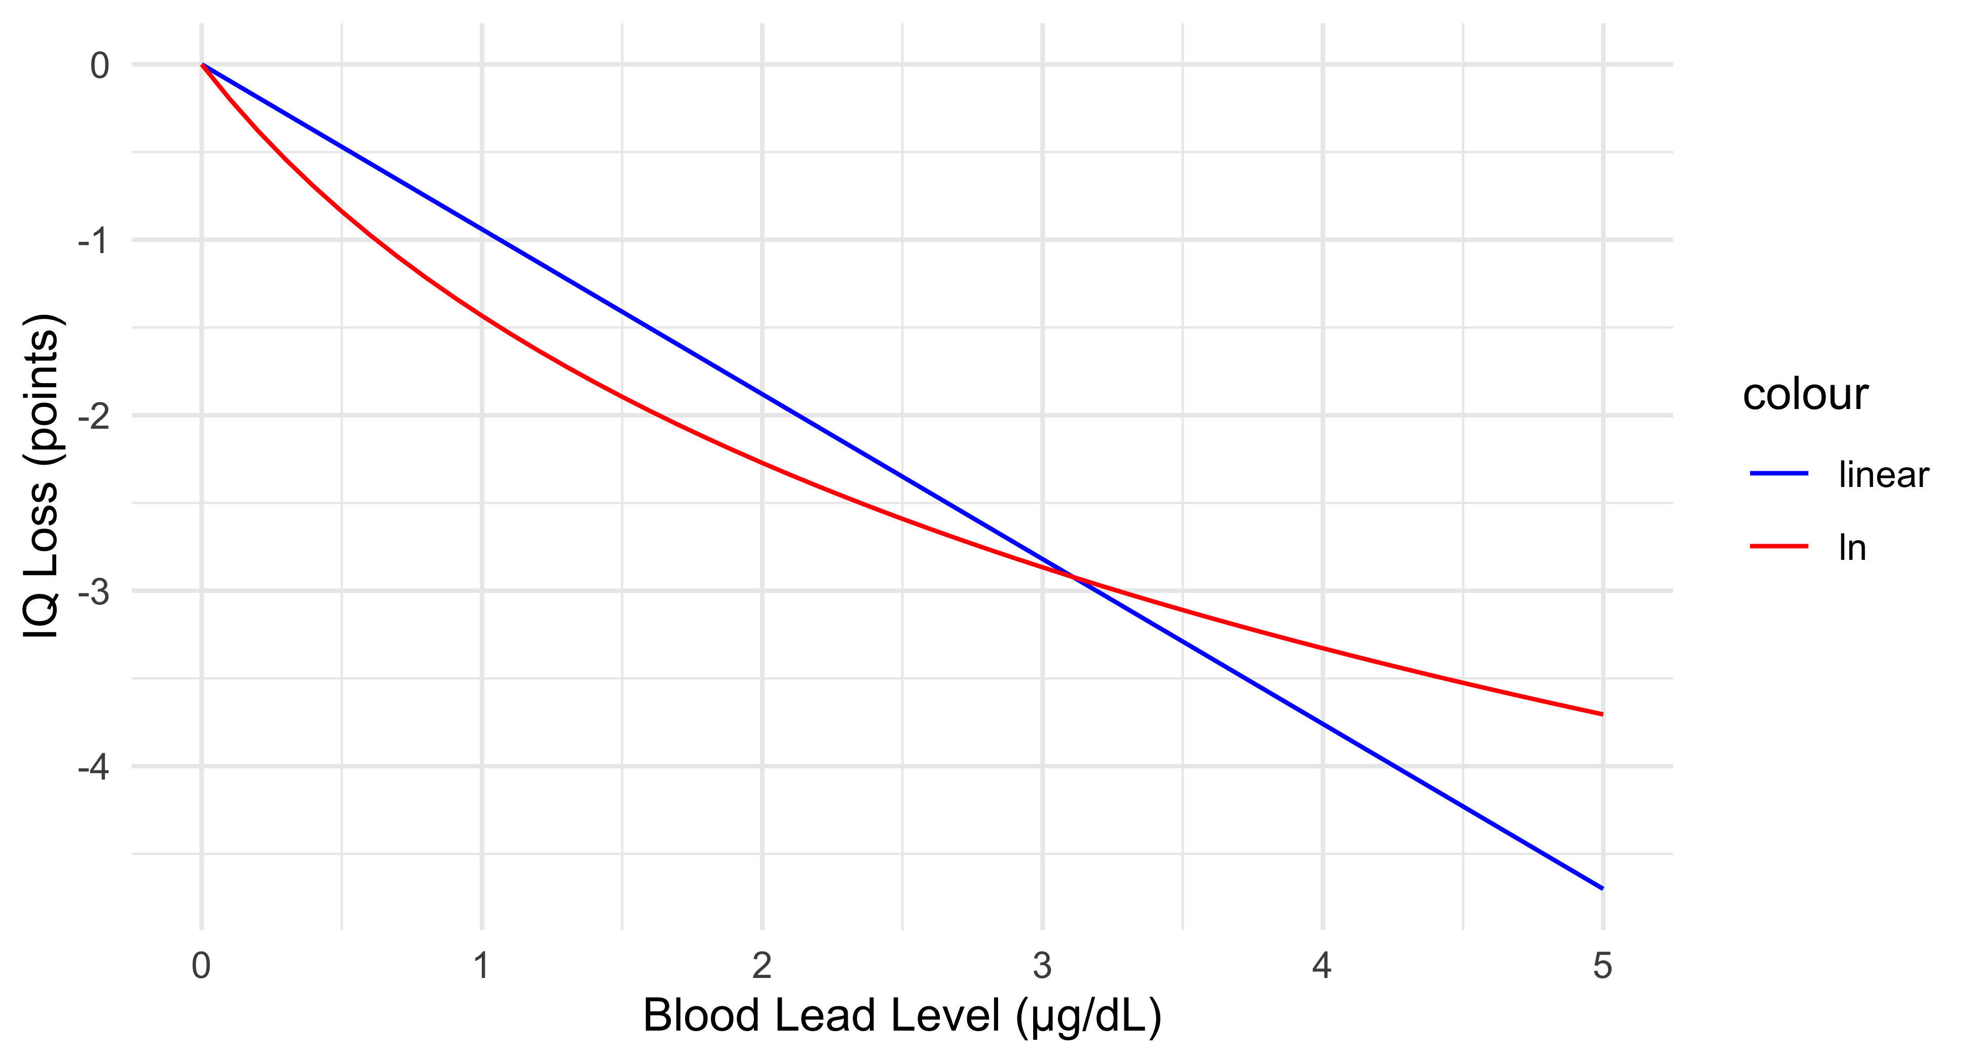
Even in the lower concentration range, it appears that the transformed estimate does not accurately approximate the original estimate. For my meta analysis, I therefore decided to exclude 3/13 studies with estimates for untransformed BLL data.
This leaves us with 10 harmonized effect estimates for the association of ln(BLL) and absolute IQ point loss.
These are the final studies and transformed effect estimates that we will be working with.
author_year | doi | N | beta | se
Bauer 2020 | 10.1289/EHP6803 | 635.00 | -0.10 | 0.87
Crump 2013 | 10.3109/10408444.2013.832726 | 1,493.00 | -2.65 | 0.53
Dantzer 2020 | 10.1016/j.scitotenv.2019.134519 | 224.00 | -5.71 | 1.61
Desrochers-Couture 2018 | 10.1016/j.envint.2018.10.043 | 606.00 | 0.02 | 0.06
Hong 2015 | 10.1289/ehp.1307420 | 839.00 | -3.14 | 1.36
Lee 2021 | 10.1016/j.envint.2021.106798 | 502.00 | -3.83 | 2.25
Lucchini 2019 | 10.1186/s12940-019-0505-3 | 299.00 | -0.11 | 0.08
Lucchini 2012 | 10.1016/j.envres.2012.08.003 | 299.00 | -3.48 | 1.48
Menezes-Filho 2018 | 10.3390/ijerph15112418 | 219.00 | -3.74 | 1.29
Schnaas 2006 | 10.1289/ehp.8552 | 122.00 | 0.21 | 0.85

Step 2: Meta Analysis
Now that we have collected our study data and harmonized the effect estimates, we can finally begin our meta analysis!

Setting Priors
First, we need to define the priors. In Bayesian statistics, a prior distribution represents our initial belief about an unknown parameter before observing any data. It’s a probability distribution reflecting our knowledge or assumptions about the parameter’s possible values. This prior distribution is then combined with the likelihood function (based on observed data) to produce a posterior distribution, which represents our updated belief after considering the data. You can read more about choosing prior distributions in Bayesian statistics in this book chapter.
We will be conservative and use weakly informative priors. For the main effect ($μ$), I chose $μ∼N\left(0,1\right)$. This means that we assume the main effect to lie between -2 and 2, with a 95.4% probability.
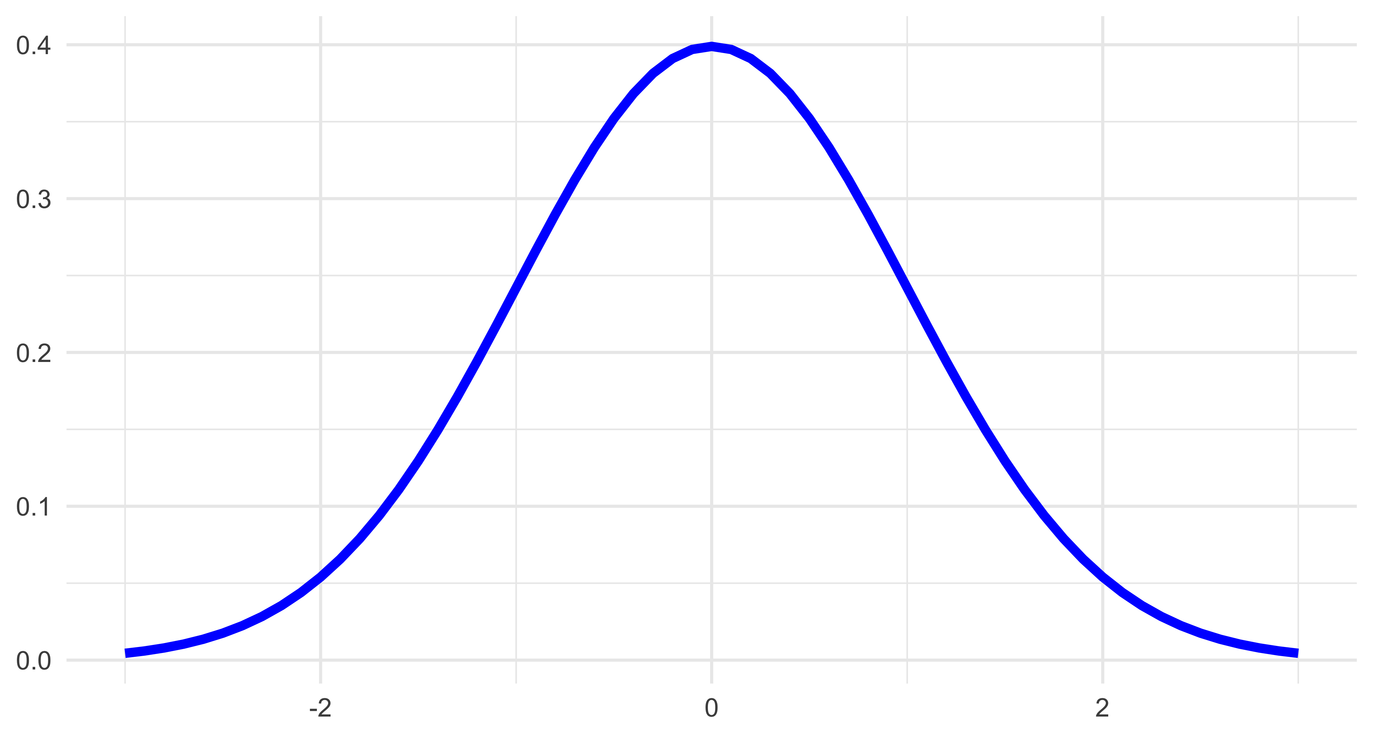
Setting the prior for heterogeneity ($τ$) is slightly more challenging since, by definition, it must be positive. Here, a half-Cauchy distribution can be useful. It is defined by two parameters: the location, which determines the center of the distribution, and the scale parameter, which controls the spread. We set the lower limit to zero (lb = 0) to make it half. For this model, I chose $τ∼HC\left(0,0.5\right)$.
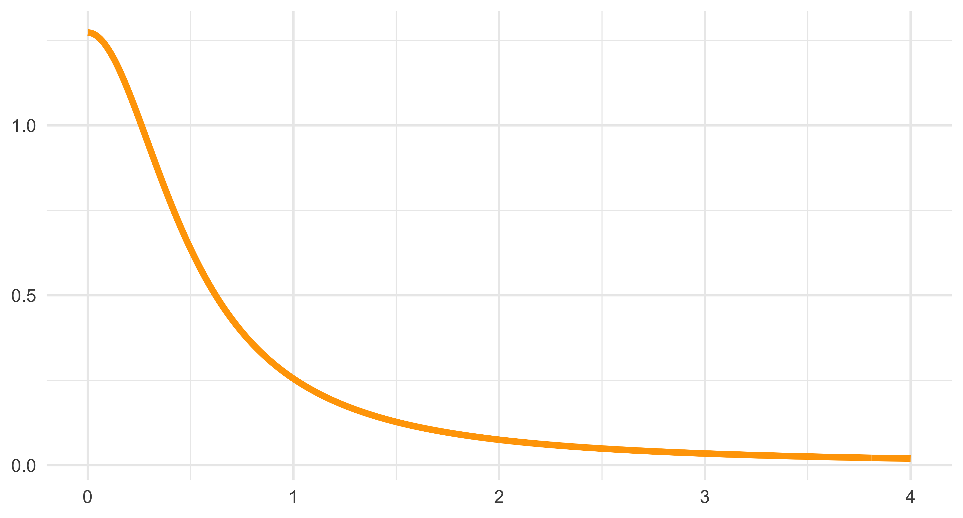
As you can see, we assign a fairly high probability (20.48%) to the heterogeneity being higher than 1.5. Considering that the median standard error extracted from our included studies is 1.08, this prior is weakly informative.
This is how we set our priors:
priors <- c(prior(normal(0,1), class = Intercept),
prior(cauchy(0,0.5), class = sd, lb = 0))

Fitting the model
We can now write and fit the model, using the package brms by Bürkner 2017. In the second line, we specify our model. We set adapt_delta to 0.99 to decrease the step size that the sampling algorithm explores the posterior distribution with. If we don’t do this, adapt_delta will default to 0.8 and we get something like Warning: There were 5 divergent transitions after warmup. This means that the algorithm is having difficulty exploring the posterior distribution.
m.brm <- brm(
beta_ln|se(se_beta_ln) ~ 1 + (1|author_year),
data = data,
prior = priors,
control = list(adapt_delta = 0.99),
save_pars = save_pars(all = TRUE),
chains = 4,
iter = 4000,
seed = 1223)

Assessing Convergence & Model Validity
First, let’s make sure that our priors are reasonable. We can do this by doing a prior predictive check. Prior predictive checks are used to evaluate the suitability of prior distributions before the model ‘sees’ our data. This involves simulating data from the model using only the prior distributions and then examining the simulated data to see if it aligns with our expectations. This can help to identify issues with the chosen priors, such as implausible parameter values, before they can influence the posterior distribution and final inferences. You can read more about prior and posterior predictive checks here.
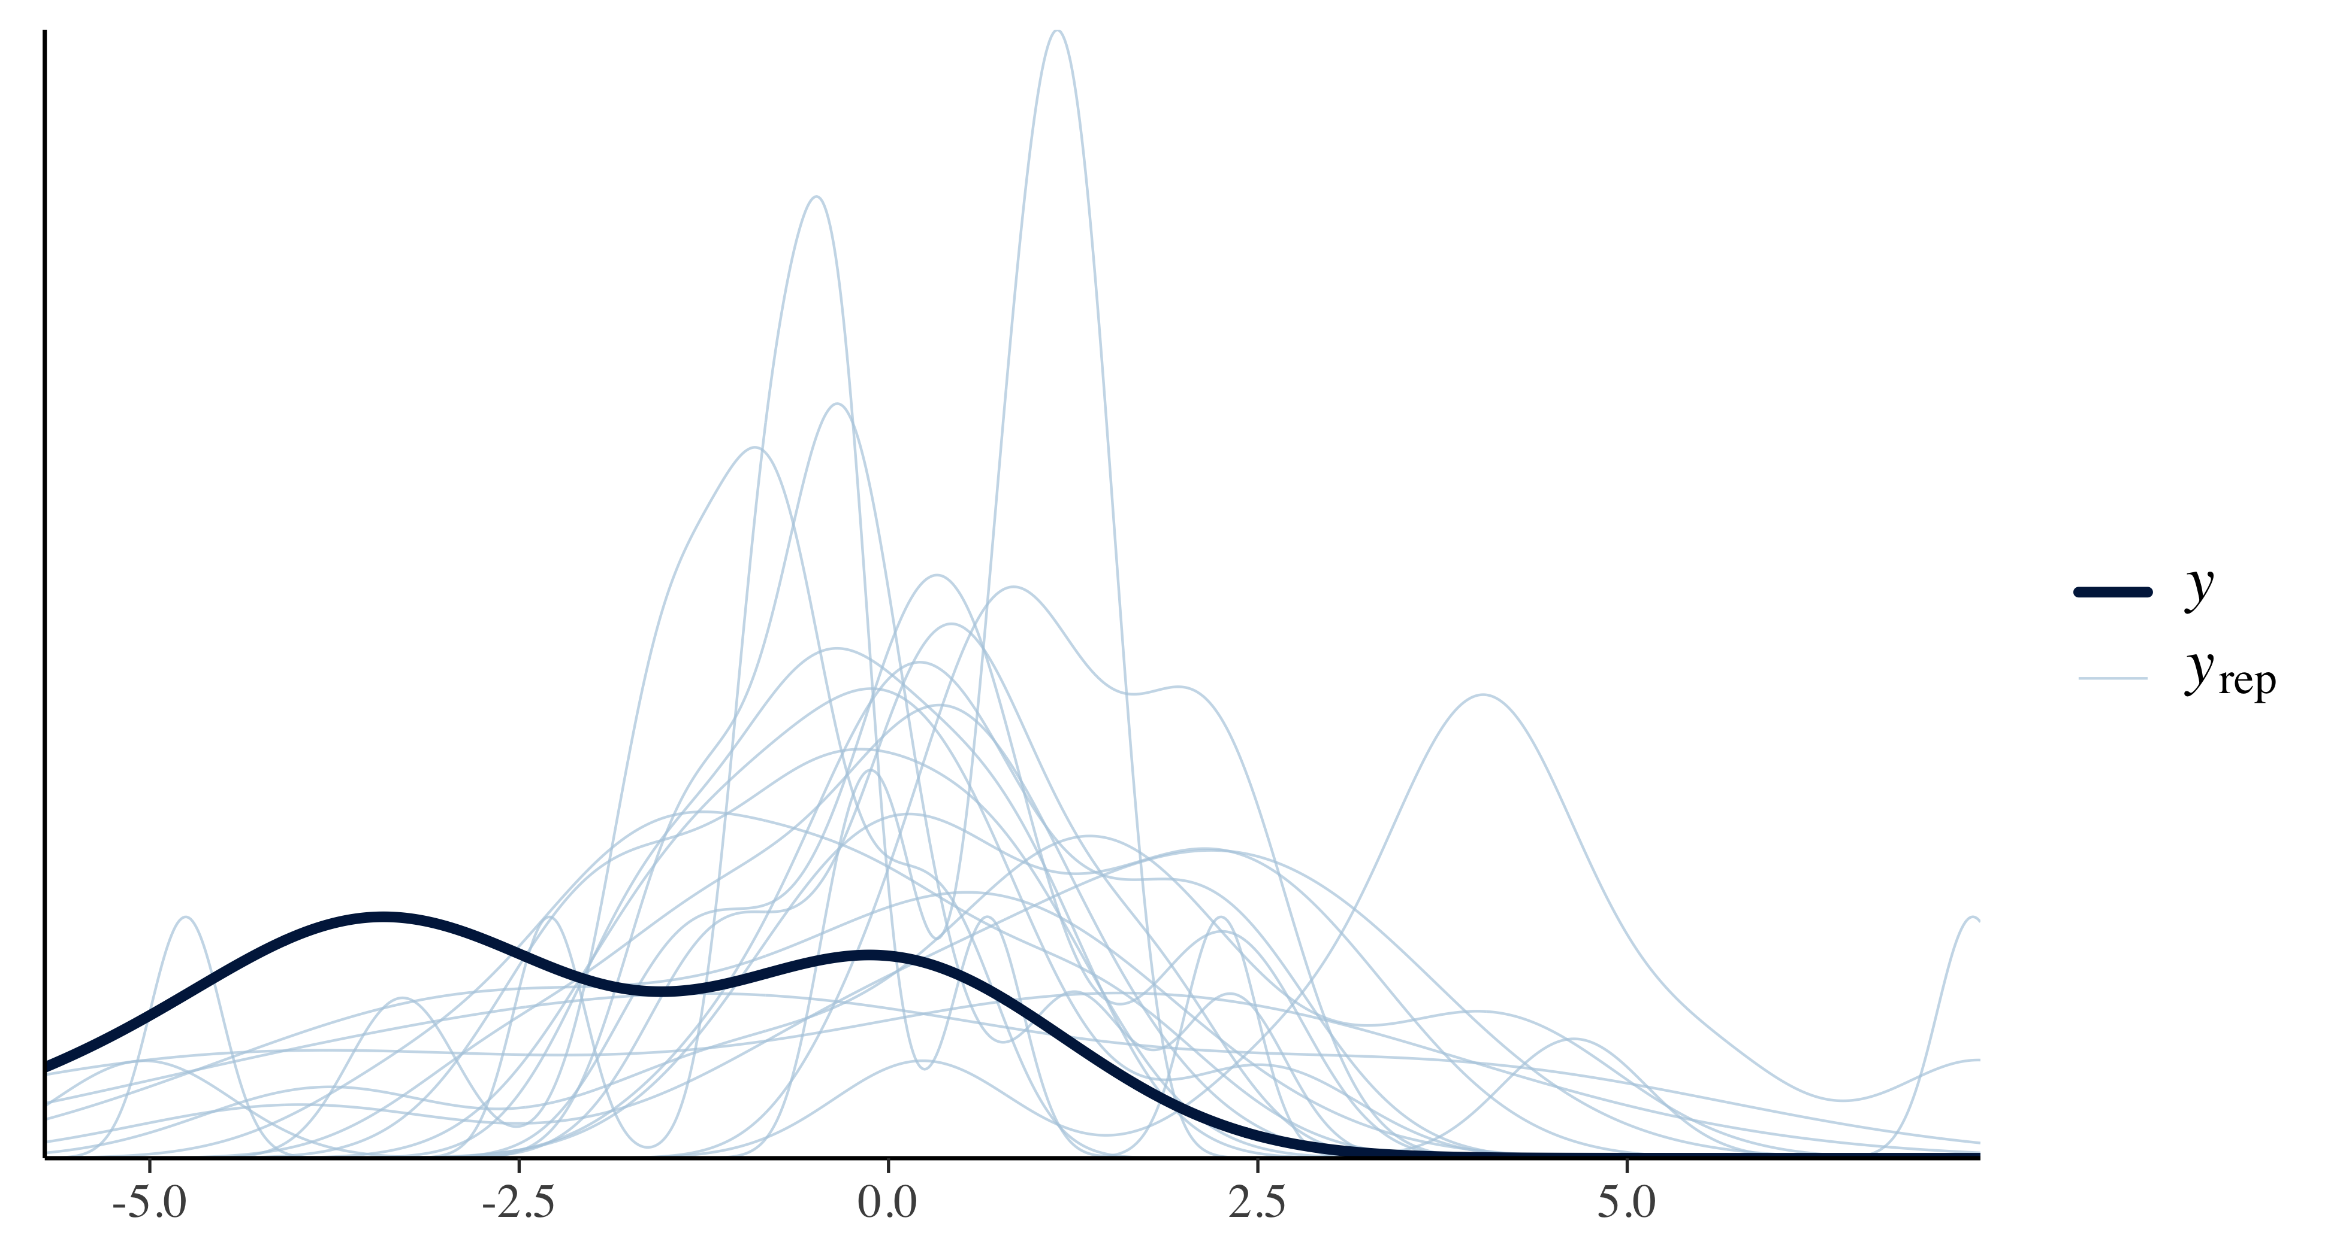
Now let’s do a posterior predictive check:
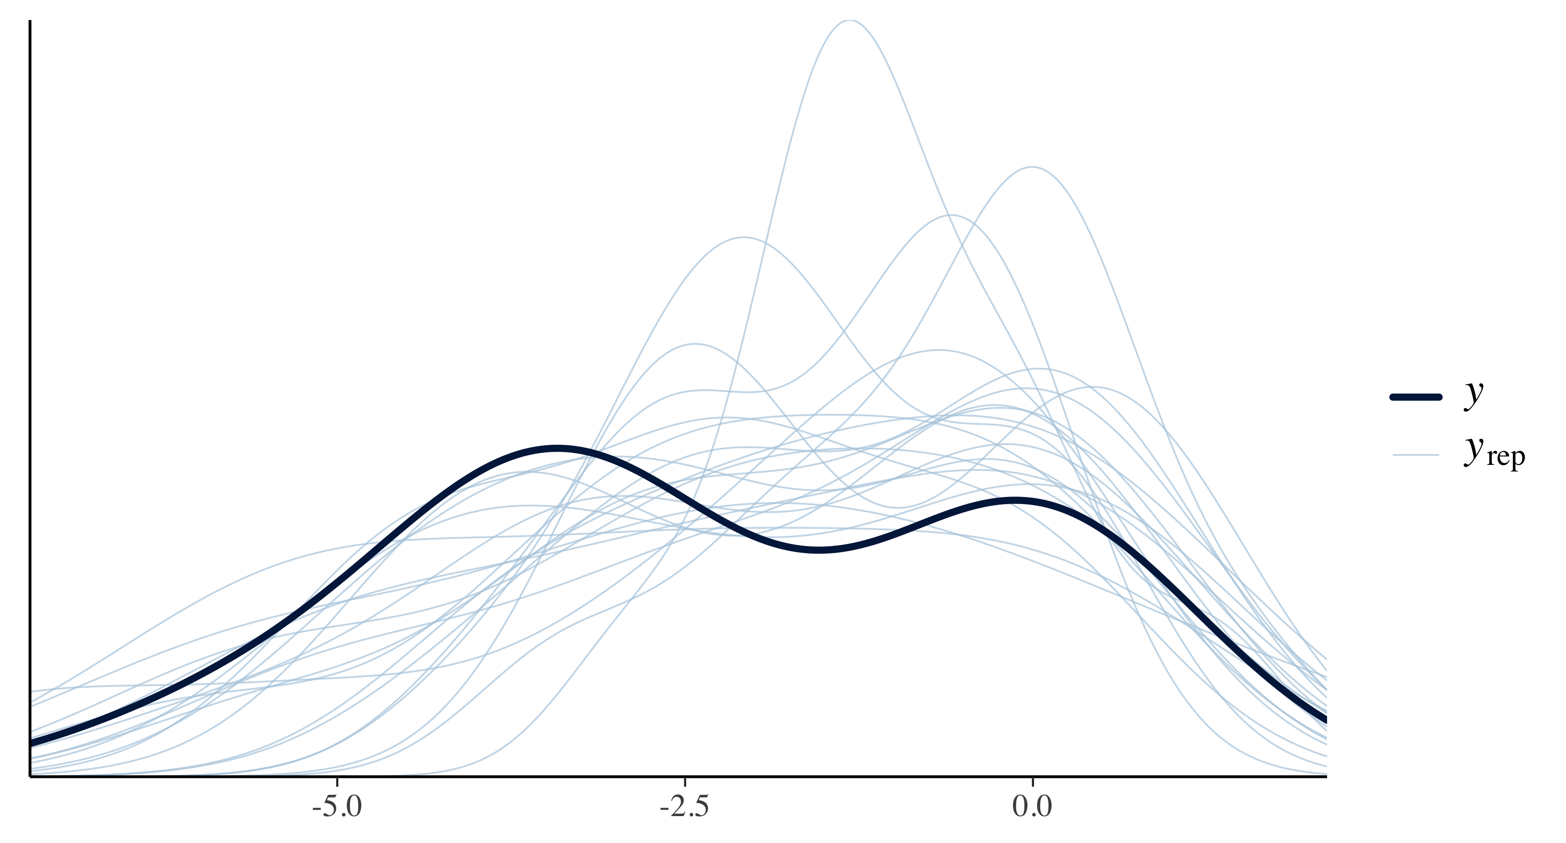
We mainly want to pay attention to extreme deviations from the area we’d expect our curves to land. Both look okay.
Let’s look at the results summary:
Family: gaussian
Links: mu = identity; sigma = identity
Formula: beta_ln | se(se_beta_ln) ~ 1 + (1 | author_year)
Data: data (Number of observations: 10)
Draws: 4 chains, each with iter = 4000; warmup = 2000; thin = 1;
total post-warmup draws = 8000
Multilevel Hyperparameters:
~author_year (Number of levels: 10)
Estimate Est.Error l-95% CI u-95% CI Rhat Bulk_ESS Tail_ESS
sd(Intercept) 1.58 0.58 0.72 2.97 1.00 1789 3113
Regression Coefficients:
Estimate Est.Error l-95% CI u-95% CI Rhat Bulk_ESS Tail_ESS
Intercept -1.24 0.51 -2.24 -0.23 1.00 2333 3356
Further Distributional Parameters:
Estimate Est.Error l-95% CI u-95% CI Rhat Bulk_ESS Tail_ESS
sigma 0.00 0.00 0.00 0.00 NA NA NA
Draws were sampled using sampling(NUTS). For each parameter, Bulk_ESS
and Tail_ESS are effective sample size measures, and Rhat is the potential
scale reduction factor on split chains (at convergence, Rhat = 1).
Here, we should pay attention to the $\overset{^}{R}$ (Rhat in output) value (potential scale reduction factor), which indicates whether the Markov chain Monte Carlo (MCMC) sampling process (this is the class of algorithms used to estimate the parameters) has converged. A value of less than 1.05 is generally considered good. Here you can read more about convergence and efficiency diagnostics for Markov chains. As we can see, our $\overset{^}{R}$ values are both 1.00 which is good!
Now let’s look at the trace plots of the four MCMC chains for both the posterior distribution of beta and the standard deviation. The red vertical lines show where the warm-up ended (samples from the warm-up will not be used further).
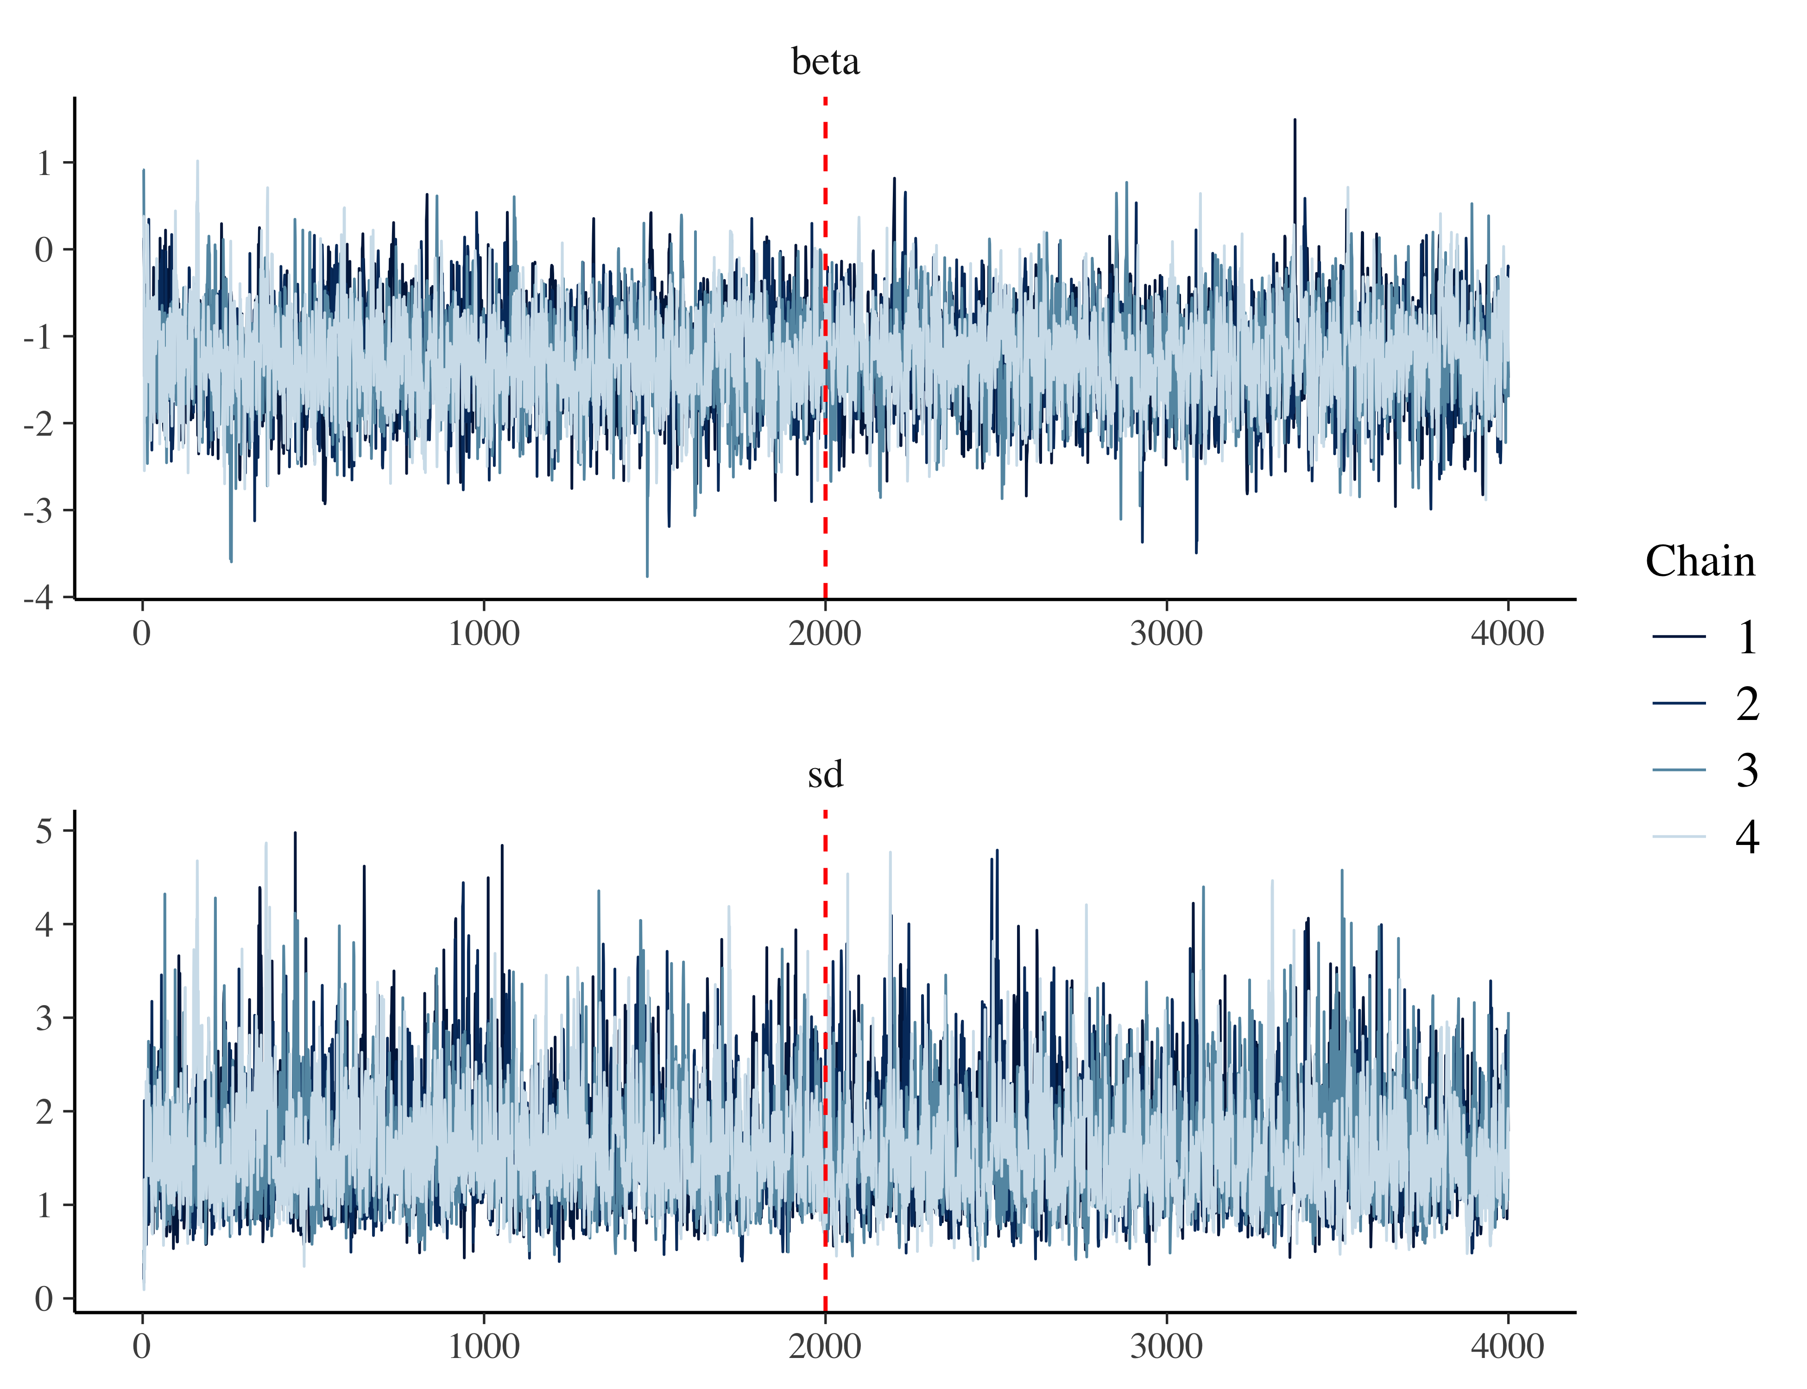

Interpreting the Results
Interesting! Now what do our posterior distributions actually look like?
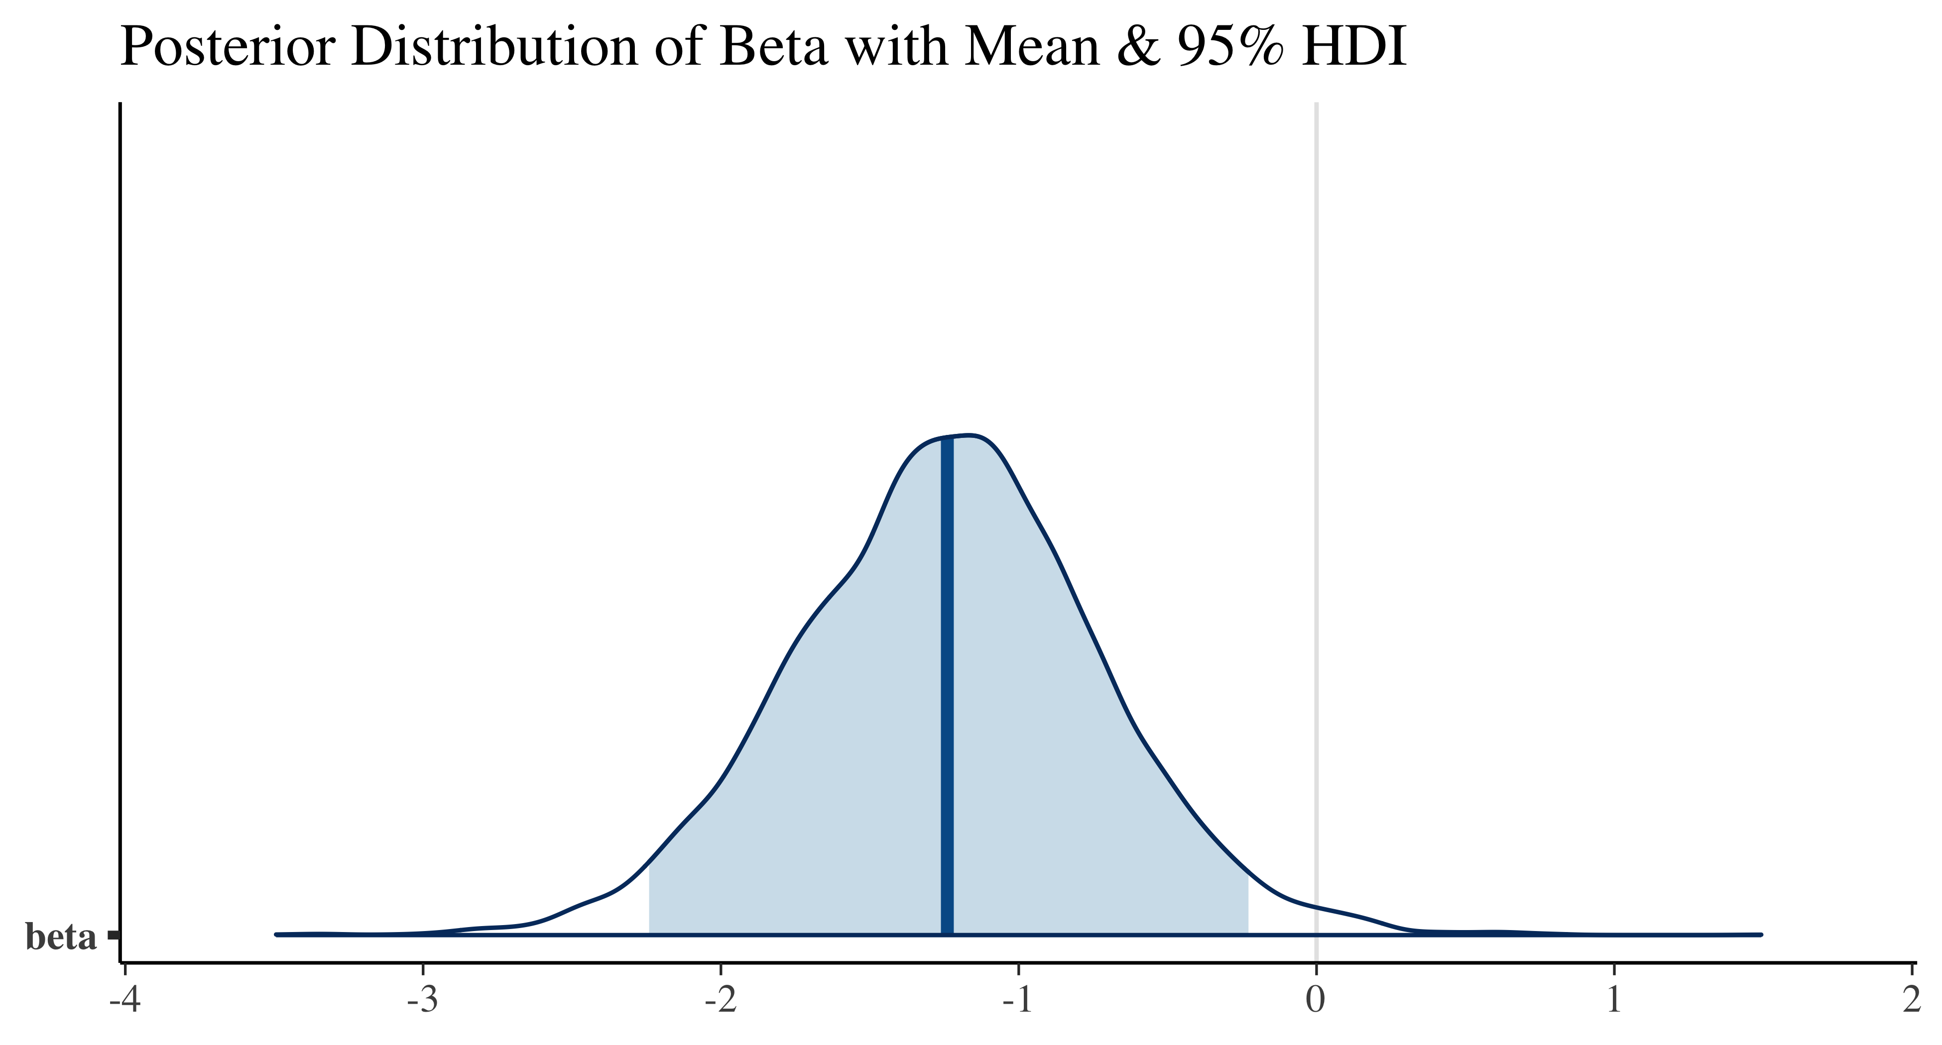
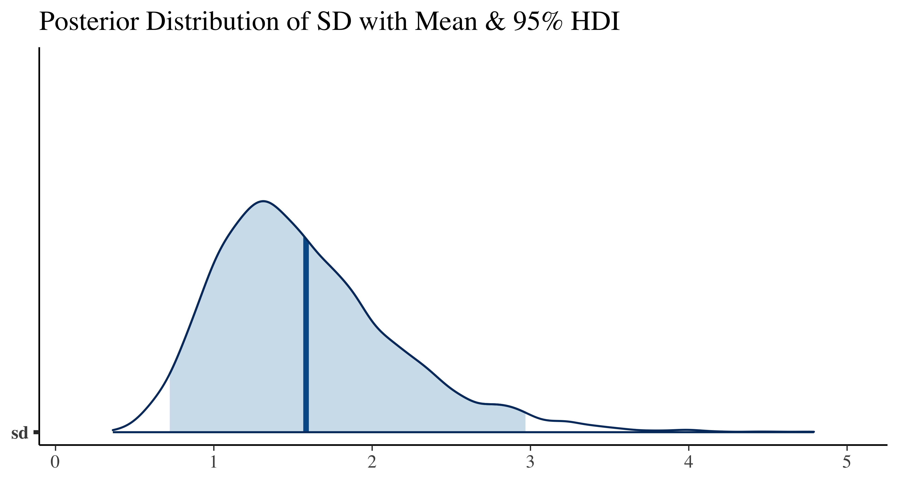
The posterior probability distribution represents the updated beliefs about an unknown parameter (e.g. the effect of BLL on IQ, beta) after observing new data, combining prior beliefs with the evidence from the data. And unlike a mean effect + confidence interval, it actually represents probability!
This means that we can ‘ask’ this distribution many questions, such as: “What is the probability that the effect is greater than -1?” ( greater meaning stronger here, so more IQ points would be lost). To answer such questions, we use the empirical cumulative distribution function (ECDF):
b.ecdf <- ecdf(posterior_samples$beta)
x <- b.ecdf(-1)
Given our data and model, the probability of the effect being greater than -1 is 69%.
We can also ask about interesting intervals; for example, consider the interval we saw in the plot above. This is a 95% high-density interval (HDI), meaning it is the narrowest interval containing 95% of the probability mass. This interval is often referred to as credible interval.
hdi <- hdi(posterior_samples$beta, credMass = 0.95)
Given our data and model, the true effect lies between -2.24 and -0.22 with 95% probability.
Coming back to the main objective of this project, we can now use the posterior distribution directly for our EBD assessment!
And of course, we can also plot a pretty forest plot showing all the posterior distributions of the included studies, the mean, and the 95% credible intervals.
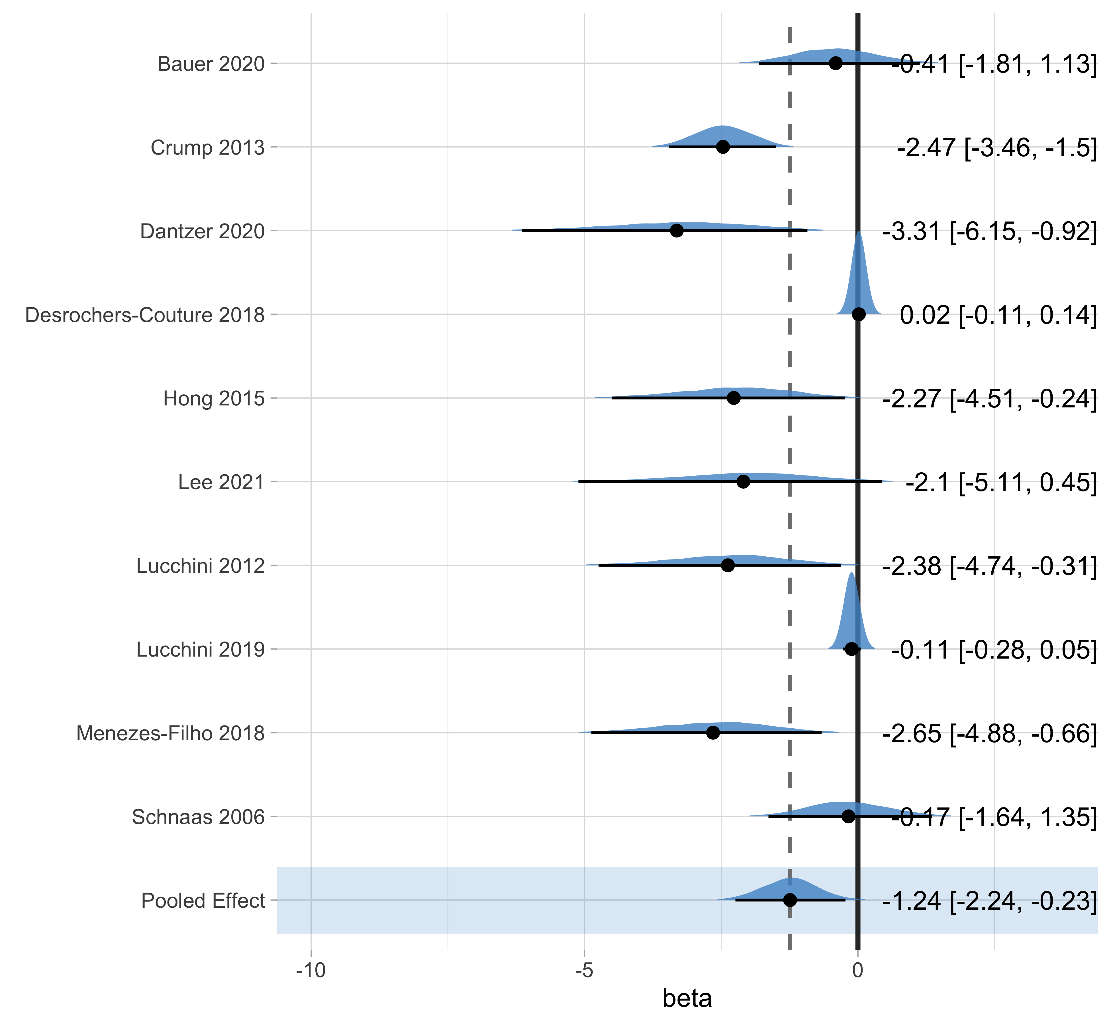
If you’re wondering why the effect sizes are not the same as those reported in the studies, it’s because of a process called shrinkage. The Bayesian model estimates ‘true’ effect sizes for each study and if it detects outliers, they will be pulled towards the overall effect. This is an advantage of the Bayesian approach, particularly when pooling a small number of studies. The model is less sensitive to outliers than frequentist models.

