Final Laboratory Activity for Lab 3: Complete Role-Based Login System with Registration, Profiles & Admin Management
Course: Web Application Development
Module: REST APIs & Authentication Fundamentals
Name: Pauline Mae A. Gallamora
Course, Year & Section: BSIT 3-E
III. Pre-Lab Questions (10 pts)
Q1. Why does the server return a redirectTo value instead of letting the client decide where to send the user?
- Server has the final say: The server is the one that knows the user's real role, so it should be the one to say which page they go to.
- Easy to change: If a page moves or a new role is added, you only edit server.js once instead of editing every HTML file.
Q2. Since users are stored in memory, what happens when the server restarts? How do you fix this in a real app?
- What happens: The users array is reset to empty and the IDs start at 1 again, so every account is gone.
- Fix: Save users in a real database like MySQL, PostgreSQL or MongoDB so the data stays even after a restart.
Q3. Why does the login route return the same error for unknown email and wrong password?
- Hides which emails exist: If the server said "email not found" for one and "wrong password" for the other, someone could keep guessing emails and find out which ones are registered.
- So: A single message, "Invalid email or password.", tells an attacker nothing extra.
Q4. Why does sanitizeUser strip the password from every response?
- No leaking: The browser and anyone looking at the network tab would be able to see the passwords of users.
- Not needed: The page only needs the id, name, email and role, so there is no reason to send the password.
Q5. Is sessionStorage a strong form of protection? Why or why not?
- No, it is not strong.
- Why: Anyone can open DevTools (F12) and edit sessionStorage, for example change the role from "user" to "admin". The browser also does not check it with the server, so it only hides pages, it does not truly secure them.
- Better option: Use server-side sessions or signed tokens that the server checks on every request.

VI. Laboratory Tasks
Task 1 — Run the Server (5 pts)
I ran node server.js and the console printed the three URLs. The login page loaded at http://localhost:3000/login.html.
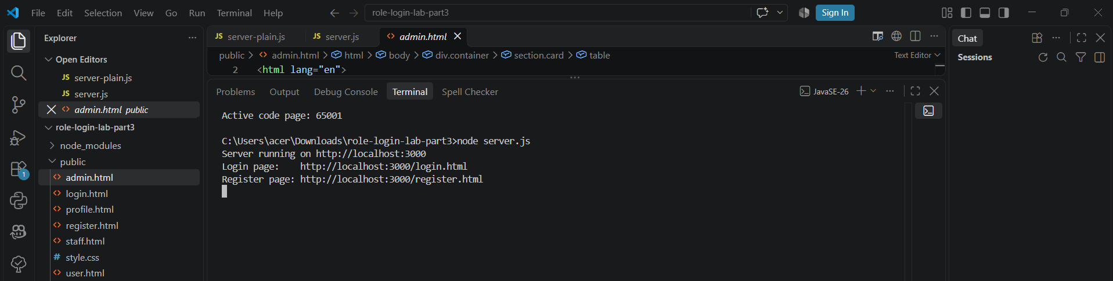
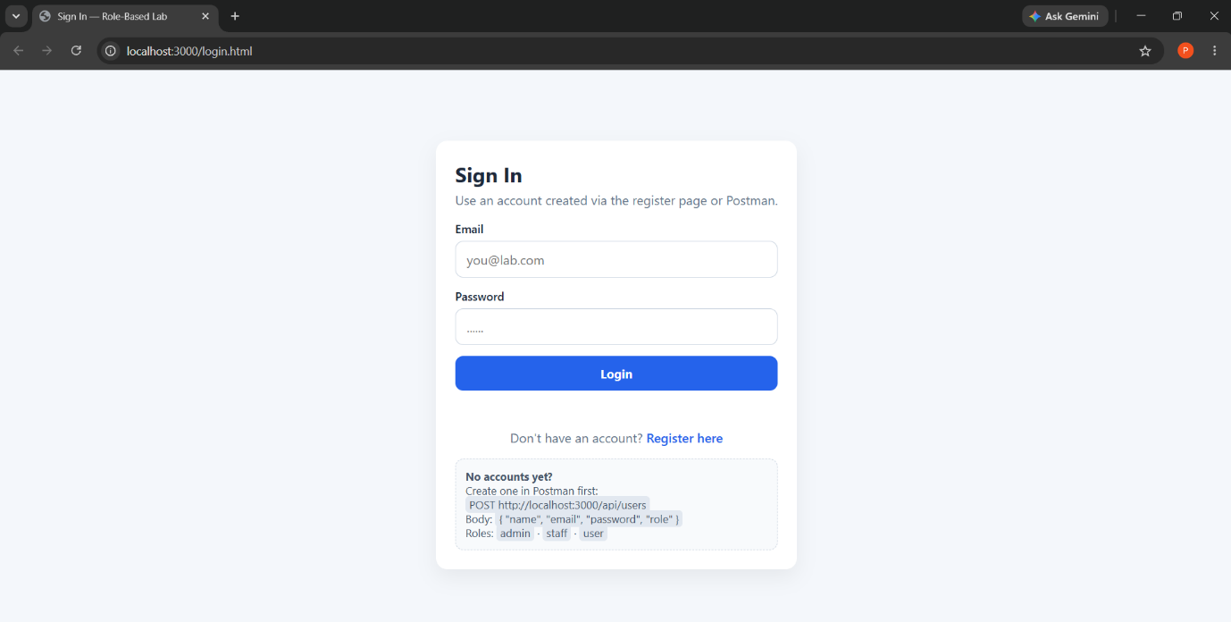
Deliverable: Screenshot of the terminal and login page.
Task 2 — Create Users via Postman (10 pts)
I used Talend API Tester to POST one user per role to /api/users, then ran GET /api/users to confirm the passwords are not shown.
Role | Body used
admin | {"name":"Admin User","email":"admin@lab.com","password":"admin123","role":"admin"}
staff | {"name":"Staff Member","email":"staff@lab.com","password":"staff123","role":"staff"}
user | {"name":"Normal User","email":"user@lab.com","password":"user123","role":"user"}

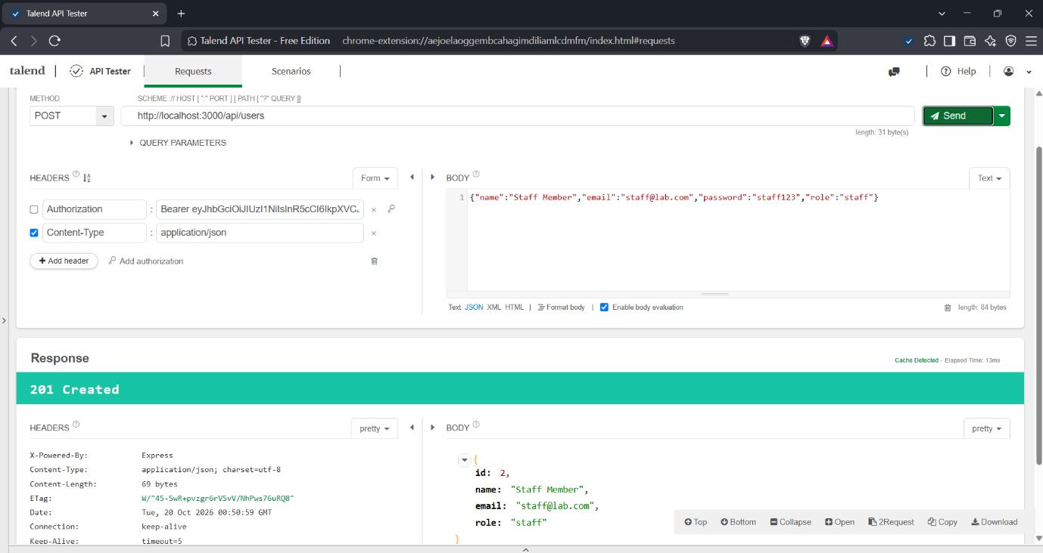
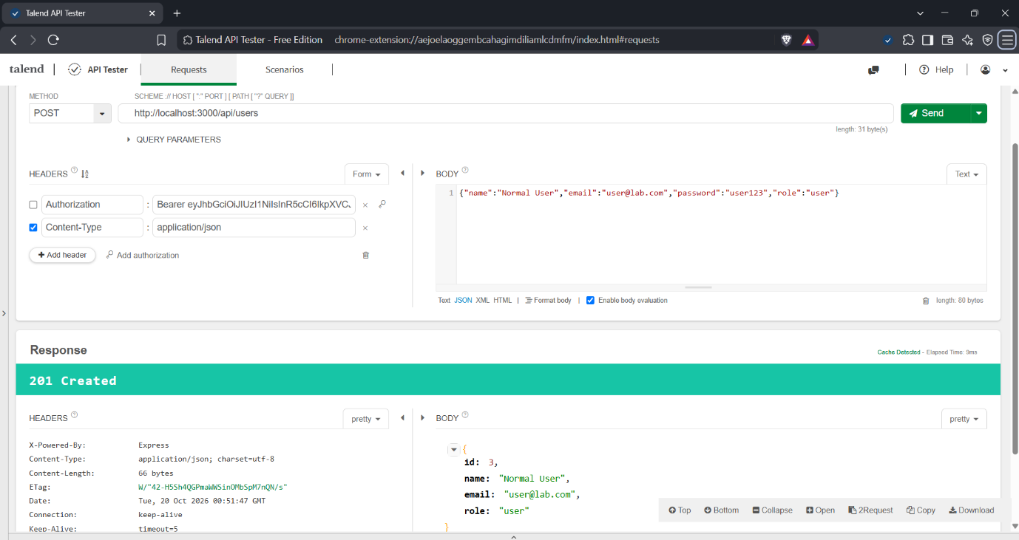
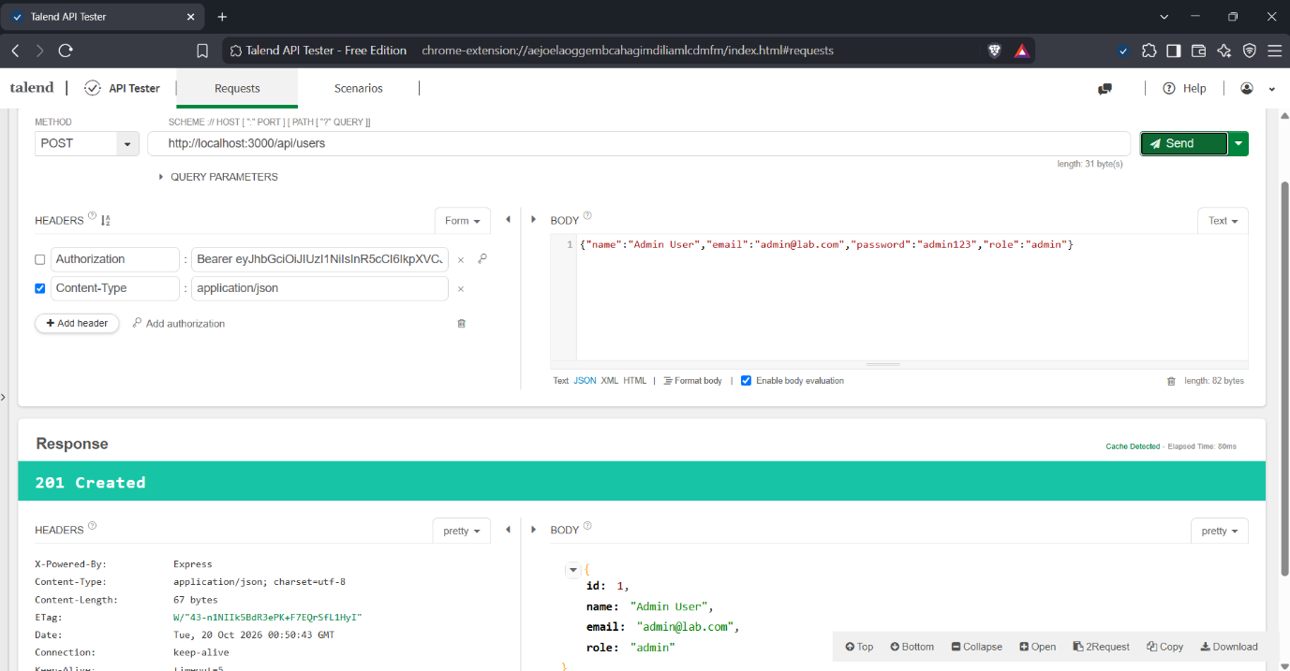

Then run GET /api/users and confirm no passwords appear.
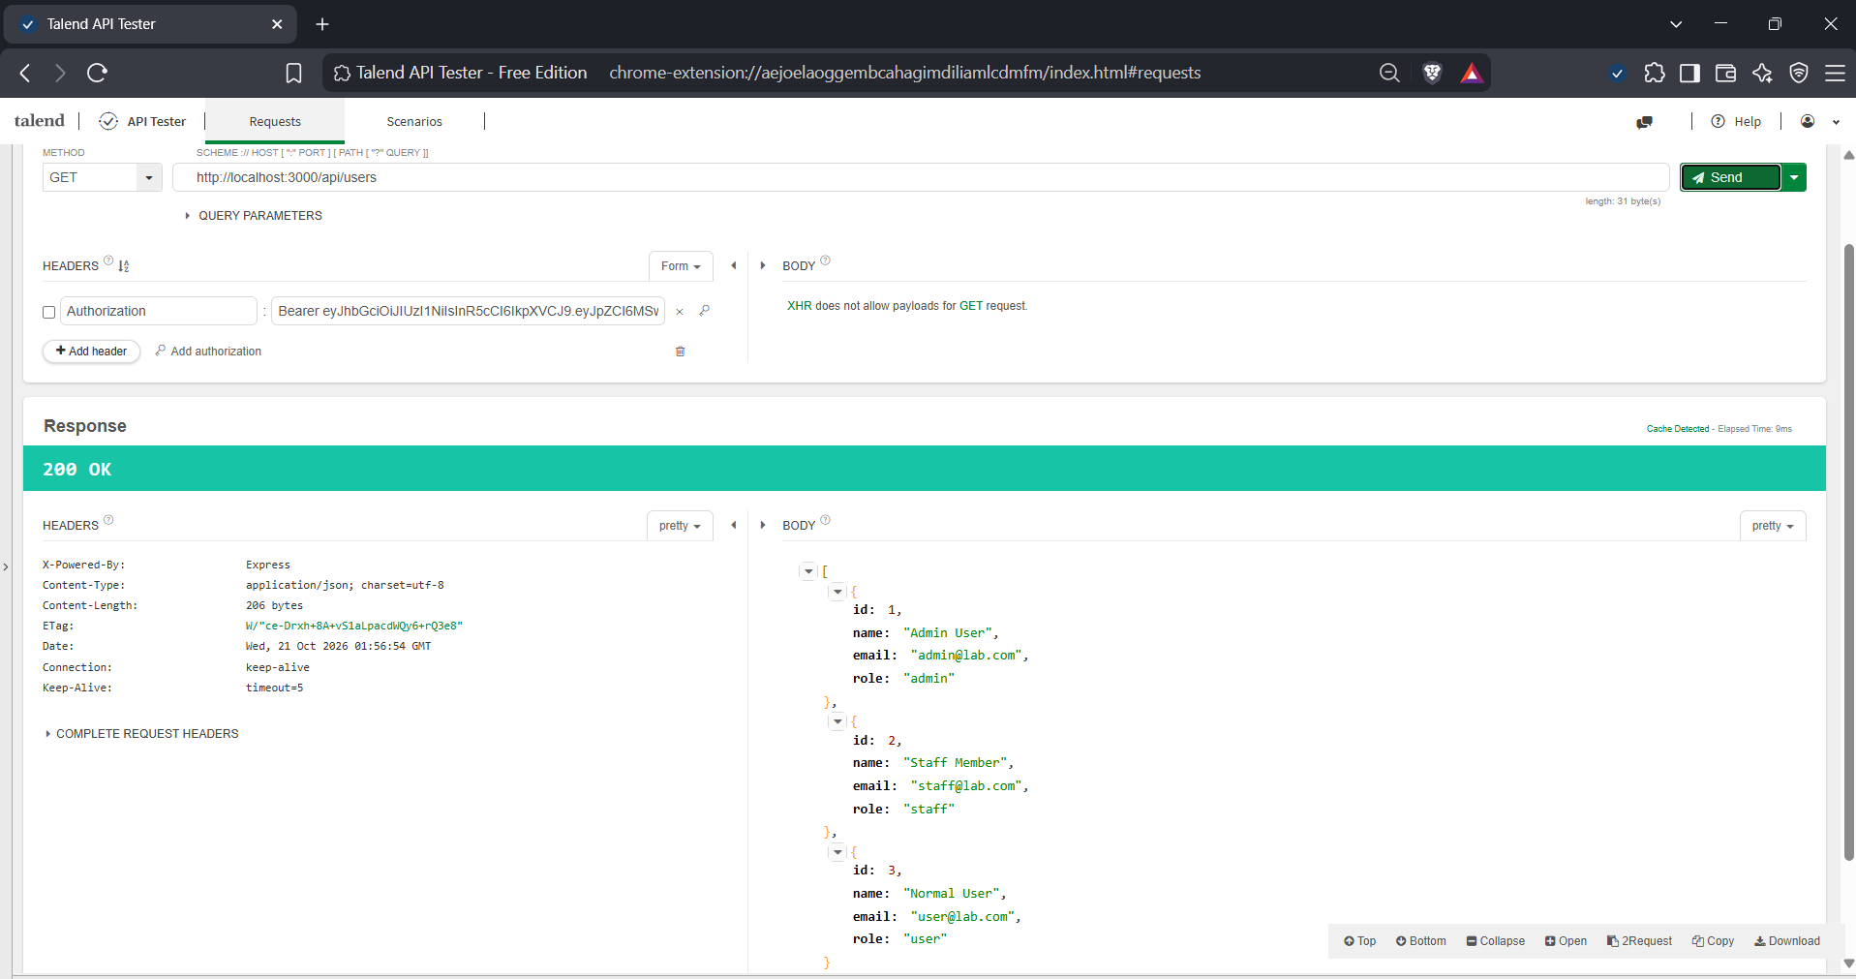
Deliverable: Screenshots of all 4 requests.

Task 3 — Test Registration in Postman (10 pts)
All five requests were sent to POST /api/register.
# | Body | Expected / Result
1 | {"name":"Test","email":"test@lab.com","password":"test123"} | 201 Created
2 | Same email again | 409 Conflict
3 | {"name":"Bad","email":"not-an-email","password":"test123"} | 400 Bad Request
4 | {"name":"Short","email":"short@lab.com","password":"123"} | 400 Bad Request
5 | {"name":"Hacker","email":"hacker@lab.com","password":"hack123",  "role":"admin"} | 201, role forced to user

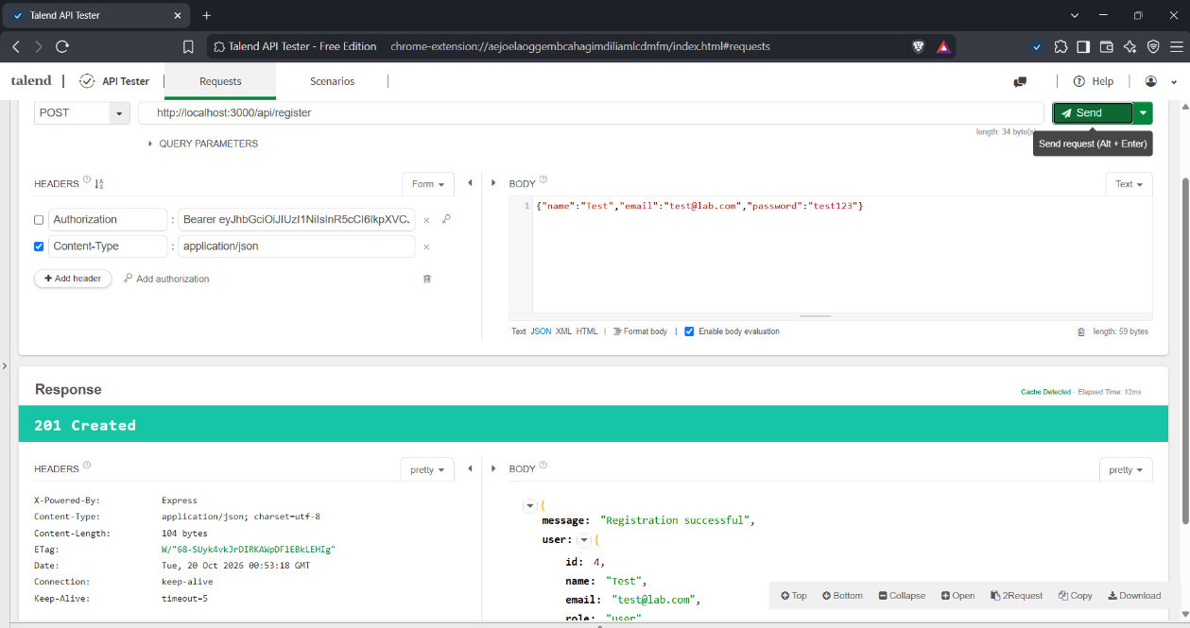
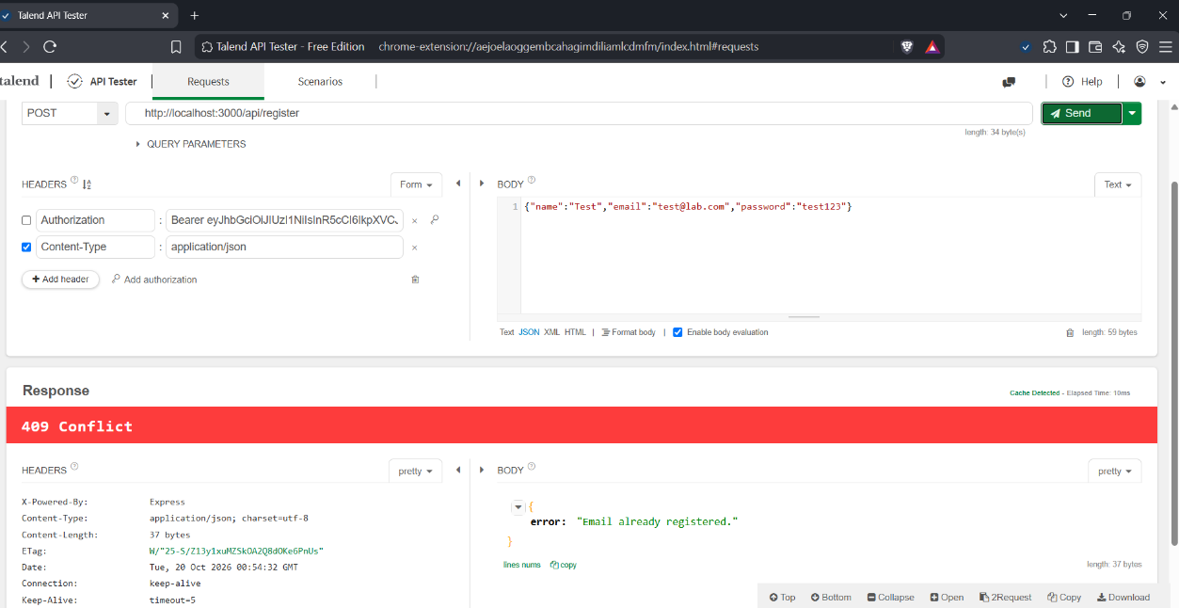
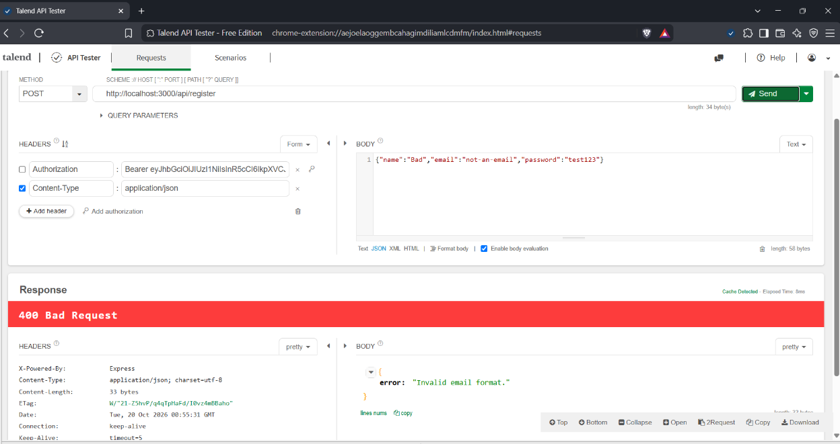
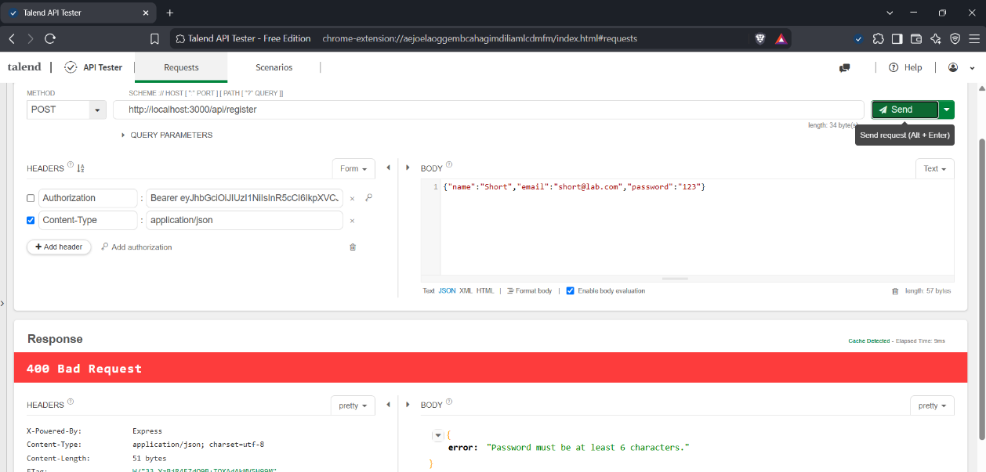
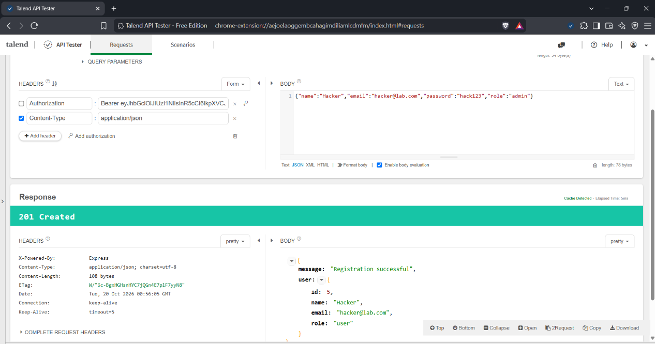
Deliverable: Screenshots of all 5 requests.

Task 4 — Test Login in Postman (10 pts)
All six requests were sent to POST /api/login.
# | Case | Expected
1 | Admin credentials | 200, redirectTo: /admin.html
2 | Staff credentials | 200, redirectTo: /staff.html
3 | User credentials | 200, redirectTo: /user.html
4 | Wrong password | 401
5 | Unknown email | 401 (same error message)
6 | Missing password | 400

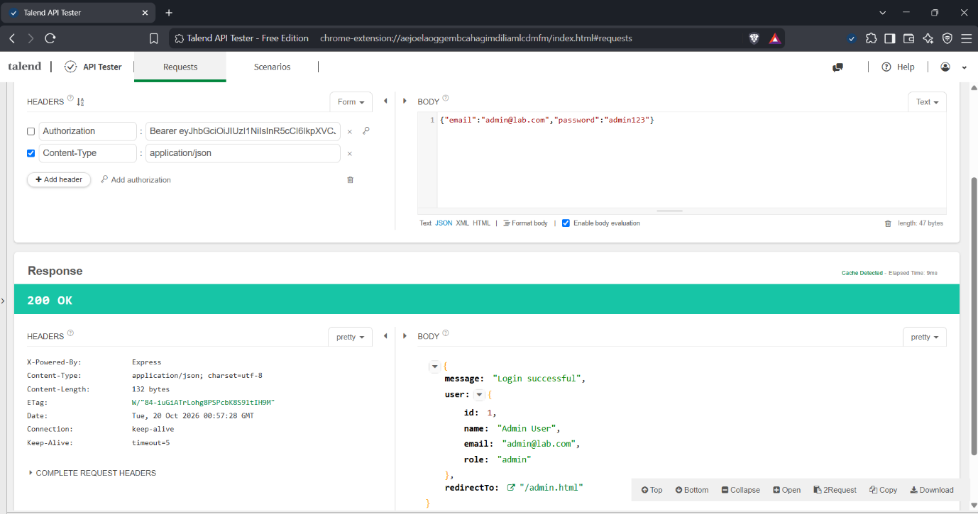
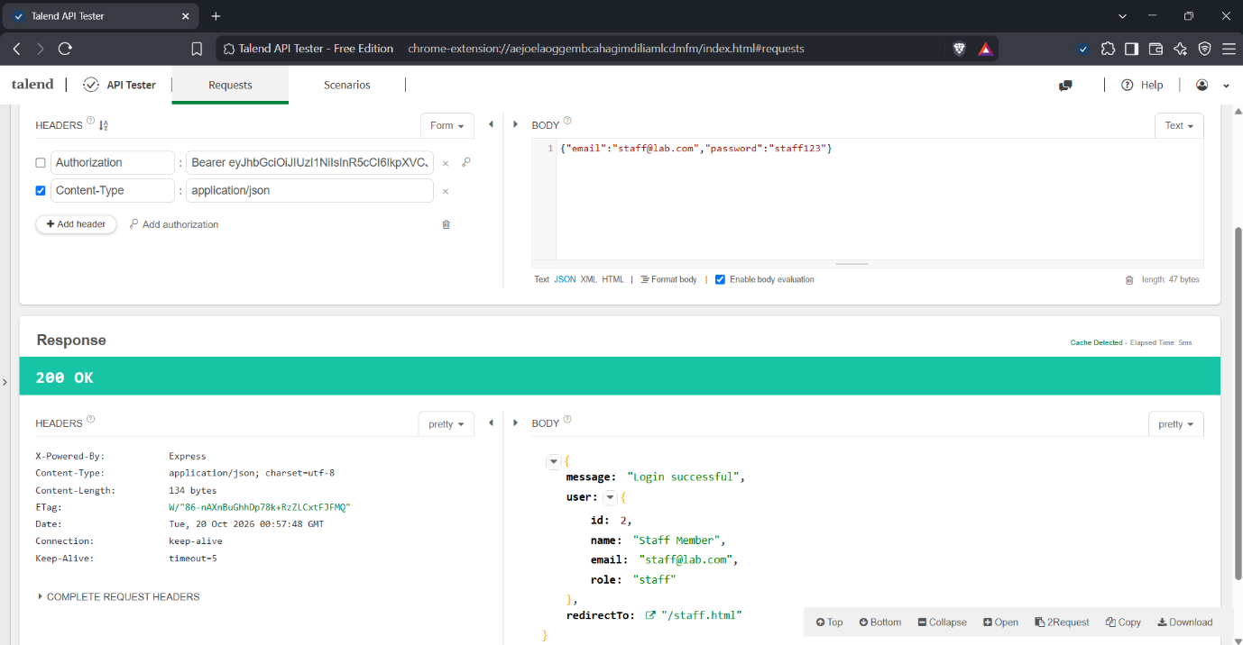
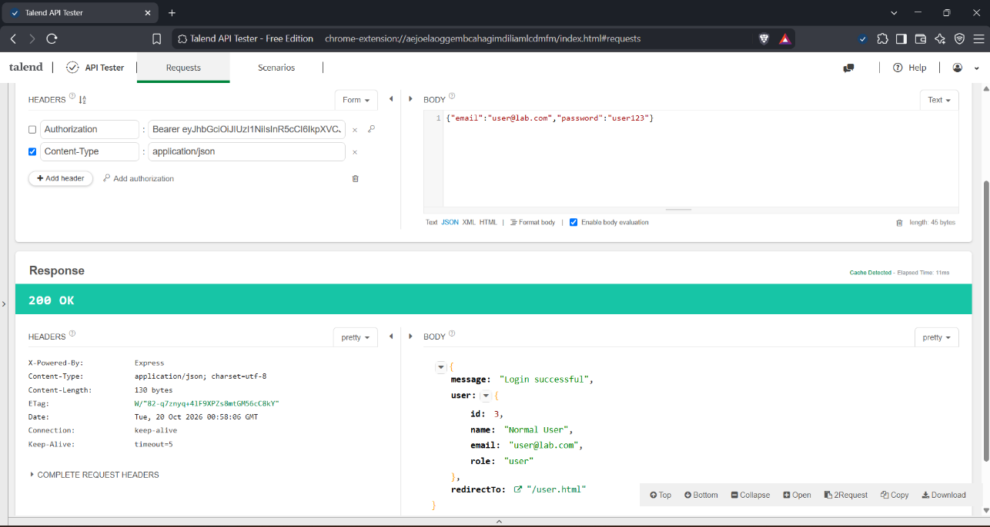
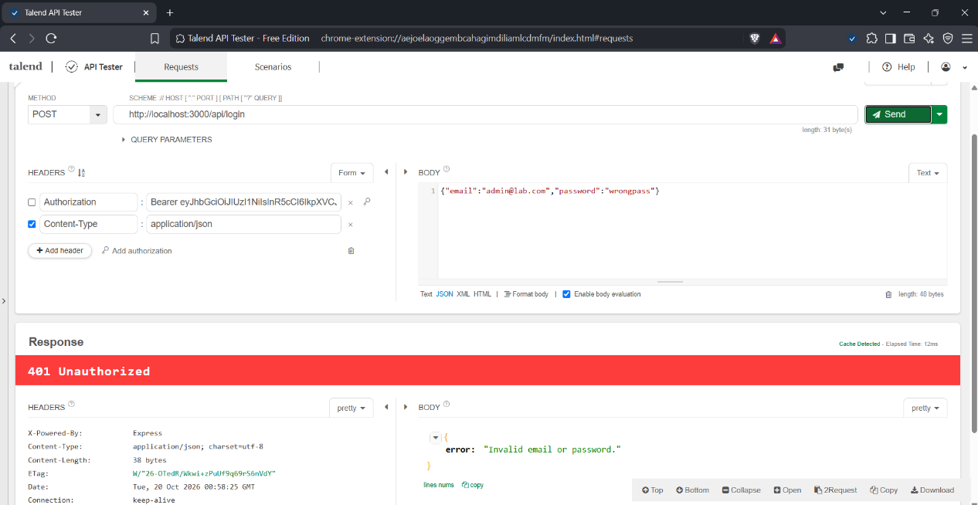
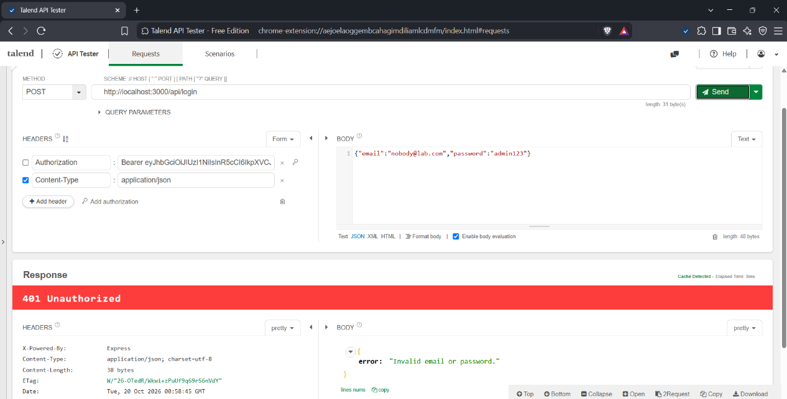
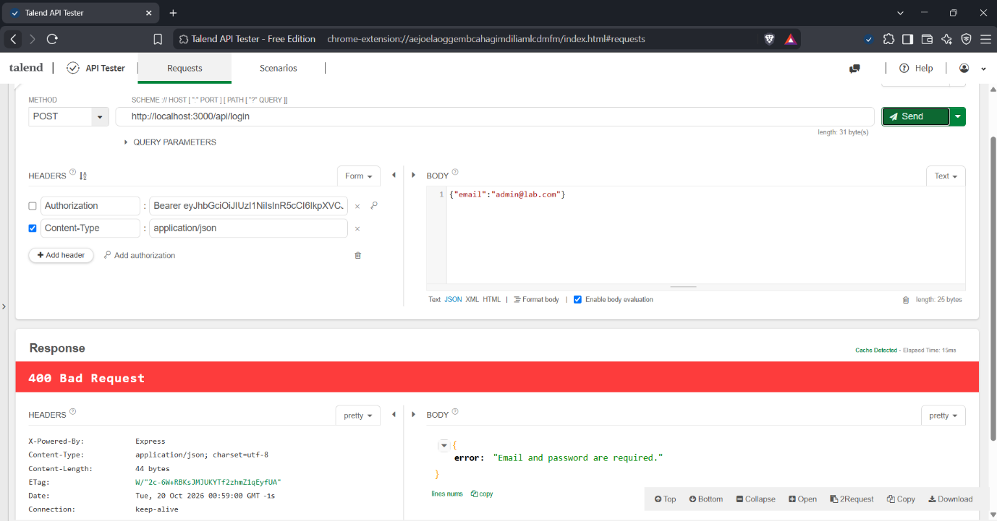
Deliverable: Screenshots of all 6 requests
Task 5 — Test Full CRUD in Postman (10 pts)
# | Method | URL | Expected
1 | GET | /api/users/1 | 200
2 | PUT | /api/users/4 | 200 (name and role updated)
3 | DELETE | /api/users/4 | 204 No Content
4 | GET | /api/users/4 | 404

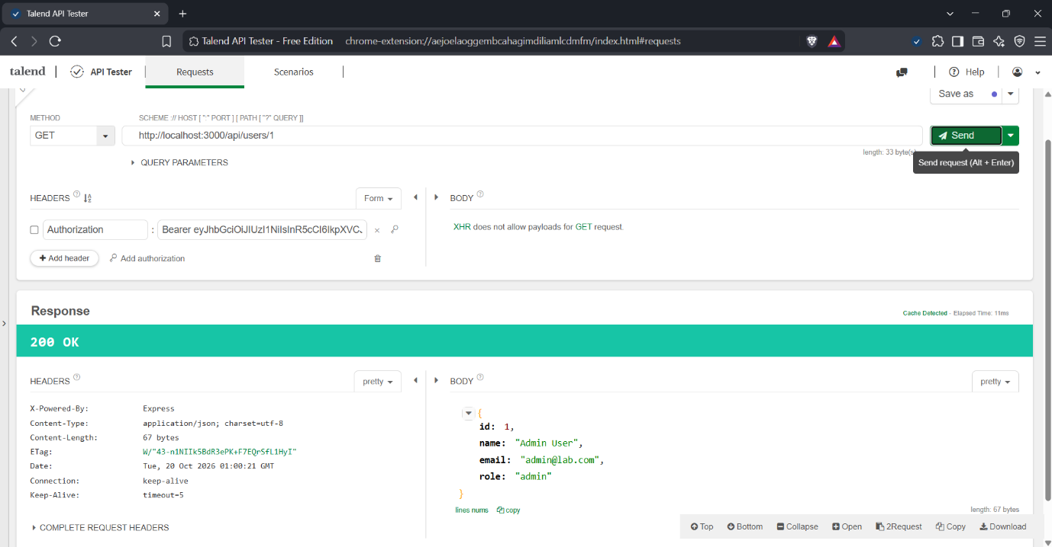
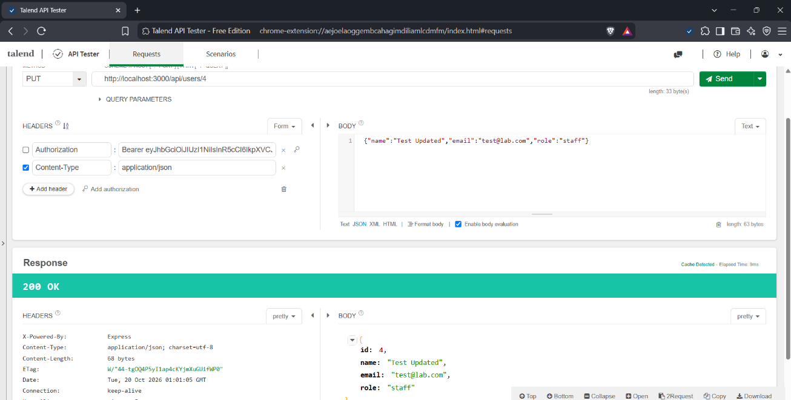
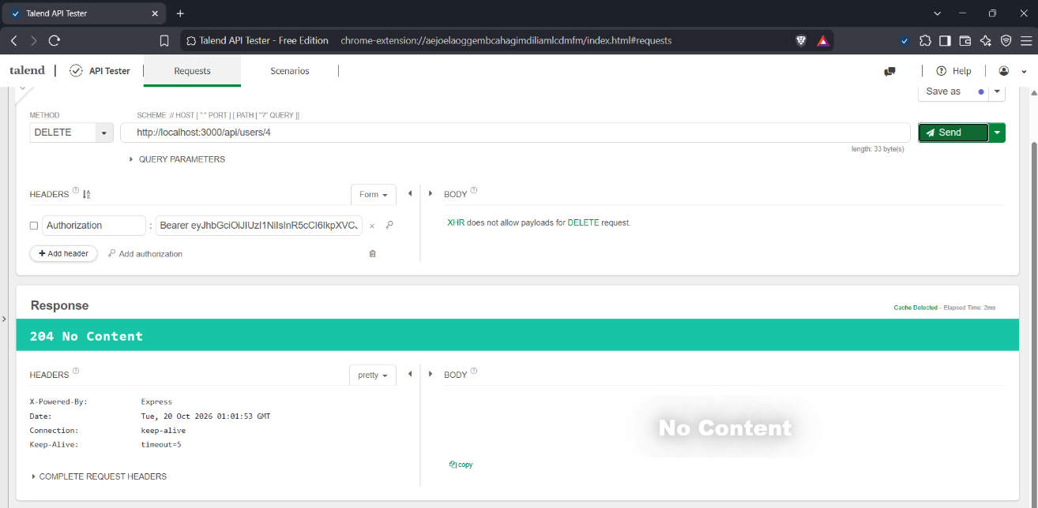
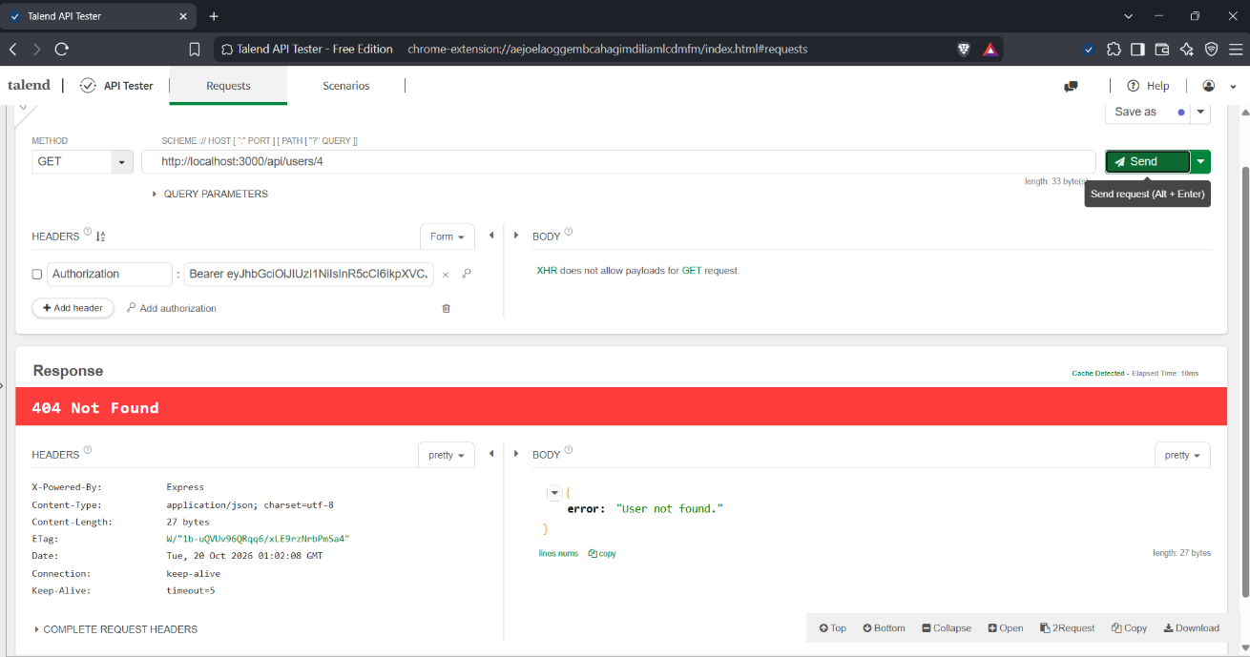
Deliverable: Screenshots of all 4 requests.
Task 6 — Browser Registration Flow (10 pts)
I registered a new account on register.html, then tried the same email again and mismatched passwords, and finally logged in with the new account.
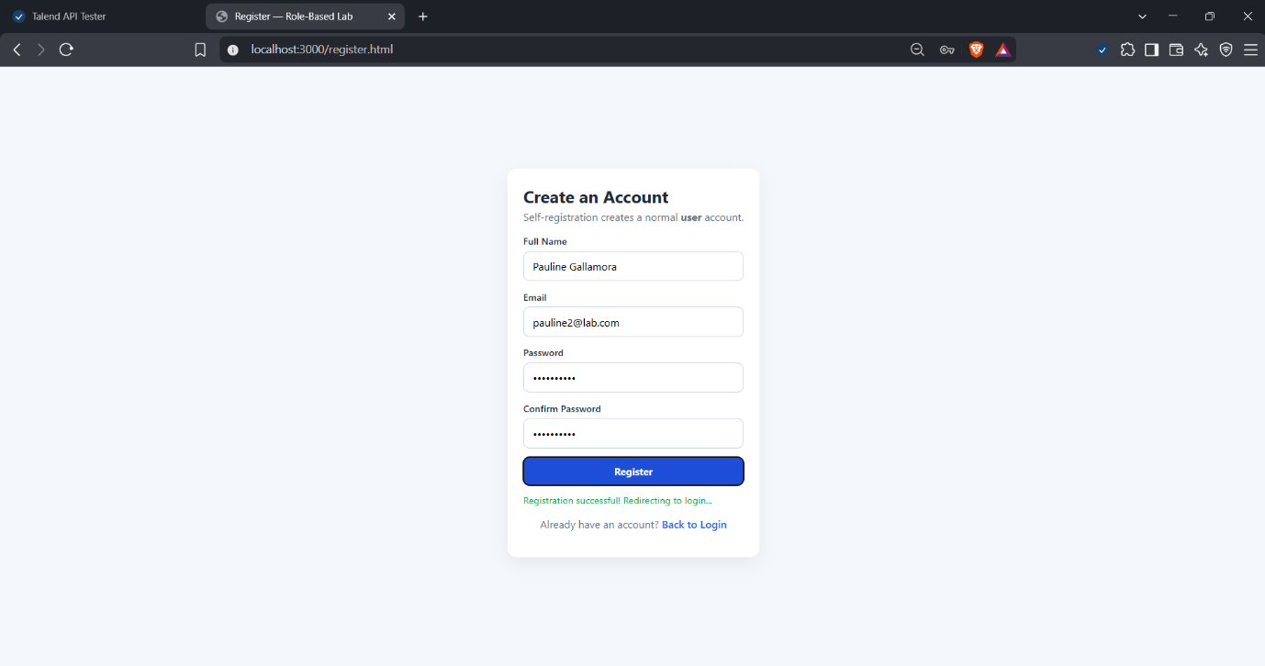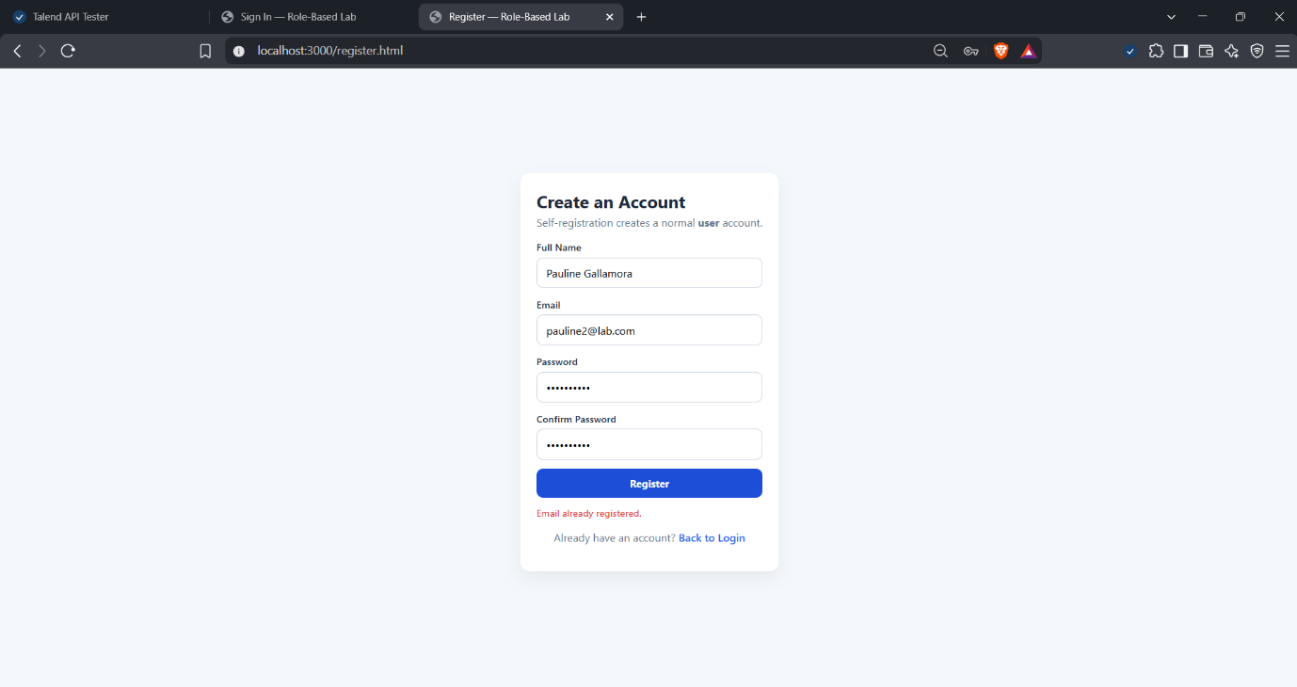

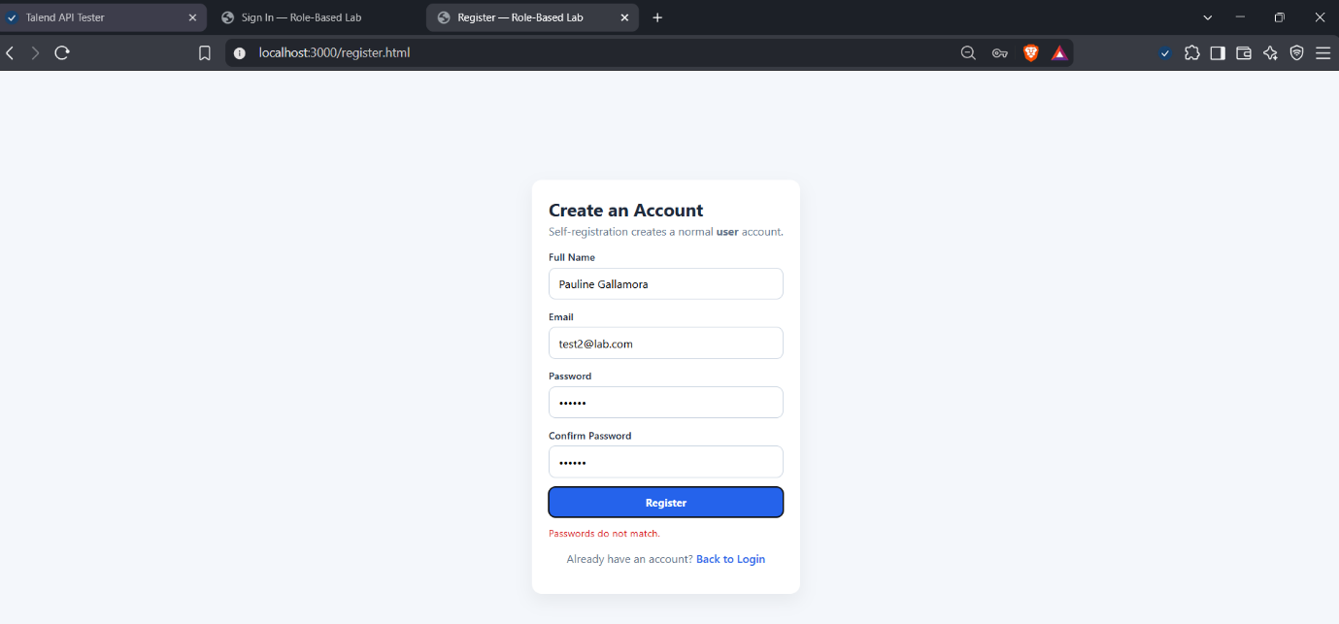

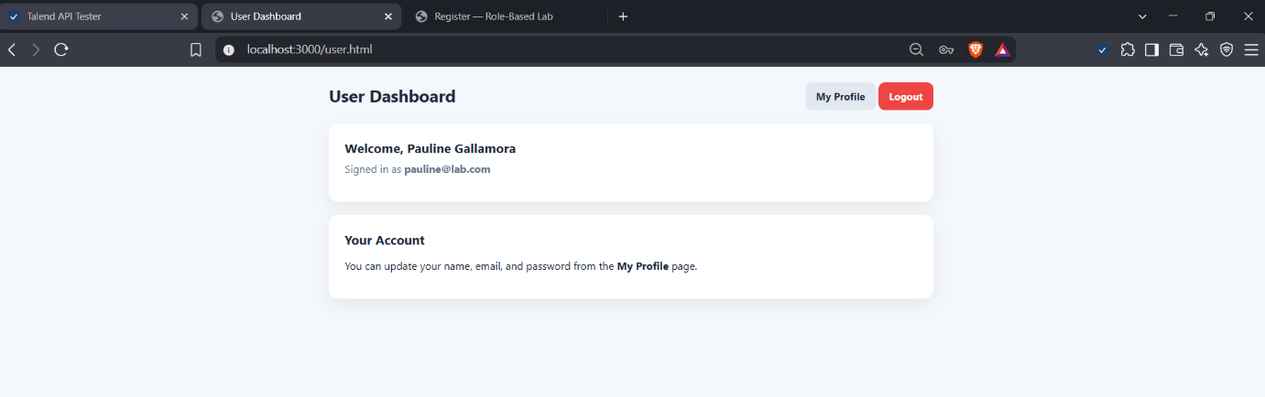

Deliverable: Screenshots of successful registration, duplicate email, mismatched password, and user dashboard

Task 7 — Browser Login & Role-Based Redirects (10 pts)
I logged in as each role and each one landed on its own page. A wrong password showed a red error.
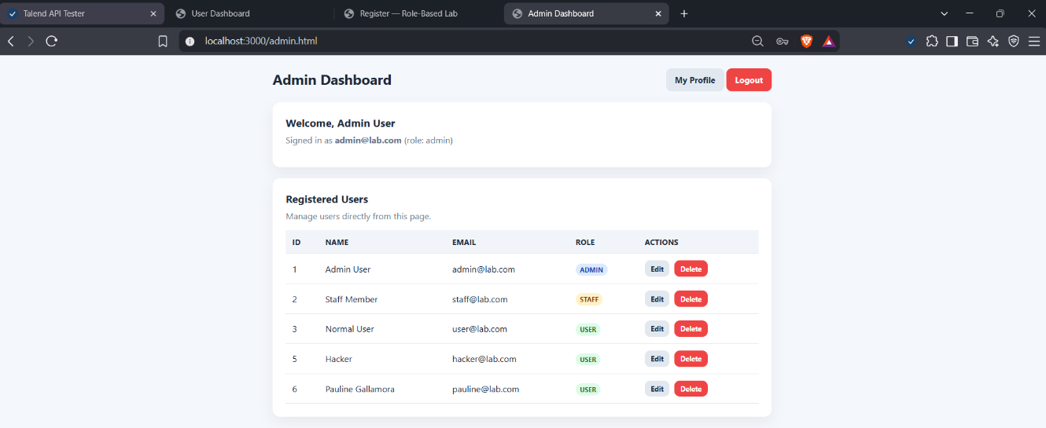
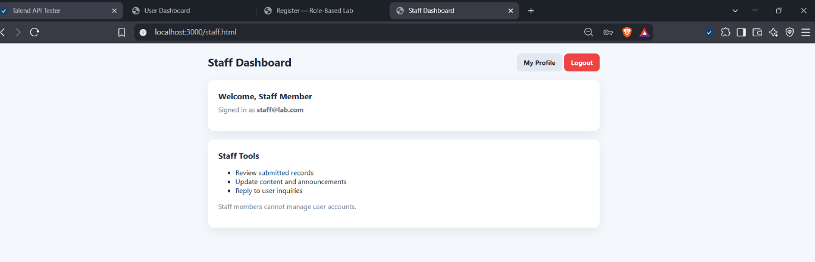
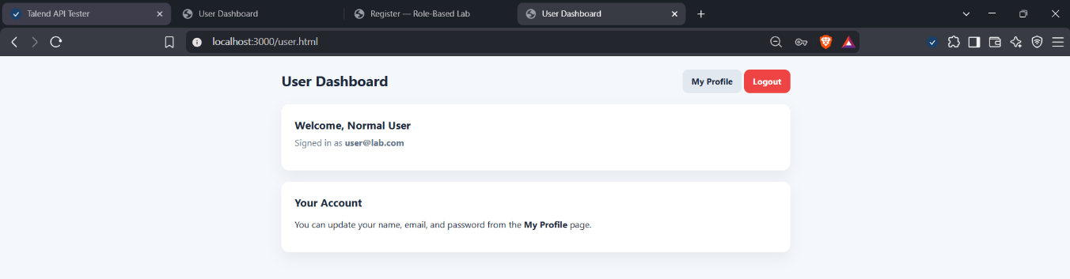
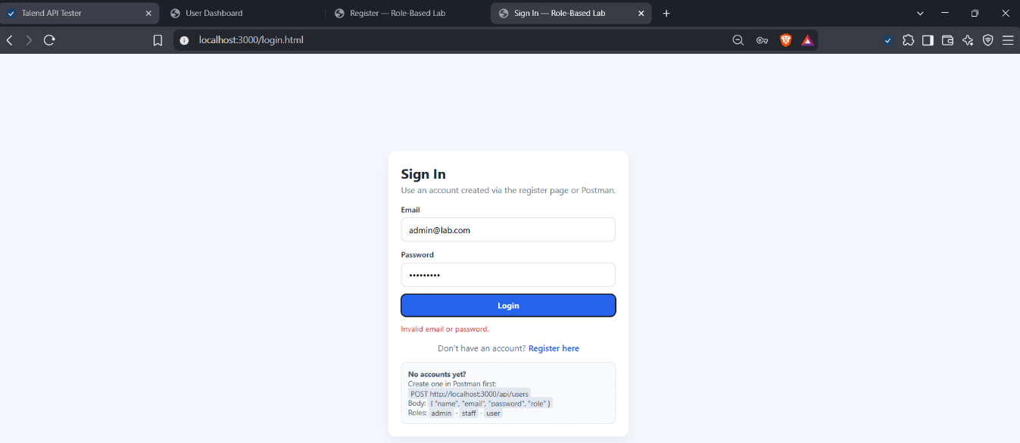Deliverable: Screenshots of all three dashboards and the error.
Task 8 — Profile Editing (10 pts)
I logged in as my own account, opened My Profile, updated my name and email, tested a wrong current password, changed the password correctly, then logged in again with the new password.
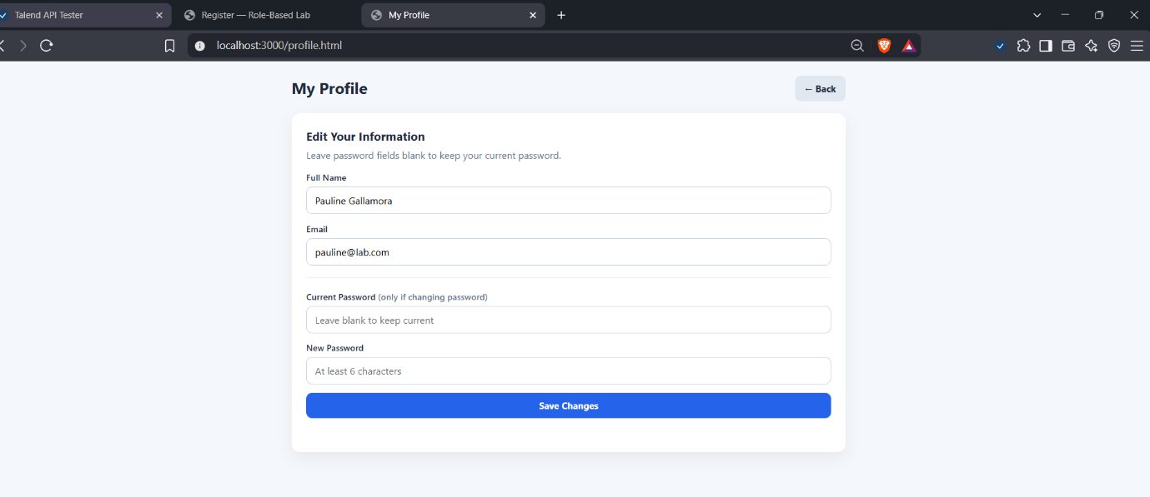

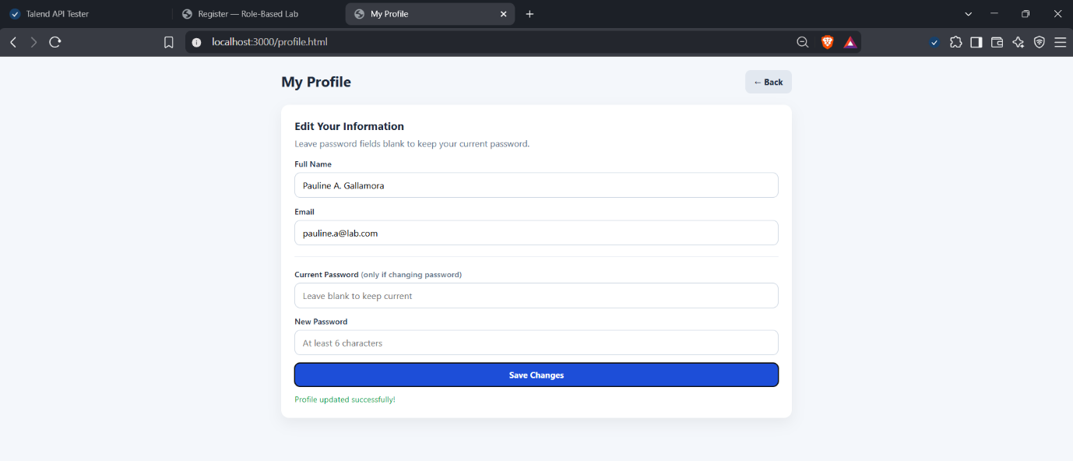

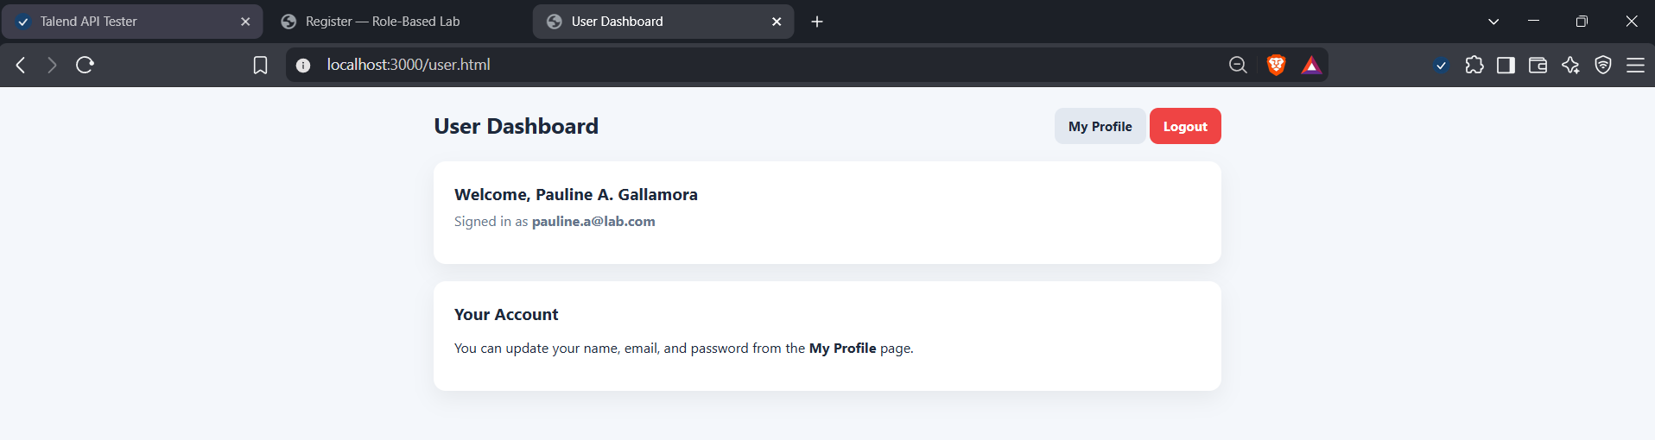
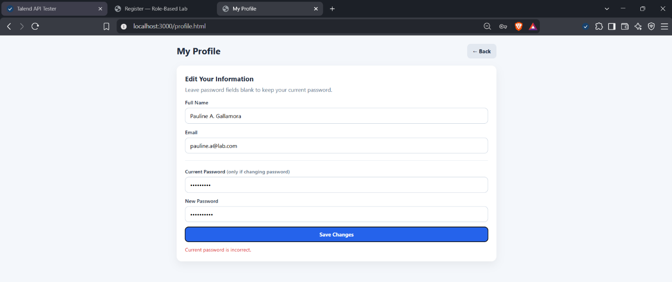

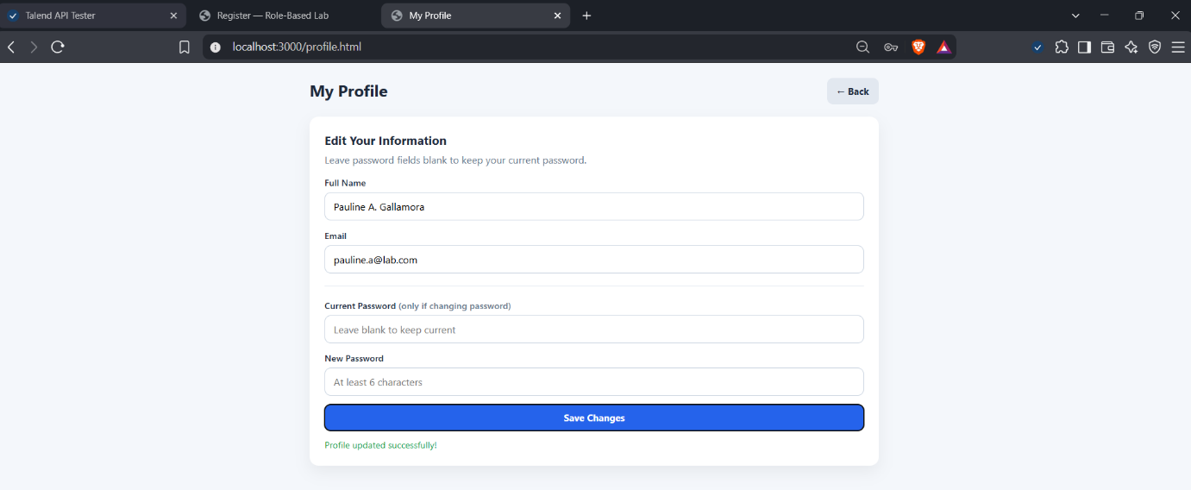

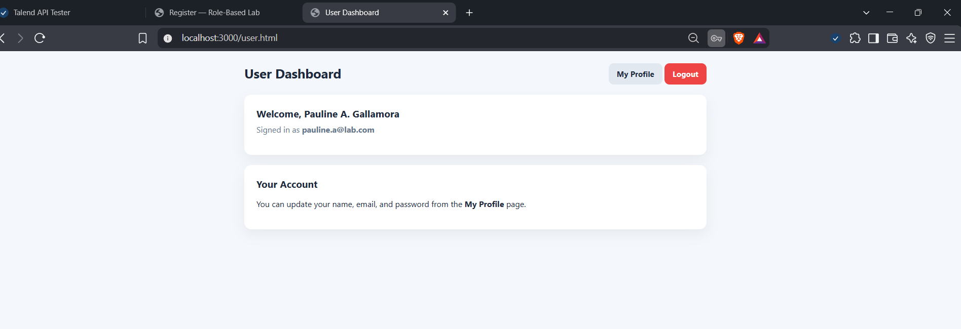

Deliverable: Screenshots of: profile page, successful update,
wrong-password error, login with new password

Task 9 — Admin User Management (10 pts)
As admin, I edited a user (promoted to staff), deleted a user, and tried to delete my own admin account, which was blocked.
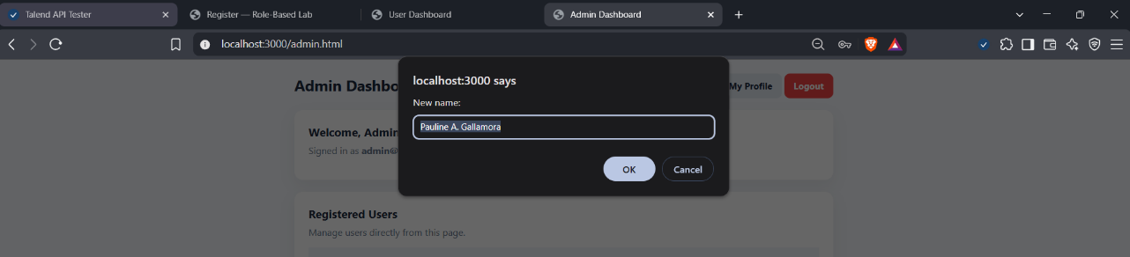
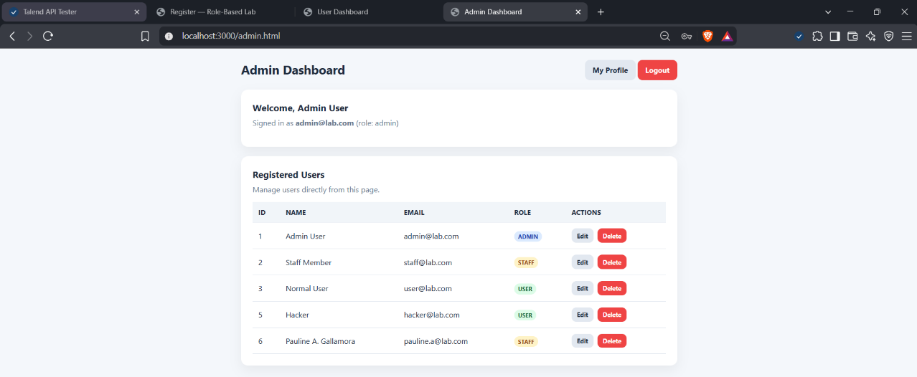
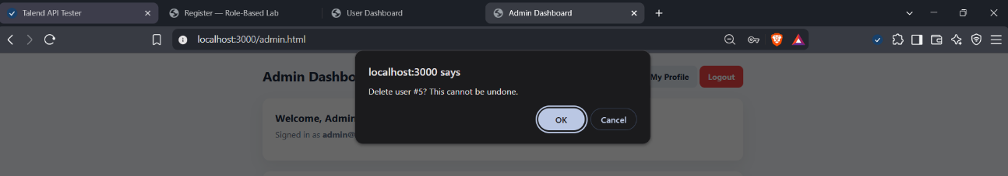
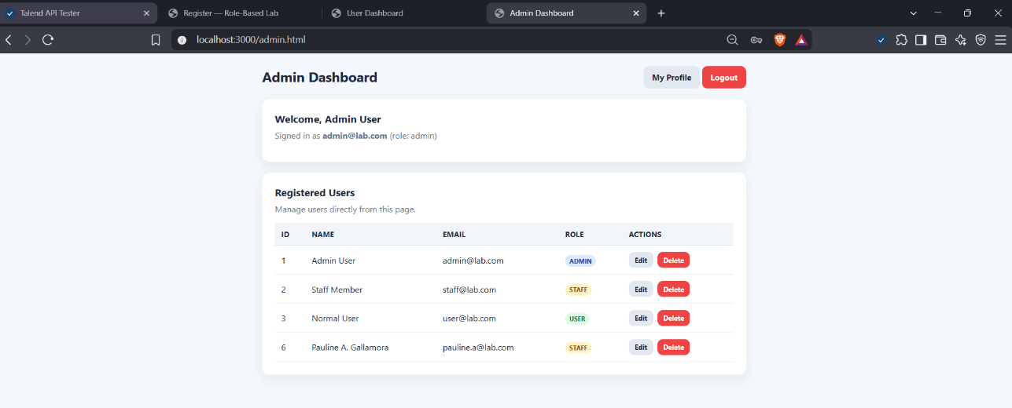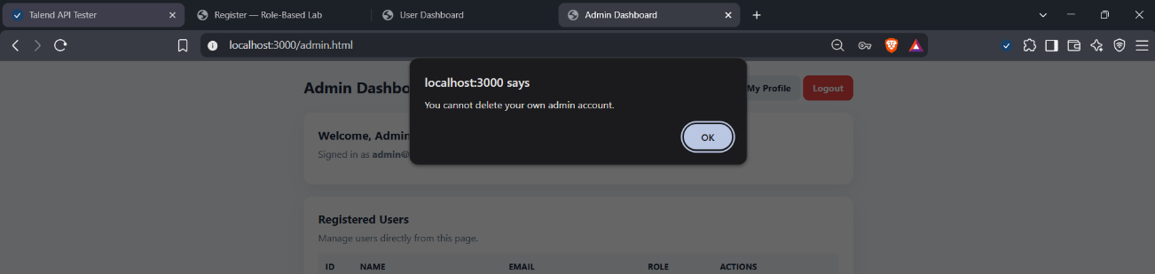
Deliverable: Screenshots of edit, delete, and blocked self delete.
Task 10 — Reflection Questions (10 pts)
Q1. In server.js, paste the exact block that decides redirectTo.
let redirectTo = '/user.html';
if (user.role === 'admin') redirectTo = '/admin.html';
else if (user.role === 'staff') redirectTo = '/staff.html';
Q2. What happens if a user manually sets sessionStorage.currentUser = {"role":"admin"} in DevTools? What does this reveal about client-side guards?
- What happens: The admin page only checks sessionStorage, so it will open and show the admin layout even if the person never logged in as admin.
- What it shows: Client-side guards only control what the page shows. They are not real security, because the user controls the browser. In this lab the API routes also have no server-side check, so the real protection has to be done on the server.
Q3. Why is the role forced to 'user' in /api/register?
- Reason: Registration is open to anyone. If the server accepted any role from the form, a person could register themselves as admin by changing the request.
- So: New accounts always start as normal users, and only an admin can create or promote other roles.
Q4. Why does /api/profile/:id require the current password before accepting a new one?
- Reason: It proves the person changing the password is the real owner of the account and not someone who just got on their open browser.
- Also: It stops a stranger from locking the owner out of their own account.
Q5. Why does sanitizeUser strip passwords from every response?
- Reason: Passwords should never leave the server. If they were in the JSON, anyone could see them in the browser's network tab or in Postman, and every list of users would leak everyone's passwords.
Q6. What happens to registered users when the server restarts? How is this fixed in real applications?
- What happens: They are all lost, because they are only stored in the users array in memory.
- Fix: Real applications store users in a database, so the data stays when the server restarts.
Q7. How does this lab demonstrate synchronous client–server communication?
- Answer: The browser sends a request, such as a login, and waits for the server's response before doing the next thing. For example, the login page does not move to the dashboard until the server replies with the redirectTo value. It is one request, one response, in order.
Q8. What role does JSON play in every request and response?
- Answer: JSON is the common format both sides understand. The browser or Postman sends data as JSON (like the email and password), and the server answers in JSON (like the user info or an error message). It makes it easy for different programs to share the same data.
Q9. Give one example of authentication and one of authorization in this lab.
- Authentication: Logging in with an email and password. The server checks them to confirm who the user is.
- Authorization: Deciding what a role is allowed to do or see, like only admins getting the user management table, or the server blocking the admin from deleting their own account.
Q10. Propose one security improvement for production. Explain why.
- Improvement: Hash the passwords with bcrypt and use real session cookies or tokens that the server checks on every request.
- Why: Right now passwords are stored in plain text and the role checks are only in the browser. Hashing protects passwords if the data leaks, and server-side checks make sure that people cannot fake being an admin.

Task 11 — Testing Checklist (5 pts)
# | Test Case | Expected | Done
1 | Server starts with node server.js | Console shows URLs | ✓
2 | Login page loads with styling | Renders correctly | ✓
3 | Register page loads | Renders correctly | ✓
4 | GET /api/users when empty | [] | ✓
5 | POST /api/users creates admin | 201, no password | ✓
6 | POST /api/users creates staff | 201, role=staff | ✓
7 | POST /api/users creates user | 201, role=user | ✓
8 | GET /api/users | No passwords shown | ✓
9 | POST /api/register valid | 201, role=user | ✓
10 | POST /api/register duplicate | 409 | ✓
11 | POST /api/register short password | 400 | ✓
12 | POST /api/register with role=admin | Role forced to user | ✓
13 | POST /api/login admin | 200, redirectTo=/admin.html | ✓
14 | POST /api/login staff | 200, redirectTo=/staff.html | ✓
15 | POST /api/login user | 200, redirectTo=/user.html | ✓
16 | POST /api/login wrong password | 401 | ✓
17 | POST /api/login unknown email | 401 (same error) | ✓
18 | POST /api/login missing password | 400 | ✓
19 | Browser register → login → user dashboard | Works | ✓
20 | Browser login as admin | Redirects to /admin.html | ✓
21 | Browser login as staff | Redirects to /staff.html | ✓
22 | Browser login as user | Redirects to /user.html | ✓
23 | Logout clears sessionStorage | Returns to login | ✓
24 | Profile page loads current data | Pre-filled | ✓
25 | PUT /api/profile/:id name/email | 200 | ✓
26 | PUT profile with wrong current password | 401 | ✓
27 | PUT profile with correct current password | 200 | ✓
28 | Login with new password | 200 | ✓
29 | Admin edit user | Table updates | ✓
30 | Admin delete user | Row removed | ✓
31 | Admin delete own account | Blocked | ✓
32 | GET deleted user | 404 | ✓
33 | Restart server — all users cleared | Login fails | ✓

IX. Bonus Task (+10 pts) — Hash Passwords with bcrypt
I installed bcrypt and updated server.js so passwords are hashed before they are stored (in POST /api/users, POST /api/register, PUT /api/users/:id and PUT /api/profile/:id). Login and the current-password check now use bcrypt.compare. After restarting the server, I recreated the users in Talend. Login still works, and GET /api/users does not show any passwords or hashes.
const hashed = await bcrypt.hash(password, 10);
const match = await bcrypt.compare(password, user.password);

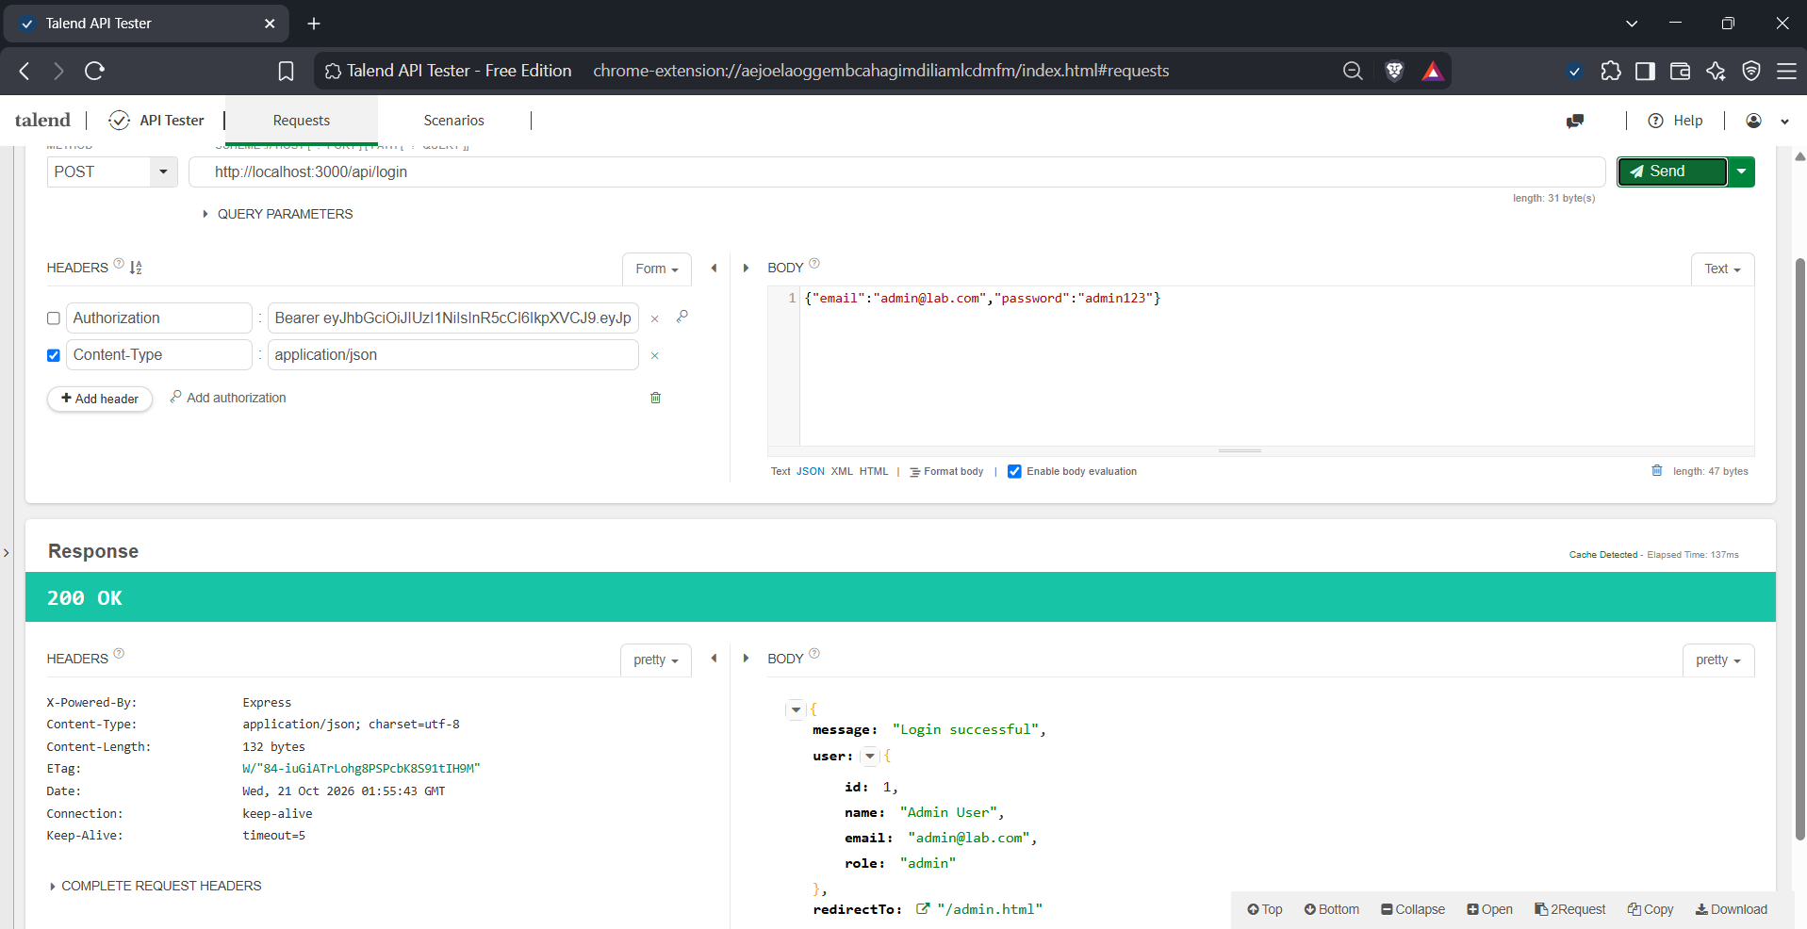
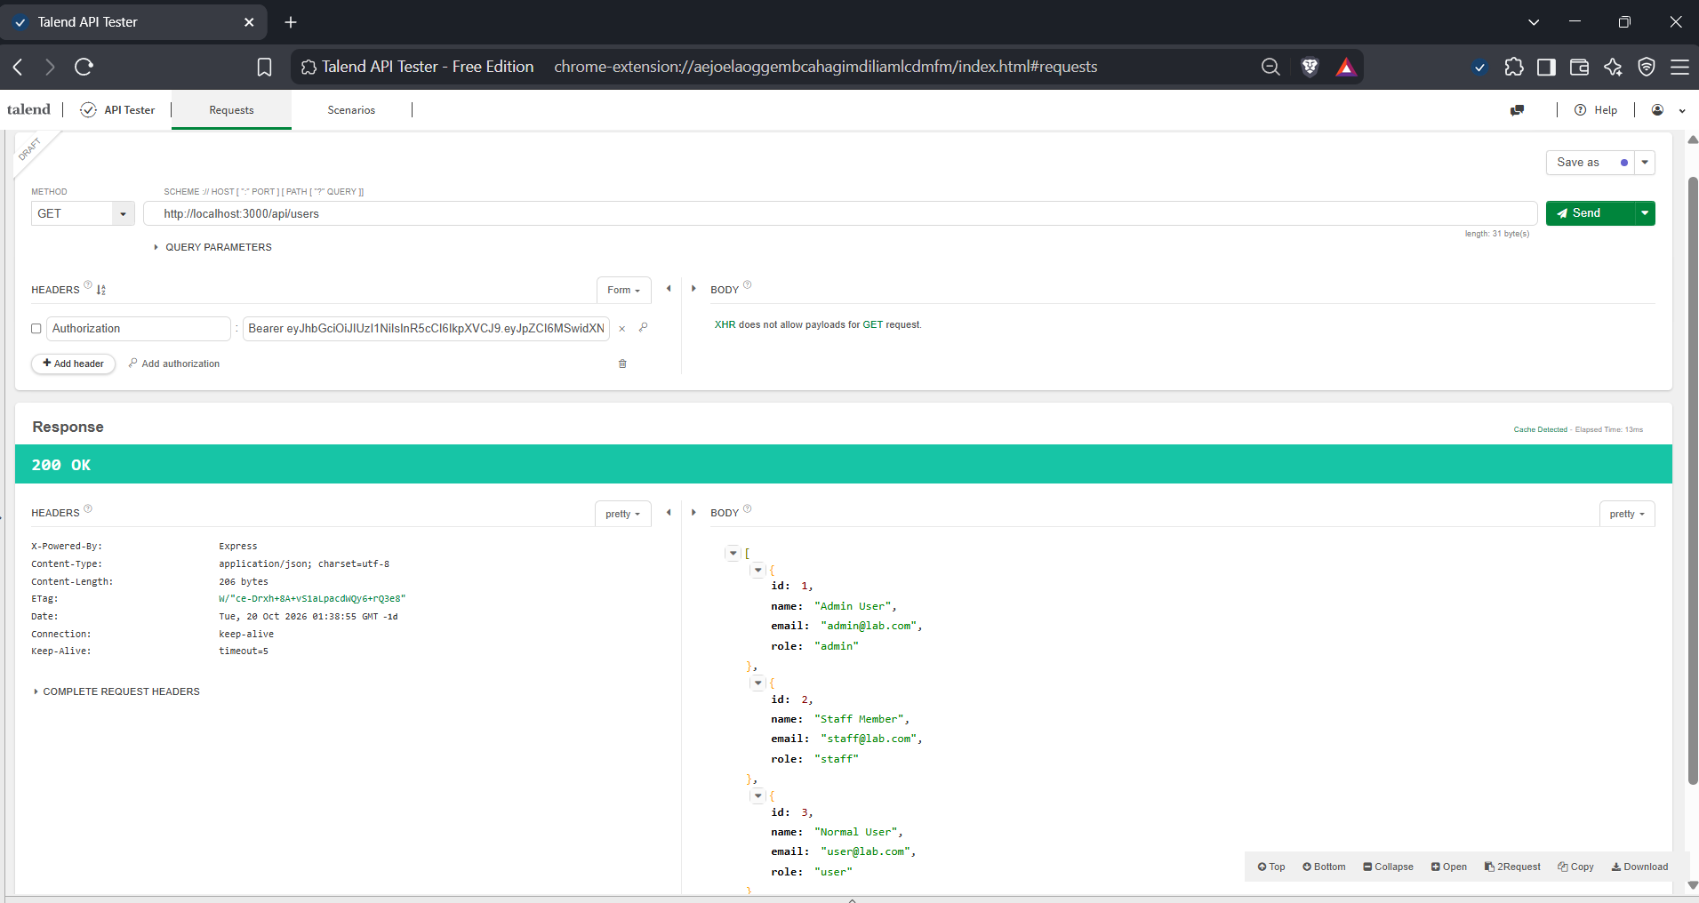
Deliverable: Updated server.js (included in the submitted files) and screenshots showing login still works and GET /api/users never reveals hashes.

Notes and Observations
- At first, POST /api/register returned 404 Not Found. The cause was that the wrong or old server was running, which had no register route. I stopped it, ran node server.js from the correct project folder, and it worked.
- The first run of node server.js said "Cannot find module 'express'". I fixed it by running npm install inside the project folder.
- Because the users are only in memory, every restart emptied the list, so I had to recreate the users in Task 2 and Task 3 after restarting.
- For the bonus, I installed bcrypt with npm install bcrypt, replaced the plain-text password checks with bcrypt.hash and bcrypt.compare, and recreated all users after restarting the server.
- The routes /api/users and /api/users/:id have no server-side check, so anyone who knows the URL can call them. Only the pages check the role in the browser.

