NORTHWIND SALES ANALYSIS

Executive Business Analysis
Prepared by: Paulinus Okon
Tools: MySQL, SQL, LibreOffice
Project Type: Sales & Business Performance Analysis

Project Overview
This project analyzes the Northwind sales database to evaluate overall sales performance, revenue trends, customer behavior, product performance, employee performance and key business risks.
SQL was used to transform the raw relational data into business-focused metrics and insights. The analysis combines transactional, customer, product, category and employee data to provide an integrated view of business performance.

Business Objectives
The analysis was designed to answer the following business questions:
- How much revenue did the business generate?
- How many orders and customers were involved?
- How did revenue change over time?
- Which customers generate the most revenue?
- Which products and categories perform best?
- Which employees generate the most sales?
- How strong is customer retention?
- How concentrated is revenue among major customers?
- Are there significant data-quality issues?
- What actions could management take based on the findings?

Dataset Overview

Dataset Component | Records/Items
Customers | 89
Orders | 830
Order Details | 2,155
Products | 77
Categories | 8
Employees | 9

The analysis covers sales transactions across customers, orders, order details, products, categories and employees. Revenue was calculated from order-detail records using unit price, quantity and recorded discount information.

Executive KPI Summary

KPI | Result
Total Revenue | 1,354,458.59
Total Orders | 830
Active Customers | 89
Products Sold | 77
Active Employees | 9
Units Sold | 51,317
Average Order Value | 1,631.88
Repeat Customer Rate | 98.9%
Top 10 Customer Revenue Share | 45.5%
Average Recorded Discount | 0%

The business generated 1,354,458.59 in revenue across 830 orders and 51,317 units sold. Customer retention was particularly strong, with 88 of 89 active customers classified as repeat customers.

Revenue Trend Analysis

Year | Revenue
2013 | 226,298.50
2014 | 658,388.75
2015 | 469,771.34

Revenue increased substantially between 2013 and 2014, rising from 226,298.50 to 658,388.75. Revenue subsequently declined to 469,771.34 in 2015.
The 2014 peak followed by the 2015 decline represents one of the most important performance patterns identified in the analysis and warrants further investigation into the underlying customer, product, geographic and sales-representative drivers.

Customer Analysis

Customer | Country | Revenue
QUICK-Stop | Germany | 117,483.39
Save-a-lot Markets | USA | 115,673.39
Ernst Handel | Austria | 113,236.68
Hungry Owl All-Night Grocers | Ireland | 57,317.39
Rattlesnake Canyon Grocery | USA | 52,245.90

The customer analysis indicates strong customer loyalty, with a 98.9% repeat-customer rate.
However, the top 10 customers account for 45.5% of total revenue. This creates a degree of key-account dependency and means that customer retention should remain a strategic priority.

Product & Category Analysis

Product | Category | Units Sold | Revenue
Côte de Blaye | Beverages | 623 | 149,984.20
Thüringer Rostbratwurst | Meat & Poultry | 746 | 87,736.40
Raclette Courdavault | Dairy Products | 1,496 | 76,296.00
Camembert Pierrot | Dairy Products | 1,577 | 50,286.00
Tarte au sucre | Confections | 1,083 | 49,827.90

Côte de Blaye was the strongest revenue-generating product, producing 149,984.20. The difference between unit volume and revenue among leading products demonstrates why both measures should be considered when evaluating product performance.

Employee Performance

Employee | Orders | Revenue
Margaret Peacock | 156 | 250,187.45
Janet Leverling | 127 | 213,051.30
Nancy Davolio | 123 | 202,143.71
Andrew Fuller | 96 | 177,749.26
Robert King | 72 | 141,295.99
Laura Callahan | 104 | 133,301.03
Anne Dodsworth | 43 | 82,964.00
Michael Suyama | 67 | 78,198.10
Steven Buchanan | 42 | 75,567.75

Margaret Peacock generated the highest recorded employee revenue at 250,187.45. Employee performance varied substantially across the nine active sales representatives.
These differences should be investigated alongside customer portfolios, territories, order volumes and product mix before attributing performance differences solely to individual sales effectiveness.

Discount Analysis

No discounts were recorded in the supplied order-detail dataset. All 2,155 order-detail records contained a discount value of 0, with no NULL discount values.
Therefore, the analysis records an average discount of 0% and an estimated recorded discount value of 0.

Data Quality & Validation

Multiple validation checks were performed to assess the reliability of the analysis. These included checks for missing customer and employee references, orphan order-detail records, duplicate identifiers, invalid quantities or prices, missing product categories, date ranges and revenue reconciliation.
The final revenue reconciliation successfully matched, confirming consistency between the revenue calculations used in the analysis.

Key Business Findings

Finding 1 — Strong overall performance
The business generated 1,354,458.59 in revenue from 830 orders.

Finding 2 — Exceptional customer retention
98.9% of active customers were repeat customers.

Finding 3 — Revenue concentration
The top 10 customers contributed 45.5% of total revenue.

Finding 4 — Revenue volatility
Revenue peaked at 658,388.75 in 2014 before declining to 469,771.34 in 2015.

Finding 5 — Product performance is not simply volume-driven
Côte de Blaye generated 149,984.20 despite selling fewer units than some other leading products.

Finding 6 — Sales performance varies significantly
Margaret Peacock generated 250,187.45, the highest employee revenue in the analysis.

Business Risks

Risk 1 — Key-account dependency
45.5% of revenue comes from the top 10 customers.

Risk 2 — Revenue slowdown
The 2015 decline requires investigation.

Risk 3 — Employee performance concentration
Revenue is not evenly distributed across employees.

Risk 4 — Limited discount information
Although discounts are recorded as zero, the dataset cannot tell us whether promotional activity existed outside the recorded field.

Recommendations

1. Protect key accounts
Prioritize retention strategies for the top revenue-generating customers.

2. Investigate the 2015 decline
Break the decline down by:
- month
- customer
- product
- category
- employee
- country

3. Protect high-value products
Monitor Côte de Blaye and other high-revenue products for availability and demand.

4. Investigate employee performance differences
Compare representatives by:
- orders
- revenue
- customers
- product mix
- average order value

5. Expand the customer base
Maintain the excellent repeat-customer rate while acquiring additional customers.

6. Improve promotional data capture
If discounts or promotions exist operationally, ensure they are properly recorded in the database.

Conclusion
Use:
The Northwind sales analysis demonstrates a business with strong revenue generation, exceptional repeat-customer behavior and several high-performing products and sales representatives. However, the analysis also identifies important management considerations, particularly revenue concentration among major customers and the significant decline following the 2014 revenue peak.
The findings demonstrate how SQL can be used not only to retrieve data but to transform transactional records into actionable business intelligence. The resulting analysis provides management with a structured basis for customer retention, sales performance monitoring, product prioritization and future revenue-growth strategies.

Technical Skills Demonstrated

MySQL
SQL
CTEs
JOINs
Aggregate Functions
Window Functions
CASE Statements
Subqueries
Data Validation
Revenue Analysis
Customer Analysis
Product Analysis
Employee Performance Analysis
Business Intelligence
Dashboard Development
Data Storytelling

OUTPUT IMAGES

1. Executive KPI/Dashboard section

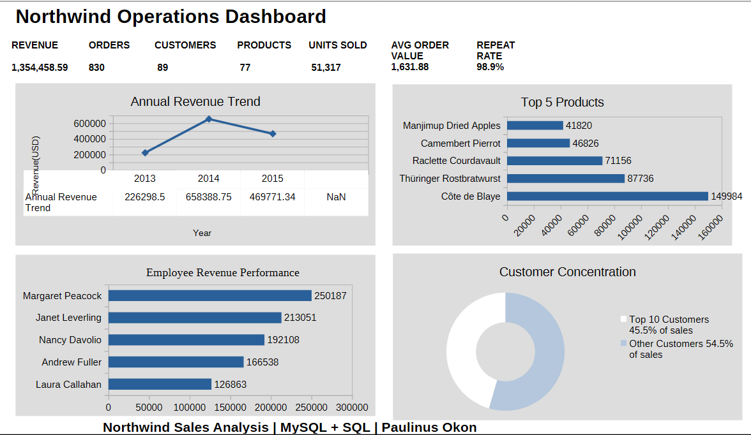

2. Revenue Trend section

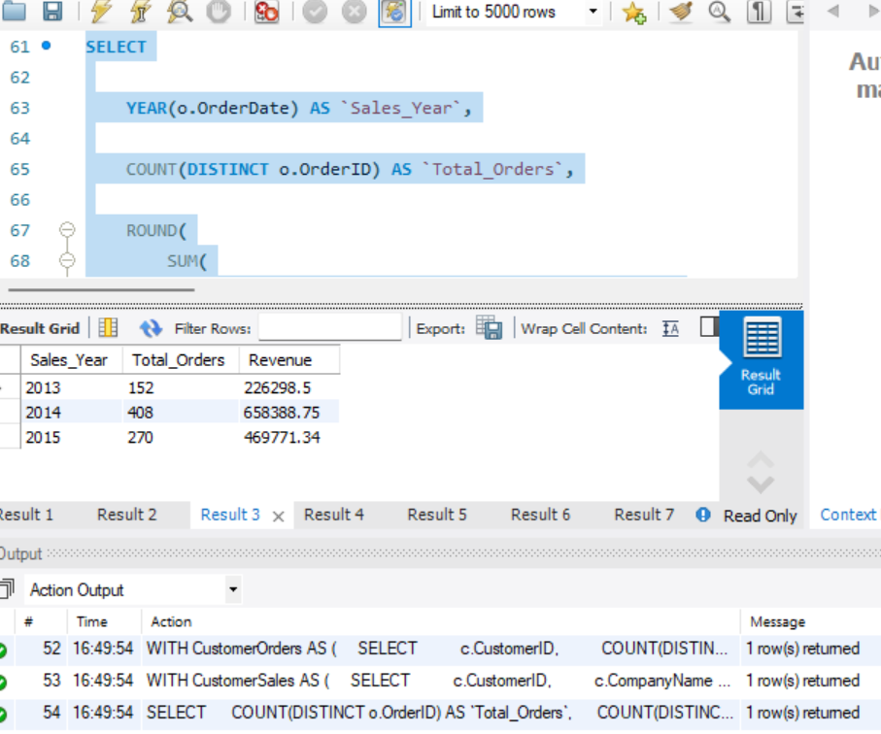
3. Customer/Product section

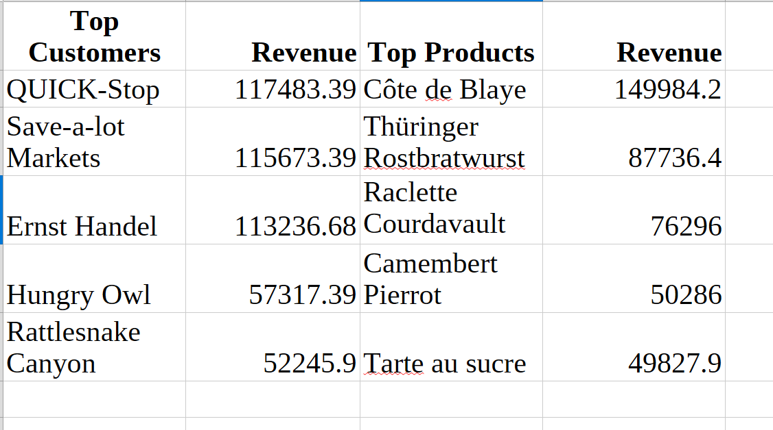

4. Data Quality section

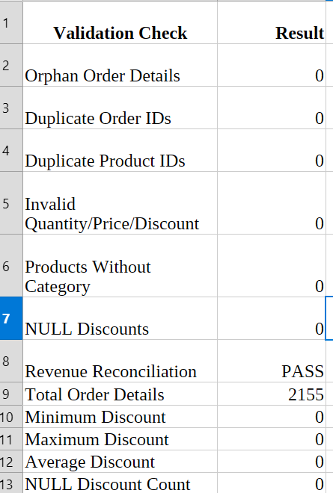

Key Findings at a Glance
💰 REVENUE

1,354,458.59

Total revenue generated
📈 REVENUE PEAK

658,388.75

2014 revenue
Repeat customer rate
👥 CUSTOMER RETENTION

98.9%

Repeat customer rate
⚠️ Revenue Concentration

45.5%

Top 10 customers' share.
🥇 Top Product

Côte de Blaye

149,984.20 revenue
🏆 Top Employee

Margaret Peacock

250,187.45 revenue

