**Emoticon (顏面)**

Emoticon is want to show audience that people may force themselves to smile to each other while inside their heart they feel worried and anxious due to challenges in everyday life – work, love, etc. They have no choice but force themselves to pretend a mood or feeling that not match they really are.

Game instructions:

Esc - Exit the program

W - Go front

A - Go left

D - Go right

S - Go behind

Spacebar - Jump

Making of photos:

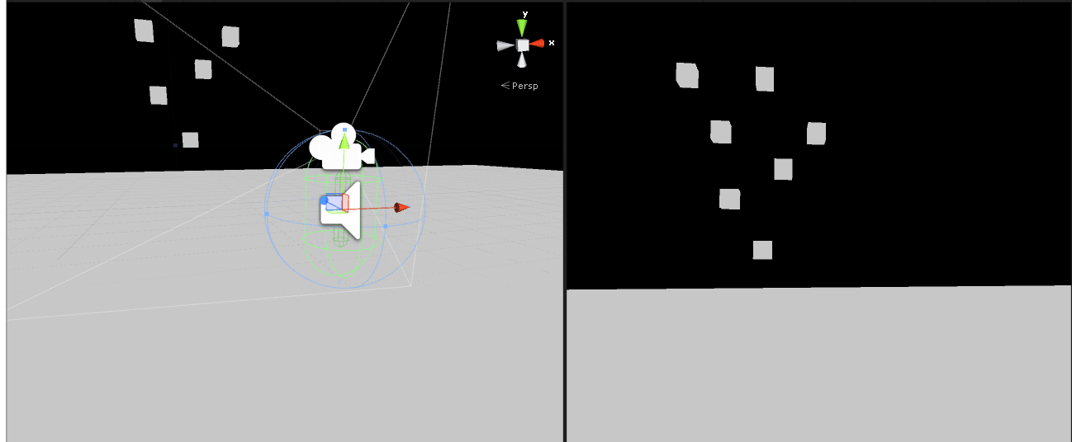

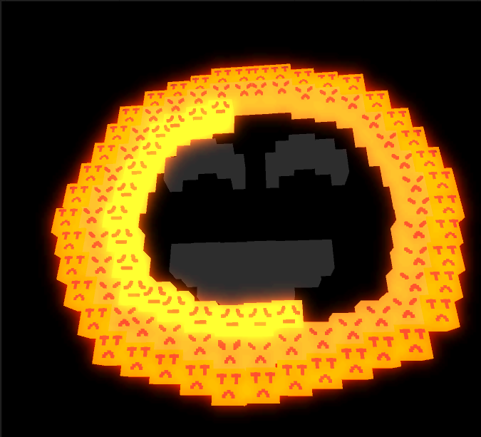

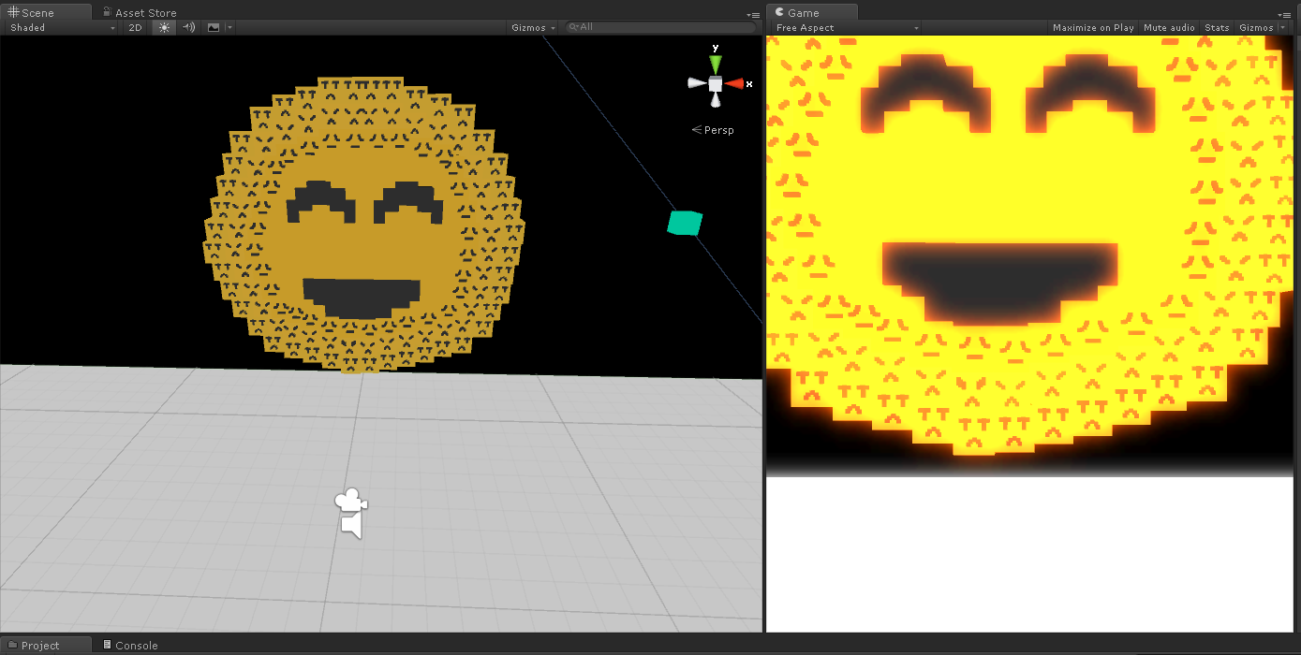

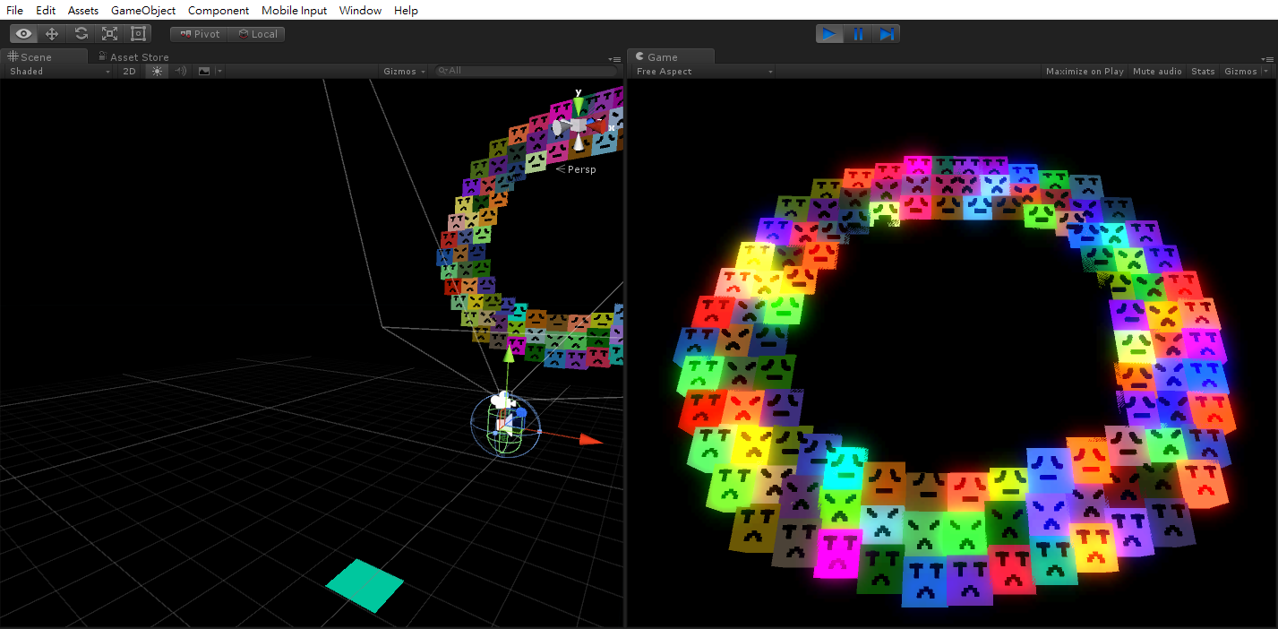

Sound Reference:

Standard library from Unity asset store

<http://taira-komori.jpn.org/>